Functional Job Description: Induction

Company: | Bluestem Brands, Inc. | 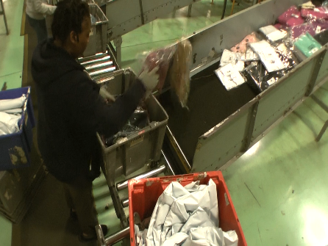
Job Title: | Induction
Date: | 11-13-17
Dept/Facility: | DC, Eatonton, GA
Product Section: | Outbound
Electronic Doc. # | FJD Induction FINAL 11-13-17

Work Hours | Overtime: | Voluntary and/or mandatory per production requirements. | Breaks: | Two 15-minute breaks and one 30-minute lunch within 8-hour shift
 | Shift: | Days of week: | Time:
 | First | Monday – Friday | 6:00 AM to 2:30 PM
 | Second | Monday – Friday | 2:30 PM to 8:30 PM

Job Rotation | Yes

Job Training or Credentials Required at Hire | Education/ training: | None required; high school diploma or GED preferred.
 | Knowledge/ cognitive skills: | Basic math, reading, writing and oral communication skills preferred. Ability to organize work tasks and work independently or as part of a team.

Machines, Tools and/or Equipment Used | Totes, bags, boxes.

Job Purpose/ Objectives | Takes merchandise (bags and boxes) out of totes and places onto inclined conveyor. Takes merchandise (bags and boxes) off the inclined conveyor and places onto the sorter conveyor.

Safety and Personal Protective Equipment Required  *Available | Hard Hat | Steel Toe Footwear | Safety Glasses | Gloves:
 | Face Shield | Protective Clothing | Safety Glasses/Side Shields | Leather
 | Dust Mask | Safety Vest  Fall Protection Harness | Safety Goggles  Hearing Protection*  Compensatory methods to mitigate heat | Rubberized/cloth*  Chemical

Safety/ Equipment Training/ Certification Required | Daily Meeting and Stretch Breaks (includes:) | Industrial Truck Training | OSHA Training (Rules and Regulations)
 | - Safety Topics | EZ-Go | New Hire Safety Orientation
 | - Safety Policies | Walkie-Rider | Right to Know
 | - Questions & Answers | Pallet Jack | Lockout/Tag Out
 | - Review Safety Committee Minutes | Forklift (sit down) | Regulated Materials Training (ORM-D)  Supervisor Safety Updates
 |  | Stand-up Reach Truck
 |  | Order Picker
 |  | Transpositioner
 |  | Pivot Pro Vacuum Lift

Functional Job Elements |  |  | % of Shift
- Dump Totes  - Lifts full tote over the short lip that holds the tote in the staging area on the conveyor.  - Maximum weight handled up to 35# (full totes).  - Takes merchandise (bags and boxes) out of tote and places onto inclined conveyor.  - Average weight in range of 2 to 10#.  - Rotates between Dump Totes and Load Sorter Conveyor. |  |  | 0 to 100
 | 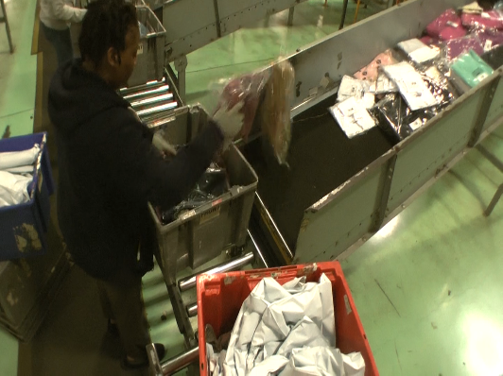 | 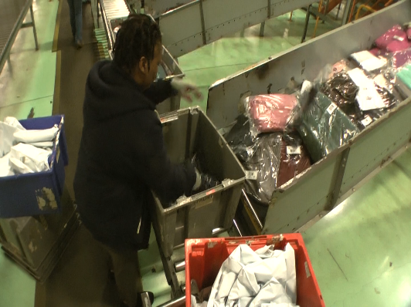
- Load Sorter Conveyor  - Takes merchandise (bags and boxes) off the staging area of the inclined conveyor and places onto the sorter conveyor.  - Average weight in range of 2 to 10#.  - Rotates between Dump Totes and Load Sorter Conveyor. | 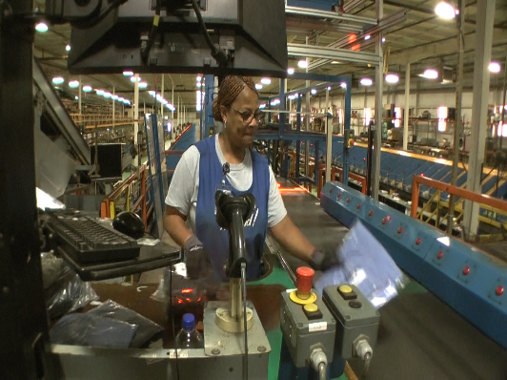 | 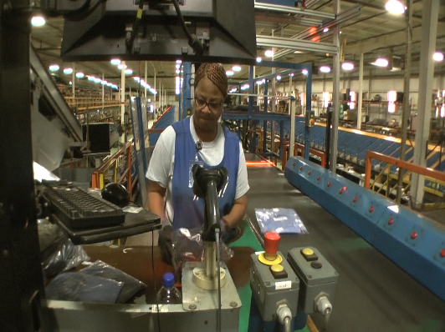 | 0 to 100
 | 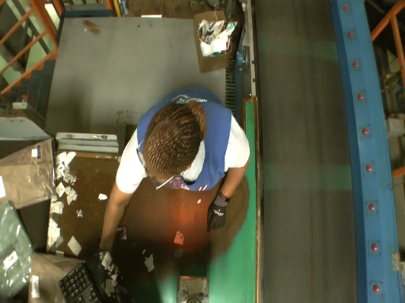

Physical Factors
Manual Material Handling
(lbs) | Floor-Knuckle (0” to 30”) |  |  |  |  |  | Knuckle-Chest (30” to 50’) |  |  |  |  |  | Chest-Overhead  ( > 50”) |  |  |  |  |  | Carry - Two Hands; Front |  |  |  |  |  | Carry - One Hand; Side |  |  |  |  |  | Push |  |  |  |  |  | Pull
100
75
50
35
15
10
5
0
Exp | N | R | O | F | C |  | N | R | O | F | C |  | N | R | O | F | C |  | N | R | O | F | C |  | N | R | O | F | C |  | N | R | O | F | C |  | N | R | O | F | C

Postures/Movements |  |  |  |  |  |  |  |  |  |  |  |  |  |  |  | Head/Neck
Exp | Sit | Stand | Walk | Bal | Stairs | Lad-der | Foot contrl | Twist Waist | Bend Waist | Squat | Kneel | Crawl | Reach below 54” | Reach above 54” |  | Flex Static | Ext Static | Rot Static | Flex Dyn | Ext Dyn | Rot Dyn
C
F
O
R
N

Hand Use |  |  |  |  | Sensory |  |  |  |  |  | Communication |  |  |  |  | Key C - Continuous: 67 to 100% of shift  F - Frequent: 34 to 66% of shift  O - Occasional: 6 to 33% of shift  R - Rarely: up to 5% of shift  N - Never: 0% of shift  Abbreviations: Bal=Bal, Exp=Exposure, Contrl=Control, Flex=Flexion, Ext=Extension, Dyn=Dynamic, Manip=Manipulation
Exp | Simple Grasp | Firm Grasp | Fine Manip | Bal | See | Hear | Touch Feel | Taste | Smell |  | Talk | Read | Write | Hand Signal
C
F
O
R
N

Environmental Factors | Exposure Level |  |  |  |  | Key/Comments
 | N | R | O | F | C
Outdoor Work |  |  |  |  |  | Key C - Continuous: 67 to 100% of shift  F - Frequent: 34 to 66% of shift  O - Occasional: 6 to 33% of shift  R - Rarely: up to 5% of shift  N - Never: 0% of shift  Comments:  Indoor Work: Primary work area is a large indoor warehouse complex.  Moving Objects: Be aware of and avoid moving objects including product and equipment.  Heat: Based on external temperature, occasionally performs job tasks in hot indoor environment; warehouse complex is not air-conditioned. Large fans are used for ventilation.  Cold: Cold in the winter.
Indoor Work
Heat
Cold
Wet/ Humid
Hearing Protection
Vibration
Fumes/Gases/Odors
Dust
Moving Objects
Electrical
Chemical
Protected Work Heights
Unprotected Work Heights
Flying Debris
Lighting (Inadequate/Excessive)

Position eligible to be considered for temporary modification in conjunction with a Return to Work transitional duty program agreement: Yes
This Functional Job Description was completed through an on-site job analysis by a certified professional ergonomist/licensed physical therapist. It is for the purpose of identifying and quantifying the physical functional requirements of this job. The Functional Job Description should not be construed as a detailed description of all specific job duties and/or tools, equipment and materials that may be necessary or incidental to the performance of this job. Further consideration may be necessary when applying the standards to the injured population in the medical management process.
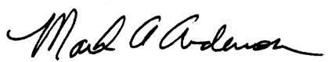 | This Functional Job Description has been reviewed by company representatives and is believed to be an accurate representation of most of the job content.
Mark A Anderson, MA, PT CPE  Certified Professional Economist  Licensed Physical Therapist  ErgoSystems Consulting Group, Inc.  7421 W Shoreline Dr  Waconia, MN 55387  952-401-9296  mark.anderson@ergosystemsconsulting.com  www.ergosystemsconsulting.com | _______________________________________
 | Christopher Simmons, Outbound Manager
_______________________________________
Joel McCullough, Maintenance Manager

