Functional Job Description: Picker

Company: | Bluestem Brands, Inc. | 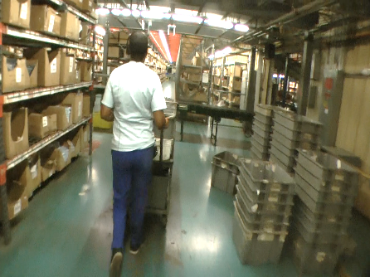 | 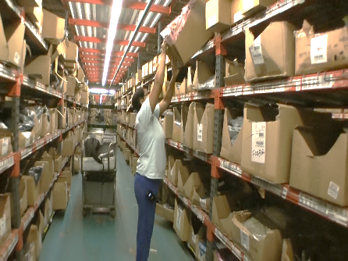
Job Title: | Picker
Date: | 11-13-17
Dept/Facility: | DC, Eatonton, GA
Product Section: | Outbound
Electronic Doc. # | FJD Picker FINAL 11-13-17

Work Hours | Overtime: | Voluntary and/or mandatory per production requirements. | Breaks: | Two 15-minute breaks and one 30-minute lunch within 8-hour shift
 | Shift: | Days of week: | Time:
 | First | Monday - Friday | 5:00 AM to 1:30 PM
 | Second | NA | NA

Job Rotation | Yes

Job Training or Credentials Required at Hire | Education/ training: | None required; high school diploma or GED preferred.
 | Knowledge/ cognitive skills: | Basic math, reading, writing and oral communication skills preferred. Ability to organize work tasks and work independently or as part of a team.

Machines, Tools and/or Equipment Used | Carts, totes, pick to voice system, scanner, labels.

Job Purpose/ Objectives | Voice pick 220 pieces of merchandise/hour, scan, label and place full totes on zone outbound conveyor.

Safety and Personal Protective Equipment Required  *Available | Hard Hat | Steel Toe Footwear | Safety Glasses | Gloves:
 | Face Shield | Protective Clothing | Safety Glasses/Side Shields | Leather
 | Dust Mask | Safety Vest  Fall Protection Harness | Safety Goggles  Hearing Protection*  Compensatory methods to mitigate heat | Rubberized/cloth*  Chemical

Safety/ Equipment Training/ Certification Required | Daily Meeting and Stretch Breaks (includes:) | Industrial Truck Training | OSHA Training (Rules and Regulations)
 | - Safety Topics | EZ-Go | New Hire Safety Orientation
 | - Safety Policies | Walkie-Rider | Right to Know
 | - Questions & Answers | Pallet Jack | Lockout/Tag Out
 | - Review Safety Committee Minutes | Forklift (sit down) | Regulated Materials Training (ORM-D)  Supervisor Safety Updates
 |  | Stand-up Reach Truck
 |  | Order Picker
 |  | Transpositioner
 |  | Pivot Pro Vacuum Lift

Functional Job Elements |  |  | % of Shift
- Load empty totes onto cart  - Load empty totes (2 to 3#) onto bottom (6”) and top shelves (26”) of the cart.  - Up to 6 totes on the cart. | 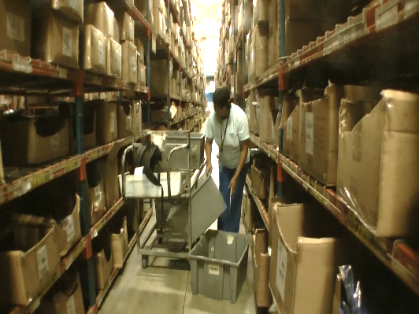 |  | 5
- Pick merchandise  - Push cart through racks to pick merchandise (primarily bags) to voice command (wears headset).  - Shelf height levels are 6”, 26”, 46”, 66” and 82” from floor.  - Typical merchandise weight is 2 to 8#.  - Goal is to pick 220 items per hour.  . | 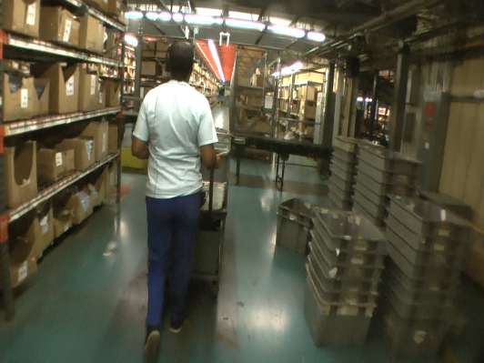 |  | 85
 |  | 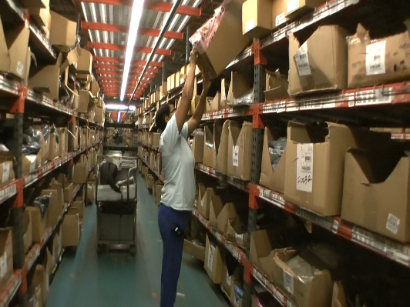
- Load totes onto conveyor  - Scan totes.  - Put batch number on top item in tote.  - Push full totes on cart to conveyor.  - Load full totes (up to 60#) from cart onto the conveyor (about 26” height). | 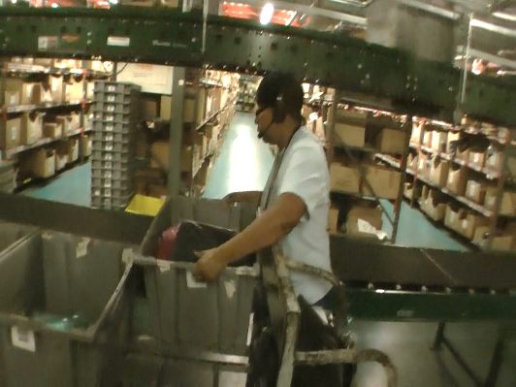 | 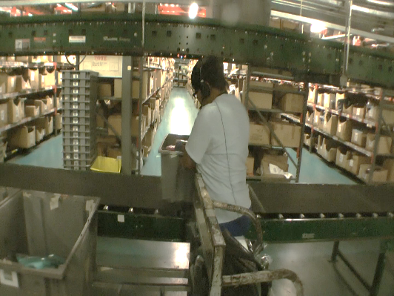 | 10

Physical Factors
Manual Material Handling
(lbs) | Floor-Knuckle (0” to 30”) |  |  |  |  |  | Knuckle-Chest (30” to 50’) |  |  |  |  |  | Chest-Overhead  ( > 50”) |  |  |  |  |  | Carry - Two Hands; Front |  |  |  |  |  | Carry - One Hand; Side |  |  |  |  |  | Push |  |  |  |  |  | Pull
100
75
60
35
15
10
5
0
Exp | N | R | O | F | C |  | N | R | O | F | C |  | N | R | O | F | C |  | N | R | O | F | C |  | N | R | O | F | C |  | N | R | O | F | C |  | N | R | O | F | C

Postures/Movements |  |  |  |  |  |  |  |  |  |  |  |  |  |  |  | Head/Neck
Exp | Sit | Stand | Walk | Bal | Stairs | Lad-der | Foot contrl | Twist Waist | Bend Waist | Squat | Kneel | Crawl | Reach below 54” | Reach above 54” |  | Flex Static | Ext Static | Rot Static | Flex Dyn | Ext Dyn | Rot Dyn
C
F
O
R
N

Hand Use |  |  |  |  | Sensory |  |  |  |  |  | Communication |  |  |  |  | Key C - Continuous: 67 to 100% of shift  F - Frequent: 34 to 66% of shift  O - Occasional: 6 to 33% of shift  R - Rarely: up to 5% of shift  N - Never: 0% of shift  Abbreviations: Bal=Bal, Exp=Exposure, Contrl=Control, Flex=Flexion, Ext=Extension, Dyn=Dynamic, Manip=Manipulation
Exp | Simple Grasp | Firm Grasp | Fine Manip | Bal | See | Hear | Touch Feel | Taste | Smell |  | Talk | Read | Write | Hand Signal
C
F
O
R
N

Environmental Factors | Exposure Level |  |  |  |  | Key/Comments
 | N | R | O | F | C
Outdoor Work |  |  |  |  |  | Key C - Continuous: 67 to 100% of shift  F - Frequent: 34 to 66% of shift  O - Occasional: 6 to 33% of shift  R - Rarely: up to 5% of shift  N - Never: 0% of shift  Comments:  Indoor Work: Primary work area is a large indoor warehouse complex.  Moving Objects: Be aware of and avoid moving objects including product and equipment.  Heat: Based on external temperature, occasionally performs job tasks in hot indoor environment; warehouse complex is not air-conditioned. Large fans are used for ventilation.  Cold: Cold in the winter.
Indoor Work
Heat
Cold
Wet/ Humid
Hearing Protection
Vibration
Fumes/Gases/Odors
Dust
Moving Objects
Electrical
Chemical
Protected Work Heights
Unprotected Work Heights
Flying Debris
Lighting (Inadequate/Excessive)

Position eligible to be considered for temporary modification in conjunction with a Return to Work transitional duty program agreement: Yes
This Functional Job Description was completed through an on-site job analysis by a certified professional ergonomist/licensed physical therapist. It is for the purpose of identifying and quantifying the physical functional requirements of this job. The Functional Job Description should not be construed as a detailed description of all specific job duties and/or tools, equipment and materials that may be necessary or incidental to the performance of this job. Further consideration may be necessary when applying the standards to the injured population in the medical management process.
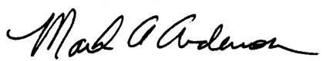 | This Functional Job Description has been reviewed by company representatives and is believed to be an accurate representation of most of the job content.
Mark A Anderson, MA, PT CPE  Certified Professional Economist  Licensed Physical Therapist  ErgoSystems Consulting Group, Inc.  7421 W Shoreline Dr  Waconia, MN 55387  952-401-9296  mark.anderson@ergosystemsconsulting.com  www.ergosystemsconsulting.com | _______________________________________
 | Christopher Simmons, Outbound Manager
 | _______________________________________
 | Joel McCullough, Maintenance Manager

