Functional Job Description: Pack Ship Material Handler

Company: | Bluestem Brands, Inc. |  | 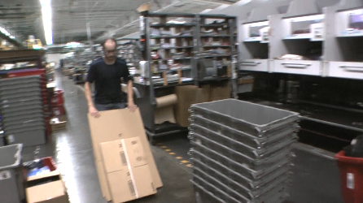
Job Title: | Pack Ship Material Handler
Date: | 11-13-17
Dept/Facility: | DC, Irvine, PA
Product Section: | Outbound
Electronic Doc. # | FJD Pack Ship Material Handler FINAL 11-13-17

Work Hours | Overtime: | Voluntary and/or mandatory per production requirements. | Breaks: | (2) 15 minute & (1) 30 minute lunch break
 | Shift: | Days of week: | Time:
 | First | Monday - Friday | 7:15 AM to 3:45 PM, 9:15 AM to 5:45 PM
 | Second | NA | NA

Job Rotation | Yes

Job Training or Credentials Required at Hire | Education/ training: | None required; high school diploma or GED preferred.
 | Knowledge/ cognitive skills: | Basic math, reading, writing and oral communication skills preferred. Ability to organize work tasks and work independently or as part of a team.

Machines, Tools and/or Equipment Used | Cart, safety knife, totes, bins, cantilever conveyor.

Job Purpose/ Objectives | Supply Pack/Sort workstations with needed materials and supplies. Load trailers. Stack totes. Dump totes. Handle Hospital Line Materials. Dump bulk totes. Shipping induction, Pack/Sort Induction.

Safety and Personal Protective Equipment Required  *Available | Hard Hat | Steel Toe Footwear | Safety Glasses | Gloves:
 | Face Shield  Battery Change | Protective Clothing | Safety Glasses/Side Shields | Leather
 | Dust Mask | Safety Vest  Fall Protection Harness | Safety Goggles  Hearing Protection*  Compensatory methods to mitigate heat | Rubberized/cloth*  Chemical

Safety/ Equipment Training/ Certification Required | Daily Meeting and Stretch Breaks (includes:) | Industrial Truck Training | OSHA Training (Rules and Regulations)
 | - Safety Topics | EZ-Go | New Hire Safety Orientation
 | - Safety Policies | Walkie-Rider | Right to Know
 | - Questions & Answers | Pallet Jack | Lockout/Tag Out
 | - Review Safety Committee Minutes | Forklift (sit down) | Regulated Materials Training (ORM-D)  Supervisor Safety Updates
 |  | Stand-up Reach Truck
 |  | Order Picker
 |  | Transpositioner
 |  | Pivot Pro Vacuum Lift

Functional Job Elements |  |  | % of Shift
- Supply Pack/Sort Workstations  - Supply with materials needed by the Pack/Sort workstations including cardboard boxes, bags, rubber bands, promotional materials.  - Take away oversize items.  - Job rotation within the Pack Ship Material Handler position may occur on a daily basis. | 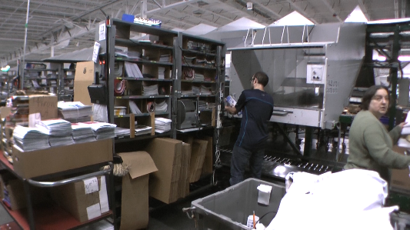 | 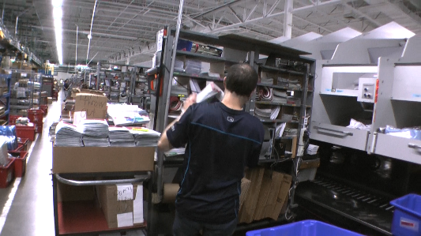 | 0 to 100
 | 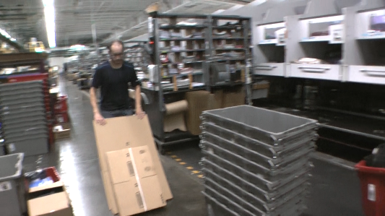 | 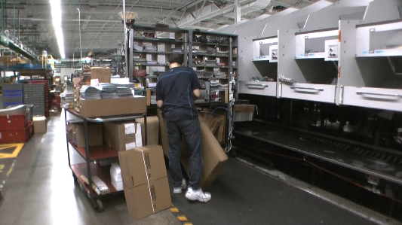
 | 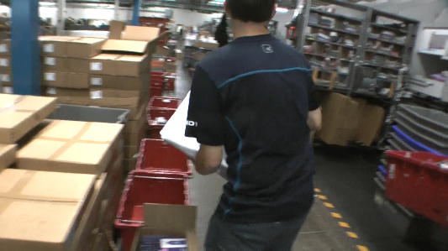 | 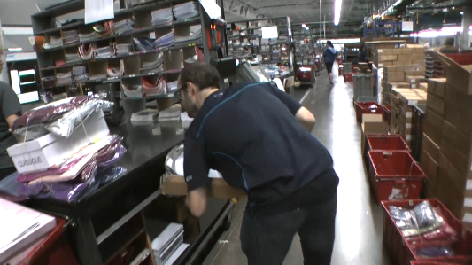
- Load Trailers  - Manually load bags and boxes into the shipping trailer.  - Bags and boxes may weigh from 1# to 25#.  - Materials come into the trailer on a cantilevered conveyor.  - Materials are bed or floor loaded – not on a pallet – from floor to ceiling in the trailer.  - Job rotation within the Pack Ship Material Handler position may occur on a daily basis.  . | 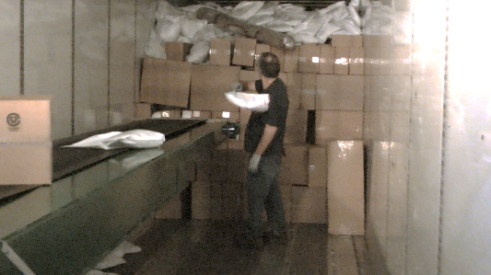 | 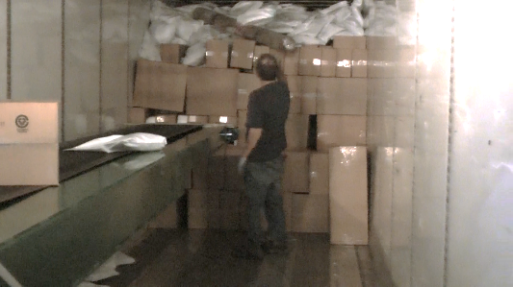 | 0 to 100
 | 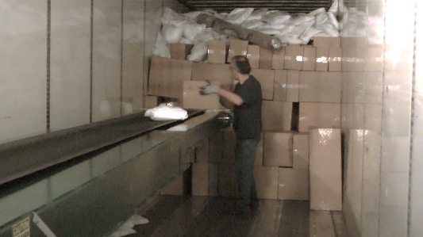 | 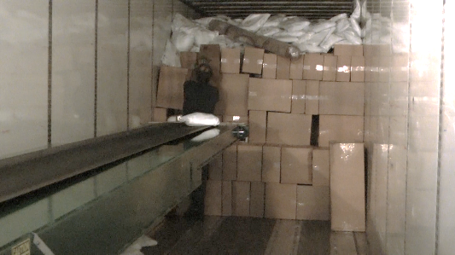
- Stack Totes  - Stack empty totes coming off the conveyor onto pallets. Empty totes weigh 6 to 8#.  - Throw cardboard to be recycled into the bin.  - Job rotation within the Pack Ship Material Handler position may occur on a daily basis. | 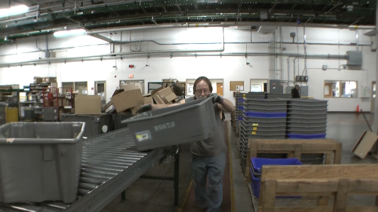 | 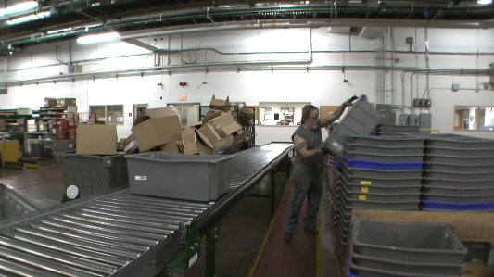 | 0 to 100
 | 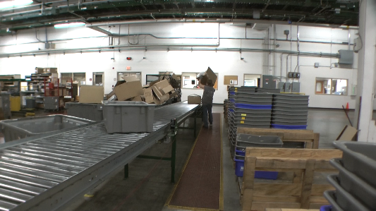 | 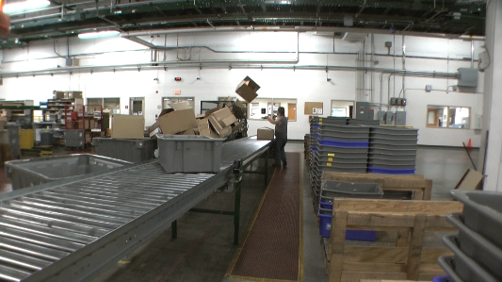
- Dump Totes  - Dumps full totes coming down a conveyor line into chutes that lead to the pack workstations.  - Full totes may weigh up to 50#.  - Job rotation within the Pack Ship Material Handler position may occur on a daily basis. | 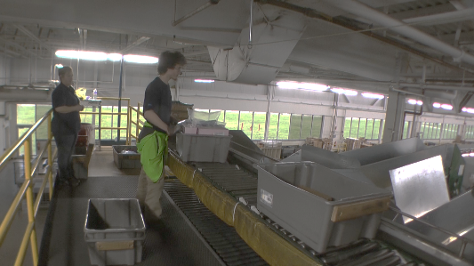 | 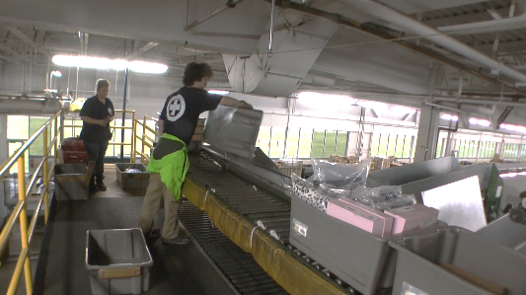 | 0 to 100
- Hospital Line Materials  - This are materials that require customer immediate attention.  - Remove totes from conveyor and stack about 4 to 5 totes high.  - Push totes to staging area.  - Full totes may weigh up to 50#.  - Job rotation within the Pack Ship Material Handler position may occur on a daily basis. | 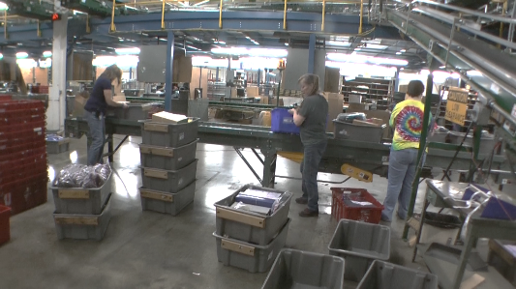 | 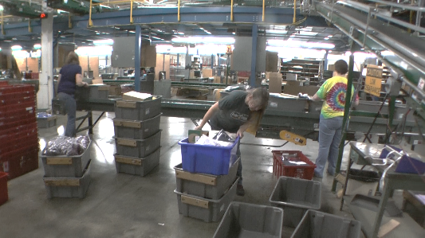 | 0 to 100
 | 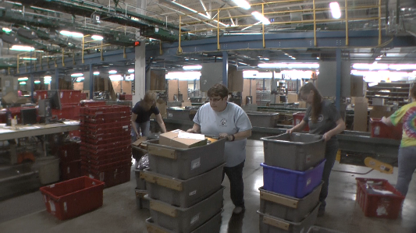 | 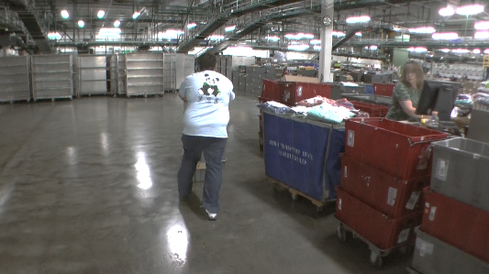
- Dump Bulk Totes  - Dump full totes coming onto a conveyor. May weigh up to 50#.  - Stack the now empty totes.  - Push the stack of empty totes to the staging area.  - Job rotation within the Pack Ship Material Handler position may occur on a daily basis. | 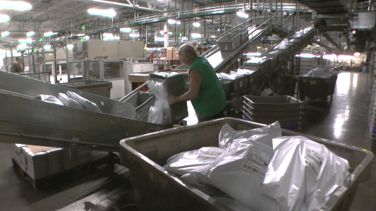 | 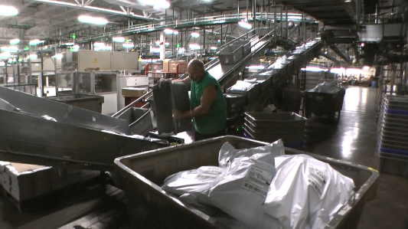 | 0 to 100
 | 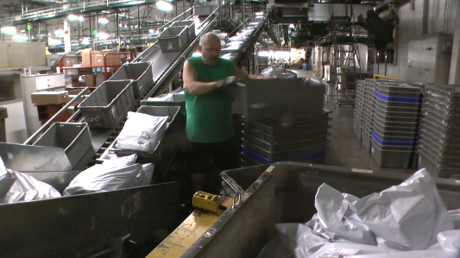
- Shipping Induction  - Place items coming down onto the conveyor in a specific alignment on the conveyor.  - Bags weigh 1 to 10#.  - Job rotation within the Pack Ship Material Handler position may occur on a daily basis. | 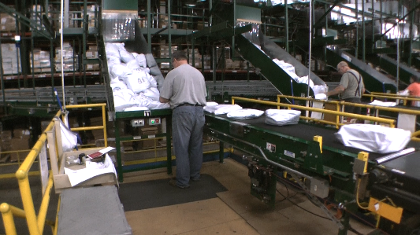 | 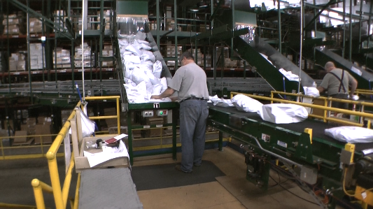 | 0 to 100
- Mezzanine  - Part One: take totes from conveyor and stack on floor conveyor, then push stack down conveyor.  - Part Two: take totes from stack and place onto conveyor.  - Job rotation within the Pack Ship Material Handler position may occur on a daily basis. | 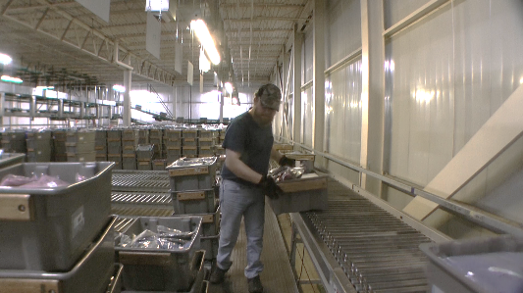 | 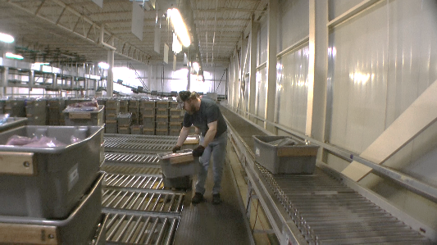 | 0 to 100
 | 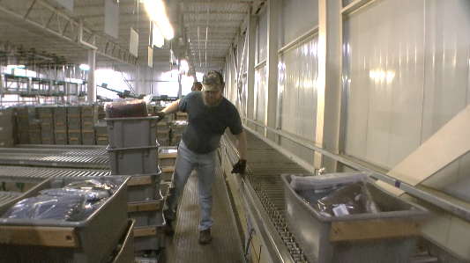 | 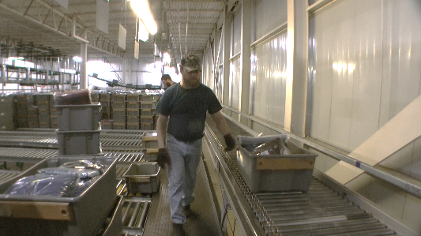
 | 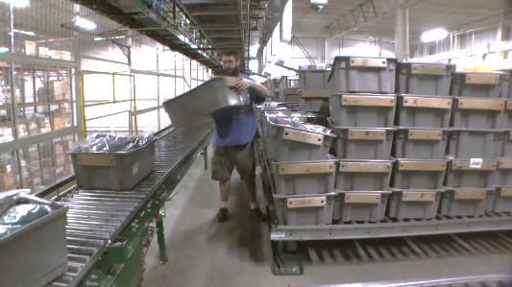 | 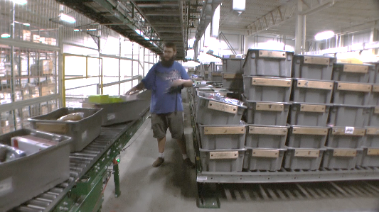
- Packing Sorter Induction  - Place items onto the conveyor in a specific alignment on the conveyor.  - Bags weigh 1 to 10#.  - Job rotation within the Pack Ship Material Handler position may occur on a daily basis. | 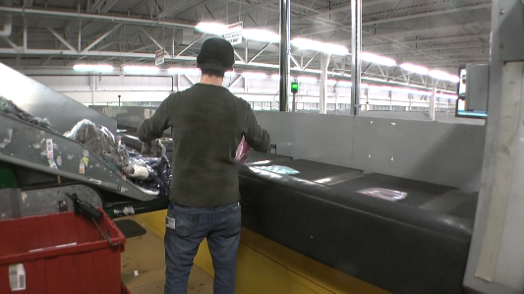 |  | 0 to 100

Physical Factors
Manual Material Handling
(lbs) | Floor-Knuckle (0” to 30”) |  |  |  |  |  | Knuckle-Chest (30” to 50’) |  |  |  |  |  | Chest-Overhead  ( > 50”) |  |  |  |  |  | Carry - Two Hands; Front |  |  |  |  |  | Carry - One Hand; Side |  |  |  |  |  | Push |  |  |  |  |  | Pull
100
75
50
30
20
10
5
0
Exp | N | R | O | F | C |  | N | R | O | F | C |  | N | R | O | F | C |  | N | R | O | F | C |  | N | R | O | F | C |  | N | R | O | F | C |  | N | R | O | F | C

Postures/Movements |  |  |  |  |  |  |  |  |  |  |  |  |  |  |  | Head/Neck
Exp | Sit | Stand | Walk | Bal | Stairs | Lad-der | Foot contrl | Twist Waist | Bend Waist | Squat | Kneel | Crawl | Reach below 54” | Reach above 54” |  | Flex Static | Ext Static | Rot Static | Flex Dyn | Ext Dyn | Rot Dyn
C
F
O
R
N

Hand Use |  |  |  |  | Sensory |  |  |  |  |  | Communication |  |  |  |  | Key C - Continuous: 67 to 100% of shift  F - Frequent: 34 to 66% of shift  O - Occasional: 6 to 33% of shift  R - Rarely: up to 5% of shift  N - Never: 0% of shift  Abbreviations: Bal=Bal, Exp=Exposure, Contrl=Control, Flex=Flexion, Ext=Extension, Dyn=Dynamic, Manip=Manipulation
Exp | Simple Grasp | Firm Grasp | Fine Manip | Bal | See | Hear | Touch Feel | Taste | Smell |  | Talk | Read | Write | Hand Signal
C
F
O
R
N

Environmental Factors | Exposure Level |  |  |  |  | Key/Comments
 | N | R | O | F | C
Outdoor Work |  |  |  |  |  | Key C - Continuous: 67 to 100% of shift  F - Frequent: 34 to 66% of shift  O - Occasional: 6 to 33% of shift  R - Rarely: up to 5% of shift  N - Never: 0% of shift  Comments:  Indoor Work: Primary work area is a large indoor warehouse complex.  Moving Objects: Be aware of and avoid moving objects including product and equipment.
Indoor Work
Heat
Cold
Wet/ Humid
Hearing Protection
Vibration
Fumes/Gases/Odors
Dust
Moving Objects
Electrical
Chemical
Protected Work Heights
Unprotected Work Heights
Flying Debris
Lighting (Inadequate/Excessive)

Position eligible to be considered for temporary modification in conjunction with a Return to Work transitional duty program agreement: Yes
This Functional Job Description was completed through an on-site job analysis by a certified professional ergonomist/licensed physical therapist. It is for the purpose of identifying and quantifying the physical functional requirements of this job. The Functional Job Description should not be construed as a detailed description of all specific job duties and/or tools, equipment and materials that may be necessary or incidental to the performance of this job. Further consideration may be necessary when applying the standards to the injured population in the medical management process.
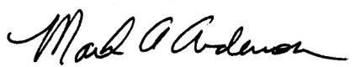 | This Functional Job Description has been reviewed by company representatives and is believed to be an accurate representation of most of the job content.
Mark A Anderson, MA, PT CPE  Certified Professional Economist  Licensed Physical Therapist  ErgoSystems Consulting Group, Inc.  7421 W Shoreline Dr  Waconia, MN 55387  952-401-9296  mark.anderson@ergosystemsconsulting.com  www.ergosystemsconsulting.com | 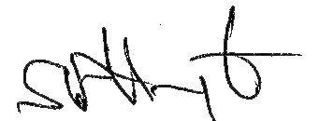  _______________________________________
 | Shawn Harrington, Pack/Ship Manager
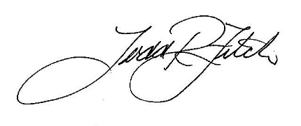
_______________________________________
 | Todd Fitch, Facilities Operations Director

