Functional Job Description: Prepper

Company: | Bluestem Brands, Inc. | 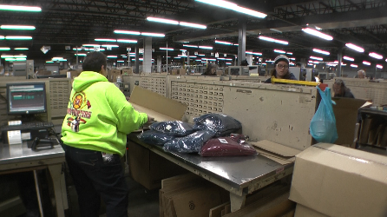 | 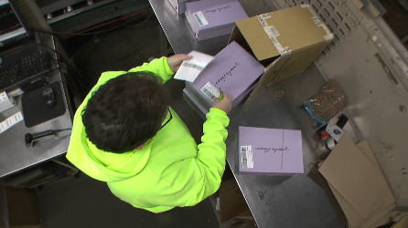
Job Title: | Prepper
Date: | 11-13-17
Dept/Facility: | DC, Irvine, PA
Product Section: | Inbound
Electronic Doc. # | FJD Prepper FINAL 11-13-17

Work Hours | Overtime: | Voluntary and/or mandatory per production requirements. | Breaks: | (2) 15 minute & (1) 30 minute lunch break
 | Shift: | Days of week: | Time:
 | First | Monday - Friday | 6:00 AM to 2:30 PM
 | Second | NA | NA

Job Rotation | Yes

Job Training or Credentials Required at Hire | Education/ training: | None required; high school diploma or GED preferred.
 | Knowledge/ cognitive skills: | Basic math, reading, writing and oral communication skills preferred. Ability to organize work tasks and work independently or as part of a team.

Machines, Tools and/or Equipment Used | Computer, safety knife, tape dispenser, rubber bands, handheld scanner, label printer and labels, wheeled cart, boxes, pallets, hand pallet jack, workbench at 35” height.

Job Purpose/ Objectives | Prepare products (clothing, shoes, housewares, etc.) to be picked. Involves removing items from boxes, prepping with tagging, rubber banding, rebox some items. etc. and then place in totes/boxes and then onto conveyor line.

Safety and Personal Protective Equipment Required  *Available | Hard Hat | Steel Toe Footwear | Safety Glasses | Gloves:
 | Face Shield | Protective Clothing | Safety Glasses/Side Shields | Leather
 | Dust Mask * | Safety Vest  Fall Protection Harness | Safety Goggles  Hearing Protection*  Compensatory methods to mitigate heat | Rubberized/cloth*  Chemical

Safety/ Equipment Training/ Certification Required | Daily Meeting and Stretch Breaks (includes:) | Industrial Truck Training | OSHA Training (Rules and Regulations)
 | - Safety Topics | EZ-Go | New Hire Safety Orientation
 | - Safety Policies | Walkie-Rider | Right to Know
 | - Questions & Answers | Pallet Jack - Powered | Lockout/Tag Out
 | - Review Safety Committee Minutes | Forklift (sit down) | Regulated Materials Training (ORM-D)  Supervisor Safety Updates
 |  | Stand-up Reach Truck
 |  | Order Picker
 |  | Transpositioner
 |  | Pivot Pro Vacuum Lift

Functional Job Elements |  |  | % of Shift
- Obtain items  - Bring boxes to workbench (35” height bench).  - Heaviest box handled by one person is 50#, beyond this weight, a team lift is employed. | 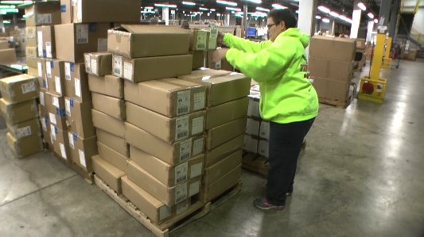 | 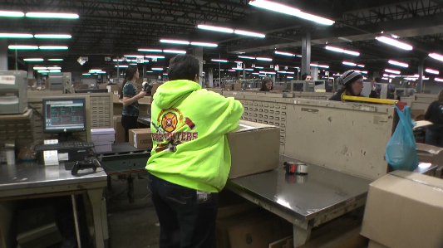 | 10
- Prep products  Bags  - Open box with knife.  - Scan box.  - Remove bags from box.  - Place stickers on the bags.  - Get empty tote.  - Place bags into the tote.  - Place tote onto conveyor.  - Full tote weight up to about 30#.  - Individual bags about 1 to 3#. | 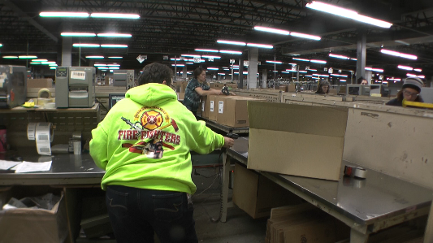 | 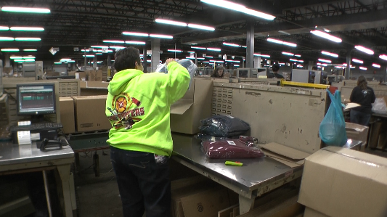 | 85
 | 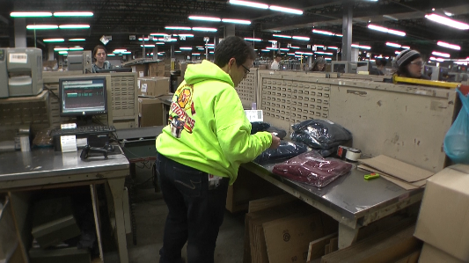 | 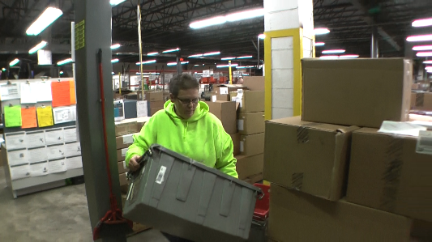
 | 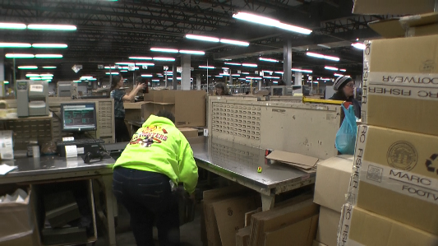 | 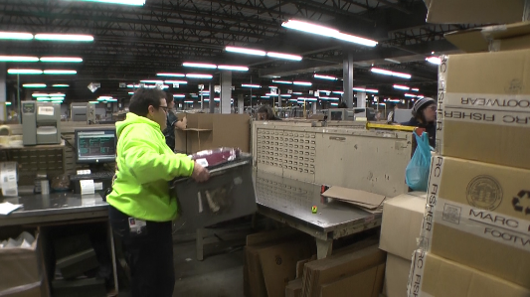
Shoe Boxes  - Remove shoe boxes from box (about 10#).  - Place sticker on box.  - Place boxes (individual box 2 to 3#) on conveyor.  NOTE: A wheeled cart is available for additional workspace as needed. | 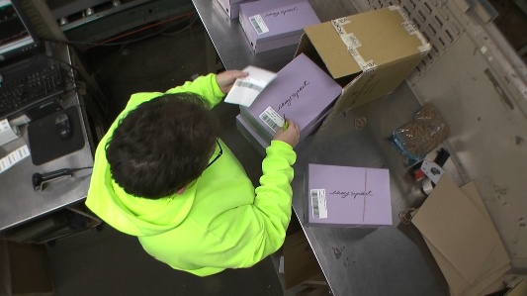 | 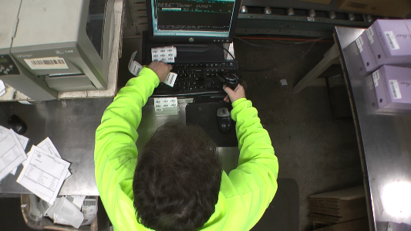
 | 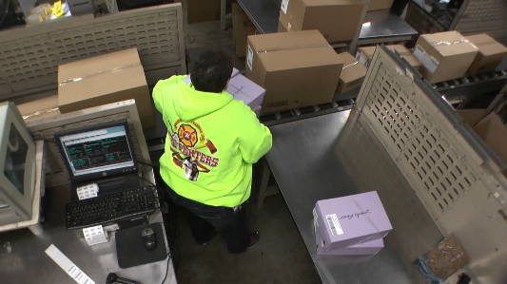 | 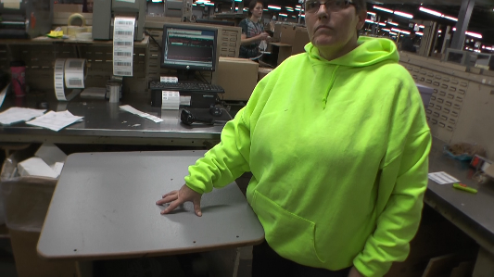
New Box  - Some items are placed into a new box, taped shut and placed onto the conveyor.  - Average weight of items handled is 5 to 10#. | 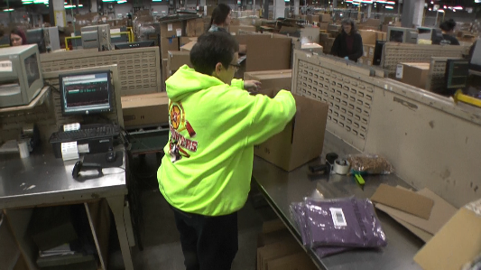 | 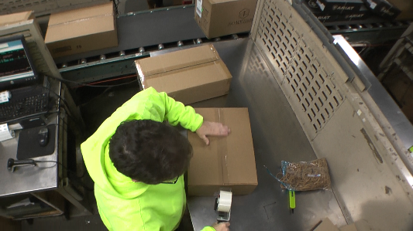
 | 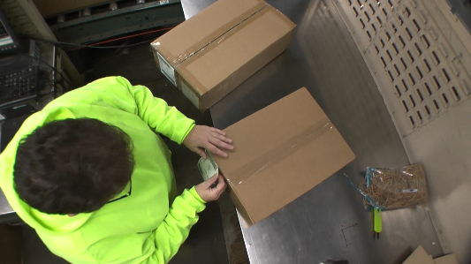 | 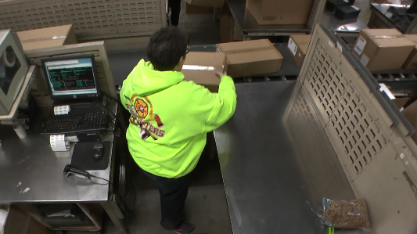
- Workstation cleanup  - Move empty pallets to stack of pallets. Pallet weight about 35#.  - Collapse used boxes and carry to container. | 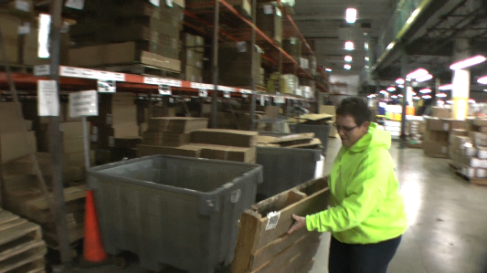 | 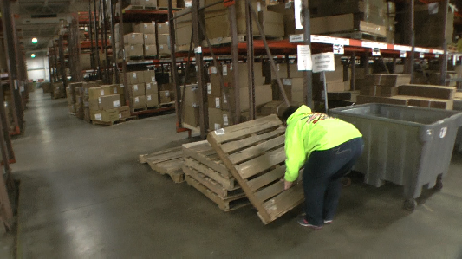 | 5
 | 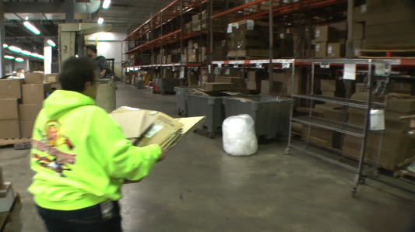 | 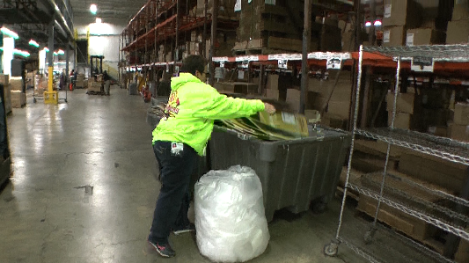

Physical Factors
Manual Material Handling
(lbs) | Floor-Knuckle (0” to 30”) |  |  |  |  |  | Knuckle-Chest (30” to 50’) |  |  |  |  |  | Chest-Overhead  ( > 50”) |  |  |  |  |  | Carry - Two Hands; Front |  |  |  |  |  | Carry - One Hand; Side |  |  |  |  |  | Push |  |  |  |  |  | Pull
100
75
50
25
15
10
5
0
Exp | N | R | O | F | C |  | N | R | O | F | C |  | N | R | O | F | C |  | N | R | O | F | C |  | N | R | O | F | C |  | N | R | O | F | C |  | N | R | O | F | C

Postures/Movements |  |  |  |  |  |  |  |  |  |  |  |  |  |  |  | Head/Neck
Exp | Sit | Stand | Walk | Bal | Stairs | Lad-der | Foot contrl | Twist Waist | Bend Waist | Squat | Kneel | Crawl | Reach below 54” | Reach above 54” |  | Flex Static | Ext Static | Rot Static | Flex Dyn | Ext Dyn | Rot Dyn
C
F
O
R
N

Hand Use |  |  |  |  | Sensory |  |  |  |  |  | Communication |  |  |  |  | Key C - Continuous: 67 to 100% of shift  F - Frequent: 34 to 66% of shift  O - Occasional: 6 to 33% of shift  R - Rarely: up to 5% of shift  N - Never: 0% of shift  Abbreviations: Bal=Bal, Exp=Exposure, Contrl=Control, Flex=Flexion, Ext=Extension, Dyn=Dynamic, Manip=Manipulation
Exp | Simple Grasp | Firm Grasp | Fine Manip | Bal | See | Hear | Touch Feel | Taste | Smell |  | Talk | Read | Write | Hand Signal
C
F
O
R
N

Environmental Factors | Exposure Level |  |  |  |  | Key/Comments
 | N | R | O | F | C
Outdoor Work |  |  |  |  |  | Key C - Continuous: 67 to 100% of shift  F - Frequent: 34 to 66% of shift  O - Occasional: 6 to 33% of shift  R - Rarely: up to 5% of shift  N - Never: 0% of shift  Comments:  Indoor Work: Primary work area is a large indoor warehouse complex.  Moving Objects: Be aware of and avoid moving objects including product and equipment.
Indoor Work
Heat
Cold
Wet/ Humid
Hearing Protection
Vibration
Fumes/Gases/Odors
Dust
Moving Objects
Electrical
Chemical
Protected Work Heights
Unprotected Work Heights
Flying Debris
Lighting (Inadequate/Excessive)

Position eligible to be considered for temporary modification in conjunction with a Return to Work transitional duty program agreement: Yes
This Functional Job Description was completed through an on-site job analysis by a certified professional ergonomist/licensed physical therapist. It is for the purpose of identifying and quantifying the physical functional requirements of this job. The Functional Job Description should not be construed as a detailed description of all specific job duties and/or tools, equipment and materials that may be necessary or incidental to the performance of this job. Further consideration may be necessary when applying the standards to the injured population in the medical management process.
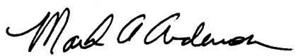 | This Functional Job Description has been reviewed by company representatives and is believed to be an accurate representation of most of the job content.
Mark A Anderson, MA, PT CPE  Certified Professional Economist  Licensed Physical Therapist  ErgoSystems Consulting Group, Inc.  7421 W Shoreline Dr  Waconia, MN 55387  952-401-9296  mark.anderson@ergosystemsconsulting.com  www.ergosystemsconsulting.com | 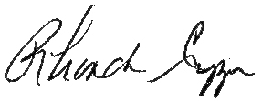  _______________________________________
 | Rhonda Crippen, Inbound Manager
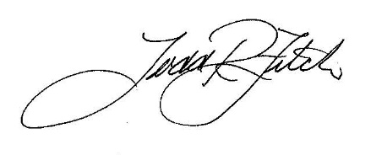
_______________________________________
 | Todd Fitch, Facilities Operations Director

