Functional Job Description: VAS Processor

Company: | Bluestem Brands, Inc. | 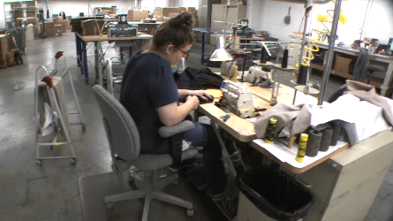 | 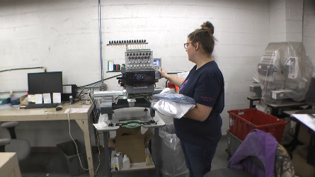
Job Title: | VAS Processor
Date: | 11-13-17
Dept/Facility: | DC, Irvine, PA
Product Section: | Outbound
Electronic Doc. # | FJD VAS Processor FINAL 11-13-17

Work Hours | Overtime: | Voluntary and/or mandatory per production requirements. | Breaks: | (2) 15 minute & (1) 30 minute lunch break
 | Shift: | Days of week: | Time:
 | First | Monday – Friday | 6:00 AM to 2:30 PM
 | Second | NA | NA

Job Rotation | Yes

Job Training or Credentials Required at Hire | Education/ training: | None required; high school diploma or GED preferred.
 | Knowledge/ cognitive skills: | Basic math, reading, writing and oral communication skills preferred. Ability to organize work tasks and work independently or as part of a team.

Machines, Tools and/or Equipment Used | Cart, pants trimmer, sewing machines, steam iron, steam presser, seam rippers, monogram machine, workbench, chalk, pen, scissors, computer, pens.

Job Purpose/ Objectives | Value Added Services (VAS) Processor adds value to products by hemming pants, applying monograms and providing an exam and measure service to ensure the customer order is correct.

Safety and Personal Protective Equipment Required  *Available | Hard Hat | Steel Toe Footwear | Safety Glasses | Gloves:
 | Face Shield | Protective Clothing | Safety Glasses/Side Shields | Leather
 | Dust Mask | Safety Vest  Fall Protection Harness | Safety Goggles  Hearing Protection*  Compensatory methods to mitigate heat | Rubberized/cloth*  Chemical

Safety/ Equipment Training/ Certification Required | Daily Meeting and Stretch Breaks (includes:) | Industrial Truck Training | OSHA Training (Rules and Regulations)
 | - Safety Topics | EZ-Go | New Hire Safety Orientation
 | - Safety Policies | Walkie-Rider | Right to Know
 | - Questions & Answers | Pallet Jack | Lockout/Tag Out
 | - Review Safety Committee Minutes | Forklift (sit down) | Regulated Materials Training (ORM-D)  Supervisor Safety Updates
 |  | Stand-up Reach Truck
 |  | Order Picker
 |  | Transpositioner
 |  | Pivot Pro Vacuum Lift

Functional Job Elements |  |  | % of Shift
- Hem Pants  - Convey tote (15#) with pants from floor onto workbench  - Sort pants at workbench into cuff or not for hemming request.  - Measure requested hem length and cut pants at trimmer.  - Take pants on cart to sewing machine.  - At sewing machine sew the hem.  - Convey to the steam press on the cart, inserts pants into press and press hem.  - Check length with tape.  - Bag pants:  - Apply pressure tag.  - Put insert in bag.  - Tape bag closed.  - Take to auditor or drop off. |  | 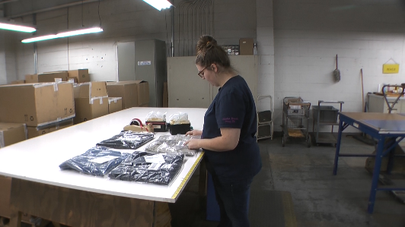 | 40
 | 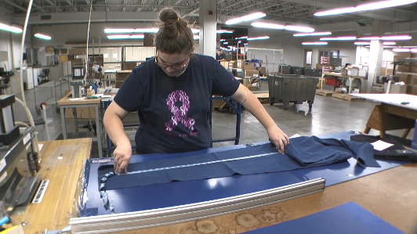 | 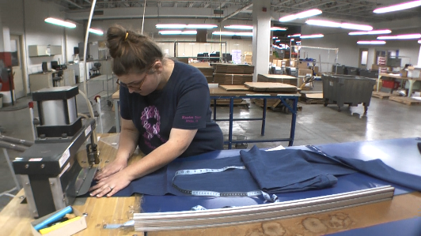
 | 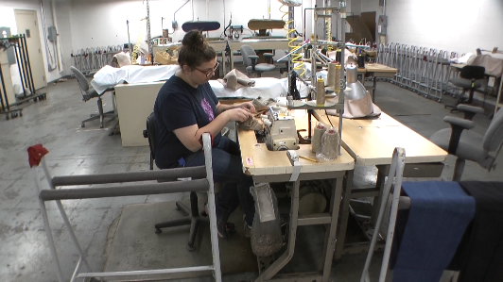 | 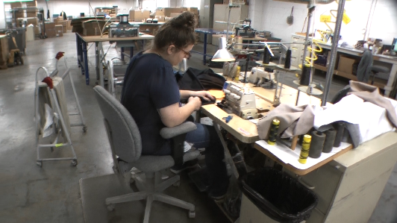
 | 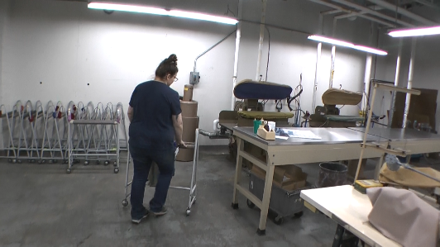 | 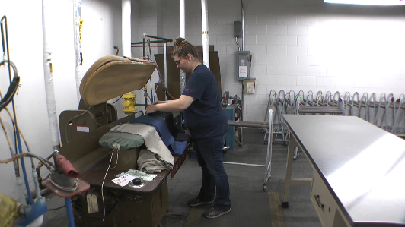
 | 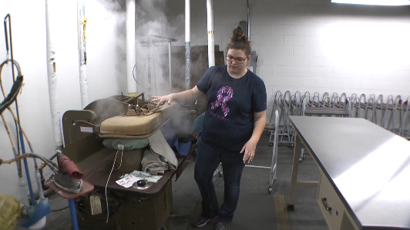 | 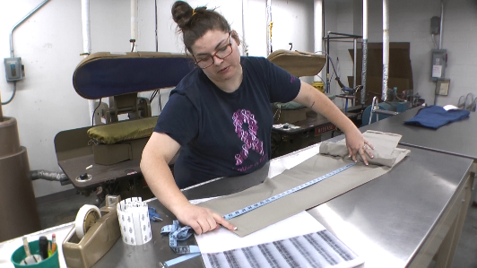
 | 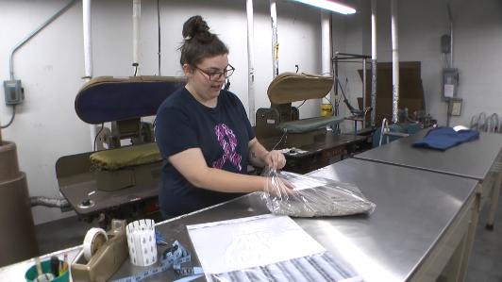
- Monogram  - Enter monogram into computer.  - Insert shirt into the monogram machine.  - Operate machine.  - Remove and bag shirt. | 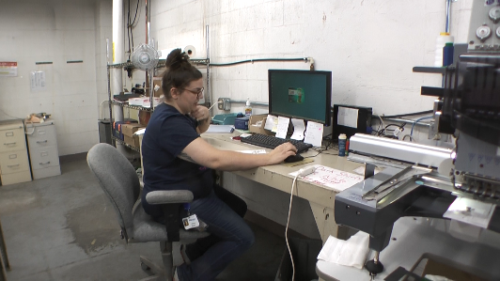 | 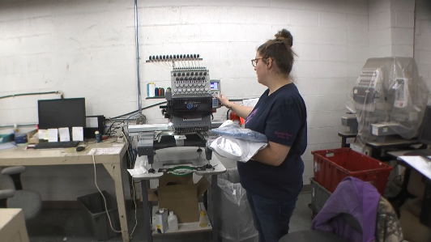 | 45
- Exam and Measure  - Remove item to be examined from bag.  - Perform measurements with a tape.  - Record information.  - Return item to packaging. | 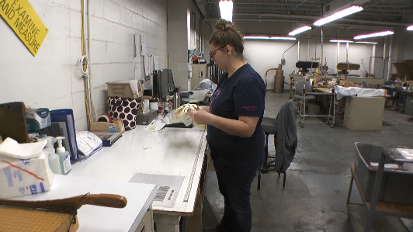 | 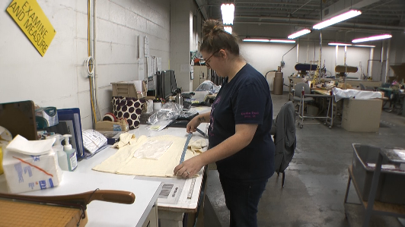 | 15
 | 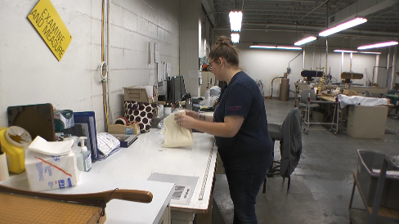

Physical Factors
Manual Material Handling
(lbs) | Floor-Knuckle (0” to 30”) |  |  |  |  |  | Knuckle-Chest (30” to 50’) |  |  |  |  |  | Chest-Overhead  ( > 50”) |  |  |  |  |  | Carry - Two Hands; Front |  |  |  |  |  | Carry - One Hand; Side |  |  |  |  |  | Push |  |  |  |  |  | Pull
100
75
50
25
15
10
5
0
Exp | N | R | O | F | C |  | N | R | O | F | C |  | N | R | O | F | C |  | N | R | O | F | C |  | N | R | O | F | C |  | N | R | O | F | C |  | N | R | O | F | C

Postures/Movements |  |  |  |  |  |  |  |  |  |  |  |  |  |  |  | Head/Neck
Exp | Sit | Stand | Walk | Bal | Stairs | Lad-der | Foot contrl | Twist Waist | Bend Waist | Squat | Kneel | Crawl | Reach below 54” | Reach above 54” |  | Flex Static | Ext Static | Rot Static | Flex Dyn | Ext Dyn | Rot Dyn
C
F
O
R
N

Hand Use |  |  |  |  | Sensory |  |  |  |  |  | Communication |  |  |  |  | Key C - Continuous: 67 to 100% of shift  F - Frequent: 34 to 66% of shift  O - Occasional: 6 to 33% of shift  R - Rarely: up to 5% of shift  N - Never: 0% of shift  Abbreviations: Bal=Bal, Exp=Exposure, Contrl=Control, Flex=Flexion, Ext=Extension, Dyn=Dynamic, Manip=Manipulation
Exp | Simple Grasp | Firm Grasp | Fine Manip | Bal | See | Hear | Touch Feel | Taste | Smell |  | Talk | Read | Write | Hand Signal
C
F
O
R
N

Environmental Factors | Exposure Level |  |  |  |  | Key/Comments
 | N | R | O | F | C
Outdoor Work |  |  |  |  |  | Key C - Continuous: 67 to 100% of shift  F - Frequent: 34 to 66% of shift  O - Occasional: 6 to 33% of shift  R - Rarely: up to 5% of shift  N - Never: 0% of shift  Comments:  Indoor Work: Primary work area is a large indoor warehouse complex.  Moving Objects: Be aware of and avoid moving objects including product and equipment.
Indoor Work
Heat
Cold
Wet/ Humid
Hearing Protection
Vibration
Fumes/Gases/Odors
Dust
Moving Objects
Electrical
Chemical
Protected Work Heights
Unprotected Work Heights
Flying Debris
Lighting (Inadequate/Excessive)

Position eligible to be considered for temporary modification in conjunction with a Return to Work transitional duty program agreement: Yes
This Functional Job Description was completed through an on-site job analysis by a certified professional ergonomist/licensed physical therapist. It is for the purpose of identifying and quantifying the physical functional requirements of this job. The Functional Job Description should not be construed as a detailed description of all specific job duties and/or tools, equipment and materials that may be necessary or incidental to the performance of this job. Further consideration may be necessary when applying the standards to the injured population in the medical management process.
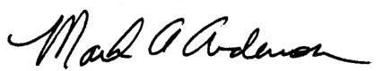 | This Functional Job Description has been reviewed by company representatives and is believed to be an accurate representation of most of the job content.
Mark A Anderson, MA, PT CPE  Certified Professional Economist  Licensed Physical Therapist  ErgoSystems Consulting Group, Inc.  7421 W Shoreline Dr  Waconia, MN 55387  952-401-9296  mark.anderson@ergosystemsconsulting.com  www.ergosystemsconsulting.com | 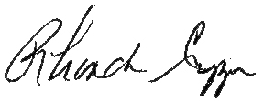  _______________________________________
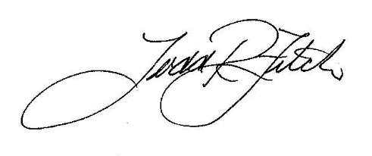
Rhonda Crippen, Inbound Manager

 | _______________________________________
 | Todd Fitch, Facilities Operations Director

