Functional Job Description: Warehouse Material Handler

Company: | Bluestem Brands, Inc. | 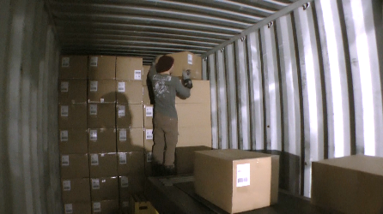 | 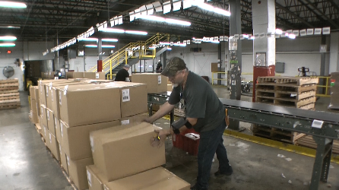
Job Title: | Warehouse Material Handler
Date: | 11-13-17
Dept/Facility: | DC, Irvine, PA
Product Section: | Inbound
Electronic Doc. # | FJD Warehouse Material Handler FINAL 11-13-17

Work Hours | Overtime: | Voluntary and/or mandatory per production requirements. | Breaks: | (2) 15 minute & (1) 30 minute lunch break
 | Shift: | Days of week: | Time:
 | First | Monday – Friday | 6:30 AM to 3:00 PM, 7:00 AM to 3:30 PM
 | Third | Sunday - Thursday | 10:00 PM to 6:30 AM

Job Rotation | Yes

Job Training or Credentials Required at Hire | Education/ training: | None required; high school diploma or GED preferred.
 | Knowledge/ cognitive skills: | Basic math, reading, writing and oral communication skills preferred. Ability to organize work tasks and work independently or as part of a team.

Machines, Tools and/or Equipment Used | Reach truck, pallet jack -powered, two-step platform (inside trailer), wearable scanner. Pallet repair – powered woodworking tools.

Job Purpose/ Objectives | Uses reach truck and powered pallet jack to receive and deliver materials. Also performs pallet repair as time allows.

Safety and Personal Protective Equipment Required  *Available | Hard Hat | Steel Toe Footwear | Safety Glasses | Gloves:
 | Face Shield  Battery change | Protective Clothing | Safety Glasses/Side Shields  Glasses and hearing for pallet repair | Leather
 | Dust Mask | Safety Vest  Fall Protection Harness | Safety Goggles  Hearing Protection*  Compensatory methods to mitigate heat | Rubberized/cloth*  Chemical

Safety/ Equipment Training/ Certification Required | Daily Meeting and Stretch Breaks (includes:) | Industrial Truck Training | OSHA Training (Rules and Regulations)
 | - Safety Topics | EZ-Go | New Hire Safety Orientation
 | - Safety Policies | Walkie-Rider | Right to Know
 | - Questions & Answers | Pallet Jack | Lockout/Tag Out
 | - Review Safety Committee Minutes | Forklift (sit down) | Regulated Materials Training (ORM-D)  Supervisor Safety Updates
 |  | Stand-up Reach Truck
 |  | Order Picker
 |  | Transpositioner
 |  | Pivot Pro Vacuum Lift

Functional Job Elements |  |  | % of Shift
- Unloader (bed load)  - Unloads trailers.  - Scans boxes with wearable scanner.  - Manually loads boxes onto a cantilevered conveyor that has been maneuvered into trailer.  - Heaviest box handled individually is 50# with average of 15 to 20#.  - Rotates among the other tasks that make up the Warehouse Material Handler position. | 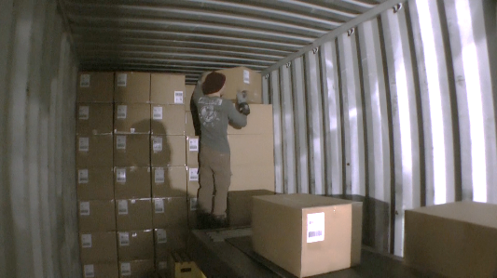 | 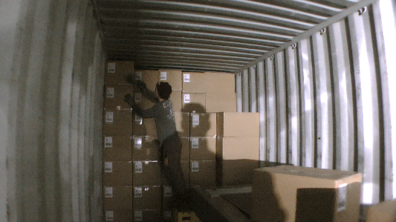 | 0  to 100
- Sorters  - Typically, the sorting is performed by two Material Handlers on each side of the conveyor.  - For every other box, each Material Handler uses a wearable to scan the box and then carries the box to the designated pallet.  - Pallets are stacked three boxes high (no higher than about shoulder height).  - Heaviest box handled individually is 50# with average of 15 to 20#.  - Rotates among the other tasks that make up the Warehouse Material Handler position. | 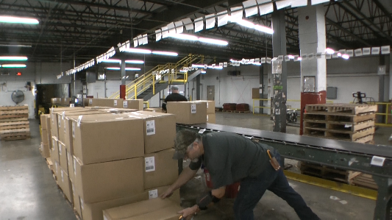 | 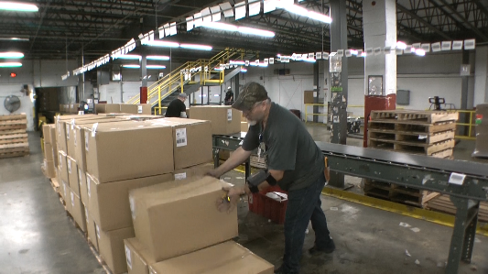 | 0  to 100
 | 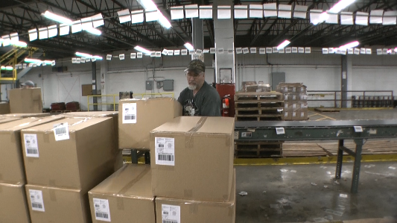 | 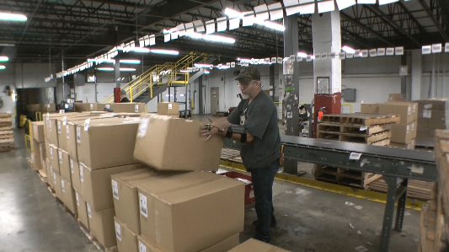
- Pallet Tally and Transport  - Counts number of boxes on pallet and transports pallet to the staging area.  - Manually handles pallets.  - Once count is accomplished transports pallet to the warehouse staging area (paper boy area) or to the picking racks where the boxes are moved from the pallet to the floor.  - Rotates among the other tasks that make up the Warehouse Material Handler position. | 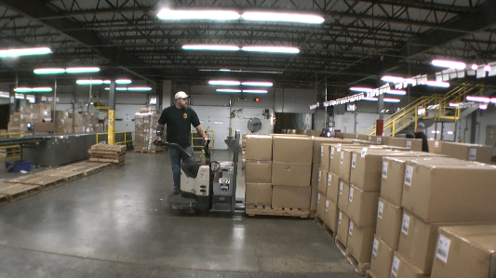 | 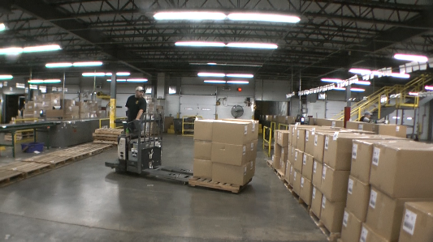 | 0  to 100
 | 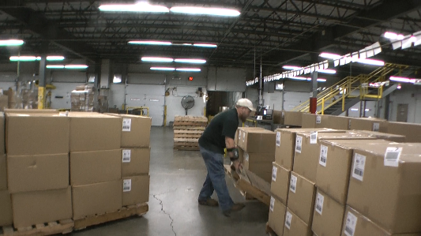 | 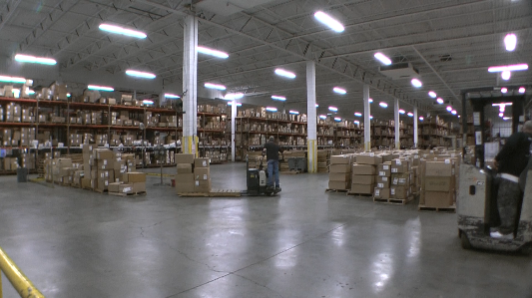
- Unloader (pallet load)  - Unloads trailer that is a pallet load with reach truck or powered pallet jack.  - Rotates among the other tasks that make up the Warehouse Material Handler position. | 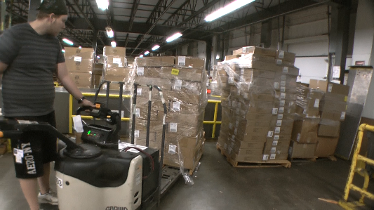 | 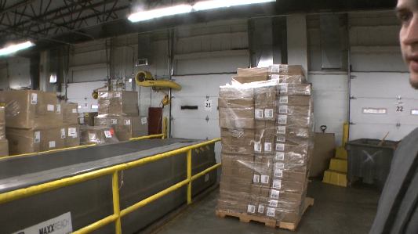 | 0  to 100
- Pallet Repair  - Repairs pallets using power tools.  - Manually handles pallets (weigh up to 35#).  - Rotates among the other tasks that make up the Warehouse Material Handler position. | 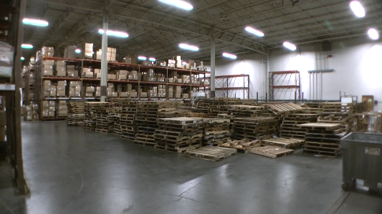 | 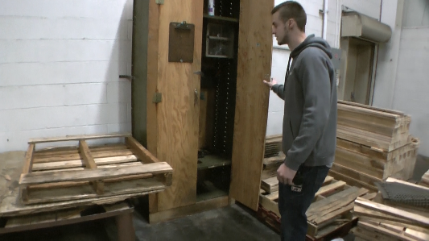 | 0  to 100

Physical Factors
Manual Material Handling
(lbs) | Floor-Knuckle (0” to 30”) |  |  |  |  |  | Knuckle-Chest (30” to 50’) |  |  |  |  |  | Chest-Overhead  ( > 50”) |  |  |  |  |  | Carry - Two Hands; Front |  |  |  |  |  | Carry - One Hand; Side |  |  |  |  |  | Push |  |  |  |  |  | Pull
100
75
50
25
15
10
5
0
Exp | N | R | O | F | C |  | N | R | O | F | C |  | N | R | O | F | C |  | N | R | O | F | C |  | N | R | O | F | C |  | N | R | O | F | C |  | N | R | O | F | C

Postures/Movements |  |  |  |  |  |  |  |  |  |  |  |  |  |  |  | Head/Neck
Exp | Sit | Stand | Walk | Bal | Stairs | Lad-der | Foot contrl | Twist Waist | Bend Waist | Squat | Kneel | Crawl | Reach below 54” | Reach above 54” |  | Flex Static | Ext Static | Rot Static | Flex Dyn | Ext Dyn | Rot Dyn
C
F
O
R
N

Hand Use |  |  |  |  | Sensory |  |  |  |  |  | Communication |  |  |  |  | Key C - Continuous: 67 to 100% of shift  F - Frequent: 34 to 66% of shift  O - Occasional: 6 to 33% of shift  R - Rarely: up to 5% of shift  N - Never: 0% of shift  Abbreviations: Bal=Bal, Exp=Exposure, Contrl=Control, Flex=Flexion, Ext=Extension, Dyn=Dynamic, Manip=Manipulation
Exp | Simple Grasp | Firm Grasp | Fine Manip | Bal | See | Hear | Touch Feel | Taste | Smell |  | Talk | Read | Write | Hand Signal
C
F
O
R
N

Environmental Factors | Exposure Level |  |  |  |  | Key/Comments
 | N | R | O | F | C
Outdoor Work |  |  |  |  |  | Key C - Continuous: 67 to 100% of shift  F - Frequent: 34 to 66% of shift  O - Occasional: 6 to 33% of shift  R - Rarely: up to 5% of shift  N - Never: 0% of shift  Comments:  Indoor Work: Primary work area is a large indoor warehouse complex.  Moving Objects: Be aware of and avoid moving objects including product and equipment.
Indoor Work
Heat
Cold
Wet/ Humid
Hearing Protection
Vibration
Fumes/Gases/Odors
Dust
Moving Objects
Electrical
Chemical
Protected Work Heights
Unprotected Work Heights
Flying Debris
Lighting (Inadequate/Excessive)

Position eligible to be considered for temporary modification in conjunction with a Return to Work transitional duty program agreement: Yes
This Functional Job Description was completed through an on-site job analysis by a certified professional ergonomist/licensed physical therapist. It is for the purpose of identifying and quantifying the physical functional requirements of this job. The Functional Job Description should not be construed as a detailed description of all specific job duties and/or tools, equipment and materials that may be necessary or incidental to the performance of this job. Further consideration may be necessary when applying the standards to the injured population in the medical management process.
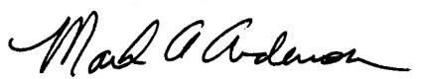 | This Functional Job Description has been reviewed by company representatives and is believed to be an accurate representation of most of the job content.  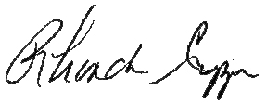
Mark A Anderson, MA, PT, CPE  Certified Professional Economist  Licensed Physical Therapist  ErgoSystems Consulting Group, Inc.  7421 W Shoreline Dr  Waconia, MN 55387  952-401-9296  mark.anderson@ergosystemsconsulting.com  www.ergosystemsconsulting.com | _______________________________________
 | Rhonda Crippen, Inbound Manager
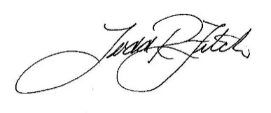
_______________________________________
 | Todd Fitch, Facilities Operations Director

