Functional Job Description: Assistant Conveyor/Assistant Forklift Mechanic

Company: | Bluestem Brands, Inc. | 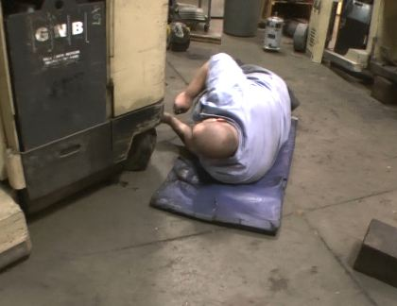 | 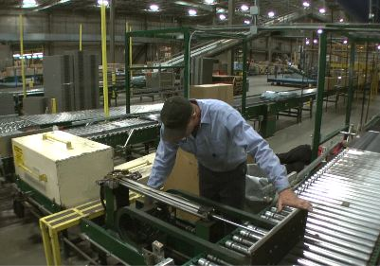
Job Title: | Assistant Conveyor/Assistant Forklift Mechanic
Date: | May 7, 2012
Dept/Facility: | West DC, St. Cloud, MN
Product Section: | Maintenance
Electronic Doc. # | FJDAssistConvey-AssistForkliftMech2012

Work Hours | Overtime: | Voluntary and/or mandatory per production requirements. | Breaks: | 10 minutes every two hours, one 30 minute lunch break.
 | Shift: | Days of week: | Time:
 | First | Monday-Friday | 6:00 AM to 2:30 PM
 | Second | Monday-Friday | 4:00 PM to 12:30 AM

Job Rotation | Yes

Job Training / Credentials Required at Hire | Education/ training: | None required; high school diploma or GED preferred.
 | Knowledge/ cognitive skills: | Basic math, reading, writing and oral communication skills preferred. Ability to organize work tasks and work independently or as part of a team.

Machines, Tools, Equipment Used | General Hand Tools  - Wrenches  - Hammers  - Screw Drivers  - Pry bars  - Paint brushes  Specialized Hand Tools  - Torque wrenches  - Belt splicer - Conveyor | Powered Hand Tools  - Drills - electric, pneumatic, battery powered  - Saws- reciprocating, portable band,  - Grinders - 4 and 7 inch angle, die grinder  - Impact wrench | Shop Tools/Equipment  - Bench/pedestal grinder  - Table belt and disc sanders  - Band saws  - Bench cut-off saws  - Table and radial arm saws  - Two wheel hand carts  - Drill Press  - Ladders  - Arc and MIG welders  - Lathe  - Tire Press  - Portable hoist lifts  - Pump jacks

Job Purpose/ Objectives/  List of Tasks | Conveyor Maintenance: Perform general maintenance and repair of conveyors and associated systems and other duties as assigned.  Forklift Maintenance: Perform general maintenance and repair of Powered Industrial Trucks (EZ-Go, Walkie-Rider, Pallet Jack, Forklift (sit down), Stand-up Reach Truck, Order Picker, Elevated Work Platform) and associated systems and other duties as assigned.  List of tasks includes:
 | General tasks (common to both Conveyor and Forklift)  - Torch work / Brazing  - Arc Welding  - MIG welding  - Battery maintenance  - Multi-meter use  - Painting  - Ceiling tile replacement  Misc. restroom repairs (common to both Conveyor and Forklift)  - Valve kits  - Dispensing equipment  - Hardware  - Plugged closets, urinals, drains  Dock levelers (common to both Conveyor and Forklift)  - Cleaning and PM  - Component Replacement / Repair  Dock doors (common to both Conveyor and Forklift)  - Lubrication hinges, bearings, rollers  - Limited repairs, chains, rollers  Dock locks (common to both Conveyor and Forklift)  - PM, lubrication, cleaning  General repairs | Unique to Conveyor Maintenance  - Component Replacement  - Conveyor Installation  - Hand Taper Repair  - Marsh Taper Repair  - Signode Tape Machines  - Signode Skid Wrapping machines  - RMF Carton Machine  Unique to Conveyor Maintenance (cont)  - Rite Size Carton Machine  - Shedder / Balers  - Pallet Jack Repair  - Traco Bag Sealer repair  - Conveyor Control Trouble Shooting  - Peanut Delivery System  - Quantum Sorter | Unique to Forklift Maintenance  - Tire changing  - Hydraulic component replacement  - Electrical component replacement  - Drive unit replacement  - Cylinder repair  - Cylinder replacement  - Control Wire replacement  Unique to Forklift Maintenance (cont)  - Hydraulic hose installation  - Hydraulic hose fabrication  - Use of crimper (set up, calibration,)  - EV100 controller  - 123 controller  - Electrical troubleshooting  - Electric Motor repair (DC)  - Electric Motor replacement (DC)  - MTC portable battery changer maintenance / repair  - MTC multi level battery changer maintenance / repair  - EZ Go repairs

Safety and Personal Protective Equipment Required  *Available | Back Support*  Compensatory methods to mitigate heat  Dust Mask*  Face Shield  Fall Protection Harness  Hard Hat  Hearing Protection*  Floor pads* | Gloves: Chemical  Gloves: Leather  Gloves: Nitrile  Gloves: Rubberized/cloth*  Protective Clothing: Apron  Protective Clothing: Chaps  Protective Clothing: Sleeves  Protective Clothing: Jacket  Protective Clothing: Cap | Safety Glasses/Side Shields  Safety Goggles/Chemical  Safety Vest*  Steel Toe Footwear

Safety/ Equipment Training/ Certification Required | Daily Meeting and Stretch Breaks (includes:) | Industrial Truck Training | OSHA Training (Rules and Regulations)
 | - Safety Topics  - Safety Policies  - Questions & Answers  - Review Safety Committee Minutes | EZ-Go  Walkie-Rider  Pallet Jack  Forklift (sit down)  Stand-up Reach Truck  Order Picker  Elevated Work Platform | New Hire Safety Orientation  Right to Know  Blood Borne Pathogens  Fire Extinguisher  Hot Work Permit  Lockout/Tag Out  Regulated Materials Training (ORM-D)  Supervisor Safety Updates

Functional Job Elements
(Tasks illustrated below are common to both Conveyor and Forklift Maintenance)
(10% of total shift)  General tasks  - Torch work / Brazing  - Arc Welding  - MIG welding  - Battery maintenance  - Multi-meter use  - Painting  - Ceiling tile replacement | 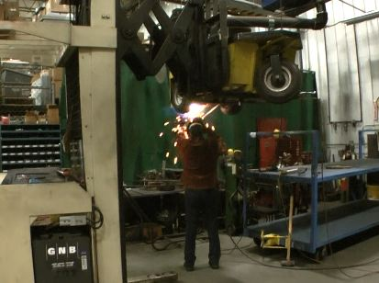 | 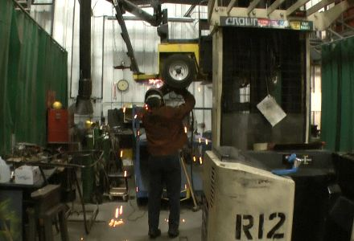
 | 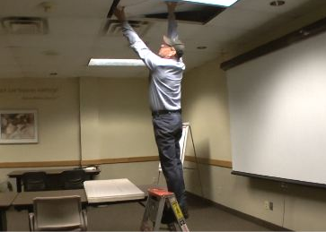
Misc. restroom repairs  - Valve kits  - Dispensing equipment  - Hardware  - Plugged closets, urinals, drains | 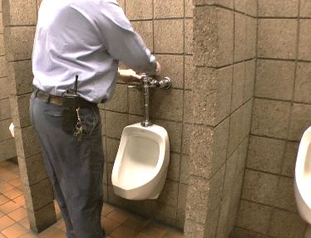
Dock levelers  - Cleaning and PM  - Component Replacement / Repair | 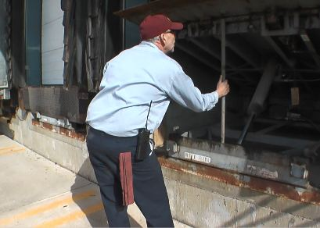 | 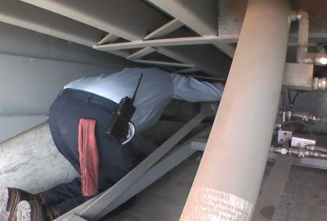
Dock doors  - Lubrication hinges, bearings, rollers  - Limited repairs, chains, rollers | 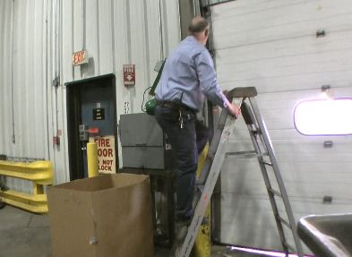 | 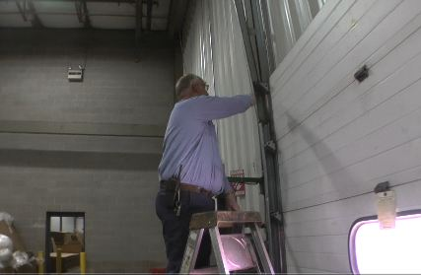
Dock locks  - PM, lubrication, cleaning  - General repairs | 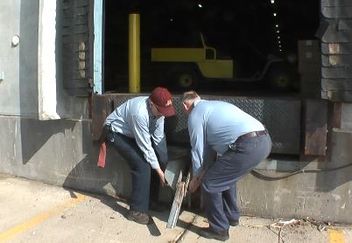

Functional Job Elements
(Tasks illustrated below are unique to Conveyor Maintenance)
(90% of total shift)  - Component Replacement  - Conveyor Installation  - Hand Taper Repair  - Marsh Taper Repair  - Signode Tape Machines  - Signode Skid Wrapping machines  - RMF Carton Machine  - Rite Size Carton Machine  - Shedder / Balers  - Pallet Jack Repair  - Traco Bag Sealer repair  - Conveyor Control Trouble Shooting  - Peanut Delivery System  - Quantum Sorter | 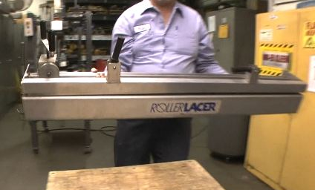 | 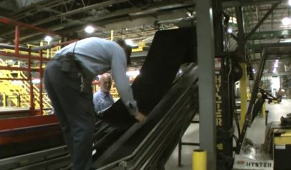
 | 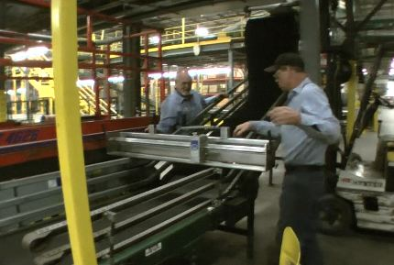 | 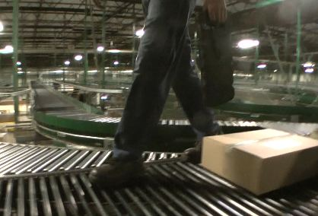
 | 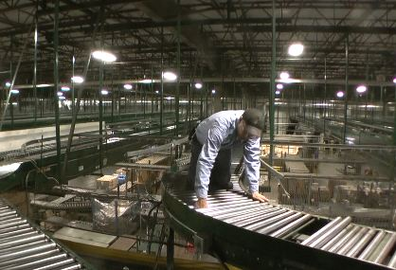 | 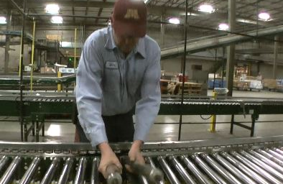
 | 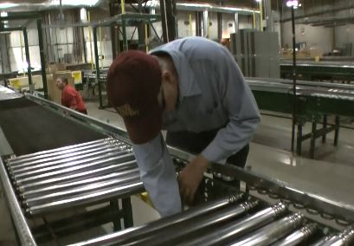 | 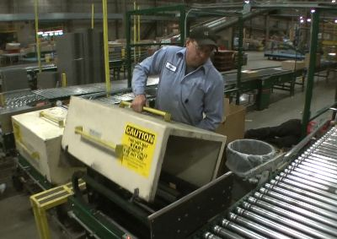
 |  | 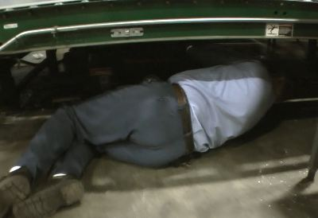
 | 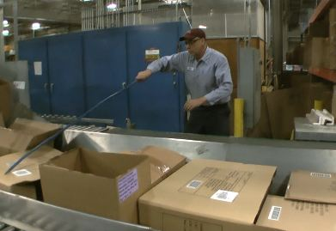 | 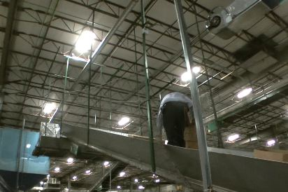
 | 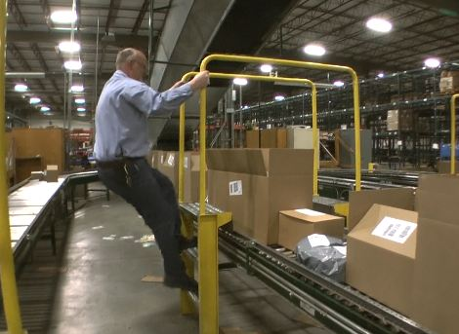 | 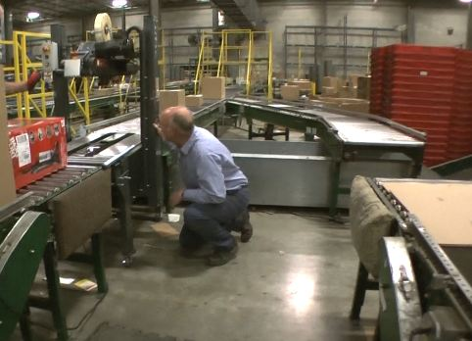
 | 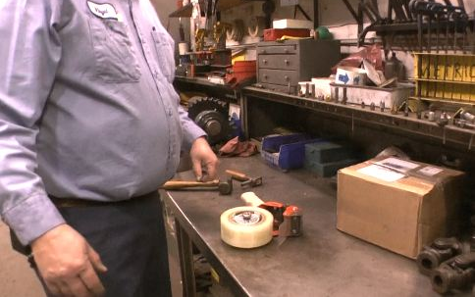 | 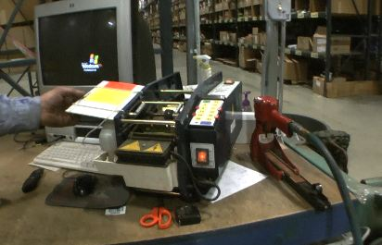
 | 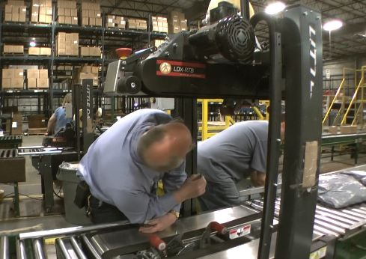 | 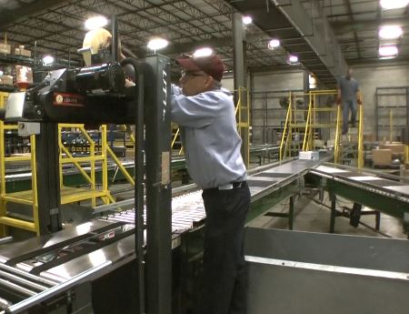
 | 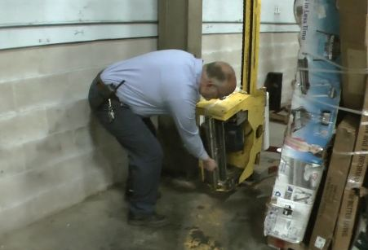 | 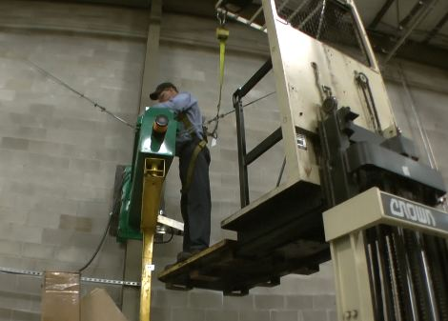
 | 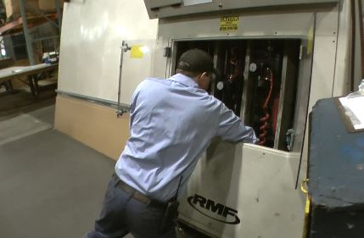 | 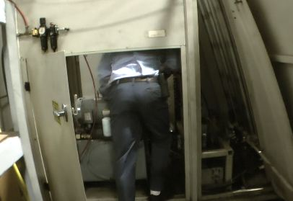
 | 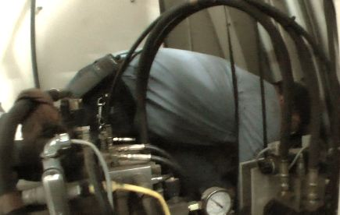 | 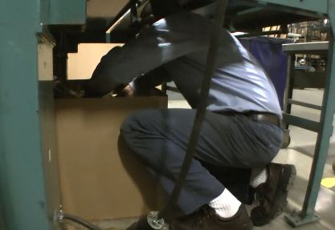
 | 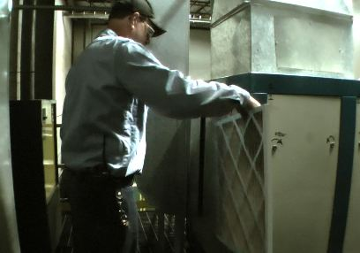 | 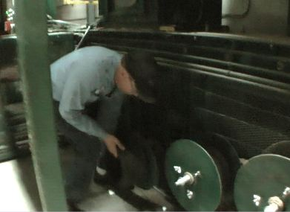
 | 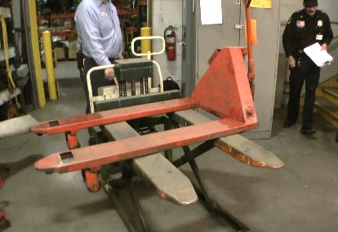 | 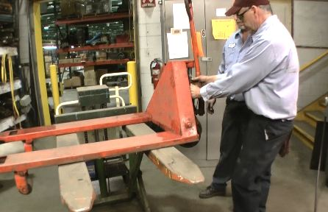
 | 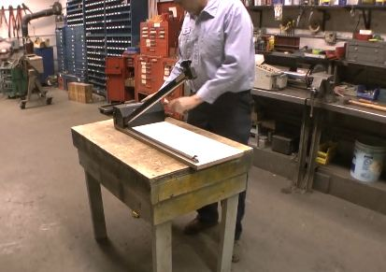 | 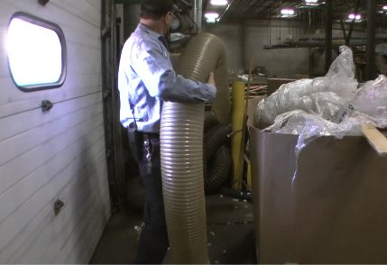
 | 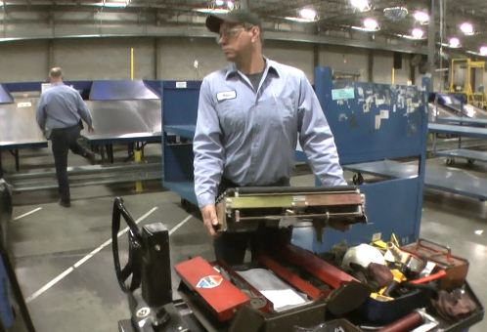 | 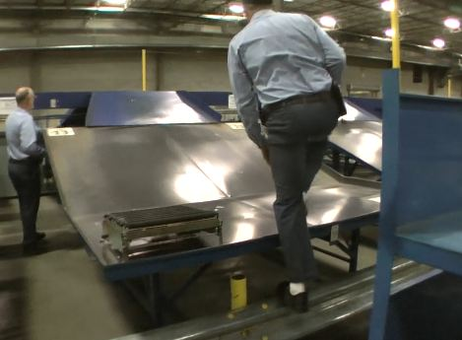
 | 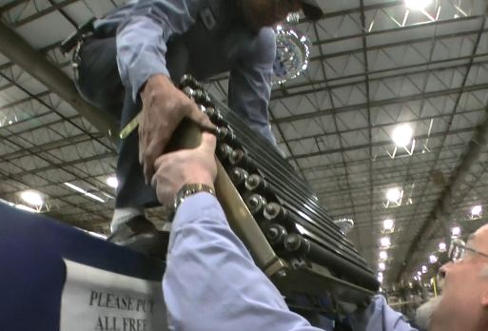 | 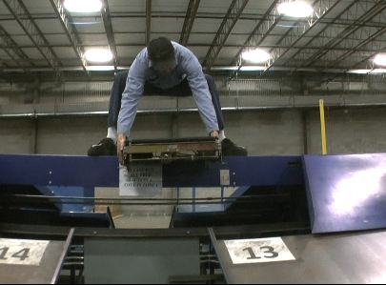

Functional Job Elements
(Tasks illustrated below are unique to Forklift Maintenance)
(90% of total shift)  - Tire changing  - Hydraulic component replacement  - Electrical component replacement  - Drive unit replacement  - Cylinder repair  - Cylinder replacement  - Control Wire replacement  - Hydraulic hose installation  - Hydraulic hose fabrication  - Use of crimper (set up, calibration,)  - EV100 controller  - 123 controller  - Electrical troubleshooting  - Electric Motor repair (DC)  - Electric Motor replacement (DC)  - MTC portable battery changer maintenance / repair  - MTC multi level battery changer maintenance / repair  - EZ Go repairs | 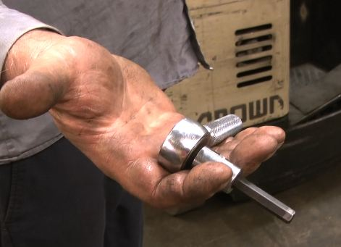 | 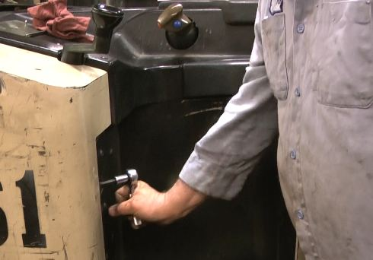
 | 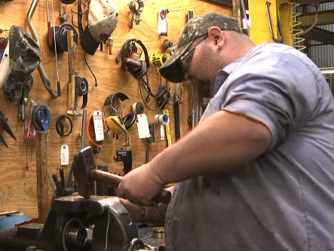 | 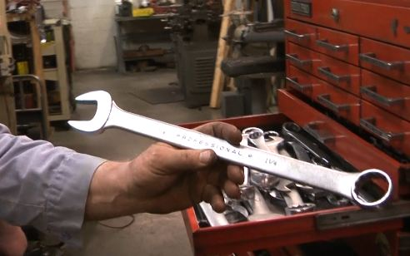
 | 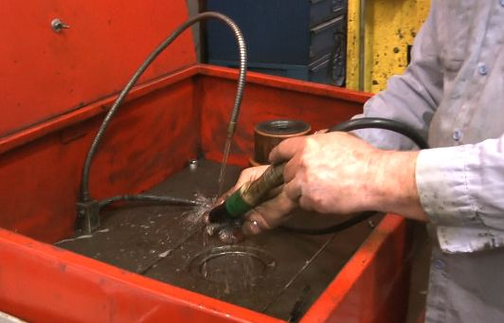 | 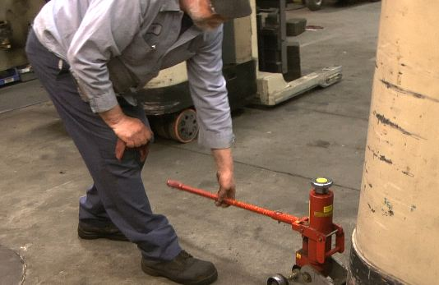
 | 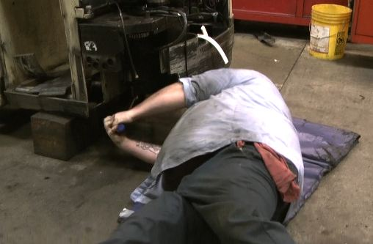 | 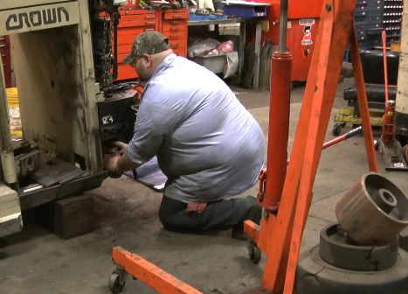
 | 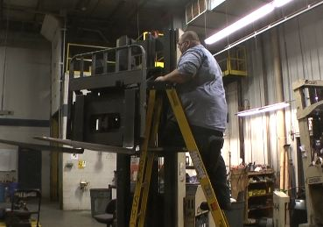 | 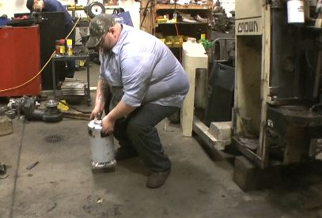
 | 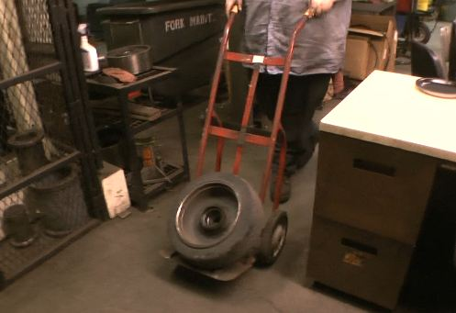 | 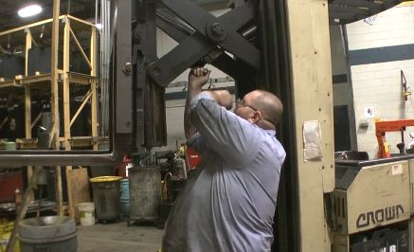
 | 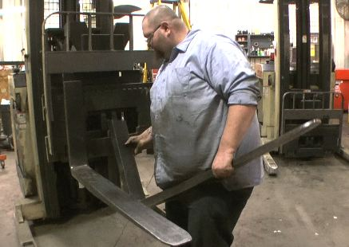 | 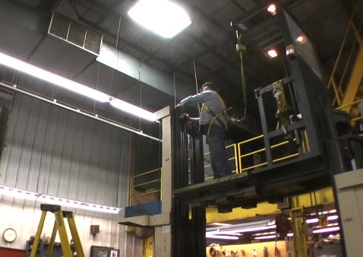
 | 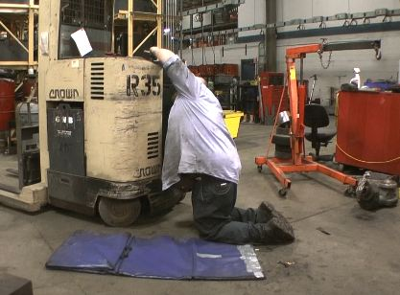 | 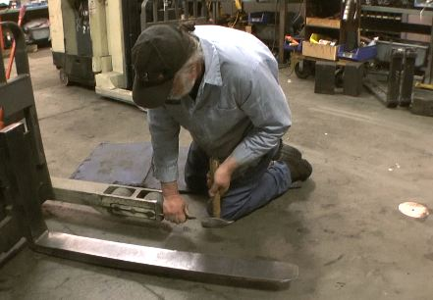
 | 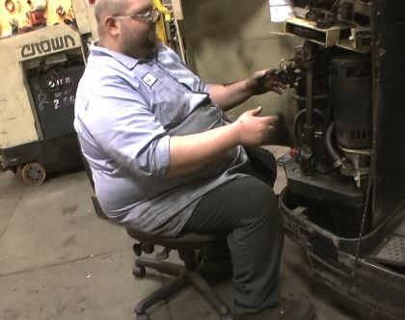

Physical Factors
Manual Material Handling
(lbs) | Floor-Knuckle (0” to 30”) |  |  |  |  |  | Knuckle-Chest (30” to 50’) |  |  |  |  |  | Chest-Overhead  ( > 50”) |  |  |  |  |  | Carry - Two Hands; Front |  |  |  |  |  | Carry - One Hand; Side |  |  |  |  |  | Push |  |  |  |  |  | Pull
100
75
50
25
15
10
5
0
Exp | N | R | O | F | C |  | N | R | O | F | C |  | N | R | O | F | C |  | N | R | O | F | C |  | N | R | O | F | C |  | N | R | O | F | C |  | N | R | O | F | C

Postures/Movements |  |  |  |  |  |  |  |  |  |  |  |  |  |  |  | Head/Neck
Exp | Sit | Stand | Walk | Bal | Stairs | Lad-der | Foot contrl | Twist Waist | Bend Waist | Squat | Kneel | Crawl | Reach below 54” | Reach above 54” |  | Flex Static | Ext Static | Rot Static | Flex Dyn | Ext Dyn | Rot Dyn
C
F
O
R
N

Hand Use |  |  |  |  | Sensory |  |  |  |  |  | Communication |  |  |  |  | Key C - Continuous: 67 to 100% of shift  F - Frequent: 34 to 66% of shift  O - Occasional: 6 to 33% of shift  R - Rarely: up to 5% of shift  N - Never: 0% of shift  Abbreviations: Bal=Balance, Exp=Exposure, Contrl=Control, Flex=Flexion, Ext=Extension, Dyn=Dynamic, Manip=Manipulation
Exp | Simple Grasp | Firm Grasp | Fine Manip | Bal | See | Hear | Touch Feel | Taste | Smell |  | Talk | Read | Write | Hand Signal
C
F
O
R
N

Environmental Factors | Exposure Level |  |  |  |  | Key/Comments
 | N | R | O | F | C
Outdoor Work |  |  |  |  |  | Key C - Continuous: 67 to 100% of shift  F - Frequent: 34 to 66% of shift  O - Occasional: 6 to 33% of shift  R - Rarely: up to 5% of shift  N - Never: 0% of shift  Comments:  Outdoor Work: Rarely will operate mechanical handling equipment outdoors.  Indoor Work: Primary work area is a large indoor warehouse complex.  Heat: Based on external temperature, occasionally performs job tasks in hot indoor environment; warehouse complex is not air-conditioned. Large fans are used for ventilation.  Moving Objects: Be aware of and avoid moving objects including equipment.  Protected Work Heights: May work at heights – fall protection is in place.
Indoor Work
Heat
Cold
Wet/ Humid
Hearing Protection
Vibration
Fumes/Gases/Odors
Dust
Moving Objects
Electrical
Chemical
Protected Work Heights
Unprotected Work Heights
Flying Debris
Lighting (Inadequate/Excessive)

Position eligible to be considered for temporary modification in conjunction with a Return to Work transitional duty program agreement: Yes
This Functional Job Description was completed through an on-site job analysis by a certified professional ergonomist/licensed physical therapist. It is for the purpose of identifying and quantifying the physical functional requirements of this job. The Functional Job Description should not be construed as a detailed description of all specific job duties and/or tools, equipment and materials that may be necessary or incidental to the performance of this job. Further consideration may be necessary when applying the standards to the injured population in the medical management process.
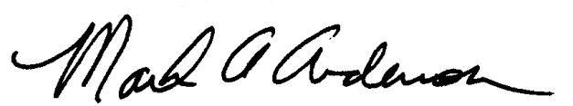 | 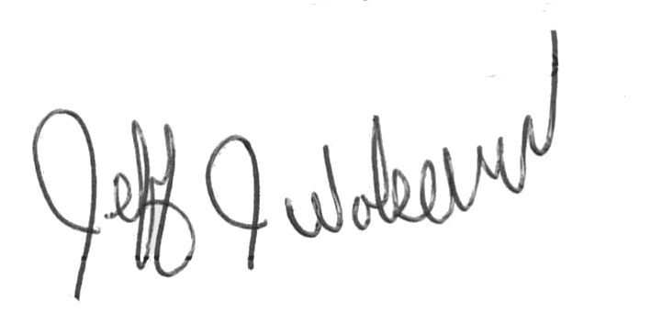  This Functional Job Description has been reviewed by company representatives and is believed to be an accurate representation of most of the job content.
Mark A Anderson, MA, PT CPE  Certified Professional Economist  Licensed Physical Therapist  ErgoSystems Consulting Group, Inc.  19285 Shady Hills Road  Minneapolis, MN 55331  952-401-9296  mark.anderson@ergosystemsconsulting.com  www.ergosystemsconsulting.com | _______________________________________
Jeff Wolseth
Manager - Occupational Safety and Health
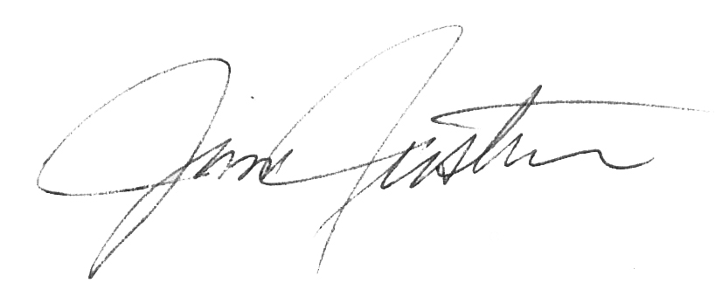
 | _______________________________________
Jim Justin
Manager - Facilities

