Functional Job Description:

Company: | Bluestem Brands, Inc. | 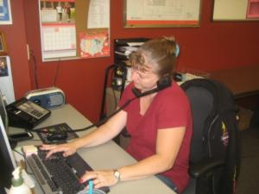 | 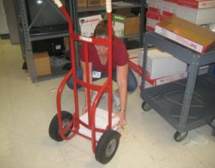
Job Title: | Call Center Coordinator
Date: | 5-28-14
Dept/Facility: | Call Center, St. Cloud, MN
Product Section: | Customer Service
Electronic Doc. # | FJD Call Center Coordinator 5-2014 FINAL

Work Hours | Overtime: | Voluntary and/or mandatory per production requirements. | Breaks: | Two 15 minute breaks.
 | Shift: | Days of week: | Time:
 | First | Monday through Friday  (40 hour work week) | 7:00 AM to 3:00 PM

Job Rotation | Yes

Job Training or Credentials Required at Hire | Education/ training: | High School Diploma or GED.
 | Knowledge/ cognitive skills: | Basic math, reading, writing and oral communication skills preferred. Ability to organize work tasks and work independently or as part of a team.

Machines, Tools, Equipment Used | Computer (keyboard, mouse, monitor(s)), telephone headset (two-ear or one ear), telephone handset, storage room keys, laminating machine, paper cutter, rolling cart, two wheel dolly, chair, workstation, foot rest, writing utensils, stapler, scissors, highlighter, calculator, white out, staple remover, EZ-Go.

Job Purpose/ Objectives | Responsible for performing a variety of clerical and administrative duties in a call center environment. Follows organization and department procedures to complete tasks in a timely manner. This includes sorting and delivering mail, ordering supplies, daily trip to the warehouse and back, handling customer letters and working back office functions as needed. Specifically includes: (Obtained from Customer Service Representative job description from HR.)  - Tracking and preparing outgoing mail as necessary - Update spreadsheets - Scanning - Open sort and deliver incoming mail - Order and distribute supplies - Distribute catalogs - Keep storage room clean and orderly - Work back office function as needed like calling back customers

Safety and Personal Protective Equipment Required  *Available | Hard Hat | Steel Toe Footwear | Safety Glasses | Gloves:
 | Face Shield | Protective Clothing | Safety Glasses/Side Shields | Leather
 | Dust Mask | Safety Vest  Fall Protection Harness  Back Support* | Safety Goggles  Hearing Protection*  Compensatory methods to mitigate heat | Rubberized/cloth*  Chemical

Safety/ Equipment Training/ Certification Required |  | Daily Meeting and Stretch Breaks (includes:) | Industrial Truck Training |  | OSHA Training (Rules and Regulations)
 |  | - Safety Topics | EZ-Go (warehouse) |  | New Hire Safety Orientation
 |  | - Safety Policies | Walkie-Rider |  | Right to Know
 |  | - Questions & Answers | Pallet Jack |  | Lockout/Tag Out
 |  | - Review Safety Committee Minutes | Forklift (sit down) |  | Regulated Materials Training (ORM-D)  Supervisor Safety Updates
 |  |  | Stand-up Reach Truck
 |  |  | Order Picker
 | Functional Job Elements (Duration)
- Go to workstation (5 minutes)
Obtain entry to the Call Center building from the parking lot and go to the Call Center Coordinator’s workstation
 | - Collect letters and faxes (total 8 to 10 minutes)  Pull and collect letters off the printers (5 minutes).  Collect faxes from fax machines (3 to 5 minutes). |  |  | 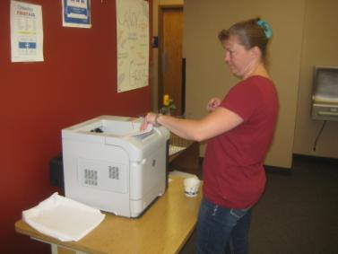
 | - Distribute paper to printers (10 to 15 minutes)  Ensure adequate paper supplies at the printers by bringing boxes/reams of paper to the printers from the storeroom.  Weight of a box of paper is approximately 50 pounds.  Typical weight of a ream of paper is about 5 pounds. |  |  | 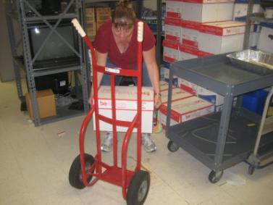  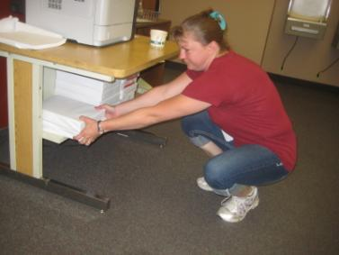
 | - Unlock metal cabinets (1 minute) |  |  | 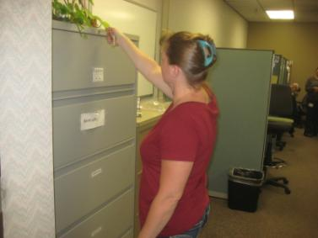
 | - Return to desk to print HAP (Home Agent Program) letters (1 to 60 minutes)  Number of letters can vary significantly from day to day; typically in the range of 400 to 800 letters. Letters printed via computer. |  |  | 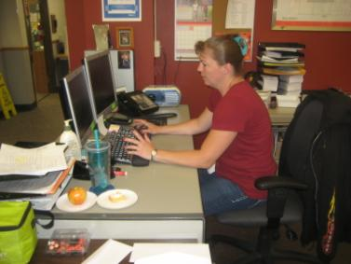
 | - Sort letters (30 to 60 minutes)  Obtain letters from the printer.  At the sorting table sort letters. Rubber band bundles together.  Bundles weigh 2 to 3 pounds. |  |  | 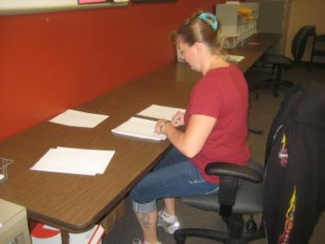  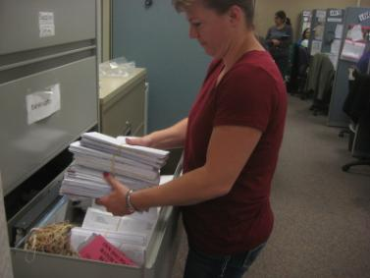
- Distribute letters (30 to 60 minutes)
Return to the desk to enter numbers into a spreadsheet at the computer. Via computer fax the letters to appropriate individuals.
 | - Operate scanner (up to 60 minutes)  Operate scanner.  Return to the desk to forward the scans via computer. |  |  | 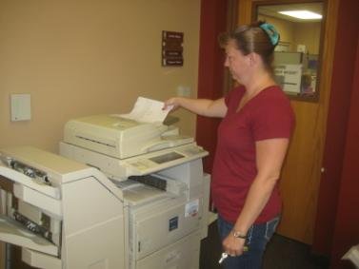
 | - Mail buckets (20 to 30 minutes)  Load mail cart, transport the cart to her car and place in the back seat, drive to warehouse and distribute mail to two locations at the warehouse. Make use of an EZ-Go for one location and either stairs or elevator to go to the second floor area for the second location.  Bring return mail from the warehouse back to the call center via her personal vehicle.  Mail bucket weighs up to 15 to 20 pounds. |  |  | 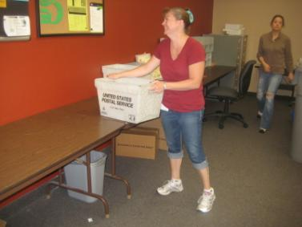  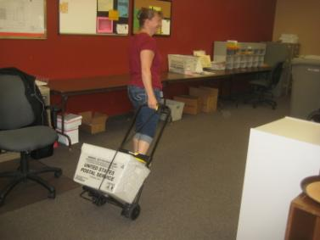  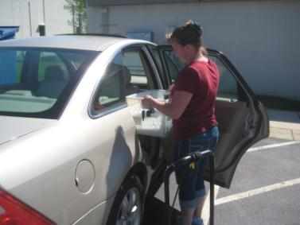
 | - Sort mail (20 minutes)  Sort mail on the mail sorting table.  Distribute mail to Call Center departments via hand carrying. |  |  | 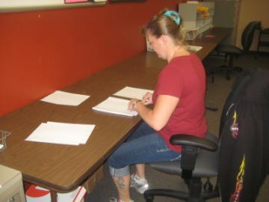
 | - Distribute catalog boxes (10 to 15 minutes)  Distribute catalogs by hand carrying to various departments as needed.  Bundle of catalogs weighs 5 to 7 pounds. |  |  | 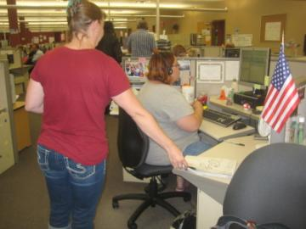
 | - Corporate callbacks (throughout the day, during the remainder of the day)  At the computer workstation perform corporate callbacks. Need to perform corporate callbacks is determined by checking on an hourly basis.  Performs the task at her computer workstation. Make use of computer and telephone headset (handset is pictured but typically headset is used). |  |  | 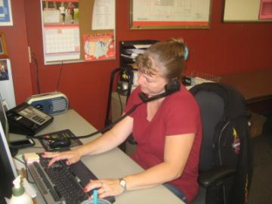
 | - Trash to dumpster (as needed)  Take trash to the outside dumpster as needed, typically hand carried.  Trash bag may weigh 7 to 10 pounds. |  |  | 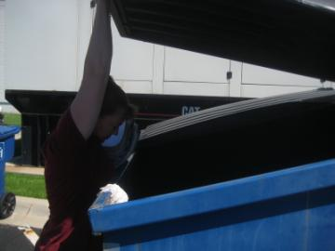
- Organize storage room (as needed)
Keep storage room clean and orderly.
Handles variety of boxes, materials, etc. in the storage room. Weight can vary from a few pounds to 50 pounds.
- End of shift shutdown (2 to 3 minutes)
Clock out and turn off computer system. Exit the building to the parking lot.

Physical Factors

Manual Material Handling
(lbs) | Floor-Knuckle (0” to 30”) |  |  |  |  |  | Knuckle-Chest (30” to 50’) |  |  |  |  |  | Chest-Overhead  ( > 50”) |  |  |  |  |  | Carry - Two Hands; Front |  |  |  |  |  | Carry - One Hand; Side |  |  |  |  |  | Push |  |  |  |  |  | Pull
100
75
50
25
15
10
5
0
Exp | N | R | O | F | C |  | N | R | O | F | C |  | N | R | O | F | C |  | N | R | O | F | C |  | N | R | O | F | C |  | N | R | O | F | C |  | N | R | O | F | C

Postures/Movements |  |  |  |  |  |  |  |  |  |  |  |  |  |  |  | Head/Neck
Exp | Sit | Stand | Walk | Bal | Stairs | Lad-der | Foot contrl | Twist Waist | Bend Waist | Squat | Kneel | Crawl | Reach below 54” | Reach above 54” |  | Flex Static | Ext Static | Rot Static | Flex Dyn | Ext Dyn | Rot Dyn
C
F
O
R
N

Hand Use |  |  |  |  | Sensory |  |  |  |  |  | Communication |  |  |  |  | Key C - Continuous: 67 to 100% of shift  F - Frequent: 34 to 66% of shift  O - Occasional: 6 to 33% of shift  R - Rarely: up to 5% of shift  N - Never: 0% of shift  Abbreviations: Bal=Balance, Exp=Exposure, Contrl=Control, Flex=Flexion, Ext=Extension, Dyn=Dynamic, Manip=Manipulation
Exp | Simple Grasp | Firm Grasp | Fine Manip | Bal | See | Hear | Touch Feel | Taste | Smell |  | Talk | Read | Write | Hand Signal
C
F
O
R
N

Environmental Factors | Exposure Level |  |  |  |  | Key/Comments
 | N | R | O | F | C
Outdoor Work |  |  |  |  |  | Key C - Continuous: 67 to 100% of shift  F - Frequent: 34 to 66% of shift  O - Occasional: 6 to 33% of shift  R - Rarely: up to 5% of shift  N - Never: 0% of shift  Comments:  Indoor Work: Primary work area is a large open concept floor plan with cubicles with HVAC controlled environment. Secondary work area is a large indoor warehouse complex.  Heat: Based on external temperature, occasionally performs job tasks in hot indoor environment; warehouse complex is not air-conditioned. Large fans are used for ventilation.  Moving Objects: Be aware of and avoid moving objects including equipment.
Indoor Work
Heat
Cold
Wet/ Humid
Hearing Protection
Vibration
Fumes/Gases/Orders
Dust
Moving Objects
Electrical
Chemical
Protected Work Heights
Unprotected Work Heights
Flying Debris
Lighting (Inadequate/Excessive)

Position eligible to be considered for temporary modification in conjunction with a Return to Work transitional duty program agreement: Yes
This Functional Job Description was completed through an on-site job analysis by a certified professional ergonomist/licensed physical therapist. It is for the purpose of identifying and quantifying the physical functional requirements of this job. The Functional Job Description should not be construed as a detailed description of all specific job duties and/or tools, equipment and materials that may be necessary or incidental to the performance of this job. Further consideration may be necessary when applying the standards to the injured population in the medical management process.
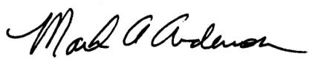 | 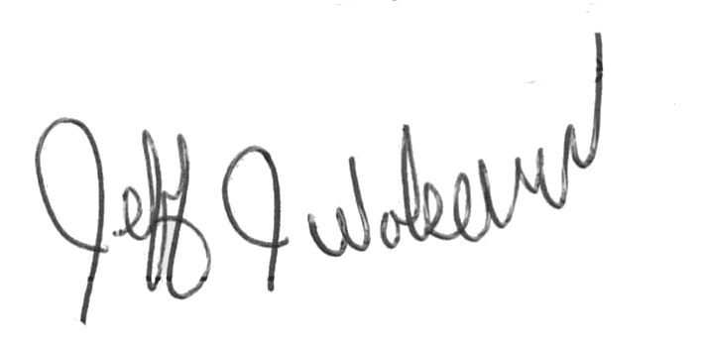  This Functional Job Description has been reviewed by company representatives and is believed to be an accurate representation of most of the job content.
Mark A Anderson, MA, PT CPE  Certified Professional Ergonomist  Licensed Physical Therapist  ErgoSystems Consulting Group, Inc.  19285 Shady Hills Road  Minneapolis, MN 55331  952-401-9296  mark.anderson@ergosystemsconsulting.com  www.ergosystemsconsulting.com | _______________________________________
Jeff Wolseth
Manager - Occupational Safety and Health
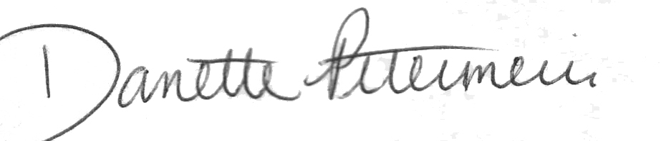
 | _______________________________________
Danette Petermeier
Supervisor - Customer Service

