Functional Job Description:

Company: | Bluestem Brands, Inc. | 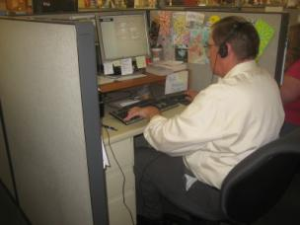 | 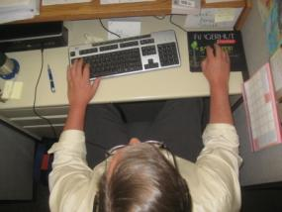
Job Title: | Inbound/Outbound Collections
Date: | 5-28-14
Dept/Facility: | Call Center, St. Cloud, MN
Product Section: | Customer Service
Electronic Doc. # | FJD Collections 5-2014 FINAL

Work Hours | Overtime: | Voluntary and/or mandatory per production requirements. | Breaks: | Two15 minute breaks, one 30 minute lunch break.
 | Shift: | Days of week: | Time:
 | First | Monday through Saturday, 40 hour work week for individual, eight hour shift. | Time of shift varies based on the day, will be within Collections open hours of 7:00 AM to 9:00 PM, Monday through Thursday, 7:00 AM to 6:00 PM Friday and 7:00 AM to 12:00 PM Saturday:

Job Rotation | Yes

Job Training or Credentials Required at Hire | Education/ training: | High School Diploma, GED, or equivalent combination of education and experience.
 | Knowledge/ cognitive skills: | Basic math, reading, writing and oral communication skills preferred. Ability to organize work tasks and work independently or as part of a team.

Machines, Tools, Equipment Used | Computer (keyboard, mouse, monitor(s)), telephone headset (two-ear or one ear), chair, workstation, foot rest, writing utensils, stapler, scissors, highlighter, calculator, white out, staple remover.

Job Purpose/ Objectives | Maximize the achievement of high quality and sustainable growth at Bluestem Brands Inc. through the positive, cost effective, efficient, and timely resolution of customer issues. Foster long-term customer retention through professional interactions in a variety of calls. Continuously strive for single contact resolution. Obtain payments by notifying customers of past due status, develop solutions to obtain payments and document actions while maintaining a relationship with the customer to ensure future ordering. Provide customers with timely and accurate information concerning deferred payments and future payments. (Obtained from Customer Service Representative job description from HR.)

Safety and Personal Protective Equipment Required  *Available | Hard Hat | Steel Toe Footwear | Safety Glasses | Gloves:
 | Face Shield | Protective Clothing | Safety Glasses/Side Shields | Leather
 | Dust Mask | Safety Vest  Fall Protection Harness  Back Support* | Safety Goggles  Hearing Protection*  Compensatory methods to mitigate heat | Rubberized/cloth*  Chemical

Safety/ Equipment Training/ Certification Required | Daily Meeting and Stretch Breaks (includes:) | Industrial Truck Training | OSHA Training (Rules and Regulations)
 | - Safety Topics | EZ-Go | New Hire Safety Orientation
 | - Safety Policies | Walkie-Rider | Right to Know
 | - Questions & Answers | Pallet Jack | Lockout/Tag Out
 | - Review Safety Committee Minutes | Forklift (sit down) | Regulated Materials Training (ORM-D)  Supervisor Safety Updates
 |  | Stand-up Reach Truck
 |  | Order Picker

Functional Job Elements (Duration)
- Go to workstation (5 minutes)
Obtain entry to the Call Center building from the parking lot and go to the individual's workstation. Workstations are primarily single-user; occasionally may share a workstation with another individual during fourth quarter.
- Setup workstation (1 to 2 minutes)  As needed make any adjustments to the workstation in terms of chair adjustment, work surface height (sit/stand workstation), foot rest placement, computer equipment (keyboard, mouse, monitor) placement. Put on telephone headset, load ream of paper into printer if needed, etc. Disinfect equipment if needed.  Workstation configuration* may be a desk height workstation (height range: about 26 to 30 inches) with chair or a standing height workstation (height range: about 38 to 44 inches).  *Note: Based on the particular individual's needs, workstation configuration options include either a traditional seated height desk or an option for a sit/stand desk with work surface height controlled by the user. With the sit/stand configuration the user is able to alternate between a seated and standing position based on personal preference throughout the shift. | 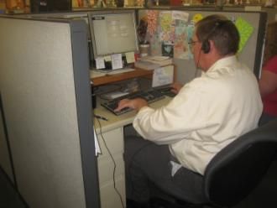  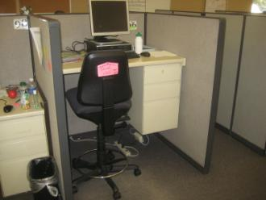
- Turn on computer, clock in and bring up software systems (3 to 5 minutes)
Turn on the computer. Clock in via the computer.
Bring up required software systems.
- Inbound outbound calls (six hours)  Via the telephone system integrated into the computer make inbound and outbound calls.  Use of the computer requires use of the computer keyboard and mouse while viewing either a single or double monitor configuration. Telephone configuration is headset for hands-free operation.  Most materials are referenced through the computer monitor or in some cases hardcopy reference materials.  Occasionally written notes are made throughout the shift.  Performance metrics. Objectively, performance metrics that relate to number of calls per hour throughout the shift include:  - Inbound –average 10-12 calls per hour  - Inbound/Outbound –average 15-17 calls per hou | 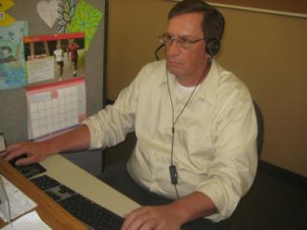  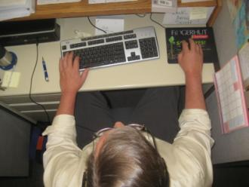
- Other activities include:
- Weekly huddle meeting (30 minutes)
- Monthly call listening sessions (30 to 60 minutes)
- Check in’s-work with individuals at workstation (15 to 30 minutes)
- Other special projects as needed
- End of shift shutdown (2 to 3 minutes)
Clock out and turn off computer system. Exit the building to the parking lot.

Physical Factors

Manual Material Handling
(lbs) | Floor-Knuckle (0” to 30”) |  |  |  |  |  | Knuckle-Chest (30” to 50’) |  |  |  |  |  | Chest-Overhead  ( > 50”) |  |  |  |  |  | Carry - Two Hands; Front |  |  |  |  |  | Carry - One Hand; Side |  |  |  |  |  | Push |  |  |  |  |  | Pull
100
75
50
25
15
10
5
0
Exp | N | R | O | F | C |  | N | R | O | F | C |  | N | R | O | F | C |  | N | R | O | F | C |  | N | R | O | F | C |  | N | R | O | F | C |  | N | R | O | F | C

Postures/Movements |  |  |  |  |  |  |  |  |  |  |  |  |  |  |  | Head/Neck
Exp | Sit | Stand | Walk | Bal | Stairs | Lad-der | Foot contrl | Twist Waist | Bend Waist | Squat | Kneel | Crawl | Reach below 54” | Reach above 54” |  | Flex Static | Ext Static | Rot Static | Flex Dyn | Ext Dyn | Rot Dyn
C
F
O
R
N

Hand Use |  |  |  |  | Sensory |  |  |  |  |  | Communication |  |  |  |  | Key C - Continuous: 67 to 100% of shift  F - Frequent: 34 to 66% of shift  O - Occasional: 6 to 33% of shift  R - Rarely: up to 5% of shift  N - Never: 0% of shift  Abbreviations: Bal=Balance, Exp=Exposure, Contrl=Control, Flex=Flexion, Ext=Extension, Dyn=Dynamic, Manip=Manipulation
Exp | Simple Grasp | Firm Grasp | Fine Manip | Bal | See | Hear | Touch Feel | Taste | Smell |  | Talk | Read | Write | Hand Signal
C
F
O
R
N

Environmental Factors | Exposure Level |  |  |  |  | Key/Comments
 | N | R | O | F | C
Outdoor Work |  |  |  |  |  | Key C - Continuous: 67 to 100% of shift  F - Frequent: 34 to 66% of shift  O - Occasional: 6 to 33% of shift  R - Rarely: up to 5% of shift  N - Never: 0% of shift  Comments:  Indoor Work: Primary work area is a large open concept floor plan with cubicles with HVAC controlled environment.
Indoor Work
Heat
Cold
Wet/ Humid
Hearing Protection
Vibration
Fumes/Gases/Orders
Dust
Moving Objects
Electrical
Chemical
Protected Work Heights
Unprotected Work Heights
Flying Debris
Lighting (Inadequate/Excessive)

Position eligible to be considered for temporary modification in conjunction with a Return to Work transitional duty program agreement: Yes
This Functional Job Description was completed through an on-site job analysis by a certified professional ergonomist/licensed physical therapist. It is for the purpose of identifying and quantifying the physical functional requirements of this job. The Functional Job Description should not be construed as a detailed description of all specific job duties and/or tools, equipment and materials that may be necessary or incidental to the performance of this job. Further consideration may be necessary when applying the standards to the injured population in the medical management process.
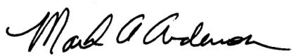 | 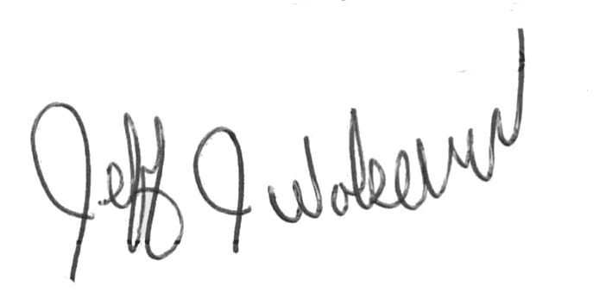  This Functional Job Description has been reviewed by company representatives and is believed to be an accurate representation of most of the job content.
Mark A Anderson, MA, PT CPE  Certified Professional Ergonomist  Licensed Physical Therapist  ErgoSystems Consulting Group, Inc.  19285 Shady Hills Road  Minneapolis, MN 55331  952-401-9296  mark.anderson@ergosystemsconsulting.com  www.ergosystemsconsulting.com | _______________________________________
Jeff Wolseth
Manager - Occupational Safety and Health
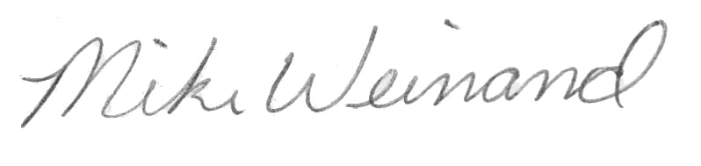
 | _______________________________________
Mike Weinand
Supervisor - Collections

