Functional Job Description:

Company: | Bluestem Brands, Inc. | 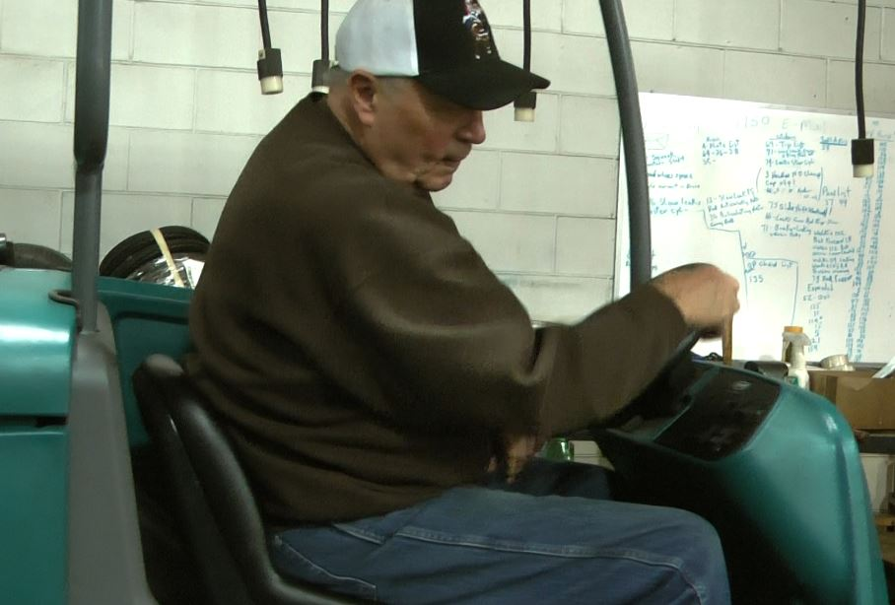 | 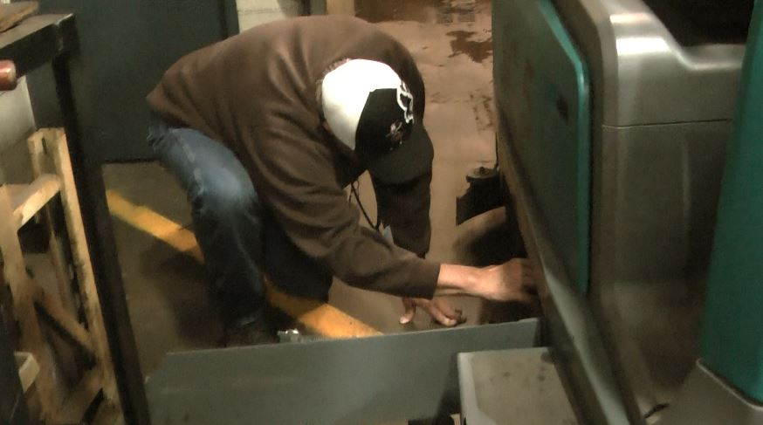
Job Title: | General Labor – Floor Scrubber
Date: | 6-16-16
Dept/Facility: | West DC, St. Cloud, MN
Product Section: | Outbound
Electronic Doc. # | FJD Floor Scrubber 6-2016 FINAL

Work Hours | Overtime: | Voluntary and/or mandatory per production requirements. | Breaks: | 10 minutes every two hours, one 30 minute lunch break.
 | Shift: | Days of week: | Time:
 | First | Monday – Friday | 9:00 AM to 5:30 PM

Job Rotation | Yes

Job Training or Credentials Required at Hire | Education/ training: | None required; high school diploma or GED preferred.
 | Knowledge/ cognitive skills: | Basic math, reading, writing and oral communication skills preferred. Ability to organize work tasks and work independently or as part of a team.

Machines, Tools, Equipment Used | Floor scrubber, pressure washer and hose.

Job Purpose/ Objectives | Operate the floor scrubber to clean floors. Use a checklist to perform safety and operational checks prior to operation. At the end of the shift clean the scrubber (includes dumping water, clean the hoses, catch pan, rollers, brushes, etc.).

Safety and Personal Protective Equipment Required  *Available | Hard Hat | Steel Toe Footwear | Safety Glasses | Gloves:
 | Face Shield | Protective Clothing | Safety Glasses/Side Shields | Leather
 | Dust Mask | Safety Vest  Fall Protection Harness  Back Support* | Safety Goggles  Hearing Protection*  Compensatory methods to mitigate heat | Rubberized/cloth*  Chemical

Safety/ Equipment Training/ Certification Required | Daily Meeting and Stretch Breaks (includes:) |  | Industrial Truck Training |  | OSHA Training (Rules and Regulations)
 | - Safety Topics |  | EZ-Go |  | New Hire Safety Orientation
 | - Safety Policies |  | Walkie-Rider |  | Right to Know
 | - Questions & Answers |  | Pallet Jack |  | Lockout/Tag Out
 | - Review Safety Committee Minutes |  | Forklift (sit down) |  | Regulated Materials Training (ORM-D)  Supervisor Safety Updates  Power Washer Hands-on Safety Training
 |  |  | Stand-up Reach Truck
 |  |  | Order Picker
Functional Job Elements |  |  |  |  |  | % of shift
- Preparation  - Go through the equipment checklist to check operational and safety features of the scrubber.  - Use the 1” water hose in the Wash Bay to fill the scrubber water tank.  - Obtain the schedule for the day. |  | 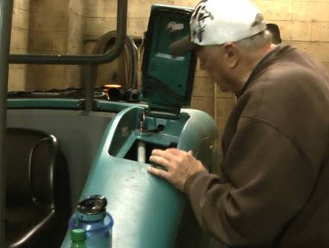 |  | 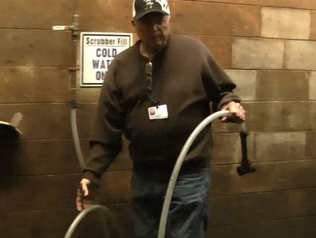 |  | < 1%
- Operate Floor Scrubber  - Drive the floor scrubber following safe driving procedures.  - The scrubber is operated from a seated position.  - The scrubber has power steering with hand controls to control various operations of the scrubber and foot controls (brake and accelerator).  - The scrubber can be driven with one arm/hand.  - May occasionally get off the scrubber to pick up debris (paper, wood, etc.) off the floor and take to a trash can. |  | 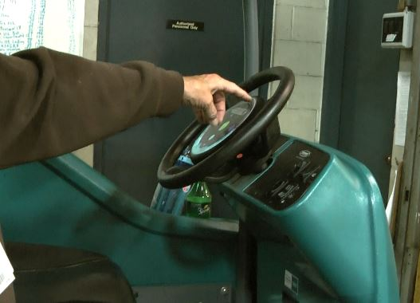 |  | 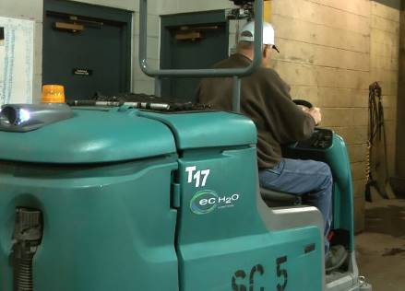 |  | 94%
 |  | 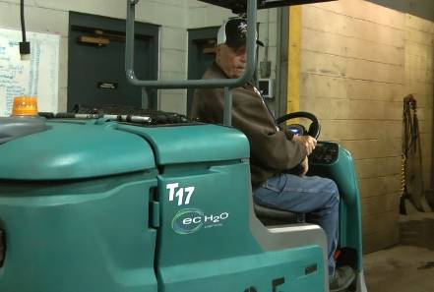 |  | 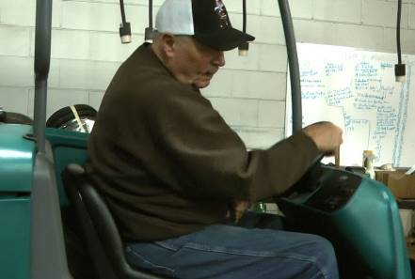
- End of shift cleaning  - At the shift the scrubber is thoroughly cleaned by the operator including:  - Dump remaining water.  - Clean hoses, catch pan, rollers and brushes.  - Cleaning takes about 20 to 30 minutes to do a thorough job and involves kneeling, squatting, on all fours and up to 25# of hand/arm force to open access panels, disconnect/ connect hoses, pull out/push in brushes, etc.  - Two hands are required to perform the cleaning functions.  - The water hose is used to clean components of the scrubber.  - If not cleaned on a daily basis, the scrubber components become caked with dried dirt, debris, etc. with resulting increase in the physical demands on the operator and time required to clean the scrubber. |  | 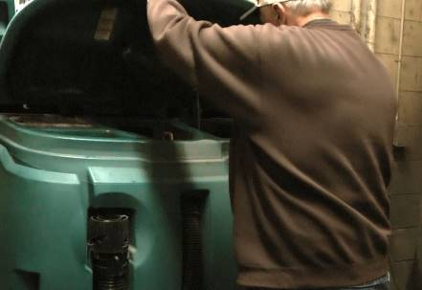 |  | 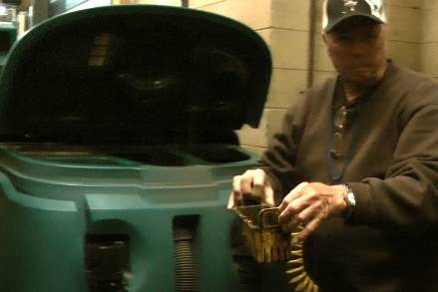 |  | 5%
 |  | 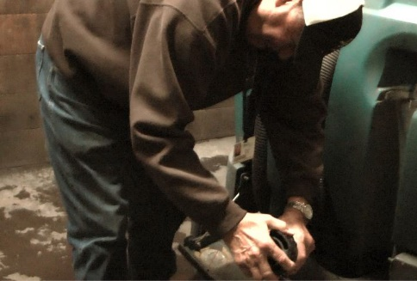 |  | 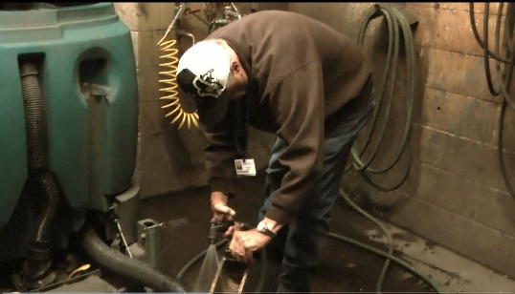
 |  |  |  | 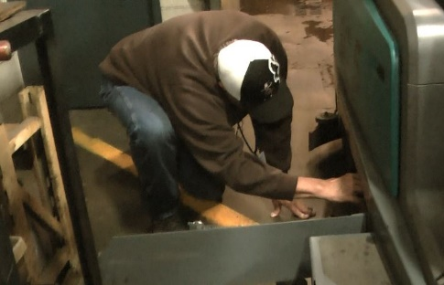
 |  | 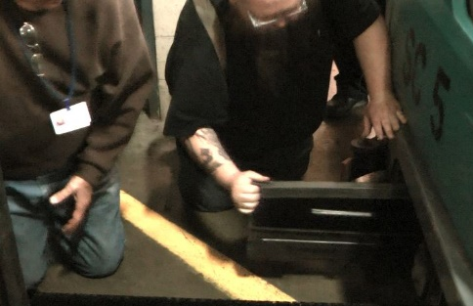 |  | 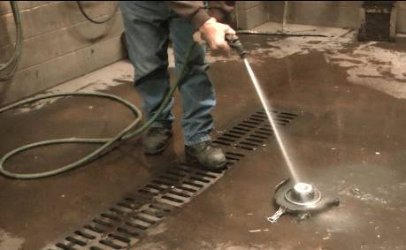
- Park in Wash Bay  - At the completion of the cleaning process the scrubber is parked in the wash bay. |  | 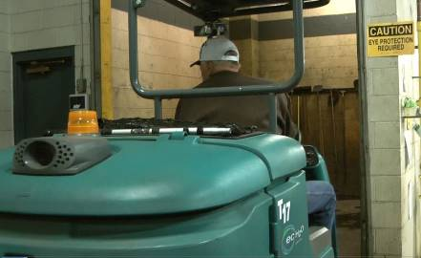 |  |  |  | < 1%

Physical Factors

Manual Material Handling
(lbs) | Floor-Knuckle (0” to 30”) |  |  |  |  |  | Knuckle-Chest (30” to 50’) |  |  |  |  |  | Chest-Overhead  ( > 50”) |  |  |  |  |  | Carry - Two Hands; Front |  |  |  |  |  | Carry - One Hand; Side |  |  |  |  |  | Push |  |  |  |  |  | Pull
100
75
50
25
15
10
5
0
Exp | N | R | O | F | C |  | N | R | O | F | C |  | N | R | O | F | C |  | N | R | O | F | C |  | N | R | O | F | C |  | N | R | O | F | C |  | N | R | O | F | C

Postures/Movements |  |  |  |  |  |  |  |  |  |  |  |  |  |  |  | Head/Neck
Exp | Sit | Stand | Walk | Bal | Stairs | Lad-der | Foot contrl | Twist Waist | Bend Waist | Squat | Kneel | Crawl | Reach below 54” | Reach above 54” |  | Flex Static | Ext Static | Rot Static | Flex Dyn | Ext Dyn | Rot Dyn
C
F
O
R
N

Hand Use |  |  |  |  | Sensory |  |  |  |  |  | Communication |  |  |  |  | Key C - Continuous: 67 to 100% of shift  F - Frequent: 34 to 66% of shift  O - Occasional: 6 to 33% of shift  R - Rarely: up to 5% of shift  N - Never: 0% of shift  Abbreviations: Bal=Balance, Exp=Exposure, Contrl=Control, Flex=Flexion, Ext=Extension, Dyn=Dynamic, Manip=Manipulation
Exp | Simple Grasp | Firm Grasp | Fine Manip | Bal | See | Hear | Touch Feel | Taste | Smell |  | Talk | Read | Write | Hand Signal
C
F
O
R
N

Environmental Factors | Exposure Level |  |  |  |  | Key/Comments
 | N | R | O | F | C
Outdoor Work |  |  |  |  |  | Key C - Continuous: 67 to 100% of shift  F - Frequent: 34 to 66% of shift  O - Occasional: 6 to 33% of shift  R - Rarely: up to 5% of shift  N - Never: 0% of shift  Comments:  Indoor Work: Primary work area is a large indoor warehouse complex.  Heat: Based on external temperature, occasionally performs job tasks in hot indoor environment; warehouse complex is not air-conditioned.  Climate Control Plan: Ambient temperature in the warehouse is controlled via opening/closing building outside doors as appropriate in conjunction with fan use.  Moving Objects: Be aware of and avoid moving objects including equipment.
Indoor Work
Heat
Cold
Wet/ Humid
Hearing Protection
Vibration
Fumes/Gases/Orders
Dust
Moving Objects
Electrical
Chemical
Protected Work Heights
Unprotected Work Heights
Flying Debris
Lighting (Inadequate/Excessive)

Position eligible to be considered for temporary modification in conjunction with a Return to Work transitional duty program agreement: Yes
This Functional Job Description was completed through an on-site job analysis by a certified professional ergonomist/licensed physical therapist. It is for the purpose of identifying and quantifying the physical functional requirements of this job. The Functional Job Description should not be construed as a detailed description of all specific job duties and/or tools, equipment and materials that may be necessary or incidental to the performance of this job. Further consideration may be necessary when applying the standards to the injured population in the medical management process.
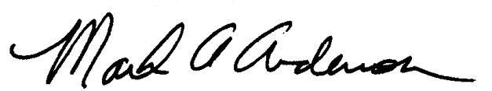 | 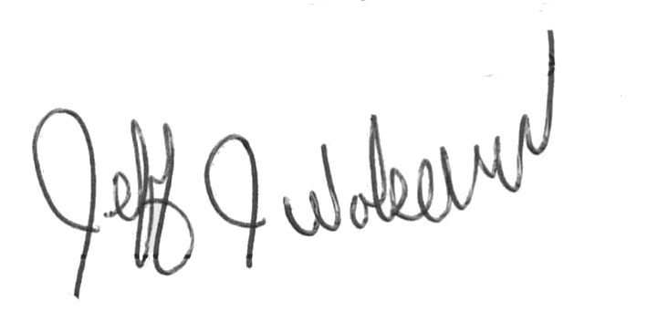  This Functional Job Description has been reviewed by company representatives and is believed to be an accurate representation of most of the job content.
Mark A Anderson, MA, PT CPE  Certified Professional Ergonomist  Licensed Physical Therapist  ErgoSystems Consulting Group, Inc.  19285 Shady Hills Road  Minneapolis, MN 55331  952-401-9296  mark.anderson@ergosystemsconsulting.com  www.ergosystemsconsulting.com | _______________________________________
Jeff Wolseth
Manager - Occupational Safety and Health

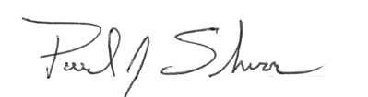
_______________________________________
Paul Schroer
Manager – Warehouse Operations

