Functional Job Description: General Maintenance/Battery Changer

Company: | Bluestem Brands, Inc. | 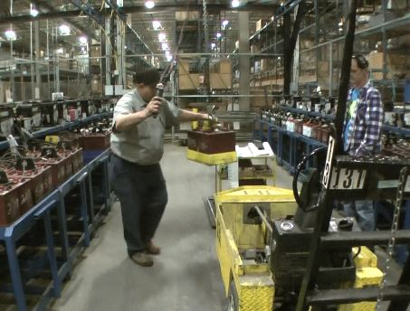 | 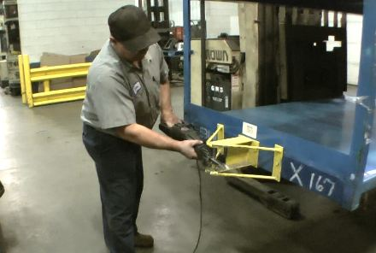
Job Title: | General Maintenance/  Battery Changer
Date: | May 7, 2012
Dept/Facility: | West DC, St. Cloud, MN
Product Section: | Maintenance
Electronic Doc. # | FJDGenMaintBattChanger2012

Work Hours | Overtime: | Voluntary and/or mandatory per production requirements. | Breaks: | 10 minutes every two hours, one 30 minute lunch break.
 | Shift: | Days of week: | Time:
 | First | Monday-Friday | 6:00 AM to 2:30 PM
 | Second | Monday-Friday | 4:00 PM to 12:30 AM

Job Rotation | Yes

Job Training / Credentials Required at Hire | Education/ training: | None required; high school diploma or GED preferred.
 | Knowledge/ cognitive skills: | Basic math, reading, writing and oral communication skills preferred. Ability to organize work tasks and work independently or as part of a team.

Machines, Tools, Equipment Used | General Hand Tools  - Wrenches  - Hammers  - Screw Drivers  - Pry bars  Specialized Hand Tools  - Hydrometer  - Multi meter  - Load Tester  - Watering systems  - Wash Bay  - Battery Washer | Powered Hand Tools  - Drills - electric, pneumatic, battery powered  - Saws- reciprocating, portable band,  - Grinders - 4 and 7 inch angle, die grinder  - Impact wrench | Shop Tools/Equipment  - Bench/pedestal grinder  - Band saws  - Drill Press  - Ladder  - Arc and MIG welders  - 4 Ton Bridge Crane  - MTC Three Level System  - MTC Portable Changers  - 250 lb. hoist

Job Purpose/ Objectives/  List of Tasks | Perform general maintenance and repair of carts, change out batteries for powered industrial trucks, general maintenance of batteries and other duties as assigned. List of tasks includes:
 | General tasks  - Charger Operation  - Battery maintenance  - EZ Go adjustments  - Torch work / Brazing  - Arc Welding  - MIG welding  - Cable repair/fabrication  Cart repairs  - Casters  - Hitches | Misc. restroom repairs  - Valve kits  - Dispensing equipment  - Hardware  - Plugged closets, urinals, drains  Dock levelers  - Cleaning and PM  - Component Replacement / Repair | Dock doors  - Lubrication hinges, bearings, rollers  - Limited repairs, chains, rollers  Dock locks  - PM, lubrication, cleaning  - General repairs

Safety and Personal Protective Equipment Required  *Available | Back Support*  Compensatory methods to mitigate heat  Dust Mask*  Face Shield  Fall Protection Harness  Hard Hat  Hearing Protection* | Gloves: Chemical  Gloves: Leather  Gloves: Nitrile  Gloves: Rubberized/cloth*  Protective Clothing: Apron  Protective Clothing: Chaps  Protective Clothing: Sleeves  Protective Clothing: Jacket  Protective Clothing: Cap | Safety Glasses/Side Shields  Safety Goggles/Chemical  Safety Vest*  Steel Toe Footwear

Safety/ Equipment Training/ Certification Required | Daily Meeting and Stretch Breaks (includes:) | Industrial Truck Training | OSHA Training (Rules and Regulations)
 | - Safety Topics  - Safety Policies  - Questions & Answers  - Review Safety Committee Minutes | EZ-Go  Walkie-Rider  Pallet Jack  Forklift (sit down)  Stand-up Reach Truck  Order Picker  Elevated Work Platform | New Hire Safety Orientation  Right to Know  Blood Borne Pathogens  Fire Extinguisher  Hot Work Permit  Lockout/Tag Out  Regulated Materials Training (ORM-D)  Supervisor Safety Updates

Functional Job Elements
Changes batteries  (25% of total shift)  - Change batteries (MTC Three Level System)  - Disconnect/connect battery  - Operate equipment to remove and replace battery  - Connect to battery charger  - Check battery water level  - Using hose, fill battery with water as needed | 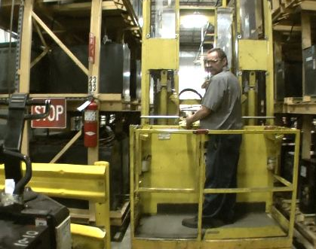 | 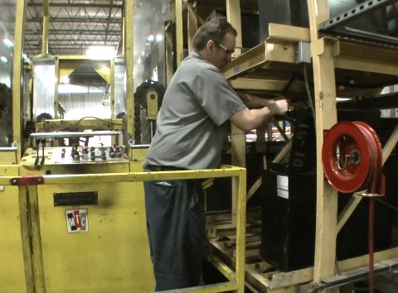
 | 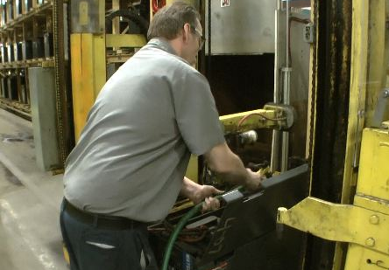 | 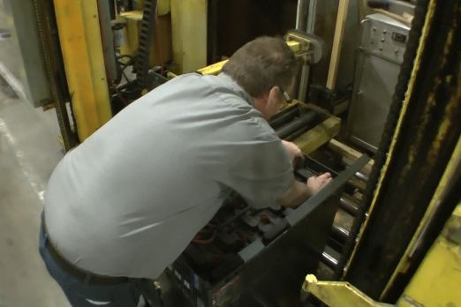
- Change batteries (EZ-GO)  - Remove cover from battery compartment  - Disconnect batteries from terminals  - Use 250 lb capacity overhead hoist to remove and replace batteries  - Put battery cover back on | 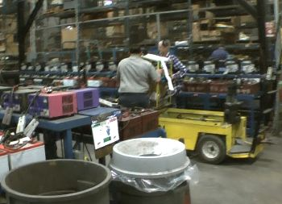 | 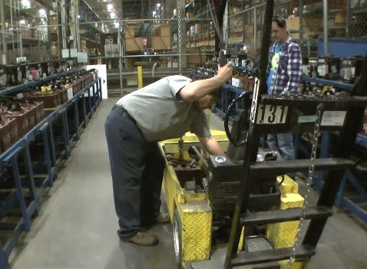
 |  | 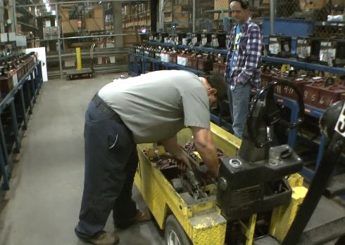
- Change batteries (MTC Portable Changers)  - Operate equipment to handle battery (remove from PIT)  - Open battery water covers to check water level  - Fill with water as needed  - Disconnect and connect to charger | 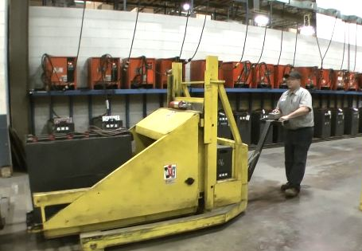 | 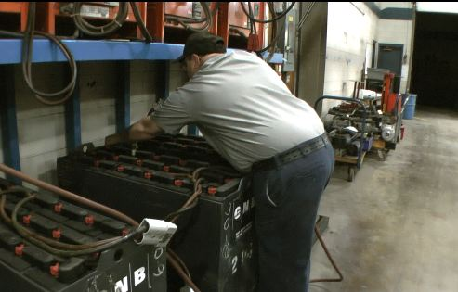
 | 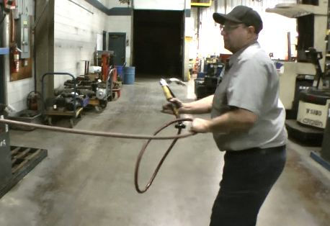 | 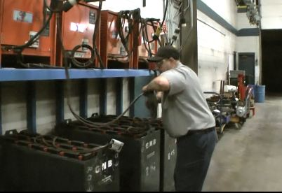
Battery Equipment Maintenance  (45% of total shift)  - EZ-GO batteries  - Check water level  - Use hydrometer  - Hook up battery charger  - Transport battery with overhead hoist  - Manually handle battery (battery weight is 62#) | 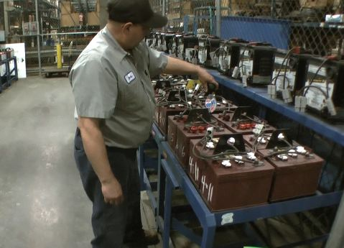 | 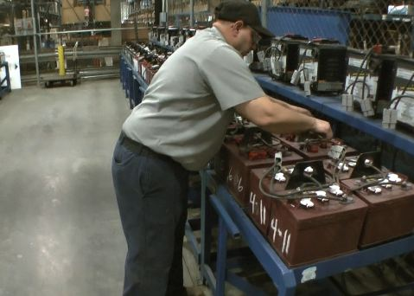
 | 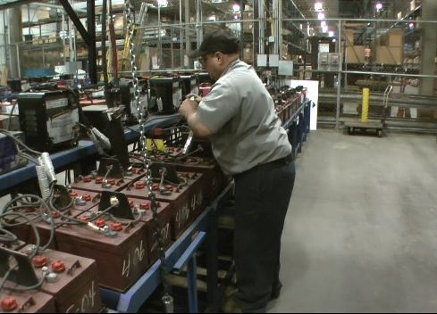 | 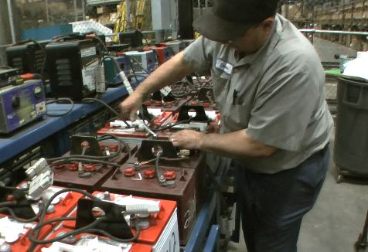
 | 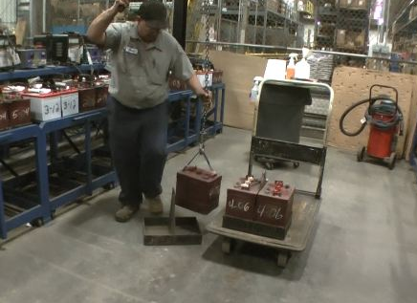 | 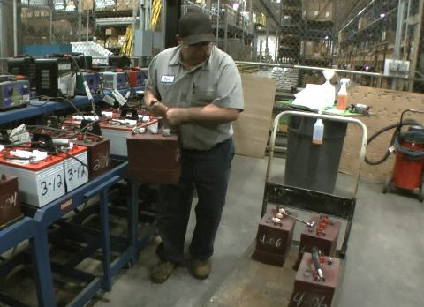
- Battery wash (EZ-GO)  - Transfer EZ-GO batteries to hand truck  - Transport hand truck to battery wash station  - Spray on battery wash solution  - Wash with water hose and dry with air hose  - Return batteries to staging area |  | 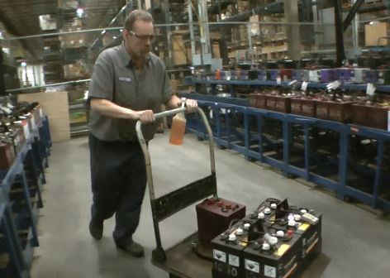
 | 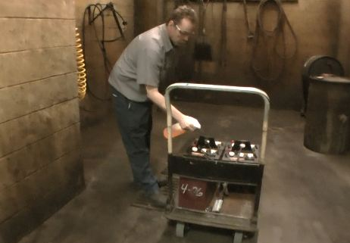 | 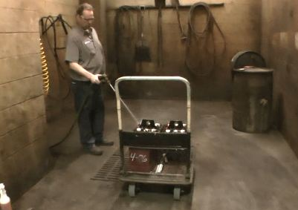
- Battery washer  - Transfer batteries into battery washer with equipment  - Spray on battery wash solution  - Operate battery washer  - Return batteries to staging area | 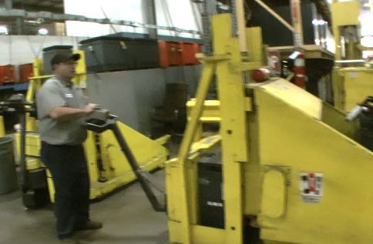 | 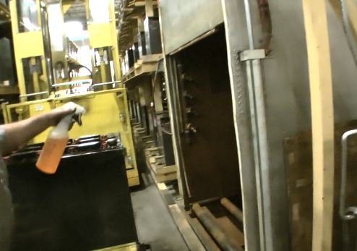
- Touch up spray paint  - Clean item to be cleaned  - Paint item with spray paint | 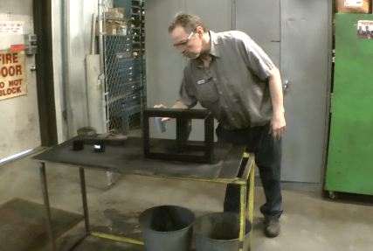
Cart Maintenance  (20% of total shift)  - Cart caster maintenance  - Grease caster with grease gun  - Remove caster with hand wrench and impact wrench  - Service caster bearings | 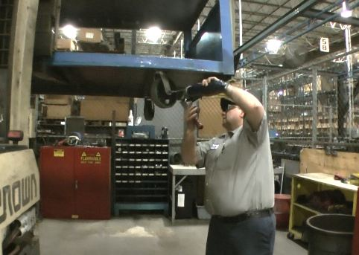 | 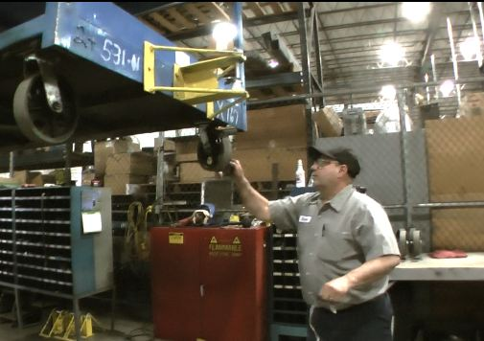
 | 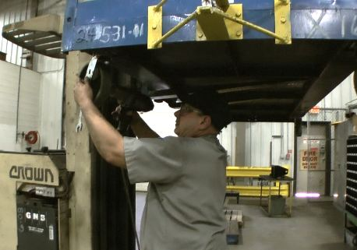 | 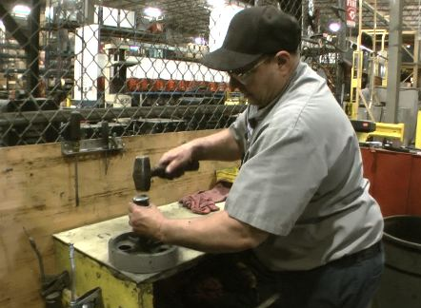
- Cart hitch maintenance  - Cut off old hitch with reciprocating saw  - Use sledge hammer to remove sawn off hitch  - Replace new hitch  - Secure with impact wrench |  | 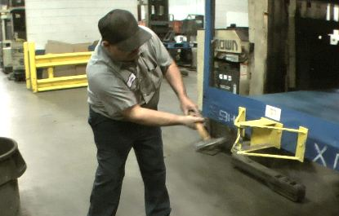
 | 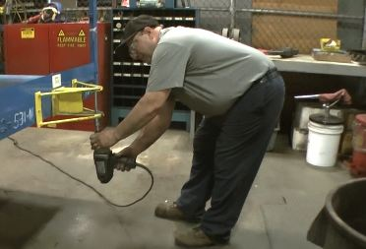
(10% of total shift)  General tasks  - Torch work / Brazing  - Arc Welding  - MIG welding  - Multi-meter use  - Painting  - Ceiling tile replacement | 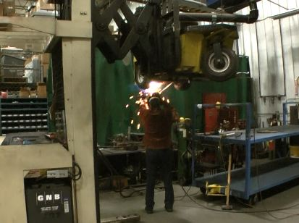 | 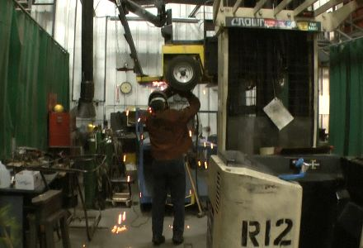
 | 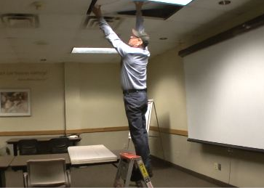
Misc. restroom repairs  - Valve kits  - Dispensing equipment  - Hardware  - Plugged closets, urinals, drains | 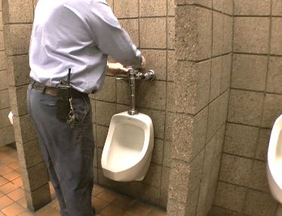
Dock levelers  - Cleaning and PM  - Component Replacement / Repair | 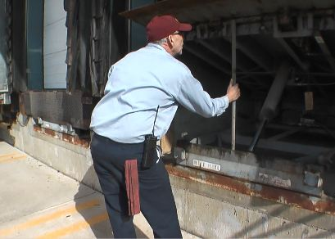 | 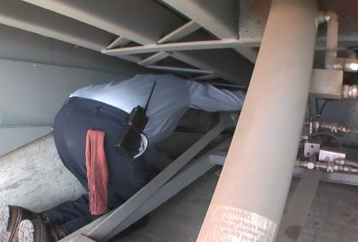
Dock doors  - Lubrication hinges, bearings, rollers  - Limited repairs, chains, rollers | 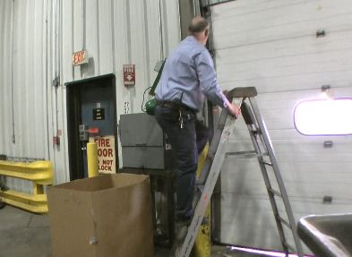 | 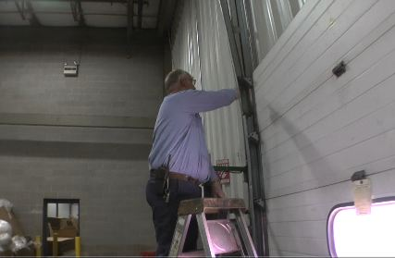
Dock locks  - PM, lubrication, cleaning  - General repairs | 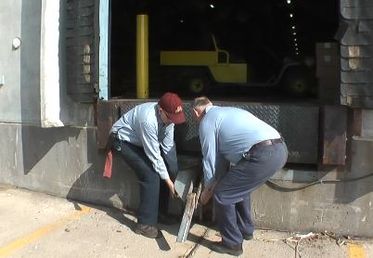

Physical Factors
Manual Material Handling
(lbs) | Floor-Knuckle (0” to 30”) |  |  |  |  |  | Knuckle-Chest (30” to 50’) |  |  |  |  |  | Chest-Overhead  ( > 50”) |  |  |  |  |  | Carry - Two Hands; Front |  |  |  |  |  | Carry - One Hand; Side |  |  |  |  |  | Push |  |  |  |  |  | Pull
100
75
50
25
15
10
5
0
Exp | N | R | O | F | C |  | N | R | O | F | C |  | N | R | O | F | C |  | N | R | O | F | C |  | N | R | O | F | C |  | N | R | O | F | C |  | N | R | O | F | C

Postures/Movements |  |  |  |  |  |  |  |  |  |  |  |  |  |  |  | Head/Neck
Exp | Sit | Stand | Walk | Bal | Stairs | Lad-der | Foot contrl | Twist Waist | Bend Waist | Squat | Kneel | Crawl | Reach below 54” | Reach above 54” |  | Flex Static | Ext Static | Rot Static | Flex Dyn | Ext Dyn | Rot Dyn
C
F
O
R
N

Hand Use |  |  |  |  | Sensory |  |  |  |  |  | Communication |  |  |  |  | Key C - Continuous: 67 to 100% of shift  F - Frequent: 34 to 66% of shift  O - Occasional: 6 to 33% of shift  R - Rarely: up to 5% of shift  N - Never: 0% of shift  Abbreviations: Bal=Balance, Exp=Exposure, Contrl=Control, Flex=Flexion, Ext=Extension, Dyn=Dynamic, Manip=Manipulation
Exp | Simple Grasp | Firm Grasp | Fine Manip | Bal | See | Hear | Touch Feel | Taste | Smell |  | Talk | Read | Write | Hand Signal
C
F
O
R
N

Environmental Factors | Exposure Level |  |  |  |  | Key/Comments
 | N | R | O | F | C
Outdoor Work |  |  |  |  |  | Key C - Continuous: 67 to 100% of shift  F - Frequent: 34 to 66% of shift  O - Occasional: 6 to 33% of shift  R - Rarely: up to 5% of shift  N - Never: 0% of shift  Comments:  Outdoor Work: Rarely will operate mechanical handling equipment outdoors.  Indoor Work: Primary work area is a large indoor warehouse complex.  Heat: Based on external temperature, occasionally performs job tasks in hot indoor environment; warehouse complex is not air-conditioned. Large fans are used for ventilation.  Moving Objects: Be aware of and avoid moving objects including equipment.  Protected Work Heights: May work at heights – fall protection is in place.
Indoor Work
Heat
Cold
Wet/ Humid
Hearing Protection
Vibration
Fumes/Gases/Odors
Dust
Moving Objects
Electrical
Chemical
Protected Work Heights
Unprotected Work Heights
Flying Debris
Lighting (Inadequate/Excessive)

Position eligible to be considered for temporary modification in conjunction with a Return to Work transitional duty program agreement: Yes
This Functional Job Description was completed through an on-site job analysis by a certified professional ergonomist/licensed physical therapist. It is for the purpose of identifying and quantifying the physical functional requirements of this job. The Functional Job Description should not be construed as a detailed description of all specific job duties and/or tools, equipment and materials that may be necessary or incidental to the performance of this job. Further consideration may be necessary when applying the standards to the injured population in the medical management process.
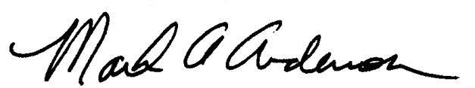 | 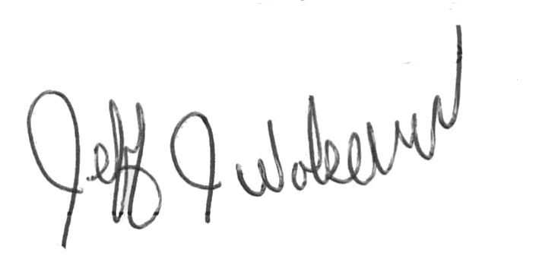  This Functional Job Description has been reviewed by company representatives and is believed to be an accurate representation of most of the job content.
Mark A Anderson, MA, PT CPE  Certified Professional Economist  Licensed Physical Therapist  ErgoSystems Consulting Group, Inc.  19285 Shady Hills Road  Minneapolis, MN 55331  952-401-9296  mark.anderson@ergosystemsconsulting.com  www.ergosystemsconsulting.com | _______________________________________
Jeff Wolseth
Manager - Occupational Safety and Health
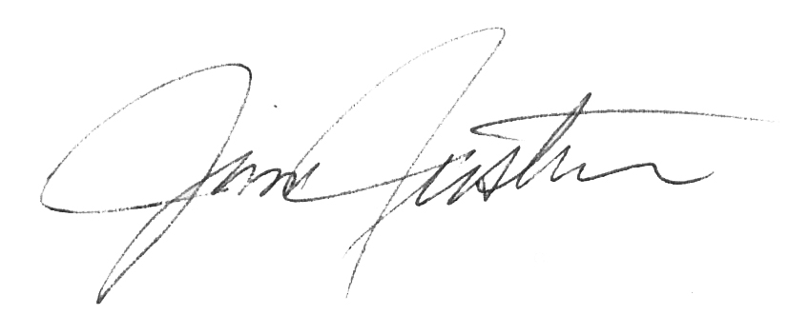
 | _______________________________________
Jim Justin
Manager - Facilities

