Functional Job Description:

Company: | Bluestem Brands, Inc. | 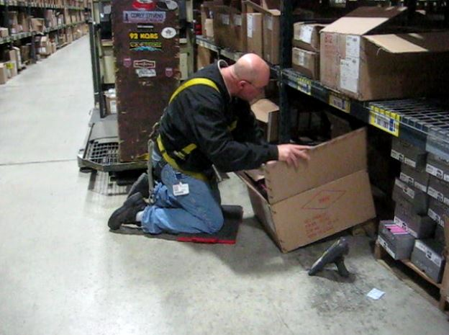 | 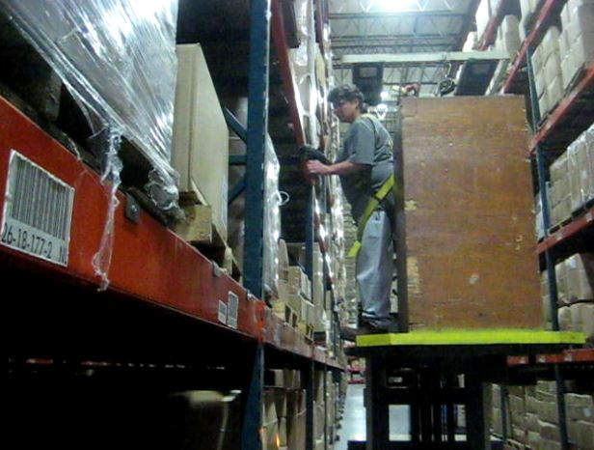
Job Title: | Inventory Specialist
Date: | 3-20-13
Dept/Facility: | West DC, St. Cloud, MN
Product Section: | Inventory Control
Electronic Doc. # | FJD Inventory Specialist 4-2013

Work Hours | Overtime: | Voluntary and/or mandatory per production requirements. | Breaks: | Straight 8 hours with 20 minute lunch break or 10 minutes/2 hours with one 30 minute lunch break
 | Shift: | Days of week: | Time:
 | First | Monday – Friday | 6:00 AM to 2:00 PM
 | Second | Sunday – Thursday | 3:00 PM to 11:00 PM

Job Rotation | Yes

Job Training or Credentials Required at Hire | Education/ training: | None required; high school diploma or GED preferred.
 | Knowledge/ cognitive skills: | Basic math, reading, writing and oral communication skills preferred. Ability to organize work tasks and work independently or as part of a team.

Machines, Tools, Equipment Used | EZ-GO, Stand-up Reach Truck, fall protection harness, Order Picker, PC, knife, handheld taper

Job Purpose/ Objectives | Control inventory.  Accomplished by pulling samples from inventory and counting to verify inventory.  Problem solve on-site as possible, also includes research as needed in the office to resolve the issue.  Will pull/pick product in Returns-CSOs as needed to control inventory.

Safety and Personal Protective Equipment Required  *Available | Hard Hat | Steel Toe Footwear | Safety Glasses | Gloves:
 | Face Shield | Protective Clothing | Safety Glasses/Side Shields | Leather
 | Dust Mask | Safety Vest  Fall Protection Harness  Back Support*  Kneeling pads | Safety Goggles  Hearing Protection*  Compensatory methods to mitigate heat | Rubberized/cloth*  Chemical

Safety/ Equipment Training/ Certification Required | Daily Meeting and Stretch Breaks (includes:) | Industrial Truck Training | OSHA Training (Rules and Regulations)
 | - Safety Topics | EZ-Go | New Hire Safety Orientation
 | - Safety Policies | Walkie-Rider | Right to Know
 | - Questions & Answers | Pallet Jack | Lockout/Tag Out
 | - Review Safety Committee Minutes | Forklift (sit down) | Regulated Materials Training (ORM-D)  Supervisor Safety Updates
 |  | Stand-up Reach Truck
 |  | Order Picker

Functional Job Elements (Refer to video clip for complete details) |  |  | % of Shift
- DC floor work:  - In the DC operates EZ-GO, Stand-up Reach Truck and Order Picker to accomplish job tasks.  - Goes to the area in DC where directed for Inventory Control  - May work from floor and off the Stand-up Reach Truck  - When working with Returns will work from the Order Picker/Cart  - Rack heights are pallets on the floor (5”), 33” and 66”.  - Cart shelf heights are 12” and 42”  - Depending where the item is located in the racking may need to work under the upper rack to gain access to merchandise  - Item weight ranges from 1# to 150#  - For items in excess of 75# can work in team of two  - Average item weight is 15#  - Handles between 500 to 1200 items/shift  - A knife is used to cut open the master carton to remove merchandise as needed to count items  - Reboxes items and returns master carton  - Processes Customer Service Orders (CSO), e.g. request for replacement parts  - Pull samples, box, prepare for shipping and transport to truck for shipping | 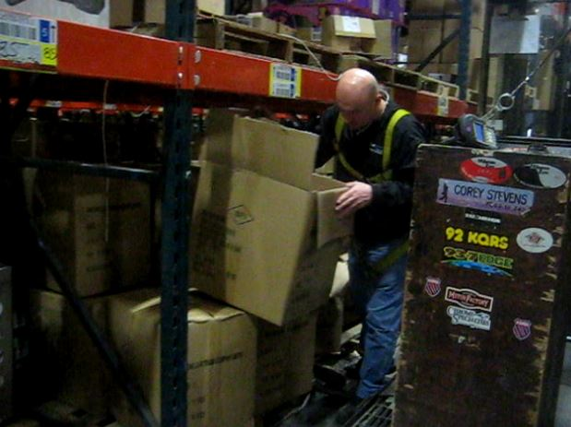 | 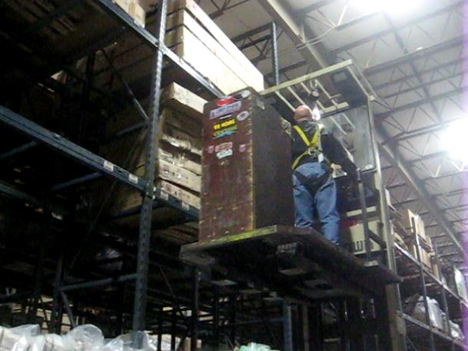 | 80
 | 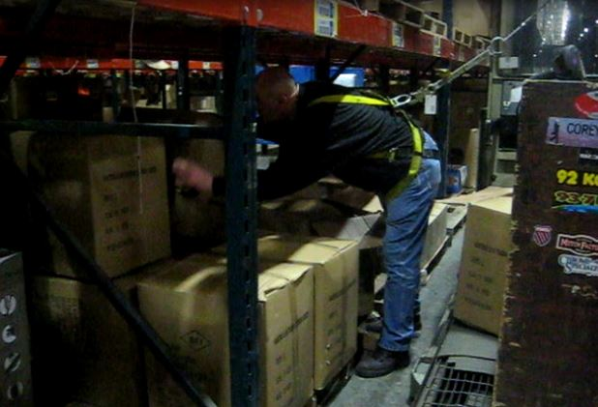
 | 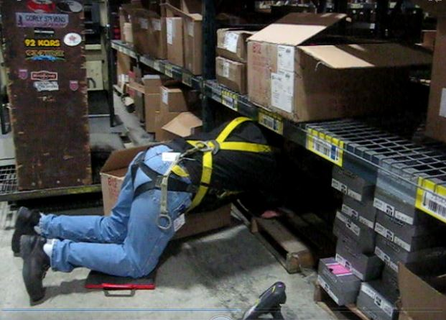 | 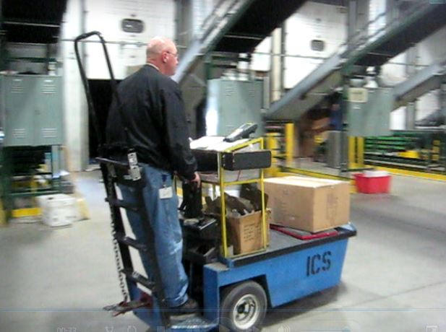
 | 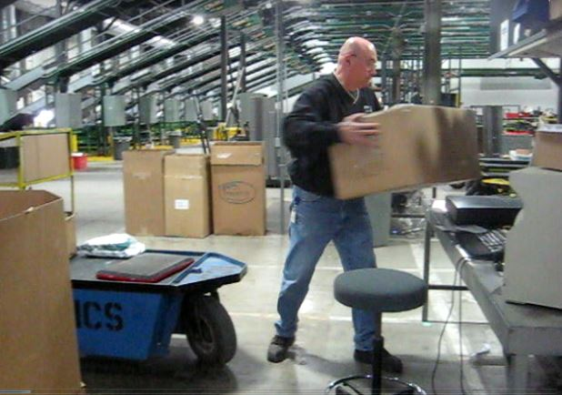 | 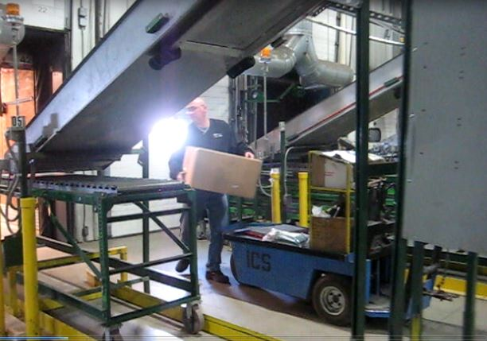
- Office work:  - Spends approximately20% of the time in the office  - Seated at the desk  - Operating PC  - Researching issues | 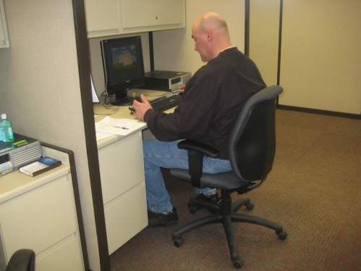 | 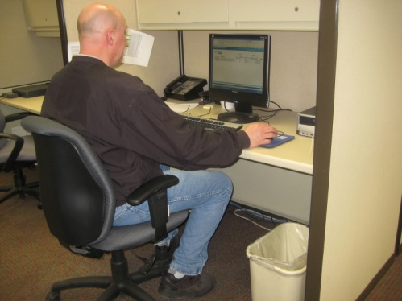 | 20

Physical Factors

Manual Material Handling
(lbs) | Floor-Knuckle (0” to 30”) |  |  |  |  |  | Knuckle-Chest (30” to 50”) |  |  |  |  |  | Chest-Overhead  ( > 50”) |  |  |  |  |  | Carry - Two Hands; Front |  |  |  |  |  | Carry - One Hand; Side |  |  |  |  |  | Push |  |  |  |  |  | Pull
100
75
50
25
15
10
5
0
Exp | N | R | O | F | C |  | N | R | O | F | C |  | N | R | O | F | C |  | N | R | O | F | C |  | N | R | O | F | C |  | N | R | O | F | C |  | N | R | O | F | C

Postures/Movements |  |  |  |  |  |  |  |  |  |  |  |  |  |  |  | Head/Neck
Exp | Sit | Stand | Walk | Bal | Stairs | Lad-der | Foot contrl | Twist Waist | Bend Waist | Squat | Kneel | Crawl | Reach below 54” | Reach above 54” |  | Flex Static | Ext Static | Rot Static | Flex Dyn | Ext Dyn | Rot Dyn
C
F
O
R
N

Hand Use |  |  |  |  | Sensory |  |  |  |  |  | Communication |  |  |  |  | Key C - Continuous: 67 to 100% of shift  F - Frequent: 34 to 66% of shift  O - Occasional: 6 to 33% of shift  R - Rarely: up to 5% of shift  N - Never: 0% of shift  Abbreviations: Bal=Balance, Exp=Exposure, Contrl=Control, Flex=Flexion, Ext=Extension, Dyn=Dynamic, Manip=Manipulation
Exp | Simple Grasp | Firm Grasp | Fine Manip | Bal | See | Hear | Touch Feel | Taste | Smell |  | Talk | Read | Write | Hand Signal
C
F
O
R
N

Environmental Factors | Exposure Level |  |  |  |  | Key/Comments
 | N | R | O | F | C
Outdoor Work |  |  |  |  |  | Key C - Continuous: 67 to 100% of shift  F - Frequent: 34 to 66% of shift  O - Occasional: 6 to 33% of shift  R - Rarely: up to 5% of shift  N - Never: 0% of shift  Comments:  Indoor Work: Primary work area is a large indoor warehouse complex.  Heat: Based on external temperature, occasionally performs job tasks in hot indoor environment; warehouse complex is not air-conditioned. Large fans are used for ventilation.  Moving Objects: Be aware of and avoid moving objects including equipment.  Protected Work Heights: May work at heights – fall protection is in place.
Indoor Work
Heat
Cold
Wet/ Humid
Hearing Protection
Vibration
Fumes/Gases/Orders
Dust
Moving Objects
Electrical
Chemical
Protected Work Heights
Unprotected Work Heights
Flying Debris
Lighting (Inadequate/Excessive)

Position eligible to be considered for temporary modification in conjunction with a Return to Work transitional duty program agreement: Yes
This Functional Job Description was completed through an on-site job analysis by a certified professional ergonomist/licensed physical therapist. It is for the purpose of identifying and quantifying the physical functional requirements of this job. The Functional Job Description should not be construed as a detailed description of all specific job duties and/or tools, equipment and materials that may be necessary or incidental to the performance of this job. Further consideration may be necessary when applying the standards to the injured population in the medical management process.
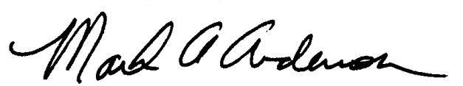 | 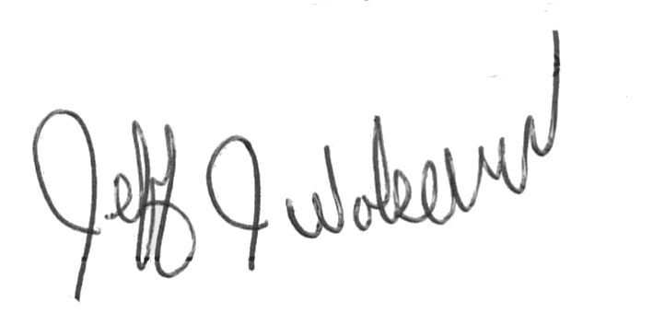  This Functional Job Description has been reviewed by company representatives and is believed to be an accurate representation of most of the job content.
Mark A Anderson, MA, PT CPE  Certified Professional Economist  Licensed Physical Therapist  ErgoSystems Consulting Group, Inc.  19285 Shady Hills Road  Minneapolis, MN 55331  952-401-9296  mark.anderson@ergosystemsconsulting.com  www.ergosystemsconsulting.com | _______________________________________
Jeff Wolseth
Manager - Occupational Safety and Health

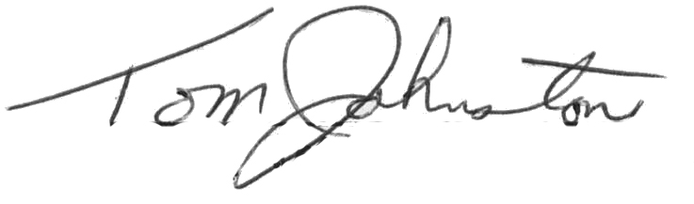
________________________________________
Tom Johnston
Manager – Inventory and Engineering

