Functional Job Description: Jewelry – Packer
Company: | Bluestem Brands, Inc. | 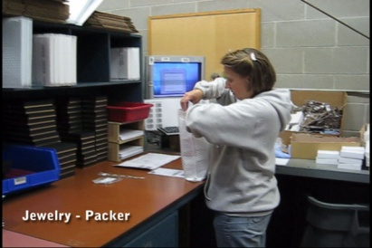 | 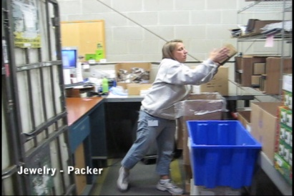
Job Title: | Jewelry – Packer
Date: | 5-5-2010
Dept/Facility: | West DC, St. Cloud, MN
Product Section: | Returns
Electronic Doc. # | FJD Jewelry-Packer 5-10 FINAL.pdf

Work Hours | Overtime: | Voluntary and/or mandatory per production requirements. | Breaks: | 10 minutes every two hours, one 30 minute lunch break.
 | Shift: | Days of week: | Time:
 | First | Monday-Friday | 6:00 AM to 2:30 PM

Job Rotation | Yes

Job Training or Credentials Required at Hire | Education/ training: | None required; high school diploma or GED preferred.
 | Knowledge/ cognitive skills: | Basic math, reading, writing and oral communication skills preferred. Ability to organize work tasks and work independently or as part of a team.

Machines, Tools and/or Equipment Used | Hand held scanner, hand taper, PC, pens, markers, knife, scissors, telephone, EZ-GO, pallet jack.

Job Purpose/ Objectives | Combines all merchandise and written materials into a package (padded shipping envelope) that is sent to the customer.

Safety and Personal Protective Equipment Required  *Available | Hard Hat | Steel Toe Footwear | Safety Glasses | Gloves:
 | Face Shield | Protective Clothing | Safety Glasses/Side Shields | Leather
 | Dust Mask* | Safety Vest  Fall Protection Harness  Back Support* | Safety Goggles  Hearing Protection*  Compensatory methods to mitigate heat | Rubberized/cloth*  Chemical

Safety/ Equipment Training/ Certification Required | Daily Meeting and Stretch Breaks (includes:) | Industrial Truck Training | OSHA Training (Rules and Regulations)
 | - Safety Topics | EZ-Go | New Hire Safety Orientation
 | - Safety Policies | Walkie-Rider | Right to Know
 | - Questions & Answers | Pallet Jack | Lockout/Tag Out
 | - Review Safety Committee Minutes | Forklift (sit down) | Regulated Materials Training (ORM-D)  Supervisor Safety Updates
 |  | Stand-up Reach Truck
Order Picker
Transpositioner

Functional Job Elements (Refer to video clip for complete details) |  |  | % of Shift
- Transport boxes into workstation  - Manually carry totes into the workstation | 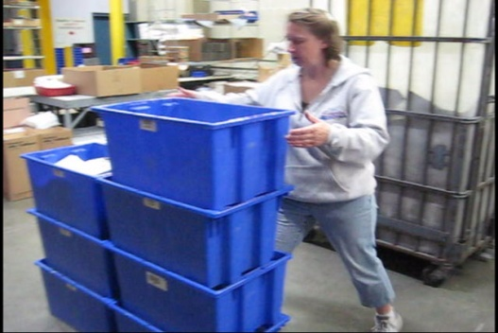 | 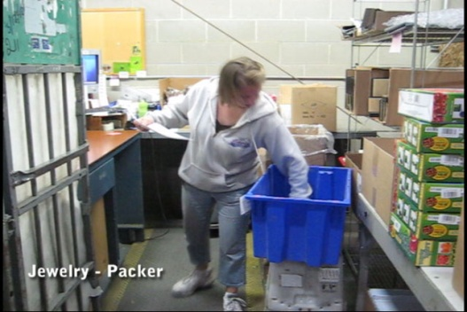 | 5
- Pack product  - Padded shipping envelope is removed from the storage shelf  - Product is inserted into the envelope  - Promotional materials are also inserted  - Paperwork is inserted  - Envelope is sealed by removing cover from the adhesive seal  - Sealed envelope is tossed into the wheeled shipping container  - Weight range of envelope is 0.25# to 2.0# with average weight of 0.75# | 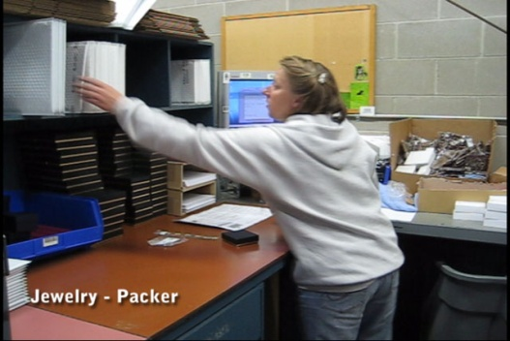 | 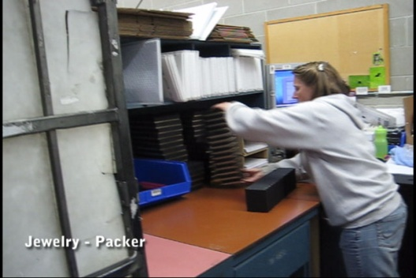 | 80
 | 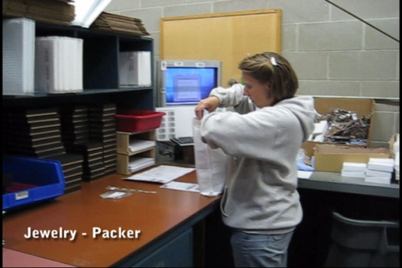 | 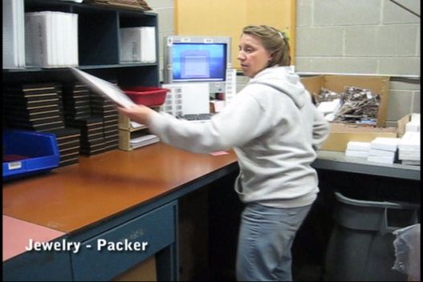
- Transport wheeled shipping container  - Wheeled shipping container is closed up via the side straps  - Container is manually pushed to the staging area  - Shipping container requires approximately up to 50# of push or pull force to move | 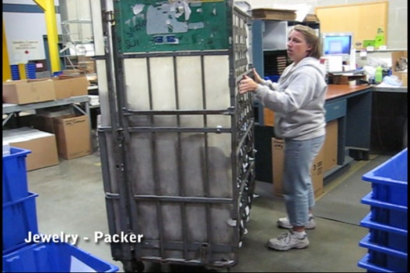 | 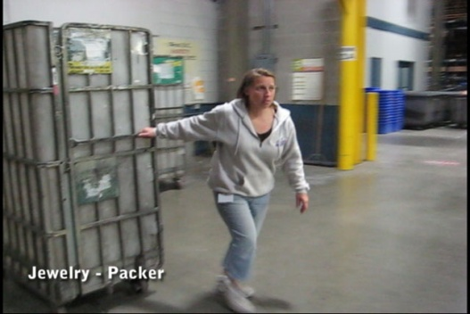 | 5
- Replenish packing and promotional materials  - Packing and promotional materials are manually carried from the storage area to the workstation  - Boxes are cut open with a knife  - Packing and promotional materials are removed from the box and stored in the appropriate locations in the workstation  - Weight range of boxes is 5# to 25# with average weight of 20#  - Empty blue totes are returned to the jewelry storage area by sliding them on the floor  - EZ-GO operation is also required | 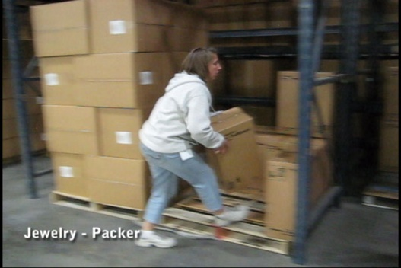 | 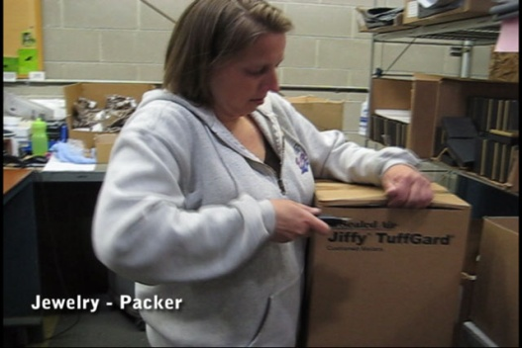 | 10
 | 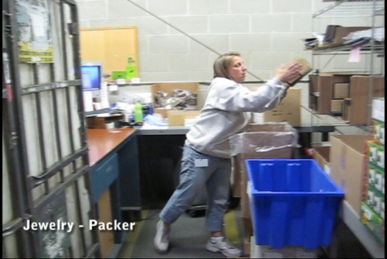 | 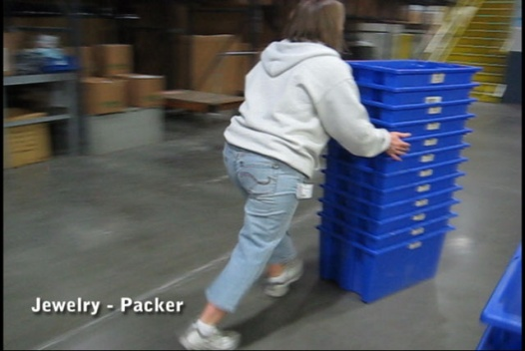
 | 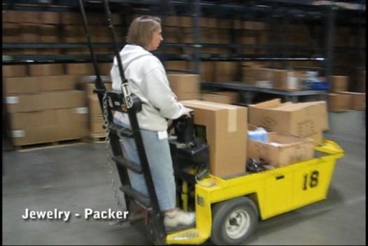

Physical Factors
Manual Material Handling
(lbs) | Floor-Knuckle (0” to 30”) |  |  |  |  |  | Knuckle-Chest (30” to 50’) |  |  |  |  |  | Chest-Overhead  ( > 50”) |  |  |  |  |  | Carry - Two Hands; Front |  |  |  |  |  | Carry - One Hand; Side |  |  |  |  |  | Push |  |  |  |  |  | Pull
100
75
50
25
15
10
5
0
Exp | N | R | O | F | C |  | N | R | O | F | C |  | N | R | O | F | C |  | N | R | O | F | C |  | N | R | O | F | C |  | N | R | O | F | C |  | N | R | O | F | C

 | N - Never  0% of shift |  | R - Rarely  up to 5% of shift |  | O - Occasional  6 to 33% of shift |  | F - Frequent  34 to 66% of shift |  | C - Continuous  67 to 100% of shift

Postures/Movements |  |  |  |  |  |  |  |  |  |  |  |  |  |  |  | Head/Neck
Exp | Sit | Stand | Walk | Bal | Stairs | Lad-der | Foot contrl | Twist Waist | Bend Waist | Squat | Kneel | Crawl | Reach below 54” | Reach above 54” |  | Flex Static | Ext Static | Rot Static | Flex Dyn | Ext Dyn | Rot Dyn
C
F
O
R
N

 | N - Never  0% of shift |  | R - Rarely  up to 5% of shift |  | O - Occasional  6 to 33% of shift |  | F - Frequent  34 to 66% of shift |  | C - Continuous  67 to 100% of shift

Hand Use |  |  |  |  | Sensory |  |  |  |  |  | Communication |  |  |  |  | Key C - Continuous: 67 to 100% of shift  F - Frequent: 34 to 66% of shift  O - Occasional: 6 to 33% of shift  R - Rarely: up to 5% of shift  N - Never: 0% of shift
Exp | Simple Grasp | Firm Grasp | Fine Manip | Bal | See | Hear | Touch Feel | Taste | Smell |  | Talk | Read | Write | Hand Signal
C
F
O
R
N

Environmental Factors | Exposure Level |  |  |  |  | Key/Comments
 | N | R | O | F | C
Outdoor Work |  |  |  |  |  | Key C - Continuous: 67 to 100% of shift  F - Frequent: 34 to 66% of shift  O - Occasional: 6 to 33% of shift  R - Rarely: up to 5% of shift  N - Never: 0% of shift  Comments:  Indoor Work: Primary work area is a large indoor warehouse complex.  Moving Objects: Be aware of and avoid moving objects including product and equipment.  Abbreviations: Bal=Bal, Exp=Exposure, Contrl=Control, Flex=Flexion, Ext=Extension, Dyn=Dynamic, Manip=Manipulation
Indoor Work
Heat
Wet/ Humid
Hearing Protection
Vibration
Fumes/Gases/Orders
Dust
Moving Objects
Electrical
Chemical
Protected Work Heights
Unprotected Work Heights
Flying Debris
Lighting (Inadequate/Excessive)
Position eligible to be considered for temporary modification in conjunction with a Return to Work transitional duty program agreement: Yes
This Functional Job Description was completed through an on-site job analysis by a certified professional ergonomist/licensed physical therapist. It is for the purpose of identifying and quantifying the physical functional requirements of this job. The Functional Job Description should not be construed as a detailed description of all specific job duties and/or tools, equipment and materials that may be necessary or incidental to the performance of this job. Further consideration may be necessary when applying the standards to the injured population in the medical management process.
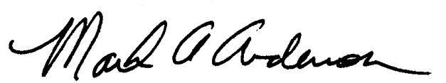 | 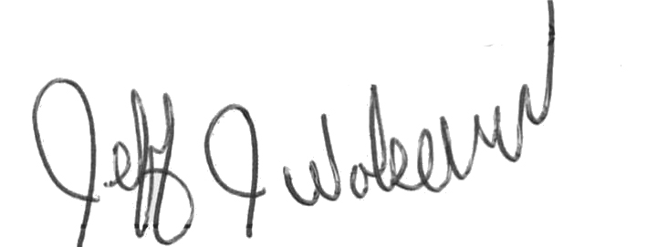  This Functional Job Description has been reviewed by company representatives and is believed to be an accurate representation of most of the job content.
Mark A Anderson, MA, PT CPE  Certified Professional Economist  Licensed Physical Therapist  ErgoSystems Consulting Group, Inc.  19285 Shady Hills Road  Minneapolis, MN 55331  952-401-9296  mark.anderson@ergosystemsconsulting.com  www.ergosystemsconsulting.com | _______________________________________
Jeff Wolseth
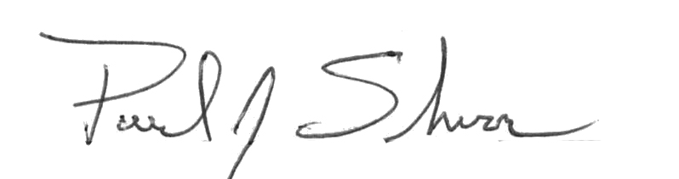
Manager - Occupational Safety and Health

 | _____________________________________
Paul Schroer
Manager - Inbound Operations

