Functional Job Description: Jewelry – Picker
Company: | Bluestem Brands, Inc. | 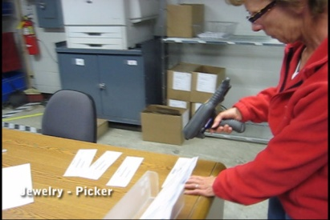 | 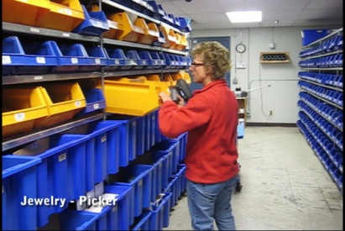
Job Title: | Jewelry – Picker
Date: | 5-5-2010
Dept/Facility: | West DC, St. Cloud, MN
Product Section: | Returns
Electronic Doc. # | FJD Jewelry-Picker 5-10 FINAL.pdf

Work Hours | Overtime: | Voluntary and/or mandatory per production requirements. | Breaks: | 10 minutes every two hours, one 30 minute lunch break.
 | Shift: | Days of week: | Time:
 | First | Monday-Friday | 6:00 AM to 2:30 PM

Job Rotation | Yes

Job Training or Credentials Required at Hire | Education/ training: | None required; high school diploma or GED preferred.
 | Knowledge/ cognitive skills: | Basic math, reading, writing and oral communication skills preferred. Ability to organize work tasks and work independently or as part of a team.

Machines, Tools and/or Equipment Used | Hand held scanner, hand taper, PC, pens, markers, knife, scissors, telephone, EZ-GO, pallet jack.

Job Purpose/ Objectives | Working from a pick list (handheld scanner), pick merchandise from storage racks in the jewelry area.

Safety and Personal Protective Equipment Required  *Available | Hard Hat | Steel Toe Footwear | Safety Glasses | Gloves:
 | Face Shield | Protective Clothing | Safety Glasses/Side Shields | Leather
 | Dust Mask* | Safety Vest  Fall Protection Harness  Back Support* | Safety Goggles  Hearing Protection*  Compensatory methods to mitigate heat | Rubberized/cloth*  Chemical

Safety/ Equipment Training/ Certification Required | Daily Meeting and Stretch Breaks (includes:) | Industrial Truck Training | OSHA Training (Rules and Regulations)
 | - Safety Topics | EZ-Go | New Hire Safety Orientation
 | - Safety Policies | Walkie-Rider | Right to Know
 | - Questions & Answers | Pallet Jack | Lockout/Tag Out
 | - Review Safety Committee Minutes | Forklift (sit down) | Regulated Materials Training (ORM-D)  Supervisor Safety Updates
 |  | Stand-up Reach Truck
Order Picker
Transpositioner

Functional Job Elements (Refer to video clip for complete details) |  |  | % of Shift
- Process pick order  - Pick order paperwork is removed from the printer  - Paperwork is processed using the hand-held scanner and sorted into the appropriate pick order based on product location in the shelving | 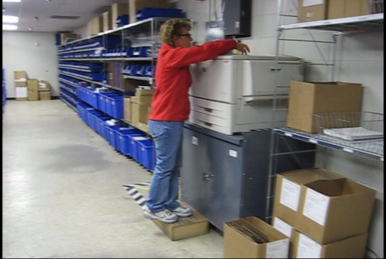 | 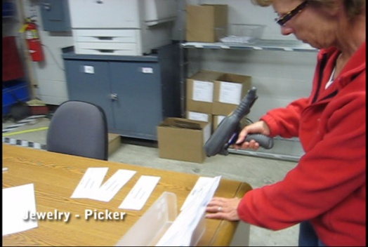 | 10
- Pick order  - Order is picked from the shelving  - Depending on the quantity of the materials picked they are handled either manually or placed into a tote transported via the cart  - Handheld scanner is used for each item picked  - Weight range of product is 0.25# to 2.0# with average weight of 0.75#  - Weight range of tote is 5# to 30# with average weight of 12# | 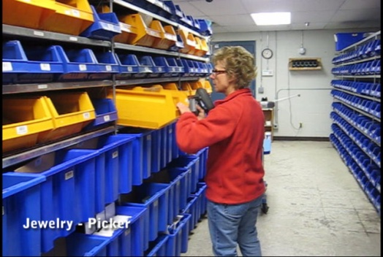 | 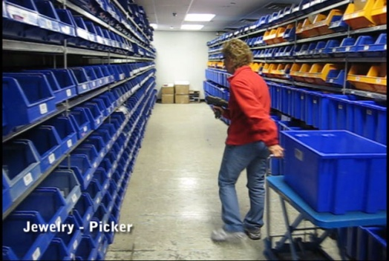 | 80
 | 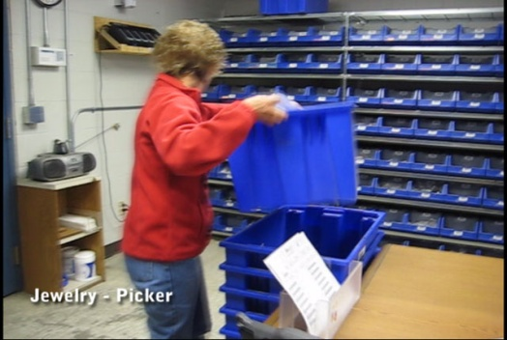 | 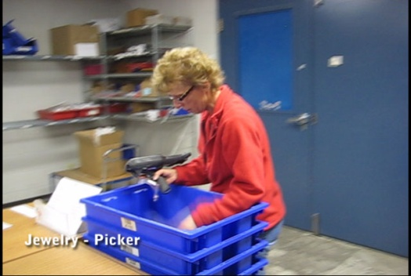
- Transport picked order totes to Packing  - Picked order totes are stacked by the jewelry area door  - stacks for totes are transported to the packing area by sliding them on the floor-distance transported is approximately 50 feet  - Weight range of tote is 5# to 30# with average weight of 12# | 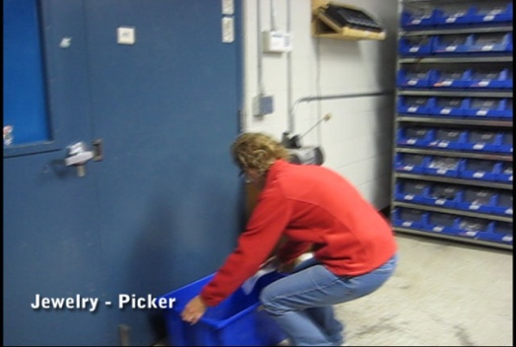 | 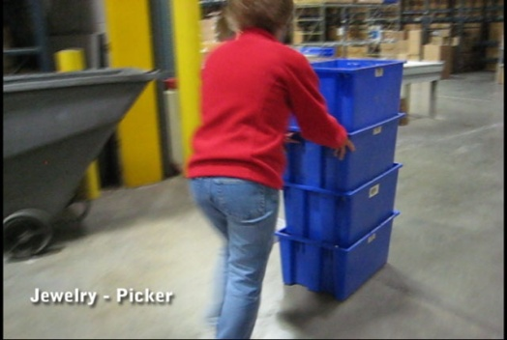 | 10

Physical Factors
Manual Material Handling
(lbs) | Floor-Knuckle (0” to 30”) |  |  |  |  |  | Knuckle-Chest (30” to 50’) |  |  |  |  |  | Chest-Overhead  ( > 50”) |  |  |  |  |  | Carry - Two Hands; Front |  |  |  |  |  | Carry - One Hand; Side |  |  |  |  |  | Push |  |  |  |  |  | Pull
100
75
50
25
15
10
5
0
Exp | N | R | O | F | C |  | N | R | O | F | C |  | N | R | O | F | C |  | N | R | O | F | C |  | N | R | O | F | C |  | N | R | O | F | C |  | N | R | O | F | C

 | N - Never  0% of shift |  | R - Rarely  up to 5% of shift |  | O - Occasional  6 to 33% of shift |  | F - Frequent  34 to 66% of shift |  | C - Continuous  67 to 100% of shift

Postures/Movements |  |  |  |  |  |  |  |  |  |  |  |  |  |  |  | Head/Neck
Exp | Sit | Stand | Walk | Bal | Stairs | Lad-der | Foot contrl | Twist Waist | Bend Waist | Squat | Kneel | Crawl | Reach below 54” | Reach above 54” |  | Flex Static | Ext Static | Rot Static | Flex Dyn | Ext Dyn | Rot Dyn
C
F
O
R
N

 | N - Never  0% of shift |  | R - Rarely  up to 5% of shift |  | O - Occasional  6 to 33% of shift |  | F - Frequent  34 to 66% of shift |  | C - Continuous  67 to 100% of shift

Hand Use |  |  |  |  | Sensory |  |  |  |  |  | Communication |  |  |  |  | Key C - Continuous: 67 to 100% of shift  F - Frequent: 34 to 66% of shift  O - Occasional: 6 to 33% of shift  R - Rarely: up to 5% of shift  N - Never: 0% of shift
Exp | Simple Grasp | Firm Grasp | Fine Manip | Bal | See | Hear | Touch Feel | Taste | Smell |  | Talk | Read | Write | Hand Signal
C
F
O
R
N

Environmental Factors | Exposure Level |  |  |  |  | Key/Comments
 | N | R | O | F | C
Outdoor Work |  |  |  |  |  | Key C - Continuous: 67 to 100% of shift  F - Frequent: 34 to 66% of shift  O - Occasional: 6 to 33% of shift  R - Rarely: up to 5% of shift  N - Never: 0% of shift  Comments:  Indoor Work: Primary work area is a large indoor warehouse complex.  Moving Objects: Be aware of and avoid moving objects including product and equipment.  Abbreviations: Bal=Bal, Exp=Exposure, Contrl=Control, Flex=Flexion, Ext=Extension, Dyn=Dynamic, Manip=Manipulation
Indoor Work
Heat
Wet/ Humid
Hearing Protection
Vibration
Fumes/Gases/Orders
Dust
Moving Objects
Electrical
Chemical
Protected Work Heights
Unprotected Work Heights
Flying Debris
Lighting (Inadequate/Excessive)

Position eligible to be considered for temporary modification in conjunction with a Return to Work transitional duty program agreement: Yes
This Functional Job Description was completed through an on-site job analysis by a certified professional ergonomist/licensed physical therapist. It is for the purpose of identifying and quantifying the physical functional requirements of this job. The Functional Job Description should not be construed as a detailed description of all specific job duties and/or tools, equipment and materials that may be necessary or incidental to the performance of this job. Further consideration may be necessary when applying the standards to the injured population in the medical management process.

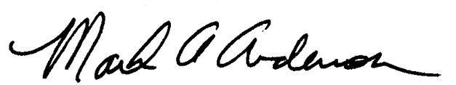 | 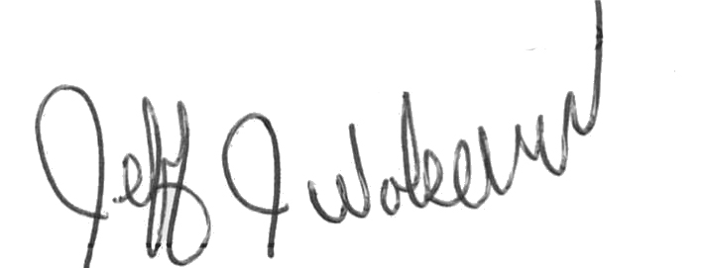  This Functional Job Description has been reviewed by company representatives and is believed to be an accurate representation of most of the job content.
Mark A Anderson, MA, PT CPE  Certified Professional Economist  Licensed Physical Therapist  ErgoSystems Consulting Group, Inc.  19285 Shady Hills Road  Minneapolis, MN 55331  952-401-9296  mark.anderson@ergosystemsconsulting.com  www.ergosystemsconsulting.com | _______________________________________
Jeff Wolseth
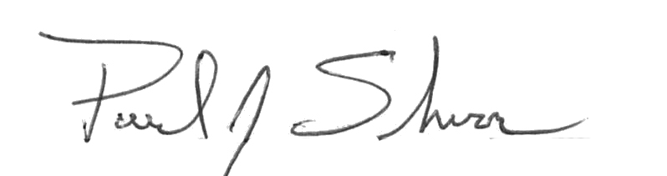
Manager - Occupational Safety and Health

 | _____________________________________
Paul Schroer
Manager - Inbound Operations

