Functional Job Description: Jewelry – Receiving/Replenishment

Company: | Bluestem Brands, Inc. | 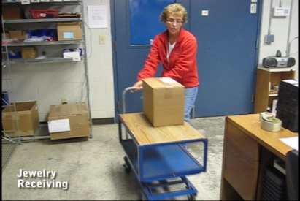 | 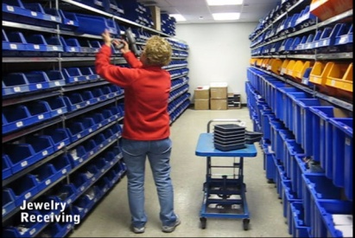
Job Title: | Jewelry – Receiving and Replenishment
Date: | 5-5-2010
Dept/Facility: | West DC, St. Cloud, MN
Product Section: | Returns
Electronic Doc. # | FJD Jewelry-Receiving Replenishment 5-10 FINAL.pdf

Work Hours | Overtime: | Voluntary and/or mandatory per production requirements. | Breaks: | 10 minutes every two hours, one 30 minute lunch break.
 | Shift: | Days of week: | Time:
 | First | Monday-Friday | 6:00 AM to 2:30 PM

Job Rotation | Yes

Job Training or Credentials Required at Hire | Education/ training: | None required; high school diploma or GED preferred.
 | Knowledge/ cognitive skills: | Basic math, reading, writing and oral communication skills preferred. Ability to organize work tasks and work independently or as part of a team.

Machines, Tools and/or Equipment Used | Hand held scanner, hand taper, PC, pens, markers, knife, scissors, telephone, EZ-GO, pallet jack.

Job Purpose/ Objectives | Receive jewelry products. Includes processing of received inventory and physical disposition into storage shelving in the jewelry area. Replenishes jewelry products into the jewelry area from the jewelry vault.

Safety and Personal Protective Equipment Required  *Available | Hard Hat | Steel Toe Footwear | Safety Glasses | Gloves:
 | Face Shield | Protective Clothing | Safety Glasses/Side Shields | Leather
 | Dust Mask* | Safety Vest  Fall Protection Harness  Back Support* | Safety Goggles  Hearing Protection*  Compensatory methods to mitigate heat | Rubberized/cloth*  Chemical

Safety/ Equipment Training/ Certification Required | Daily Meeting and Stretch Breaks (includes:) | Industrial Truck Training | OSHA Training (Rules and Regulations)
 | - Safety Topics | EZ-Go | New Hire Safety Orientation
 | - Safety Policies | Walkie-Rider | Right to Know
 | - Questions & Answers | Pallet Jack | Lockout/Tag Out
 | - Review Safety Committee Minutes | Forklift (sit down) | Regulated Materials Training (ORM-D)  Supervisor Safety Updates
 |  | Stand-up Reach Truck
Order Picker
Transpositioner

Functional Job Elements (Refer to video clip for complete details) |  |  | % of Shift
- Transport boxes from shelving to workstation  - Depending on weight of the box, it may be carried manually from the shelving to the workstation or placed on the cart for transport  - Weight range of box is 5# to 50# with average weight of 15# | 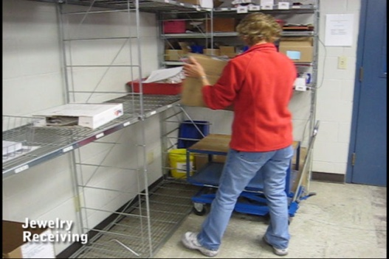 | 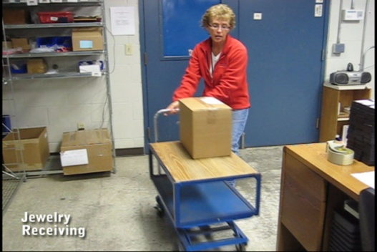 | 5
- Open box and process contents  - Knife is used to open the box  - Computer is used to process paperwork  - Visual inspection of the product is accomplished  - Handheld scanners is used | 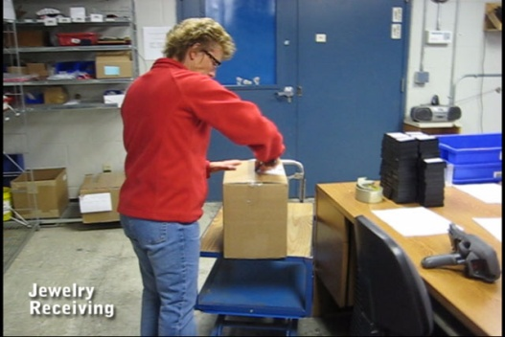 | 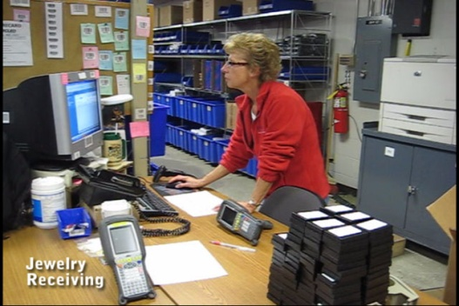 | 70
 | 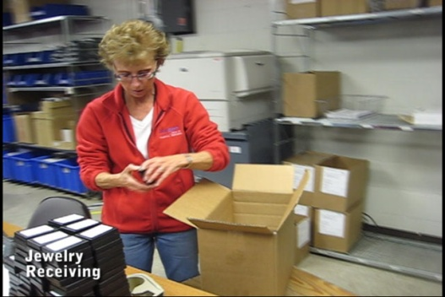 | 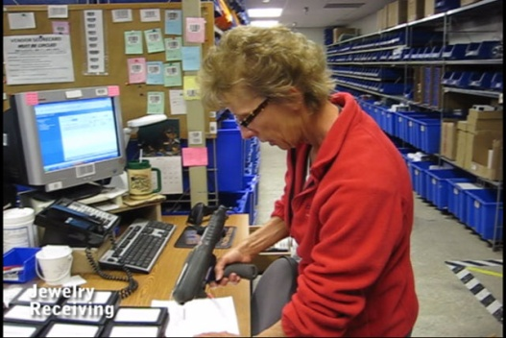
- Transport processed product to shelving  - Appropriate product tote is identified on the shelving and brought back to the workstation  - Processed product is transported via the tote to the appropriate shelf location - may be manually carried or transported via the cart  - Tote with product is manually returned to the appropriate shelf  - Weight range of tote is 5# to 50# with average weight of 15#  - Shelf height ranges from below knees to overhead position | 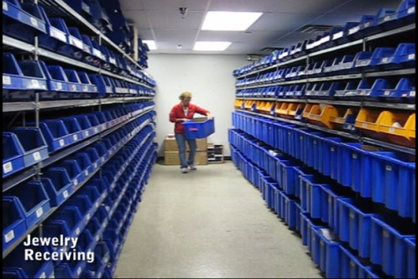 | 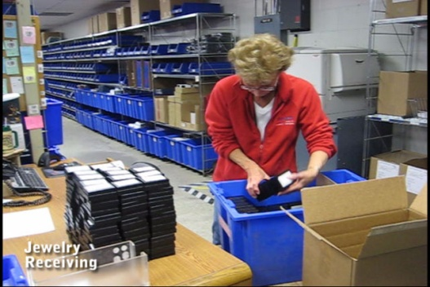 | 20
 | 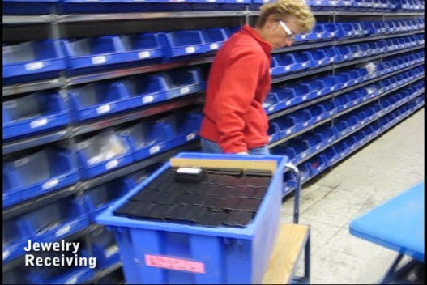 | 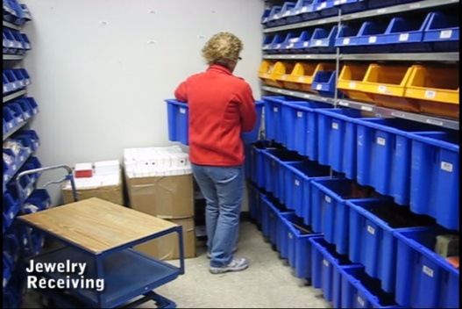
- Replenishment  - Overflow product that has been stored in the jewelry vault is brought to the jewelry area via EZ-GO  - Depending on weight of the box it is either manually carried or transported via cart into the jewelry area  - Jewelry products are removed from the box and transferred into the shelf storage totes  - Weight range of box is 5# to 50# with average weight of 15#  - Shelf height ranges from below knees to overhead position | 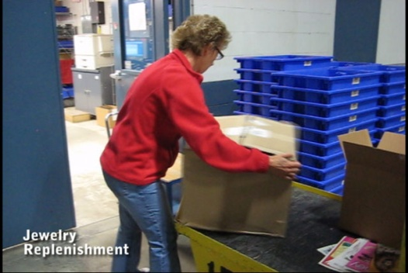 | 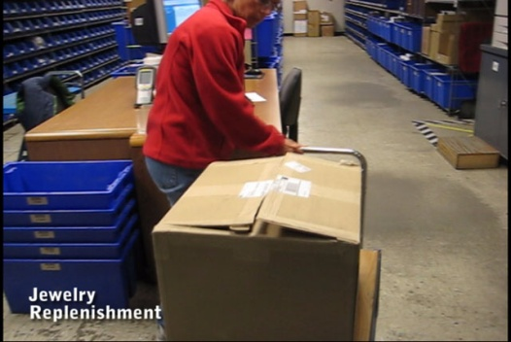 | 5

Physical Factors
Manual Material Handling
(lbs) | Floor-Knuckle (0” to 30”) |  |  |  |  |  | Knuckle-Chest (30” to 50’) |  |  |  |  |  | Chest-Overhead  ( > 50”) |  |  |  |  |  | Carry - Two Hands; Front |  |  |  |  |  | Carry - One Hand; Side |  |  |  |  |  | Push |  |  |  |  |  | Pull
100
75
50
25
15
10
5
0
Exp | N | R | O | F | C |  | N | R | O | F | C |  | N | R | O | F | C |  | N | R | O | F | C |  | N | R | O | F | C |  | N | R | O | F | C |  | N | R | O | F | C

 | N - Never  0% of shift |  | R - Rarely  up to 5% of shift |  | O - Occasional  6 to 33% of shift |  | F - Frequent  34 to 66% of shift |  | C - Continuous  67 to 100% of shift

Postures/Movements |  |  |  |  |  |  |  |  |  |  |  |  |  |  |  | Head/Neck
Exp | Sit | Stand | Walk | Bal | Stairs | Lad-der | Foot contrl | Twist Waist | Bend Waist | Squat | Kneel | Crawl | Reach below 54” | Reach above 54” |  | Flex Static | Ext Static | Rot Static | Flex Dyn | Ext Dyn | Rot Dyn
C
F
O
R
N

 | N - Never  0% of shift |  | R - Rarely  up to 5% of shift |  | O - Occasional  6 to 33% of shift |  | F - Frequent  34 to 66% of shift |  | C - Continuous  67 to 100% of shift

Hand Use |  |  |  |  | Sensory |  |  |  |  |  | Communication |  |  |  |  | Key C - Continuous: 67 to 100% of shift  F - Frequent: 34 to 66% of shift  O - Occasional: 6 to 33% of shift  R - Rarely: up to 5% of shift  N - Never: 0% of shift
Exp | Simple Grasp | Firm Grasp | Fine Manip | Bal | See | Hear | Touch Feel | Taste | Smell |  | Talk | Read | Write | Hand Signal
C
F
O
R
N

Environmental Factors | Exposure Level |  |  |  |  | Key/Comments
 | N | R | O | F | C
Outdoor Work |  |  |  |  |  | Key C - Continuous: 67 to 100% of shift  F - Frequent: 34 to 66% of shift  O - Occasional: 6 to 33% of shift  R - Rarely: up to 5% of shift  N - Never: 0% of shift  Comments:  Indoor Work: Primary work area is a large indoor warehouse complex.  Moving Objects: Be aware of and avoid moving objects including product and equipment.  Abbreviations: Bal=Bal, Exp=Exposure, Contrl=Control, Flex=Flexion, Ext=Extension, Dyn=Dynamic, Manip=Manipulation
Indoor Work
Heat
Wet/ Humid
Hearing Protection
Vibration
Fumes/Gases/Orders
Dust
Moving Objects
Electrical
Chemical
Protected Work Heights
Unprotected Work Heights
Flying Debris
Lighting (Inadequate/Excessive)
Position eligible to be considered for temporary modification in conjunction with a Return to Work transitional duty program agreement: Yes
This Functional Job Description was completed through an on-site job analysis by a certified professional ergonomist/licensed physical therapist. It is for the purpose of identifying and quantifying the physical functional requirements of this job. The Functional Job Description should not be construed as a detailed description of all specific job duties and/or tools, equipment and materials that may be necessary or incidental to the performance of this job. Further consideration may be necessary when applying the standards to the injured population in the medical management process.
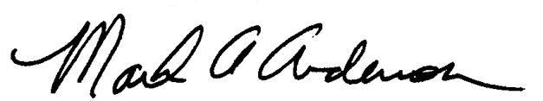 | 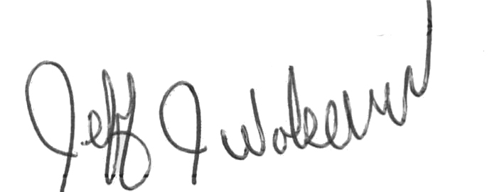  This Functional Job Description has been reviewed by company representatives and is believed to be an accurate representation of most of the job content.
Mark A Anderson, MA, PT CPE  Certified Professional Economist  Licensed Physical Therapist  ErgoSystems Consulting Group, Inc.  19285 Shady Hills Road  Minneapolis, MN 55331  952-401-9296  mark.anderson@ergosystemsconsulting.com  www.ergosystemsconsulting.com | _______________________________________
Jeff Wolseth
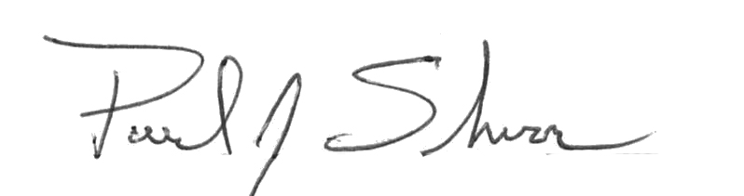
Manager - Occupational Safety and Health

 | _____________________________________
Paul Schroer
Manager - Inbound Operations

