Functional Job Description: Material Handler - Inbound

Company: | Bluestem Brands, Inc. | 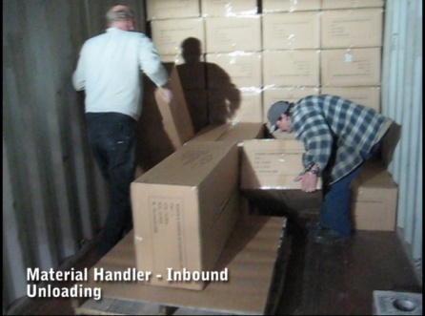
Job Title: | Material Handler - Inbound
Date: | 3-16-2010
Dept/Facility: | West DC, St. Cloud, MN
Product Section: | Inbound
Electronic Doc. # | JFD Material Handler – Inbound 3-2010 FINAL

Work Hours | Overtime: | Voluntary and/or mandatory per production requirements. | Breaks: | 10 minutes every two hours, one 30 minute lunch break.
 | Shift: | Days of week: | Time:
 | First | Monday-Friday | 7:00 AM to 3:30 PM
 | Second | Monday-Friday | 4:00 PM to 12:30 AM

Job Rotation | Yes

Job Training or Credentials Required at Hire | Education/ training: | None required; high school diploma or GED preferred.
 | Knowledge/ cognitive skills: | Basic math, reading, writing and oral communication skills preferred. Ability to organize work tasks and work independently or as part of a team.

Machines, Tools and/or Equipment Used | Hand held scanner, hand taper, PC, pens, markers, knife, twine, scissors, telephone, EZ-GO, Walkie-Rider.

Job Purpose/ Objectives | Handle inbound materials including: 1.) Unloading, 2.) Sorting, 3.) Processing, 4.) Pallet Shuttle, and 5.) Put Away

Safety and Personal Protective Equipment Required  *Available | Hard Hat | Steel Toe Footwear | Safety Glasses | Gloves:
 | Face Shield | Protective Clothing | Safety Glasses/Side Shields | Leather
 | Dust Mask* | Safety Vest  Fall Protection Harness  Back Support* | Safety Goggles  Hearing Protection*  Compensatory methods to mitigate heat | Rubberized/cloth*  Chemical

Safety/ Equipment Training/ Certification Required | Daily Meeting and Stretch Breaks (includes:) | Industrial Truck Training | OSHA Training (Rules and Regulations)
 | - Safety Topics | EZ-Go | New Hire Safety Orientation
 | - Safety Policies | Walkie-Rider | Right to Know
 | - Questions & Answers | Pallet Jack | Lockout/Tag Out
 | - Review Safety Committee Minutes | Forklift (sit down) | Regulated Materials Training (ORM-D)  Supervisor Safety Updates
 |  | Stand-up Reach Truck
Order Picker
Transpositioner

Functional Job Elements (Refer to video clip for complete details)
NOTE: Manual Material Handling Functional Job Elements are different for the various components of the Material Handler–Inbound job description. They are categorized by 1.) Truck Unloading, 2.) Processing and Sorting and 3.) Pallet Shuttle and Put Away.

Truck Unloading
Unload truck  - The Industrial Truck Operator (ITO) uses a fork truck to bring a stack of pallets (typically 4 to 5) into the trailer or cargo container  - The Material Handlers – Inbound, typically working in a team of two, manual move the materials onto the pallet  - The materials are secured by tying twine around the stacked load  - Manual material working height range is from the floor to overhead level  - Box or step platform may be used to stand on to reach to the overhead levels  - Weight maximum is up to 150#; for weights greater than75# a team lift is used  - Average weight is 50# | 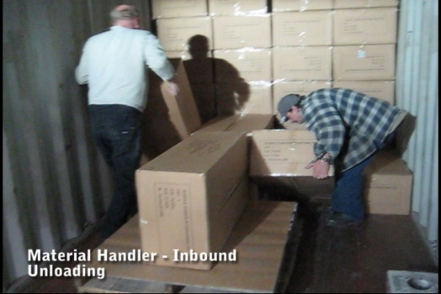 | 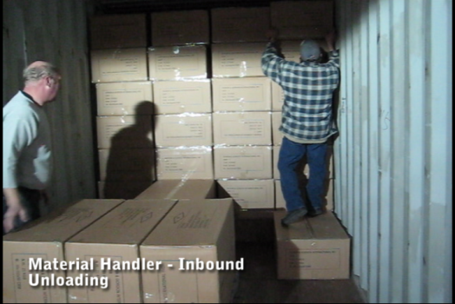 | % of Shift
 |  |  | XX
 | 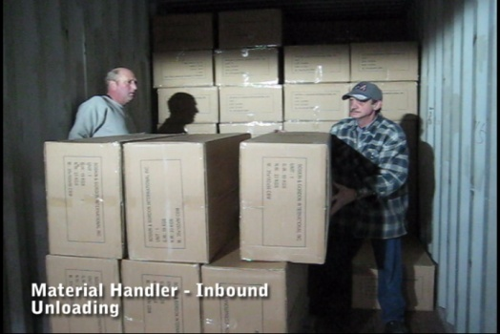 | 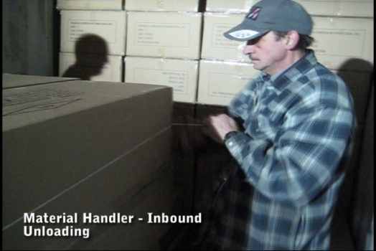

Manual Material Handling
(lbs) | Floor-Knuckle (0” to 30”) |  |  |  |  |  | Knuckle-Chest (30” to 50’) |  |  |  |  |  | Chest-Overhead  ( > 50”) |  |  |  |  |  | Carry - Two Hands; Front |  |  |  |  |  | Carry - One Hand; Side |  |  |  |  |  | Push |  |  |  |  |  | Pull
100
75
50
25
15
10
5
0
Exp | N | R | O | F | C |  | N | R | O | F | C |  | N | R | O | F | C |  | N | R | O | F | C |  | N | R | O | F | C |  | N | R | O | F | C |  | N | R | O | F | C

 | N - Never  0% of shift |  | R - Rarely  up to 5% of shift |  | O - Occasional  6 to 33% of shift |  | F - Frequent  34 to 66% of shift |  | C - Continuous  67 to 100% of shift

Sorting and Processing
Sort and Process  - Once unloaded the Sorting and Processing components of the Material Handler – Inbound position are performed  - A pallet may include several different products (SKUs) and need to be processed into the system and sorted onto pallets for eventual put away in the racking  - Pallets are laid out on the floor  - Product is sorted onto the various pallets  - Work height is from pallet level (6”) to overhead  - Weight range of the product is up to XX#  - Average weight of the product handled is XX#  - The product stacked on the pallet is secured by tying twine around the stack  - A handheld scanner is used | 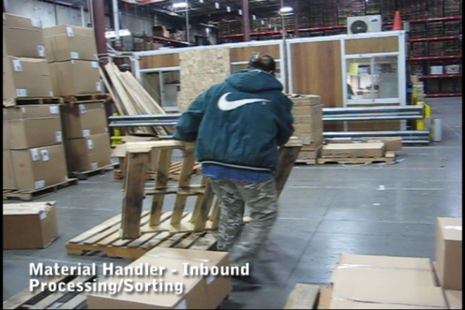 | 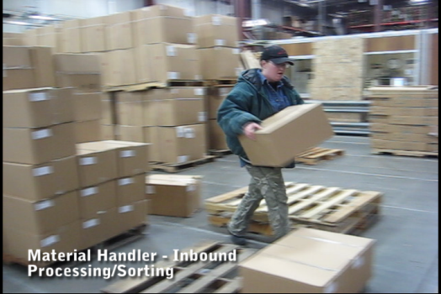 | % of Shift
 |  |  | XX
 | 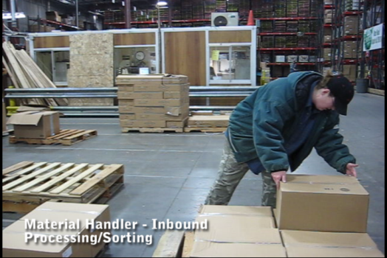
 | 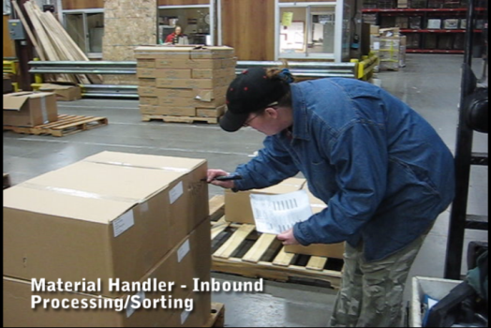 | 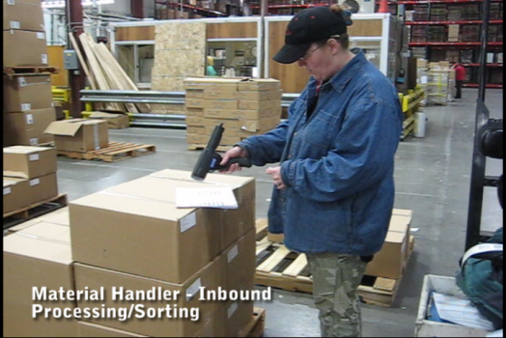

Manual Material Handling
(lbs) | Floor-Knuckle (0” to 30”) |  |  |  |  |  | Knuckle-Chest (30” to 50’) |  |  |  |  |  | Chest-Overhead  ( > 50”) |  |  |  |  |  | Carry - Two Hands; Front |  |  |  |  |  | Carry - One Hand; Side |  |  |  |  |  | Push |  |  |  |  |  | Pull
100
75
50
25
15
10
5
0
Exp | N | R | O | F | C |  | N | R | O | F | C |  | N | R | O | F | C |  | N | R | O | F | C |  | N | R | O | F | C |  | N | R | O | F | C |  | N | R | O | F | C

 | N - Never  0% of shift |  | R - Rarely  up to 5% of shift |  | O - Occasional  6 to 33% of shift |  | F - Frequent  34 to 66% of shift |  | C - Continuous  67 to 100% of shift

Pallet Shuttle and Put Away
Sort and Process  - The palletized materials are shuttled via powered pallet jack to the storage racking location in the warehouse.  - If needed, manual material handling occurs to organize (fill in and put away) the materials  - Weight range is up to XX# with average weight of XX# | 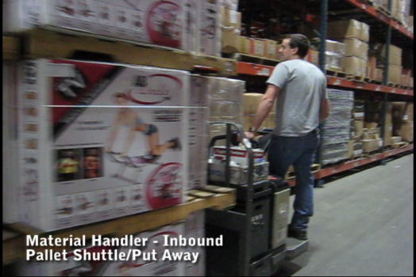 | 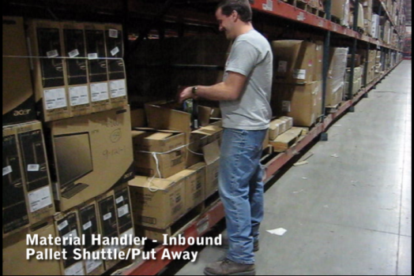 | % of Shift
 |  |  | XX

Manual Material Handling
(lbs) | Floor-Knuckle (0” to 30”) |  |  |  |  |  | Knuckle-Chest (30” to 50’) |  |  |  |  |  | Chest-Overhead  ( > 50”) |  |  |  |  |  | Carry - Two Hands; Front |  |  |  |  |  | Carry - One Hand; Side |  |  |  |  |  | Push |  |  |  |  |  | Pull
100
75
50
25
15
10
5
0
Exp | N | R | O | F | C |  | N | R | O | F | C |  | N | R | O | F | C |  | N | R | O | F | C |  | N | R | O | F | C |  | N | R | O | F | C |  | N | R | O | F | C

 | N - Never  0% of shift |  | R - Rarely  up to 5% of shift |  | O - Occasional  6 to 33% of shift |  | F - Frequent  34 to 66% of shift |  | C - Continuous  67 to 100% of shift

The following Physical Factors are common to all Material Handler – Inbound tasks.
Physical Factors
Postures/Movements |  |  |  |  |  |  |  |  |  |  |  |  |  |  |  | Head/Neck
Exp | Sit | Stand | Walk | Bal | Stairs | Lad-der | Foot contrl | Twist Waist | Bend Waist | Squat | Kneel | Crawl | Reach below 54” | Reach above 54” |  | Flex Static | Ext Static | Rot Static | Flex Dyn | Ext Dyn | Rot Dyn
C
F
O
R
N

Hand Use |  |  |  |  | Sensory |  |  |  |  |  | Communication |  |  |  |  | Key C - Continuous: 67 to 100% of shift  F - Frequent: 34 to 66% of shift  O - Occasional: 6 to 33% of shift  R - Rarely: up to 5% of shift  N - Never: 0% of shift
Exp | Simple Grasp | Firm Grasp | Fine Manip | Bal | See | Hear | Touch Feel | Taste | Smell |  | Talk | Read | Write | Hand Signal
C
F
O
R
N

Environmental Factors | Exposure Level |  |  |  |  | Key/Comments
 | N | R | O | F | C
Outdoor Work |  |  |  |  |  | Key C - Continuous: 67 to 100% of shift  F - Frequent: 34 to 66% of shift  O - Occasional: 6 to 33% of shift  R - Rarely: up to 5% of shift  N - Never: 0% of shift  Comments:  Indoor Work: Primary work area is a large indoor warehouse complex.  Moving Objects: Be aware of and avoid moving objects including product and equipment.  Heat: Based on external temperature, occasionally performs job tasks in hot indoor environment; warehouse complex is not air-conditioned. Large fans are used for ventilation.  .
Indoor Work
Heat
Wet/ Humid
Hearing Protection
Vibration
Fumes/Gases/Orders
Dust
Moving Objects
Electrical
Chemical
Protected Work Heights
Unprotected Work Heights
Flying Debris
Lighting (Inadequate/Excessive)

Position eligible to be considered for temporary modification in conjunction with a Return to Work transitional duty program agreement: Yes
This Functional Job Description was completed through an on-site job analysis by a certified professional ergonomist/licensed physical therapist. It is for the purpose of identifying and quantifying the physical functional requirements of this job. The Functional Job Description should not be construed as a detailed description of all specific job duties and/or tools, equipment and materials that may be necessary or incidental to the performance of this job. Further consideration may be necessary when applying the standards to the injured population in the medical management process.
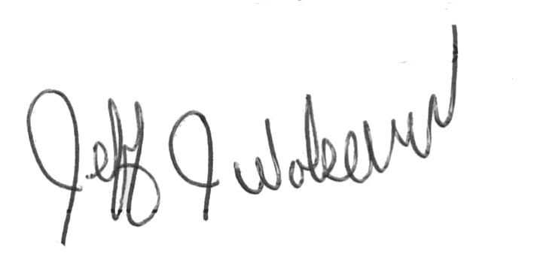
This Functional Job Description has been reviewed by company representatives and is believed to be an accurate representation of most of the job content.
Mark A Anderson, MA, PT CPE  Certified Professional Economist  Licensed Physical Therapist  ErgoSystems Consulting Group, Inc.  19285 Shady Hills Road  Minneapolis, MN 55331  952-401-9296  mark.anderson@ergosystemsconsulting.com  www.ergosystemsconsulting.com | _______________________________________
Jeff Wolseth
Manager - Occupational Safety and Health
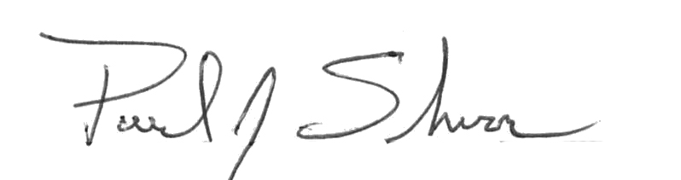
 | _______________________________________
Paul Schroer
Manager - Inbound Operations

