Functional Job Description: Material Handler - Setup

Company: | Bluestem Brands, Inc. | 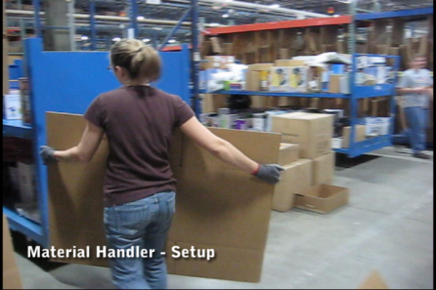
Job Title: | Material Handler - Setup
Date: | 3-16-2010
Dept/Facility: | West DC, St. Cloud, MN
Product Section: | Outbound
Electronic Doc. # | JFD Material Handler Setup 3-2010 FINAL

Work Hours | Overtime: | Voluntary and/or mandatory per production requirements. | Breaks: | 10 minutes every two hours, one 30 minute lunch break.
 | Shift: | Days of week: | Time:
 | First | Monday-Friday | 7:00 AM to 3:30 PM
 | Second | Monday-Friday | 4:00 PM to 12:30 AM

Job Rotation | Yes

Job Training or Credentials Required at Hire | Education/ training: | None required; high school diploma or GED preferred.
 | Knowledge/ cognitive skills: | Basic math, reading, writing and oral communication skills preferred. Ability to organize work tasks and work independently or as part of a team.

Machines, Tools and/or Equipment Used | Hand held scanner, hand taper, PC, pens, markers, knife, scissors, telephone, EZ-go, Walkie-Rider, pallet jack.

Job Purpose/ Objectives | Setup and resupply the Packing workstations through manual handling of flat packing boxes, boxes of packing bags and bundles of catalogs. Operate manual pallet jack to position pallets of materials. Operate EZ-Go and Walkie-Rider to position carts and pallet jacks.

Safety and Personal Protective Equipment Required  *Available | Hard Hat | Steel Toe Footwear | Safety Glasses | Gloves:
 | Face Shield | Protective Clothing | Safety Glasses/Side Shields | Leather
 | Dust Mask* | Safety Vest  Fall Protection Harness  Back Support* | Safety Goggles  Hearing Protection*  Compensatory methods to mitigate heat | Rubberized/cloth*  Chemical

Safety/ Equipment Training/ Certification Required | Daily Meeting and Stretch Breaks (includes:) | Industrial Truck Training | OSHA Training (Rules and Regulations)
 | - Safety Topics | EZ-Go | New Hire Safety Orientation
 | - Safety Policies | Walkie-Rider | Right to Know
 | - Questions & Answers | Pallet Jack | Lockout/Tag Out
 | - Review Safety Committee Minutes | Forklift (sit down) | Regulated Materials Training (ORM-D)  Supervisor Safety Updates
 |  | Stand-up Reach Truck
Order Picker
Transpositioner

Functional Job Elements (Refer to video clip for complete details) |  |  | % of Shift
- Position blue carts and pallet jacks at Packing workstations  - Hook up blue cart to EZ-GO  - Use handheld scanner  - Drive EZ-GO to position the blue cart at the Packing workstation  - Disconnect EZ-GO from blue cart  - Hook up pallet jack to EZ-GO  - Drive EZ-GO to position pallet jack at various locations at the Packing workstations  - Disconnect EZ-GO from the pallet jack | 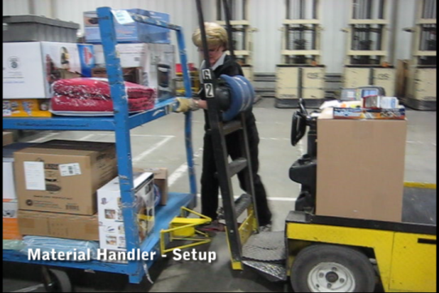 | 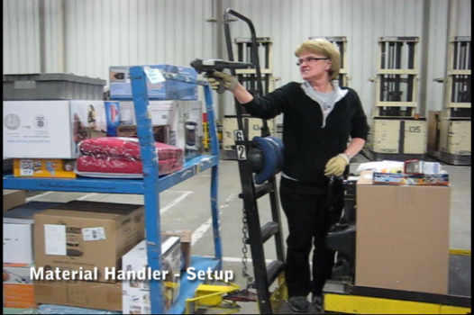 | 25
 | 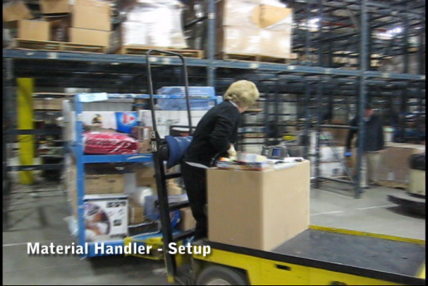 | 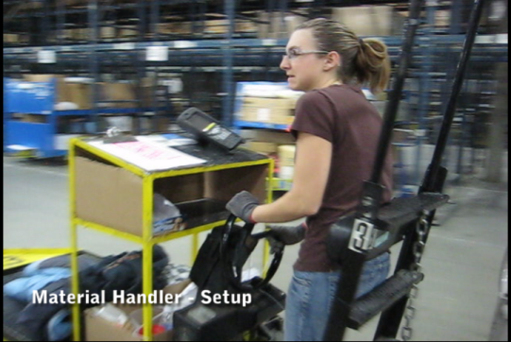
- Use manual pallet jack to move pallets  - Use manual pallet jacks to move materials on pallets in the area  - Pallets may hold flat cardboard boxes, boxes of products, etc. | 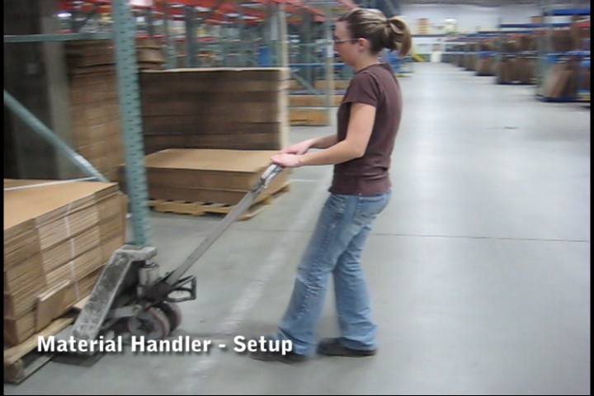 | 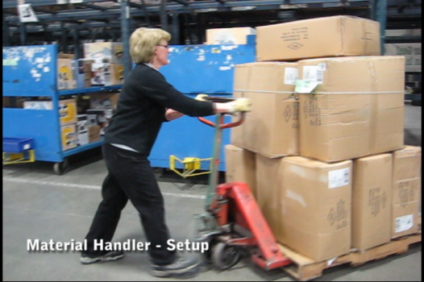 | 25
- Resupply Packing workstations with supplies  - Transport flat packing boxes from pallet jack to storage racks at the workstation  - Transport bundles of catalogs to storage racks at the workstation  - Transport boxes of packing bags to storage racks at the workstation  - Manual handling occurs in the range of 6” from the floor to shoulder height  - Manual handling weight range is up to 50# with average weight of 20# | 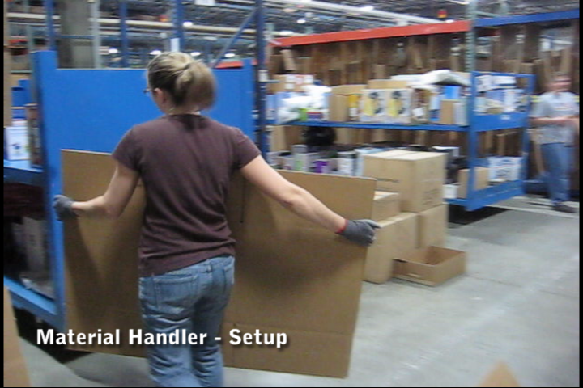 | 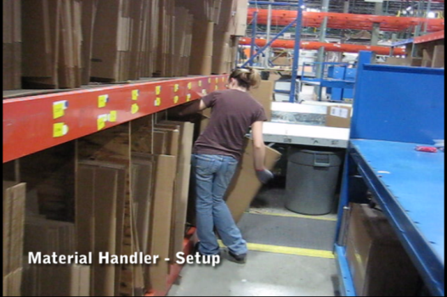 | 50
 | 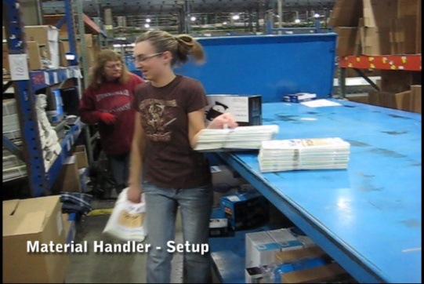 | 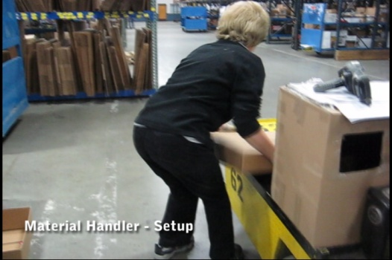

Physical Factors
Manual Material Handling
(lbs) | Floor-Knuckle (0” to 30”) |  |  |  |  |  | Knuckle-Chest (30” to 50’) |  |  |  |  |  | Chest-Overhead  ( > 50”) |  |  |  |  |  | Carry - Two Hands; Front |  |  |  |  |  | Carry - One Hand; Side |  |  |  |  |  | Push |  |  |  |  |  | Pull
100
75
50
25
15
10
5
0
Exp | N | R | O | F | C |  | N | R | O | F | C |  | N | R | O | F | C |  | N | R | O | F | C |  | N | R | O | F | C |  | N | R | O | F | C |  | N | R | O | F | C

Postures/Movements |  |  |  |  |  |  |  |  |  |  |  |  |  |  |  | Head/Neck
Exp | Sit | Stand | Walk | Bal | Stairs | Lad-der | Foot contrl | Twist Waist | Bend Waist | Squat | Kneel | Crawl | Reach below 54” | Reach above 54” |  | Flex Static | Ext Static | Rot Static | Flex Dyn | Ext Dyn | Rot Dyn
C
F
O
R
N

Hand Use |  |  |  |  | Sensory |  |  |  |  |  | Communication |  |  |  |  | Key C - Continuous: 67 to 100% of shift  F - Frequent: 34 to 66% of shift  O - Occasional: 6 to 33% of shift  R - Rarely: up to 5% of shift  N - Never: 0% of shift  Abbreviations: Bal=Bal, Exp=Exposure, Contrl=Control, Flex=Flexion, Ext=Extension, Dyn=Dynamic, Manip=Manipulation
Exp | Simple Grasp | Firm Grasp | Fine Manip | Bal | See | Hear | Touch Feel | Taste | Smell |  | Talk | Read | Write | Hand Signal
C
F
O
R
N

Environmental Factors | Exposure Level |  |  |  |  | Key/Comments
 | N | R | O | F | C
Outdoor Work |  |  |  |  |  | Key C - Continuous: 67 to 100% of shift  F - Frequent: 34 to 66% of shift  O - Occasional: 6 to 33% of shift  R - Rarely: up to 5% of shift  N - Never: 0% of shift  Comments:  Indoor Work: Primary work area is a large indoor warehouse complex.  Moving Objects: Be aware of and avoid moving objects including product and equipment.  Heat: Based on external temperature, occasionally performs job tasks in hot indoor environment; warehouse complex is not air-conditioned. Large fans are used for ventilation.
Indoor Work
Heat
Wet/ Humid
Hearing Protection
Vibration
Fumes/Gases/Orders
Dust
Moving Objects
Electrical
Chemical
Protected Work Heights
Unprotected Work Heights
Flying Debris
Lighting (Inadequate/Excessive)

Position eligible to be considered for temporary modification in conjunction with a Return to Work transitional duty program agreement: Yes
This Functional Job Description was completed through an on-site job analysis by a certified professional ergonomist/licensed physical therapist. It is for the purpose of identifying and quantifying the physical functional requirements of this job. The Functional Job Description should not be construed as a detailed description of all specific job duties and/or tools, equipment and materials that may be necessary or incidental to the performance of this job. Further consideration may be necessary when applying the standards to the injured population in the medical management process.
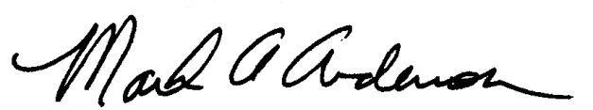 | 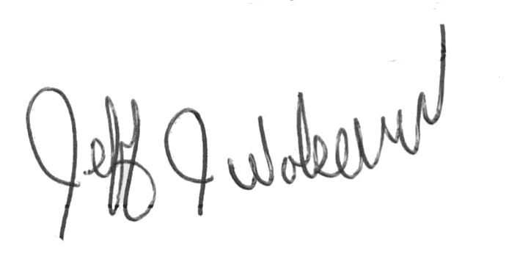  This Functional Job Description has been reviewed by company representatives and is believed to be an accurate representation of most of the job content.
Mark A Anderson, MA, PT CPE  Certified Professional Economist  Licensed Physical Therapist  ErgoSystems Consulting Group, Inc.  19285 Shady Hills Road  Minneapolis, MN 55331  952-401-9296  mark.anderson@ergosystemsconsulting.com  www.ergosystemsconsulting.com | _______________________________________
Jeff Wolseth
Manager - Occupational Safety and Health
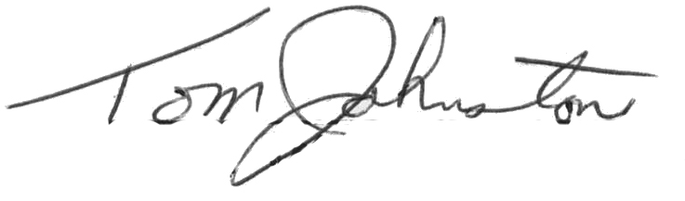
 | _______________________________________
Tom Johnstone
Manager - Returns Operations

