Material Handler – Outbound

Company: | Bluestem Brands, Inc. | 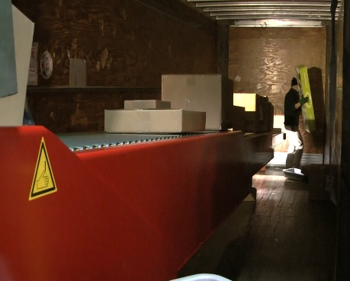 | 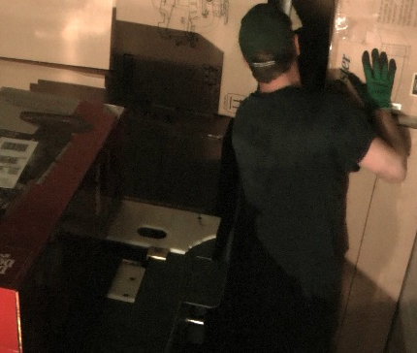
Job Title: | Material Handler – Outbound (Truck Loader)
Date: | 2-24-2022
Dept/Facility: | West DC, St. Cloud, MN
Product Section: | Outbound
Electronic Doc. # | FJD Material Handler –Outbound 2-24-22 FINAL

Work Hours | Overtime: | Voluntary and/or mandatory per production requirements. | Breaks: | 10 minutes every two hours, one 30 minute lunch break.
 | Shift: | Days of week: | Time:
 | First | Monday-Friday | 8:00 AM to 4:30 PM
 | Second | Sunday-Thursday | 4:30 PM to 1:00 AM

Job Rotation | Yes

Job Training or Credentials Required at Hire | Education/ training: | None required; high school diploma or GED preferred.
 | Knowledge/ cognitive skills: | Basic math, reading, writing and oral communication skills preferred. Ability to organize work tasks and work independently or as part of a team.

Machines, Tools and/or Equipment Used | Powered extendable conveyors that are operator controlled to extend and retract the conveyor into/out off of the trailer. Two-step platform.

Job Purpose/ Objectives | Handle and process outbound materials and equipment. This FJD focuses specifically on truck loading making use of the powered extendable conveyors.

Safety and Personal Protective Equipment Required  *Available | Hard Hat | Steel Toe Footwear | Safety Glasses | Gloves:
 | Face Shield | Protective Clothing | Safety Glasses/Side Shields | Leather
 | Dust Mask* | Safety Vest  Fall Protection Harness  Back Support* | Safety Goggles  Hearing Protection*  Compensatory methods to mitigate heat | Rubberized/cloth*  Chemical

 | Safety/ Equipment Training/ Certification Required | Daily Meeting and Stretch Breaks (includes:) |  | Industrial Truck Training |  | OSHA Training (Rules and Regulations)
 |  | - Safety Topics |  | EZ-Go |  | New Hire Safety Orientation
 |  | - Safety Policies |  | Walkie-Rider |  | Right to Know
 |  | - Questions & Answers |  | Pallet Jack |  | Lockout/Tag Out
 |  | - Review Safety Committee Minutes |  | Forklift (sit down) |  | Regulated Materials Training (ORM-D)  Supervisor Safety Updates
 |  |  |  | Stand-up Reach Truck
Order Picker
Extendable conveyor
Functional Job Elements
NOTE: Manual Material Handling Functional Job Elements are different for the various components of the Material Handler–Outbound job description. They are categorized by 1.) Truck Loader, 2.) Non-convey Loader, 3.) Taper, 4.) Jackpot Person and 5.) Manual Postage Keyer. |  |  |  |  |  |  | % of Shift
Truck Loader
Load truck  - Materials are conveyed to the loading area via the warehouse conveyor system  - An extendable, powered, operator controlled conveyor at the end of the warehouse conveyor system is powered into the trailer to bring the materials close to the location where they are loaded in the trailer  - Two different extendable conveyors are in use: height at the end of the conveyor is either 36 or 50“ based on which one is used.  - Outbound materials are loaded manually from floor level to overhead to completely fill the trailer  - Weight range up to 150# (with team lift), with average of 10#)  - A two-step platform is available for the Material Handler to stand on to reach to the higher levels in the trailer |  |  | 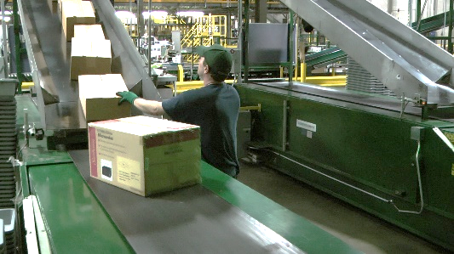 |  | 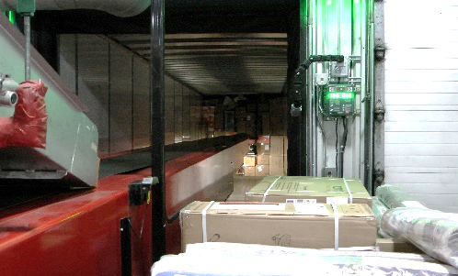 |  | 0%  to 100%
 |  |  | 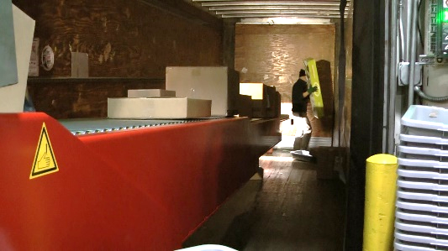 |  | 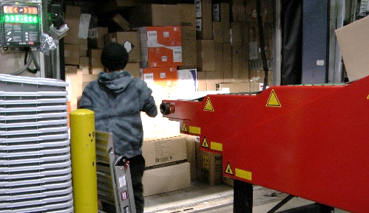
 |  |  | 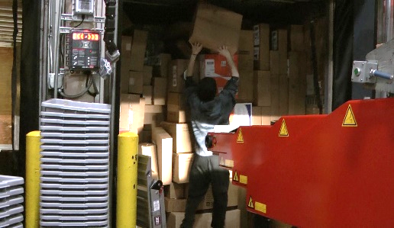 |  | 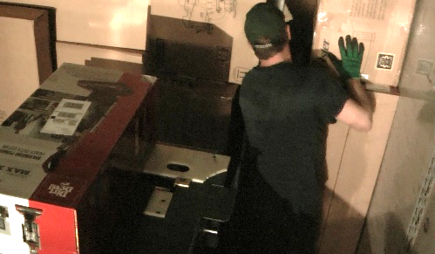
 |  |  | 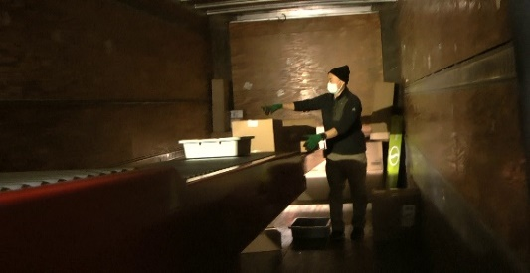 |  | 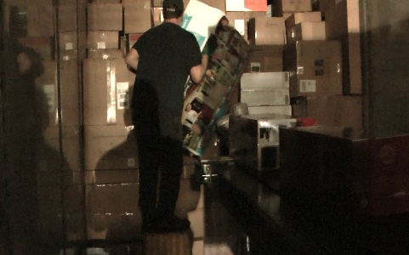

Manual Material Handling
(lbs) | Floor-Knuckle (0” to 30”) |  |  |  |  |  | Knuckle-Chest (30” to 50’) |  |  |  |  |  | Chest-Overhead  ( > 50”) |  |  |  |  |  | Carry - Two Hands; Front |  |  |  |  |  | Carry - One Hand; Side |  |  |  |  |  | Push |  |  |  |  |  | Pull
100
75
50
25
15
10
5
0
Exp | N | R | O | F | C |  | N | R | O | F | C |  | N | R | O | F | C |  | N | R | O | F | C |  | N | R | O | F | C |  | N | R | O | F | C |  | N | R | O | F | C

 |  | N - Never  0% of shift |  | R - Rarely  up to 5% of shift |  |  | O - Occasional  6 to 33% of shift |  |  | F - Frequent  34 to 66% of shift |  | C - Continuous  67 to 100% of shift
Non-Convey Loader SL/SO (Single Light Weight/Single Oversize) |  |  |  |  |  |  |  |  |  |  |  |  | % of Shift
- Positions loaded cart in trailer  - Driving EZ-GO backs the cart into the trailer.  - After cart is emptied drives empty cart out of the trailer. |  |  |  |  | 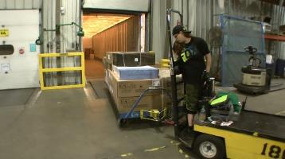 |  |  |  | 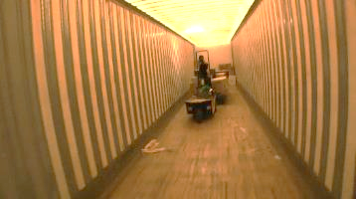 |  |  |  | 0%  to  100%
- Load non-convey items from cart into trailer  - Nonconvey: Items that due to item size and/or weight cannot be conveyed via the warehouse conveyance system.  - Items are lifted from the cart to be stacked in the trailer.  - Work height is floor to overhead level.  - May work individually or as a team of two.  - Weight range: items up to 150#, with team lift, up to 75# per person, or with material handling equipment.  - Average of 40# per item.  - Transpositioner may be used to to position product at a higher level to accomplish higher fill level in the trailer. |  |  |  |  | 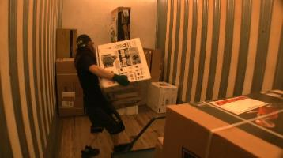 |  |  |  | 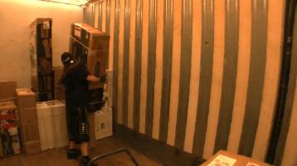
 |  |  |  |  | 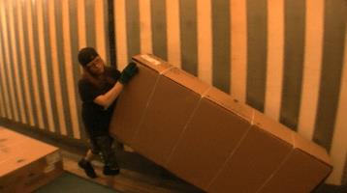 |  |  |  | 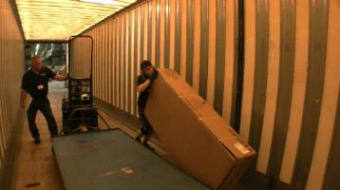
 |  |  |  |  |  |  |  |  | 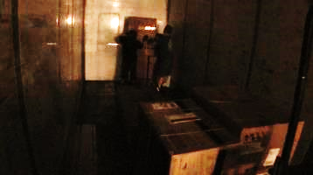

Manual Material Handling
(lbs) | Floor-Knuckle (0” to 30”) |  |  |  |  |  | Knuckle-Chest (30” to 50’) |  |  |  |  |  | Chest-Overhead  ( > 50”) |  |  |  |  |  | Carry - Two Hands; Front |  |  |  |  |  | Carry - One Hand; Side |  |  |  |  |  | Push |  |  |  |  |  | Pull
100
75
60
40
15
10
5
0
Exp | N | R | O | F | C |  | N | R | O | F | C |  | N | R | O | F | C |  | N | R | O | F | C |  | N | R | O | F | C |  | N | R | O | F | C |  | N | R | O | F | C

 | N - Never  0% of shift |  | R - Rarely  up to 5% of shift |  | O - Occasional  6 to 33% of shift |  | F - Frequent  34 to 66% of shift |  | C - Continuous  67 to 100% of shift

Taper
Operate taper  - Boxes and bags are pushed through the taper to be taped and conveyed  - Bags weigh up to 10# with average of 5# |  |  |  |  |  |  |  |  |  |  |  |  | 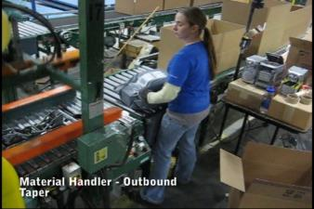 |  |  |  |  |  |  |  |  |  |  |  |  |  |  | 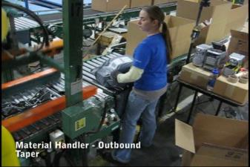 |  |  |  |  |  |  |  |  |  |  |  |  |  | % of Shift
0%
To 100%
Change tape roll  - The top and bottom tape rolls are replaced as needed  - Tape roll weighs about 20#  - The bottom roll is lifted out of the conveyer for access  - The top roll can be mechanically lowered to the conveyor for access |  |  |  |  |  |  |  |  |  |  |  |  | 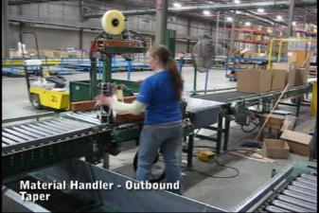 |  |  |  |  |  |  |  |  |  |  |  |  |  |  | 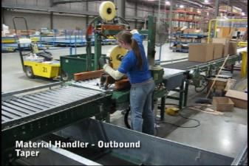
Manual Material Handling
(lbs) | Floor-Knuckle (0” to 30”) |  |  |  |  |  | Knuckle-Chest (30” to 50’) |  |  |  |  |  |  | Chest-Overhead  ( > 50”) |  |  |  |  |  | Carry - Two Hands; Front |  |  |  |  |  | Carry - One Hand; Side |  |  |  |  |  |  | Push |  |  |  |  |  | Pull
100
75
50
25
15
10
5
0
Exp | N | R | O | F | C |  | N | R | O | F | C |  |  | N | R | O | F | C |  | N | R | O | F | C |  | N | R |  | O | F | C |  | N | R | O | F | C |  | N | R | O |  | F | C

 | N - Never  0% of shift |  | R - Rarely  up to 5% of shift |  | O - Occasional  6 to 33% of shift |  | F - Frequent  34 to 66% of shift |  | C - Continuous  67 to 100% of shift

Jackpot Person
Process box  - Boxes are manually removed from conveyor and placed onto work table  - Boxes are cut open and processed  - Boxes are taped shut with hand taper  - Box weight range is up to 50# with an average of 15#  - Boxes are returned to conveyor | 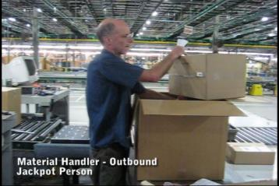 | 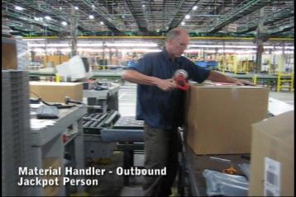 | % of Shift
0%
to
100%
Misc.  - Occasionally boxes get stuck on the conveyor system; a long pole is used to free them | 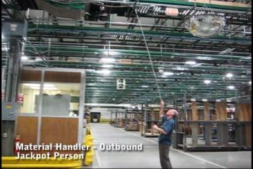

Manual Material Handling
(lbs) | Floor-Knuckle (0” to 30”) |  |  |  |  |  | Knuckle-Chest (30” to 50’) |  |  |  |  |  | Chest-Overhead  ( > 50”) |  |  |  |  |  | Carry - Two Hands; Front |  |  |  |  |  | Carry - One Hand; Side |  |  |  |  |  | Push |  |  |  |  |  | Pull
100
75
50
25
15
10
5
0
Exp | N | R | O | F | C |  | N | R | O | F | C |  | N | R | O | F | C |  | N | R | O | F | C |  | N | R | O | F | C |  | N | R | O | F | C |  | N | R | O | F | C

 | N - Never  0% of shift |  | R - Rarely  up to 5% of shift |  | O - Occasional  6 to 33% of shift |  | F - Frequent  34 to 66% of shift |  | C - Continuous  67 to 100% of shift

Manual Parcel Handler
Setup workstation  - Workstation is setup by placing pallets onto floor next to the workstation  - Empty boxes are brought to the workstation, sides are taped up and placed on the pallet  - Wheeled gurney or gray tote filled with bags/boxes is manually pushed to the workstation from the staging area | 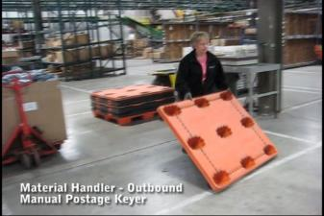 | 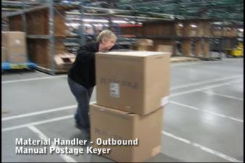 | % of Shift
0%
to
100%
 | 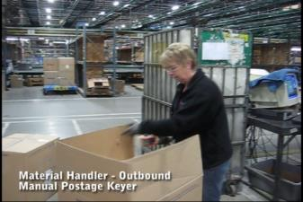 | 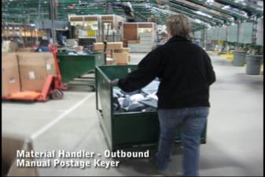
Process bags/boxes  - Bags/boxes are removed from the gurney and scanned with the handheld scanner  - Once processed they are tossed into the cardboard boxes on the pallets  - Weight range of bags/boxes is up to 10# with an average of 5# | 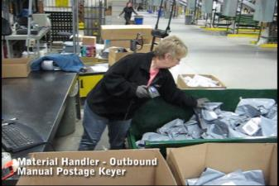 | 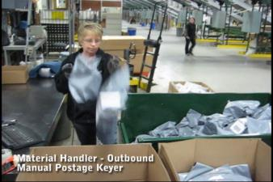
Transport filled boxes  - Filled cardboard boxes are transported via manual pallet jack to the staging area | 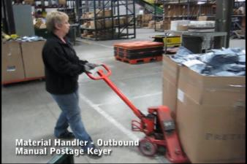

Manual Material Handling
(lbs) | Floor-Knuckle (0” to 30”) |  |  |  |  |  | Knuckle-Chest (30” to 50’) |  |  |  |  |  | Chest-Overhead  ( > 50”) |  |  |  |  |  | Carry - Two Hands; Front |  |  |  |  |  | Carry - One Hand; Side |  |  |  |  |  | Push |  |  |  |  |  | Pull
100
75
50
25
15
10
5
0
Exp | N | R | O | F | C |  | N | R | O | F | C |  | N | R | O | F | C |  | N | R | O | F | C |  | N | R | O | F | C |  | N | R | O | F | C |  | N | R | O | F | C

 | N - Never  0% of shift |  | R - Rarely  up to 5% of shift |  |  | O - Occasional  6 to 33% of shift |  |  | F - Frequent  34 to 66% of shift |  | C - Continuous  67 to 100% of shift
Manual Postage Keyer
Position green bin  - Manually maneuver rolling green bin or gurney box into position at the postage keyer workstation.  - Up to 50# of push/pull force required to move full bin. |  |  |  | 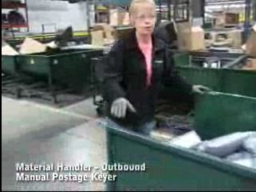 |  |  |  | 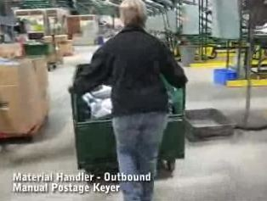 |  |  |  | % of Shift
0%
to 100%
Process parcels  - Remove parcels from green bin or gurney box– reach into bin/box.  - Weight range of parcels of 1# to 15# with average weight of 5#.  - Scan parcels with handheld scanner.  - Throw scanned parcels into cardboard box placed on pallet.  - May scan several items placed on workbench and place stack of parcels into the cardboard box as a unit. |  |  |  | 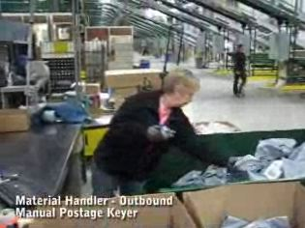 |  |  |  | 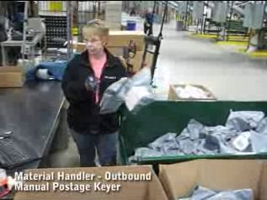
 |  |  |  | 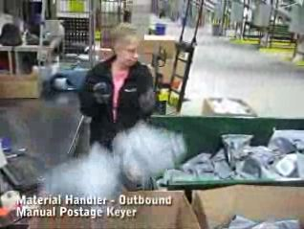 |  |  |  | 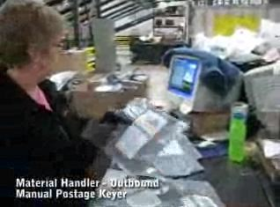
Remove full cardboard box/pallet and bring in empty box/pallet  - Use manual pallet jack to remove cardboard box/pallet.  - Push/pull force up to 50# required.  - Bring into position new pallet and empty cardboard box. |  |  |  | 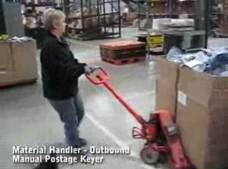 |  |  |  | 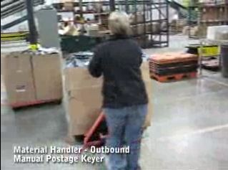

Manual Material Handling
(lbs) | Floor-Knuckle (0” to 30”) |  |  |  |  |  | Knuckle-Chest (30” to 50’) |  |  |  |  |  | Chest-Overhead  ( > 50”) |  |  |  |  |  | Carry - Two Hands; Front |  |  |  |  |  | Carry - One Hand; Side |  |  |  |  |  | Push |  |  |  |  |  | Pull
100
75
50
25
15
10
5
0
Exp | N | R | O | F | C |  | N | R | O | F | C |  | N | R | O | F | C |  | N | R | O | F | C |  | N | R | O | F | C |  | N | R | O | F | C |  | N | R | O | F | C

 | N - Never  0% of shift |  | R - Rarely  up to 5% of shift |  | O - Occasional  6 to 33% of shift |  | F - Frequent  34 to 66% of shift |  | C - Continuous  67 to 100% of shift

The following Physical Factors are common to all Material Handler – Outbound tasks.
Physical Factors
Postures/Movements |  |  |  |  |  |  |  |  |  |  |  |  |  |  |  | Head/Neck
Exp | Sit | Stand | Walk | Bal | Stairs | Lad-der | Foot contrl | Twist Waist | Bend Waist | Squat | Kneel | Crawl | Reach below 54” | Reach above 54” |  | Flex Static | Ext Static | Rot Static | Flex Dyn | Ext Dyn | Rot Dyn
C
F
O
R
N

Hand Use |  |  |  |  | Sensory |  |  |  |  |  | Communication |  |  |  |  | Key C - Continuous: 67 to 100% of shift  F - Frequent: 34 to 66% of shift  O - Occasional: 6 to 33% of shift  R - Rarely: up to 5% of shift  N - Never: 0% of shift  Abbreviations: Bal=Bal, Exp=Exposure, Contrl=Control, Flex=Flexion, Ext=Extension, Dyn=Dynamic, Manip=Manipulation
Exp | Simple Grasp | Firm Grasp | Fine Manip | Bal | See | Hear | Touch Feel | Taste | Smell |  | Talk | Read | Write | Hand Signal
C
F
O
R
N

Environmental Factors | Exposure Level |  |  |  |  | Key/Comments
 | N | R | O | F | C
Outdoor Work |  |  |  |  |  | Key C - Continuous: 67 to 100% of shift  F - Frequent: 34 to 66% of shift  O - Occasional: 6 to 33% of shift  R - Rarely: up to 5% of shift  N - Never: 0% of shift  Comments:  Indoor Work: Primary work area is a large indoor warehouse complex.  Moving Objects: Be aware of and avoid moving objects including product and equipment.  Heat: Based on external temperature, occasionally performs job tasks in hot indoor environment; warehouse complex is not air-conditioned. Large fans are used for ventilation.
Indoor Work
Heat
Wet/ Humid
Hearing Protection
Vibration
Fumes/Gases/Orders
Dust
Moving Objects
Electrical
Chemical
Protected Work Heights
Unprotected Work Heights
Flying Debris
Lighting (Inadequate/Excessive)

Position eligible to be considered for temporary modification in conjunction with a Return to Work transitional duty program agreement: Yes
This Functional Job Description was completed through an on-site job analysis by a certified professional ergonomist/physical therapist. It is for the purpose of identifying and quantifying the physical functional requirements of this job. The Functional Job Description should not be construed as a detailed description of all specific job duties and/or tools, equipment and materials that may be necessary or incidental to the performance of this job. Further consideration may be necessary when applying the standards to the injured population in the medical management process.
 | This Functional Job Description has been reviewed by company representatives and is believed to be an accurate representation of most of the job content.
Mark A. Anderson, MA, PT, CPE  Certified Professional Economist  Physical Therapist  ErgoSystems Consulting, LLC.  7421 West Shoreline Drive  Waconia, MN 55387  952-401-9296  mark.anderson@ergosystemsconsulting.com  www.ergosystemsconsulting.com | 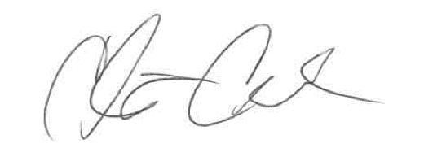  _______________________________________
Chris Condon
Supervisor – Safety, Security and Facilities

 | ___________________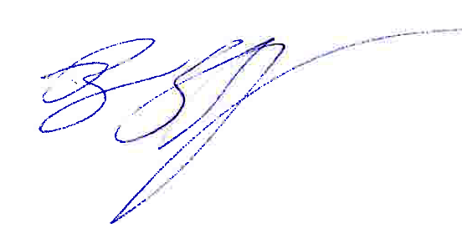____________________
Brian Schaefer
Manager – Production Control

