Functional Job Description: Nonconvey Pick/Pack SO

Company: | Bluestem Brands, Inc. | 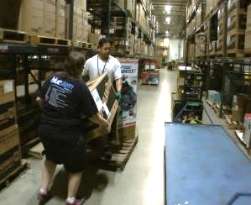 | 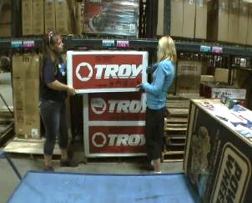
Job Title: | Nonconvey Pick/Pack SO (Single Oversize)
Date: | 9-20-17
Dept/Facility: | DC, St. Cloud, MN
Product Section: | Outbound
Electronic Doc. # | FJD Nonconvey Pick Pack SO 9-2017 FINAL

Work Hours | Overtime: | Voluntary and/or mandatory per production requirements. | Breaks: | 10 minutes every two hours, one 30 minute lunch break.
 | Shift: | Days of week: | Time:
 | First | Monday-Friday | 8:00 AM to 4:30 PM
 | Second | Sunday-Thursday | 4:30 PM to 1:00 AM

Job Rotation | Yes

Job Training or Credentials Required at Hire | Education/ training: | None required; high school diploma or GED preferred.
 | Knowledge/ cognitive skills: | Basic math, reading, writing and oral communication skills preferred. Ability to organize work tasks and work independently or as part of a team.

Machines, Tools and/or Equipment Used | RDT/Hand held scanner, hand taper, pens, markers, knife, scissors, EZ-GO, garbage receptacle

Job Purpose/ Objectives | Working as a team of two (Picker and Packer) pick and label Single Oversize (SO) items, up to 130# total (65# per person) nonconvey items (nonconvey: product because of weight and size that cannot be conveyed on the warehouse conveyance system). Picker maneuvers EZ-GO and cart through warehouse to pick product. Packer follows on EZ-Go to assist with team lift of items and prepares/places shipping labels on the product box.

Safety and Personal Protective Equipment Required  *Available | Hard Hat | Steel Toe Footwear | Safety Glasses | Gloves:
 | Face Shield | Protective Clothing | Safety Glasses/Side Shields | Leather
 | Dust Mask | Safety Vest  Fall Protection Harness  Back Support* | Safety Goggles  Hearing Protection*  Compensatory methods to mitigate heat | Rubberized/cloth*  Chemical

Safety/ Equipment Training/ Certification Required | Daily Meeting and Stretch Breaks (includes:) | Industrial Truck Training | OSHA Training (Rules and Regulations)
 | - Safety Topics | EZ-Go | New Hire Safety Orientation
 | - Safety Policies | Walkie-Rider | Right to Know
 | - Questions & Answers | Pallet Jack | Lockout/Tag Out
 | - Review Safety Committee Minutes | Forklift (sit down) | Regulated Materials Training (ORM-D)  Supervisor Safety Updates

Functional Job Elements |  |  | % of Shift
- Hook up EZ-GO to cart  - Drives EZ-GO to connect to the cart.  - May push/pull empty cart if needed. (up to 25# of push/pull force). | 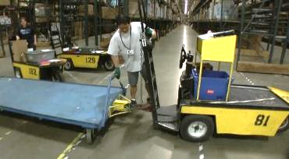 | 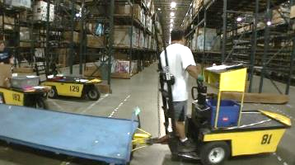 | 2
- Picker - maneuver EZ-GO and cart through warehouse  - Operates the handheld RDT  - Work as a team of two with Packer drives EZ-GO/pulls cart to pick nonconvey product (nonconvey: product that because of weight and size, cannot be conveyed on the warehouse conveyance system).  - Packer - maneuver EZ-GO through warehouse to follow Packer  - Work as a team of two with Picker drives EZ-GO to follow Packer to assist with team lift of items and prepare/place shipping labels on the product box.  - Picker/Packer – load product onto cart  - Working as a team of two load items from pallets on the floor onto the cart.  - Lifts, pushes and pulls items to load onto the cart.  - To obtain items may reach into the racking to gain access.  - Picks about 12 to 15 items per cart.  - Some items may be stacked on the cart up to a height of about 60”.  - Weight range: up to 130#, with average of about 50# | 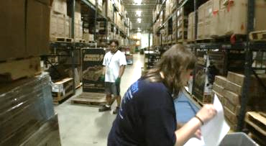 | 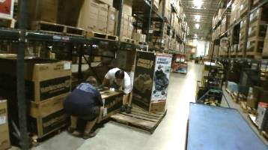 | 96
 | 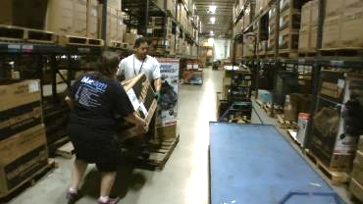 | 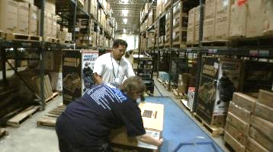
 | 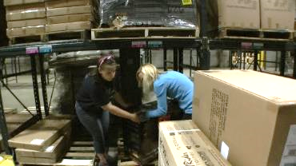 | 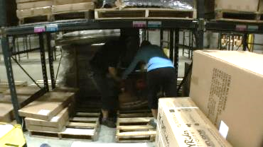
 | 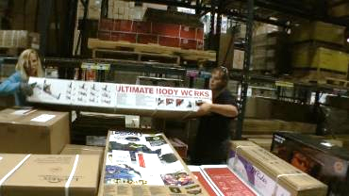
- Returns cart to Packing area  - When full cart has been picked returns cart to packing area and disconnects cart from the EZ-GO. | 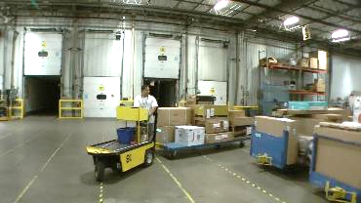 | 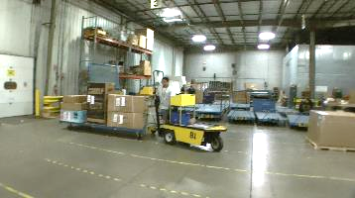 | 2

Physical Factors
Manual Material Handling
(lbs) | Floor-Knuckle (0” to 30”) |  |  |  |  |  | Knuckle-Chest (30” to 50’) |  |  |  |  |  | Chest-Overhead  ( > 50”) |  |  |  |  |  | Carry - Two Hands; Front |  |  |  |  |  | Carry - One Hand; Side |  |  |  |  |  | Push |  |  |  |  |  | Pull
100
75
65
40
25
10
5
0
Exp | N | R | O | F | C |  | N | R | O | F | C |  | N | R | O | F | C |  | N | R | O | F | C |  | N | R | O | F | C |  | N | R | O | F | C |  | N | R | O | F | C

Postures/Movements |  |  |  |  |  |  |  |  |  |  |  |  |  |  |  | Head/Neck
Exp | Sit | Stand | Walk | Bal | Stairs | Lad-der | Foot contrl | Twist Waist | Bend Waist | Squat | Kneel | Crawl | Reach below 54” | Reach above 54” |  | Flex Static | Ext Static | Rot Static | Flex Dyn | Ext Dyn | Rot Dyn
C
F
O
R
N

Hand Use |  |  |  |  | Sensory |  |  |  |  |  | Communication |  |  |  |  | Key C - Continuous: 67 to 100% of shift  F - Frequent: 34 to 66% of shift  O - Occasional: 6 to 33% of shift  R - Rarely: up to 5% of shift  N - Never: 0% of shift  Abbreviations: Bal=Bal, Exp=Exposure, Contrl=Control, Flex=Flexion, Ext=Extension, Dyn=Dynamic, Manip=Manipulation
Exp | Simple Grasp | Firm Grasp | Fine Manip | Bal | See | Hear | Touch Feel | Taste | Smell |  | Talk | Read | Write | Hand Signal
C
F
O
R
N

Environmental Factors | Exposure Level |  |  |  |  | Key/Comments
 | N | R | O | F | C
Outdoor Work |  |  |  |  |  | Key C - Continuous: 67 to 100% of shift  F - Frequent: 34 to 66% of shift  O - Occasional: 6 to 33% of shift  R - Rarely: up to 5% of shift  N - Never: 0% of shift  Comments:  Indoor Work: Primary work area is a large indoor warehouse complex.  Moving Objects: Be aware of and avoid moving objects including product and equipment.  Heat: Based on external temperature, occasionally performs job tasks in hot indoor environment; warehouse complex is not air-conditioned. Large fans are used for ventilation.
Indoor Work
Heat
Cold
Wet/ Humid
Hearing Protection
Vibration
Fumes/Gases/Orders
Dust
Moving Objects
Electrical
Chemical
Protected Work Heights
Unprotected Work Heights
Flying Debris
Lighting (Inadequate/Excessive)

Position eligible to be considered for temporary modification in conjunction with a Return to Work transitional duty program agreement: Yes
This Functional Job Description was completed through an on-site job analysis by a certified professional ergonomist/licensed physical therapist. It is for the purpose of identifying and quantifying the physical functional requirements of this job. The Functional Job Description should not be construed as a detailed description of all specific job duties and/or tools, equipment and materials that may be necessary or incidental to the performance of this job. Further consideration may be necessary when applying the standards to the injured population in the medical management process.
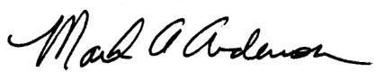 | 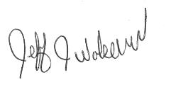  This Functional Job Description has been reviewed by company representatives and is believed to be an accurate representation of most of the job content.
Mark A Anderson, MA, PT CPE  Certified Professional Economist  Licensed Physical Therapist  ErgoSystems Consulting Group, Inc.  7421 W Shoreline Dr  Waconia, MN 55387  952-401-9296  mark.anderson@ergosystemsconsulting.com  www.ergosystemsconsulting.com | _______________________________________
Jeff Wolseth
Sr. Manager – Safety, Security and Facilities

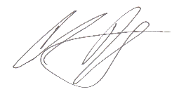
_______________________________________
Chris Yogerst
Sr. Supervisor – Pick/Pack

