Functional Job Description: Package Insert Collator

Company: | Bluestem Brands, Inc. | 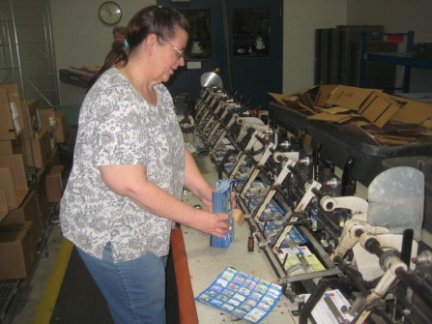 | 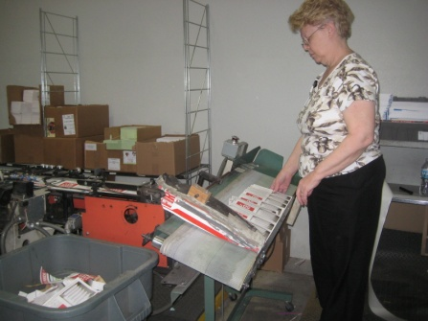
Job Title: | Package Insert Collator
Date: | 3-12-14
Dept/Facility: | West DC, St. Cloud, MN
Product Section: | Package Insertion
Electronic Doc. # | FJD Package Insert Collator FINAL 3-2014

Work Hours | Overtime: | Voluntary and/or mandatory per production requirements. | Breaks: | Two 10 minute breaks per shift
 | Shift: | Days of week: | Time:
 | First | 3 to 5 days/week, Monday-Friday | 6:00 AM to 2:00 PM

Job Rotation | Yes

Job Training or Credentials Required at Hire | Education/ training: | None required; high school diploma or GED preferred.
 | Knowledge/ cognitive skills: | Basic math, reading, writing and oral communication skills preferred. Ability to organize work tasks and work independently or as part of a team.

Machines, Tools, Equipment Used | Inserting machines, boxes, pallets, garbage tubs, garbage can, holder folder totes, 2-wheel dolly, pallet jack, computer, pen, marker, knife, scissors, telephone, compressor, rags, broom, dust pan, HEPA vacuum.

Job Purpose/ Objectives | Collate vendor advertisements from outside client into advertisement holder folders (up to 16 pieces per holder folder).

Safety and Personal Protective Equipment Required  *Available | Hard Hat | Steel Toe Footwear | Safety Glasses | Gloves:
 | Face Shield | Protective Clothing | Safety Glasses/Side Shields | Leather
 | Dust Mask | Safety Vest  Fall Protection Harness  Back Support* | Safety Goggles  Hearing Protection*  Compensatory methods to mitigate heat | Rubberized/cloth*  Chemical

Safety/ Equipment Training/ Certification Required | Daily Meeting and Stretch Breaks (includes:) | Industrial Truck Training | OSHA Training (Rules and Regulations)
 | - Safety Topics | EZ-Go | New Hire Safety Orientation
 | - Safety Policies | Walkie-Rider | Right to Know
 | - Questions & Answers | Manual Pallet Jack | Lockout/Tag Out
 | - Review Safety Committee Minutes | Forklift (sit down) | Regulated Materials Training (ORM-D)  Supervisor Safety Updates
 |  | Stand-up Reach Truck
 |  | Order Picker

Functional Job Elements (% of Shift is an estimate and may vary from day to day)

- Receive Inventory (% of Shift: 1%)  - On a weekly basis receives inventory of advertisements and holder folders in boxes on pallets.  - Does not require any manual handling on the part of the Package Insert Collator.  - Material Handlers are responsible for conveying the pallets. | 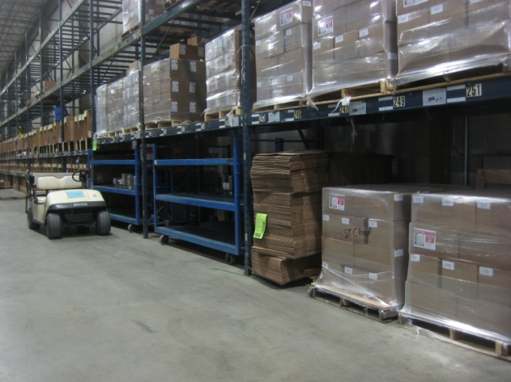
- Stock Room (% of Shift: 1%)  - The pallets of materials are brought by the Material Handler to a staging area outside the stockroom.  - Package Insert Collator uses a manual pallet jack to move the pallets into the stockroom.  - Distance transported is about 25 to 50’.  - About 35 to 40 pallets/month are moved from the staging area into the stockroom.  - 60# of force required to initiate movement of the loaded pallet jack and 15# of force required to sustain movement of the loaded pallet jack. | 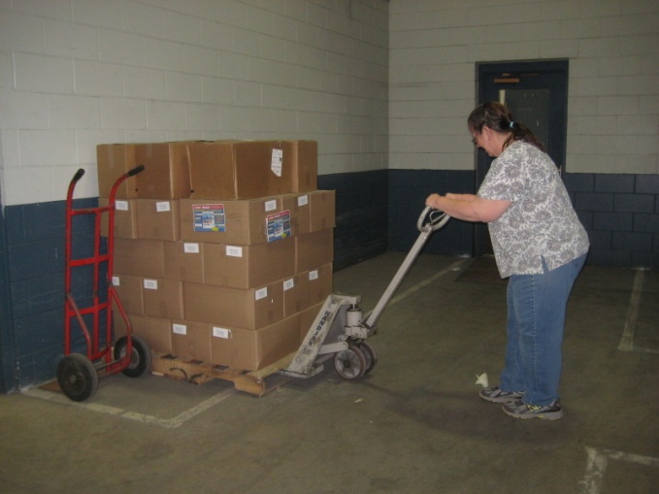
- Two-Wheeler use (% of Shift: 2%)  - Uses a two-wheeler to transport 4 boxes at one time from the stockroom into the inserter room.  - Distance transported is about 50 to 100’.  - Manually loads the two-wheeler.  - Performed daily at the end of the shift to prep for the next day.  - About 48 to 55 total boxes are handled (about 12 to 14 two-wheeler loads) in a 30 minute time frame.  - Box weight ranges from 35# to 50#.  - Two individuals typically involved to handle the 48 to 55 boxes. | 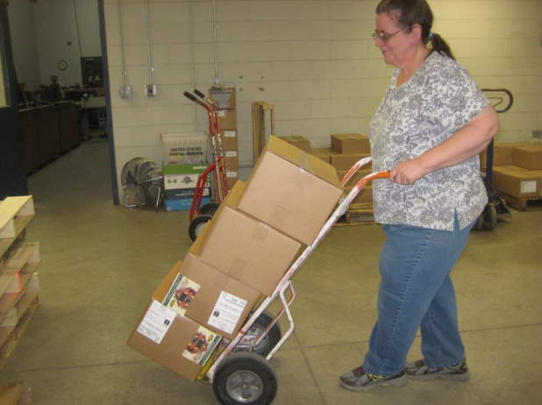
- Load floor/platform/shelves with boxes (% of Shift: 3%)  - Once transported to the Inserter room, manually transfers boxes from the two-wheeler to floor/platform/shelves at the inserter machines.  - There are two inserter machines.  - Some boxes are placed on the floor.  - Some boxes are placed on the platforms at height of about 24”.  - Some boxes are placed on the two level shelf at height of about 6” and 24”.  - Two individuals typically involved to handle the 48 to 55 boxes. | 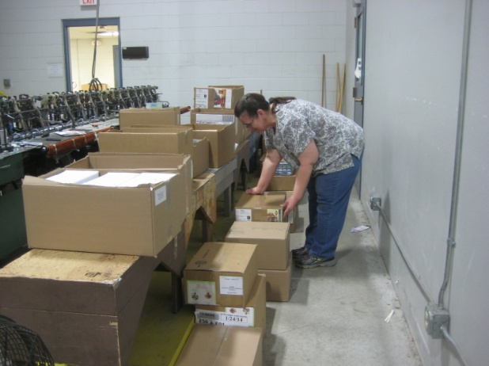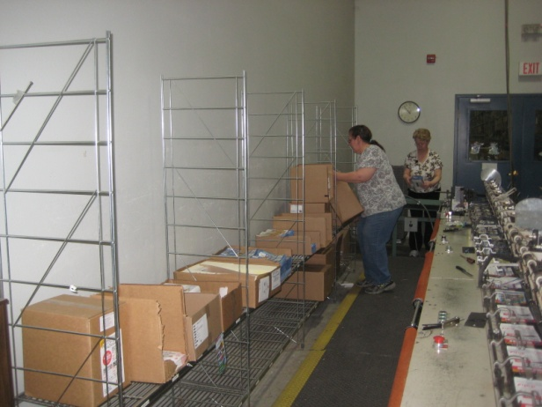
- Handles pallets (% of Shift: 1%)  - As pallets are emptied, manually stacks pallets in the stock room.  - About 35 to 40 pallets handled per month.  - Stacked about 8 pallets high (about 4’).  - Uses pallet jack to move pallet stack to outside of the stock room.  - Material Handler will then remove the pallet stack. | 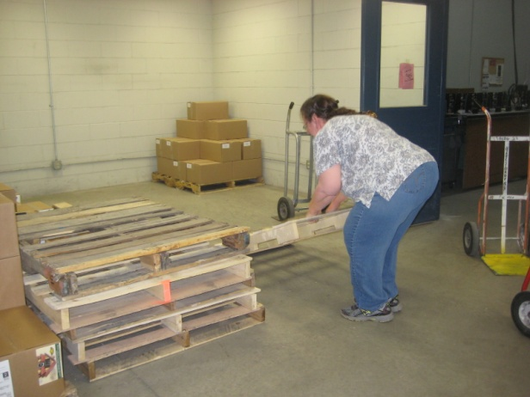
- Load insert bundles into inserter (% of Shift: 45 to 90%)  - Cuts boxes open with a knife.  - On average, loads 240 bundles of inserts per hour into the inserter machine slots.  - Number based on 20 bundles loaded into 12 slots/hour.  - Maximum would be 20 bundles loaded into 17 slots/hour.  - Requires a forward reach of about 20”.  - Standing and walking is required.  - Typical bundle weighs 1 to 2#.  - Monitors inserter machine operation:  - Empty slots.  - Jammed slots.  - Wrong count.  - Cuts down and throws empty cardboard into the gray garbage tubs | 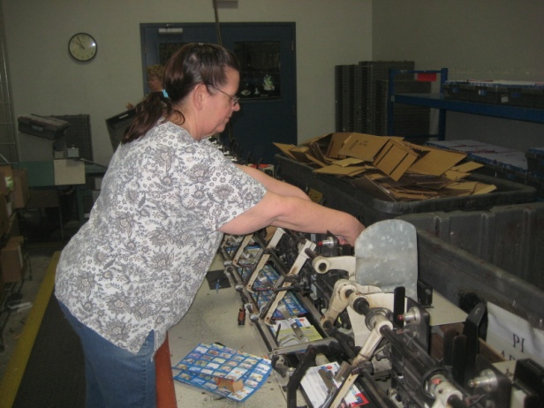  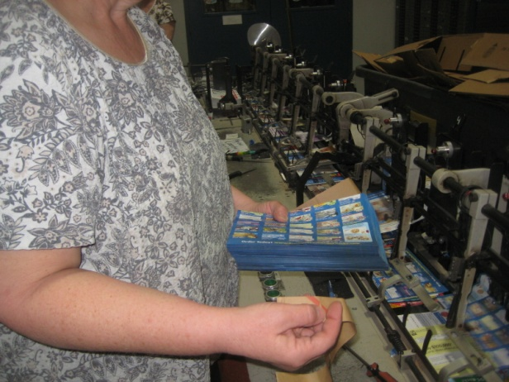
- Places filled holder folders into gray totes (% of Shift: 45 to 90%)  - Filled holder folders come out at the end of the inserter machine.  - Height of the platform at the end of the inserter machine is about 27” at the low end and about 32” at the high end.  - Stacks of them are manually placed into gray totes (located at the right shoulder of the person pictured).  - Standing and walking required.  - Depending on number of inserts per holder folder, the range is 150 to 350 holder folders per gray tote.  - About 20 holder folders are handled at one time.  - The full gray totes are labeled with two labels attached to both sides of the tote.  - About 9 full gray totes per hour are manually transported to the blue carts.  - A full gray tote weighs 22#.  - The blue carts hold 24 totes.  - The three cart shelf heights respectively are: 10, 30 and 52” from the floor.  - Totes are double stacked on the middle shelf and may be double stacked on the bottom shelf. They are never double stacked on the top shelf. | 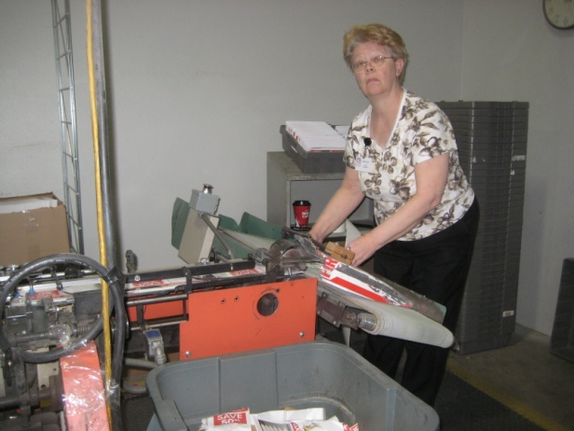  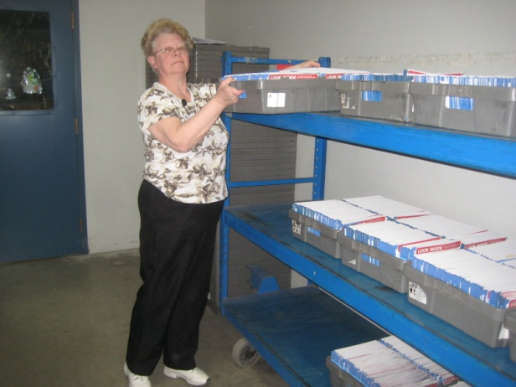
- Transport blue carts (% of Shift: 1%)  - Once full, two individuals manually transport the cart from the inserter room to the staging area outside the insert room.  - 45# of force required to initiate cart movement and about 15# of force to sustain it.  - Distance transported is about 50 to 75’.  - One cart is transported about every 2.5 hours. | 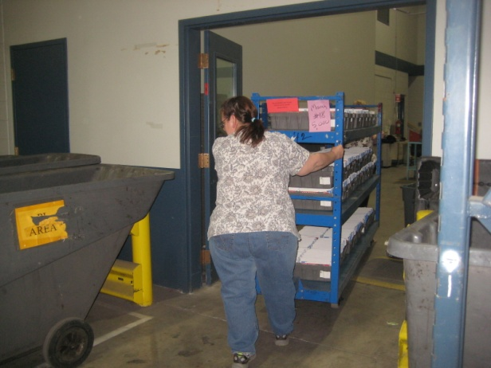
- Move garbage tubs and dump small garbage can into garbage tub (% of Shift: 1%)  - About 2 times per day moves garbage tubs from insert room to right outside the room.  - Requires about 10# of force to initiate tub movement and 5# of force to sustain movement.  - 1 to 2 times/day manually dumps small garbage can (about 15 to 17# when full) into the garbage tub. |  | 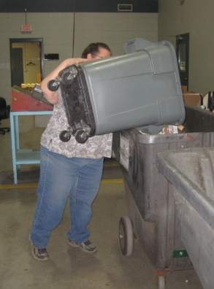

Physical Factors

Manual Material Handling
(lbs) | Floor-Knuckle (0” to 30”) |  |  |  |  |  | Knuckle-Chest (30” to 50’) |  |  |  |  |  | Chest-Overhead  ( > 50”) |  |  |  |  |  | Carry - Two Hands; Front |  |  |  |  |  | Carry - One Hand; Side |  |  |  |  |  | Push |  |  |  |  |  | Pull
100
75 |  |  |  |  |  |  |  |  |  |  |  |  |  |  |  |  |  |  |  |  |  |  |  |  |  |  |  |  |  |  |  | 60# |  |  |  |  |  | 60#
50
25
15
10
5
0
Exp | N | R | O | F | C |  | N | R | O | F | C |  | N | R | O | F | C |  | N | R | O | F | C |  | N | R | O | F | C |  | N | R | O | F | C |  | N | R | O | F | C

Postures/Movements |  |  |  |  |  |  |  |  |  |  |  |  |  |  |  | Head/Neck
Exp | Sit | Stand | Walk | Bal | Stairs | Lad-der | Foot contrl | Twist Waist | Bend Waist | Squat | Kneel | Crawl | Reach below 54” | Reach above 54” |  | Flex Static | Ext Static | Rot Static | Flex Dyn | Ext Dyn | Rot Dyn
C
F
O
R
N

Hand Use |  |  |  |  | Sensory |  |  |  |  |  | Communication |  |  |  |  | Key C - Continuous: 67 to 100% of shift  F - Frequent: 34 to 66% of shift  O - Occasional: 6 to 33% of shift  R - Rarely: up to 5% of shift  N - Never: 0% of shift  Abbreviations: Bal=Balance, Exp=Exposure, Contrl=Control, Flex=Flexion, Ext=Extension, Dyn=Dynamic, Manip=Manipulation
Exp | Simple Grasp | Firm Grasp | Fine Manip | Bal | See | Hear | Touch Feel | Taste | Smell |  | Talk | Read | Write | Hand Signal
C
F
O
R
N

Environmental Factors | Exposure Level |  |  |  |  | Key/Comments
 | N | R | O | F | C
Outdoor Work |  |  |  |  |  | Key C - Continuous: 67 to 100% of shift  F - Frequent: 34 to 66% of shift  O - Occasional: 6 to 33% of shift  R - Rarely: up to 5% of shift  N - Never: 0% of shift  Comments:  Indoor Work: Primary work area is a large indoor warehouse complex.  Noise Sampling:  Jeff Wolseth conducted a 30 min noise sampling study on 03-12-14 in conjunction with this functional evaluation. He used a calibrated CEL-231 dosimeter to perform various noise “spot checks” in the employees hearing zone. Results are as follows  - Inside work room main entrance (75.4 dba – 77.2dba ).  - North employee work area / machine running at capacity (80.5 dba – 82.1 dba) (both machines running at same time).  - South employee work area / machine running at capacity (79.5 dba – 81.3 dba) (both machines running at same time).  - Main work room near back doorway , near product stock room ( 75.0 dba – 76.8 dba.
Indoor Work
Heat
Cold
Wet/ Humid
Hearing Protection
Vibration
Fumes/Gases/Orders
Dust (paper)
Moving Objects
Electrical
Chemical
Protected Work Heights
Unprotected Work Heights
Flying Debris
Lighting (Inadequate/Excessive)

Position eligible to be considered for temporary modification in conjunction with a Return to Work transitional duty program agreement: Yes
This Functional Job Description was completed through an on-site job analysis by a certified professional ergonomist/licensed physical therapist. It is for the purpose of identifying and quantifying the physical functional requirements of this job. The Functional Job Description should not be construed as a detailed description of all specific job duties and/or tools, equipment and materials that may be necessary or incidental to the performance of this job. Further consideration may be necessary when applying the standards to the injured population in the medical management process.
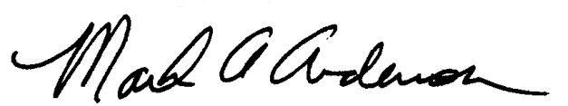 | 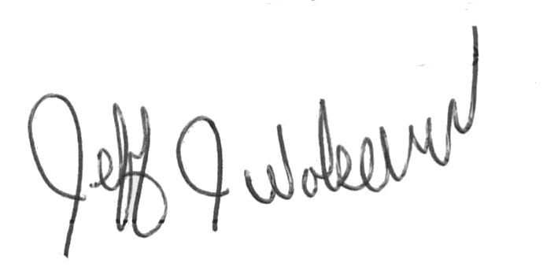  This Functional Job Description has been reviewed by company representatives and is believed to be an accurate representation of most of the job content.
Mark A Anderson, MA, PT CPE  Certified Professional Economist  Licensed Physical Therapist  ErgoSystems Consulting Group, Inc.  19285 Shady Hills Road  Minneapolis, MN 55331  952-401-9296  mark.anderson@ergosystemsconsulting.com  www.ergosystemsconsulting.com | _______________________________________
Jeff Wolseth
Manager – Occupational Safety and Health

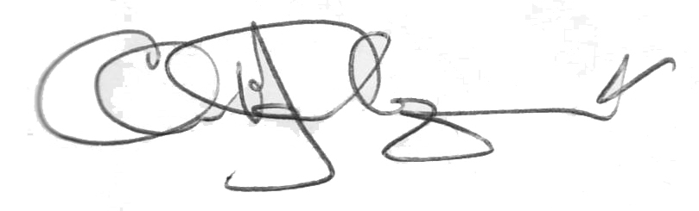
_______________________________________
Chris Lindquist
Manager – Order Processing Manager

