Functional Job Description: Packer

Company: | Bluestem Brands, Inc. | 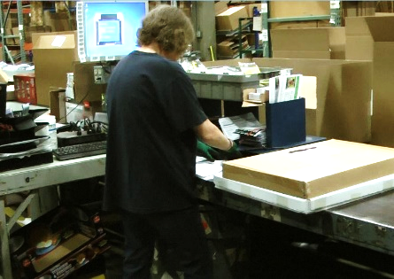 | 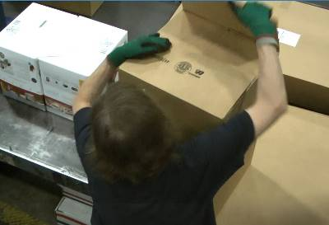
Job Title: | Packer
Date: | 6-16-2016
Dept/Facility: | West DC, St. Cloud, MN
Product Section: | Outbound
Electronic Doc. # | FJD Packer 6-2016 DRAFT

Work Hours | Overtime: | Voluntary and/or mandatory per production requirements. | Breaks: | 10 minutes every two hours, one 30 minute lunch break.
 | Shift: | Days of week: | Time:
 | First | Monday-Friday | 7:00 AM to 3:30 PM

Job Rotation | Yes

Job Training or Credentials Required at Hire | Education/ training: | None required; high school diploma or GED preferred.
 | Knowledge/ cognitive skills: | Basic math, reading, writing and oral communication skills preferred. Ability to organize work tasks and work independently or as part of a team.

Machines, Tools and/or Equipment Used | Hand held scanner, hand taper, PC, pens, markers, knife, scissors, staple puller, pallet jack.

Job Purpose/ Objectives | Combines all merchandise and written materials into a package (box or poly bag) that is sent to the customer.

Safety and Personal Protective Equipment Required  *Available | Hard Hat | Steel Toe Footwear | Safety Glasses | Gloves:
 | Face Shield | Protective Clothing | Safety Glasses/Side Shields | Leather
 | Dust Mask | Safety Vest  Fall Protection Harness  Back Support* | Safety Goggles  Hearing Protection*  Compensatory methods to mitigate heat | Rubberized/cloth*  Chemical

Safety/ Equipment Training/ Certification Required | Daily Meeting and Stretch Breaks (includes:) | Industrial Truck Training | OSHA Training (Rules and Regulations)
 | - Safety Topics | EZ-Go | New Hire Safety Orientation
 | - Safety Policies | Walkie-Rider | Right to Know
 | - Questions & Answers | Hand Pallet Jack | Lockout/Tag Out
 | - Review Safety Committee Minutes | Forklift (sit down) | Regulated Materials Training (ORM-D)  Supervisor Safety Updates
 |  | Stand-up Reach Truck
 |  | Order Picker

Functional Job Elements |  |  | % of Shift
- Pull/push cart into workstation  - Cart loaded with product is pulled/pushed about 20 to 40’ into workstation.  - Typical force required to initiate cart movement is 50# with force up to 70# sometimes required.  - Typical force required to sustain cart movement is 25#. | 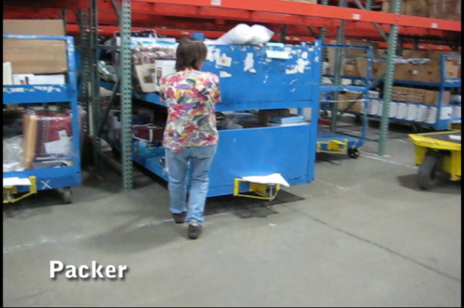 | 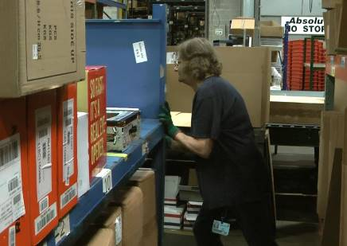 | 3
- Obtain cardboard boxes from storage rack and carry to workstation workbench  - Cardboard boxes are obtained from the storage rack, weight of box is 1 to 2#, 3 or 4 may be carried at one time.  - Box is carried to workbench to be used to pack products. | 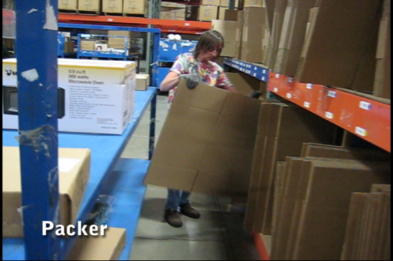 | 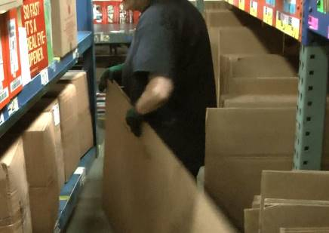 | 4
- Product is packed into box or poly bag and pushed onto conveyor  - Workstation is setup for packing: paperwork, tools in place, poly bags staged on storage shelf, etc.  - Box is staged on workbench.  - Product may be removed from master carton.  - Product is carried from cart to workbench.  - Cart shelf heights are 12” and 42” from floor.  - Workbench height is 36” from floor. Some user adjustable workbenches are being added (at this time less than 10%).  - Product is packed in box/poly bag; box/poly bag is positioned/ repositioned on workbench to facilitate packing.  - Depending on product size over-shoulder lifting may be required.  - Individual product weight ranges from 1# to 50#.  - Average individual product weight is 8#.  - Paper work is placed into box.  - Label is placed on package.  - Box is pushed onto the conveyor. | 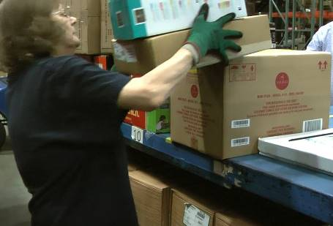 | 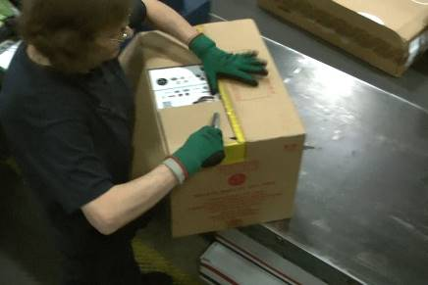 | 90
 | 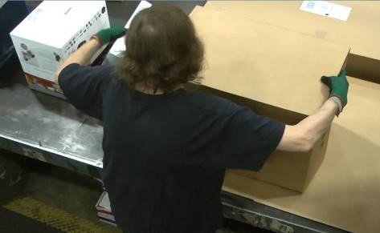 | 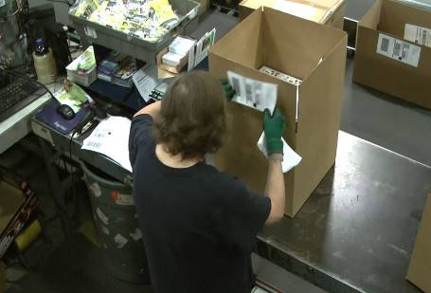
 | 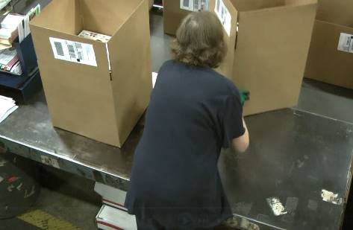 | 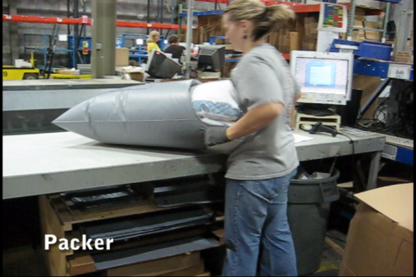
- Push empty cart out of workstation  - Once cart has been emptied it is pushed out of the workstation and returned to the cart holding area.  - About 20# force is needed to initiate cart movement.  - About 10# is needed to sustain cart movement. | 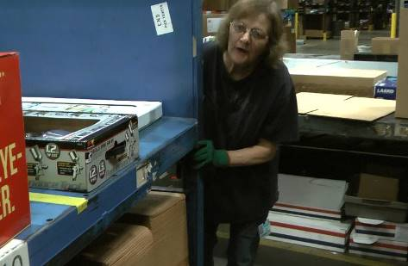 | 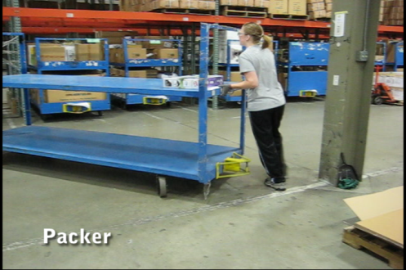 | 3

Physical Factors
Manual Material Handling
(lbs) | Floor-Knuckle (0” to 30”) |  |  |  |  |  | Knuckle-Chest (30” to 50’) |  |  |  |  |  | Chest-Overhead  ( > 50”) |  |  |  |  |  | Carry - Two Hands; Front |  |  |  |  |  | Carry - One Hand; Side |  |  |  |  |  | Push |  |  |  |  |  | Pull
75
50
25
15
10
8
5
0
Exp | N | R | O | F | C |  | N | R | O | F | C |  | N | R | O | F | C |  | N | R | O | F | C |  | N | R | O | F | C |  | N | R | O | F | C |  | N | R | O | F | C

Postures/Movements |  |  |  |  |  |  |  |  |  |  |  |  |  |  |  | Head/Neck
Exp | Sit | Stand | Walk | Bal | Stairs | Lad-der | Foot contrl | Twist Waist | Bend Waist | Squat | Kneel | Crawl | Reach below 54” | Reach above 54” |  | Flex Static | Ext Static | Rot Static | Flex Dyn | Ext Dyn | Rot Dyn
C
F
O
R
N

Hand Use |  |  |  |  | Sensory |  |  |  |  |  | Communication |  |  |  |  | Key C - Continuous: 67 to 100% of shift  F - Frequent: 34 to 66% of shift  O - Occasional: 6 to 33% of shift  R - Rarely: up to 5% of shift  N - Never: 0% of shift  Abbreviations: Bal=Balance, Exp=Exposure, Contrl=Control, Flex=Flexion, Ext=Extension, Dyn=Dynamic, Manip=Manipulation
Exp | Simple Grasp | Firm Grasp | Fine Manip | Bal | See | Hear | Touch Feel | Taste | Smell |  | Talk | Read | Write | Hand Signal
C
F
O
R
N

Environmental Factors | Exposure Level |  |  |  |  | Key/Comments
 | N | R | O | F | C
Outdoor Work |  |  |  |  |  | Key C - Continuous: 67 to 100% of shift  F - Frequent: 34 to 66% of shift  O - Occasional: 6 to 33% of shift  R - Rarely: up to 5% of shift  N - Never: 0% of shift  Comments:  Indoor Work: Primary work area is a large indoor warehouse complex.  Moving Objects: Be aware of and avoid moving objects including product and equipment.  Heat: Based on external temperature, occasionally performs job tasks in hot indoor environment; warehouse complex is not air-conditioned. Large fans are used for ventilation.  Climate Control Plan: Ambient temperature in the warehouse is controlled via opening/closing building outside doors as appropriate in conjunction with fan use.
Indoor Work
Heat
Cold
Wet/ Humid
Hearing Protection
Vibration
Fumes/Gases/Orders
Dust
Moving Objects
Electrical
Chemical
Protected Work Heights
Unprotected Work Heights
Flying Debris
Lighting (Inadequate/Excessive)

Position eligible to be considered for temporary modification in conjunction with a Return to Work transitional duty program agreement: Yes
This Functional Job Description was completed through an on-site job analysis by a certified professional ergonomist/licensed physical therapist. It is for the purpose of identifying and quantifying the physical functional requirements of this job. The Functional Job Description should not be construed as a detailed description of all specific job duties and/or tools, equipment and materials that may be necessary or incidental to the performance of this job. Further consideration may be necessary when applying the standards to the injured population in the medical management process.

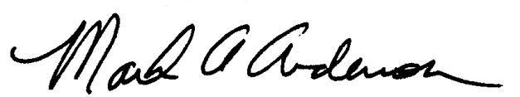 | 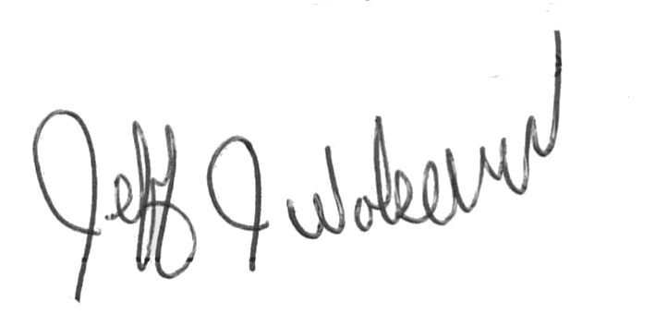  This Functional Job Description has been reviewed by company representatives and is believed to be an accurate representation of most of the job content.
Mark A Anderson, MA, PT CPE  Certified Professional Economist  Licensed Physical Therapist  ErgoSystems Consulting Group, Inc.  19285 Shady Hills Road  Minneapolis, MN 55331  952-401-9296  mark.anderson@ergosystemsconsulting.com  www.ergosystemsconsulting.com | _______________________________________
Jeff Wolseth
Manager - Occupational Safety and Health

 | 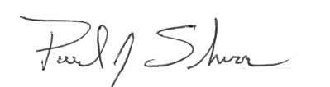
Paul Schroer
Manager – Warehouse Operations

