Functional Job Description: Packer Auto Bagger

Company: | Bluestem Brands, Inc. |  | 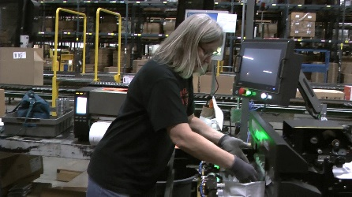
Job Title: | Packer – Auto Bagger
Date: | 2-23-2022
Dept/Facility: | West DC, St. Cloud, MN
Product Section: | Outbound
Electronic Doc. # | FJD Packer Auto Bagger 2-22 FINAL

Work Hours | Overtime: | Voluntary and/or mandatory per production requirements. | Breaks: | 10 minutes every two hours, one 30 minute lunch break.
 | Shift: | Days of week: | Time:
 | First | Monday-Friday | 7:00 AM to 3:30 PM
 | Second | Monday-Friday | 4:00 PM to 12:30 AM

Job Rotation | Yes

Job Training or Credentials Required at Hire | Education/ training: | None required; high school diploma or GED preferred.
 | Knowledge/ cognitive skills: | Basic math, reading, writing and oral communication skills preferred. Ability to organize work tasks and work independently or as part of a team.

Machines, Tools and/or Equipment Used | Auto Bagger, hand held scanner, PC, printer, pens, markers

Job Purpose/ Objectives | Places merchandise and written materials into the Auto Bagger that is sent to the customer.

Safety and Personal Protective Equipment Required  *Available | Hard Hat | Steel Toe Footwear | Safety Glasses | Gloves:
 | Face Shield | Protective Clothing | Safety Glasses/Side Shields | Leather
 | Dust Mask | Safety Vest  Fall Protection Harness  Back Support* | Safety Goggles  Hearing Protection*  Compensatory methods to mitigate heat | Rubberized/cloth*  Chemical

Safety/ Equipment Training/ Certification Required | Daily Meeting and Stretch Breaks (includes:) | Industrial Truck Training | OSHA Training (Rules and Regulations)
 | - Safety Topics | EZ-Go | New Hire Safety Orientation
 | - Safety Policies | Walkie-Rider | Right to Know
 | - Questions & Answers | Pallet Jack | Lockout/Tag Out
 | - Review Safety Committee Minutes | Forklift (sit down) | Regulated Materials Training (ORM-D)  Supervisor Safety Updates
 |  | Stand-up Reach Truck
 |  | Order Picker

Functional Job Elements (Refer to video clip for complete details) |  |  | % of Shift
- Pull/push cart into workstation  - Cart loaded with product is pulled/pushed about 20 to 40’ into workstation.  - Typical force required to initiate cart movement is 40# with force up to 50# sometimes required.  - Typical force required to sustain cart movement is 20#. | 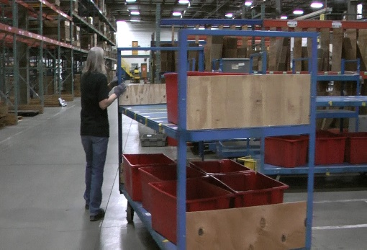 | 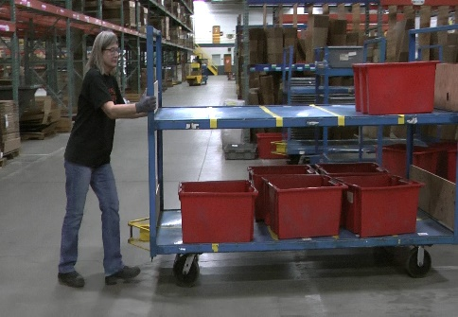 | 3
- Stage red totes on Workbench  - Red totes are manually moved from the blue cart to the workbench (36” height) for processing  - Empty tote weight is 6# and full tote weight is about 20#  - Tote placed on side for access to the contents  - Blue carts with three shelves have heights are about 10, 31 and 53” from the floor  - Blue carts with two shelves have heights at about 12 and 42” from the floor  - Sometimes tote is left on the middle shelf of the 3-shelf cart or top shelf of the 2-shelf cart and processed from there | 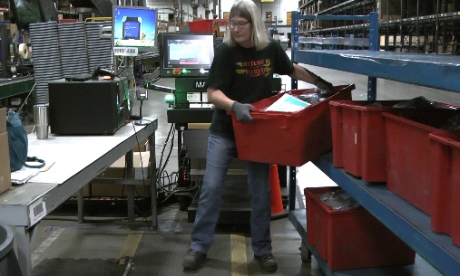 | 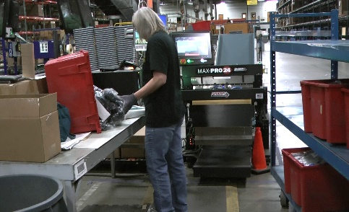 | 4
 | 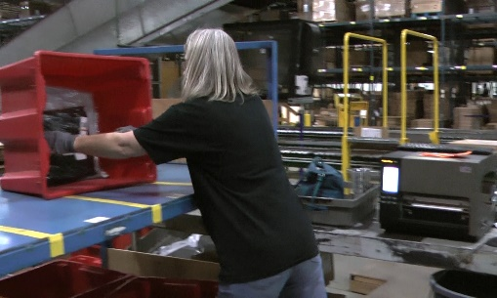 | 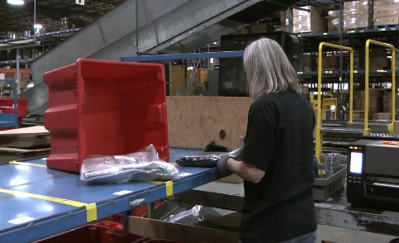
- Product is processed and placed into the Auto Bagger  - Products are scanned with hand held scanner either from the workbench or the cart shelf  - Product is placed into the Auto Bagger  - Bagger insert height is 36”  - Pack slip is removed from the printer (positioned on the workbench) and placed into the Auto Bagger  - Individual product weight ranges from 1# to 3#.  - Average individual product weight is 2#. | 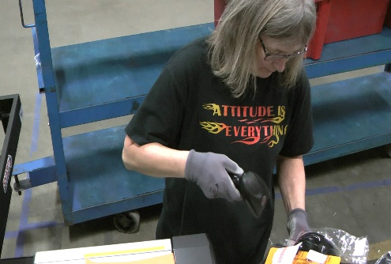 | 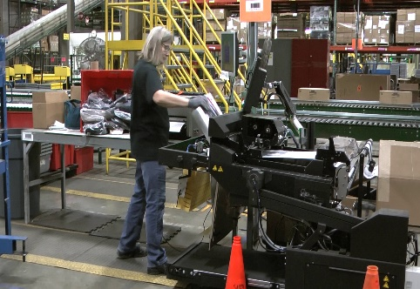 | 90
 | 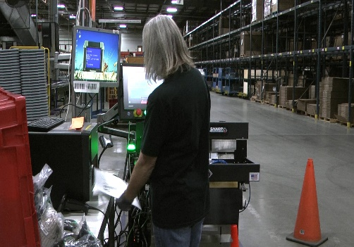 | 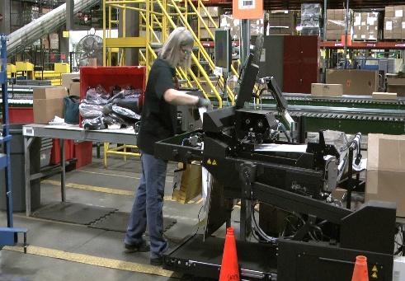
- Push empty cart out of workstation  - Once cart has been emptied it is pushed out of the workstation and returned to the cart holding area.  - About 20# force is needed to initiate cart movement.  - About 10# is needed to sustain cart movement. | 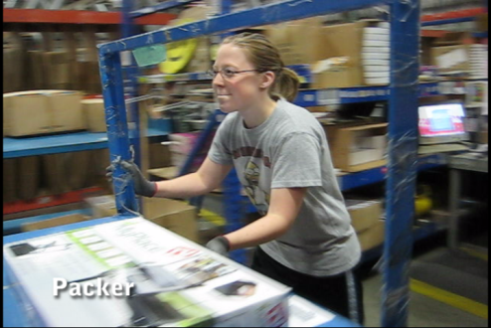 | 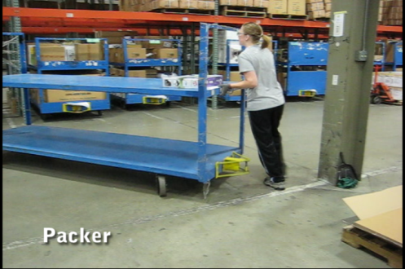 | 3

Physical Factors
Manual Material Handling
(lbs) | Floor-Knuckle (0” to 30”) |  |  |  |  |  | Knuckle-Chest (30” to 50’) |  |  |  |  |  | Chest-Overhead  ( > 50”) |  |  |  |  |  | Carry - Two Hands; Front |  |  |  |  |  | Carry - One Hand; Side |  |  |  |  |  | Push |  |  |  |  |  | Pull
100
75
50
20
15
3
2
0
Exp | N | R | O | F | C |  | N | R | O | F | C |  | N | R | O | F | C |  | N | R | O | F | C |  | N | R | O | F | C |  | N | R | O | F | C |  | N | R | O | F | C

Postures/Movements |  |  |  |  |  |  |  |  |  |  |  |  |  |  |  | Head/Neck
Exp | Sit | Stand | Walk | Bal | Stairs | Lad-der | Foot contrl | Twist Waist | Bend Waist | Squat | Kneel | Crawl | Reach below 54” | Reach above 54” |  | Flex Static | Ext Static | Rot Static | Flex Dyn | Ext Dyn | Rot Dyn
C
F
O
R
N

Hand Use |  |  |  |  | Sensory |  |  |  |  |  | Communication |  |  |  |  | Key C - Continuous: 67 to 100% of shift  F - Frequent: 34 to 66% of shift  O - Occasional: 6 to 33% of shift  R - Rarely: up to 5% of shift  N - Never: 0% of shift  Abbreviations: Bal=Balance, Exp=Exposure, Contrl=Control, Flex=Flexion, Ext=Extension, Dyn=Dynamic, Manip=Manipulation
Exp | Simple Grasp | Firm Grasp | Fine Manip | Bal | See | Hear | Touch Feel | Taste | Smell |  | Talk | Read | Write | Hand Signal
C
F
O
R
N

Environmental Factors | Exposure Level |  |  |  |  | Key/Comments
 | N | R | O | F | C
Outdoor Work |  |  |  |  |  | Key C - Continuous: 67 to 100% of shift  F - Frequent: 34 to 66% of shift  O - Occasional: 6 to 33% of shift  R - Rarely: up to 5% of shift  N - Never: 0% of shift  Comments:  Indoor Work: Primary work area is a large indoor warehouse complex.  Moving Objects: Be aware of and avoid moving objects including product and equipment.  Heat: Based on external temperature, occasionally performs job tasks in hot indoor environment; warehouse complex is not air-conditioned. Large fans are used for ventilation.
Indoor Work
Heat
Cold
Wet/ Humid
Hearing Protection
Vibration
Fumes/Gases/Orders
Dust
Moving Objects
Electrical
Chemical
Protected Work Heights
Unprotected Work Heights
Flying Debris
Lighting (Inadequate/Excessive)

Position eligible to be considered for temporary modification in conjunction with a Return to Work transitional duty program agreement: Yes
This Functional Job Description was completed through an on-site job analysis by a certified professional ergonomist/physical therapist. It is for the purpose of identifying and quantifying the physical functional requirements of this job. The Functional Job Description should not be construed as a detailed description of all specific job duties and/or tools, equipment and materials that may be necessary or incidental to the performance of this job. Further consideration may be necessary when applying the standards to the injured population in the medical management process.

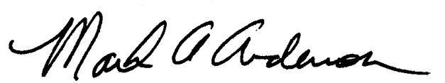 | This Functional Job Description has been reviewed by company representatives and is believed to be an accurate representation of most of the job content.
Mark A. Anderson, MA, PT, CPE  Certified Professional Economist  Physical Therapist  ErgoSystems Consulting, LLC  7421 West Shoreline Drive  Waconia, MN 55387  952-401-9296  mark.anderson@ergosystemsconsulting.com  www.ergosystemsconsulting.com | 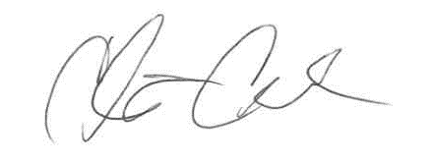  _______________________________________
Chris Condon
Supervisor - Safety, Security and Facilities

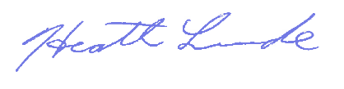
_______________________________________
Heath Lunde
Manager - Outbound Operations

