Functional Job Description: Picker

Company: | Bluestem Brands, Inc. | 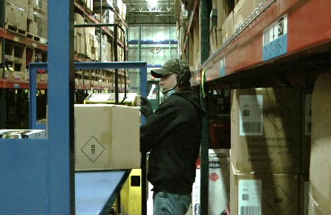 | 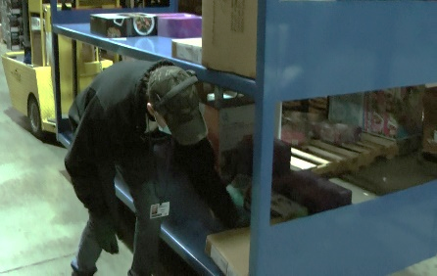
Job Title: | Picker
Date: | 2-23-2022
Dept/Facility: | West DC, St. Cloud, MN
Product Section: | Outbound
Electronic Doc. # | FJD Picker 2-22 FINAL

Work Hours | Overtime: | Voluntary and/or mandatory per production requirements. | Breaks: | 10 minutes every two hours, one 30 minute lunch break.
 | Shift: | Days of week: | Time:
 | First | Monday-Friday | 7:00 AM to 3:30 PM
 | Second | Monday-Friday | 4:00 PM to 12:30 AM

Job Rotation | Yes

Job Training or Credentials Required at Hire | Education/ training: | None required; high school diploma or GED preferred.
 | Knowledge/ cognitive skills: | Basic math, reading, writing and oral communication skills preferred. Ability to organize work tasks and work independently or as part of a team.

Machines, Tools and/or Equipment Used | Pick to voice headset, hand held scanner, hand taper, pens, markers, knife, scissors, EZ-Go, cart.

Job Purpose/ Objectives | Working from a pick list (Pick to Voice Headset (NOTE: handheld scanner was observed in use by one Picker), pick merchandise from storage racks in the warehouse that can be conveyed on the sortation system. Operate an EZ-Go pulling a cart to transport picked merchandise.

Safety and Personal Protective Equipment Required  *Available | Hard Hat | Steel Toe Footwear | Safety Glasses | Gloves:
 | Face Shield | Protective Clothing | Safety Glasses/Side Shields | Leather
 | Dust Mask | Safety Vest  Fall Protection Harness  Back Support* | Safety Goggles  Hearing Protection*  Compensatory methods to mitigate heat | Rubberized/cloth*  Chemical

Safety/ Equipment Training/ Certification Required | Daily Meeting and Stretch Breaks (includes:) | Industrial Truck Training | OSHA Training (Rules and Regulations)
 | - Safety Topics | EZ-Go | New Hire Safety Orientation
 | - Safety Policies | Walkie-Rider | Right to Know
 | - Questions & Answers | Pallet Jack | Lockout/Tag Out
 | - Review Safety Committee Minutes | Forklift (sit down) | Regulated Materials Training (ORM-D)  Supervisor Safety Updates
 |  | Stand-up Reach Truck
 |  | Order Picker

Functional Job Elements (Refer to video clip for complete details) |  |  | % of Shift
- Prep equipment and materials  - Prep equipment and materials.  - Hook up cart to EZ-GO.  - Drive to first pick point in the warehouse. | 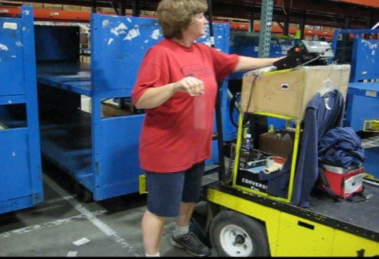 | 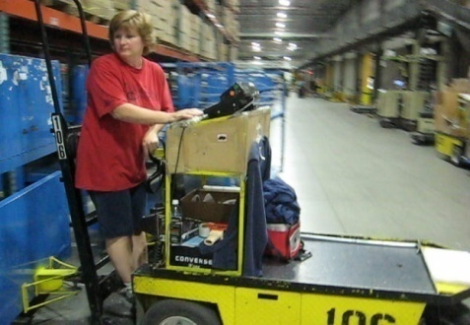 | 5
- Pick merchandise  - Operate the EZ-GO with cart attached throughout the warehouse to pick merchandise.  - A Pick to Voice Headset is typically used, this allows for hands-free operation.  - Note a handheld scanner was used by one picker  - Merchandise is obtained from the master carton on the shelf and placed on the cart.  - Shelf heights are pallets on the floor (5”) and about 81”.  - Cart shelf heights are 12” and 42”.  - Items weight ranges from 1# to 50#.  - Average item weight is 2.75#.  - A knife is used to cut open the master carton to remove merchandise.  - A ladder on the EZ-Go is used to obtain access to the top shelf if needed  - A reach stick is used to pull higher items down to within reach range.  - A reach stick used to pull out items from the back of master cartons.  - A yellow one step stool is available. |  | 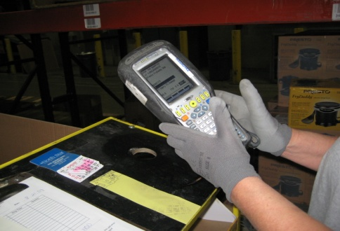 | 90
 |  | 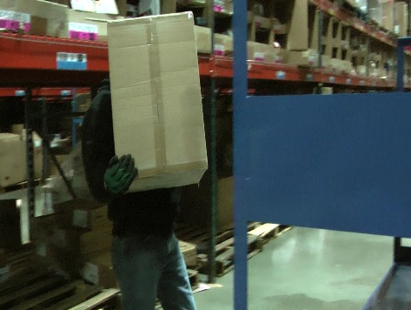
 | 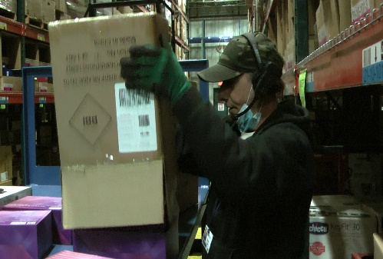 | 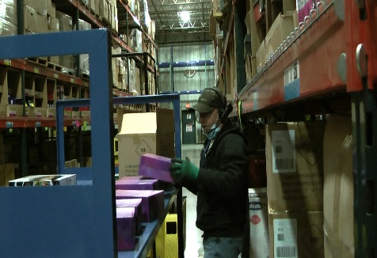
 | 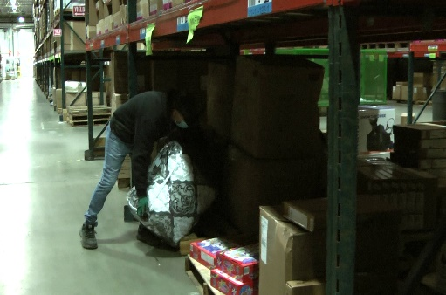
- Deliver cart to Packing  - Once the cart has been filled it is transported to Packing. | 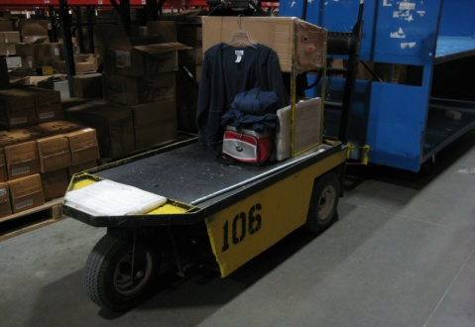 | 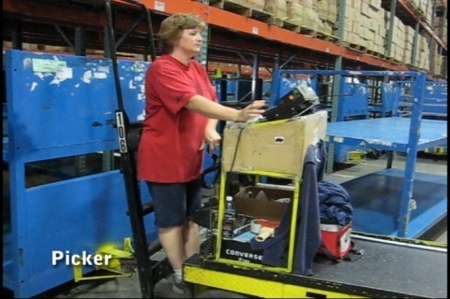 | 5

Physical Factors
Manual Material Handling
(lbs) | Floor-Knuckle (0” to 30”) |  |  |  |  |  | Knuckle-Chest (30” to 50’) |  |  |  |  |  | Chest-Overhead  ( > 50”) |  |  |  |  |  | Carry - Two Hands; Front |  |  |  |  |  | Carry - One Hand; Side |  |  |  |  |  | Push |  |  |  |  |  | Pull
100
75
50
25
15
10
3
0
Exp | N | R | O | F | C |  | N | R | O | F | C |  | N | R | O | F | C |  | N | R | O | F | C |  | N | R | O | F | C |  | N | R | O | F | C |  | N | R | O | F | C

Postures/Movements |  |  |  |  |  |  |  |  |  |  |  |  |  |  |  | Head/Neck
Exp | Sit | Stand | Walk | Bal | Stairs | Lad-der | Foot contrl | Twist Waist | Bend Waist | Squat | Kneel | Crawl | Reach below 54” | Reach above 54” |  | Flex Static | Ext Static | Rot Static | Flex Dyn | Ext Dyn | Rot Dyn
C
F
O
R
N

 | Hand Use |  |  |  |  | Sensory |  |  |  |  |  |  |  |  |  |  | Communication |  |  |  |  | Key C - Continuous: 67 to 100% of shift  F - Frequent: 34 to 66% of shift  O - Occasional: 6 to 33% of shift  R - Rarely: up to 5% of shift  N - Never: 0% of shift  Abbreviations: Bal=Balance, Exp=Exposure, Contrl=Control, Flex=Flexion, Ext=Extension, Dyn=Dynamic, Manip=Manipulation
 | Exp | Simple Grasp | Firm Grasp | Fine Manip | Bal | See | Hear |  | Touch Feel |  | Taste |  |  | Smell |  |  | Talk | Read | Write | Hand Signal
 | C
 | F
 | O
 | R
 | N
Environmental Factors |  |  |  |  |  |  |  | Exposure Level |  |  |  |  |  |  |  | Key/Comments
 |  |  |  |  |  |  |  | N |  | R |  | O | F |  | C
Outdoor Work |  |  |  |  |  |  |  |  |  |  |  |  |  |  |  | Key C - Continuous: 67 to 100% of shift  F - Frequent: 34 to 66% of shift  O - Occasional: 6 to 33% of shift  R - Rarely: up to 5% of shift  N - Never: 0% of shift  Comments:  Indoor Work: Primary work area is a large indoor warehouse complex.  Moving Objects: Be aware of and avoid moving objects including equipment.  Heat: Based on external temperature, occasionally performs job tasks in hot indoor environment; warehouse complex is not air-conditioned. Large fans are used for ventilation.
Indoor Work
Heat
Cold
Wet/ Humid
Hearing Protection
Vibration
Fumes/Gases/Orders
Dust
Moving Objects
Electrical
Chemical
Protected Work Heights
Unprotected Work Heights
Flying Debris
Lighting (Inadequate/Excessive)

Position eligible to be considered for temporary modification in conjunction with a Return to Work transitional duty program agreement: Yes
This Functional Job Description was completed through an on-site job analysis by a certified professional ergonomist/physical therapist. It is for the purpose of identifying and quantifying the physical functional requirements of this job. The Functional Job Description should not be construed as a detailed description of all specific job duties and/or tools, equipment and materials that may be necessary or incidental to the performance of this job. Further consideration may be necessary when applying the standards to the injured population in the medical management process.
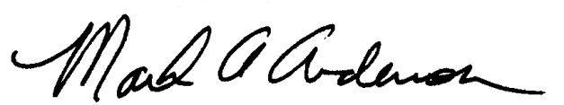 | This Functional Job Description has been reviewed by company representatives and is believed to be an accurate representation of most of the job content.
Mark A. Anderson, MA, PT, CPE  Certified Professional Economist  Physical Therapist  ErgoSystems Consulting, LLC.  7421 West Shoreline Drive  Waconia, MN 55387  952-401-9296  mark.anderson@ergosystemsconsulting.com  www.ergosystemsconsulting.com | 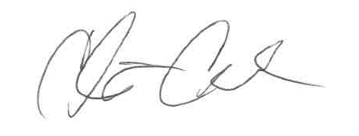  _______________________________________
Chris Condon
Supervisor - Safety, Security and Facilities

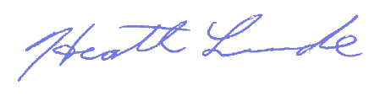
_______________________________________
Heath Lunde
Manager - Outbound Operations

