Functional Job Description: Picker-Nonconvey

Company: | Fingerhut Fulfillment, Inc. | 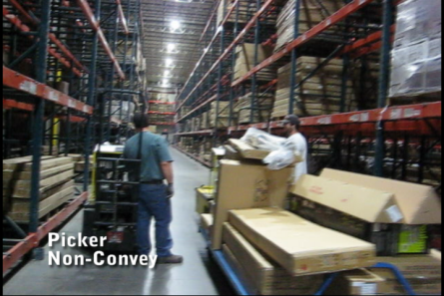 | 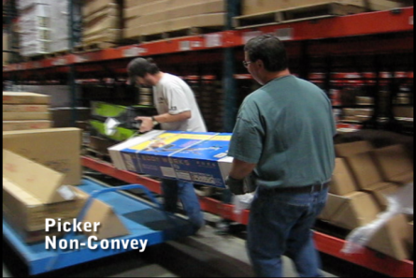
Job Title: | Picker-Nonconvey
Date: | 9/28/2009
Dept/Facility: | West DC, St. Cloud, MN
Product Section: | Outbound
Electronic Doc. # | FJD Picker Nonconvey 9-2009 FINAL

Work Hours | Overtime: | Voluntary and/or mandatory per production requirements. | Breaks: | 10 minutes every two hours, one 30 minute lunch break.
 | Shift: | Days of week: | Time:
 | First | Monday-Friday | 7:00 AM to 3:30 PM
 | Second | Monday-Friday | 4:00 PM to 12:30 AM

Job Rotation | Yes

Job Training or Credentials Required at Hire | Education/ training: | None required; high school diploma or GED preferred.
 | Knowledge/ cognitive skills: | Basic math, reading, writing and oral communication skills preferred. Ability to organize work tasks and work independently or as part of a team.

Machines, Tools and/or Equipment Used | Scanner, hand taper, PC, pens, markers, knife, scissors, EZ-Go, cart, pallet jack.

Job Purpose/ Objectives | Working in a team of two individuals from a pick list (scanner), pick merchandise from storage racks in the warehouse that cannot be conveyed on the sortation system. One person operates an EZ-Go pulling a cart to transport picked merchandise. Other person operates an EZ-Go.

Safety and Personal Protective Equipment Required  *Available | Hard Hat | Steel Toe Footwear | Safety Glasses | Gloves:
 | Face Shield | Protective Clothing | Safety Glasses/Side Shields | Leather
 | Dust Mask | Safety Vest  Fall Protection Harness  Back Support* | Safety Goggles  Hearing Protection*  Compensatory methods to mitigate heat | Rubberized/cloth*  Chemical

Safety/ Equipment Training/ Certification Required |  | Daily Meeting and Stretch Breaks (includes:) |  | Industrial Truck Training |  | OSHA Training (Rules and Regulations)
 |  | - Safety Topics |  | EZ-Go |  | New Hire Safety Orientation
 |  | - Safety Policies |  | Walkie-Rider |  | Right to Know
 |  | - Questions & Answers |  | Pallet Jack |  | Lockout/Tag Out
 |  | - Review Safety Committee Minutes |  | Forklift (sit down) |  | Regulated Materials Training (ORM-D)  Supervisor Safety Updates
 |  |  |  | Stand-up Reach Truck
 |  |  |  | Order Picker
 | Functional Job Elements (Refer to video clip for complete details) |  |  |  |  |  | % of Shift
 | - Prep equipment and materials  - Work in team of two individuals.  - Prep equipment and materials.  - Hook up cart to EZ-G0.  - Drive to first pick point in the warehouse. |  | 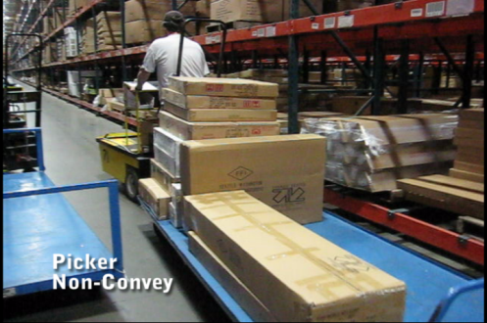 |  | 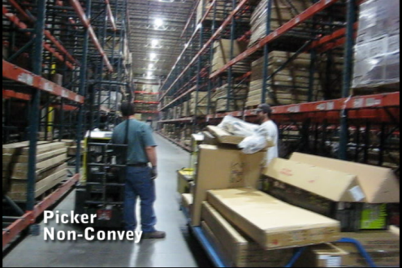 |  | 5
 | - Pick merchandise  - One person operates the EZ-GO with cart attached throughout the warehouse to pick merchandise.  - A scanner is used to guide the pick process.  - Merchandise is obtained from the pallets on the floor, labeled and placed on the cart.  - Work height is from pallets on the floor (5”).  - Cart shelf height is 12”.  - Depending where the merchandise is located in the racking may need to work under the upper rack to gain access to merchandise.  - Items weight ranges from 1# to 150#.  - Working in a team of two, each individual will manually handle up to 75#.  - Average item weight is 50#.  - A knife is used to cut open the master carton to remove merchandise if needed.  - Often have to manually reorganize merchandise already on the cart so additional merchandise can be added to the cart. |  | 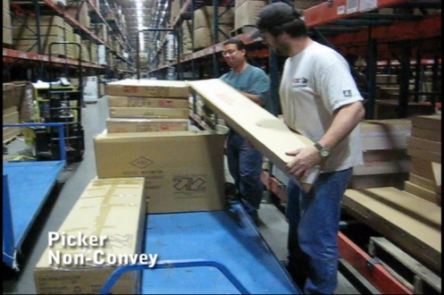 |  | 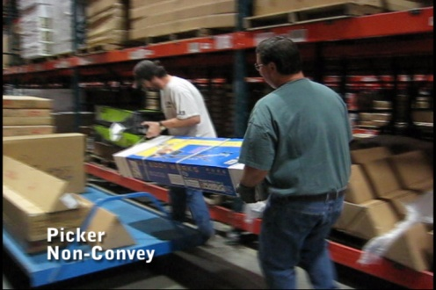 |  | 90
 |  |  | 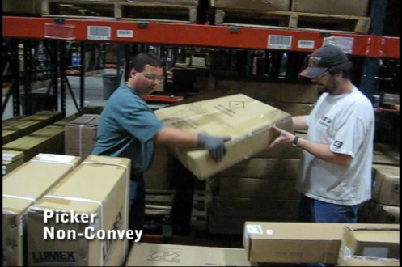 |  | 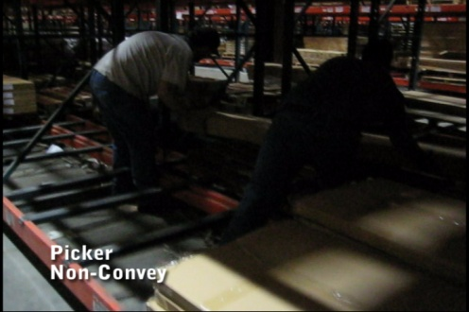
 |  |  | 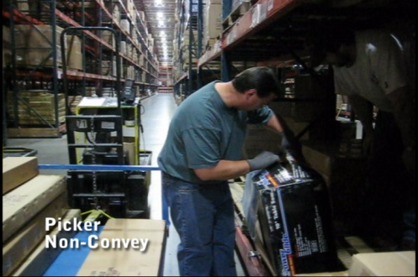 |  | 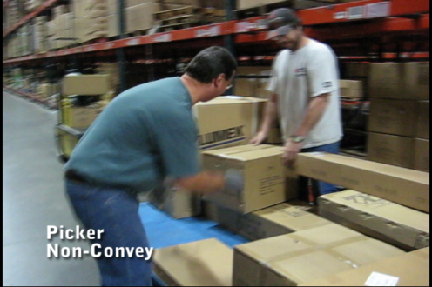
 | - Deliver cart to Packing-Nonconvey  - Once the pick order has been completed the cart is transported to Packing-Nonconvey. |  |  |  |  |  | 5

Physical Factors
Manual Material Handling
(lbs) | Floor-Knuckle (0” to 30”) |  |  |  |  |  | Knuckle-Chest (30” to 50’) |  |  |  |  |  | Chest-Overhead  ( > 50”) |  |  |  |  |  | Carry - Two Hands; Front |  |  |  |  |  | Carry - One Hand; Side |  |  |  |  |  | Push |  |  |  |  |  | Pull
100
75
50
25
15
10
5
0
Exp | N | R | O | F | C |  | N | R | O | F | C |  | N | R | O | F | C |  | N | R | O | F | C |  | N | R | O | F | C |  | N | R | O | F | C |  | N | R | O | F | C

Postures/Movements |  |  |  |  |  |  |  |  |  |  |  |  |  |  |  | Head/Neck
Exp | Sit | Stand | Walk | Bal | Stairs | Lad-der | Foot contrl | Twist Waist | Bend Waist | Squat | Kneel | Crawl | Reach below 54” | Reach above 54” |  | Flex Static | Ext Static | Rot Static | Flex Dyn | Ext Dyn | Rot Dyn
C
F
O
R
N

Hand Use |  |  |  |  | Sensory |  |  |  |  |  | Communication |  |  |  |  | Key C - Continuous: 67 to 100% of shift  F - Frequent: 34 to 66% of shift  O - Occasional: 6 to 33% of shift  R - Rarely: up to 5% of shift  N - Never: 0% of shift  Abbreviations: Bal=Balance, Exp=Exposure, Contrl=Control, Flex=Flexion, Ext=Extension, Dyn=Dynamic, Manip=Manipulation
Exp | Simple Grasp | Firm Grasp | Fine Manip | Bal | See | Hear | Touch Feel | Taste | Smell |  | Talk | Read | Write | Hand Signal
C
F
O
R
N

Environmental Factors | Exposure Level |  |  |  |  | Key/Comments
 | N | R | O | F | C
Outdoor Work |  |  |  |  |  | Key C - Continuous: 67 to 100% of shift  F - Frequent: 34 to 66% of shift  O - Occasional: 6 to 33% of shift  R - Rarely: up to 5% of shift  N - Never: 0% of shift  Comments:  Indoor Work: Primary work area is a large indoor warehouse complex.  Moving Objects: Be aware of and avoid moving objects including equipment.  Heat: Based on external temperature, occasionally performs job tasks in hot indoor environment; warehouse complex is not air-conditioned. Large fans are used for ventilation.
Indoor Work
Heat
Cold
Wet/ Humid
Hearing Protection
Vibration
Fumes/Gases/Orders
Dust
Moving Objects
Electrical
Chemical
Protected Work Heights
Unprotected Work Heights
Flying Debris
Lighting (Inadequate/Excessive)

Position eligible to be considered for temporary modification in conjunction with a Return to Work transitional duty program agreement: Yes
This Functional Job Description was completed through an on-site job analysis by a certified professional ergonomist/licensed physical therapist. It is for the purpose of identifying and quantifying the physical functional requirements of this job. The Functional Job Description should not be construed as a detailed description of all specific job duties and/or tools, equipment and materials that may be necessary or incidental to the performance of this job. Further consideration may be necessary when applying the standards to the injured population in the medical management process
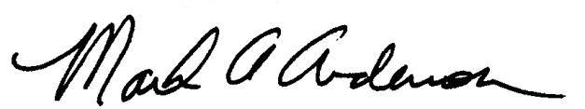 | 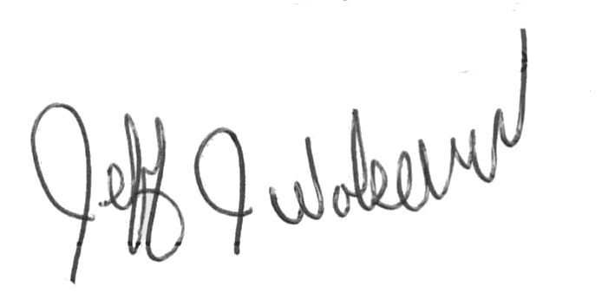  This Functional Job Description has been reviewed by company representatives and is believed to be an accurate representation of most of the job content.
Mark A Anderson, MA, PT CPE  Certified Professional Economist  Licensed Physical Therapist  ErgoSystems Consulting Group, Inc.  19285 Shady Hills Road  Minneapolis, MN 55331  952-401-9296  mark.anderson@ergosystemsconsulting.com  www.ergosystemsconsulting.com | _______________________________________
Jeff Wolseth
Manager - Occupational Safety and Health
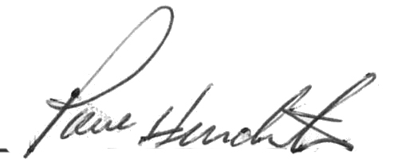
 | _______________________________________
Paul Hendrickson
Manager - Outbound Operations

