Functional Job Description: Returns Processor

Company: | Fingerhut Fulfillment, Inc. | 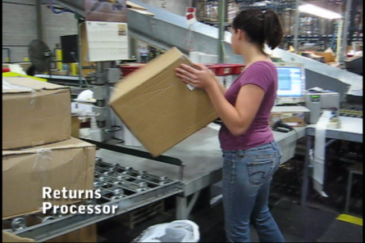 | 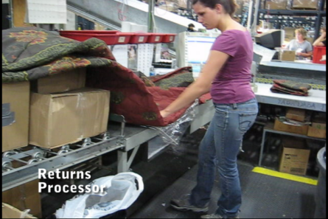
Job Title: | Returns Processor
Date: | 9/28/2009
Dept/Facility: | West DC, St. Cloud, MN
Product Section: | Returns
Electronic Doc. # | FJD Returns Processor  9-2009 FINAL

Work Hours | Overtime: | Voluntary and/or mandatory per production requirements. | Breaks: | 10 minutes every two hours, one 30 minute lunch break.
 | Shift: | Days of week: | Time:
 | First | Monday-Friday | 6:00 AM to 2:30 PM

Job Rotation | Yes

Job Training or Credentials Required at Hire | Education/ training: | None required; high school diploma or GED preferred.
 | Knowledge/ cognitive skills: | Basic math, reading, writing and oral communication skills preferred. Ability to organize work tasks and work independently or as part of a team.

Machines, Tools and/or Equipment Used | Hand held scanner, hand taper, PC, pens, markers, knife, scissors, staple puller, foot pump hydraulic lift table, label printer.

Job Purpose/ Objectives | Processes merchandise returns for final disposition.

Safety and Personal Protective Equipment Required  *Available | Hard Hat | Steel Toe Footwear | Safety Glasses | Gloves:
 | Face Shield | Protective Clothing | Safety Glasses/Side Shields | Leather
 | Dust Mask | Safety Vest  Fall Protection Harness  Back Support* | Safety Goggles  Hearing Protection*  Compensatory methods to mitigate heat | Rubberized/cloth*  Chemical

Safety/ Equipment Training/ Certification Required | Daily Meeting and Stretch Breaks (includes:) | Industrial Truck Training | OSHA Training (Rules and Regulations)
 | - Safety Topics | EZ-Go | New Hire Safety Orientation
 | - Safety Policies | Walkie-Rider | Right to Know
 | - Questions & Answers | Pallet Jack | Lockout/Tag Out
 | - Review Safety Committee Minutes | Forklift (sit down) | Regulated Materials Training (ORM-D)  Supervisor Safety Updates
 |  | Stand-up Reach Truck
 |  | Order Picker

Functional Job Elements (Refer to video clip for complete details) |  |  | % of Shift
- Move merchandise from conveyor onto workbench  - Merchandise is manually moved from conveyor onto workbench (height: 33”).  - Weight up to 50#.  - Average weight: 15#.  - Foot pump hydraulic lift cart is available to transfer heavier materials. | 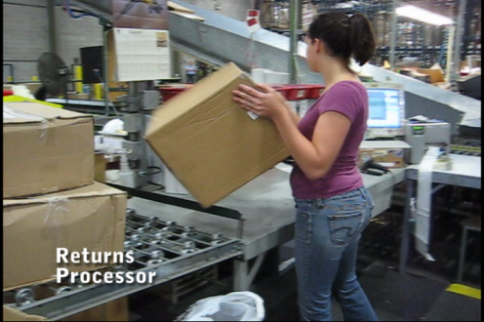 | 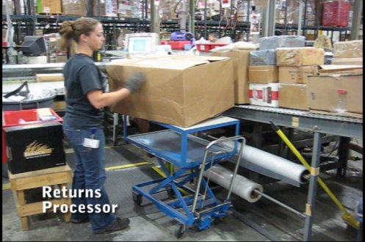 | 25
- Process return  - Box is cut open with knife.  - Paper work is processed.  - Customer information is input into the PC.  - Contents are removed.  - Contents are inspected. |  | 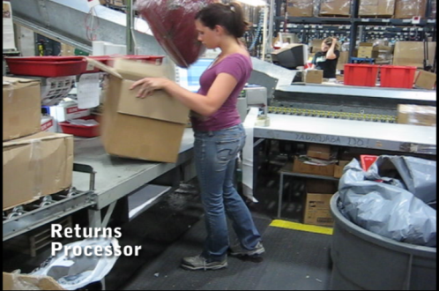 | 50
 | 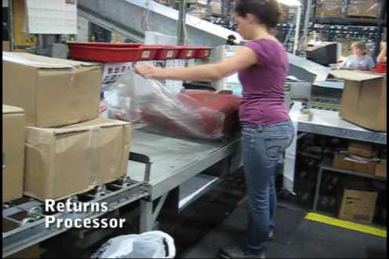 | 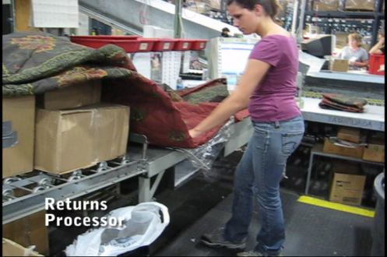
- Merchandise disposition is determined /accomplished  - Merchandise is repacked or disposed of.  - Heat sealer is used, as needed, to seal merchandise in new plastic bags.  - Tote is used to hold smaller items-it is manually lifted onto the conveyor and a new tote is staged.  - Returned merchandise is transported to returns area.  - Trash can in workstation used for trash. When full, handled by line support.  - Shipping box, if not reused, is placed on the conveyor. | 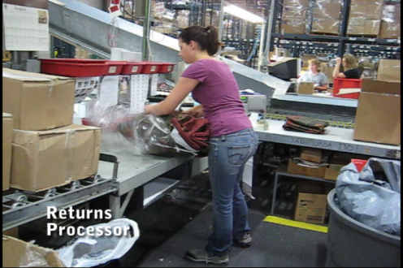 |  | 25
 | 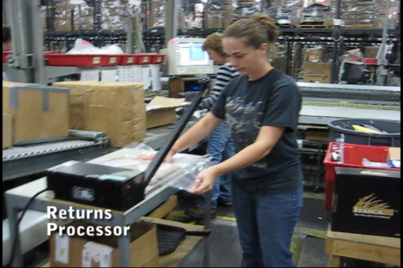 | 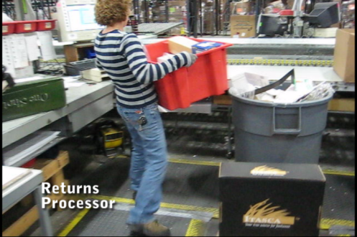

Physical Factors

Manual Material Handling
(lbs) | Floor-Knuckle (0” to 30”) |  |  |  |  |  | Knuckle-Chest (30” to 50’) |  |  |  |  |  | Chest-Overhead  ( > 50”) |  |  |  |  |  | Carry - Two Hands; Front |  |  |  |  |  | Carry - One Hand; Side |  |  |  |  |  | Push |  |  |  |  |  | Pull
100
75
50
25
15
10
5
0
Exp | N | R | O | F | C |  | N | R | O | F | C |  | N | R | O | F | C |  | N | R | O | F | C |  | N | R | O | F | C |  | N | R | O | F | C |  | N | R | O | F | C

Postures/Movements |  |  |  |  |  |  |  |  |  |  |  |  |  |  |  | Head/Neck
Exp | Sit | Stand | Walk | Bal | Stairs | Lad-der | Foot contrl | Twist Waist | Bend Waist | Squat | Kneel | Crawl | Reach below 54” | Reach above 54” |  | Flex Static | Ext Static | Rot Static | Flex Dyn | Ext Dyn | Rot Dyn
C
F
O
R
N

Hand Use |  |  |  |  | Sensory |  |  |  |  |  | Communication |  |  |  |  | Key C - Continuous: 67 to 100% of shift  F - Frequent: 34 to 66% of shift  O - Occasional: 6 to 33% of shift  R - Rarely: up to 5% of shift  N - Never: 0% of shift  Abbreviations: Bal=Balance, Exp=Exposure, Contrl=Control, Flex=Flexion, Ext=Extension, Dyn=Dynamic, Manip=Manipulation
Exp | Simple Grasp | Firm Grasp | Fine Manip | Bal | See | Hear | Touch Feel | Taste | Smell |  | Talk | Read | Write | Hand Signal
C
F
O
R
N

Environmental Factors | Exposure Level |  |  |  |  | Key/Comments
 | N | R | O | F | C
Outdoor Work |  |  |  |  |  | Key C - Continuous: 67 to 100% of shift  F - Frequent: 34 to 66% of shift  O - Occasional: 6 to 33% of shift  R - Rarely: up to 5% of shift  N - Never: 0% of shift  Comments:  Indoor Work: Primary work area is a large indoor warehouse complex.  Moving Objects: Be aware of and avoid moving objects including product and equipment.  Heat: Based on external temperature, occasionally performs job tasks in hot indoor environment; warehouse complex is not air-conditioned. Large fans are used for ventilation.
Indoor Work
Heat
Cold
Wet/ Humid
Hearing Protection
Vibration
Fumes/Gases/Orders
Dust
Moving Objects
Electrical
Chemical
Protected Work Heights
Unprotected Work Heights
Flying Debris
Lighting (Inadequate/Excessive)

Position eligible to be considered for temporary modification in conjunction with a Return to Work transitional duty program agreement: Yes
This Functional Job Description was completed through an on-site job analysis by a certified professional ergonomist/licensed physical therapist. It is for the purpose of identifying and quantifying the physical functional requirements of this job. The Functional Job Description should not be construed as a detailed description of all specific job duties and/or tools, equipment and materials that may be necessary or incidental to the performance of this job. Further consideration may be necessary when applying the standards to the injured population in the medical management process.
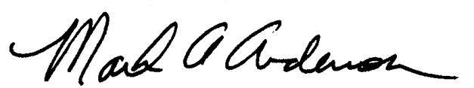 | 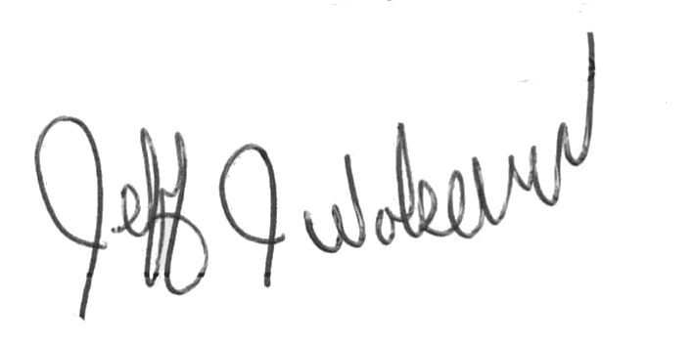  This Functional Job Description has been reviewed by company representatives and is believed to be an accurate representation of most of the job content.
Mark A Anderson, MA, PT CPE  Certified Professional Economist  Licensed Physical Therapist  ErgoSystems Consulting Group, Inc.  19285 Shady Hills Road  Minneapolis, MN 55331  952-401-9296  mark.anderson@ergosystemsconsulting.com  www.ergosystemsconsulting.com | _______________________________________
Jeff Wolseth
Manager - Occupational Safety and Health
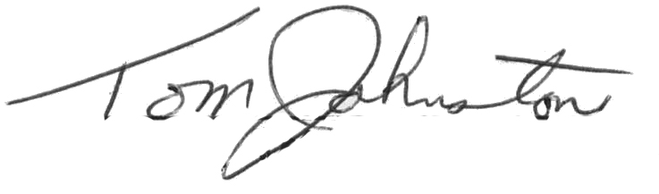
 | _______________________________________
Tom Johnstone
Manager - Returns Operations

