ROUTINE ONE
Neck Side– Arm Behind | Shoulder Roll | Elbow Pull - Hands Up |  | Carpal Tunnel Stretch
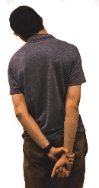 | 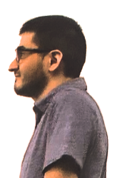 | 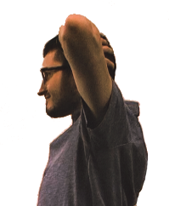 |  | 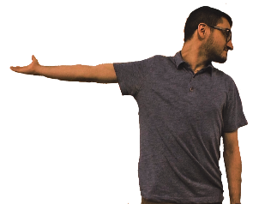
Right arm behind back  Grasp right wrist with left hand and pull arm down  Tip head to left side  Hold for count of 3  Relax stretch and repeat  Switch hand position  Repeat sequence | Roll shoulders forward in a circle four times  Relax shoulders  Roll shoulders backward in a circle four times | Place hands up at head level, pull elbows back and squeeze shoulder blades together  Hold for count of 3  Relax stretch, allow elbows to come forward  Repeat sequence |  | Extend right arm to side, palm rotated up  Rotate head to left  Hold for count of 3  Relax and repeat  Extend left arm to side, palm rotated up  Rotate head to right  Hold for count of 3  Relax and repeat
Trunk Rotation | High Reach – One hand | Slump |  | Back-Bend
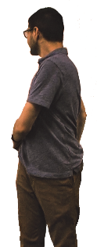 | 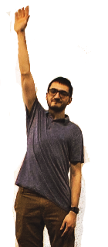 | 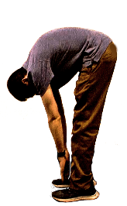 | 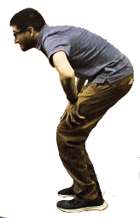 | 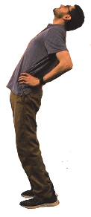
Swing right arm in front and left arm behind back rotating trunk to left  Hold for count of 3  Reverse arm position and rotate to the right  Repeat sequence | Take a deep breath and reach right arm to ceiling  Hold for count of 3  Relax arm to side  Repeat with left arm  Relax arm to side  Repeat sequence | Bend back to carefully reach to floor  Hold for count of 3  Bend knees, look up, pause with hands on knees, drive up with legs to return to neutral  Repeat sequence |  | Place hands at belt line  Bend backward letting head normally follow shoulders  Hold for count of 3  Return to neutral  Repeat sequence

ROUTINE TWO
Neck Side Stretch | Shoulder Shrug | Arm Cross Pull | Wrist/Elbow Arm Out
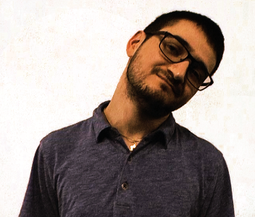 |  | 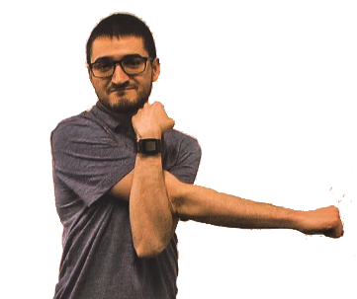 | 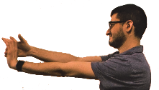
 |  |  | 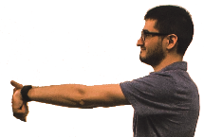
Looking straight ahead, tip head to right and hold for count of 3  Return to neutral  Tip head to left and hold for count of 3  Return to neutral  Repeat sequence | Pull shoulders up to ears  Hold for count of 3  Slowly lower shoulders to return to neutral - don’t drop them - slowly lower them  Repeat sequence | Extend right arm in front with palm down  With left arm pull right arm toward chest  Hold for count of 3  Relax stretch and repeat  Reverse arm position and repeat sequence | Extend left arm  Make fist with left hand and bend left wrist down  Hold for count of 3  Bend left wrist up  Hold for count of 3  Repeat sequence with another arm
Produced for Hennepin County Library by ErgoSystems Consulting Group, Inc. www.ergosystemsconsulting.com Version 020520
ROUTINE TWO (cont.)
Large Arm Circles - Forward | Trunk Rotation | Straddle | Ankle Circles
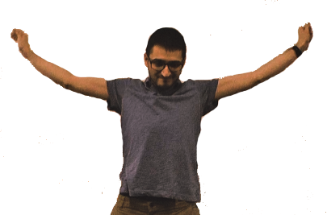 | 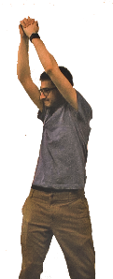 | 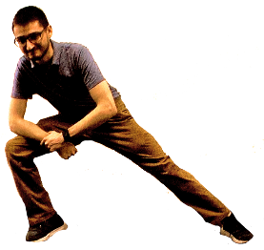 | 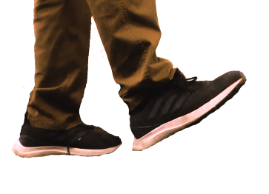
Extend arms out in front, crossing wrists  Take a deep breath, raise arms overhead to make a large circle, exhale on way down to finish circle  Repeat sequence | Reach hands with fingers interlaced overhead  Rotate trunk to right  Hold for count of 3  Rotate to left  Hold for count of 3  Repeat sequence | Extend right leg to side  Support body weight with hand on right hip and bend left knee  Hold for count of 3  Straighten left knee  Repeat stretch  Switch leg position  Repeat sequence | Using support for balance if needed  Circle ankle five times to right and to left five times  Return to neutral position  Lift left foot and circle left ankle to right five times and to left five times

ROUTINE THREE
Neck Rotation | Elbow Pull-Behind Back | Pat Back | Open/Close Hands
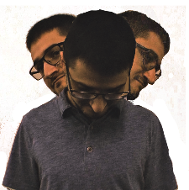 | 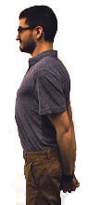 | 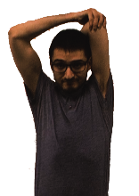 | 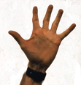 | 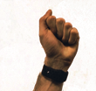
Rotate head to left  Hold for count of 3  Rotate to middle, look down, Hold for count of 3  Rotate head to right, hold for count of 3  Repeat sequence | Hands behind back interlacing fingers  Pull elbows back  Squeeze shoulder blades together  Hold for count of 3  Relax stretch  Repeat sequence | Raise right arm overhead and pat back  Hold for count of 3  Switch arms  Repeat sequence | Start with arms/hands in front of body  Open hands to spread fingers as wide as possible  Close hands to make fists.  Repeat sequence
Large Arm Circles  Backward | Side Stretch  Arms Overhead | High Reach  With Rotation | Heel Cord
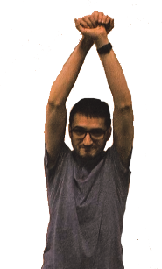 | 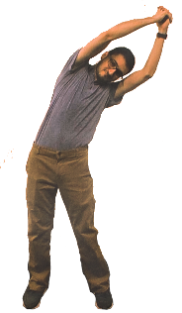 | 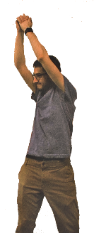 | 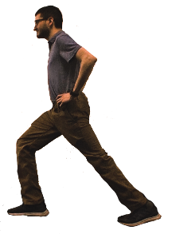
Pull arms back  Take a deep breath  Raise arms overhead to make a large circle  Exhale on way down to finish circle  Repeat sequence | Reach hands to ceiling with fingers interlaced  Bend to right side  Hold for count of 3  Back to middle position  Bend to left side  Hold for count of 3  Repeat sequence | Reach hands with fingers interlaced overhead  Rotate trunk to right  Hold for count of 3  Rotate to left  Hold for count of 3  Repeat sequence | Right foot front, left foot back  Feet pointed straight ahead, head and shoulders upright  Back heel flat, bend front knee, hold for count of 3  Relax stretch and repeat  Switch foot position and repeat sequence
Produced for Hennepin County Library by ErgoSystems Consulting Group, Inc. www.ergosystemsconsulting.com Version 020520

ROUTINE FOUR
Neck Side Stretch  Arm out | Elbow Pull  with Roll | Arm Cross Pull | Elbow Pull  Hands at Neck
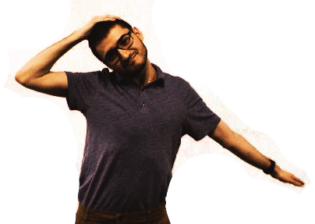 | 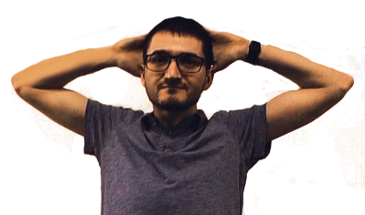 | 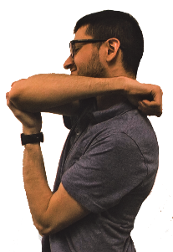 | 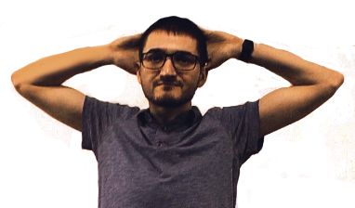
Extend left arm 45⁰ to side  Reach right hand over head on left side  Gently pull head to right side  Hold for count of 3  Relax stretch  Repeat  Switch, right arm out at 45⁰  Left hand over head  Gently pull head to left side  Hold for count of 3  Relax stretch  Repeat | Place hands on back of neck  Circle elbows at shoulders three times  Circle elbows in opposite direction three times  Relax arms down to sides | Place right hand on left shoulder  With left hand pull elbow under chin toward body  Hold for count of 3  Relax stretch  Repeat  Place left hand on right shoulder  With right hand pull elbow under chin  Hold for count of 3  Relax stretch  Repeat sequence | Hands at back of head  Pull elbows back  Squeeze shoulder blades together  Hold for count of 3  Relax stretch, allow elbows to come forward  Repeat sequence
Rotation  Hands on Head | High Reach – Two hand | Hamstring | Power Squat
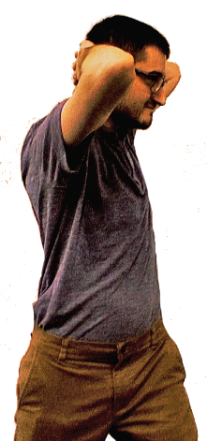 | 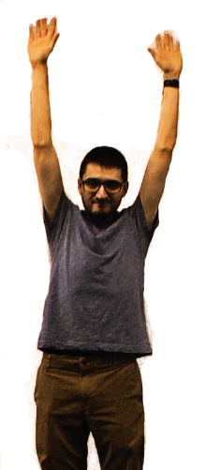 | 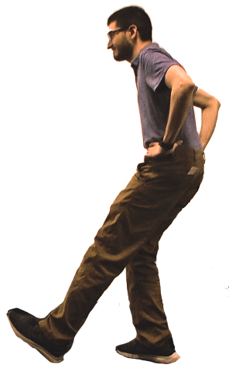 | 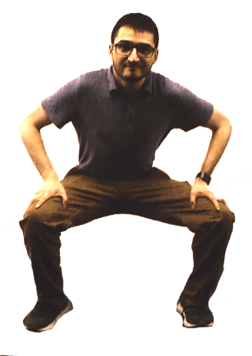
Place hands on back of head  Slowly rotate trunk to right  Slowly rotate trunk to left  Repeat sequence | Take a deep breath and reach both arms to ceiling  Hold for count of 3  Relax arm to side  Repeat  Relax arms to side  Repeat sequence | Right leg forward with heel on floor, toes pointing up  Hands on hips, head and shoulders upright  Bend at hips to stretch behind right knee  Hold for count of 3  Relax stretch  Repeat  Switch legs  Repeat sequence | Stand with feet wider than shoulders  Keep head and shoulders upright  Slide hands down to knees  Bend hips and knees keeping heels flat on floor  Go as low as comfortable  Return to upright position  Repeat sequence
Produced for Hennepin County Library by ErgoSystems Consulting Group, Inc. www.ergosystemsconsulting.com Version 020520

Produced for Pentair Technical Products by ErgoSystems Consulting Group, Inc. www.ergosystemsconsulting.com Version 022412

