ERGONOMICS ASSESSMENT REPORT
Medtronic
ILS Packaging (Traying Parts and BA Assembly)
Plymouth, Minnesota
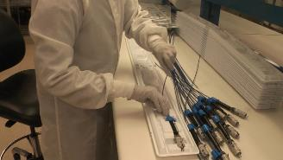 | 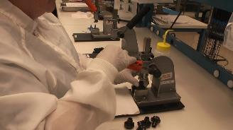
Date:
8/7/2023
Project Number:
1002116
Organization:
Medtronic
Location:
161 Cheshire Lane
Suite 100, MS MN042
Plymouth, MN 55441
Contact
Reyna Lex
EHS Program Manager | Americas Commercial EHS
Medtronic
161 Cheshire Lane suite 100, MS MN042
Plymouth, MN 55441
Office: 763.210.4051
Mobile: 612.590.0654
Email: reyna.lex@medtronic.com
Ergonomist:
Mark A. Anderson, MA, PT, CPE
ErgoSystems Consulting Group, Inc.
7421 West Shoreline Drive
Waconia, MN 55387
Voice: (952) 401-9296
Email: Mark.Anderson@ergosystemsconsulting.com

Table of Contents
Background 1
Coordination and Purpose 1
Ergonomics Defined and Principles 1
Methods 2
Issues and Recommendations 2
1. Traying Parts 2
a) Repetitive task 3
b) Flex Breaks 3
c) Technique 3
d) Workstation configuration 4
a) Job Rotation 3
b) Focus on individual Microbreaks 3
c) Technique focus 3
d) User controlled height adjustable workbench 3
2. BA Assembly 5
a) Repetitive task 6
b) Flex Breaks 6
c) Workstation configuration 6
d) Press Operation 6
a) Job Rotation 6
b) Focus on individual Microbreaks 6
c) User controlled height adjustable workbench 6
d) Press operation recommendations 6

Background

Coordination and Purpose
The ergonomics consultation was performed by Mark Anderson, MA, PT, CPE, (Physical Therapist and Certified Professional Ergonomist) of ErgoSystems Consulting, LLC with onsite data collection on 8/2/2023. The evaluation was coordinated by Reyna Lex, EHS Program Manager, Americas Commercial EHS. Appreciation is extended to the Medtronic employees who provided input during the assessment and were observed performing the job tasks.
The purpose of the assessment is to focus on ergonomics issues of the workstation, work practices and work process to provide a set of workstation ergonomics recommendations to help improve comfort, safety and productivity in the workplace.

Ergonomics Defined and Principles
Ergonomics is defined as a scientific method to enhance job performance through improved workstation, tools and equipment design and work processes. Specific focus is on human performance with methods that optimize the ability of an individual to perform job tasks safely and effectively. The primary factors of task repetition, body and extremity positions and forces imposed on or produced by the body are considered. The ergonomics consultation is based on a set of ergonomics principles coupled to human performance:
- PROCESS – Promote effective work methods
- POSITION/SUPPORT – Promote neutral and well based spinal and limb postures
- MOVEMENT – Promote periodic and controlled physical motions
- MATERIAL HANDLING – Control manual movement of materials
- REACH – Promote work in the individual’s functional range
- WORKSTATION/TOOLS/EQUIPMENT – Provide the correct work setting and functional aides to accomplish the required job tasks
- TRAINING – Provide didactic and performance based educational experiences
- ENVIRONMENT – Control factors affecting the workstation, worker and workplace
- HEALTH/WELLNESS – Promote factors and activities that enhance employee well-being
- FEEDBACK – Provide on-going information for continuous improvement

Methods
The consultation process consisted of:
- Observation, photography and physical measurements of the employee, workstation and processes as appropriate
- Interviews as appropriate
- Generate the report
- Submit conclusions and recommendations
The ergonomics consultation was accomplished by identifying current major work process steps, comparing these steps to the set of ergonomics principles to identify pertinent ergonomics issues and generating a list of proposed recommendations.
Issues and Recommendations are noted below.

Issues and Recommendations

Traying Parts
Overview:
- Traying parts consists of manually inserting the catheter into the plastic tray.
- Workstation is currently a fixed height (34”) workbench.
- An ergonomics stool is used when seated.
- Lot size has determined the repetition rate. A lot size has been a maximum of 400. A typical lot size is 124 and would take about 60 to 90 minutes to tray.
- Job rotation has been employed with 2 to 6 rotations through Traying Parts during a shift.
- Changes in job rotation are being considered that would limit a maximum of traying 90 pieces during one rotation.
- Primary issue identified is the finger push force required to seat the catheter into the slots on the tray.
- The employee was asked to rate the Perceived Exertion on a scale of 0 to 10 (0: no force, 10: maximum force) and rated it at 2 to 3/10 with the higher number at the end of the repetitive task as physical fatigue plays a larger role.
- Video (double click on the ILS Traying Parts.mp4 icon to play a short video of the task).

Issues | Recommendations
Repetitive task  The task in question – placing the catheter in the tray – is a repetitive task that requires significant pushing down of the fingers to seat the catheter in the slots in conjunction with pinching of the catheter (key pinch between the thumb and index finger).  Lot size appears to determine the repetition rate. A lot size has been a maximum of 400.  A typical lot size is 124 and takes about 60 to 90 minutes to tray.  Job rotation has been employed with 2 to 6 rotations through Traying Parts task during a shift.  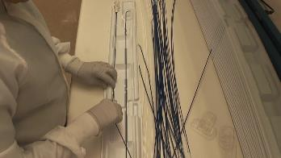  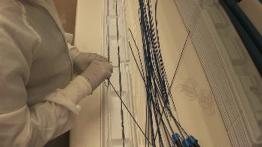  Flex Breaks  I am not aware that any scheduled Flex Breaks (physically active stretching) are part of the work day.  Technique  A specific technique was observed to improve the effectiveness of seating the catheter in the slots in the tray. The catheter is bent up and then “rolled” into the slots. This appeared to reduce the amount of “finger pushing” the catheter into the slot. Leverage was exerted on the catheter to seat it in the slots. (Refer to the video)  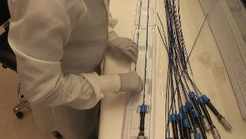  Workstation configuration  Currently the workbench is a fixed height workbench at 34”.  This is a multi-user workstation used by a number of employees who may vary significantly in stature. The employee observed is 5’2”.  The Traying Parts task is performed either seated or standing.  Seated  When seated the employee is noted to “perch” on the front of the chair and uses the support bar under the workbench as a makeshift footrest.  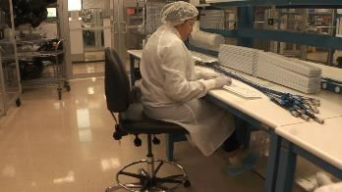  Standing  When standing the employee stands at the workbench.  No anti-fatigue standing mat is in place.  No foot rest to provide for alternate foot placement is in place.  As it turns out for this employee (stature of 5’2”) the 34” height workbench when standing is appropriate. This would not be the situation for someone of different stature.  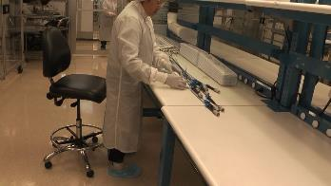 | Job Rotation  Part of the strategy to control overall exposure of an individual to the wear and tear of the repetitive task is job rotation.  Changes in job rotation are being considered that would limit a maximum of traying 90 pieces during one rotation. This would be advantageous as long as the tasks in the next rotation provide a variation in the physical requirements.  Focus on individual Microbreaks  Part of the strategy to control overall physical demand exposure of an individual is to promote microbreaks designed to promote dynamic activity and enhance blood circulation.  Recommended microbreak schedule for the task at hand is to take a 20 to 30 second microbreak about every 20 minutes.  Also promote the concept of group Flex Breaks once or twice a shift.  Technique focus  We were not able at the time of data collection to observe other employees performing the task. Recommendation is to confirm this technique is used by others and is viable.  Also investigate if other employees have other tips.  User controlled height adjustable workbench  Investigate adding a powered user controlled height adjustable workbench to accommodate the multi-user nature of the workstation. This would allow for appropriate user setup when seated or standing.  Seated  Chair seatpan height that would allow for the feet to be positioned directly on the floor. Replace the current “stool” with a fully featured ergonomics chair and ensure employes can demonstrate appropriate chair set-up.  A footrest that provides for alternative foot placement when seated to allow for some occasional knee extension.  Workbench height to provide for neutral position of the spine and upper extremities based on the user’s anthropometry.  Typical workbench height when seated is in the range of 26” to 34” to accommodate a 5th percentile female (about 5’0”) to a 95th percentile male (about 6’4”).  Standing  Workbench height to provide for neutral position of the spine and upper extremities.  Typical workbench height when standing is in the range of 32” to 46” to accommodate a 5th percentile female (about 5’0”) to a 95th percentile male (about 6’4”).  A footrest that provides for alternative foot placement when standing. One foot up on the foot rest, the other foot and then both feet on the floor.  Anti-fatigue standing mat to mitigate joint compression. Sized appropriately for the standing area, approximately 24 by 36”. This would be moved when the chair is used for the seated configuration.  NOTES:  Ideal Range  The ideal adjustment range of the seat to stand workbench is 26” to 46” to accommodate a 5th percentile female (about 5’0”) to a 95th percentile male (about 6’4”).  Practical Range  Here is an example of a vendor that has workbenches that height adjust from 27” to 42”.  https://www.gotopac.com/products/workbenches-workstations/work-benches.html?cat=48&p_adjustment=93&p_height=2706  Recognizing we have a workforce that tends to be on the shorter side, this height adjustment range would generally be acceptable.  Tray Sealing Operation  The tray sealing operation also needs to be considered to be in concert with the Traying Parts task. The sealer probably needs to be on the height adjustable workbench.

BA Assembly
Overview:
- BA Assembly is a three-step process of manually operating three presses to insert various components into the BA Assembly.
- Workstation is currently a fixed height (34”) workbench.
- An ergonomics stool is used for the seated position. Tasks are always performed when seated.
- The support bar on the workbench is used as a makeshift footrest.
- A batch size is from 200 to a maximum of 400. A typical batch size is 48 and would take about 60 minutes to perform.
- Job rotation has been employed with trying to limit BA Assembly to 60 minutes are one time.
- Primary issue identified is the hand, wrist forearm force required to rotate the handle of the press (particularly Press One). Second issue is pinching and twisting (thumb and index finger) when squeezing the part during Press Two operation.
- The employee was asked to rate the Perceived Exertion on a scale of 0 to 10 (0: no force, 10: maximum force). For handle operation on Press One she rated it at 2 to 4/10 with the higher number at the end of the repetitive task as physical fatigue plays a larger role. For pinching and twisting on Press Two she rated it 4/10.
- Video (double click on the ILS BA Assembly Press1.mp4 icon and ILS BA Assembly Press2.mp4 icon to play short videos of the tasks).

Issues | Recommendations
Repetitive task  A batch size is from 200 to a maximum of 400. A typical batch size is 48 and would take about 60 minutes to perform.  Job rotation has been employed with trying to limit BA Assembly to 60 minutes are one time.  Flex Breaks  I am not aware that any scheduled Flex Breaks (physically active stretching) are part of the work day.  Workstation configuration  Currently the workbench is a fixed height workbench at 34”.  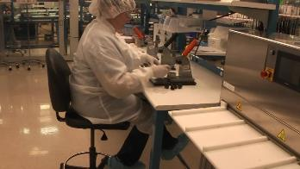  This is a multi-user workstation used by a number of employees who may vary significantly in stature. The employee observed is about 5’2”.  The BA Assembly task is performed seated.  When seated the employee is noted to sit back in the chair making use of the chair back support.  The support bar under the workbench is used as a makeshift footrest.  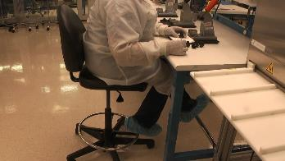  Press Operation  Press One  Operation of the handle on Press One was identified as the primary issue for press operation.  Primary issue is the hand, wrist forearm force required to rotate the handle of the press.  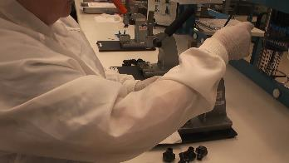  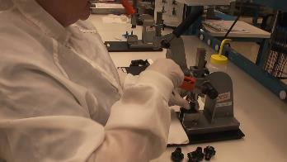  For handle operation on Press One she rated it at 2 to 4/10 with the higher number at the end of the repetitive task as physical fatigue plays a larger role.  Press Two  Second issue is pinching and twisting (thumb and index finger) when squeezing the part during Press Two operation.  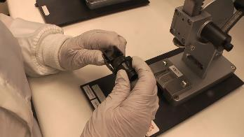  For pinching and twisting on Press Two she rated it 4/10. | Job Rotation  Part of the strategy to control overall exposure of an individual to the wear and tear of the repetitive task is job rotation.  Changes in job rotation are being considered that would limit a maximum of one hour during one rotation. This would be advantageous as long as the tasks in the next rotation provide a variation in the physical requirements.  Focus on individual Microbreaks  Part of the strategy to control overall physical demand exposure of an individual is to promote microbreaks designed to promote dynamic activity and enhance blood circulation.  Recommended microbreak schedule for the task at hand is to take a 20 to 30 second microbreak about every 20 minutes.  Also promote the concept of group Flex Breaks once or twice a shift.  User controlled height adjustable workbench  Investigate adding a powered user controlled height adjustable workbench to accommodate the multi-user nature of the workstation. This would allow for appropriate user setup when seated.  Seated  Chair seatpan height that would allow for the feet to be positioned directly on the floor. Replace the current “stool” with a fully featured ergonomics chair and ensure employes can demonstrate appropriate chair set-up.  A footrest that provides for alternative foot placement when seated to allow for some occasional knee extension.  Workbench height to provide for neutral position of the spine and upper extremities based on the user’s anthropometry.  Typical workbench height when seated is in the range of 26” to 34” to accommodate a 5th percentile female (about 5’0”) to a 95th percentile male (about 6’4”).  NOTES:  Here is a vendor.  Industrial Workbenches (gotopac.com)  Press operation recommendations  The engineer working with the group was able to be in attendance during the data collection.  We discussed the issues identified and she is working on recommendations for handle modification. We discussed changing the linear motion as the handle is pulled down to a rotary motion.  She is also exploring potential work process changes that will decrease the amount of rework sometimes required on Press One, particularly to get the component to seat properly as it is being pressed into position. This seemed to be a significant issue during the data collection.  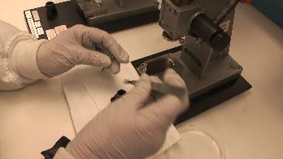  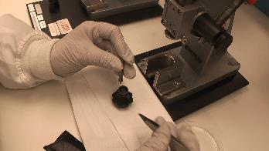  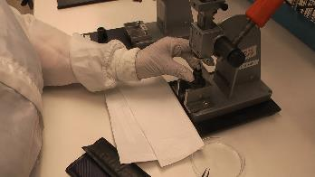  She will explore potential options to automate/semi-automate parts of the BA Assembly process.

