
Stretching
ROUTINE ONE
Neck Side Stretch | Shoulder Shrug | Elbow Pull
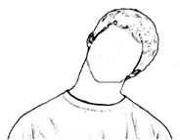 | 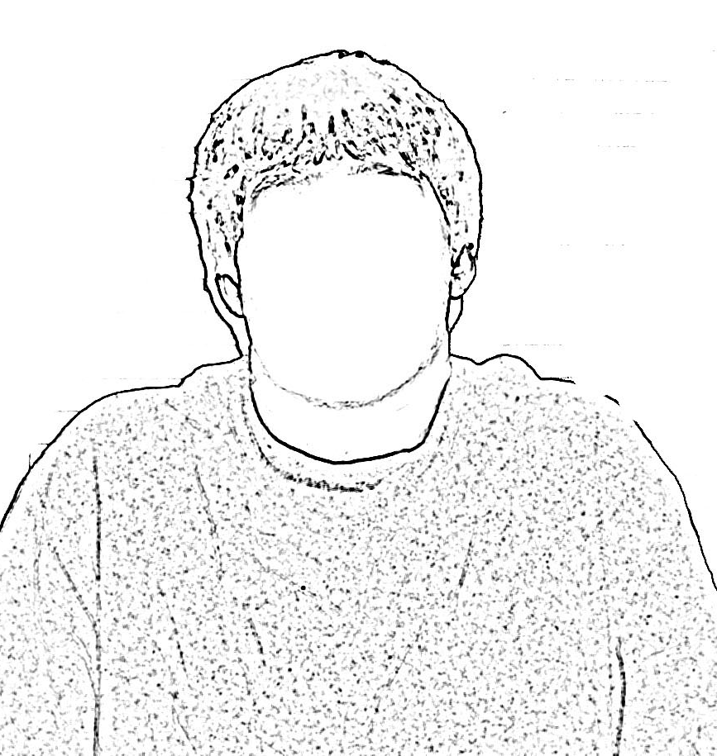 | 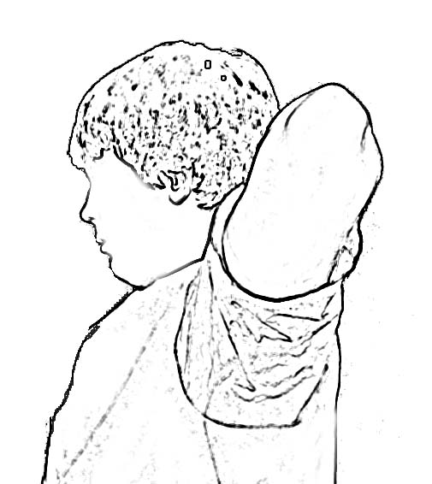
Look straight ahead, arms at sides  Tip head to side to lay ear on shoulder  Hold for count of 3  Return to neutral  Repeat on other side  Repeat sequence 2 times | Shrug shoulders up to the ears  Hold for count of 3  Relax  Repeat 2 times | Place hands on back of neck  Pull elbows back, squeeze shoulder blades together  Hold for count of 3  Relax arms/shoulder  Repeat 2 times

Wrist/Elbow Flex – Arm Down | Wrist/Elbow Extend – Arm Down | Large Arm Circles
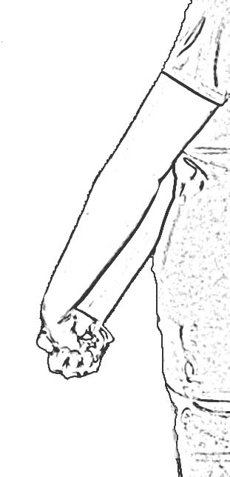 | 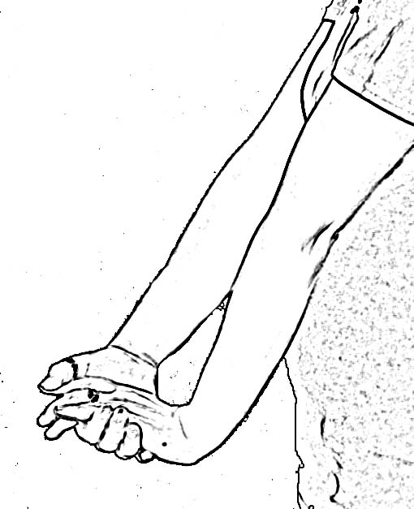 | 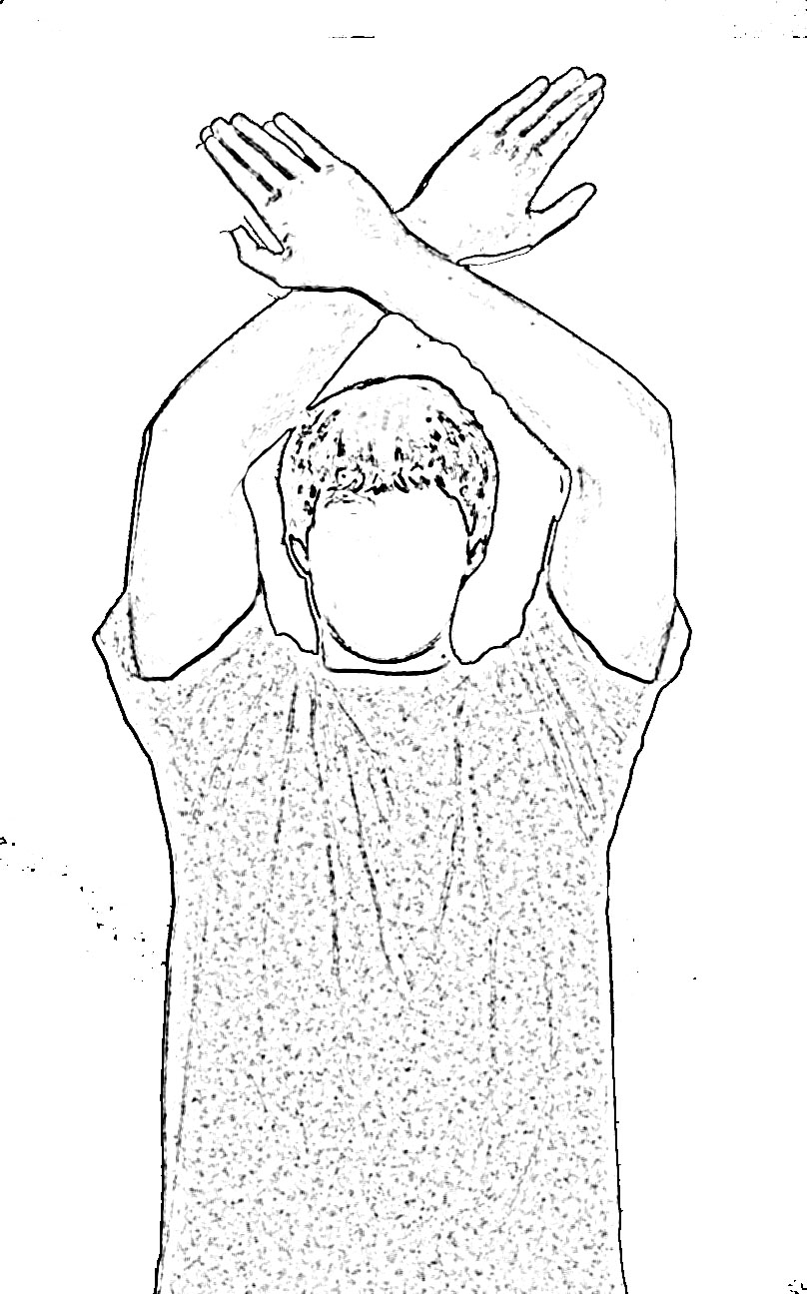
Extend arm down to side  With elbow straight, bend wrist down to stretch, make a fist  Hold for count of 3  Relax  Repeat on other side.  Repeat sequence 2 times | Extend arm down to side  With elbow straight, bend wrist up to stretch  Hold for count of 3  Relax  Repeat on other side.  Repeat sequence 2 times | Place arms in front  Cross wrists  Make big arm circles as you can - breath in on the way up and out on the way down  Go 3 times in one direction  Relax arms to sides  Repeat 3 times in other direction
Toro Version R1 - 03152022
High Reach Both Hands | Back Bend | Ankle Circles
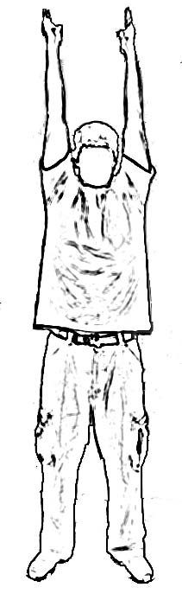 | 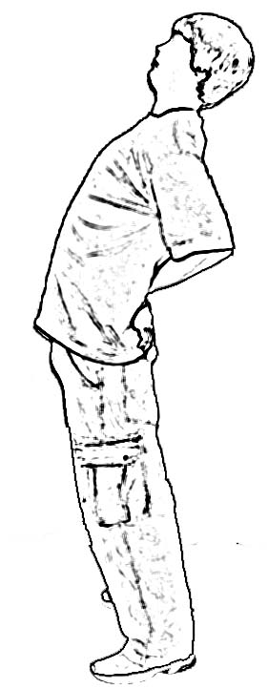 | 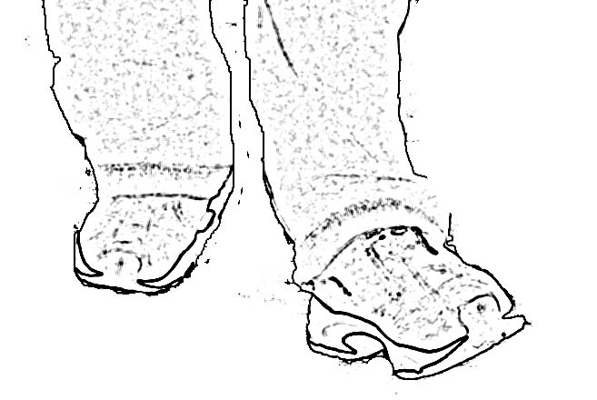
Start in neutral position with arms at sides  Take a deep breathe and reach arms to ceiling  Stretch it out  Hold at top for count of 3  Exhale and return to neutral position  Repeat 2 times | Start in neutral position  Place hands on belt line  Bend backward.  Let head naturally follow shoulders.  Hold for a count of 3  Return to neutral position  Repeat 2 times | Use support for balance  Circle ankle 5 times each way.  Repeat with other ankle

