
Stretching
ROUTINE TWO
Neck Side Arm Behind | Shoulder Roll | Elbow Pull – Hands Up
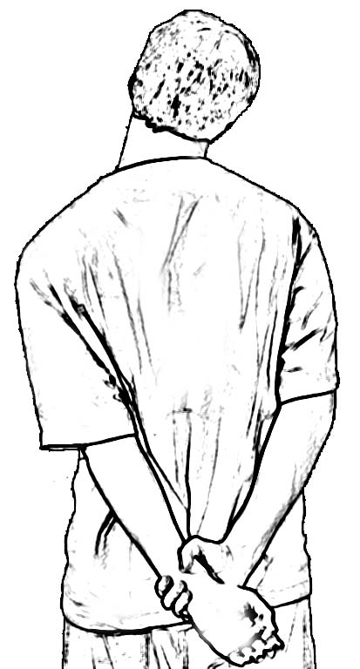 | 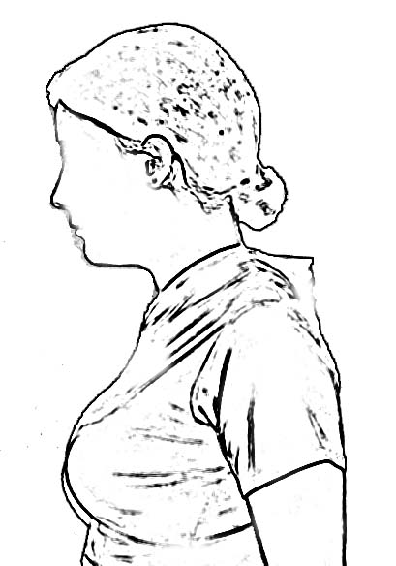 | 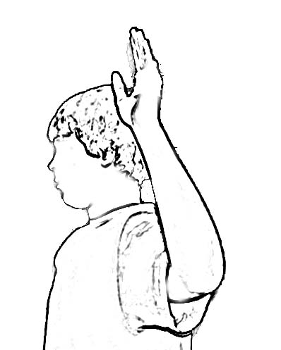
Place arm behind back, pull down on hand with other hand/arm  Tip head to side to lay ear on shoulder  Hold for count of 3  Return to neutral  Repeat on the other side  Repeat sequence 2 times | Roll shoulders 3 times in one direction, make small circles  Relax shoulders  Repeat sequence in other direction | Place arms in “Stick’em up” position  Hold for count of 3  Relax arms to sides  Repeat 2 times

Wrist/Elbow Flex – Arm Out | Wrist/Elbow Extend – Arm Out | High Reach Fingers Laced
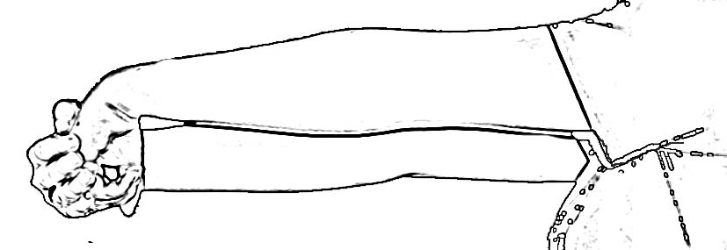 | 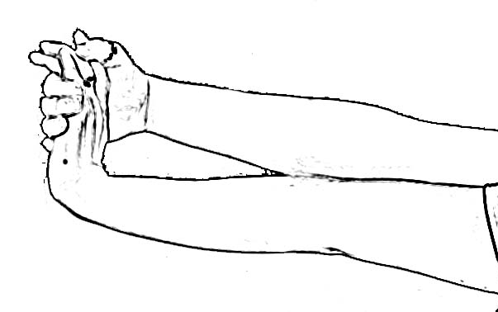 | 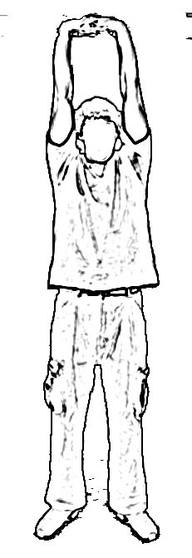
Extend arm out to front  With elbow straight, bend wrist down to stretch, make a fist  Hold for count of 3  Relax  Repeat on other side.  Repeat sequence 2 times | Extend arm out to front  With elbow straight, bend wrist up to stretch  Hold for count of 3  Relax  Repeat on other side.  Repeat sequence 2 times | Start in neutral position with arms at sides  Interlock fingers, take a deep breath and reach arms to ceiling  Stretch it out  Hold at top for count of 2  Exhale and return to neutral position  Repeat 2 times

Rotation Hug | Hamstring Floor | Power Squat
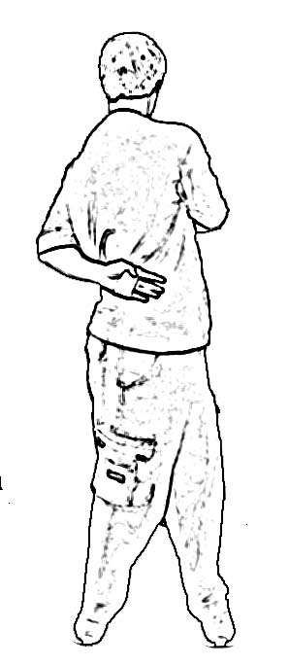 | 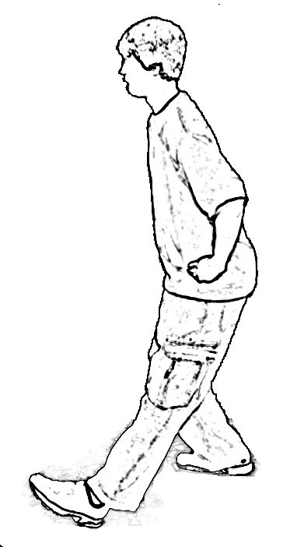 | 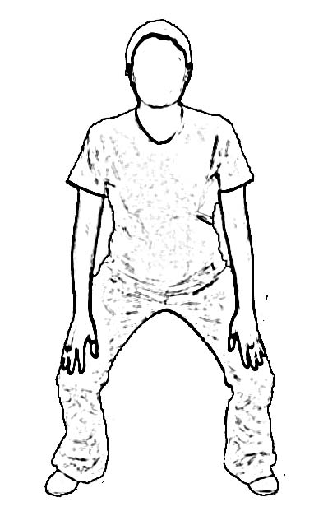
Start in neutral position with arms at sides  Swing one arm to front and one arm to back as you rotate your trunk  Hold for count of 3  Return to neutral  Repeat to other side  Repeat sequence 2 times | Place leg forward with heel on floor  With hands on hips, keep head and shoulders upright  Bend opposite knee to lower hips and stretch behind knee  Hold for count of 3  Return to neutral  Repeat 2 times  Switch legs and repeat sequence | Stand with feet wider than shoulders  Place hands on knees  Keep head and shoulders up  Drop hips and bend knees keeping heels flat on the floor.  Go as low as comfortable.  Repeat 2 times
Toro Version R2- 03132022

