
Stretching
ROUTINE THREE
Neck Rotation | Elbow Pull Behind Back | Pat Back
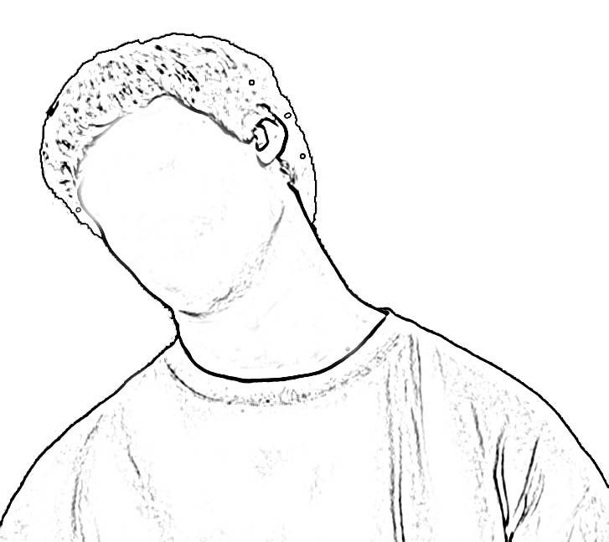 | 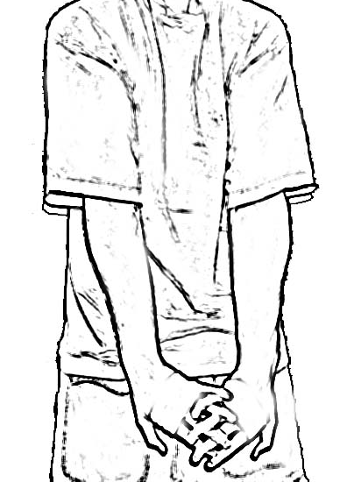 | 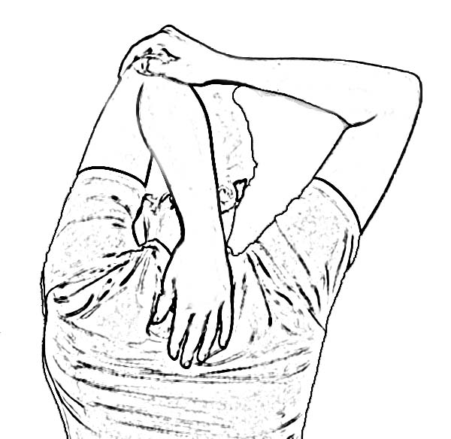
Rotate head/neck to one side, hold for count of 3  Rotate head to middle, look down  Rotate head to other side, look down, hold for count of 3  Repeat sequence 2 times | Interlock fingers behind back  Pull elbows together  Hold for count of 3  Repeat 2 times | Raise one arm with elbow pointed ceiling  Use other hand to pull elbow backward  Hold for count of 3  Switch arms  Repeat 2 times

Open Close Hand | Large Arm Circles | Side Stretch Arms Overhead
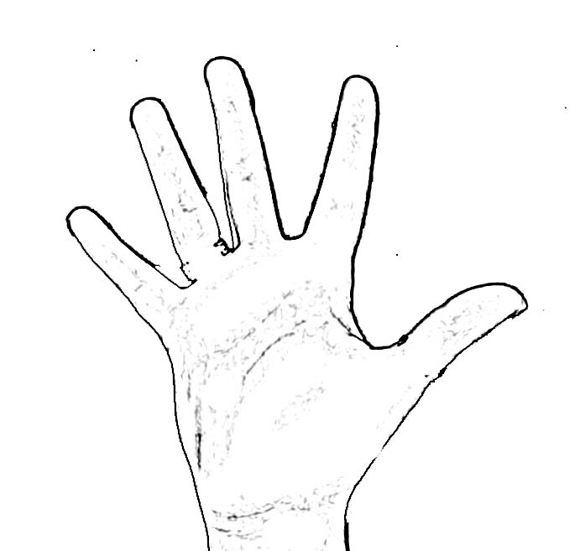 | 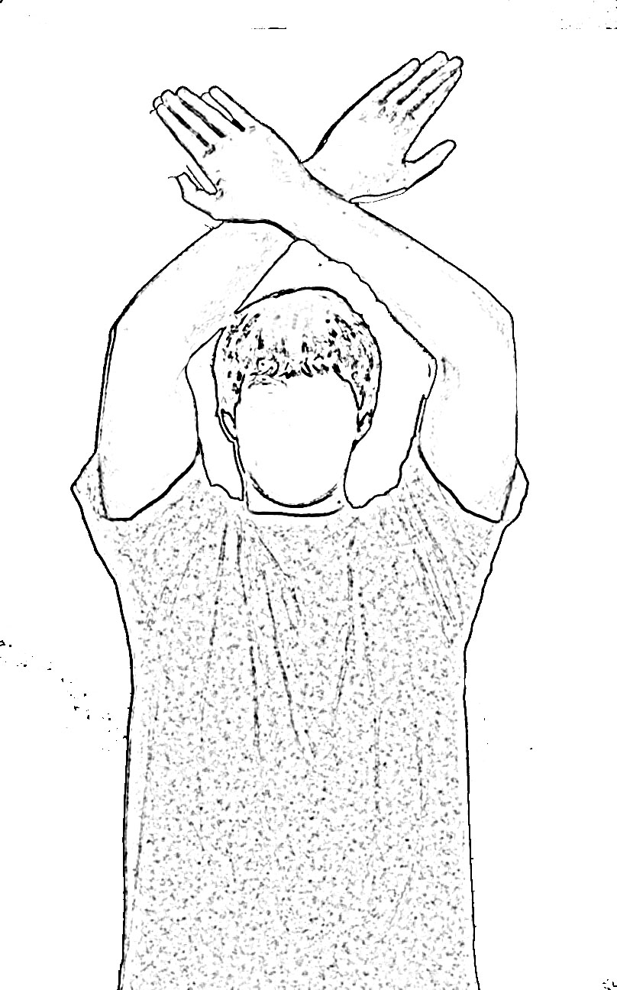 | 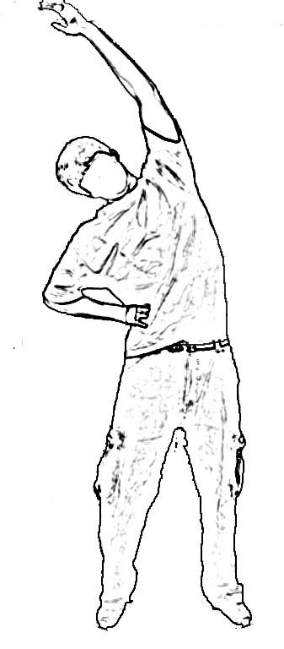
Start with arms/hands in front of body  Open hands to spread fingers as wide as possible  Hold for count of 3  Close hands to make fists  Hold for count of 3  Relax hands  Repeat 2 times | Place arms in front  Cross wrists  Make big arm circles as you can - breath in on the way up and out on the way down  Go 3 times in one direction  Relax arms to sides  Repeat 3 times in other direction | Start in neutral position with arms at sides  Interlock fingers, reach arms to ceiling  Bend to one side  Hold for count of 3  Repeat to other side  Repeat sequence 2 times

Heel Cord | Slump | Back Bend
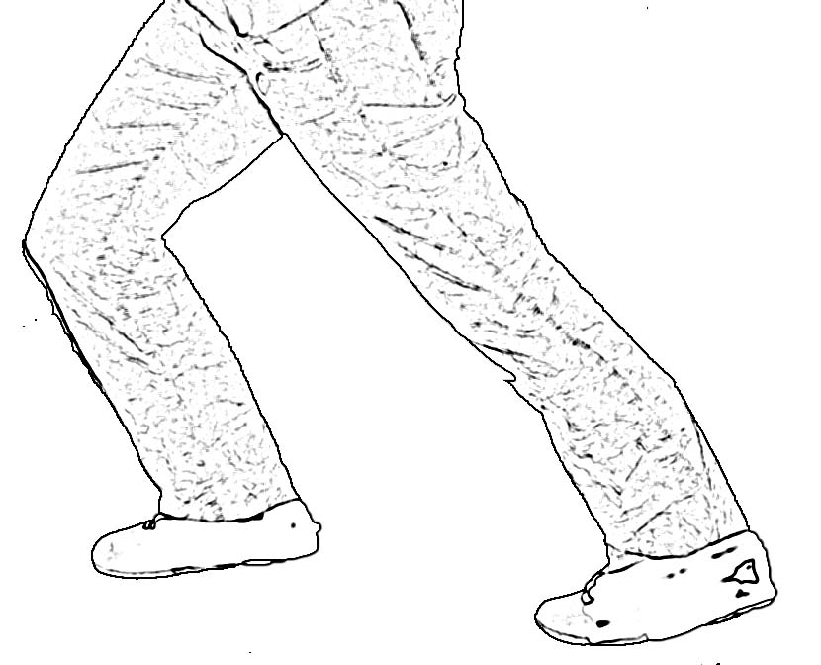 | 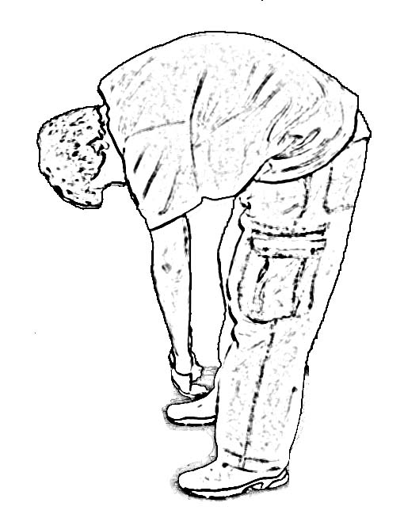 | 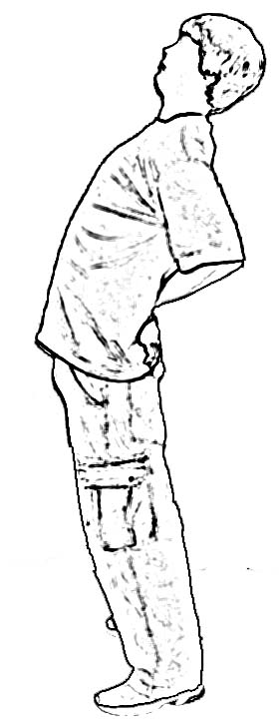
Place one foot behind the other with both feet pointed straight ahead  Keep the heel of the back foot flat  Keep the head and shoulders upright, bend the front knee  Hold for a count of 3  Repeat 2 times  Switch legs and repeat sequence | Start in neutral position with arms at sides  Allow your back to bend to reach to the floor  Hold for count of 3  BEND YOUR KNEES and return to neutral  Repeat 2 times | Start in neutral position  Place hands on belt line  Bend backward.  Let head naturally follow shoulders.  Hold for a count of 3  Return to neutral position  Repeat 2 times
Toro Version R3 - 03132022

