
Rosemount, Inc.
Worksite Stretches
Compilation of Stretches
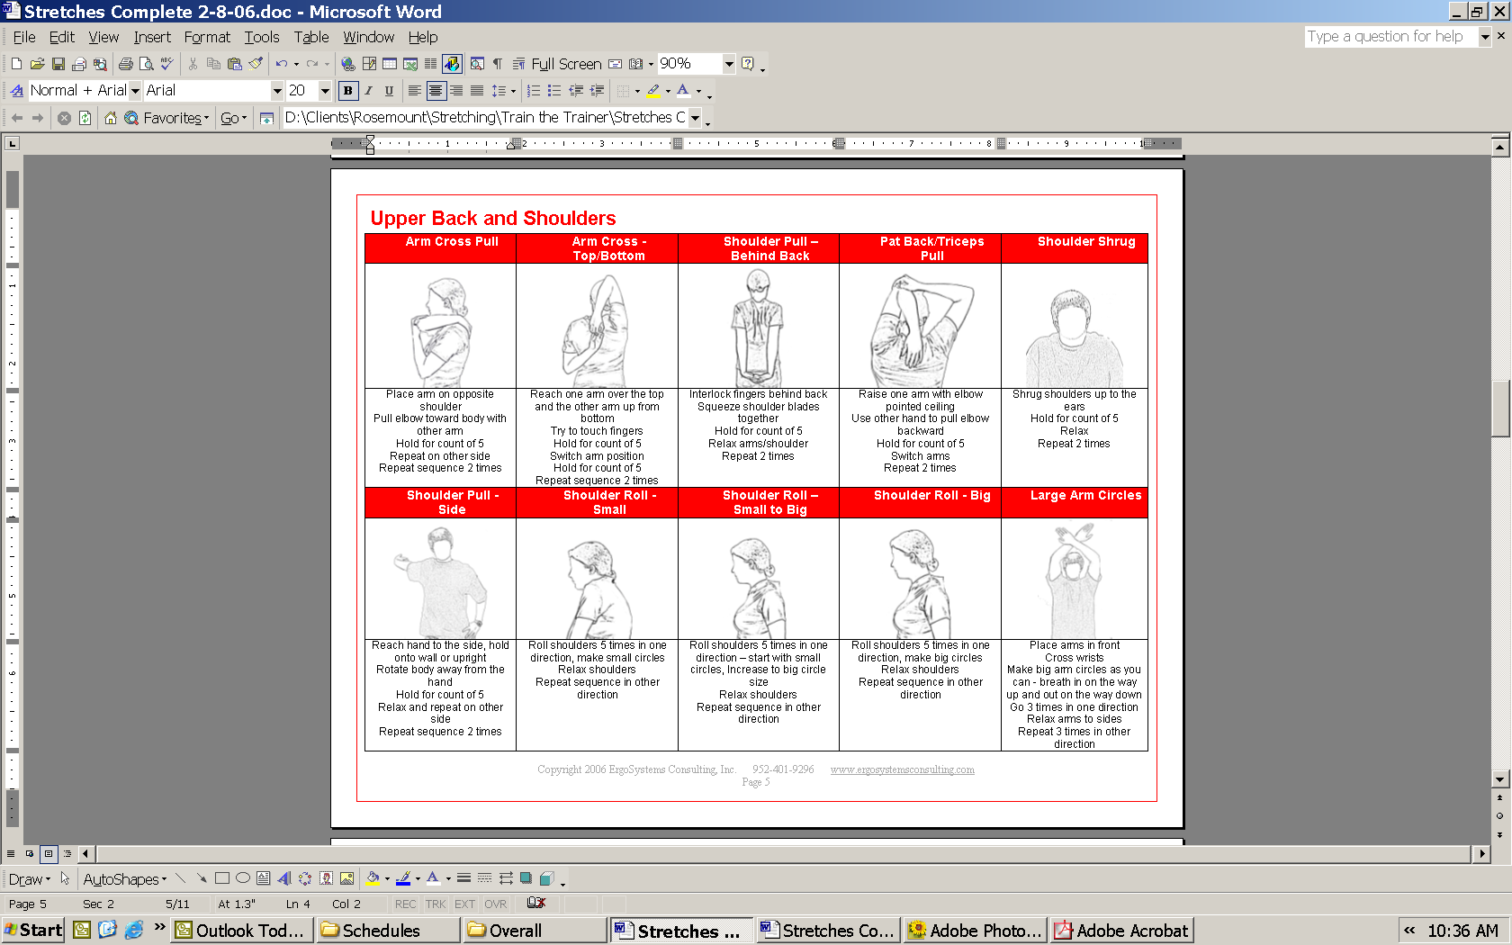
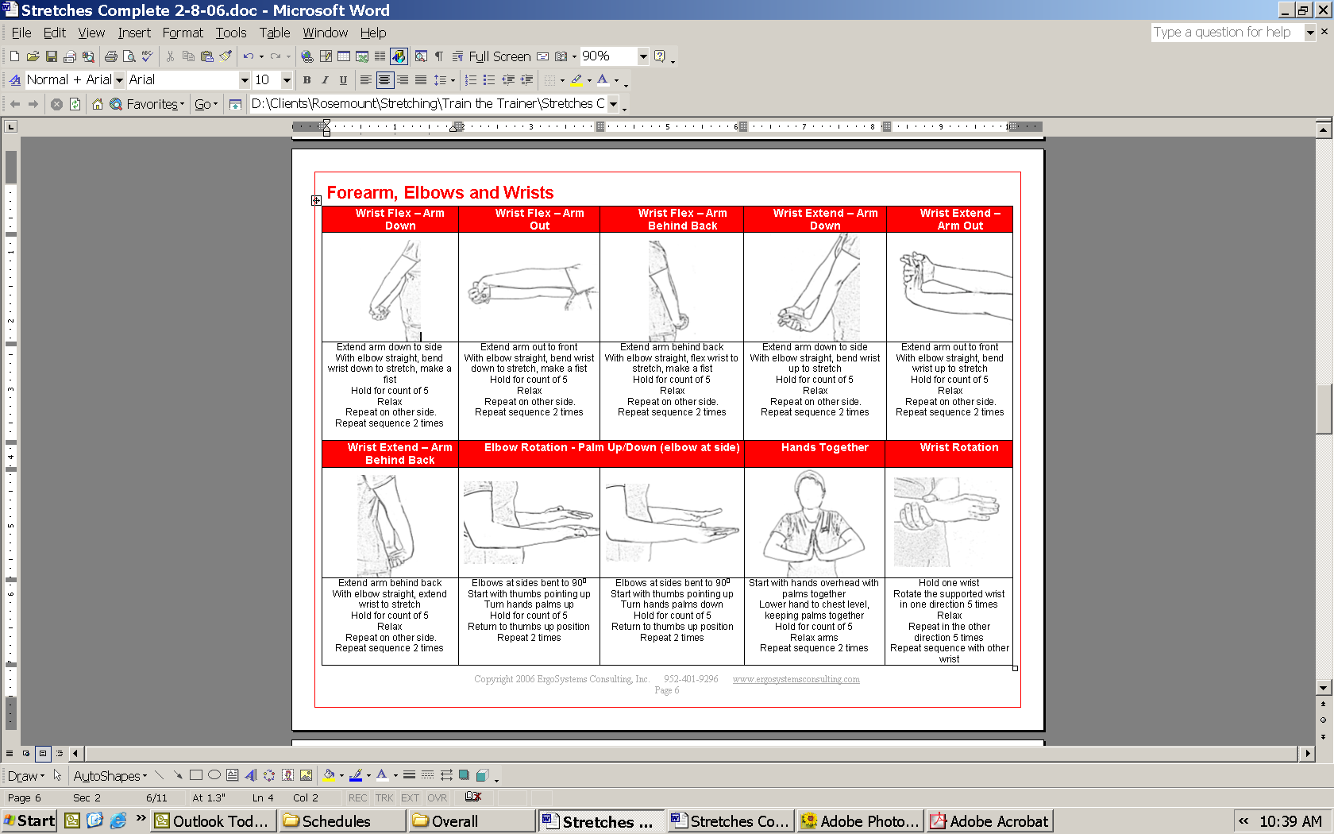
ErgoSystems Consulting Group, Inc.
Minneapolis, MN

Table of Contents
Stretching Compilation

Face 3
Cup Eyes 3
Smile 3
Frown 3
Eyes/Mouth 3
Fish Mouth 3
Neck 3
Chin Tuck 3
Chicken Neck 3
Neck Side Stretch 3
Neck Side Stretch –Reach 3
Neck Side Stretch – Arm behind back 4
Neck Rotation - Side-Front-Side 4
Chest 4
Elbow Pull 4
Elbow Pull/Roll 4
Elbow Pull – Behind Back 4
Stick’em Up/Pull 4
Stick’em Up/Roll 4
Upper Back and Shoulders 5
Arm Cross Pull 5
Arm Cross - Top/Bottom 5
Shoulder Pull – Behind Back 5
Pat Back/Triceps Pull 5
Shoulder Shrug 5
Shoulder Pull - Side 5
Shoulder Roll - Small 5
Shoulder Roll – Small to Big 5
Shoulder Roll - Big 5
Large Arm Circles 5
Forearm, Elbows and Wrists 6
Wrist Flex – Arm Down 6
Wrist Flex – Arm Out 6
Wrist Flex – Arm Behind Back 6
Wrist Extend – Arm Down 6
Wrist Extend – Arm Out 6
Wrist Extend – Arm Behind Back 6
Elbow Rotation - Palm Up/Down (elbow at side) 6
Hands Together 6
Wrist Rotation 6
Fingers and Hands 7
Open/Close Hands 7
Table Top 7
Thumb to Fingers 7
Back 7
Back Bend 7
High Reach – Both Hands 7
High Reach – Fingers interlaced 7
High Reach – One Hand 7
Overhead Arm Twist 7
Side Stretch with High Reach (both hands) 7
Side Stretch with Table Top 7
Side Stretch with High Reach (one hand) 7
Side Stretch (hands on head) 7
Rotation Hug 7
Rotation (hands on head) 7
Slump/Return to Neutral 7
Slump/Return to Back Bend 7
Knee to Chest Pull 7
Hips and Legs 7
Power Squat – Hands on Hips 7
Power Squat – Hands on Knees 7
Power Squat – Reach to Floor 7
Hip Flexor 7
Straddle 7
Hip Rotate - Front-Side-Back 7
Hip Sag 7
Hamstring/Floor 7
Hamstring/Rest 7
Bent Knee Hold 7
Ankles and Feet 7
Heel Cord 7
Ankle Circles 7
Soles In/out 7
Overall 7
The ‘Scoop’ 7
Step In Place 7
Belly Breathing 7
Neutral Postition 7

Face
Cup Eyes | Smile | Frown | Eyes/Mouth | Fish Mouth
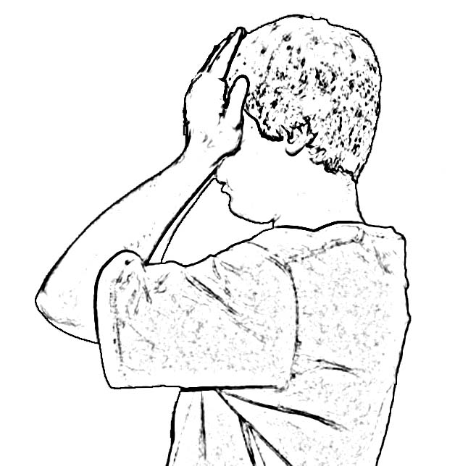 | 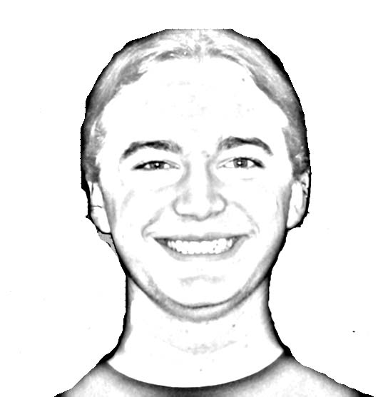 | 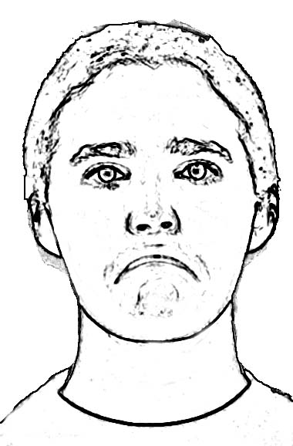 | 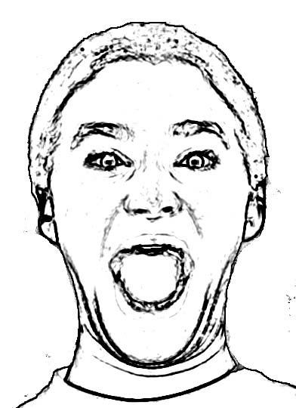 | 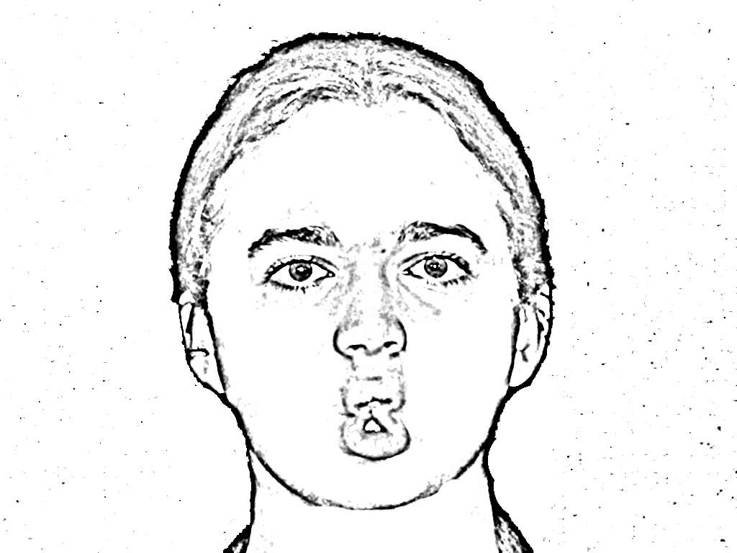
Remove any eyeglasses  Gently place palms on eyes  Hold for count of 5  Remove hands  Repeat 2 times | Smile as large as you can  Hold for count of 5  Relax smile  Repeat 2 times | Frown  Hold for count of 5  Relax frown  Repeat 2 times | Open eyes and mouth as wide as possible  Hold for count of 5  Relax eyes and mouth  Repeat 2 times | Make a fish mouth (pucker lips and suck in cheeks)  Hold for count of 5  Relax mouth  Repeat 2 times

Neck
Chin Tuck | Chicken Neck | Neck Side Stretch | Neck Side Stretch –Reach
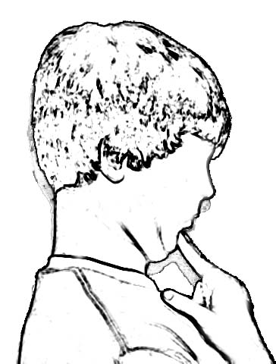 | 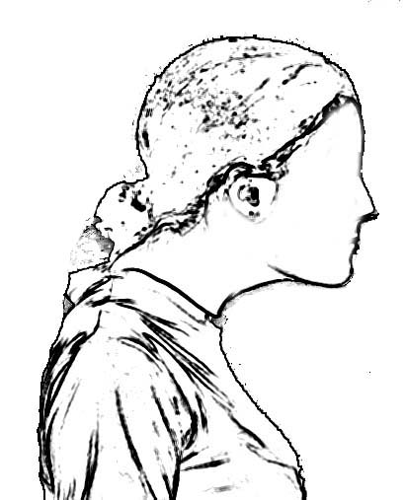 | 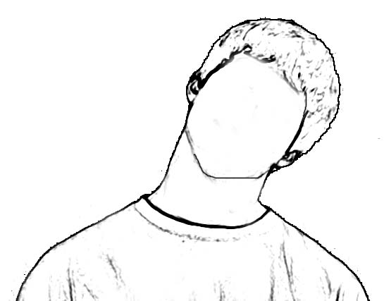 | 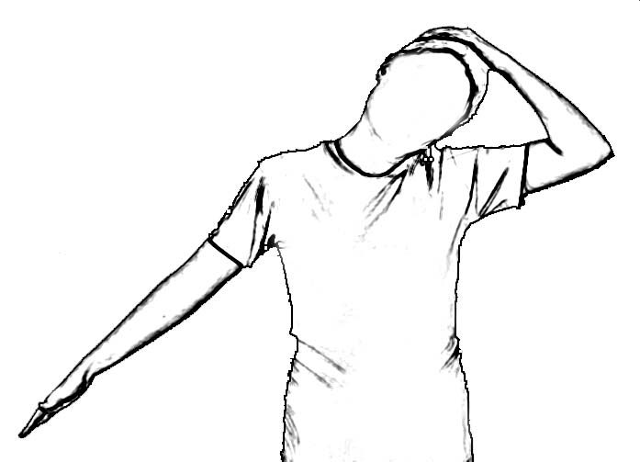
Place fingers on chin  Tuck chin  Pull head straight back  Hold for count of 5  Relax  Repeat 2 times | Glide head forward - protrude chin  Tuck chin - pull head straight back  Relax to neutral position  Repeat 2 times | Look straight ahead, arms at sides  Tip head to side to lay ear on shoulder  Hold for count of 5  Return to neutral  Repeat on other side  Repeat sequence 2 times | Look straight ahead, hand on head other arm out to side  Tip head to side to lay ear on shoulder  Hold for count of 5  Return to neutral  Repeat on the other side  Repeat sequence 2 times

Neck Side Stretch – Arm behind back | Neck Rotation - Side-Front-Side
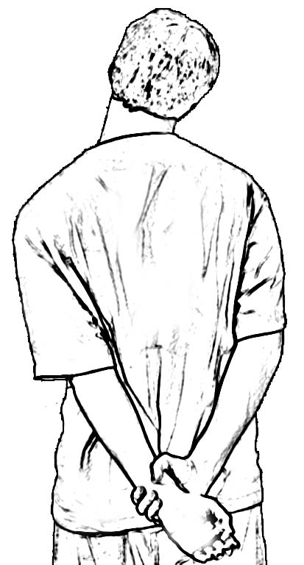 | 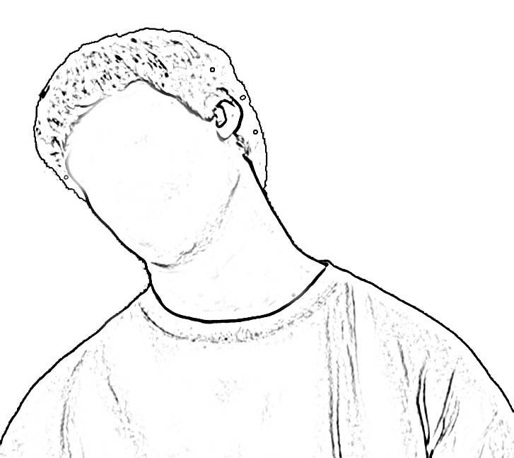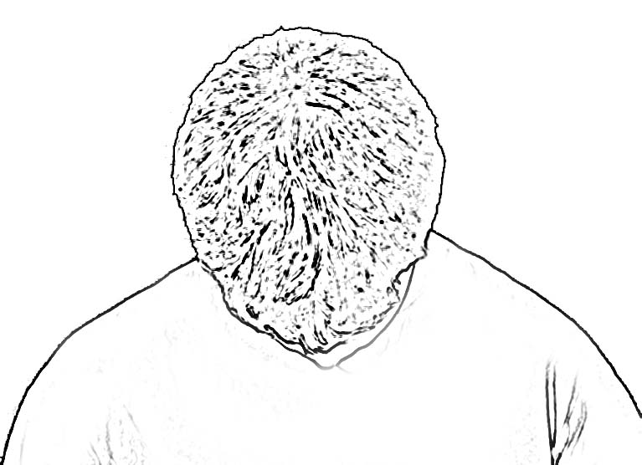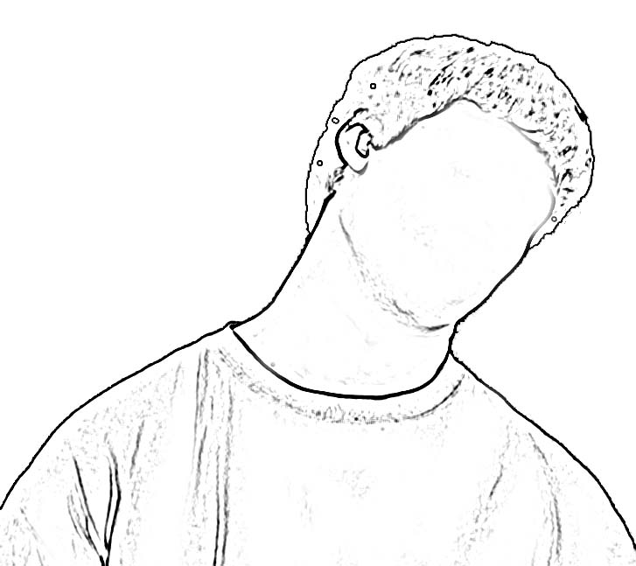
Place arm behind back, pull down on hand with other arm  Tip head to side to lay ear on shoulder  Hold for count of 5  Return to neutral  Repeat on the other side  Repeat sequence 2 times | Rotate head/neck to one side, hold for count of 5  Rotate head to middle, look down  Rotate head to other side, look down, hold for count of 5  Repeat sequence 2 times
Chest
Elbow Pull | Elbow Pull/Roll | Elbow Pull – Behind Back | Stick’em Up/Pull | Stick’em Up/Roll
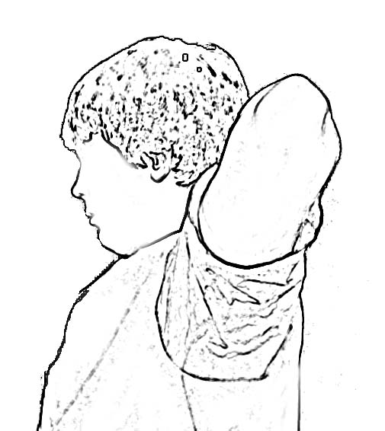 | 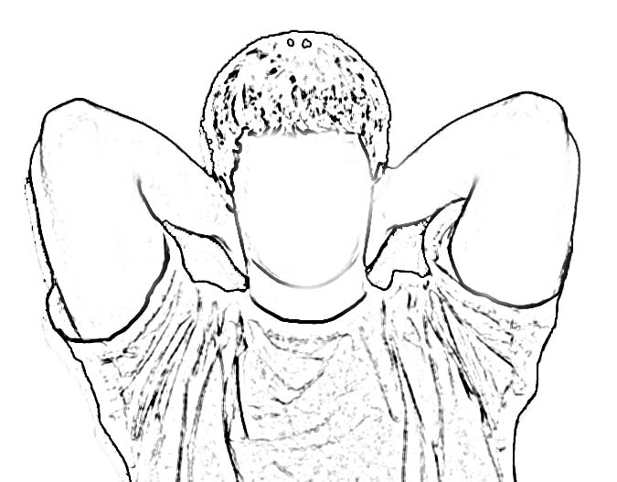 | 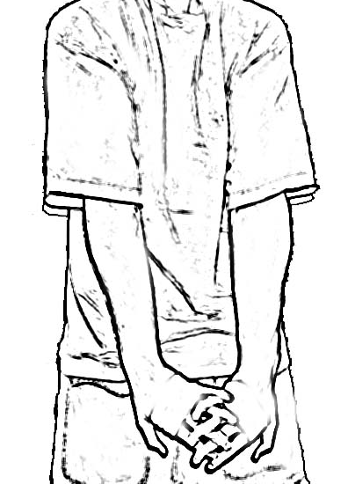 | 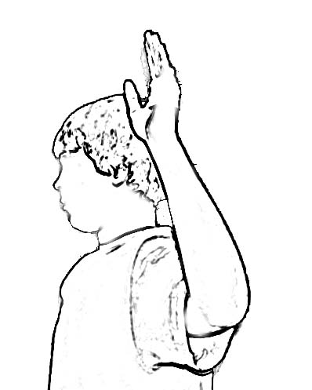 | 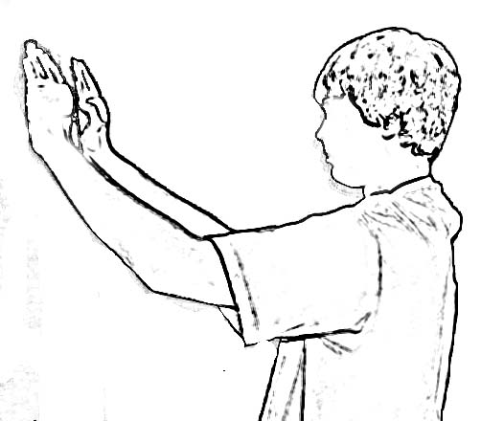
Place hands on back of neck  Pull elbows back, squeeze shoulder blades together  Hold for count of 5  Relax arms/shoulder  Repeat 2 times | Place hands on back of neck  Circle elbows at shoulders, 2 times one way and 2 times the other way  Repeat sequence 2 times | Interlock fingers behind back  Pull elbows together  Hold for count of 5  Repeat 2 times | Place arms in “Stick’em up” position  Hold for count of 5  Relax arms to sides  Repeat 2 times | Place arms in “Stick’em up” position  Rotate arms in one direction 2 times  Rotate arms in opposite direction 2 times  Repeat sequence 2 times
Upper Back and Shoulders
Arm Cross Pull | Arm Cross - Top/Bottom | Shoulder Pull – Behind Back | Pat Back/Triceps Pull | Shoulder Shrug
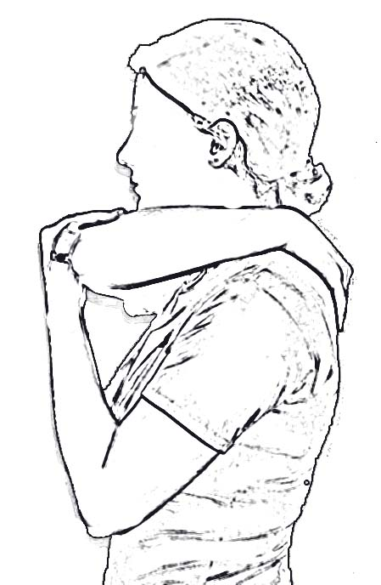 | 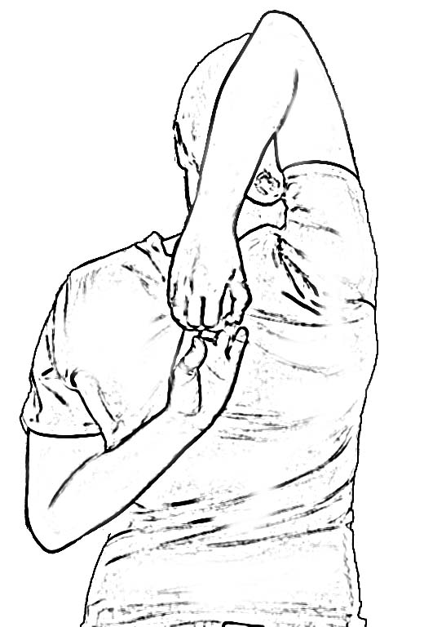 | 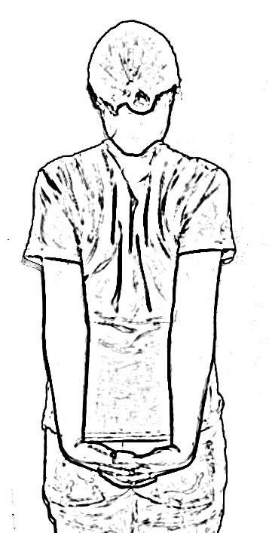 | 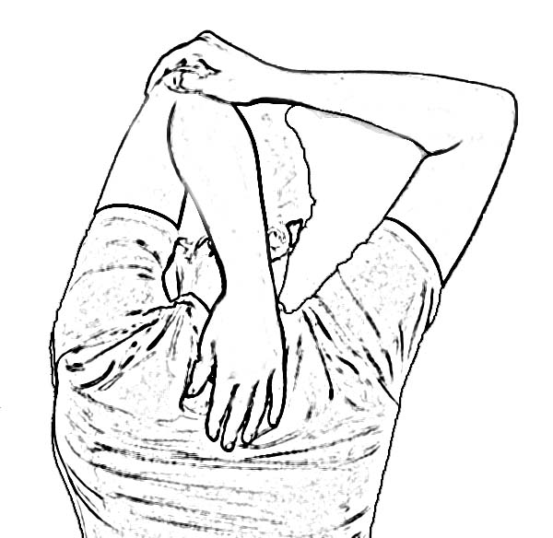 | 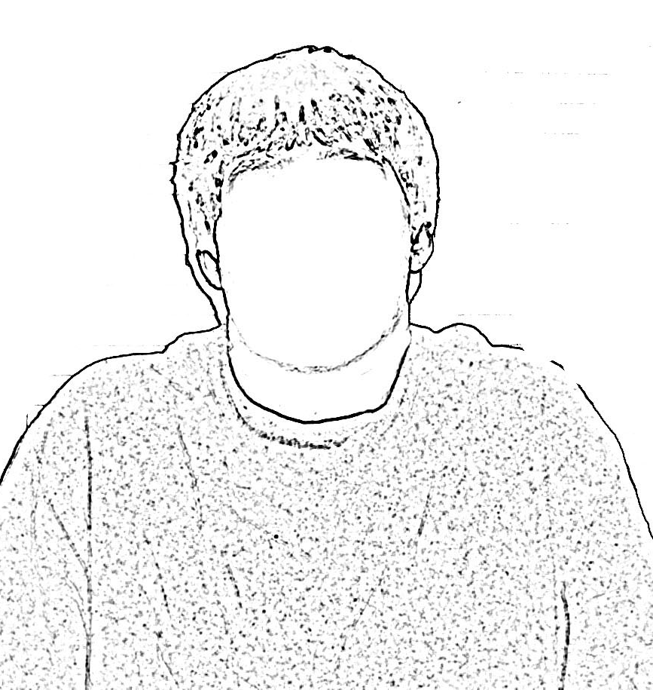
Place arm on opposite shoulder  Pull elbow toward body with other arm  Hold for count of 5  Repeat on other side  Repeat sequence 2 times | Reach one arm over the top and the other arm up from bottom  Try to touch fingers  Hold for count of 5  Switch arm position  Hold for count of 5  Repeat sequence 2 times | Interlock fingers behind back  Squeeze shoulder blades together  Hold for count of 5  Relax arms/shoulder  Repeat 2 times | Raise one arm with elbow pointed ceiling  Use other hand to pull elbow backward  Hold for count of 5  Switch arms  Repeat 2 times | Shrug shoulders up to the ears  Hold for count of 5  Relax  Repeat 2 times
Shoulder Pull - Side | Shoulder Roll - Small | Shoulder Roll – Small to Big | Shoulder Roll - Big | Large Arm Circles
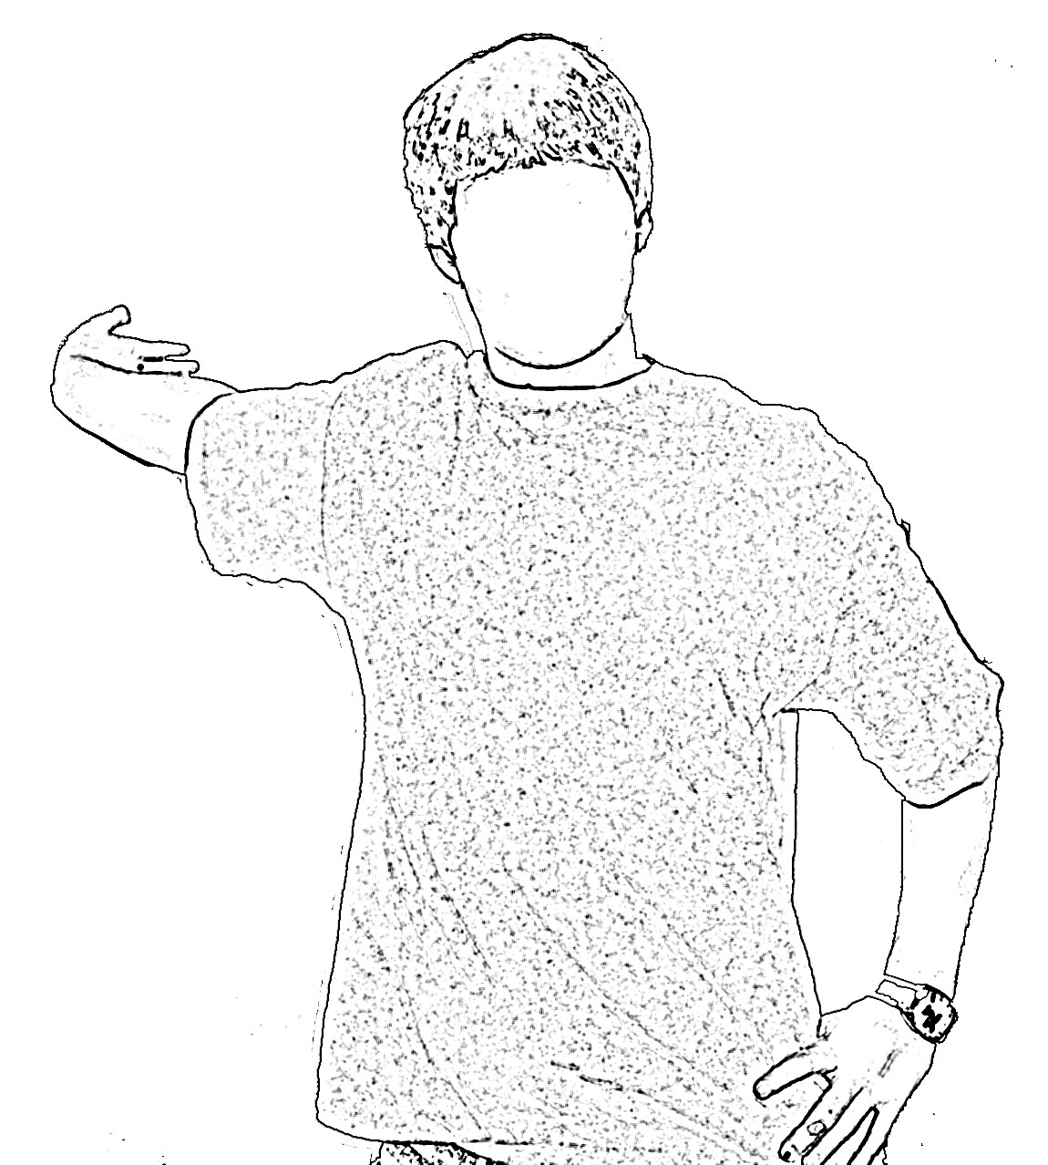 | 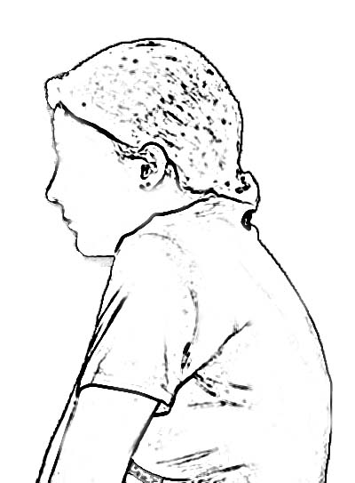 | 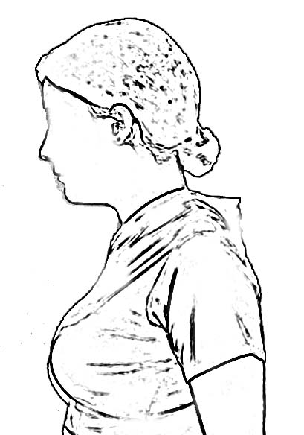 |  | 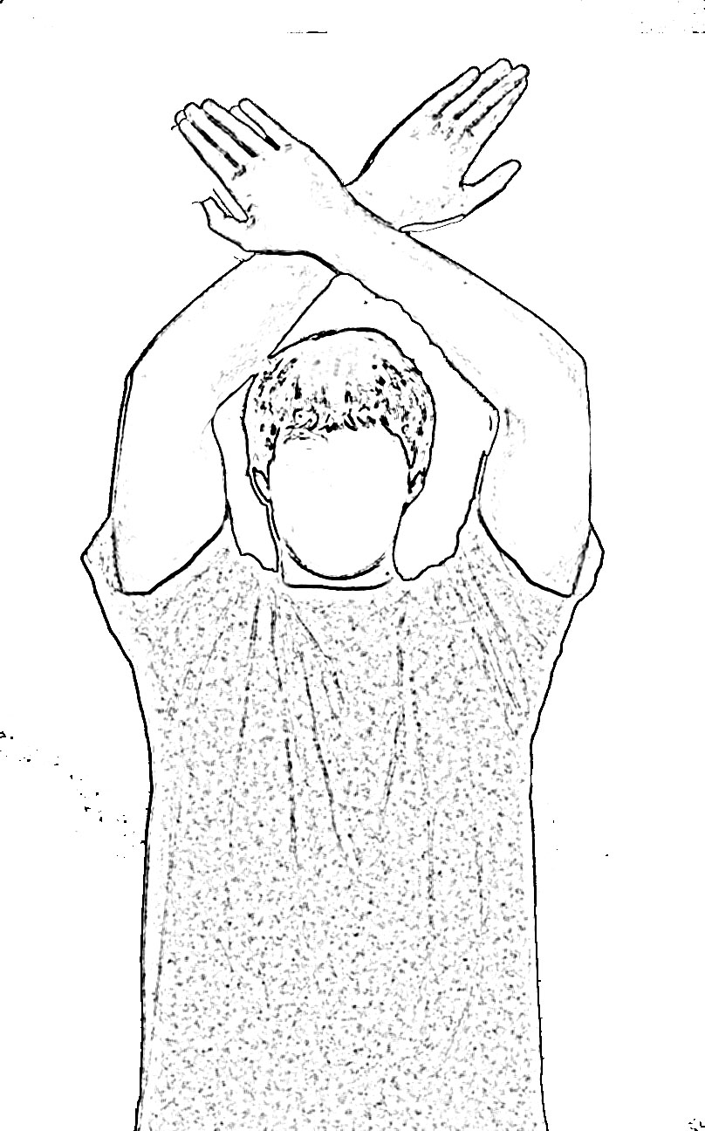
Reach hand to the side, hold onto wall or upright  Rotate body away from the hand  Hold for count of 5  Relax and repeat on other side  Repeat sequence 2 times | Roll shoulders 5 times in one direction, make small circles  Relax shoulders  Repeat sequence in other direction | Roll shoulders 5 times in one direction – start with small circles, Increase to big circle size  Relax shoulders  Repeat sequence in other direction | Roll shoulders 5 times in one direction, make big circles  Relax shoulders  Repeat sequence in other direction | Place arms in front  Cross wrists  Make big arm circles as you can - breath in on the way up and out on the way down  Go 3 times in one direction  Relax arms to sides  Repeat 3 times in other direction
Forearm, Elbows and Wrists
Wrist Flex – Arm Down | Wrist Flex – Arm Out | Wrist Flex – Arm Behind Back | Wrist Extend – Arm Down |  |  | Wrist Extend – Arm Out
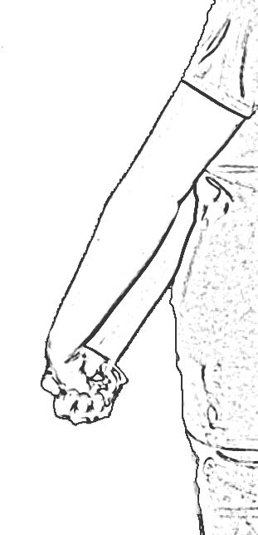 | 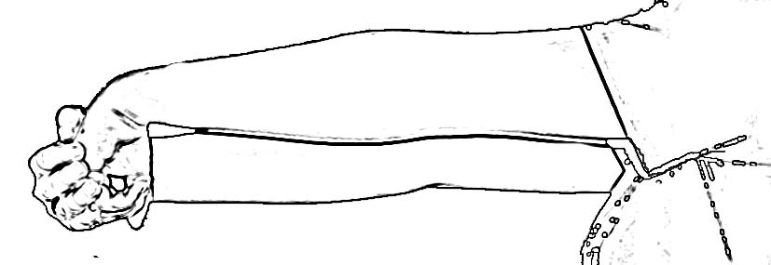 | 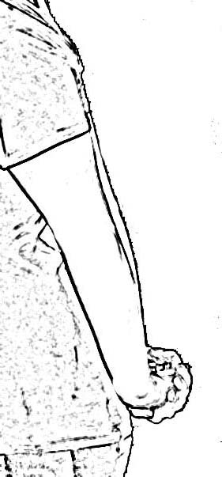 | 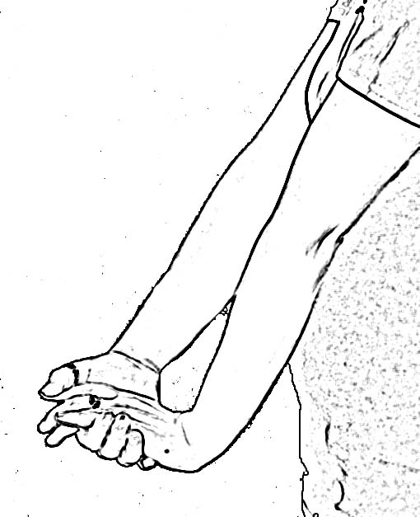 |  |  | 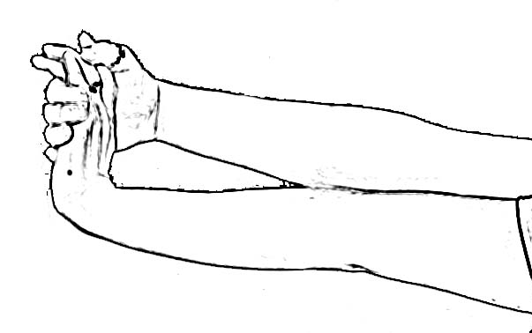
Extend arm down to side  With elbow straight, bend wrist down to stretch, make a fist  Hold for count of 5  Relax  Repeat on other side.  Repeat sequence 2 times | Extend arm out to front  With elbow straight, bend wrist down to stretch, make a fist  Hold for count of 5  Relax  Repeat on other side.  Repeat sequence 2 times | Extend arm behind back  With elbow straight, flex wrist to stretch, make a fist  Hold for count of 5  Relax  Repeat on other side.  Repeat sequence 2 times | Extend arm down to side  With elbow straight, bend wrist up to stretch  Hold for count of 5  Relax  Repeat on other side.  Repeat sequence 2 times |  |  | Extend arm out to front  With elbow straight, bend wrist up to stretch  Hold for count of 5  Relax  Repeat on other side.  Repeat sequence 2 times
Wrist Extend – Arm Behind Back | Elbow Rotation - Palm Up/Down (elbow at side) |  |  | Hands Together | Wrist Rotation
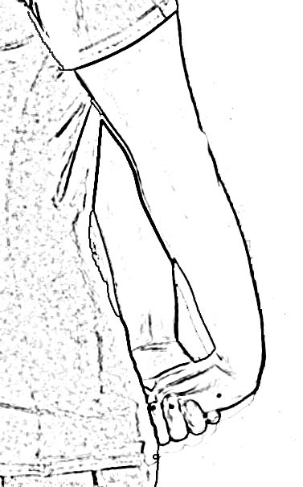 | 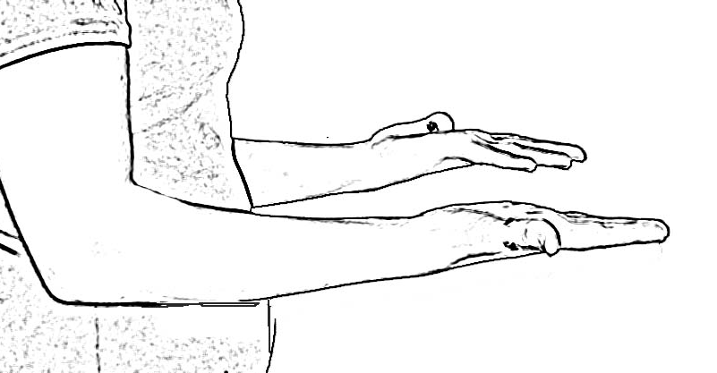 | 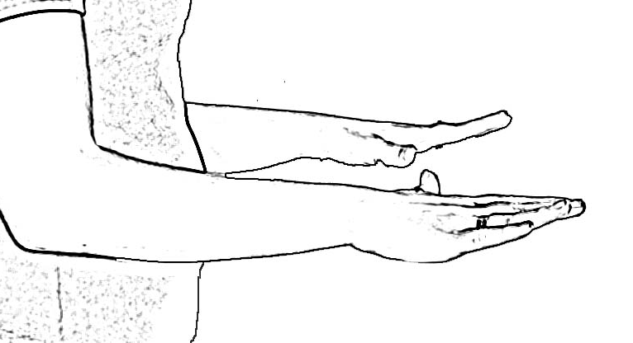 |  | 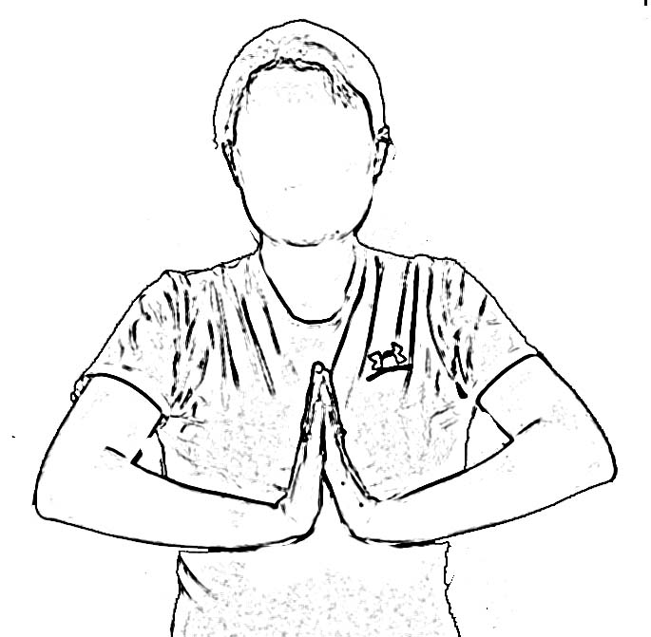 | 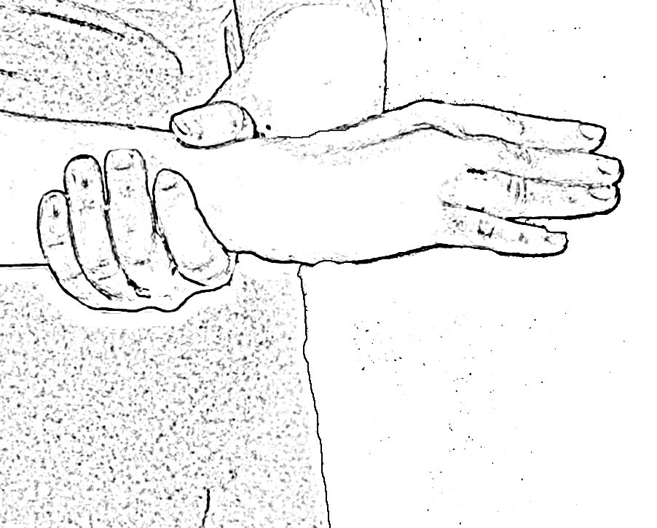
Extend arm behind back  With elbow straight, extend wrist to stretch  Hold for count of 5  Relax  Repeat on other side.  Repeat sequence 2 times | Elbows at sides bent to 90⁰  Start with thumbs pointing up  Turn hands palms up  Hold for count of 5  Return to thumbs up position  Repeat 2 times | Elbows at sides bent to 90⁰  Start with thumbs pointing up  Turn hands palms down  Hold for count of 5  Return to thumbs up position  Repeat 2 times |  | Start with hands overhead with palms together  Lower hand to chest level, keeping palms together  Hold for count of 5  Relax arms  Repeat sequence 2 times | Hold one wrist  Rotate the supported wrist in one direction 5 times  Relax  Repeat in the other direction 5 times  Repeat sequence with other wrist
Fingers and Hands
Open/Close Hands | Table Top | Thumb to Fingers
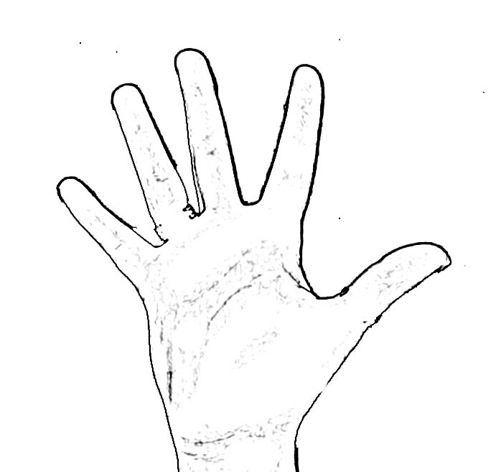 | 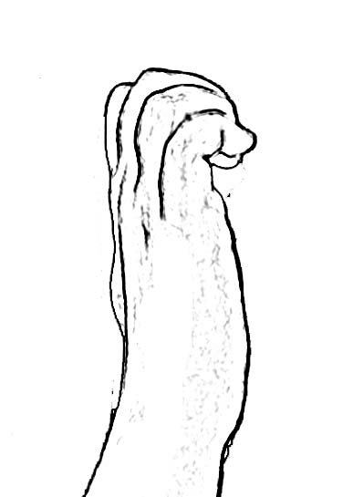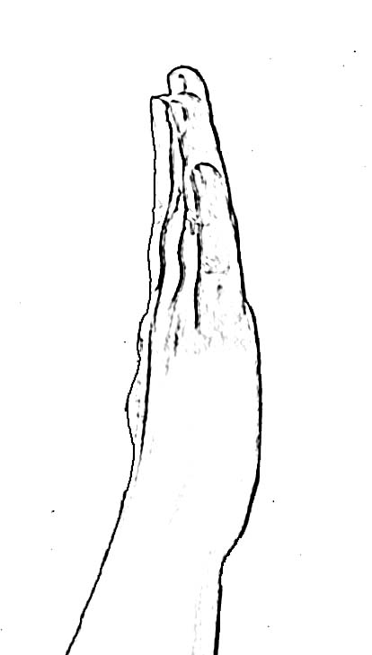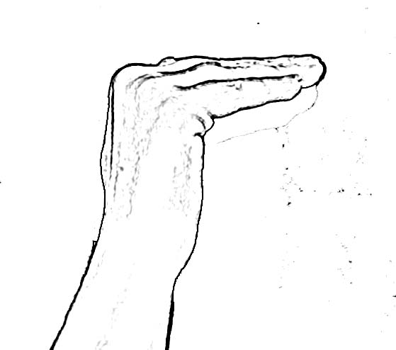 | 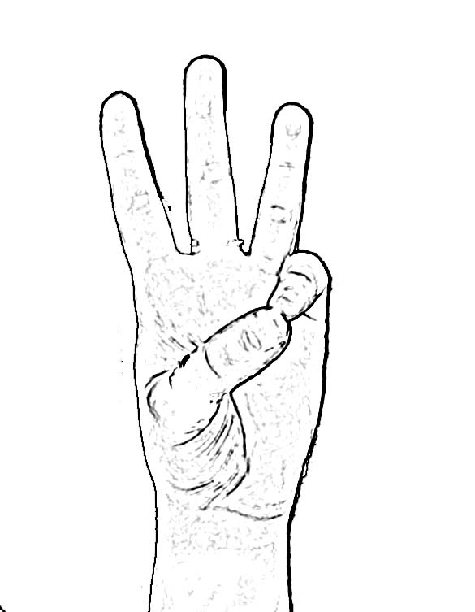
Start with arms/hands in front of body  Open hands to spread fingers as wide as possible  Hold for count of 5  Close hands to make fists  Hold for count of 5  Relax hands  Repeat 2 times | With both hands point fingers to the ceiling  Bend the fingers  Straighten the fingers to make a table top  Bend the fingers  Point the fingers to the ceiling  Repeat 2 times | Start with arms/hands in front of body, wrists straight  Open hands to spread fingers as wide as possible  Touch thumb to tip of each finger beginning with little finger  Repeat 3 times
Back
Back Bend | High Reach – Both Hands |  | High Reach – Fingers interlaced |  | High Reach – One Hand | Overhead Arm Twist
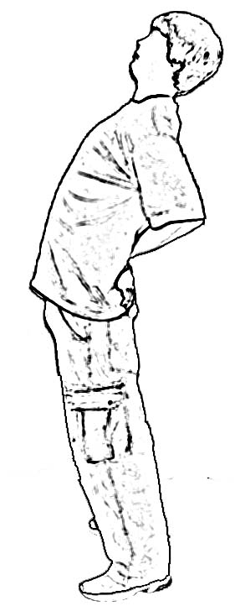 | 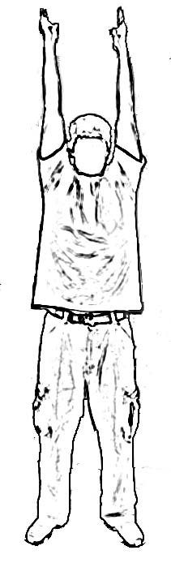 |  | 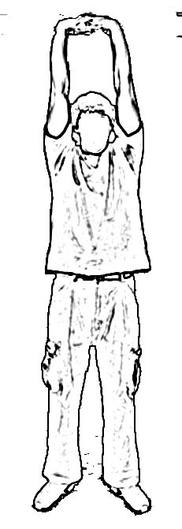 |  | 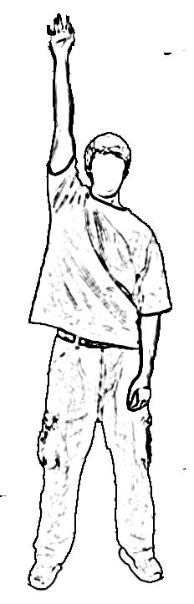 | 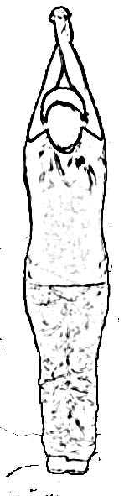
Start in neutral position  Place hands on belt line  Bend backward.  Let head naturally follow shoulders.  Hold for a count of 5  Return to neutral position  Repeat 2 times | Start in neutral position with arms at sides  Take a deep breathe and reach arms to ceiling  Stretch it out  Hold at top for count of 2  Exhale and return to neutral position  Repeat 2 times |  | Start in neutral position with arms at sides  Interlock fingers, take a deep breathe and reach arms to ceiling  Stretch it out  Hold at top for count of 2  Exhale and return to neutral position  Repeat 2 times |  | Start in neutral position with arms at sides  Take a deep breathe and reach one arm to ceiling  Stretch it out  Hold at top for count of 2  Exhale and return to neutral position  Repeat with other arm  Repeat sequence 2 times | Start in neutral position with arms at sides  Interlock arms and fingers, take a deep breathe and reach arms to ceiling  Stretch it out  Hold at top for count of 2  Exhale and return to neutral position  Repeat 2 times
Side Stretch with High Reach (both hands) | Side Stretch with Table Top |  | Side Stretch with High Reach (one hand) |  | Side Stretch (hands on head) | Rotation Hug
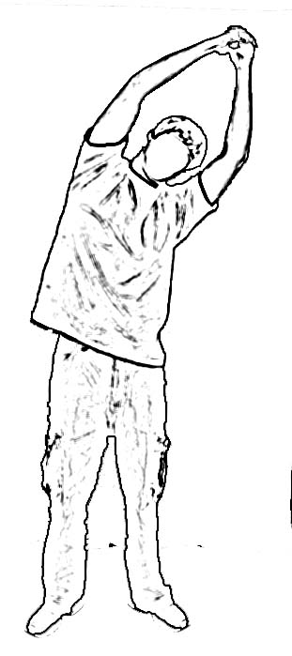 | 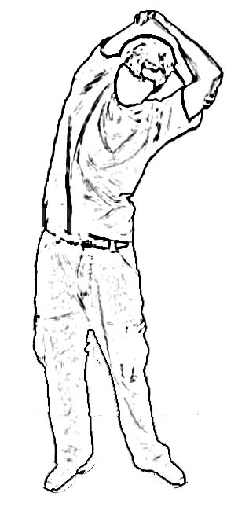 |  | 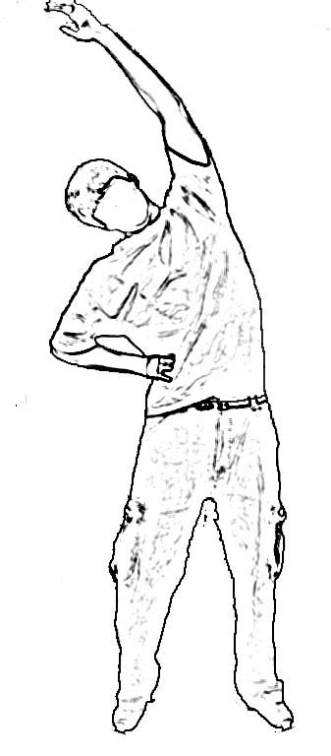 |  | 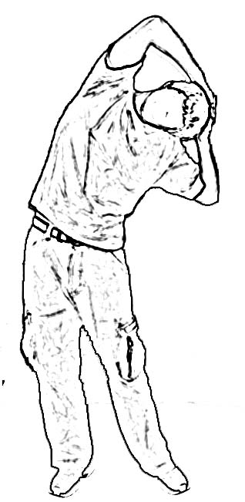 | 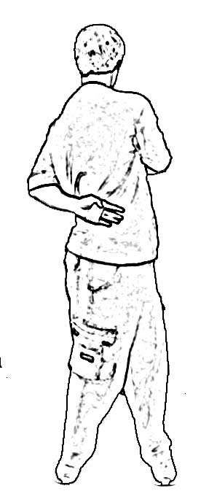
Start in neutral position with arms at sides  Interlock fingers, reach arms to ceiling  Bend to one side  Hold for count of 5  Repeat to other side  Repeat sequence 2 times | Start in neutral position with arms at sides  Place arms on top of head Bend to one side  Hold for count of 5  Repeat to other side  Repeat sequence 2 times |  | Start in neutral position with arms at sides  Reach one arm to ceiling  Bend to one side  Hold for count of 5  Repeat to other side  Repeat sequence 2 times |  | Start in neutral position with arms at sides  Place hands on back of head  Bend to one side  Hold for count of 5  Repeat to other side  Repeat sequence 2 times | Start in neutral position with arms at sides  Swing one arm to front and one arm to back as you rotate your trunk  Hold for count of 5  Return to neutral  Repeat to other side  Repeat sequence 2 times
Rotation (hands on head) |  | Slump/Return to Neutral |  | Slump/Return to Back Bend |  |  | Knee to Chest Pull
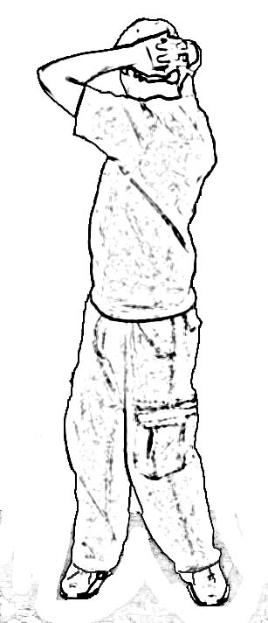 |  | 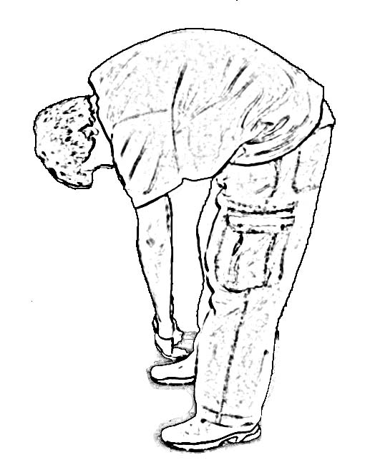 |  |  |  |  | 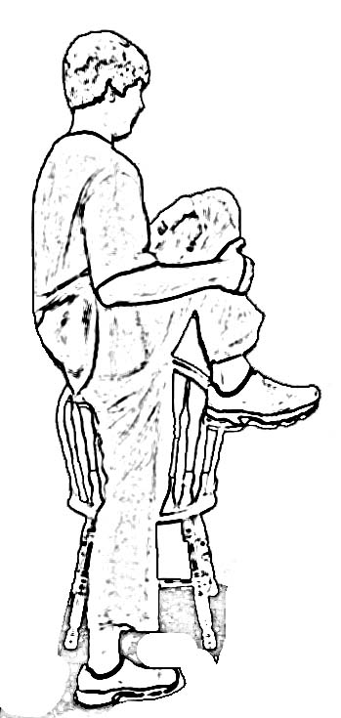
Start in neutral position with arms at sides  Place hands on back of head as you rotate your trunk  Hold for count of 5  Return to neutral  Repeat to other side  Repeat sequence 2 times |  | Start in neutral position with arms at sides  Allow your back to bend to reach to the floor  Hold for count of 5  BEND YOUR KNEES and return to neutral  Repeat 2 times |  | Start in neutral position with arms at sides  Allow your back to bend to reach to the floor  Hold for count of 5  BEND YOUR KNEES and return to neutral  Go right into the Back Bend  Return to neutral  Repeat 2 times |  |  | Use support for balance  Pull one knee up to the chest  Hold for count of 5  Switch legs  Repeat sequence 2 times
Hips and Legs
Power Squat – Hands on Hips | Power Squat – Hands on Knees | Power Squat – Reach to Floor | Hip Flexor | Straddle
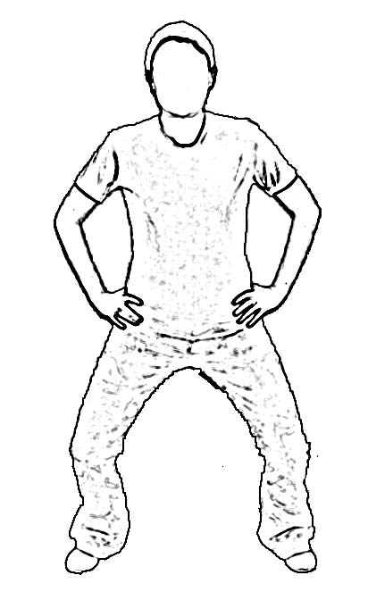 | 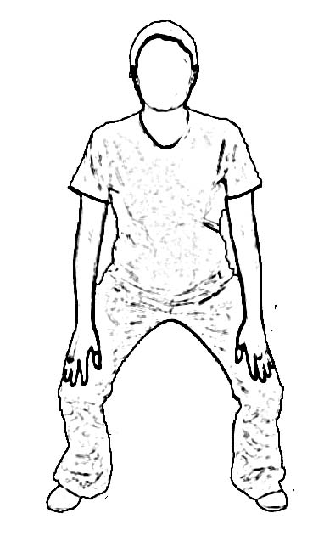 | 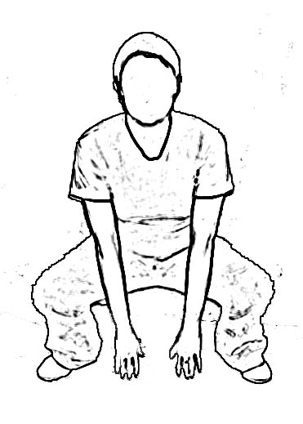 | 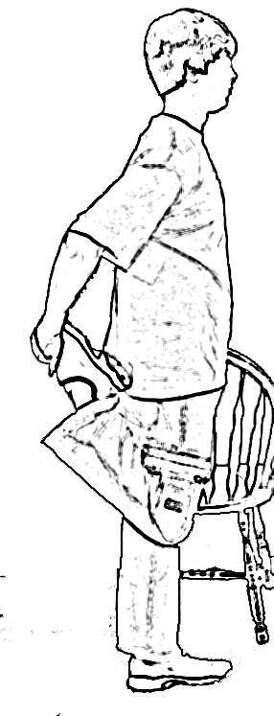 | 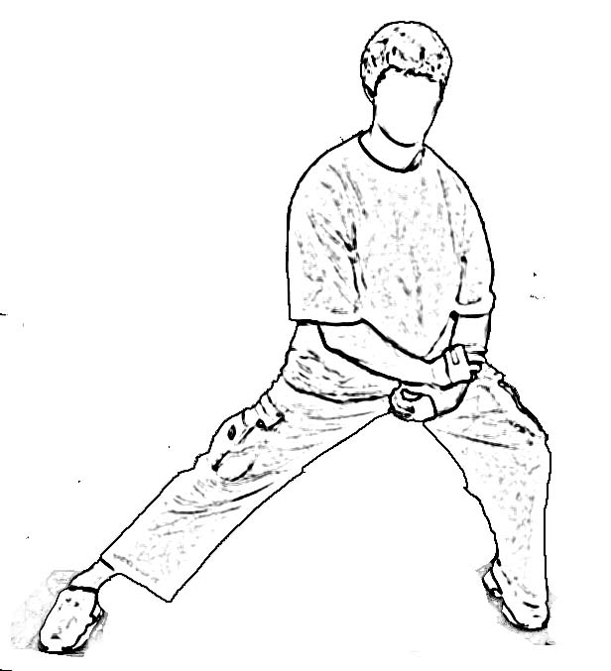
Stand with feet wider than shoulders  Place hands on hips  Keep head and shoulders up  Drop hips and bend knees keeping heels flat on the floor.  Go as low as comfortable.  Repeat 2 times | Stand with feet wider than shoulders  Place hands on knees  Keep head and shoulders up  Drop hips and bend knees keeping heels flat on the floor.  Go as low as comfortable.  Repeat 2 times | Stand with feet wider than shoulders  Reach hands to floor  Keep head and shoulders up  Drop hips and bend knees keeping heels flat on the floor.  Go as low as comfortable.  Repeat 2 times | Use support for balance  Bend knee, grab ankle/foot with hand  Tuck foot  Hold for count of 5  Switch legs and repeat  Repeat sequence 2 times | Stand with wide base  Support body weight with elbow on thigh as you bend knee  Maintain other knee straight  Go as low as comfortable  Hold for count of 5  Switch legs and repeat  Repeat sequence 2 times
Hip Rotate - Front-Side-Back | Hip Sag | Hamstring/Floor | Hamstring/Rest | Bent Knee Hold
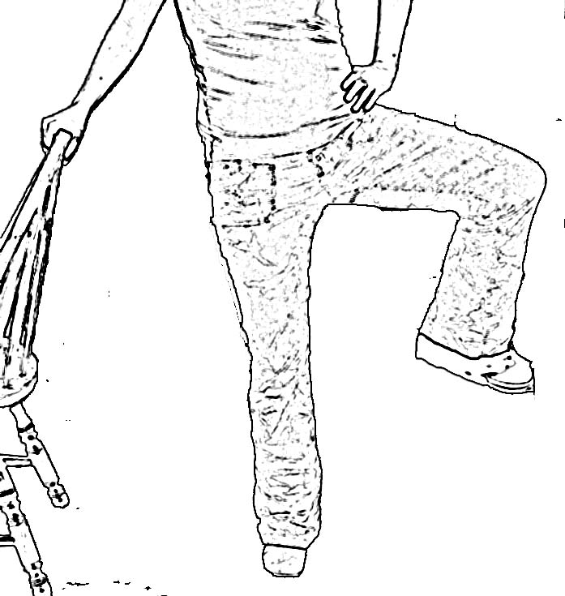 | 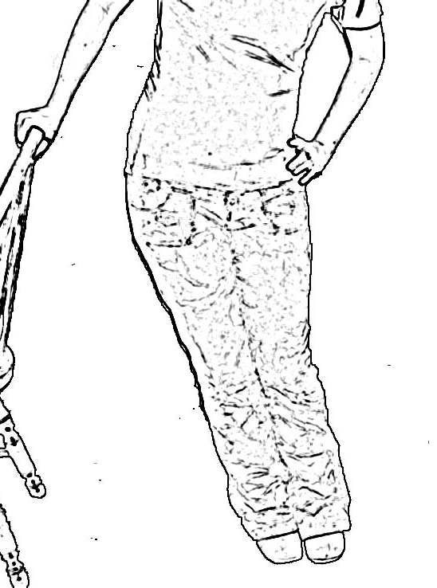 | 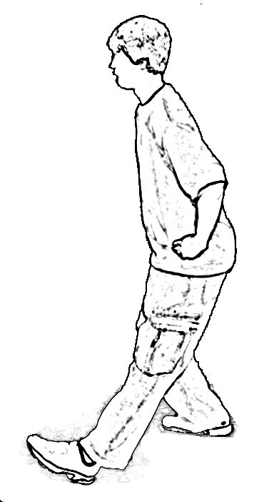 | 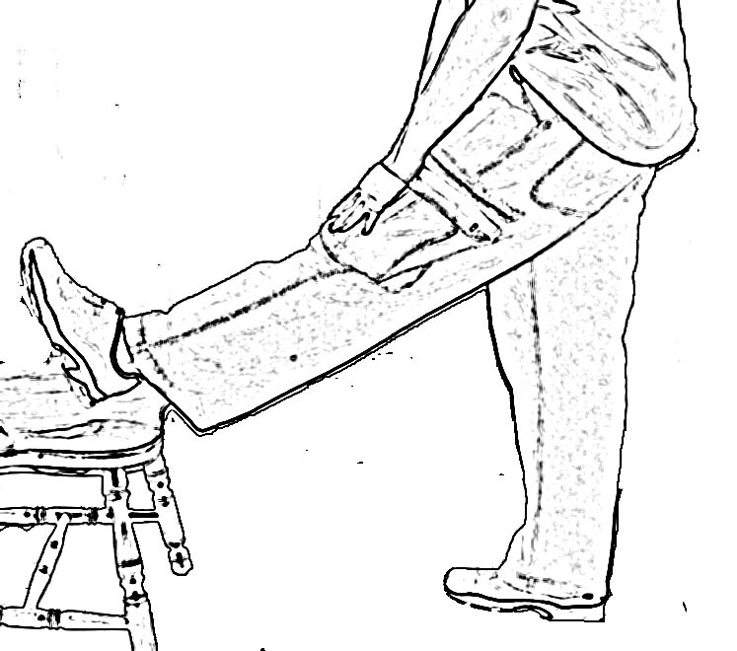 | 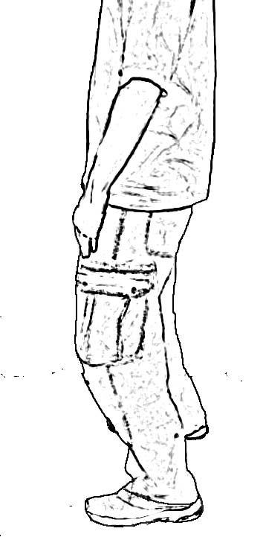
Use support for balance  Lift leg and bend knee  Rotate the leg one way 3 times  Reverse direction and rotate 3 times  Switch legs and repeat sequence | Use support for balance  Start in neutral position  With feet together, lean hips toward support  Hold for count of 5  Return to neutral  Repeat 2 times  Switch sides and repeat sequence | Place leg forward with heel on floor  With hands on hips, keep head and shoulders upright  Bend opposite knee to lower hips and stretch behind knee  Hold for count of 5  Return to neutral  Repeat 2 times  Switch legs and repeat sequence | Place leg forward with heel on elevated surface  With hands on hips, keep head and shoulder upright  Bend ankle, bringing foot up to stretch behind knee  Hold for count of 5  Return to neutral  Repeat 2 times  Switch legs and repeat sequence | Start in neutral position  Bend knees slightly to activate the front thigh muscles, this will relax the hamstring (back thigh muscles)  Hold for a count of 5  Return to neutral  Repeat 3 times
Ankles and Feet
Heel Cord | Ankle Circles | Soles In/out
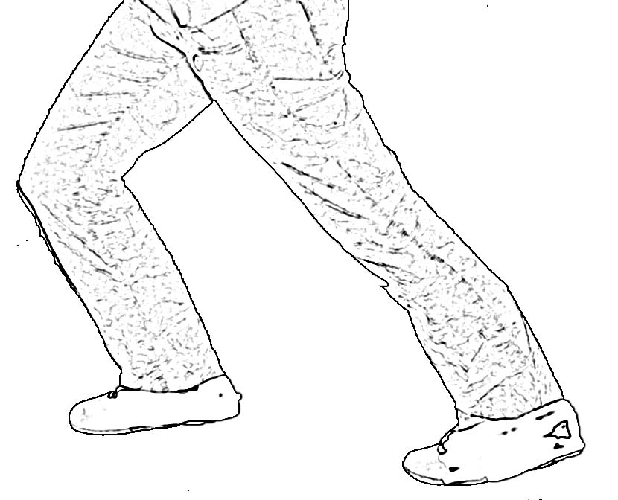 | 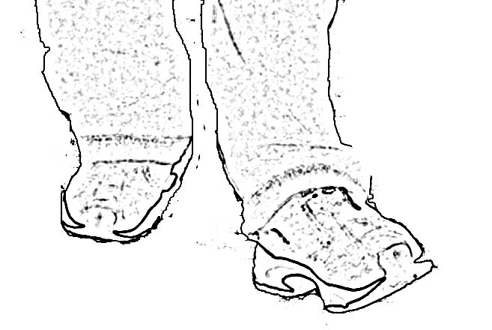 | 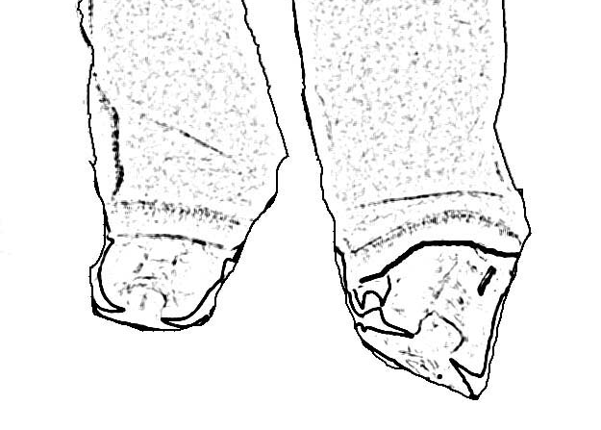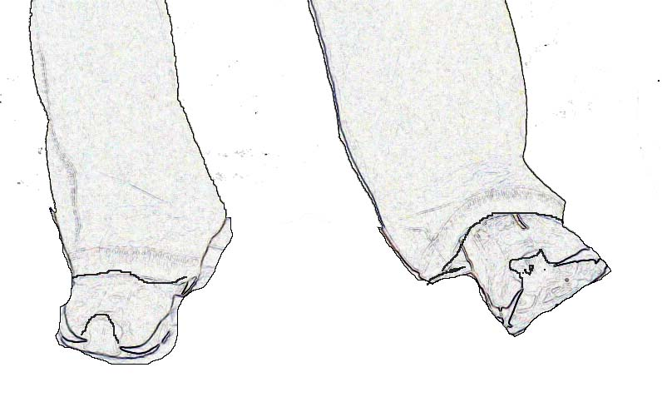
Place one foot behind the other with both feet pointed straight ahead  Keep the heel of the back foot flat  Keep the head and shoulders upright, bend the front knee  Hold for a count of 5  Repeat 2 times  Switch legs and repeat sequence | Use support for balance  Circle ankle 5 times each way.  Repeat with other ankle | Use support for balance  Turn sole of foot inward  Hold for count of 5  Turn sole of foot outward  Hold for count of 5  Repeat 2 times  Switch feet and repeat sequence

Overall

The ‘Scoop’
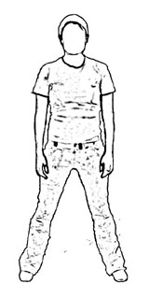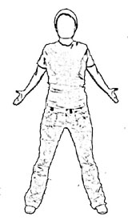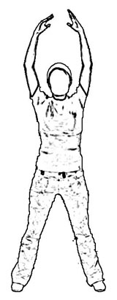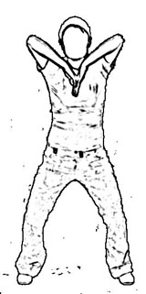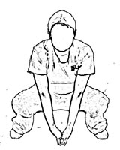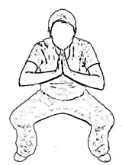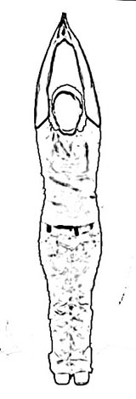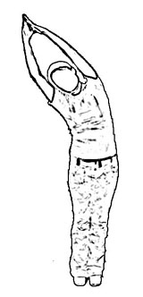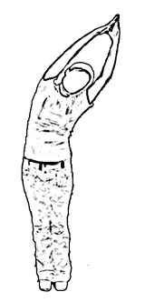
Start in Neutral Position, reach arms to side with thumbs up, raise arms overhead, bring backs of hands together, dive down into squat, put palms together, stretch into overhead reach, bring feet together, clap 3 times, stretch to one side, stretch to the other side, back to middle, lower arms, feet shoulder width apart, return to Neutral Position

Step In Place | Belly Breathing | Neutral Postition
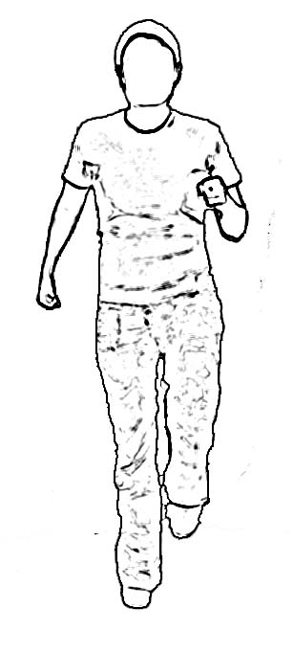 | 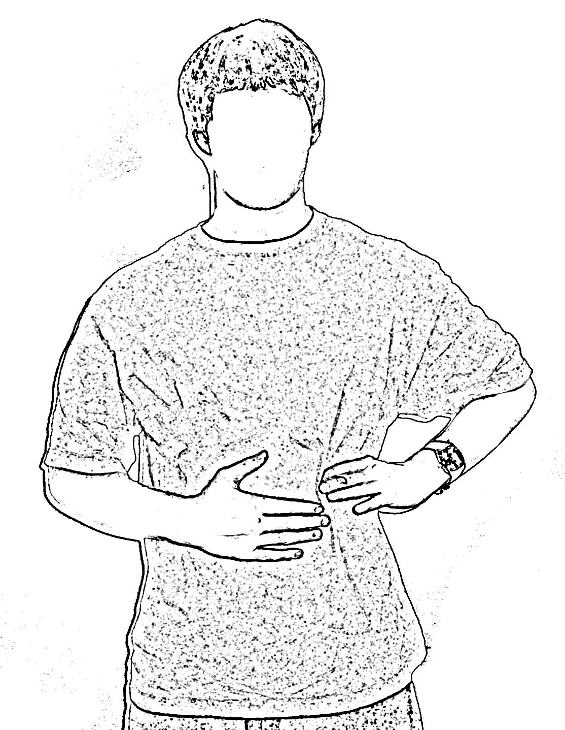 | 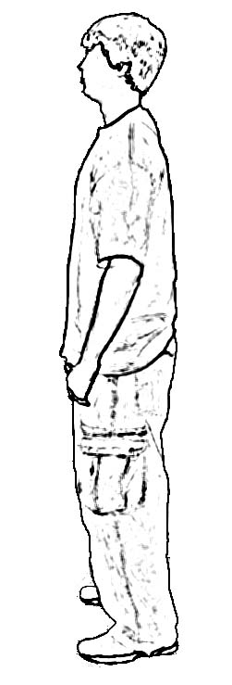
High step in place for 30 seconds  Swing arms as you step | Place one hand on rib cage on side and other hand on abdomen.  Take long slow breath and feel rib cage expand and abdomen push forward  Reach end of breath and exhale slowly, pushing as much air as possible out of lungs  Breathe normally for two breaths  Repeat sequence 2 times | To obtain neutral position, reach hand to top of head  Imagine you’re a puppet on a string and puppeteer has pulled straight up  Relax hands down to sides in this new upright position  This is called the Neutral Position

