WorkWell Prevention and Care Presents:

Ergonomics
Beyond the Traditional Office Workstation (Online)

The information contained in this training workbook has been developed in good faith and is believed to present good ergonomics principles and practices.
WorkWell Prevention and Care and all other participating organizations make no representations or warranties as to the completeness or accuracy of the materials thereof. Persons using this information must make their own determination as to its suitability for their purposes.
WorkWell Prevention and Care and all other participating organizations are in no way responsible for damages of any nature resulting from the use of this information.

Copyright 2018-2021 WorkWell Prevention and Care, Inc.
All Rights Reserved
Version 2 041112021

Table of Contents
Course Overview 6
World of Technological Connectedness! 6
Intended Audience 6
Course Logistics 6
Schedule 6
Disclosure 7
Non Discrimination 7
Participation Attendance Policy 8
Course Evaluations & Certificates of Completion 8
Record Retention 8
Questions and Inquiries 8
Complaints 8
Welcome! 9
World of Technological Connectedness! 9
Workshop Logistics 9
Workshop Guidelines 9
Participant Background and Experience 9
Learning Objectives 9
Ergonomics: Beyond the Traditional Office Workstation 10
What do we mean by “Beyond”? 10
Opportunities to apply ergonomics? 10
Home office 10
Mobile office 10
Home and beyond 11
How to get to “Beyond”? 11
Ergonomics 11
Basic Ergonomics Principles 11
Position and Support (Body and Limbs) 11
Hand Use (Reach Zone) 11
Fatigue Control (Dose/Exposure) 11
Applications 11
Assessment Tools/Checklists/Guides 12
Unique role of Health Care Professionals (HCP) 12
Ergonomics – Defined 13
Relationships 13
Problem areas/ergonomics risk factors? 13
Problem areas/ergonomics risk factors? 14
Chair 14
Monitors 14
Desk 14
Foot support 14
Physical relationships 14
Short and long term recommendations 14
Ergonomics – Basic Principles 15
Overview 15
Position and Support in Neutral 16
Spine neutral position 16
Neutral for body as a whole 16
Limb joint neutral position 16
Provide Support for Body/Limbs 17
Seated 17
Limbs 17
Standing – sustained 17
Sustained Sitting 17
Suggestions for standing comfort 17
Best Posture is the Next Posture! 18
Reach Zone 18
How much do we use our hands every day? 18
Where do we tend to use our hands? 18
Comfort Reach Zone 19
Functional Reach Zone 19
Determine Reach Zone 19
Fatigue Control (Dose/Exposure) 20
Eliminate fatigue? 20
Dose/Exposure Concept 20
Dose/Exposure Concept – Ergonomics Perspective 20
Fatigue Control – Recognize 21
Fatigue Control – Strategies 21
Move on a regular basis 21
Fatigue Control – Computer Vision Syndrome 22
Ergonomics – Basic Principles Summary 23
Work from Home (WFH) 23
Work on The Go (WOTG) 23
Universal Design (UD) 23
Working from Home (WFH) 24
No longer tethered 24
Advantages of WFH 24
Increase in work flexibility 24
Increase in productivity 25
Less or no time commuting 25
Disadvantages – Ergonomics Related 25
Increased Musculoskeletal Risks 26
Home Office Workplace 26
Home workplace set-up strategies 26
Home Office set-up considerations 27
Location options 27
Step-by-Step Approach – Laptop Computer 28
Step-by-Step Approach – Desktop or Laptop Computer 28
Step-by-Step Approach – Desk/Chair 29
Chairs – A Little More Information 29
Chairs – Adjustment 30
Best way to sit? 30
Upright keyboard position 30
Semi-reclined conversation position 30
Best advice? 31
Step-by-Step Approach – Desk/Chair 31
Adjustable height table/desk and adjustable height chair 31
Fixed height table/desk and adjustable height chair 31
Fixed height table/desk and fixed height chair 32
Fixed height table/desk and fixed height chair 32
Step-by-Step Approach – Couch 33
Step-by-Step Approach – Standing 33
A Few More Considerations 34
Vision 34
Blink 34
Phones 34
Lighting 34
Home Office Checklists, Reference Guide and Tips 34
Reference Guides 34
Tips 34
Checklists 35
Assessment tool 35
Case Study – Rapid Office Strain Assessment (ROSA) 35
Ergonomics analysis process 35
ROSA (Rapid Office Strain Assessment) 35
ROSA Case Study 35
Potential Issues 36
ROSA Assessment Tool 37
Work on the Go (WOTG) 51
Digital Nomads! 51
Perhaps not fulltime! 51
WOTG Case Study 51
Work on the Go (WOTG) – General Guidelines 53
Laptop or Tablet – Single Desk/Table 53
Laptop or Tablet – Tabletop/Travel 53
Portable Laptop/Tablet Stand and Bluetooth Keyboard 53
Be creative! 54
Laptop lap desks 54
Work on the Go (WOTG) – Cars and Airplanes 54
Car laptops 54
General tips 54
Work on the Go (WOTG) – Airports 55
Work on the Go (WOTG) – Business Travel 55
Suitcases 55
Backpacks or computer bags 55
Smartphone and Tablet Tips 55
Small hands? 56
Device selection 56
Universal Design (UD) 58
UD Examples 58
Background 58
Purpose 58
Universal Design and Ergonomics related? 59
7 Principles of Universal Design 59
Overview of 7 Universal Design Principles* 59
Universal Design and Ergonomics related! 62
Universal Design – Resources 62
Ergonomics: Beyond the Traditional Office Workstation! 62
Selected References 63
Ergonomics Beyond the Traditional Office 63
Office Ergonomics 64
Primary Ergonomics References 65
Journals (Selected) 65
Professional Organizations 65

Course Overview

World of Technological Connectedness!
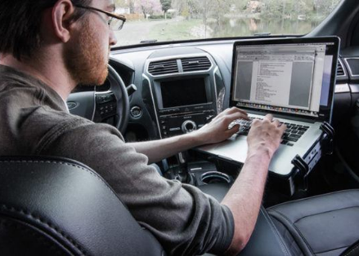
In our world of technological connectedness, the ability to complete work outside of a traditional office setting is more available than ever before.
Workers can be productive just about anywhere – from the airport to airplanes, from the coffee shop to the car, and more.
The mobile workforce, however, is not immune to musculoskeletal issues.
Ergonomics: Beyond the Traditional Office Workstation provides considerations for mobile office ergonomics to help participants generate reasonable ergonomics recommendations for the on-the-go population.

Intended Audience
Licensed health professionals ‐ Physical Therapist, Occupational Therapist, Physical Therapist Assistant, Occupational Therapist Assistant, Athletic Trainer, Physician, Physician Assistant, Chiropractor, Occupational Health Nurse. Certified/Registered Kinesiologist, Exercise Physiologist or Case Manager.
Consideration of other health/safety personnel based on space and background.

Course Logistics
- Download materials from File Repository area of dashboard in WorkWell Provider Learning Center
- Overview of online delivery method and dashboard
- Attendance log
- Course schedule
- Break/s
- Telephones and use of mute

Schedule
One Session - Duration 2 Clock Hours

- Topics
- Welcome & Introduction
- Learning Objectives
- Ergonomics Defined
- Ergonomics Principles
- Neutral Position
- Hand Use Reach Zone
- Fatigue Control
- Working from Home (WFH)
- Home Office Setup
- Home Office Checklists
- ROSA Case Study
- ROSA Case Study Interventions
- Work on The Go (WOTG)
- Universal Design (UD)
- Summary and Close
- Educational Handouts and Resources
- Computer Vision Issues and Tips
- ErgoSystems Home Office Ergonomics Quick Reference Guide
- Pain the What
- Solution Sheet for the Mobile Worker
- The 7 Principles of Universal Design
- Checklists and Assessment Tools
- ErgoSystems Home Office Ergonomics Checklist (pdf and Word)
- ROSA Instructions and Forms
- Tools, Tasks and Time Checklist
- Course Evaluation Survey (completed online in WorkWell Provider Learning Center)
(10 min. break approx. mid way through class - at faculty discretion)

Disclosure
All faculty are paid by WorkWell and have non-financial relationships with WorkWell. Non-financial relationships include a preference for WorkWell evaluation, prevention and work rehabilitation programs.
WorkWell has some degree of financial and non-financial relationships with providers through our business model. WorkWell focuses sales of services on predominantly national companies and not on local corporations, contracting with provider groups instead of operating a brick and mortar operation business model. While contracting with providers and facilities that employ clinicians trained by WorkWell allows WorkWell to have a basic understanding of quality of site service provision, there is no exclusivity requirement against sites participating in training from other vendors, nor any requirement to accept work on individual contract/s. WorkWell also does contract with providers who have not been formally trained by WorkWell to meet basic service provision such as performance of standardized post offer testing, provided the testing protocol is strictly defined and the providers have skills, training or experience to complete the limited work scope (with a manual and training for consistency of performance).
WorkWell has a commercial interest in both delivering educational programs (to various healthcare and safety oriented individuals) and delivering prevention and work disability rehabilitation/management programs (generally to employers).
Clinics who foster local employer contracts and seek to expand the footprint of those contracts may negotiate with WorkWell to help leverage resources and/or partner to expand, grow and execute regional or national contracts. There is not an implied or specific promise of additional contracting or business opportunities related to participant attending educational programs.
WorkWell offers FCE and work analysis equipment for sale to providers which meet designated safety standards/consultant measurement needs. Providers have the option to seek appropriate equipment described in the equipment list/s from any vendor.

Non Discrimination
WorkWell is committed to accessibility and non-discrimination in professional development activities. WorkWell complies with laws and rules regarding discrimination relevant to learning activities and does not discriminate on the basis of race, color, national origin, religious affiliation, sex, gender, disability, military status, sexual orientation or age. Participants who have special needs are encouraged to contact WorkWell so that reasonable efforts to accommodate these needs can be made.

Participation Attendance Policy
Participation in the entire training is Mandatory. Registrants who arrive late or miss portions of the workshop will NOT be eligible for certificate or refund. WorkWell wants to ensure a suitable learning environment and conditions free from distraction to optimize participation.

Course Evaluations & Certificates of Completion
Certificates of completion will only be provided to individuals who meet the course requirements, attend entire session, and complete the course evaluation survey. Individuals who do not complete the session will not be eligible for certificates of completion.

Record Retention
Course records are kept in a secure, electronic location. Individual participant information and forms may only be disclosed to the participant or WorkWell personnel in the course of their duties. Information may be released to other designated individuals or entities with a written request submitted via mail or fax by the participant which includes the name and date of the relevant training, contact information of the participant, contact information for the intended recipient, and signature of the participant. Participant may contact WorkWell using the contact methods listed below to request records.

Questions and Inquiries
306 W. Michigan St. Suite 301
Duluth, MN 55802
P: (866) 997-9675
F: (320) 323-4423
E: provider@workwellpc.com
www.workwell.com

Complaints
Complaints regarding any part of program sales, registration and course delivery should be directed toward WorkWell. All attempts will be made to resolve complaints in a timely and professional manner. Complaints will be forwarded to Dee Daley (Director of Clinical Practice) and Kristen Cederlind (Director, Clinical Services). Complaints may be submitted via the following methods:
Email: dee.daley@workwellpc.com or kristen.cederlind @workwellpc.com
Phone: Toll Free 1-866-997-9675
Mail: 306 W. Michigan St., Suite 301, Duluth, MN 55802

Welcome!

World of Technological Connectedness!
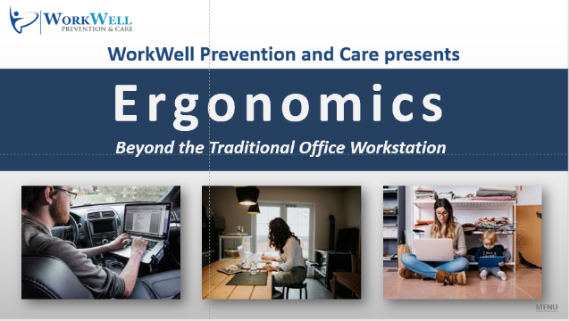
In our world of technological connectedness, the ability to complete work outside of a traditional office setting is more available than ever before.
Workers can be productive just about anywhere – from the airport to airplanes, from the coffee shop to the car and more.
The mobile workforce, however, is not immune to musculoskeletal issues.
Welcome to Ergonomics: Beyond the Traditional Office Workstation.
We will provide considerations for mobile office ergonomics to help participants generate reasonable ergonomics recommendations for the on-the-go population.

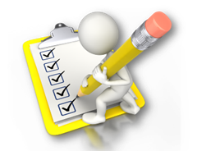
Workshop Logistics
- Manual/Handouts
- Workshop schedule
  - Starting/ending times
  - Breaks
- Telephones – mute/unmute

Workshop Guidelines
- Follow along with the demonstrations unless you think they may cause you a problem.
- Do not go against doctor's orders or do anything that you feel you should not.
- If you are uncomfortable sitting during the training, feel move to move about.
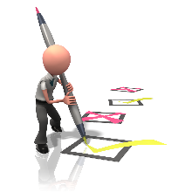
- Use your good judgment when trying new techniques or exercises once you complete the training.

Participant Background and Experience
Let’s continue by learning a bit more about you.
- Practice Setting
- Assessment Experience
- Ergonomics Consultation

Learning Objectives
By the end of the training, we anticipate you’ll be able to identify some of the common risk factors related to the mobile worker as well as have an idea where to start with assessment and interventions.
You’ll find mobile ergonomics probably isn’t quite as cut and dry as traditional office ergonomics, but there are common patterns and priorities.
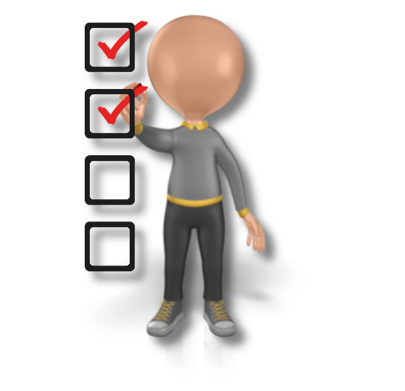
Specifically, at the end of the training, participants will be able to:
- Identify 2 of the most common ergonomic risk factors related to the mobile worker
- Identify 3 considerations which need to be assessed and included in all mobile worker office ergonomics evaluations.
- Using case information provided, select 3 mobile office ergonomic interventions.
- Prioritize ergonomic recommendations based on findings and worker’s unique situation.

Ergonomics: Beyond the Traditional Office Workstation

What do we mean by “Beyond”?
“To infinity and Beyond!”
Well, maybe not quite that far!
However, opportunities are definitely out there and available for Health Care Professionals to use ergonomics applications for the benefit of their patients and clients.

Opportunities to apply ergonomics?

Home office
With the recent significant increase in tele-commuting, the need for individuals to set-up a productive and safe home office is quite large and is expected to continue to grow.
Companies are appreciating that employees working at home can be very successful and some employees may never return to working full time in the work office.
Working from Home (WFH) is here to stay!

Mobile office
With the ability to connect to the workplace by laptop and mobile phone literally from almost everywhere, the mobile office has vastly expanded.
As a result, the need to use mobile devices safely and effectively in the car, plane, hotel room and other locations has led to a growing Work on the Go (WOTG) contingent.

Home and beyond
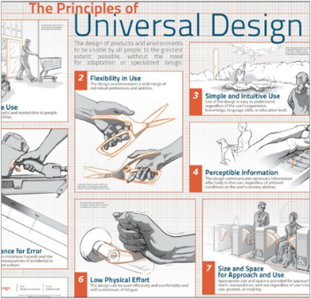
While we have traditionally applied ergonomics principles primarily to a “work” environment they can be applied to any environment; applications are being expanded to the home and other places.
Perhaps Universal Design (UD) Principles may be new to you. A few examples include curb cutouts and lever door handles.
We will introduce UD Principles to you to see how they are intended to improve use and access in both work and non-work environments.

How to get to “Beyond”?

Ergonomics
How to get beyond is a very good question. We can start by defining ergonomics.
Ergonomics has many definitions - for example, “user friendly” and “fitting the job to the worker”.
Basically, ergonomics is all about relationships. We will get into the details shortly.

Basic Ergonomics Principles
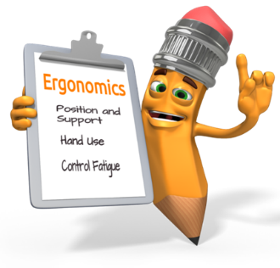
To appreciate how ergonomics works, we’ll define three basic ergonomics principles.

Position and Support (Body and Limbs)
First principle; position and support the torso and limbs in what is called a Neutral Position; more about this shortly.

Hand Use (Reach Zone)
Second principle; set-up the workspace so the hands are used in the appropriate Reach Zone. More about this is a moment too.

Fatigue Control (Dose/Exposure)
And third, practice strategies that will help to identify and control physical and mental fatigue.

Applications
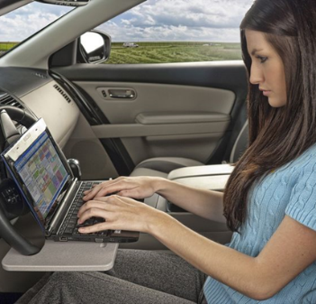
Once we have discussed the basic ergonomics principles, we’ll go through applications in a variety of settings to include:
- Home office set-up
- Mobile device use
- Home and other settings

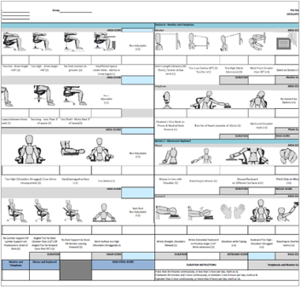
Assessment Tools/Checklists/Guides
To bring the applications to fruition we’ll use the Rapid Office Strain Assessment or ROSA and work through a Home Office Case Study. Remember other resources are also available to you and among others include:
- Tools, Tasks and Time Checklist
- Home Office Ergonomics Checklist
- Home Office Ergonomics Reference Guide

Unique role of Health Care Professionals (HCP)
QUESTION:
What advantages do Health Care Professionals (HCP) gain by acquiring new or enhancing existing skills in ergonomics principles and applications?
ANSWER:
Check those that apply and add your own unique advantages:
Assist in successful transition to home and mobile workplace
Focusing a patient’s treatment plan through an ergonomics analysis of a patient’s work and/or home demands.
Identifying potential modifications to assist a patient in the return to work, Activities of Daily Living (or other activity) process.
Preventing potential injuries to employees and others through proactive ergonomics analysis and intervention.
_______________________________________________________________

_______________________________________________________________

_______________________________________________________________

_______________________________________________________________

_______________________________________________________________

_______________________________________________________________

_______________________________________________________________

_______________________________________________________________

_______________________________________________________________

Ergonomics – Defined

Relationships
As we mentioned Ergonomics is all about relationships between the user and the workstation.

Problem areas/ergonomics risk factors?
Take a look at the pictures of the workstation in this home office.
Do you see any problem areas/ergonomics risk factors that might be a relationship problem? Enter your responses in the list below the pictures.
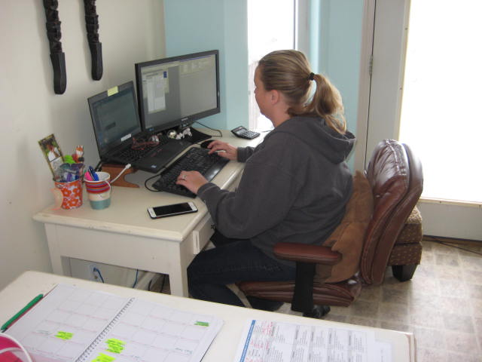 | 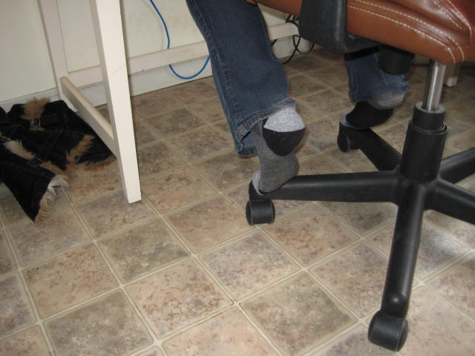

Potential Issue

Problem areas/ergonomics risk factors?
Take a look at the list on the next page.
More than likely you identified quite a few of them. These are common issues you probably will identify in many home office situations.
Look at the relationship issues.

Chair
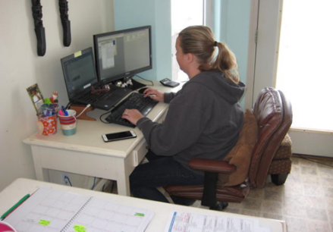
- User fix to add pillow for back support
- Limited/no adjustment
- Seatpan: height, angle
- Back support: height, angle
- Armrests: fixed position, no support

Monitors
- Laptop and stand-alone monitors
- Alignment issue
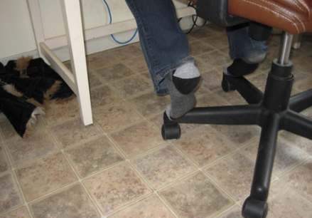
- Size mismatch

Desk
- Too high for keyboard/mouse position
- Contact stress forearm
- Limited space on desk

Foot support
- Using chair legs, feet dangling

Physical relationships
What relationships are we looking for between the user and home office furniture, computer equipment and/or mobile equipment to obtain comfortable, well supported body and limb positions?
Here are the desired relationships:
- Head well balanced on the neck and shoulders; this is directly related to the monitor, display or other screen position. The user has to be able to see them and this will dictate head and neck position
- Arms, back and feet well supported by the chair, desk and floor. Consider all the relationships involved now. Chair and desk fit and adjustment need to match the user’s stature.
- Keyboard/mouse/tablet/phone positioned to promote neutral upper extremity postures for using the equipment
We’ll get into the details in the next sections when we outline the ergonomics principles and the applications based on the situation.

Short and long term recommendations
For our example above we recognized a number of relationship issues. Some of them we were able to improve at the time of the assessment.
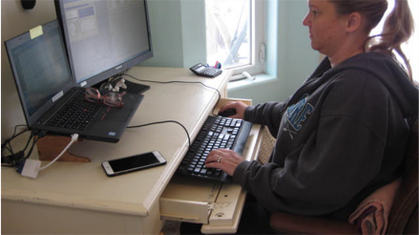
We made use of the existing slide-out keyboard drawer. Now, as it turned out this was at a fixed height and it did provide for the chair to be lowered to position the feet on the floor and neutral hand and arm position. This isn’t always the case.
Next, we were able to replace the large pillow she was using with a smaller rolled up towel for improved back support. We fine-tuned the monitor position.
So, in the short term it was improved to some extent. In the long term the recommendations were to replace the chair with a fully featured office ergonomics chair and because her spouse was handy with a saw, she was able to have her existing desk lowered to the appropriate height. It was lowered from 29 to 27”.
As possible always look for short term improvements to be made as quickly as possible and then add the longer term recommendations for more permanent improvements.

Ergonomics – Basic Principles

Overview
Now that we have defined ergonomics in the overview as establishing the desired relationships between the user and workstation, let’s briefly overview the three basic principles we will discuss in this course.
Recall they are:
- Position and Support (Body and Limbs)
- Hand Use (Reach Zone)
- Fatigue Control (Dose/Exposure)
Also, if you are interested in more details about ergonomics and principles in work office and manufacturing work environments, check out the other WorkWell courses:
- Office Ergonomics: Introduction for Health Care Professionals (Online)
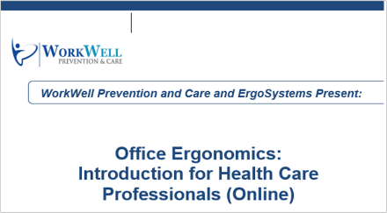
- Manufacturing Ergonomics: Introduction for Health Care Professionals (Online)
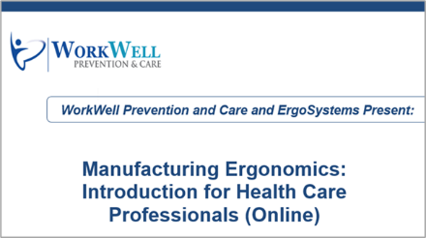

Position and Support in Neutral
The first ergonomics principle is to Position and Support (body and limbs) in Neutral.
One way to think about the neutral position is to consider what really is the foundation of the body?
Is it the feet? Consider if a person sprains an ankle . . . by using a pair of crutches they can still get around.
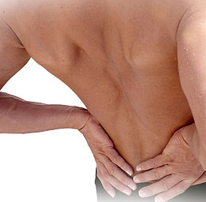
On the other hand, what if a person “sprains” their back? You know someone who's been in this condition – they have a significant problem even getting out of bed to get to the bathroom.
The foundation or core of the body truly is the spine and pelvis. This directly relates to the position of the body in general and to posture in specific.
With the spine and pelvis in a good position, this allows us to make good use of our legs and arms.

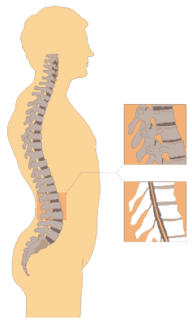
Spine neutral position
What is the neutral spine position?
Viewed from the side, a neutral spine is in an S-shape: inward curves in the low back and neck, outward curve in the midback.
The advantage is that the spring-like shape can better deal with compression and shear stresses in the spine.
Benefits of promoting the neutral spine position are significant:
- Decreased biomechanical stress
- Increased respiratory function
- Improved range of motion

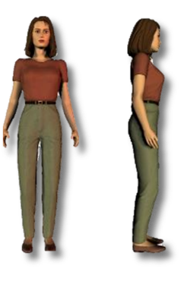
Neutral for body as a whole
Neutral position for the body as a whole is with the head over the shoulders over the hips over the knees over the feet.
Think about it as “ears over shoulders”.

Limb joint neutral position
What is neutral for the arms and hands, the hips, knees and ankles.
Neutral is the midrange of joint position. Every joint of the body has a “mid-range” of joint position.
Consider the elbow joint. What position is the most functional? With elbow straight or bent all the way?
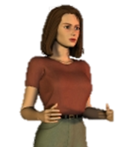
We recognize the elbow is most functional at about 90 degrees of bend. This provides the greatest strength and better protection of the joint and surrounding soft tissues.
For the upper extremities, this is with the shoulders relaxed, elbows at the sides flexed to about 90 degrees and the hands positioned with the thumbs pointing up.

Provide Support for Body/Limbs

Seated
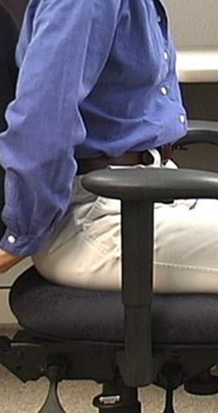
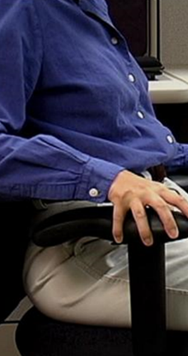
Sustained and awkward seated position can result in compression of soft tissues and decrease in blood flow and circulation. Proper seated support is critical.
We will get into the details when we cover chairs in depth.

Limbs
Proper support for the limbs, particularly the upper extremities can help to alleviate the strain of weight bearing on the neck, shoulders and back. This can be provided by chair armrests, forearm support on a desk or table and even pillows placed under the forearms if seated on a couch.

Standing – sustained
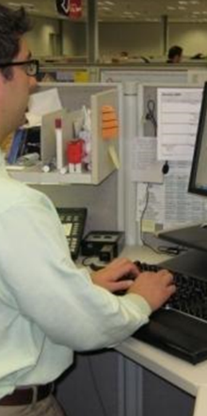
Unsupported standing for extended periods is not desired; joint compression of the weight bearing joints (hips, knees and ankles) occurs decreasing joint space.
Inadequate joint lubrication with fluid tending to pool in lower extremities can result.

Sustained Sitting
Sustaining sitting is bad, but sustained standing is not the cure!
America has a sitting problem! About 1 in 4 adults sits for more than 8 hours per day. Consider that standing at desk doesn’t count as exercise. Exercise is what protects against the harms of a sedentary lifestyle. Poor standing posture is possible too and can result in issues as we have discussed.

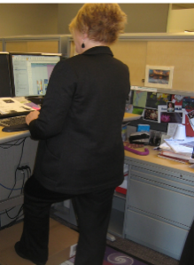
Suggestions for standing comfort
Here are some suggestions to enhance standing comfort:
- Work on standing comfortably “tall” not “slumped”
- Use anti-fatigue mat
- Good walking shoes are good standing shoes
- Use a footrest to prop up one foot at a time
- Ankle pumps: this works well to pump fluid up and out of the feet and ankles
- Alternate foot stance regularly to promote weight shift

Best Posture is the Next Posture!
Here is a question for you. “What is the best posture?”
How about the “Next posture!”
With mobile technology we have a strong tendency toward non-neutral or static postures. Think of it this way.
Now, a good thing is, that we can get very involved intellectually with what we are doing to get our work done.
But the bad thing is, we can get very involved intellectually with what we are doing and all of sudden two or three hours have gone by.
When we finally get out of our chair or change position, our body cries out in stiffness and soreness from being in one position for too long. We didn’t pay attention to our body’s need for position change and movement!
We are made to be movers and shakers. Sustained sedentary positions are not good for us.
Anyone have a dog or cat? Many of us do. Ever notice the first thing they do when they get up after a nap? Yes, they take a really good stretch.
How do they know how to do this? We suspect you did not send them to stretching school when they were puppies and kittens. They instinctively know to stretch, and they act on the instinct.
We have the same need; we just don’t act on it! We are meant to movers and shakers!
Makes movement even more important. Studies indicate that 4 in 10 Americans do not get any moderate intensity exercise.
The CDC recommends 2 ½ hour per week!

Reach Zone

How much do we use our hands every day?
More than half the day? How about more than 75% of the day?
Well in fact, most people will say they use their hands at least 99.9% of the day!

Where do we tend to use our hands?
For example, does anybody work behind their back? Pretty hard to see what you're doing!
Because in most cases we need to see what we are doing we tend to use our hands in front of and to the sides of our body. We can define two reach zones:
- Comfort Reach Zone
- Functional Reach Zone

Comfort Reach Zone
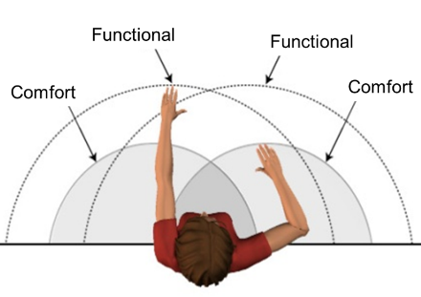
Think of the comfort reach zone as that area in front and to the side where you'd like to use our hands when we’re doing precise hand activity.
Forearm length will determine the dimensions of the Comfort Reach Zone.
To get a feel for this, position your elbows at your sides with your elbows bent at about 90°, swing your hands from side to side.
The height of this reach zone will be about three or 4 inches above and below your elbow level. This is your Comfort Reach Zone.
Typical activities in the Comfort Reach Zone will include keyboard and mouse use along with handwriting. This also includes precision assembly in a manufacturing environment where a minimal downward force is exerted.

Functional Reach Zone
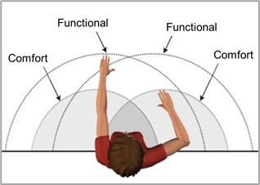
Think of the Functional Reach Zone as that area in front and to the side where we will be able to comfortably reach to obtain parts and materials.
Arm length determines the dimensions of the Functional Reach Zone. An easy way to get a feel for this is to reach your arms out in front of your body with your elbows straight. From your shoulder to the middle of your hand is your forward functional reach.
Now swing your arms out to the side about 45° from the midline of your body. This is the side-to-side functional reach.
Drop your hands so they are relaxed at your sides. This is called knuckle height and is the bottom zone of the functional reach.
Finally, with your arms extended raise them so they are about shoulder level. This is the upper zone of the functional reach.
Stature and arm’s length determine the reach zones. Determine the individual reach zones and set up the work station to promote reaches in the appropriate zones.
Reach zone is really of function of lever arms. The longer the lever arm, the greater the force that is imposed on the body.
How long can you hold 10 pounds at arm’s length compared to the exact same 10 pounds held close to your body?

Determine Reach Zone
Stature and arm’s length determine an individual’s reach zone. Set up the workstation (wherever that may be) to promote reach in the appropriate zone. This could be at home or on the go.
It will take some planning and a dose of creativity; just about any situation can be improved by applying the ergonomics principles.

Fatigue Control (Dose/Exposure)

Eliminate fatigue?
So far, we have covered the basic ergonomics principles of Neutral Position and Reach Zone.
The last basic principle is Fatigue Control. Here’s a question for you.
Is it possible to eliminate physical and mental fatigue? What do you think?
Well. we are suggesting the answer is, “No”. Fatigue is a normal daily occurrence of using up our available physical and mental energy.
You’ll notice we’re using the word “Control” and not “Eliminate” when discussing fatigue. For overall health and wellness, we need to recover from fatigue through appropriate rest, hydration and nutrition.

Dose/Exposure Concept
A common question we often get is, “How much is too much?”
At what level of intensity do the ergonomics stress factors of awkward posture and excessive reach, among other factors, result in negative repercussions?
To help us answer this question we’ll introduce the Dose/Exposure Concept.
To use an analogy. How long can a person go without oxygen? For most people at one to 2 minutes of oxygen deprivation and they are probably fine!
But how about four minutes, five minutes and longer? Blood oxygenation saturation levels start to drop dangerously low. Now the outcome is much more likely to have very serious consequences.
We must understand how the Dose, in our example the level of oxygen and the Exposure, how long without oxygen, interact to predict the eventual outcome.

Dose/Exposure Concept – Ergonomics Perspective
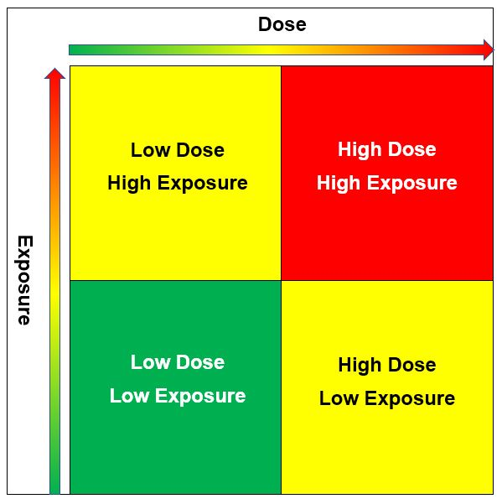
Next let’s put this into the ergonomics perspective.
Dose – is defined as the level of physical/mental stress of the ergonomics risk factors.
Exposure – is defined as how long and how often the exposure to the ergonomics risk factors is occurring.
We appreciate the higher the values for Dose and Exposure, the greater the estimated risk.
- LOW considered low risk with low priority to change.
- MED considered medium risk, recommend modification as feasible.
- HIGH considered high risk, recommend concerted effort to modify.
A combination of Low Dose/Low Exposure would be considered to have a lower relative risk.
A combination of High Dose/High Exposure would be considered to have higher relative risk.
However, it is very conceivable the job task could consist of a Low Dose (minimal force levels) combined with High Exposure (high frequency). The converse is also true; High Dose (high force levels) with Low Exposure (low level frequency).
This is the basis for the Ergonomics Risk Screen scoring system that we introduce in Manufacturing Ergonomics: Introduction for Health Care Professionals (Online).

Fatigue Control – Recognize
First, how do we recognize fatigue?
Physical fatigue is demonstrated when physical and/or repetitive tasks result in muscle tiredness. We experience a decrease in general physical strength and coordination. We are more prone to making mistakes. We may be more likely to experience injuries.
Once recognized, we need to employ strategies to control the fatigue. This is important in a traditional office workplace and we think even more so in non-traditional workplaces. It is these workplaces where we may not have the most ideal workstation setups.

Fatigue Control – Strategies
Here are some simple strategies to better manage and control fatigue:
Mix up job tasks to provide a variety of physical activities.
Break larger tasks into smaller ones. such as alternating sitting computing tasks with standing phone or reading tasks.
Throughout the day replenish energy supplies and fluid intake. Try to not skip breaks and lunch.
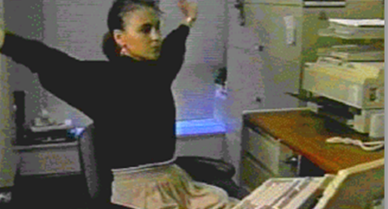
Work on stretching and personal physical fitness levels. We know now that even a few minutes of physical activity done periodically throughout the day can add up. We don’t necessarily need 30 to 45 consecutive minutes of physical activity to gain a benefit

Move on a regular basis
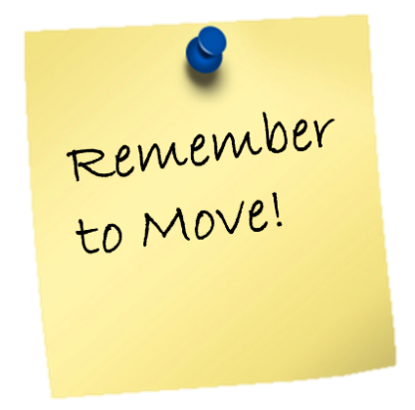
The 30/30/30 Micro-break Guideline says take a physically active micro-break of about 30 to 45 seconds in length about every 30 to 45 minutes and practice for the next 30 days to make it a habit.
In the years we have advocating this concept we have never had anyone say, “that is really a stupid idea”. Everyone agrees it makes good sense.
That is not the issue, the issue is remembering to actually do it.
Encourage patients and clients to figure out a strategy that works for them: post-it notes, the buddy approach, drink a lot of water, set reminders on a calendar.
Help them make it happen and reap the reward.

Fatigue Control – Computer Vision Syndrome
While we understand there is no evidence that computer, tablet, phone use (really anything with a screen) causes any long-term damage to the eyes; tired, dry, itchy eyes by the end of the day can sometimes be the result for some people.
Also, headaches, blurred vision, dry eyes and neck and shoulder pain may be factors. May also be related to poor ergonomics set up, poor lighting or glare or uncorrected vision problems

What can be done to have more comfortable eyes?
Try out the tips below, your eyes will thank you!

To Infinity and Beyond!
- Just like the muscles in our arms, shoulders, neck and other parts of our body can get fatigued, the small muscles that control our eye position and focus the lens in our eyes get tired from constant use.
- Get in the habit every 20 minutes of looking away from your screen for 20 seconds to something at least 20 feet away. Take a break!

Laptop Screen Position
- Because the laptop screen is directly attached to the keyboard it can present a bit of an issue to position the screen.
- With laptop use, position the keyboard so your wrists are reasonably straight and then angle the laptop screen to minimize forward head tip.

Proper Lighting
- Wherever you are using your laptop make sure you have adequate and comfortable lighting so you can comfortably see the laptop keyboard and any reading materials.
- Avoid any glare either from lights directly into your eyes or from any glare coming off the laptop screen.

Remember to Blink
- Our eyes are bathed in a protective film to moisturize the surface of the eyeball. Frequent and regular blinking (10 to 15 blinks/minute) helps to distribute the fluid and minimize dry, itchy eyes.
- Some people may also benefit from using artificial tears.

Eyeglasses
- If you wear eyeglasses, particularly bifocals or trifocals, make sure you are able to see the laptop screen clearly and in focus.
- For users of over-the-counter readers who may be having a difficult time viewing the screen, try out a lower magnification reader. This often works as a short-term substitute for prescription computer glasses.

Comprehensive Eye Exam
- If it has been several years since your last eye examination, you may want to consider getting one. Obviously, right now we need to be aware of not overloading our health care system.
- However, if you are experiencing significant vision issues, please at least consider talking with eye care health professional to determine the extent of your need.

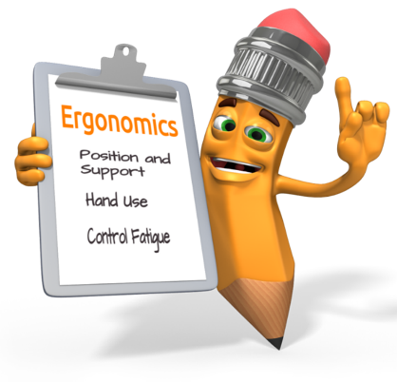
Ergonomics – Basic Principles Summary
So, we have introduced the three basic ergonomics principles of:
- Position and Support (Body and Limbs)
- Hand Use (Reach Zone)
- Fatigue Control (Dose/Exposure)
Let’s move onto applications

Work from Home (WFH)
We’ll work through specific scenarios for a variety of WFH workstation set-ups.

Work on The Go (WOTG)
No doubt with the advent of current connectivity technology people are working from almost any and all imaginable locations:
- Car
- Coffee shop
- “Hoteling” in office building
- Airport terminal
- Hotel room

Universal Design (UD)
We’ll overview of the Seven Principles of Universal Design and offer some common examples.

Working from Home (WFH)
Work in offices has changed dramatically in recent times. In fact, many people are NOT working in their work offices! They are Working from Home (WFH).
As of 2020, it is estimated that 58% of total US workforce (85 million workers) now working from home. Also estimated is that 50 to 75% will continue working from home into 2021 and beyond*. This is believed to be similar in other countries as well.
*Source: https://globalworkplaceanalytics.com/work-at-home-after-covid-19-our-forecast

No longer tethered
In the span of 10-15 years, we’re no longer tethered to the desk by phone and computer cords.
In fact, most of our phones are computers! With the advent of Wi-Fi, 5g and even mobile hotspots, we truly are free to roam about the country…and work while we are at it. (some might argue, that even though our devices are wireless and can be used anywhere, we may actually be more tethered than we ever have been to on demand connectivity).
Essentially, there has been a complete transformation of how we work.
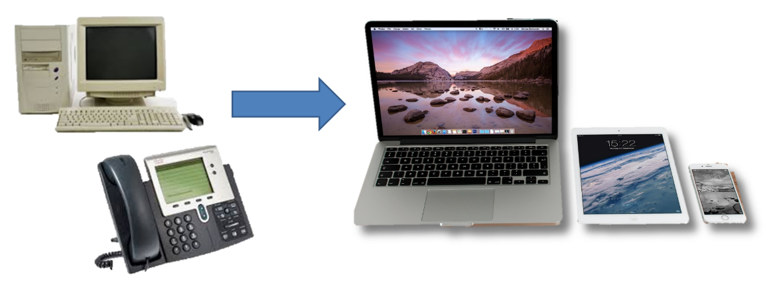

Advantages of WFH
Now, working from home is not an entirely new phenomenon. Tele-commuting has been going for several decades. We recognize, of late it has intensified. Distinct advantages of the WFH movement are becoming more and more identified.

Increase in work flexibility
No question that WFH provides for a great deal more work flexibility:
- Allows for a more flexible work schedule
- Can flex based on home and work demands
- More flexible in terms of childcare needs
- Comfy clothing!

Increase in productivity
Concerns have been expressed in terms of whether work productivity will suffer in WFH. In most cases, it appears that fear has not been realized at a significant level. In fact, for some individuals, it has to led to where the separation between work and home has blurred to the point that some people are experiencing issues.
In general, productivity has not suffered and in many may have actually been enhanced:
- Fewer co-worker interruptions (however, may have family member interruptions)
- Able to better focus

Less or no time commuting
For those individuals who used to spend significant parts of their day commuting, WFH has had a dramatic effect:
- Save on auto expenses
- Little or no time spent in traffic
- More personal time

Disadvantages – Ergonomics Related
So, has it all been rosy? Let’s look at some studies.
Mobile work: Ergonomics in a rapidly changing work environment - 2014 study by Meg Honan (great article!).
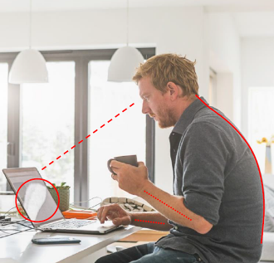
Ironic that in a discussion about screen use patterns and locations, this 2014 article stated: “one limitation is that Apple mobile devices do not currently have an option available to assess this data and there are no known plans to do so at present”. Well, that changed.
By 2019-it’s on all the devices. That is just how rapid technology changes!
Screen time. Also, ironic that we examine all the data about our screen time while looking at our screens.
Szu-Pink Lee, PT, Dept of PT UNLV. “Gender and posture are significant risk factors to musculoskeletal symptoms during touchscreen tablet use”
Mostly neck and shoulder symptoms; (sitting with device in lap, side lying during tablet use other postures noted)
Kimberly Szucs, OT; Dept of OT Duquesne University.
A comparison of upper body and limb postures across technology and handheld device use in college students”. Standard tasks using 3 devices – mobile phone, tablet, laptop – looking at posture comparison. Kids, younger and younger owning cell phones (66%). Purchase of tablets exceeding laptops.
Jack Dennerlein, 2014 – The State of ergonomics for mobile computing technology. – conclusion-work in progress.
Billions of devices out there!

Increased Musculoskeletal Risks
We’ve all seen this. We all have probably “lived this” too.
Weight of head/force study, Surgical Technology International.

Neck
Average head weighs 10 to 12 lbs.
Increased in load with neck flexion:
- 15 degrees = 30 to 40 lbs
- 45 degrees = 49 lbs
- 60 degrees = 60 lbs
Different musculoskeletal risks; how do the new technologies translate into the work environment.
Workplace design speed can’t often keep up with advances in technology.
In many cases, the devices get smaller so can fit in space built for something larger; in other cases, increased number of devices used at a time (such as multiple displays/monitors), makes fit more difficult in a space not designed to accommodate so many or such large monitors.
We’ve seen it in public places too – instead of pay phone stalls, there are charging stations.

Home Office Workplace
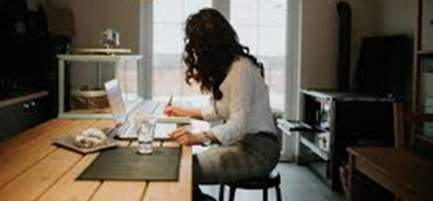
Options for a home office workplace are incredibly varied. For example, it could be:
- Dining room table and chair
- Kitchen counter and stool
- Dedicated home office
- Living room couch
- Other

Home workplace set-up strategies
What we truly understand is that there is no standard home office setup. Based on the particular situation every home office is going to be unique.
In terms of setup of the home office, you need to get a sense of what is possible and then come up with creative ideas that make it work.
We are going take you through a step-by-step setup process and offer ideas based on the situation.

Home Office set-up considerations
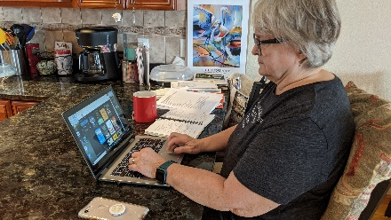
To setup a home office let’s outline some setup considerations.
First, we’ll discuss some ideas about where to locate the office.
Next, will the office be shared with a partner or kids?
What type of computer equipment will be used? Some may be working on the laptop that came from work. Perhaps, some will have a desktop computer.
How about the desk or table in use? For many people it might be a fixed height desk or table. For others it may be a height adjustable work surface.
The chair is a vital component. Chairs in the home office range from kitchen chairs to fully featured office ergonomics chairs. We will discuss chairs in some detail in a moment.
When we do a survey of people working at home, we ask them what words they would use to describe the successful home office. For about nine out of ten people the first word they think about is. “Comfortable”!
We want our office to be comfortable. Of course, we also want it to be safe and well-lit and productive.
But comfortable is a primary consideration. We’ll discuss how to enhance both physical and visual comfort in your home office.

Location options

Dedicated space
In some homes there may be an area or room that can be dedicated to the home office. By dedicated we mean you can leave it setup in the office configuration.
It may be a spare bedroom. we have seen closets that have been turned into a functional office space. It might be an existing space on a kitchen counter or dining room table.
Will the office be as single user only or will it be shared with a partner and/or kids? We call it a single-user office if only one person uses it. It can be setup for a single user and left that way.
A dedicated space may offer additional privacy – both visual and auditory; this could be an important factor to consider based on the type of work performed.

Shared space
Some home offices are part of a multi-purpose area in the home. During work hours the space may be a work desk but come mealtime you need to shift it back to being the kitchen or dining room table.
If it is shared by others, we call it a multi-user office. No question this does add more complexity to the setup. For example, one person may be 6 feet tall, and another may be 5 feet tall. You need to consider how the chair and potentially the desk height may need to be adjusted from one person to the next.
For a shared-space home office a primary objective is to make it as easy as possible to make the transition. Think about how you can quickly pack up the office equipment and store it in an easily accessed location. Perhaps a travel backpack could be used to pack and store the equipment.
Small rolling file drawers are often used to store office supplies and other equipment and be readily rolled out of the way.
We have found that many shared-space home offices evolve over time as the person gets more proficient at figuring out the most efficient way to setup and take down the office components.

Step-by-Step Approach – Laptop Computer
Many home office setups will have a laptop as the primary computer system. The person will use the laptop’s keyboard, touch pad and monitor. If this is the situation, as you see in this example, try to position the laptop height so the wrists are straight when using the keyboard and touchpad.
We’ll get into more details about how to accomplish this when we discuss chair and worksurface height setup.
Because the monitor is attached to the laptop experiment with angling the monitor to minimize the amount of forward head tip to view the monitor.
The way our eyes work we have about 30 to 40 degrees of downward eye gaze to look at materials lower than eye level.

Step-by-Step Approach – Desktop or Laptop Computer
A desktop computer will have a separate keyboard, mouse and monitor.
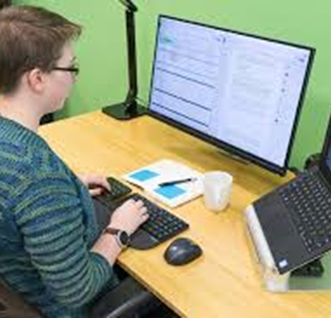
For a laptop computer, a docking station that allows a separate keyboard, mouse and monitor may be in case and makes good sense.
In either case, this provides more flexibility in the setup of the computer equipment. Position the keyboard and mouse so the wrists are reasonably straight.
Look at this setup, you can see the laptop is the processor for the computer system, but he has a separate keyboard, mouse and monitor on a stand. To make use of the laptop monitor as a second monitor he has it on a stand to position it in an appropriate viewing position.
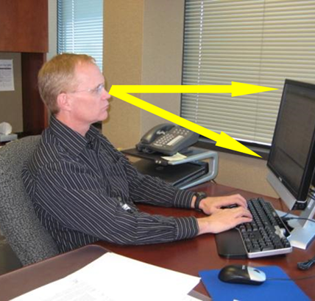
In this example, the monitor is positioned so the top of the screen is about eye level and at least arm’s length distance.
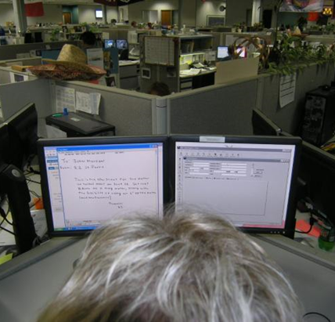
Two monitors are becoming very common these days.
If two monitors are used determine how they are viewed.
If both monitors about viewed 50% of the time each this is a primary/primary monitor set-up. Position the monitors so they centered on the user’s nose.
They will then have equal right and left head rotation.
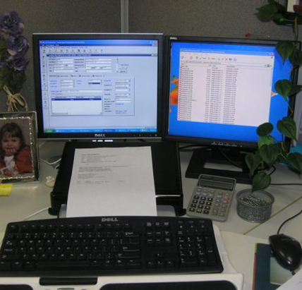
On the other hand, if one monitor is viewed predominantly it is a primary/secondary user. Position the primary monitor directly in front of the user and the secondary monitor angled to the side.
If laptop monitor is used, position laptop on stand so top of screen is at or slightly below eye level.

Step-by-Step Approach – Desk/Chair
Moving on, let’s get into the details of the chair and desk setup and use.
Experience tells us that home offices have a wide range of chair and desk configurations ranging all the way from a fixed height chair and desk setup to a fully height adjustable chair and desk setup and all combinations in between. We also recognize the living room couch sometimes becomes the home office and some people have options to stand in their home office as well.
We’ll work through strategies for the desk setup but first let’s talk chairs.

Chairs – A Little More Information
No doubt an office chair is a critical component in the home office.
Depending on the chair at hand it might be a kitchen or dining room chair that doesn't have any adjustments to an office chair that does have quite a few adjustment features.
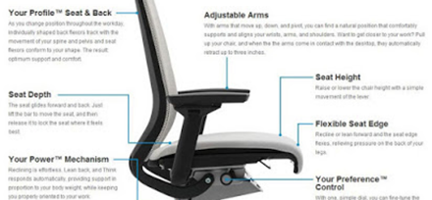
If the chair does have some levers, encourage the person to play with them to get a sense of what they do. In a minute, we’ll go through some ideas on some recommended ways to sit in the chair.
For right now, here are some of the typical office chair adjustments.
Probably the seat is height adjustable and many also allow tilt and depth adjustment of the seat.
Look to see if the back support is height and angle adjustable. If it is height adjustable, see if the low back cushion in the back support can be adjusted to be about in line with the inward curve in the lower back. For most people this is about level with the belly button.
Office chair armrests are typically height adjustable and may be side-to-side adjustable as well. Armrests are intended to provide support for the forearms to unload weight from the neck and shoulders.
Unfortunately, many people don't use their chairs to full advantage. We always encourage the person to take a good look at their chair and invest some time to see how it works.

Chairs – Adjustment

Best way to sit?
Here’s a question for you, “Is there only one best way to sit?” Or does it make sense to adjust the chair throughout the day, if possible?

Upright keyboard position
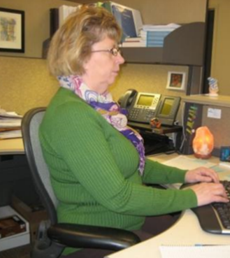
When doing hand related activities like using the keyboard and mouse or handwriting, adjust the chair to the “upright keyboard position”.
The back support is fairly upright with the head balanced over the neck and shoulders with good access to using the keyboard and mouse.

Semi-reclined conversation position
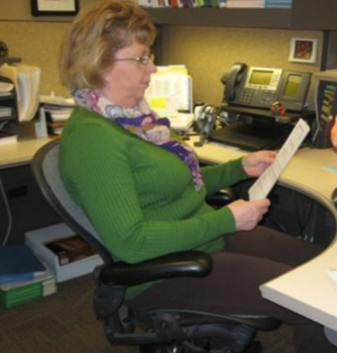
Other times when not using the hands on the keyboard and mouse, tilt the chair back some to let it rock. If the chair does have a rocking chair function also look for a rocking tension adjustment knob under the chair. If this is too loose the chair will flop back and the user will not be happy. The correct tension will make it feel like a comfortable rocking chair.
We call this the “semi-reclined conversation position” because it works well when talking on the phone or someone in the office. Or maybe just talking to themselves!

Best advice?
Of course, the best advice we can offer about the chair is to, “Get out of it on a regularly basis!”
Stand up and work at a counter if that is possible.
Stand when talking on the phone when possible.
Drink a lot of water. You know what we are talking about.

Step-by-Step Approach – Desk/Chair

Adjustable height table/desk and adjustable height chair
If it is possible to adjust the height of the desk and have an adjustable height chair here's the strategy to get the body in a good position with good support.
First, adjust the chair height to get the feet placed directly on the floor.
Next, adjust the height of the desk so when the hands are on the keyboard and the mouse the wrists will be relatively straight.
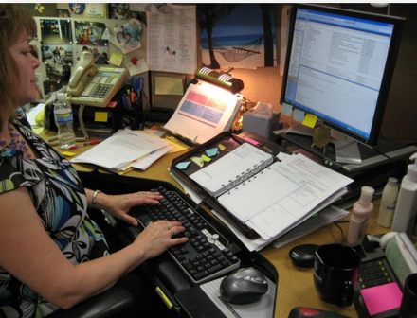
Look at the example. This person has adjusted her chair height, so her feet are on the floor. The desk height has been adjusted so her wrists are straight, and her shoulders are relaxed.
Her monitor is at a height that promotes neutral head and neck position. She has put a document holder between the keyboard and monitor.
She is good to go.

Fixed height table/desk and adjustable height chair
Here is the next chair/desk setup scenario.
How about if it is a fixed height desk or table but the chair is adjustable?
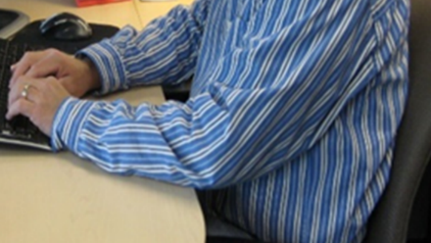
First, adjust the chair height so when the hands on the keyboard and mouse the desired relationship between the arms, wrists and hands on the keyboard and mouse is achieved.
Next check the foot support. For a lot of people, the feet are no longer around the floor. We never want to dangle our feet for any length of time; this can result in potential for circulation issues.
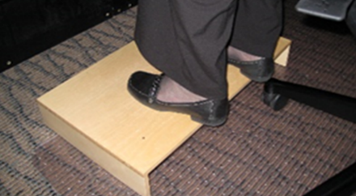
We want the feet supported. To support the feet, some type of footrest is needed. Footrests are available commercially but a study box or stool at the right height will work just fine.
Check the computer equipment positioning and adjust as needed.
Remember to encourage the 30/30/30 Micro-break Guideline.

Fixed height table/desk and fixed height chair
Now we come to the fixed height table or desk and the fixed height chair.
For this scenario with person seated in the chair.
If they are able to sit all the way back in the chair with the lower back supported AND they have 1 to 3” of space between the back of the knees and the front edge of the chair AND the feet are directly on the floor AND the wrists are straight with keyboard and mouse use AND the monitor is adjusted appropriately.
Guess what?
You guessed it – they fit. They are one of those individuals that fit in the fixed height scenario. We can predict they are about 5’9” to about 6’ 1” tall and they fit in “adult standard” dimension furniture.
Take a look at the picture. She has a folded up towel (it could be a pillow or something like that) stuffed all the way back in the chair for lower back support.
Her desk has a pull-out drawer for her keyboard and mouse and her wrists are in a good position.

Fixed height table/desk and fixed height chair
What about this last scenario?
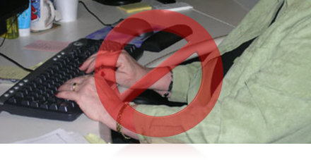
Sit in the fixed height chair and place the hands on the fixed height desk, if the wrists are not straight and perhaps the forearms on resting on the edge of the desk you need to see if they can adjust the seated height. They are probably too low in the chair.
A different height chair could be an option to get higher.
Another option maybe with a cushion on the chair’s seat so they can literally sit higher in the chair and obtain the recommended wrist position.
Now if that means the feet no longer are supported on the floor, look for a footrest.
Occasionally, we have seen where the desk could be shortened; literally the legs cut down. If this is an option, we now have a “height adjustable” desk and can go the route to adjust the chair to get the feet on the floor and adjust the desk height accordingly.
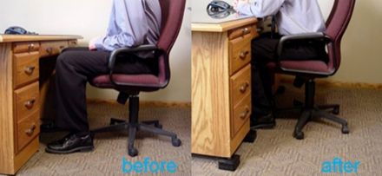
For taller individuals, it may be possible to raise the desk height. Desk risers are available commercially and you can also use other blocks. Just make sure if you go this route the desk is secure at the new height.
Now with the changes made, the wrists are now straight, and we have an acceptable arm and hand position.
Adjust the monitor position appropriately.
They are now good to go!
Remember the 30/30/30 Micro-break Guideline!

Step-by-Step Approach – Couch
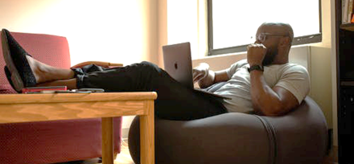
Are we saying never sit on the couch or recliner and use your laptop? The answer is no! People can certainly spend some time on the couch, just not for hours on end!
Recalling that ergonomics is all about body and arm position and support here are tips for couch and recliner laptop use:
- Place pillows underneath your elbows to support your arms and shoulders.
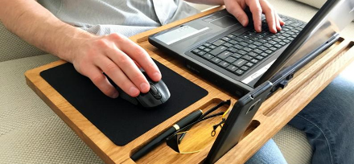
- Laptop lap desks are available. Be careful they allow for ventilation for the laptop.
- Angle the monitor for optimal head position.
- Make sure your legs and feet are well supported
- Sofa servers can work pretty well.
Limit time spent on the couch. As humans we have great ability to get engage intellectually for hours on end. All of sudden its two or three hours later and we realize we haven’t moved. And honestly, our body is not happy!
Get in the habit of the 30/30/30 micro-breaks!

Step-by-Step Approach – Standing
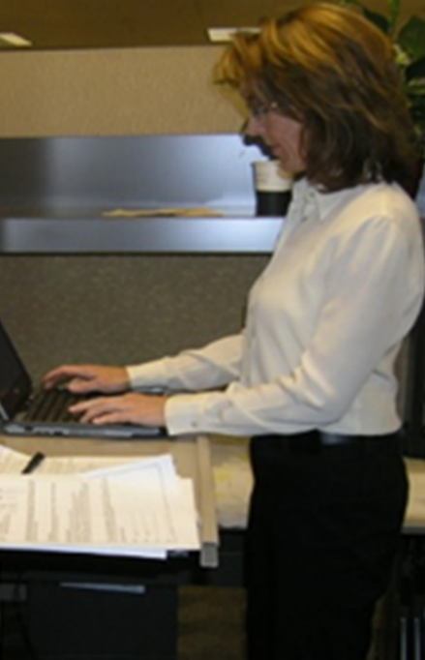
In the last several years we have seen a trend toward more standing workstations in the office and we are starting to see that occur in home offices as well. Fully powered sit/stand desks intended for the home office are in the marketplace. If you are pushing toward a full time home office, you might be considering that route as time goes on.
For right now though we can probably figure out some creative ways to stand at work. Maybe a counter is at the right height for the person, or they can place a box on a counter to achieve the correct height.
This brings up the question, “What is the correct height?”
Here is the strategy.
With whatever shoes they will be wearing when standing – here is a side note, we do encourage some cushioning for the feet when standing more than a few minutes at one time. For shoes, it they are good for walking they will be good for standing. Another option is standing mats for those that like stocking feet.
At any rate, to determine the standing worksurface height, you want them to be able to stand comfortably “tall” with the elbows at about 90 degrees, the shoulders relaxed and the wrists straight with hands on the keyboard. Angle the monitor for the least amount of forward head position.
Use a footrest to allow for alternative foot position. Imagine the last time you walked up to a bar in a restaurant where did you put one foot? On the foot rail, right? Bar keeps have known for a long time how to keep patrons comfortable at the bar.

A Few More Considerations
Let’s discuss a few more considerations in the home office.

Vision
Eyeglasses are certainly an important factor in any office. For example, if bifocals or trifocals are in use make sure they work and don’t result in out-of-neutral head and neck positions. If trying to look through the bottom of the lens, intended for reading hard copy, at a monitor that is at eye level there is going to an awkward head position. Here is where computer glasses or Progressive Addition Lenses come into play.

Blink
Visual comfort comes from having our eyes bathed in fluid throughout the day. Frequent and regular blinking, (10 to 15 blinks a minute) helps to distribute fluid and minimize dry, itchy eyes.

Phones
Cradling a phone between the ear and shoulder is awkward and uncomfortable. If they spend a lot of time on the phone, is it possible to use a speakerphone or a headset for hands-free phone use?

Lighting
Check out the lighting in the home office. Do they have adequate task lighting so they can comfortably read hard copy documents? It may be adding a desktop task light is the ticket.

Home Office Checklists, Reference Guide and Tips
Check out the Reference Guides, Tips, Checklists and Assessment Tool.

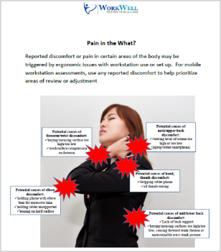
Reference Guides
- Laptop Use at Home Guidelines
- Home Office Ergonomics Quick Reference Guide

Tips
- Computer Vision Issues and Tips
- Pain in the What?
- Solution Sheet for the Mobile Worker

Checklists
- Home Office Ergonomics Checklist
- Tools, Tasks and Time Checklist (breaks down percentages of time related to task performance and location performed)

Assessment tool
- ROSA (Rapid Office Strain Assessment), visually-based risk assessment tool designed for office workstations

Case Study – Rapid Office Strain Assessment (ROSA)

Ergonomics analysis process
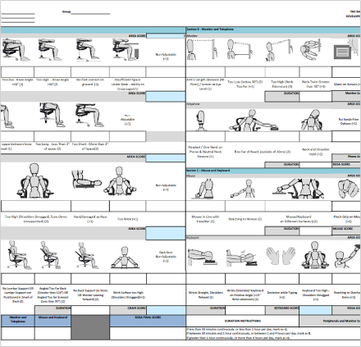
We want to use a systematic approach to ergonomics analysis of home/mobile work environments.
One assessment tool we can use is the Rapid Office Strain Assessment (ROSA).
This is a posture based process to identify ergonomics risk factors and develop reasonable and feasible recommendations to improve health, safety and productivity.

ROSA (Rapid Office Strain Assessment)
ROSA (Rapid Office Strain Assessment) was Developed by Michael Sonne and colleagues. It is a visually-based worksheet to evaluate work postures specifically in office environment.
Then the rank level of risk is generated to prioritize ergonomics interventions into three categories:
- Low
- Medium
- High
A positive correlation between discomfort and increasing ROSA scores has been established. ROSA is a good tool to use for before/after comparisons.
Please note: ROSA is designed for seated, computer-based workstation (it does not address sit-to-stand workstation or other office activities)
ROSA tool available on:
http://www.ergo.human.cornell.edu/ahROSA.html
Site contents are copyrighted, and materials may be reproduced and used without permission for noncommercial and educational purposes.

ROSA Case Study

Question
What problem areas/ergonomics risk factors do you see in this picture?
This is how she typically types.
As you look at the picture take into account the ergonomics principles we discussed and the home office workstation scenarios we went through.
Enter your comments in the Issues section.

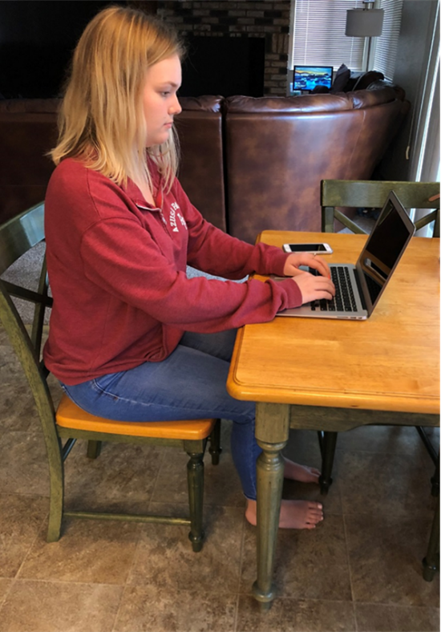 | Issues

Potential Issues
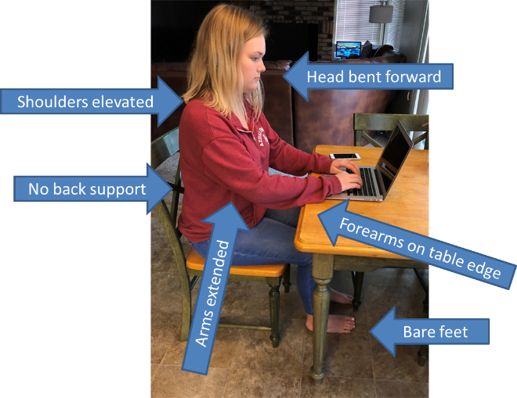
What did you identify?
Ergonomics Risk Factors of:
- Awkward postures
- Static postures
- Contact stress/Tissue compression
Specifically, how about:
- Head bent forward
- Shoulders elevated
- No back support
- Forearms on table edge
- Arms extended
- Bare feet?
Let’s apply the ROSA Assessment.

ROSA Assessment Tool
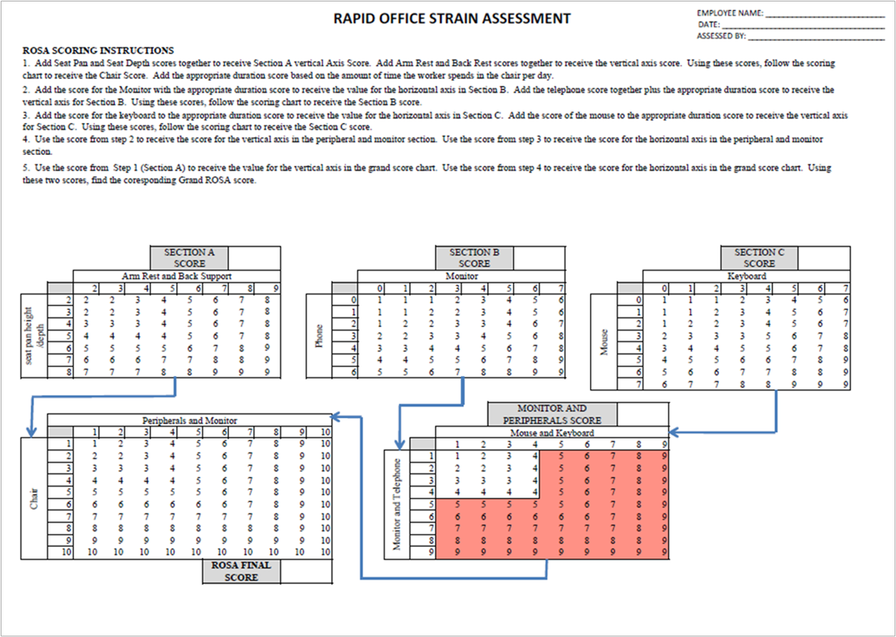
We will go step-by-step through the sections of the ROSA Assessment Tool. Once you have been through it, you will understand it is a straight-forward approach to identify and score the components.

Section A: The Chair
Examine chair use in the Case Study.
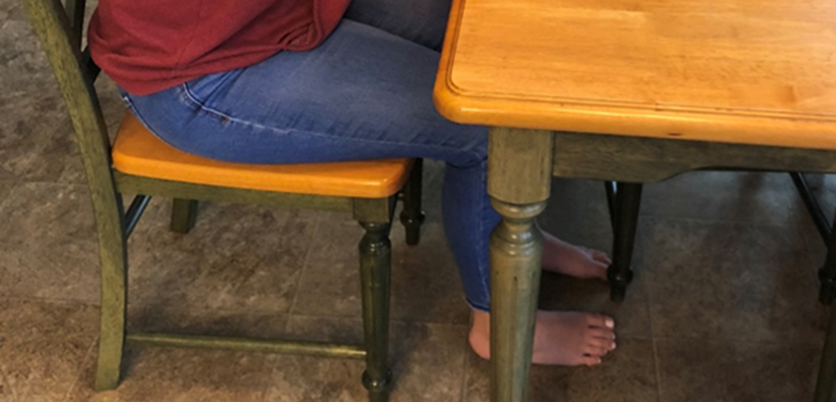
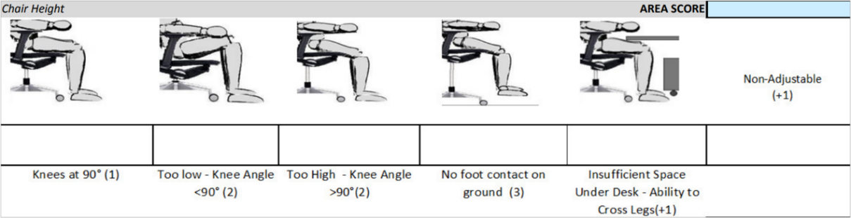
Take a look at Section A: The Chair and the Chair Height category.
You will see six categories with a number in parentheses, the number indicates the score if that particular category’s criteria is met (+1 indicates one would be added to the total score:
- Knees at 90⁰ (1)
- Too Low – Knee Angle < 90⁰ (2)
- Too High – > 90⁰ (2)
- No foot contact on ground (3)
- Insufficient Space Under Desk – Ability to Cross Legs (+1)
- Non-Adjustable (+1)
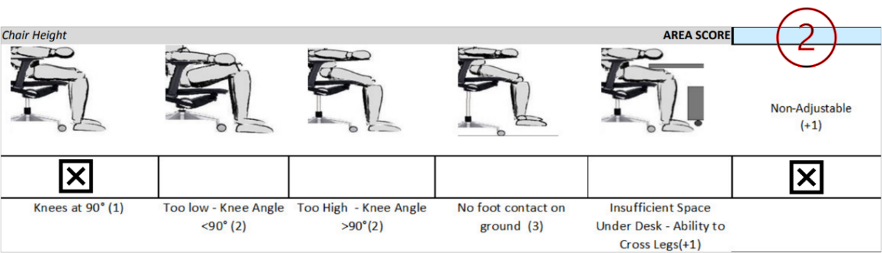
Chair Height Scoring is:
Knees at 90 degrees | 1
Non-Adjustable | +1
Area Score | 2

Section A: The Chair
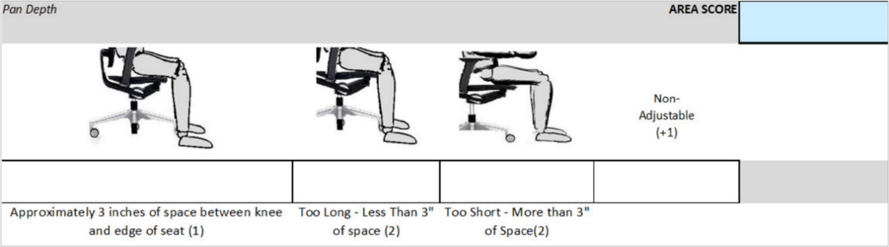
Take a look at Section A: The Chair and the Pan Depth category.
You will see four categories with a number in parentheses, the number indicates the score if that particular category’s criteria is met, (+1 indicates one would be added to the total score):
• Approximately 3 inches of space between knee and edge of seat (1)
• Too Long – Less than 3” of space (2)
• Too Short – More than 3” of space (2)
• Non-adjustable (+1)
Chair Pan Depth Scoring is:
Approximately 3 inches of space between knee and edge of seat | 1
Non-Adjustable | +1
Area Score | 2
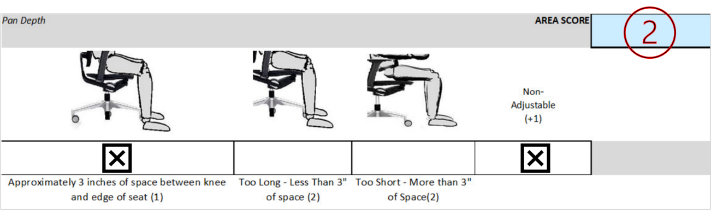
Next add the Chair Height and Pan Depth scores together for the Section A Vertical Axis Score.
Chair Height Score | 2
Chair Pan Depth Score | 2
Section A. Vertical Axis Score | 4
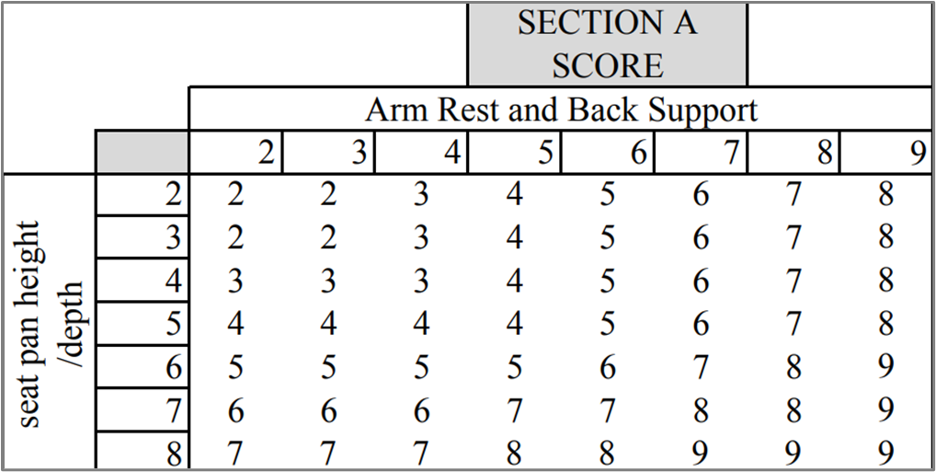

Examine the chair armrest use in the Case Study.
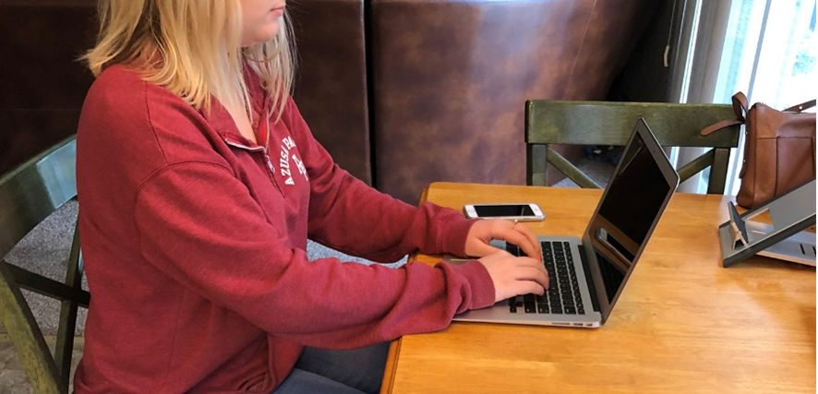

Take a look at Section A: The Chair and the Armrest category.
You will see five categories with a number in parentheses, the number indicates the score if that particular category’s criteria is met, (+1 indicates one would be added to the total score):
- Elbow supported in line with shoulder, shoulders relaxed (1)
- Too High – (Shoulders Shrugged)/Low (Arms Unsupported) (2)
- Hard/Damaged Surface (+1)
- Too Wide (+1)
- Non-adjustable (+1)
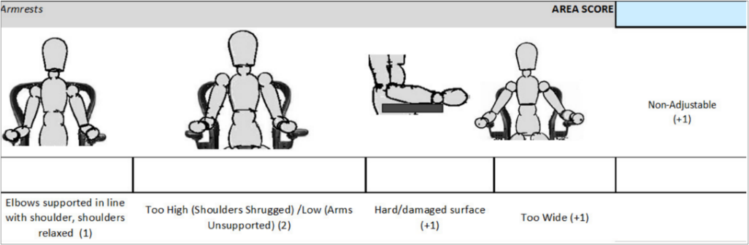
Chair Armrest scoring is:
Too High – (Shoulders Shrugged)/Low (Arms Unsupported) | 2
Non-Adjustable | +1
Area Score | 3
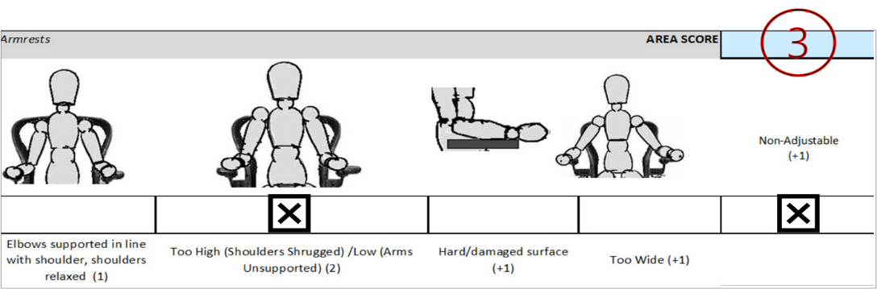
Examine the chair back support use in the Case Study.
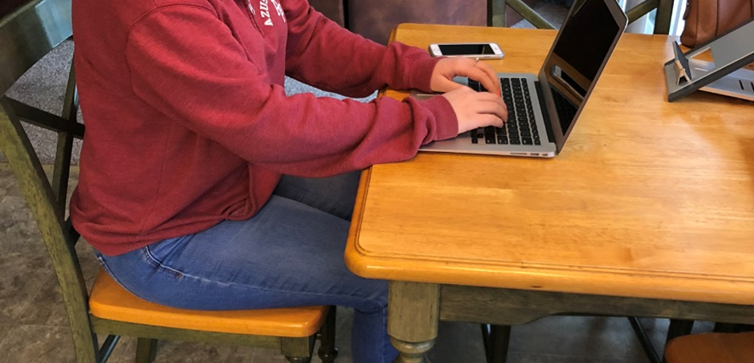
Take a look at Section A: The Chair and the Back Support category.
You will see six categories with a number in parentheses, the number indicates the score if that particular category’s criteria is met, (+1 indicates one would be added to the total score):
- Adequate Lumbar Support – Chair reclined between 95⁰ and 110⁰ (1)
- No Lumbar Support OR Lumbar Support not Positioned in Small of Back (2)
- Angled Too Far Back (Greater than 110⁰) OR Angled Too Far Forward (Less than 95⁰) (2)
- No Back Support (i.e., Stool) OR Worker Leaning Forward (2)
- Work Surface Too High (Shoulders Shrugged) (+1)
- Back Rest Non-adjustable (+1)
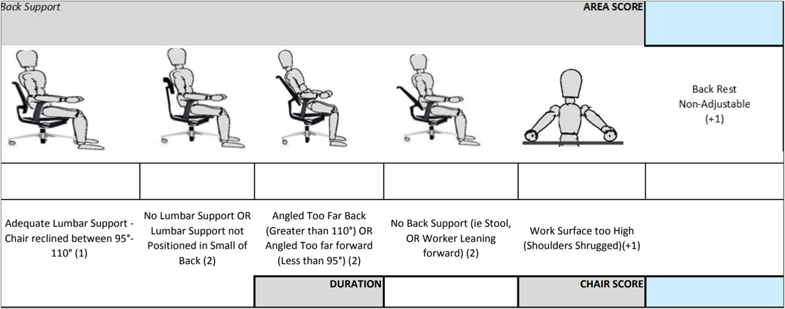

Chair Back Support scoring is:
No Back Support | 2
Work Surface Too High (Shoulders Shrugged) | +1
Non-Adjustable | +1
Area Score | 4
Next add the Arm Rest and Back Rest scores together for the Section A Horizontal Axis Score.
Arm Rest Score | 3
Back Support Score | 4
Section A. Vertical Axis Score | 7

Next plot the scores to determine Section A Score (score is 6).
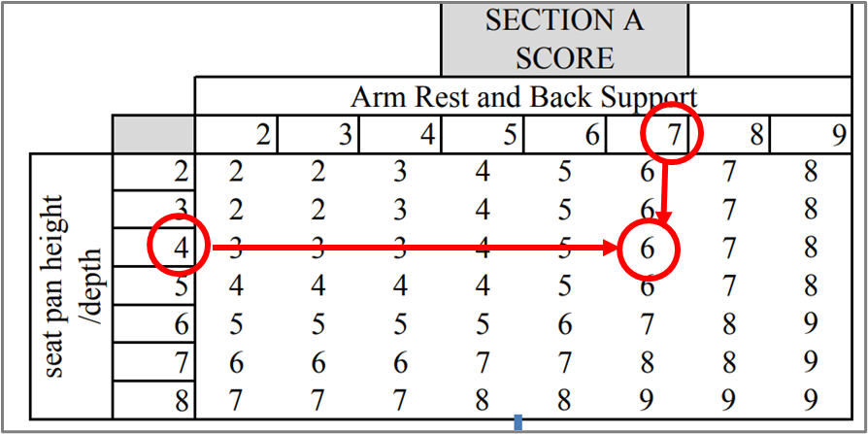
Now that we have the Chair of score six, we need to add the Duration Score. The Duration Score is determined in the following way:
- (-1) if less than 30 minutes continuously, or less than 1 hour per day
- (0) if between 30 minutes and 1 hour continuously, or between 1 and 4 hours per day
- (+1) if greater than 1 hour continuously, or more than 4 hours per day
In our example the chair is used more than one hour continuously, or more than 4 hours/day for a score of +1.
The total score for the chair is 7 (6 + 1).

Section B: Monitor/Telephone
Next, we will calculate the Monitor/Telephone score with the Monitor first.
You will see six categories with a number in parentheses, the number indicates the score if that particular category’s criteria is met, (+1 indicates one would be added to the total score):
- Arm’s Length Distance (40 to 75 cm, 16 to 30”) / Screen at Eye Level (1)
- Too Low (below 30⁰⁾ (2) OR Too Far 9+1)
- Too High (Neck Extension) (3)
- Neck Twist Greater than 30⁰) (+1)
- Glare on Screen (+1)
- Documents – No Holder (+1)
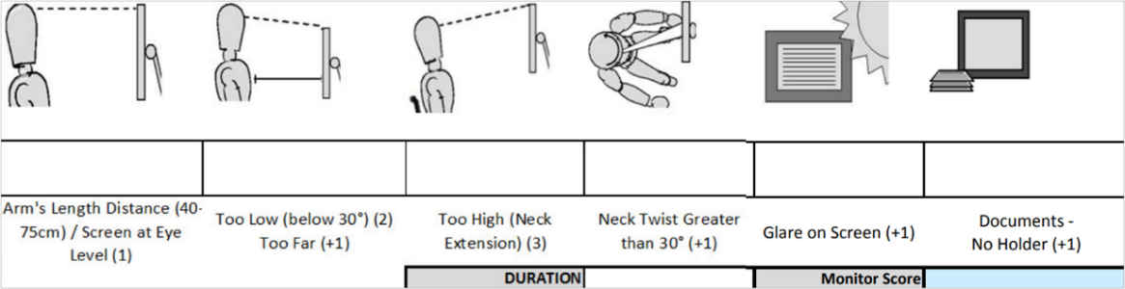
Section B Monitor scoring is:
Too Low (below 30⁰⁾ | 2
Add Duration Score (as determined previously) | +1
Area Score | 3
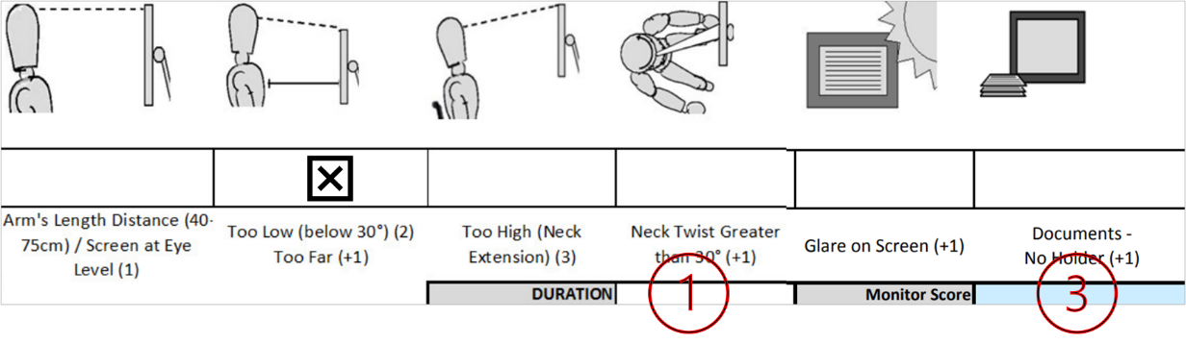

Section B: Monitor/Telephone
Next, we will calculate the Monitor/Telephone score with the Telephone next.
You will see four categories with a number in parentheses, the number indicates the score if that particular category’s criteria is met, (+1 indicates one would be added to the total score):
- Headset / One Hand on Phone and Neutral Neck Posture (1)
- Too Far of Reach (outside of 30 cm, 16” (2)
- Neck and Shoulder Hold (+2)
- No Hands-free Options (+1)
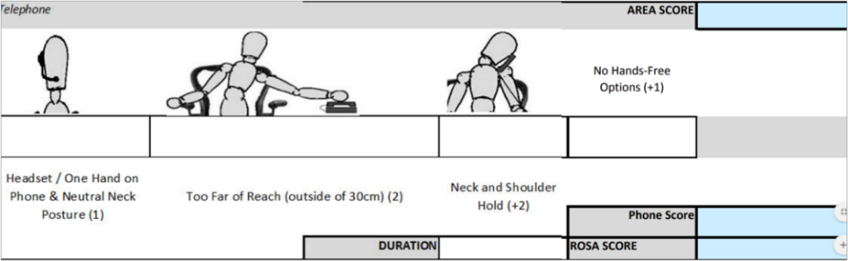
Section B Telephone scoring is:
Headset/One Hand on phone and neutral neck | 1
Add Duration Score (as determined previously) | +0
Area Score | 1
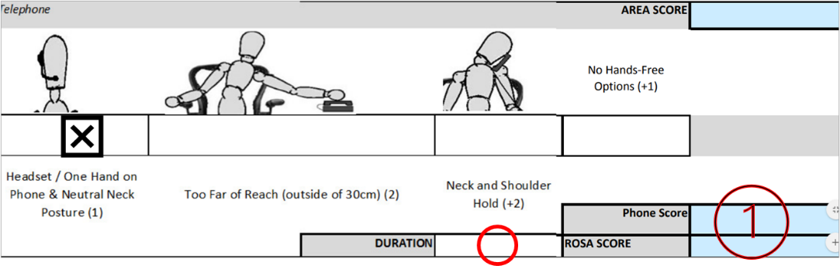
Plot total Monitor (3) and Telephone (1) score. Total Score is 2.
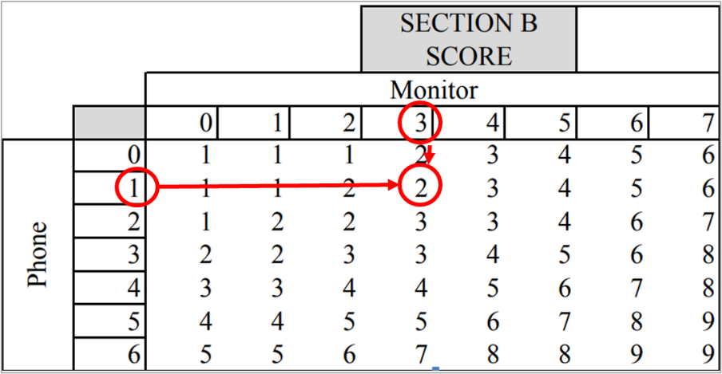

Section C: Mouse/Keyboard
Next, we will calculate the Mouse/Keyboard score with the Mouse first.
You will see five categories with a number in parentheses, the number indicates the score if that particular category’s criteria is met, (+1 indicates one would be added to the total score):
- Mouse in Line with Shoulder (1)
- Reaching to Mouse (2)
- Mouse/Keyboard on Different Surfaces (+2)
- Pinch Grip on Mouse (+1
- Palm rest in Front of Mouse (+1)
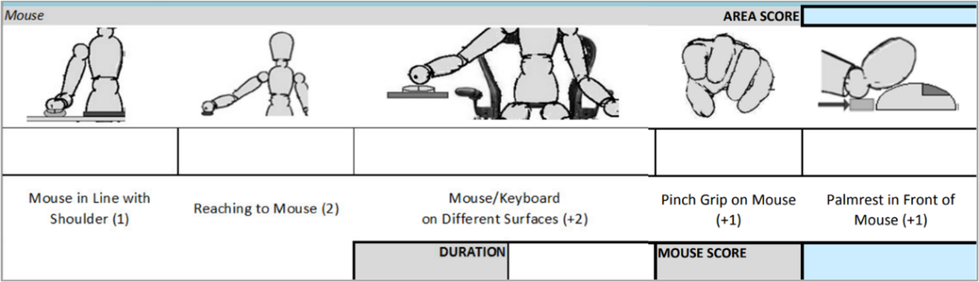
Section C: Mouse Scoring is:
Mouse in Line with Shoulder | 1
Add Duration Score (as determined previously) | +0
Area Score | 1
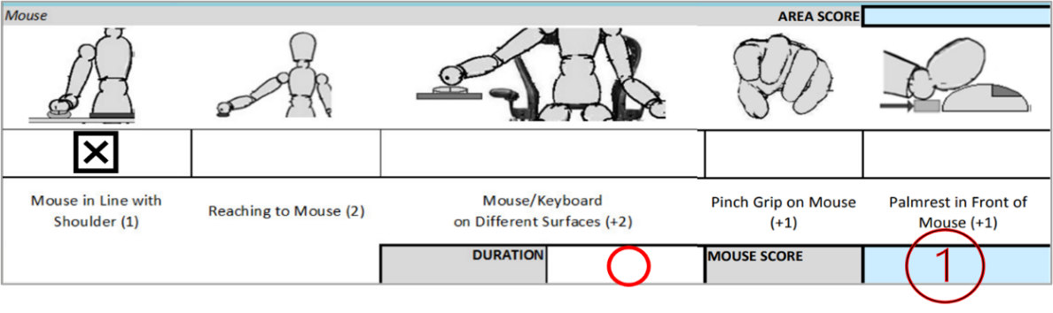

Section C: Mouse/Keyboard
Next, we will calculate the Mouse/Keyboard score with the Keyboard next.
You will see six categories with a number in parentheses, the number indicates the score if that particular category’s criteria is met, (+1 indicates one would be added to the total score):
- Wrists Straight, Shoulders Relaxed (1)
- Wrists Extended/Keyboard on Positive Angle (> 15⁰ Wrist Extension (2)
- Deviation while typing (+1)
- Keyboard Too High – Shoulders Shrugged (+1
- Reaching to Overhead Items (+1)
- Platform Non-Adjustable (+1)
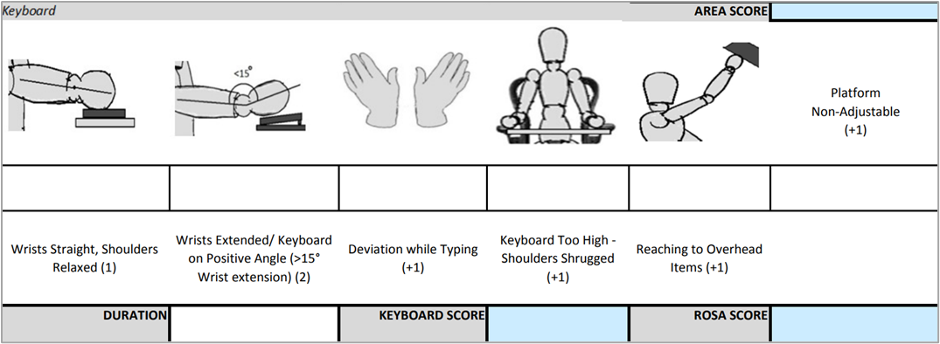
Section C: Keyboard Scoring is:
Wrists Extended/Keyboard on Positive Angle (> 15⁰ Wrist Extension | 2
Keyboard Too High – Shoulders Shrugged | +1
Platform Non-Adjustable | +1
Add Duration Score (as determined previously) | +1
Area Score | 5
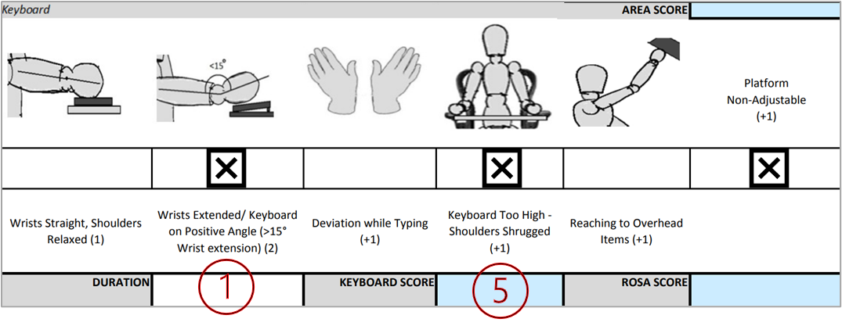
Plot total Mouse (1) and Keyboard (5) score. Total Section C Score is 5.
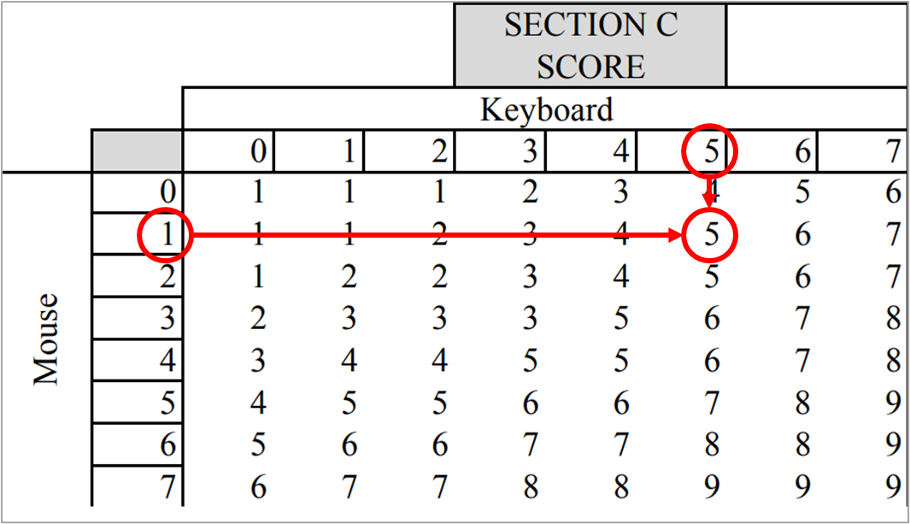
Monitor and Peripherals Score
To obtain Monitor and Peripherals Score, plot Section B Score on the vertical axis and Section C Score on horizontal axis.
Section B Score (2)
Section C Score (5)
Monitor & Peripherals Score is 5
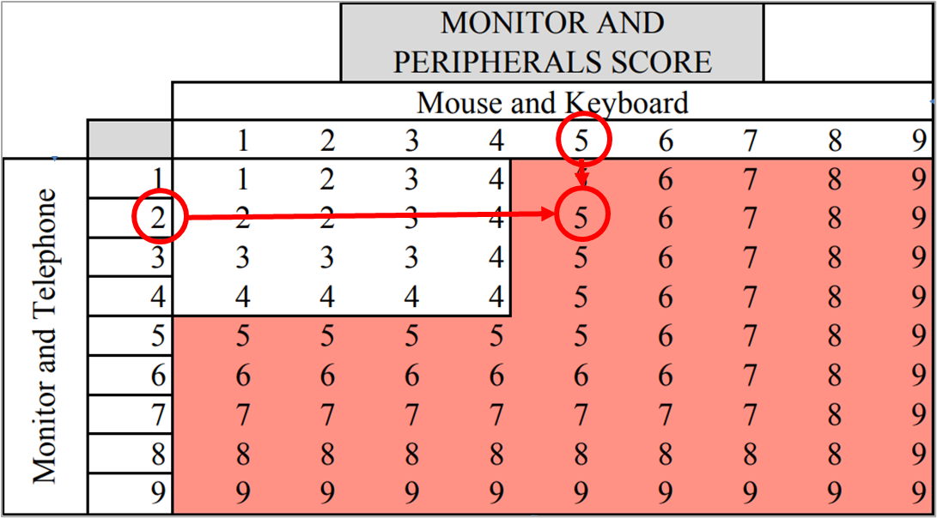
Final ROSA Score
To obtain ROSA Final Score, plot the Monitor and Peripherals Score on the horizontal axis, and the Chair Score (from Section A) on the vertical axis
Monitor/Peripherals Score (5) and Chair Score (7)
ROSA Grand Score (7)
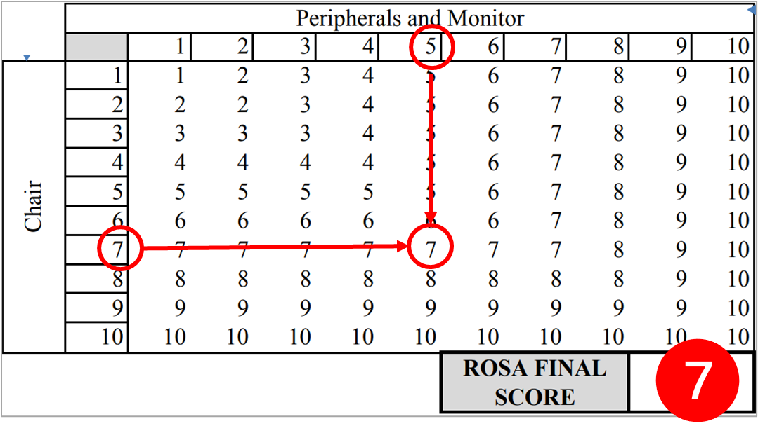

ROSA Interpretation
ROSA final scores range from 1 to 10. Scores between 3-5 are likely to benefit from further investigation. Scores > 5 indicate the potential for High Risk and recommend immediate investigation and change. In the Case Study the final ROSA Score is 7, in the range for investigation and change. What are some intervention options?

Intervention Options
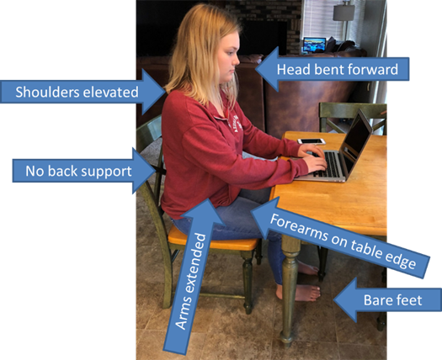
Here is what we started with.

Potential Issues
What did we identify?
Ergonomics Risk Factors of
- Awkward postures
- Static postures
- Contact stress/Tissue compression
Specifically, how about:
- Head bent forward
- Shoulders elevated
- No back support
- Forearms on table edge
- Arms extended
- Bare feet?

We made two changes
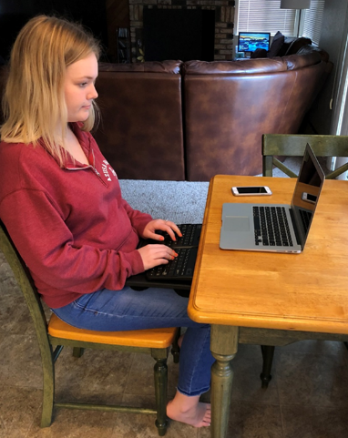
We added a lap desk and a separate keyboard. What is better about this position? Arm and shoulder position are improved.
What areas may still be problematic?
- Monitor position, too low
- No separate mouse, still has to reach to laptop touchpad
- No chair armrests, for some this would not be a problem
- Feet not flat on floor
What else could be done?
How about this? We elevated viewing level of display by putting the laptop on a stand.
What may still be problematic?
- Feet not flat on floor
- No mouse and no space for mouse
- Still no armrests

Rescore ROSA with changes
We can rescore the ROSA with the changes made so far.
Before the Monitor & Peripherals Score was 5 and the Chair Score was 7.
The ROSA Final Before Score was 7
After the changes were made the Monitor & Peripherals Score is 3 and the Chair Score is now 6.
The ROSA After Final Score is 6.
So far, some improvement but still within the range of recommended changes.

What else could be done?
Referring back to our discussion we have some potential interventions for workstation setup based on the situation.
Options could include:
- Docking station with separate keyboard, mouse and monitor?
- Replace chair?
- Replace desk?
- Add keyboard tray with same desk?
- Add footrest?
- Other?

What is the right answer?
Let’s talk about that!
I may say “to-may-toe” and you say “to-mah-toe”.
We all have different perspectives on things including ergonomics. As we think about the right answer.
We would like to put out a “fun” group poll, just to see how different our perspectives may be.
Please answer this very important question:
“What do you call carbonated beverages?”
- Pop
- Soft Drink
- Coke
- Soda
- Other
Our answers to this question may be a reflection of our geographic location.
Is there truly a right answer? Or a wrong answer? We could all probably justify our own right answer. Mobile office ergonomics is the same, in my opinion.
May not be geographic variances, but there may be several solutions that could work. It really depends on the individual.
The point is that the data you gather during your interview and observations will justify your recommendations for intervention.

ROSA Case Study – Decision Time!
How far to go when recommending changes? So, with a ROSA score of 6 or 7 and recalling that Scores > 5 are considered High Risk. What recommendation for immediate investigation and change should we make?
We have to into account a number of considerations:
- Temporary workstation now turning into long term?
- Budgetary constraints?
- Are some funds available?
- Personal history of individual?
- Have strategies to control exposure been implemented?
- Other?
No one right answer! Our goal is to accomplish what is reasonable and feasible!

Work on the Go (WOTG)

Digital Nomads!
Do you know any digital nomads? Well, Wikipedia actually has a definition.
“People who use telecommunications technologies to earn a living in a nomadic manner. Often work remotely from foreign countries, coffee shops, public libraries, co-working spaces, or recreational vehicles. Accomplished through use of devices that have wireless Internet capabilities such as smartphones or mobile hotspots.”
Wikipedia
https://en.wikipedia.org/wiki/Digital_nomad

Work can be done ANYTIME and ANYWHERE!

Perhaps not fulltime!
While it is true not everyone is going to be a fulltime digital nomad. We recognize that tele-work is fast becoming a significant component of work in general.
When you consider the technology advances in equipment coupled with fast Internet, we believe Work on the Go is definitely here to stay.
Equipment including laptop, cell phones and tablets are really double edge swords.
Yes, productivity increases but with what price from a musculoskeletal disorder perspective?

WOTG Case Study
Here is the first question.
What musculoskeletal risks do you see in this picture?
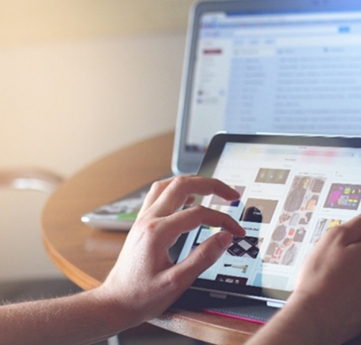
Enter answers in the chat box.
Potential Issues

Potential answers that relate to Musculoskeletal Disorder (MSD) risks include:
- Contact stress (palm on hard/sharp surface)
- Excessive wrist extension
- Sustained grip on device
- Arms extended away from body
- Others
Here is the second question.
What recommendations might you have for this person?
Enter answers in the chat box.
Potential Recommendations

Potential recommendations can include:
- Laptop lap desk
- Laptop wedge on table
- Forearms supported on table
- Stand for device
- Separate keyboard/mouse
- Hold closer to body
- Pop socket for device
- 30/30/30 Microbreak Guideline
- Other

Work on the Go (WOTG) – General Guidelines

Laptop or Tablet – Single Desk/Table
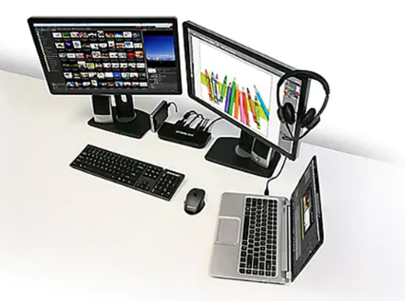
If a laptop is the primary computing device and it is used at a single location most of the time, the best solution to mitigate the postural imbalance between the neck and wrists is to use a docking station and utilize an external monitor, keyboard and mouse.
Then those components can be adjusted more like a traditional workstation.

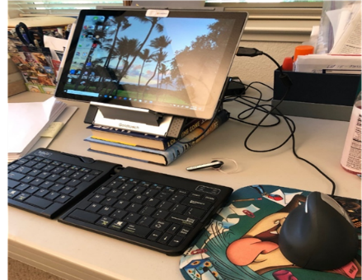
Laptop or Tablet – Tabletop/Travel
If a laptop is the primary computing device and it is moved regularly and used in different locations, the best solution involves using a laptop stand and an external keyboard and mouse, Bluetooth can work well.
Using the laptop stand allows an improved viewing angle compared to using the laptop on the table. The result is better neck position.
Conference rooms and hotel rooms often have adjustable height chairs. Coffee shops don’t. Hotel rooms have added option of pillows to help raise seat height.

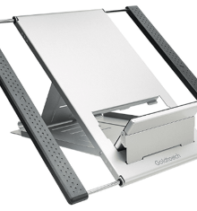
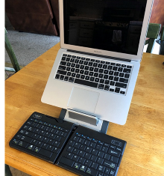
Portable Laptop/Tablet Stand and Bluetooth Keyboard
Here is an example of a laptop stand that has a very slim profile, which makes it great for portability and travel. It is also quite versatile, as it can be used with large laptops as well as tablets. This particular product is by Goldtouch.
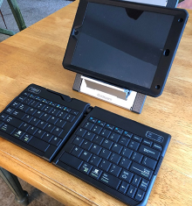
Full size keyboards are available in travel version – some fold up; this Kinesis travel keyboard has the split keyboard functionality.

Any of the equipment/tools we are discussing today are meant to be examples, as opposed to specific recommendations or product endorsements. You can research most of these items online and look at online reviews, prices, etc. I’ve researched various items by asking Dr. Google. Type in “best laptop stands for 2021” .

Be creative!
Reams of paper or books can be very helpful to reposition equipment. Common household items can be readily available. Just make sure whatever is used provides a stable platform or base to the supported item.

Laptop lap desks
If a laptop is the primary computing device and it is moved regularly and used in different locations where tabletops are not available, a laptop desk may be a good option. They can also be used with tablet to elevate the angle of surface.
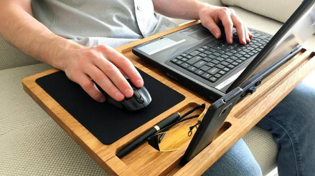
An external keyboard and mouse for tablet make sense if having to type a lot. They can also be used with laptop.
Some are wide enough for external mouse; phone holders, since that must be in reach too. Make sure the laptop does not overheat with use, be careful of putting the laptop on a pillow or some other support that does not allow for heat dissipation.
Independent reviews of office ergonomic products are available online.
www.allthingsergo.com
Also look for other information via Internet searches and feedback from others.

Work on the Go (WOTG) – Cars and Airplanes
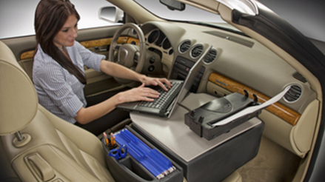
Computing in cars or planes will never be optimal because of the set-up of the seating in these vehicles. Other work, outside of computing, is one option to focus on while traveling in a car or plane.

Car laptops
For a number of people their car is their office. Consider laptop stands that are available. Some of the stands may involve some installation. Check out:
https://www.goergo.com/cargo-gallery/

General tips
At very least when using laptops/tablets/phones on cars and airplanes, place on emphasis on posture change and periodic breaks.
Work on the 30/30/30 Micro-breaks!
From the vision perspective promote looking up and away from devices regularly to allow the eyes to go to infinite focus. Also consider eye drops for dry vehicle environments.

Work on the Go (WOTG) – Airports
Airports have changed dramatically from the ergonomics perspective and many other ways as well. Some of you may remember back in the day these things called phones! There was bench seating with bench seating, with no cup holders!
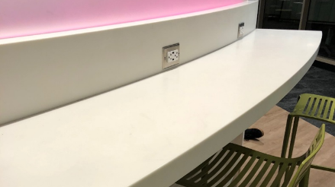
Now many options available for people who are working on the go in airports. Fully equipped business centers are available for passengers.
In the terminal, built in counters include options for sitting or standing with multiple power outlets and wireless access.
And more to come as technology continues to advance!

Work on the Go (WOTG) – Business Travel
Mobile work often includes a combination of business and pleasure travel. Ergonomic issues beyond computer use are evident.

Suitcases
For suitcases, wheels are the best and another option may be to check the bag instead of having to get it into the overhead bin.
You may to consider reviewing lifting mechanics when handling suitcases.

Backpacks or computer bags
Backpacks, particularly wheeled backpacks can do double duty as a backpack you can carry up and down stairs and then roll on hard surface floors.
While a backpack carried with a single strap over one shoulder is common, our recommendations is to double strap the backpack to position it on both shoulders for distributing the weight of the load.
A great suggestion for packing any bag is to ask, “ Do I really need that on my trip?” Many times, people tend to overpack and end up just carrying stuff around they truly do not need!

Smartphone and Tablet Tips
Work to minimize and optimize time spent on devices is a very good first thought. For example:
- Digital assistants – Siri, Alexa, Cortana, Google will allow a decreased frequency of typing as well as looking at the device.
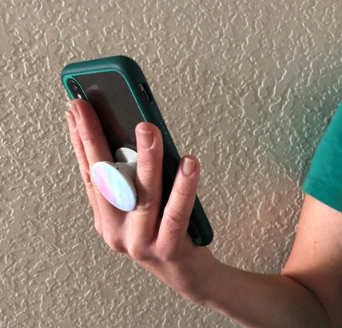
- Pop-sockets (or similar) can reduce sustained gripping/pinching.
- Use other innovations like voice-to-text software, predictive text, set-up text replacement shortcuts and swipe-typing to optimize phone and tablet use.
- Enlarge text size for easier reading.
- For extended typing use external tactile keyboard vs. virtual keyboard.
- Alternate between using the thumbs and fingers.
- Avoid sustained, unsupported elbow flexion while holding device.
- Use Bluetooth headset or speaker for calls.
- Use lap desk, or other support to hold weight of device.
Being creative can go a long way to optimize the device use!

Small hands?
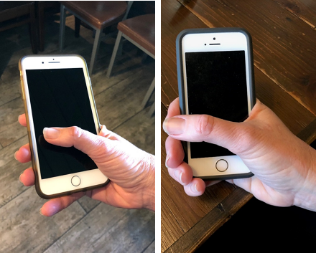
If you have tiny hands, don’t pick the largest smartphone on the market.
Find a phone that your thumb can reach to the opposite side of the phone comfortably. (Small-up to 4.5 in; Medium=4.5-5.5 in; Large=5.5 in. or more.)
Same with grip – your thumb and middle finger should be able to touch when you close your hand around your phone. Just like Goldilocks, “Just Right!”

Device selection
Recalling our Dose/Exposure discussion earlier recall the goal is to control overall exposure to use of device. Picking the right tool for the task at hand is important. Here are some Mobile Device Use Guidelines:
- Laptop – most amount of time
- Tablet – next amount of time
- Cell Phone – least amount of time
Hours
Minutes
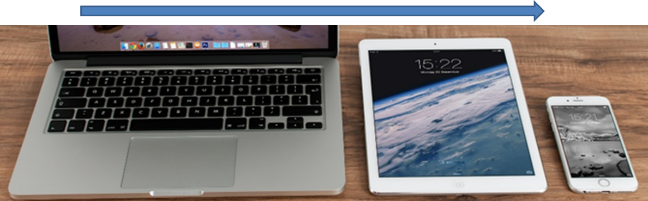
With the use of mobile technology, the work and the worksite may change. Your goal needs to be to pick the right tool for the environment and pick the right environment for the task.
Lighter is better. Consider the weight of the device in terms of portability.

Universal Design (UD)
So far . . . we have specifically discussed Working from Home (WFH) and Working on the Go (WOTG) concepts and strategies.
Next, we go “beyond” this to introduce Universal Design (UD).

UD Examples
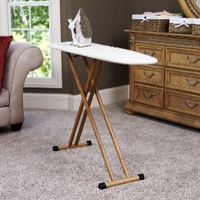
Universal Design examples include many things that at this point in time we may take for granted:
- Curb cutouts – wheelchair access, people on bikes
- Walking ramps – rather than steps
- Automatic doors – hands free access
- Lever door handles – easy to open rather than knob
- Taller bathroom sinks – improved posture at sink
- Ironing boards – height adjustable
- Others?

Background
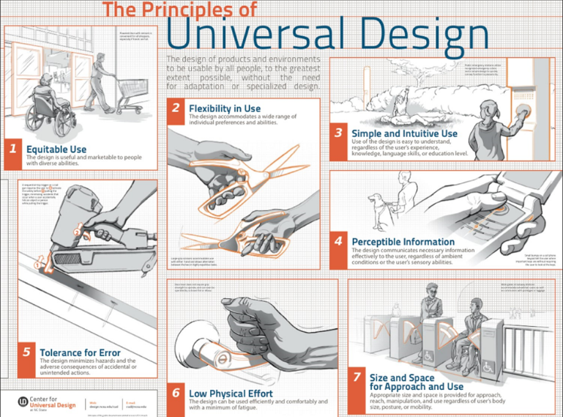
7 Principles of Universal Design were developed in 1997 at the North Carolina State University (NCSU) by a group of architects, product designers, engineers and environmental design researchers led by architect Ron Mace.

Purpose
Universal Design Principles are intended to enhance the design of environments, products and communications.

“May be applied to evaluate existing designs, guide design process and educate both designers and consumers about characteristics of more usable products and environments.“
http://universaldesign.ie/What-is-Universal-Design/The-7-Principles/

Universal Design and Ergonomics related?
“Universal Design takes into account the full range of human diversity, including physical, perceptual and cognitive abilities, as well as different body sizes and shapes.
Ergonomics is about designing for people, wherever they interact with products, systems or processes.”
https://prezi.com/0fhp-tofnmpo/universal-design-and-ergonomics/

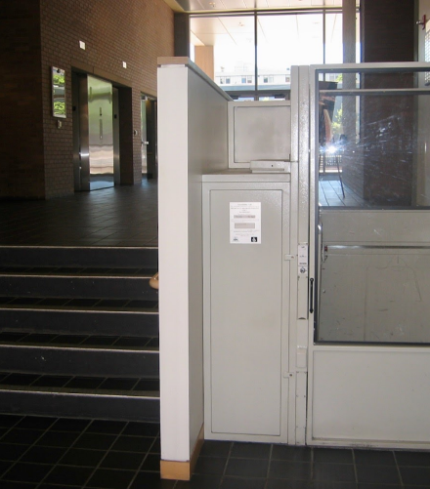
One definition of ergonomics is to optimize human performance.
In this light, Ergonomics and UD principles are fully in sync to optimize:
- Health
- Safety
- Productivity
- Quality
An overarching objective is to allow more people greater opportunities to effectively perform home and work activities.

7 Principles of Universal Design
In the workshop our intent is to introduce you to the 7 Principles of Universal Design, to sort of wet your whistle and to throw out some thoughts for additional interest.

Overview of 7 Universal Design Principles*
The 7 Principles of Universal Design include the following:
Principle 1: Equitable Use
Principle 2: Flexibility in Use
Principle 3: Simple and Intuitive Use
Principle 4: Perceptible Information
Principle 5: Tolerance for Error
Principle 6: Low Physical Effort
Principle 7: Size and Space for Approach and Use
http://universaldesign.ie/What-is-Universal-Design/The-7-Principles/

Please refer to the UD Resources page for additional references and resources.

Principle 1: Equitable Use
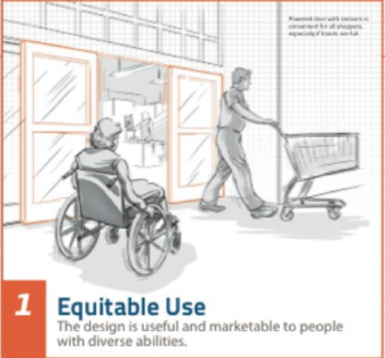
The design is useful and marketable to people with diverse abilities.
Guidelines:
- Provide the same means of use for all users: identical whenever possible; equivalent when not.
- Avoid segregating or stigmatizing any users.
- Provisions for privacy, security, and safety should be equally available to all users.
- Make the design appealing to all users.

Principle 2: Flexibility in Use
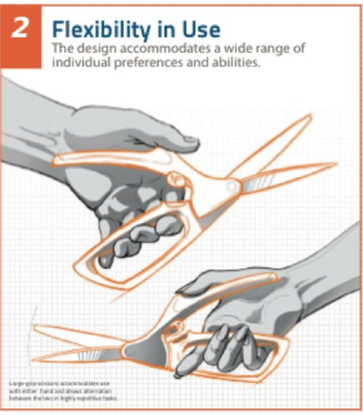
The design accommodates a wide range of individual preferences and abilities.
Guidelines:
- Provide choice in methods of use.
- Accommodate right- or left-handed access and use.
- Facilitate the user's accuracy and precision.
- Provide adaptability to the user's pace.

Principle 3: Simple and Intuitive Use
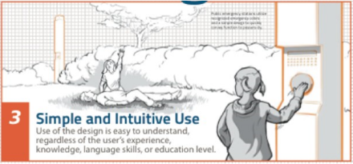
Use of the design is easy to understand, regardless of user's experience, knowledge, language skills, or current concentration level.
Guidelines:
- Eliminate unnecessary complexity.
- Be consistent with user expectations and intuition.
- Accommodate a wide range of literacy and language skills.
- Arrange information consistent with its importance.
- Provide effective prompting and feedback during and after task completion.

Principle 4: Perceptible Information
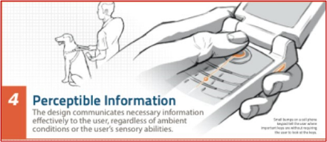
The design communicates necessary information effectively to the user, regardless of ambient conditions or the user's sensory abilities.
Guidelines:
- Use different modes (pictorial, verbal, tactile) for redundant presentation of essential information.
- Provide adequate contrast between essential information and its surroundings.
- Maximize "legibility" of essential information.
- Differentiate elements in ways that can be described (i.e., make it easy to give instructions or directions).
- Provide compatibility with a variety of techniques or devices used by people with sensory limitations.

Principle 5: Tolerance for Error
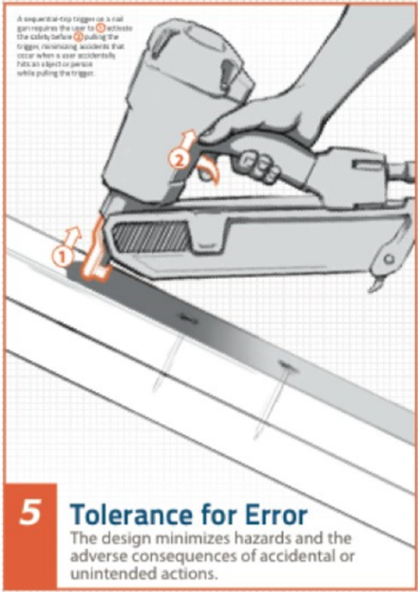
The design minimizes hazards and the adverse consequences of accidental or unintended actions.
Guidelines:
- Arrange elements to minimize hazards and errors: most used elements, most accessible; hazardous elements eliminated, isolated, or shielded.
- Provide warnings of hazards and errors.
- Provide fail safe features.
- Discourage unconscious action in tasks that require vigilance.

Principle 6: Low Physical Effort
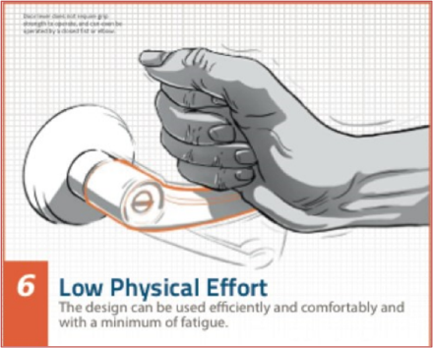
The design can be used efficiently and comfortably and with a minimum of fatigue.
Guidelines:
- Allow user to maintain a neutral body position.
- Use reasonable operating forces.
- Minimize repetitive actions.
- Minimize sustained physical effort.

Principle 7: Size and Space for Approach and Use
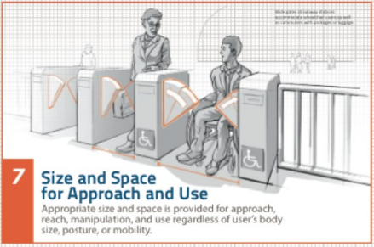
Appropriate size and space is provided for approach, reach, manipulation, and use regardless of user's body size, posture, or mobility.
Guidelines:
- Provide a clear line of sight to important elements for any seated or standing user.
- Make reach to all components comfortable for any seated or standing user.
- Accommodate variations in hand and grip size.
- Provide adequate space for the use of assistive devices or personal assistance.

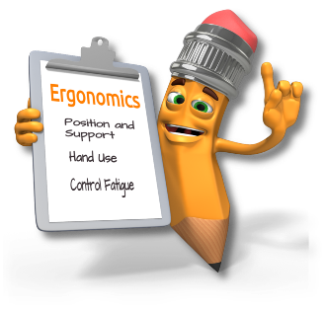
Universal Design and Ergonomics related!
Very similar to our basic set of ergonomics principles:
- Position and Support (Body and Limbs)
- Hand Use (Reach Zone)
- Fatigue Control (Dose/Exposure)
This becomes even more evident when we consider the Ten Ergonomics Principles, we detail in Manufacturing Ergonomics: Introduction for Health Care Professionals (Online)
- Process – Promote effective work processes
- Position/support – Promote neutral body and limb position/support
- Movement – Promote regular physical movement
- Material handling – Control manual material handling
- Reach – Promote work in reach zone
- Workstation/tools/equipment – Provide correct workstation, tools and equipment
- Training – Provide competency based training
- Environment – Control exposure to work environment
- Health/wellness – Promote personal health and wellness
- Feedback – Provide on-going feedback for continuous improvement

Universal Design – Resources

The Job Accommodation Network (JAN)
800-526-7234 (V)
877-781-9403 (TTY)
http://www.askjan.org/index.html(link is external)

Northwest ADA Center
800-949-4232
http://nwadacenter.org

Equal Employment Opportunity Commission (EEOC)
1-800-669-4000 (V)
1-800-669-6820 (TTY)
www.eeoc.gov(link is external)

Ergonomics: Beyond the Traditional Office Workstation!
HCP are uniquely suited to provide valuable services to patients and clients! Opportunities abound to apply ergonomics beyond the traditional office workstation!
Home Office  - Increase in tele-commuting  - Setting up a home office | Mobile Office  - Work (and play) on the go  - Laptops, tablets and cell phones | Home and Beyond  - Universal Design Principles  - Improved use and access

Selected References

Ergonomics Beyond the Traditional Office
- Honan, M. Mobile Work: Ergonomics in a Rapidly Changing Work Environment, IOS Press, 2015.
- Computer Vision Syndrome, American Optometric Association https://www.aoa.org/patients-and-public/caring-for-your-vision/protecting-your-vision/computer-vision-syndrome#1
- Sonne, M., et al., Development and evaluation of an office ergonomic risk checklist: ROSA – Rapid office strain assessment, Applied Ergonomics 43 98-108, 2012
- Miller, L., & Antle, D. The ROSA checklist: A tool for office ergonomics assessment. SIS Quarterly Practice Connections. 2016, 1(3), 28-30
- McAtamney, L., et al., RULA: a survey method for the investigation of work-related upper limb disorders, Applied Ergonomics, 1993
- Namwongsa, S., et al., Ergonomic risk assessment of smartphone users using the Rapid Upper Limb Assessment (RULA) tool, PLoS ONE 13 (8): e0203394 https://doi.org/10.1371/journal.pone.0203394 , 2018
- Dennerlein, J. The state of ergonomics for mobile computing technology, IOS Press, Work 52 269-277, 2015
- Szucs, K., et al., A comparison of upper body and limb postures across technology and handheld device use in college students. Journal of Physical Therapy Science, https://www.ncbi.nlm.nih.gov/pmc/articles/PMC6181668 , 2018.
- Juraida, Y. & A. Effects of Netbook and Tablet Usage Postures on the Development of Fatigue, Discomfort and Pain, J. Eng. Technol. Sci., Vol. 48, No. 3, pgs. 243-253, 2016.
- Institute for Work & Health, ‘Too much standing hurts, too’, At Work Issue 85, https://www.iwh.on.ca/newsletters/at-work/85/too-much-standing-hurts-too Summer 2016.
- Lowe, BD, et al., Observation-based posture assessment: review of current practice and recommendations for improvement. DHHS NIOSH publication No. 2014-131, 2014.
- Harvey, R., et al., The Effect of Head and Neck Position on Head Rotation, Cervical Muscle Tension, and Symptoms, Association for Applied Psychophysiology & Biofeedback, Biofeedback, Volume 46, Issue 3, pp. 65-71,
- Rodrigues, M. S., et al., Differences in ergonomic and workstation factors between computer office workers with and without reported musculoskeletal pain, IOS Press, Work 57 563-572, 2017
- Occupational Safety and Health Administration, Computer workstations etool. https://www.osha.gov/SLTC/etools/computerworkstations/checklist_evaluation.html
- Independent reviews of ergonomics products, All Things Ergo https://allthingsergo.com
- Lee, S, et al., Gender and posture are significant risk factors to musculoskeletal symptoms during touchscreen tablet computer use. The Journal of Physical Therapy Science, 30 855-861, 2018.
- Lin, J. & B., S. Sit-Stand Workstations – Are They a Solution to Musculoskeletal Stress? Professional Safety Journal, 63 75-77, October 2018.
- Gao, L., et al., Economic evaluation of a randomized controlled trial of an intervention to reduce office workers’ sitting time: the "Stand Up Victoria" trial, Scand J Work Environ Health 2018;44(5):503-511
- Hansraj, Kenneth. (2014). Assessment of stresses in the cervical spine caused by posture and position of the head. Surgical technology international. 25. 277-9.
- American Optometric Association: https://www.aoa.org/patients-and-public/caring-for-your-vision/protecting-your-vision/computer-vision-syndrome#1
- https://globalworkplaceanalytics.com/work-at-home-after-covid-19-our-forecast
- http://universaldesign.ie/What-is-Universal-Design/The-7-Principles/
- https://prezi.com/0fhp-tofnmpo/universal-design-and-ergonomics/

Office Ergonomics
- Human Factors and Ergonomics Society. (2007). ANSI/HFES 100-2007 Human Factors Engineering of Computer Workstations. Human Factors & Ergonomics Society
- Jacko, J.A. (ed) (2012). Human–Computer Interaction Handbook: Fundamentals, Evolving Technologies, and Emerging Applications (3rd Ed.), CRC Press
- Kroemer, Anne D., & Kroemer Karl H.E., (2nd ed), (2017), Office Ergonomics: Ease & Efficiency at Work, Taylor & Francis Group
- Occupational Safety and Health Administration, (2019) Computer Workstations eTool, https://www.osha.gov/SLTC/etools/computerworkstations/
- Pronk NP, Katz AS, Lowry M, Payfer JR. Reducing Occupational Sitting Time and Improving Worker Health: The Take-a-Stand Project, 2011. Prev Chronic Dis 2012;9:110323
- Rogers, Y., Sharp, H., & Preece, J. (2011). Interaction Design: Beyond Human Computer Interaction (3rd Ed.). Wiley
- Shneiderman, B., Plaisant, C., Cohen, M., & Jacobs, S. (2009). Designing the User Interface: Strategies for Effective Human-Computer Interaction (5th Ed.). Prentice Hall
- Washington State Department of Labor and Industries, (2019), Office Ergonomics: Practical solutions for a safer workplace, http://www.lni.wa.gov/IPUB/417-133-000.pdf

Primary Ergonomics References
- Bridger, R. S. (2008). Introduction to Ergonomics (3rd Ed.). CRC Press
- Chaffin, D.B., Andersson, G.B.J., & Martin, B.J. (2006). Occupational Biomechanics (4th Ed.). Wiley Interscience
- Guastello, S. J. (2006). Human factors engineering and ergonomics: A systems approach. CRC Press
- Helander, M. (2005). A Guide to Human Factors and Ergonomics (2nd Ed.). CRC Press
- Lehto, M. & Landry, S. J. (2012). Introduction to Human Factors and Ergonomics for Engineers (2nd Ed.). CRC Press
- Salvendy, G. (Ed.) (2012). Handbook of Human Factors and Ergonomics (4th Ed.). Wiley
- Wickens, C. D., Hollands, J. G., Parasuraman, R., & Banbury, S. (2012). Engineering Psychology and Human Performance (4th Ed.). Pearson

Journals (Selected)
- Applied Ergonomics, Elsevier Science Ltd.
- Ergonomics, Taylor and Francis.
- Human Factors, Human Factors and Ergonomics Society.
- (Reference www.ergoweb.com for a list of ergonomics related journals)

Professional Organizations
American Industrial Hygiene Association
2700 Prosperity Avenue, #250
Fairfax, VA 22031
(703) 849-8888

American Society of Safety Engineers
1800 E. Oakton St.
Des Plaines, IL 60018-2187
(847) 699-2929

Human Factors and Ergonomics Society
PO Box 1369
Santa Monica, CA 90406-1369
(310) 394-1811

International Ergonomics Association
Secretary General IEA
Pieter Rookmaaker
SEARBO/Ergonomics
PO Box 2286
3500 GG Utrecht
The Netherlands
+31 30 2399455

National Safety Council
444 North Michigan Avenue
Chicago, IL 60611
(800) 621-7619

