ErgoSystems Home Office Ergonomics Quick Reference Guide
Office Adjustment Sequence | - Desk | - Equipment (Keyboard/Mouse/Computer)
- Chair: Adjust chair (see below); remember to adjust chair throughout day based on activity  - Desk: Based on your particular keyboard technique (refer to Keyboard/Mouse/ Computer Section); adjust desk height based on seated/standing set-up; alternate between two positions frequently (use 30/30 Guideline; change position every 30 minutes or so)  - Equipment: Adjust equipment position (keyboard, mouse computer, document holder, office supplies, etc.) as needed  - Monitors: Adjust monitors as needed (includes monitor height, distance, side-to-side alignment and angle/tilt) | Desk Height Seated: Once chair has been properly adjusted and keyboard/mouse technique has been determined (piano player or forearm support, refer to Keyboard Section) adjust desk height so:  - Elbows are at sides at about 90⁰ to 100⁰ angle  - Shoulders relaxed  - Wrists straight  Desk Height Standing: Alternate seated position with standing on a regular basis; follow similar positioning guidelines as for seated:  - Use footrest for alternate foot placement  - Wear comfortable well-cushioned shoes  - Perform periodic heel lifts and shift weight front/back on feet to improve circulation | Keyboard Placement: Determine keyboard technique (with or without wrist rest)  - Piano Player: Position keyboard close to edge of worksurface, relax elbows at sides, angled to about 90⁰ and float hands over keys (like playing a piano)  - Forearm Supporter: Position keyboard farther forward on worksurface and rest forearms on worksurface; raise worksurface slightly  Note: Refer to Desk Section to adjust desk height  Mouse Placement: Ensure mouse is next to keyboard within a comfortable reach  Computer Placement: Out of way but still readily accessible to dock and undock laptop
- Chair | 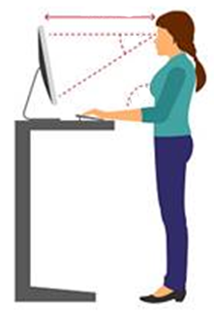  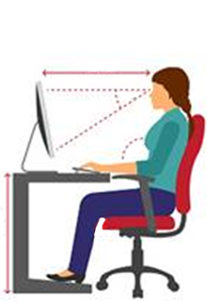 | - Monitors
Seat Height: Adjust height so feet on the floor with even weight through hips and thighs  Seat Depth: Adjust front/back seat position so minimum of two fingers between front edge of chair and back of knee  Back Support Height: Adjust so lumbar support is located at the waist/belt level area  Seat/Back Angle; Adjust for Activity  - For keyboard/mouse/handwriting; adjust so seat is about parallel to floor with trunk upright  - For other activities (talking with guests, telephone use, other non-hand activities, etc.); adjust so seat is tilted somewhat back (5⁰ to 15^{O})  Seat Rocking Tension: Adjust based on body weight to ensure amount of tension that prevents you from falling backwards or being pushed forward.  Armrests: Adjust height and side-to-side position so upper arms at sides, shoulders relaxed and forearms on armrests if desired.  NOTE: Not all chairs may have the listed features; find out about a specific chair’s features by looking for adjustment levers on the chair and experiment, also look for manual that came with chair or check out manufacturer’s web site  SSA Employee Office Ergonomics Quick Reference Guide Version April 30, 2020 |  | Height: Top of screen at eye level or slightly higher  Distance: At least arm’s length away, 22 to 28”  Monitor Arm: If arm in place adjust position of monitors; some monitor arms are adjusted with use of Allen wrenches  Dual Monitors:  - Primary/Primary: each viewed about 50% of time; centered on user’s nose  - Primary/Secondary: primary viewed most of time, secondary only occasionally; primary directly in front of user  Eyeglasses: For bi/trifocal eye glasses (bottom part of lens to view monitor), lower monitor to maintain neutral head position
 | Other Considerations | Other Considerations
 | Foot/leg Clearance: Ensure adequate foot/leg clearance under the desk; remove extraneous boxes or other items  Footrest: Never allow feet to dangle; use a footrest for support if needed  Telephone: Avoid cradling phone handset between ear and shoulder; use headset/speakerphone if needed  Document Holder: Avoid head tip down position to view hard copy documents; use a document holder | Lighting: Ensure adequate room light and task light in the workstation  Noise: Manage noise as possible in the work area  Temperature: Use personal controls like a sweater or approved fan for individual temperature controls  Alternative Duty Workstation: Implement the same guidelines recommended for the office workstation in Alternative Duty Workstations as possible
ErgoSystems Home Office Ergonomics Quick Reference Guide, Version 05222020 www.ergosystemsconulting.com

