
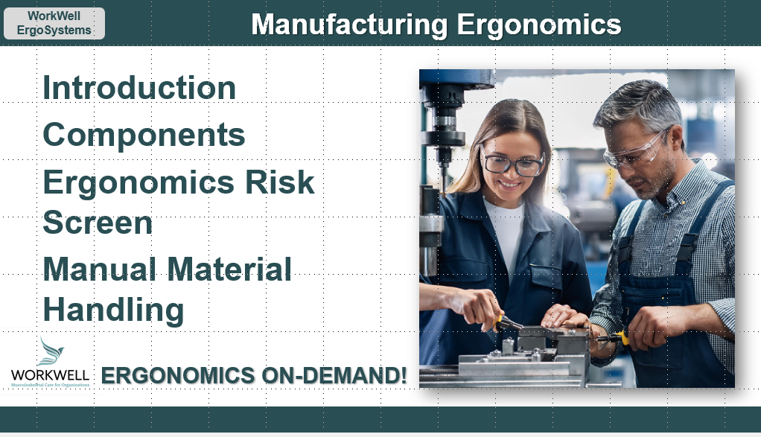

Developed by:
Mark A. Anderson, MA, PT, CPE
Certified Professional Ergonomist
Physical Therapist
ErgoSystems Consulting, LLC.
10205 28th Avenue North
Plymouth, MN 55441
Voice: 952-401-9296
Mark.Anderson@ergosystemsconsulting.com
www.ergosystemsconsulting.com

The information contained in this training workbook has been developed in good faith and is believed to present good ergonomics principles and practices. ErgoSystems Consulting, LLC and all other participating organizations make no representations or warranties as to the completeness or accuracy of the materials thereof. Persons using this information must make their own determination as to its suitability for their purposes. ErgoSystems Consulting, LLC and all other participating organizations are in no way responsible for damages of any nature resulting from the use of this information.

Copyright 1997 to 2024 ErgoSystems Consulting, LLC., All Rights Reserved Version 3_08122024

Table of Contents
Ergonomics Manufacturing Track 6
Welcome 6
Module One Introduction to Manufacturing Ergonomics 6
6
Collaborative Ergonomics 6
Typical Manufacturing Workplace 6
Typical workplace 7
Common elements 7
Enhance Human Performance 8
Repetition and Movement 8
Highly repetitive and precise tasks 8
“Movers and Shakers” 8
Apparent Dichotomy 8
Ergonomics Foundation Principles 9
Accommodation To Change 9
Ergonomics Bottom Line 9
Manufacturing Workstation Components 10
Ergonomics and Systems Design 10
Case Study – Oil Fill 10
View before video 11
Brainstorming session 11
View after video 11
Ergonomics Design Resources 12
Questions, Questions, Questions! 12
Ergonomics Design Guidelines 12
Ergonomics Design Worksheet 13
Ergonomics Design Worksheet Case Study 14
Workstation, Tool, Equipment – Identified/Defined 14
Ergonomics Risk Screen (ERS) 14
Manufacturing Work Process 15
Manufacturing Instructions 15
Cycle Time/Takt Time/Line Balancing 15
Job Rotation 15
A Quick Word about Checklists 16
Workforce 18
Workforce Demographics 18
Workbench and Chair 19
Workbench Configuration 19
Stationary/Mobile 19
Adjustability features 20
Workbench Configuration 20
Workstation Configuration – Case Study 30
Anti-fatigue mats 30
Parts/Materials/Trash 32
List of Parts/Materials 32
Storage/Staging Locations 32
Trash Receptacles 32
Micro-breaks 32
Tools 33
Brief History of Hand Tools 33
Manual to Power 34
Case Study – Slag Removal 40
Equipment 41
Fixtures/Jigs 41
Hand and Foot Controls 42
Contact Stress 43
Position 45
Prolonged or repeated non-neutral spinal positions 45
Wrist deviations greater than 15 degrees 45
Forearm rotation 45
Elbows sustained above mid-chest height 45
Reaching frequently behind the body or above the shoulders 46
Optimizing Work Positions 46
Standing work position 46
Seated work position 46
Sit/Stand work positions 46
Adjustable height workstations 47
Turntables 47
Rapid machine pacing in assembly task 47
Movement 47
Microscopes/Magnifiers 49
Computer (CPU, keyboard, mouse, displays) 51
Machine Clearance and Maintenance Accessibility Guidelines 52
Preventive Maintenance 52
Housekeeping 53
Accessibility for Maintenance 53
Equipment Checklist 55
Personal Protective Equipment (PPE) 56
Incremental improvement - Auto Metal Assembly Cell Insert Station 56
Ergonomics can be expensive! 57
Material Handling 57
Carts 57
Casters 57
Handles 58
Technique 58
Carts Checklist 59
Storage/Staging 61
Shelves/Racks 61
Shelves/Racks Checklist 61
Conveyors 62
Storage 62
Work Environment 62
Control Exposure to Work Environment 62
Work Environment Checklist 64
Recommended Specifications for Workstation 65
Case Study – Label Maker 66
Ergonomics Risk Screen 67
Welcome 67
Overview and ERS Report Formats 67
ERS Scoring Overview 68
ERS Pre and Post Intervention 69
Relative Risk Level Index – Defined and Interpretation 70
How Much is TOO Much? 70
Dose/Exposure 70
Medical Analogy 71
ERS Example Case Study – Oil Fill 71
Background Information 71
Oil Fill Video 71
ERS Results 72
ERS – Step-by-Step 75
Step One – Identify Number of ERSs to be Conducted 75
Step Two – Ergonomics Analysis Tool Box 76
Step Three – Prep for ERS Data Collection 78
Step Four – Obtain Data (Video, Interviews, Measurements) 78
Step Five – Complete ERS Worksheet and Report 79
Step Six – Implement Solutions 84
Step Seven – Follow-up 85
ERS Practice 85
CNC Reservoir Case Study 85
Next Steps 86
Manual Material Handling 87
Welcome 87
How Much Weight Can a Person Lift? 87
Physical Demands 87
Occupational Biomechanics 88
Lifting Calculators 88
Lifting Guide Criteria 88
Lifting Scenario 88
Potential Lifting Factors 89
Simplified Lifting Calculator 90
Manual Material Handling Guidelines 96
MMH Intervention strategies 97
NIOSH Ergonomics Guidelines for Manual Material Handling 100
Mechanical Handling Equipment (MHE) 100
Ergonomics and Manual Material Handling 100
Summary and Thanks! 101

Ergonomics Manufacturing Track


Welcome

Hello everyone. Welcome to the Ergonomics Manufacturing Track.
I’m Mark Anderson. I’m a Certified Professional Ergonomist and Physical Therapist with more than 35 years of experience working with ergonomics in manufacturing.
In Module One – Introduction to Manufacturing Ergonomics, I’ll define what I mean by Manufacturing Ergonomics; my definition may surprise you a bit. I’ll discuss the dichotomy between our ability to perform precise, repetitive movements with our need for regular and varied movements to maintain health and productivity.
In Module Two – Manufacturing Ergonomics Components, we’ll get into the details of the components that make up manufacturing workstations and how to apply ergonomics principles in effective ways.
A critical aspect of ergonomics is to quickly and objectively screen for ergonomics risk factors. In Module Three – Ergonomics Risk Screen, I’ll go through a detailed step-by-step screening process I’ve refined as part of my ergonomics practice.
And in Module Four – Manual Material Handling, we’ll address specific strategies to assess and control manual handling by introducing you to the LNI Lifting Calculator and strategies to control manual material handling.
Thanks for your interest in Manufacturing Ergonomics, let’s get started with Module One – Introduction to Manufacturing Ergonomics.

Module One Introduction to Manufacturing Ergonomics


Collaborative Ergonomics
I’m a strong proponent of what I call ‘collaborative ergonomics’.
So, what do I mean when I say ‘collaborative ergonomics’?
My experience has taught me ergonomics in the manufacturing workplace is the most successful when all the stakeholders – the workers, management, supervision, health and safety, medical, engineering, technical support, facilities –come together in collaboration to identify the ergonomics issues, make appropriate recommendations and then work together to implement and follow-up on the recommendations.
If you’re interested in more information about how you can use collaborative ergonomics in your practice check out the Client Collaboration Module in the Ergonomics Implementation Track.

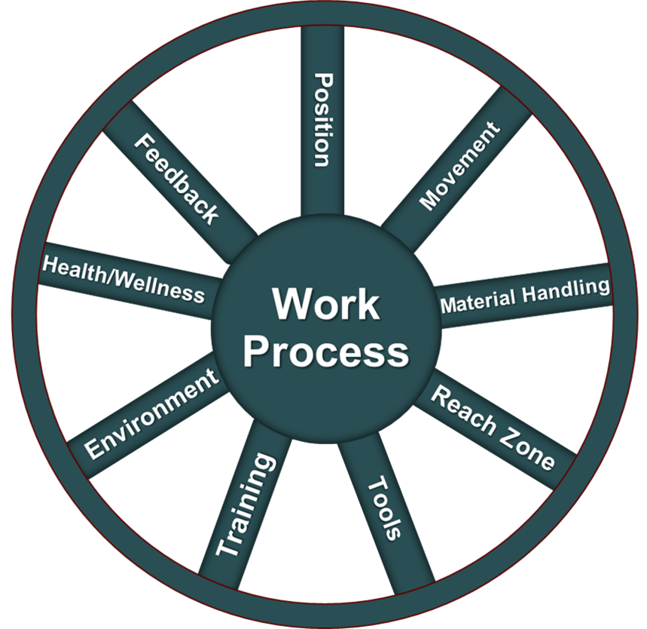
Typical Manufacturing Workplace
In the Introduction to Ergonomics Track, we defined ergonomics and introduced foundational ergonomics principles critical to designing effective workstations.
For the manufacturing workplace, let’s put together a strategy to apply ergonomics in the design and use of a ‘typical’ manufacturing workstation.

Typical workplace
All right, I should talk about my use of the word, ‘typical’. Unlike office ergonomics, which tends to follow a pretty straight-forward standard, typically involving a chair, desk, and computer system; manufacturing ergonomics presents unique challenges due to the vast array of work environments. From assembly lines for small medical devices to large-scale production of very large machinery, the scope is extensive.
So, is there the same standard in manufacturing ergonomics as there is in office ergonomics? Is there a ‘typical’ manufacturing workplace? Here's how Investopedia defines manufacturing.
“Manufacturing is defined as the process of converting raw materials or components into finished products through a series of operations involving human labor, machinery, tools, and chemical or biological processing. This transformation is not merely physical but can also involve the assembly of parts into more complex products. Manufacturing is integral to industrial production, wherein goods are produced on a large scale for consumer consumption and commercial sale.”
https://www.investopedia.com/terms/m/manufacturing.asp
Investopedia’s definition describes quite well how I think about manufacturing ergonomics. I certainly consider a manufacturing plant where measurement instruments are being assembled to be ‘manufacturing’, but I also consider the roofing crew working outside to nail shingles on the roof to also be working in ‘manufacturing’.

Common elements
Despite these differences, common elements persist across all manufacturing settings: workers use tools and equipment at some type of workstation. This universal aspect allows us to apply the set of ergonomics principles broadly while tailoring specific interventions to meet diverse needs.
Our resources, including the Ergonomics Design Guidelines and Ergonomics Design Worksheet, provide detailed guidelines and checklists to assist in this process.
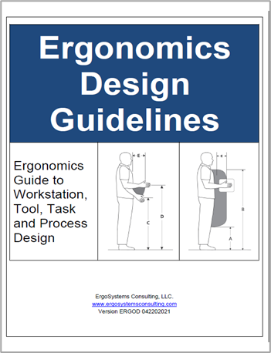 | 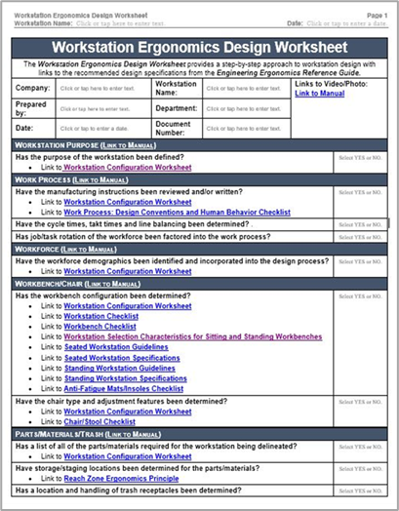
Let’s delve deeper into the fundamental ergonomics concepts in manufacturing in our next section. This ongoing discussion will further clarify how ergonomics principles can be practically and effectively applied across the spectrum of manufacturing activities.

Enhance Human Performance
What are we ultimately trying to accomplish through the use of ergonomics in manufacturing?
We want to enhance human performance by designing tasks that align with human capabilities and limitations. These enhancements not only improve the immediate working conditions but also contribute to long-term health benefits and work productivity. The fundamental goal is to create a workspace where workers can perform at their best with minimal risk of injury and be productive.
The question of course is, ‘How do we accomplish this?’

Repetition and Movement

Highly repetitive and precise tasks
As human beings, we are capable of high levels of dexterity and can perform complex repetitive tasks efficiently, a trait that has been advantageous in both evolutionary and modern industrial contexts. This ability allows people to specialize and excel in tasks that require precision, such as assembly line work.
These activities often demand focus and the repetition of a specific set of motions which can be honed into a skill over time. And not only that, but humans are also very good at identifying the need for and making minute corrections in movement patterns.
Talk with engineers who work in robotics, and they will tell you it’s very challenging to design robotic functions that can precisely duplicate tasks the human hand can perform quite easily.
However, we also appreciate that repetitive tasks, especially those that are physically or mentally monotonous, can lead to a range of health issues, including musculoskeletal disorders, mental fatigue, and decreased motivation.
In many manufacturing workplaces, we see workers performing highly repetitive tasks but from an overall body exertion perspective it’s also the case that the tasks generally can be quite sedentary. Obviously not all manufacturing jobs fit into this category, but many do. Why is this an issue?

“Movers and Shakers”
We recognize as human beings, we have a crucial physiological need for regular physical movement. We emphasized how important this is in the Introduction to Ergonomics Track. After all, one of our ten primary ergonomics principles is, ‘Promote Regular Physical Movement’.
We detailed the need to promote blood circulation for oxygen and nutrition, and movement to lubricate the body’s joints to promote general health and wellness. So, we are really good at precise repetitive tasks, but we also require regular physical movement!

Apparent Dichotomy
How can we reconcile this apparent dichotomy between our ability to perform precise, repetitive movements with our need for regular and varied movements to maintain health and productivity?
As we explore the details of manufacturing ergonomics, we’ll dive into how we can apply ergonomics principles to help workers excel at repetitive tasks that may be fairly sedentary. We’ll also examine manual material handling that can be very physically demanding.

Ergonomics Foundation Principles
In the Introduction to Ergonomics Track, we detailed ten ergonomics principles including the rationale for them. In overview, in the manufacturing workplace, we want to design workstations that meet these basic criteria:
- Provide a stable platform for the feet, hips, thighs, spine and arms in neutral positions to enhance precise repetitive tasks.
- Work within acceptable reach zones pertinent to the worker.
- Control and optimize physical forceful exertions.
- Provide regular micro-breaks and periodic longer breaks to control fatigue.
- Ensure competency-based worker training in workstation set-up and use.
- Maintain on-going follow-up to ensure appropriate feedback with the application of lessons learned going forward.

Accommodation To Change
What do you think has been the biggest challenge I’ve encountered in my ergonomics practice? Has it been performing ergonomics assessment? Has it been the collaborative effort to come up with good designs?
In my experience, what to do is quite straight forward: change the tool, change the workstation, change the training process. The operative work is . . . ‘change!’ Recall in the Introduction to Ergonomics Track, we defined ergonomics as ‘changing the set of circumstances to change the response’.
The ‘how’ to facilitate the change is when it can get tough. Most people do not like change, they have a difficult time accepting and then embracing change.
Specific to ergonomics, we recognize that a poorly designed workspace will generally lead to a poor response and a better designed workspace yields a better response. So, in many cases, changes are needed. But again, for most of us change is tough! Why is change so hard?

Adapt to Whatever We are Doing
Think about how we get through each and every day. We’ve developed hundreds, if not thousands of habits we depend on for our daily routines. From our body and mind’s perspective we get used to how it ‘feels’.
Now what we also know, is that what seems ‘normal’ to us, what we’ve gotten used to, can eventually cause us to have some health issues. It seems as if everything is going great until suddenly it’s not! As it turns out there are specific physiological and psychological reasons why this is the case.
We’ll explore them in depth in the Ergonomics Problem Solving Module and Client Collaboration Module that are part of the Ergonomics Implementation Track. In these Modules we’ll discuss ideas about how to implement positive and effective changes in any workplace. We’ll lay out a strategy to help a worker who is trying something that is ‘new – that initially seemed just ‘not right’ – to become integrated and now what was the ‘new way’ becomes the ‘old way’ and it feels ‘just fine’! Check out the Ergonomics Implementation Track for more information.

Ergonomics Bottom Line
What is the Bottom Line in manufacturing ergonomics? Our goal is to use ergonomics to make positive changes in workstations, tools, equipment and work processes. We appreciate this takes time for a workforce to accommodate to the recommended changes. Let’s next examine the specific components included in the design of manufacturing workstations.

Manufacturing Workstation Components
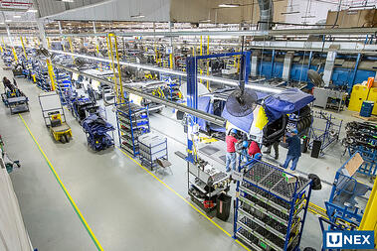
I’ve had the opportunity to apply ergonomics principles to many different manufacturing workstations over the years. What components are commonly in place?
Of course, you’ll see the worker or workers doing the work. Generally, you’ll see some sort of workstation that includes a workbench. There may be a seating system - a chair or stool.
You’ll see manufacturing instructions, either computer- based or hard copy, that the worker uses to guide the manufacturing process.
You’ll see a variety of parts and materials along with the tools and equipment needed to assemble the widget or whatever is being accomplished at the workstation.
There’ll be storage systems (bins, shelves and so on) to store and stage the parts, materials, tools and equipment and a trash receptacle to handle the trash produced.
You may see manual or powered systems to convey materials to and from the workstation; this could include pallet jacks, carts, conveyors and so on.
Of course, we also have to recognize the environment of the workstation; light, noise, temperature and ventilation.
All of these components work together to create a workstation that is safe and productive.

Ergonomics and Systems Design
In the Introduction to Ergonomics Track, we defined ergonomics:
Optimizing all aspects of job performance - safety, quality and productivity - accomplished through the appropriate DESIGN AND USE of work processes, workstations, tools and equipment and the overall organization of work.
We recognized that the systems design approach is crucial to successful ergonomics. To achieve our objective of a safe and effective workplace we needed to understand the set of circumstances that result in a certain outcome. If the current set of circumstances doesn’t provide the desired outcome, we need to figure out how to change them in reasonable and feasible ways. We need to change the circumstances to change the response!
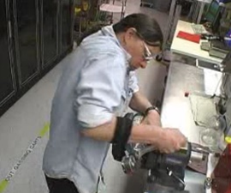
We’ll take a closer look at each of the components in the manufacturing workplace and how they are inter-related from the ergonomics perspective but first, let’s go through a case study to give you a sense of ergonomics in the manufacturing workplace.

Case Study – Oil Fill
Instruments, Inc. manufactures calibration equipment. Part of the manufacturing process is to screw a gauge onto an oil fill canister. This task had been identified as a problem in terms of discomfort and even injuries reported by the workforce.
An ergonomics assessment was conducted using the Ergonomics Risk Screen process and recommendations for improvement were made. For details about how to conduct the Ergonomics Risk Screen please refer to the Ergonomics Risk Screen Module. For now, let’s take a look at how the process had been accomplished, brainstorm on some potential modifications and then take a look what changes were made.

View before video
Play the ‘before video’ to observe how the task had been accomplished.

Brainstorming session
List options for ergonomics improvements.

View after video
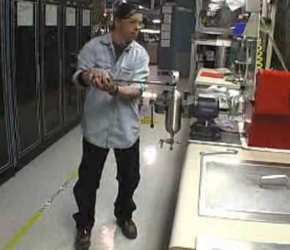
Play the after video to see how the task was modified. What do you think?
I collaborated with the worker, supervisor, health and safety manager and the engineer assigned to the area to come up with these straightforward recommendations:
- Reorient the vise to position the canister vertically.
- Replace the wrench with long handled torque wrench used with proper technique. Now the worker is able to document the amount of torque required to effectively secure the gauge.
A significant improvement was noted. To give you a sense of the before and after difference in the ERS results, take a look at the forms. GREEN indicates low or no risk. YELLOW and RED indicate higher levels of relative risk.
Visually the distinctions are quite dramatic!
Before Ergonomics Inteventions |  | After Ergonomics Interventions
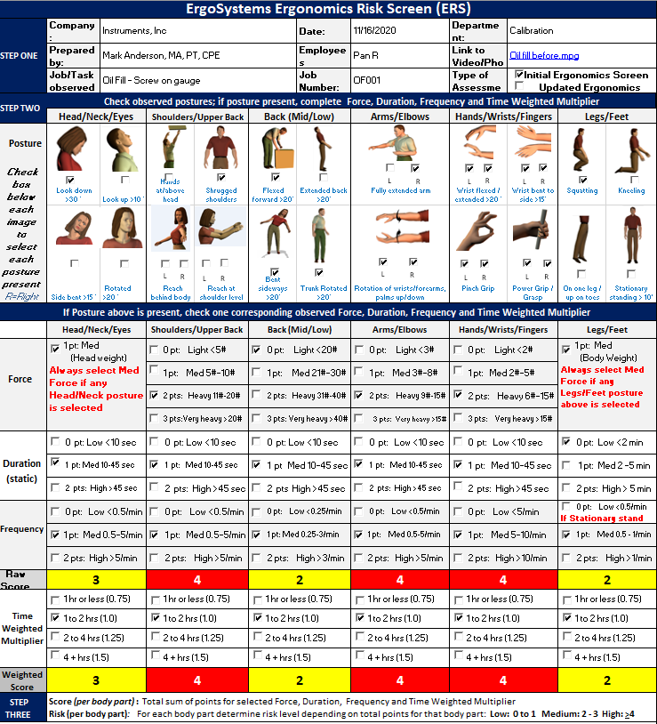 | 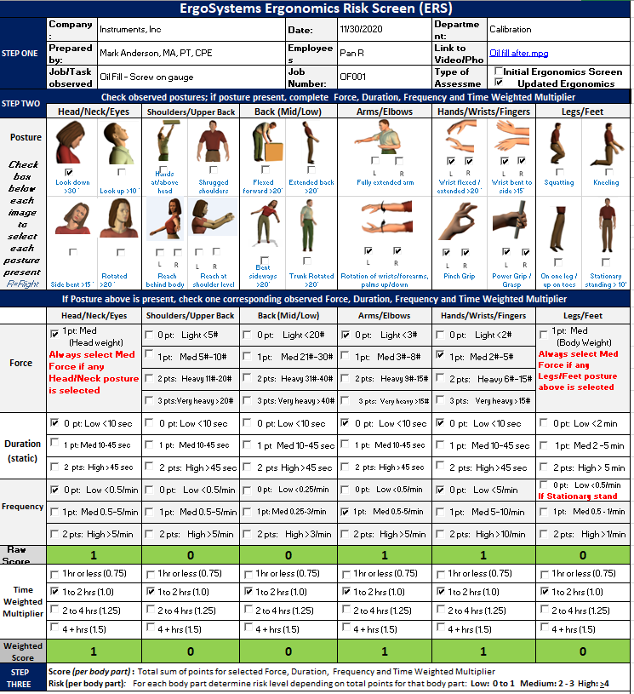
Check out the Ergonomics Risk Screen Module to learn how to perform the detailed Ergonomics Risk Screen that scores the relative ergonomics risk level.

Ergonomics Design Resources

Questions, Questions, Questions!
Now that we have examined an example of ergonomics in the workplace, let’s talk about some of the ergonomics related questions you will be working to answer. I’ve discovered while working in ergonomics on an on-going, day-in, day-out basis you need to be able to answer questions like:
- How high should that workbench be?
- We need a transport cart, what specifications does it need to meet?
- Where should we position the foot and hand controls for that machine?
- How should we position the touch screen monitors on the production line?
- How much force is needed to grip a tool and what is acceptable?
- How much weight can a worker reasonably lift?
- What clearance do we need for the operator’s feet and legs at the workbench?
- We are setting up a storage racking system, how should we adjust the shelf heights?
Honestly, the list of questions goes on and on! I suspect you are getting the point I’m making. You become the go-to resource in ergonomics workstation, tool and equipment design. In the Client Collaboration Module in the Ergonomics Implementation Track I’ll share my experience in collaborating with clients.

Ergonomics Design Guidelines
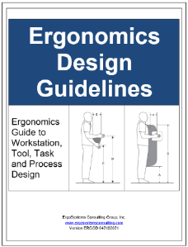
To help answer the multitude of ergonomics questions, I’ve put together a series of Checklists, Guidelines and Specifications for workstations, tools and equipment. The Guidelines are available to you as separate documents you can print out and access as you need. I will emphasize you, as the user, must always use your professional judgement when applying this information.
As we go through the Ergonomics Design Worksheet we’ll access the Guidelines in more detail.
Looking at the Table of Contents for the Guidelines, you’ll see a wide range of topics ranging from Carts to Chairs/Stools to Controls to Conveyors to Fixtures to Grip and Hand Strength to Microscopes to Manual Material Handling to a whole host of Seated and Standing Workstation Guidelines and Specifications.
Welcome to Ergonomics Design Guidelines  Primary Ergonomics Risk Factors  Primary Ergonomics Principles  Carts  - Cart Checklist  - Casters – Additional Information  - Handles – Additional Information  - Technique – Additional Information  - Shelves – Additional Information  Chairs/Stools  - Chair/Stool Checklist  Computer Workstation Guidelines  - Computer Equipment (keyboard, mouse, monitor, touch screen) Checklist  Contact Stress:  - Contact Stress Checklist  - Contact stress – sharp edge  - Contact stress – hard surface  Controls – Hand and Foot  - Hand and Foot Controls Checklist  - Recommended Specifications for Control Location  Conveyors  - Conveyor Checklist  Displays/Monitors  - Displays/Monitors Checklist  - Recommendations for Display Location – Seated and Standing  Environment  - Auditory, Temperature and Visual Checklist  - Auditory  - Temperature  Fixtures  - Fixtures Checklist  Floor: Anti-Fatigue Mats/Shoe Insoles  - Anti-Fatigue Mats/Insoles Checklist | Grip and Hand Strength  - Grip and Hand Strength Checklist  Hand Tool Design and Selection  - Tools: Checklist  - General tool guidelines  Machine Clearance and Maintenance Accessibility Guidelines  - Machine Clearance and Maintenance Accessibility Checklist  - Accessibility  - Access Doors/Ports  - Fasteners  - Accessibility for Maintenance  Manual Material Handling Guidelines  - Manual Material Handling Checklist  Microscopes/Magnifiers  - Microscopes/Magnifiers Checklist  Neutral Posture  Reach Zones (Comfort and Functional)  - Comfort Reach Zone  - Functional Reach Zone  Shelves and Racks  - Shelves Checklist  Workstation Types and Characteristics  - Workstation Checklist  - Workstation Selection Characteristics for Sitting and Standing Workstations  - Seated Workstation Guidelines  - Seated Workstation Specifications  - Standing Workstation Guidelines  - Standing Workstation Specifications  - Sit/Stand Workstation Guidelines  Glossary

Ergonomics Design Worksheet
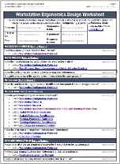
While we fully appreciate the diverse nature of manufacturing workplaces, we also understand the common elements in them, The Ergonomics Design Worksheet provides a ‘road map’ to the journey of workstation, tool and equipment design. Here are the sections of the Ergonomics Design Worksheet:
Workstation, Tool, Equipment (identified/defined)
Ergonomics Risk Screen (conducted for the project)
Workstation Purpose (define the purpose of the workstation)
Manufacturing Work Process (manufacturing instructions, etc.)
Workforce (age, gender, stature, training and experience)
Workbench/Chair (sit/stand/combination, dimensions, seating systems, footrests)
Parts/Materials/Trash (staging and handling)
Tools (manual and power)
Equipment (manual and powered)
Material Handling (manual and mechanical)
Carts (transport and storage cart requirements determined)
Conveyors (conveyor requirements determined)
Storage (workbench, carts, shelves, racks, etc.)
Work Environment (temperature, noise, illumination, etc.)
The Ergonomics Design Worksheet provides a ‘road map’ to the journey of workstation, tool and equipment design.

Ergonomics Design Worksheet Case Study
Let’s open the template of the Ergonomics Design Worksheet to take a look at it. To use the Worksheet, fill in the top section that includes the workstation, tool or equipment name and other pertinent information. Save the Worksheet with an appropriate file name.
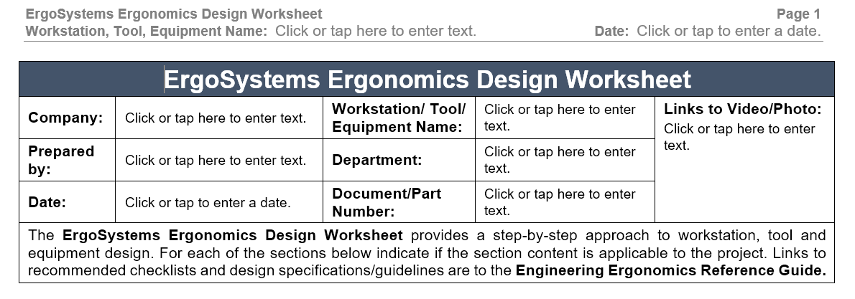
I’ll go through the Worksheet step-by-step as we apply ergonomics to the manufacturing workplace. In actual use, you won’t necessarily be able to complete the entire Worksheet in one go-around. You may not gather all of information in a linear fashion. As you use it, fill out what you can and then go back to the incomplete sections as the information becomes available.

Workstation, Tool, Equipment – Identified/Defined
"Have the workstation, tools, and equipment necessary to achieve its purpose been defined?
An obvious but critical first step in the ergonomics design process is to identify the purpose of the workstation and required workstation, tools and equipment. As much as possible, detail what will be manufactured in the workstation in terms of item size and weight, production volumes, etc.
To fill out the Worksheet select YES, NO or NA and add any comments as applicable.
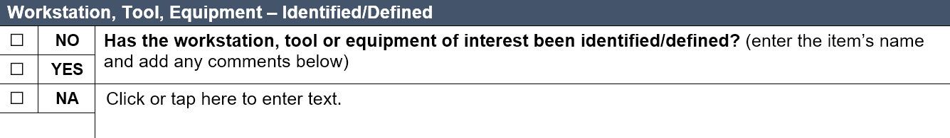

Ergonomics Risk Screen (ERS)
Has the Ergonomics Risk Screen ERS been conducted for the project?
The ERS results help you to identify potential ergonomics issues to focus on as you conduct your ergonomics design process. An ERS can be used in the redesign of an existing workstation, but we also use it in the planning phase of brand new designs. Many times, you will have enough information to be able to conduct tabletop Ergonomics Risk Screens. This information is valuable to help make informed decisions about needed changes in the design before it becomes steel and plastic. Turns out it is much easier to make changes when the information is still digital!
Remember to fill out the Worksheet select YES, NO or NA and add any comments as applicable.
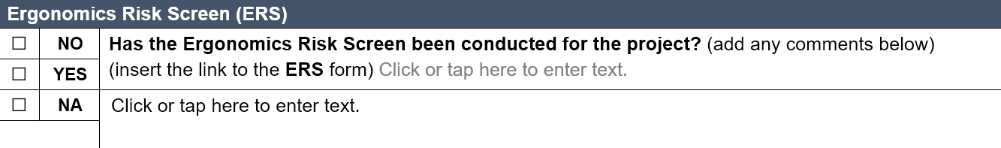

Manufacturing Work Process

Manufacturing Instructions
Have the manufacturing instructions been reviewed and/or written?
A very good place to start is the by reviewing manufacturing instructions. More than likely detailed manufacturing instructions have been written for the manufacturing process.
Or . . . perhaps not, if this is a brand-new work process. At any rate, review the current or proposed manufacturing instructions to determine if they include specific reference to ergonomics-related procedures.
For example, are there specific instructions for the setup and use of the workbench? Many workbenches are user-controlled and height adjustable. Is instruction provided to the user about how to adjust the height of the workbench to meet his or her specific stature based on the job task that is being performed?

Cycle Time/Takt Time/Line Balancing
Have cycle times, takt times and line balancing been determined?
Cycle time is determined by the time it actually takes to complete a specific task as part of the assembly process, with overall cycle time defined as the time it takes to complete the entire assembly.
Takt time is dependent on the customer demand. Takt time equals available time divided by total demand.
Are the cycle and takt times in unison? When a line is balanced in terms of cycle and takt times job performance is optimized. If the actual cycle time is less than the determined takt time, we may need to look for ways to reduce the cycle time, for example optimize processes and employ more resources.

Job Rotation
Has job rotation been factored into the work process?
Machines typically are designed to perform the exact same task in a highly repetitive manner, maintaining a high level of consistent performance. As manufacturing automation becomes increasingly sophisticated, we are seeing more machines in the workplace.
On the other hand, human beings depend on variety of activity, both physically and mentally, to optimize performance. We are extremely good at making the minute adjustments needed to successfully accomplish an intricate assembly process.
We recognize human beings are not machines. Job rotation can be an effective means to optimize human performance by providing for a variety of different physical demands.
Fill out the Worksheet as appropriate.
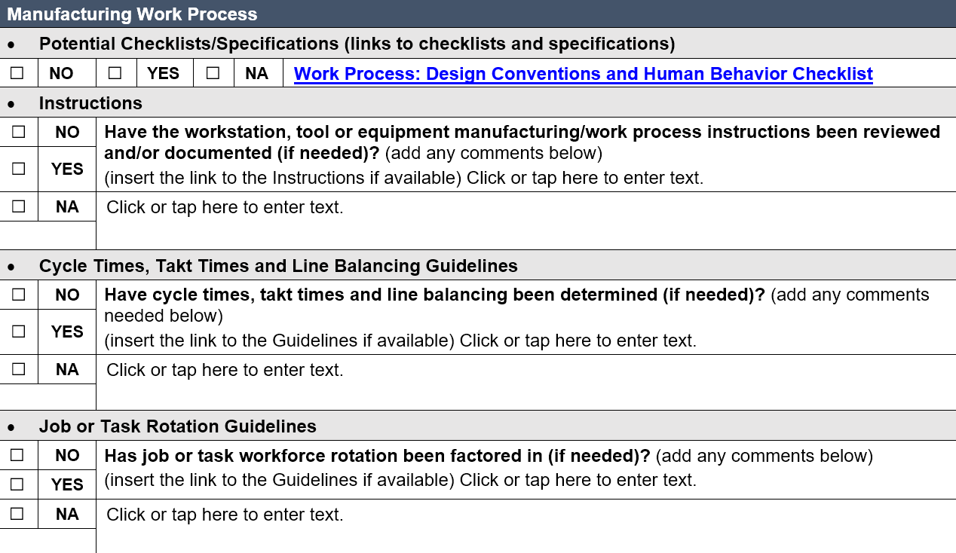

A Quick Word about Checklists
You have access to a number of checklists for resources. Not all of them will apply all the time. They are intended to be a quick method to trigger a series of problem-solving thoughts about the topics at hand to reveal potential issues. As you go through the checklist ask yourself, does that apply to my situation? If so, how should I deal with it? Maybe it needs additional investigation. Again, , checklists do not take place of professional judgement on your part.
Checklists are routinely used by some of the most highly trained professionals around. For example, airline pilots routinely use checklists. Why do they use checklists? Two primary reasons: first, they are human, just like everyone else and they can forget stuff. Checklists are great at helping us to remember what we want to remember.
And a completed checklist documents the fact that you examined the potential issues and addressed them appropriately.
Work Process: Design Conventions and Human Behavior Checklist
The Worksheet includes a link to a checklist (Work Process: Design Conventions and Human Behavior Checklist) that you may find helpful as you consider the overall work process. We covered this content in the Introduction to Ergonomics Track in the Work Process Ergonomics Principle. Let’s take a quick look at the Checklist. It asks you to think about specific information about the level of task complexity (too complex or too monotonous). It addresses Design and Use Standards and the level of Technical and Safety Training.

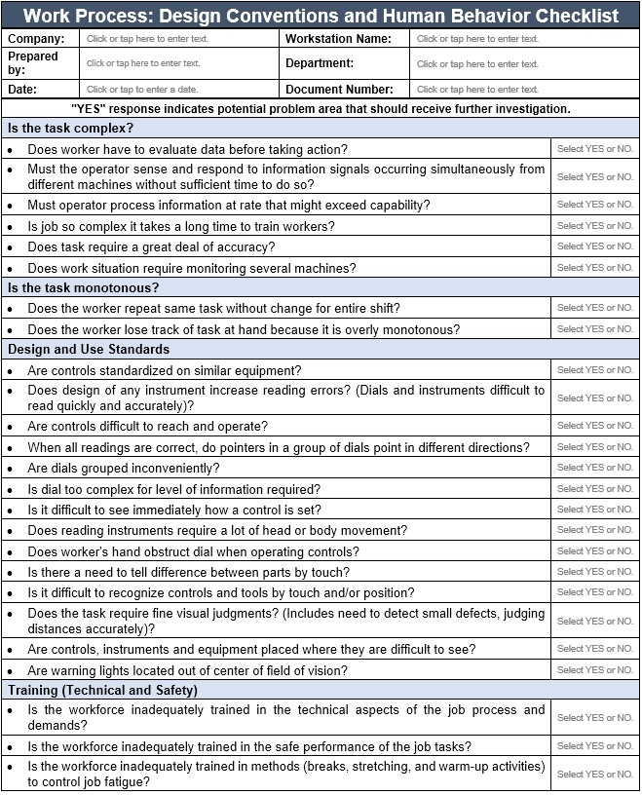

Workforce
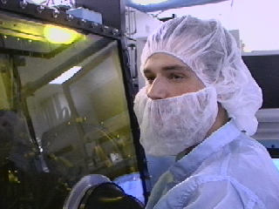
The Workforce is the critical component in the success of the workplace.
The essence of ergonomics focuses on enhancing the health, safety and productivity of the people doing the job!

Workforce Demographics
Have the workforce demographics been identified and incorporated as needed into the workstation design?
When ergonomics is used at the organizational level, it’s used to develop a description of the both the individual worker and workforce: age, fitness level, training and experience levels, gender breakdown, body stature, hand dominance, and so on. Consideration of the workforce demographics enhances the design process.

Age
Physiological changes occur as a matter of aging:
- Strength and flexibility may significantly decrease.
- Aerobic capacity and endurance decrease.
- Visual acuity may deteriorate.
- Reflexes and hand-eye coordination may deteriorate.
Changes also take place in psychosocial aspects. With age, work experience associated with work expertise is enhanced. Experienced workers bring a valuable factor to the workplace.

Gender
Knowledge of gender breakdown is often required to implement successful ergonomics interventions. This is important to know in terms of proper:
- Fit and use of workstations, tools, equipment and clothing. For example, consideration of small hand size versus large hand size related to tool handle size.
- Match between physical demands of the job and functional capacity levels of the worker.

Stature and Morphology
Anthropometry - the study of the size and shape of the body plays an important role. Assessing the stature and morphology numerical ranges of the workforce is necessary to provide for adequate design and use of the workplace.
In other words . . . How tall? How short? How big? How small? This is the science of Anthropometry – a topic we covered in depth in the Introduction to Ergonomics Track.

Hand Dominance
Approximately 90% of the general population is right-hand dominant. As a result, most workstations, tools and equipment are designed and set up to accommodate right hand dominance use. This often presents complications for the remaining 10% of the workforce.
Of course, there are those lucky few who are ambidextrous! Look for opportunities to minimize the impact on left-hand dominant workers so the task can be performed well either right or left-handed or can be easily switched from right to left hand use.
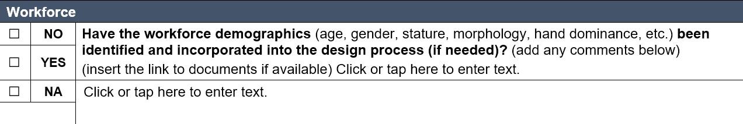

Workbench and Chair
In the manufacturing assembly workplace, the workbench and chair are at the center of the workstation. Providing an appropriate workbench and seating system that promotes appropriate application of the ergonomics principles is essential. There are several Checklists/Specifications/Guidelines that provide specific information. Here is a list.
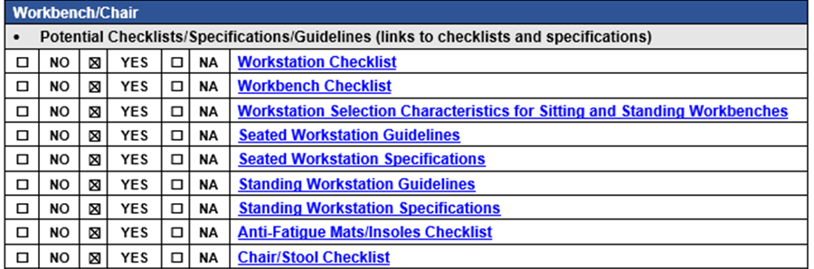

Workbench Configuration
The Ergonomics Design Guideline is the go-to guide for workstation, workbench, seated and standing configurations:
- Configuration: Seated/Standing/Both
- Height: Fixed/Adjustable
- Dimensions: Worksurface width and depth
- Others
A significant part of the Guide makes use of Anthropometric data. Recall we discussed Anthropometry in the Introduction to Ergonomics Track.

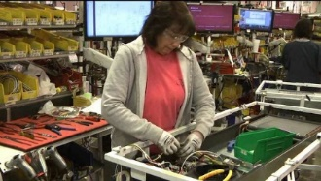
Stationary/Mobile
A good question to address is whether the workstation is stationary or mobile? A stationary workstation is used primarily in one position.
We’ll discuss recommended adjustability workstation features a little later.
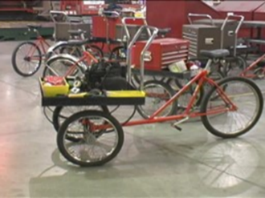
Or is the workstation mobile – taken from job site to job site? If so, how is it transported?
I’ve seen mobile workstations on tricycles with storage bins; they work well in large manufacturing facilities to quickly and efficiently get around This could be a rolling cart. Check out the information on selection and use of carts in the Guide.

Adjustability features
Can the workstation be adjusted to accommodate the needs of different workers and work processes?

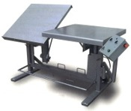
Work height
- Does the height of the work surface permit a comfortable view of the job being done?
- Is the height of the work surface adjustable?
- Does the height of the work surface permit satisfactory arm posture? (Correct hand height depends on type of work performed and object being worked on.)

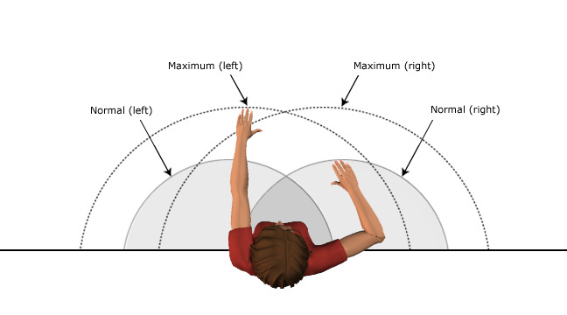
Work reach envelope
- Can the worker keep horizontal stretches within the range of normal arm reach?
- Refer to the anthropometric data tables for additional details.

Chair/stool
- If a chair/stool is provided, is its design satisfactory? (Adequate back support, vertical adjustability, etc.)

Equipment controls
- Can equipment controls and machinery be adjusted to accommodate the needs of different operators?

Worker movement
- Is it possible for the worker to alternate between sitting and standing when performing the task?

Space and clearance
- If containers are used, are they placed conveniently?
- Is there adequate space at the workstation to perform the work comfortably?
- Does the positioning of equipment controls and work surface make it possible to maintain a comfortable posture?
- Is the workplace accessible to material handling equipment?
- Is clearance space in the workplace adequate for maintenance tasks?

Workbench Configuration
Let’s take a look at how to determine if a seated or standing work position is most beneficial.

Workstation Selection Characteristics for Sitting and Standing Workbenches
In terms of worker position, the type of work performed generally determines workstation configuration: seated or standing. Check out the table.

Workstation Characteristic | Configuration
 | Sitting | Standing
 | 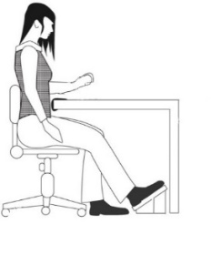 | 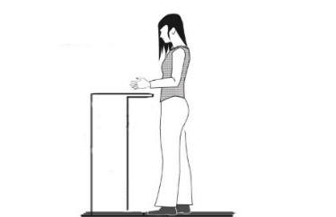
Side-to-Side Movement | Within seated workspace | Frequent movement outside of comfort zone
Task Duration | Sustained, > 5 minutes at one time | Intermittent, < than 5 minutes at one time
Hand Heights | < 6” (15 cm) above surface | > 6” (15 cm) above surface
Weight Handled | < 5 lbs (2.2 kg) | > 5 lbs (2.2 kg)
Reaches | Within Comfort Zone (within 12”, 30 cm) | Forward reaches of > 12”, 30 cm
Forces Exerted | < 5 lbs (2.2 kg) | Downward forces of > 5 lbs (2.2 kg)
Clearance | Seated clearances for legs and feet are met | Knee clearance < 18” (46 cm) or  foot clearance < 22” (56 cm)
Manipulation | Fine manipulation | Fine manipulation not required
Use of Feet | Foot pedals are used | No foot pedals are used
Here are some general guidelines for seated versus standing work positions.

Seated workstations
- A high degree of precision is required (fine manipulation and visual attention).
- Feet are used for control operations.
- All tools and materials can be easily supplied and handled within the reach envelope.
- The job consists of longer work periods (over 5 minutes).
- Hands are not required to work more than 6 inches (15 cm) above the work surface.
- Low forces are exerted (weights are less than 5 lbs. (2.2 kg))

Standing workstations
- The work requires frequent high, low, or extended reaches outside of the comfortable arm reach envelope (more than 12 inches, 30 cm).
- Frequent walking is required.
- Large forces are exerted, or heavy weights are handled (objects weighing > 5 lbs., 2.2 kg).
- It’s impossible to provide leg room for a seated operator (less than 18”, 46 cm of knee clearance and less than 22”, 56 cm of foot clearance).
- Frequent movement between various workstations (every 5 minutes or less).
- Intermittent task duration.
- Items are handled more than 6” (15 cm) above the work surface.
- Downward forces of more than 5 lbs. (2.2 kg) are required.

Workbench Height
Workbench height, whether seated or standing, is determined by three factors: the anthropometry of the worker, the position of the hands and head to see and manipulate the object and the physical demands required to accomplish the task.
Three types of work heights are typically recognized: precision work (about 3 to 5”, 7.6 12.7 cm above elbow level) to light assembly (about elbow level) and manual work (about 3 to 5”, 7.6 12.7 cm below elbow level).

Workbench standing height table
Here is a table that outlines general workbench height recommendations for a standing height workbench. Please note these recommendations are for the general population and individual variation can occur within a particular worker.
Task | Adjustable Height Workbench | Fixed Height Workbench
Precision | 40” to 52” (102 to 132 cm | 45” (114 cm)
Light assembly | 36” to 48” (91 to 122 cm) | 42” (107 cm)
Heavy assembly | 32” to 44” (81 to 112 cm) | 37” (94 cm)

Seated workbench heights
Here is an illustration of the three worksurface heights at a seated workbench.
Precision Work Light Assembly Manual Work
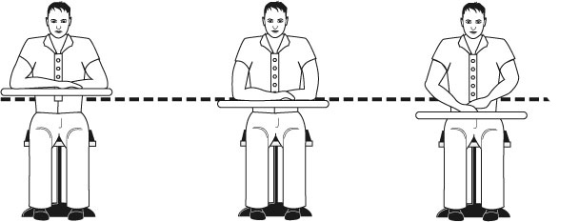

Seated Workstation Guidelines
Here are seated workstation guidelines.
All items required for the work should be located within the reach zones (not on the floor).
Handling of items should be limited to no more than 6 inches above the work surface.
Large forces (> 5 to 10#) should not be required.
A good chair with a high degree of adjustability should be provided.
Proper clearance beneath the work surface for legs and toes is necessary.
Sufficient thigh clearance between the seat pan and the underside of the work surface is required.
Reaches above shoulder level should be kept to a minimum.
Padded forearm rests should be provided along the edge of the table.
Footrests, preferably adjustable, should be provided.
Workplace layout should minimize twisting at the waist.
Seated work height should be based on resting elbow height with relation to the work surface.

Seated Workstation Specifications
Check out the illustration of seated workstation dimensions.

Illustration of seated workstation dimensions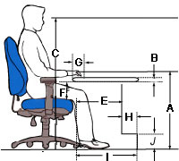

Seated workstation dimensions
Criteria | Dimension |  | Description
A. Worksurface height | Adjustable Worksurface | Fixed Height Worksurface (with chair/ footrest) | Distance from the floor to placement of hands on the work surface.  NOTE: This may not be the actual worksurface height - it reflects the hand work height based on size of the object.
- Precision work | 26” to 36” | 34”
- Light assembly | 22” to 32” | 29”
- Manual work | 20” to 28” | 26”
B. Work surface thickness | Maximum of 2”” |  | Allows for thigh clearance.
C. Screen height | Fixed: 46”  Adjustable: 44” to 50” |  | Distance from floor to top of screen.
D. Knee space - width | Minimum of 20” |  | Side-to-side clearance for legs.
E. Knee space - front to back | Minimum of 16" |  | Allows for knee clearance.
F. Thigh clearance | Minimum of 8” |  | Seatpan top to undersurface of the worksurface.
G. Distance to work | Up to 4” |  | Front of worksurface to hand work position.
H. Foot space depth | Minimum of 4” |  | Allows for foot clearance.
I. Distance for toe clearance | Minimum of 20" |  | Allows for foot clearance with legs extended.
J. Foot space | Minimum of 4” |  | Allows for foot clearance.

Standing Workstation Guidelines
Here are guidelines for standing workstations.
- Work height should be based on resting elbow height and the type of work being performed.
- Provide footrests, preferably adjustable, to reduce low back fatigue.
- Locate the foot rail 6 inches off the floor.
- Minimum foot rail length of 24 inches.
- Provide anti-fatigue mats if standing on hard surfaces for long periods of time is required.
- At least ½ inch thick.
- Interlocking edges for securely joining adjacent edges.
- Beveled edges to eliminate trip hazards, prevent curling, and easy cart access.
- Cleanable.
- Avoid the use of foot pedals. If necessary, then provide a support stool to avoid overuse of one leg for support.
- If large forces must be exerted, then design to allow pushing rather than pulling. The standing worker’s arms have more power when pushing.
- Even though the standing operator is free to move about, design the workplace to eliminate:
- Strained head positions because of visual requirements.
- Stooping and bending.
- Twisting of the body.
- Excessive reaches.
- Provide at least 5 inches for knee clearance, with an additional 6 inches for toe clearance.
If the same workbench will be used by a variety of workers, then apply one of these approaches:
- Provide a height adjustable workbench.
- Design the height of the work surface to accommodate the taller worker and provide platforms for the others to stand on.
- Adjust the height of the work on the workbench with a lift or platform.

Standing Workstation Specifications
Check out the illustration of standing workstation dimensions.
Illustration of standing workstation dimensions
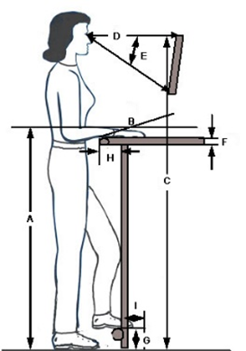
Criteria | Dimension |  | Description
A. Height | Adjustable Height Workbench | Fixed Height Workbench | Distance from floor to height on the workbench at which the hands will accomplish the task.  NOTE: This may NOT be the actual height of the worksurface. Dependent on size and placement of the object, etc. on the worksurface. Defined as the ‘hand work height”
- Precision | 38” to 48” | 46”
- Light assembly | 36” to 46” | 42”
- Heavy assembly | 26” to 40” | 36”
B. Inclination | Adjustable from -5° to 35°  (-) = away from operator  (+) = towards operator |  | Inclination of work surface. Inclined work surface will present the materials closer in the user's reach zone.
C. Screen height | Adjustable screen: 56”-72"  Fixed: 54” |  | Floor to top of the screen.
D. Viewing Distance | 18-30" |  | Distance from eyes to screen.
E. Viewing Angle | 0° - 35° |  | Adjusted by user as indicated
F. Worksurface edges | At least 1/8" radius on the worksurface edge |  | Eliminate any issue of contact stress.
G. Footrest height | Min 4"” off the floor |  | Floor to foot position.
H. Knee clearance | Minimum of 5” |  | Allows for knee clearance.
I. Foot clearance | Minimum of 4" |  | Allows for foot clearance.

Sit/Stand Workstation Adjustability
Sometimes it makes sense to have the ability to sit some of the time and stand some of the time. Here are some guidelines.
- Minimum worksurface height adjustment range: from floor to top of work surface or keyboard is 26 to 48 inches.
- Work surface should be height adjustable in 1-inch increments or less.
- Height should be easily adjusted by multiple users (pneumatic, etc.).
- Adjacent work surfaces should have the same range of height adjustability.
- Furniture legs, supports, or posts should not impair movement between these surfaces.
- Enough clearance should be allowed between adjoining surfaces to avoid pinching fingers during adjustment.
- Use a height adjustable chair at high workstations when adequate leg room is provided and when the task can be performed while either sitting or standing.
- The support stool is designed for use at high workstations with inadequate leg room to support standing or where regular changes in work position are required.

Chair/Stool Configuration
Depending on the type of work being accomplished, the use of a chair or stool can be a vital component in the manufacturing workplace. We will cover the basics of chairs and stools here; please refer to the Office Ergonomics Track for additional details.
We define a chair as a seating system where the seatpan can be adjusted so the user’s feet are supported on the floor.
A stool on the other hand, typically has a higher seatpan and the user’s feet will not be able to be placed on the floor – a footrest will be required for foot support.

Objectives of chair/stool
What does the chair or stool accomplish for the user?
- Support the body and limbs to provide relief from weight bearing.
- Provide a stable base or platform for the body and limbs.
- Position the user at the correct height and reach relationship to the worksurface and tasks at hand.
- Allow for easy change in position/movement of the user.
Check out the Workstation, Workbench and Chair/Stool Checklists.
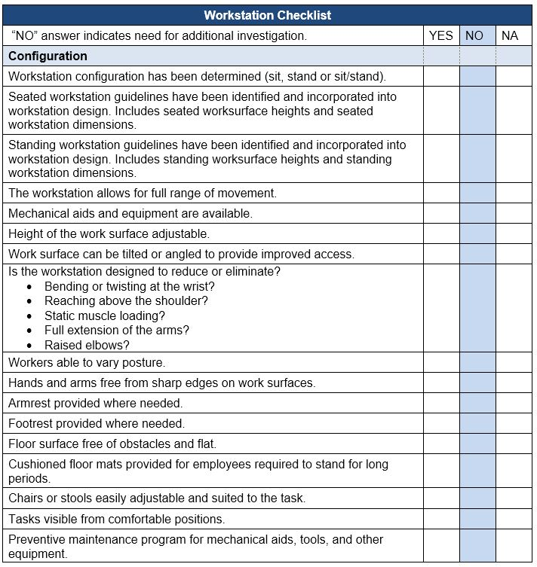
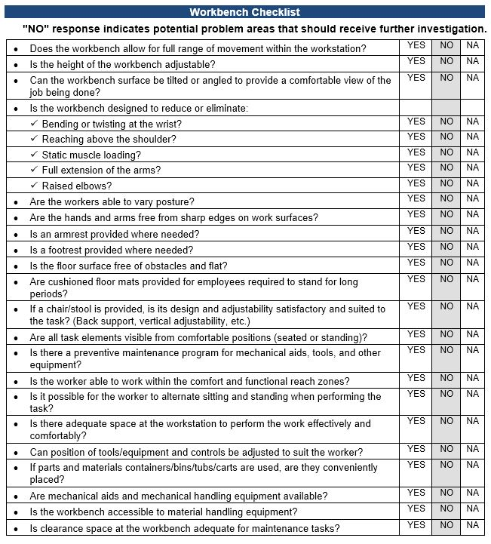
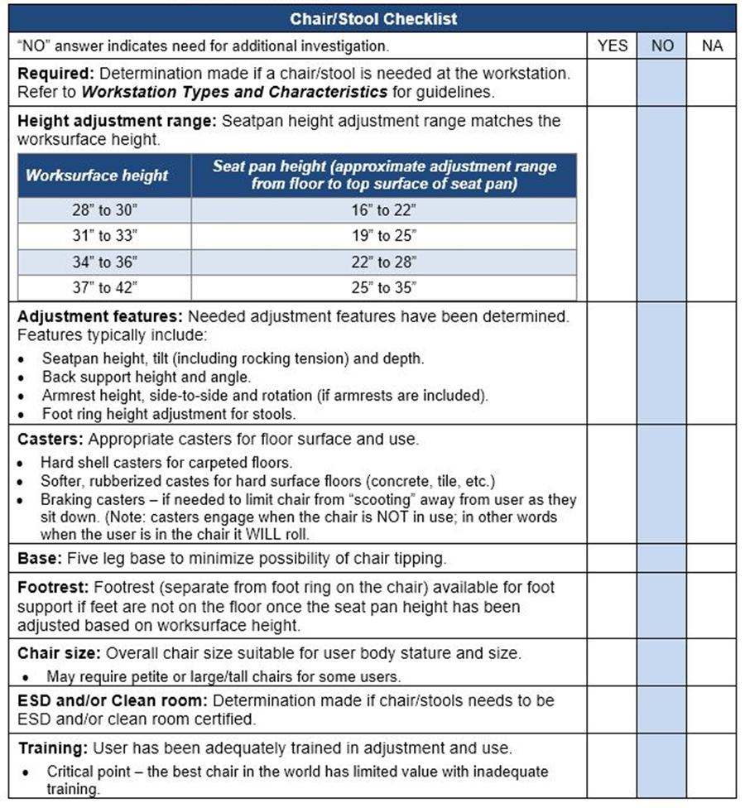
Here is the Ergonomics Design Worksheet to complete.
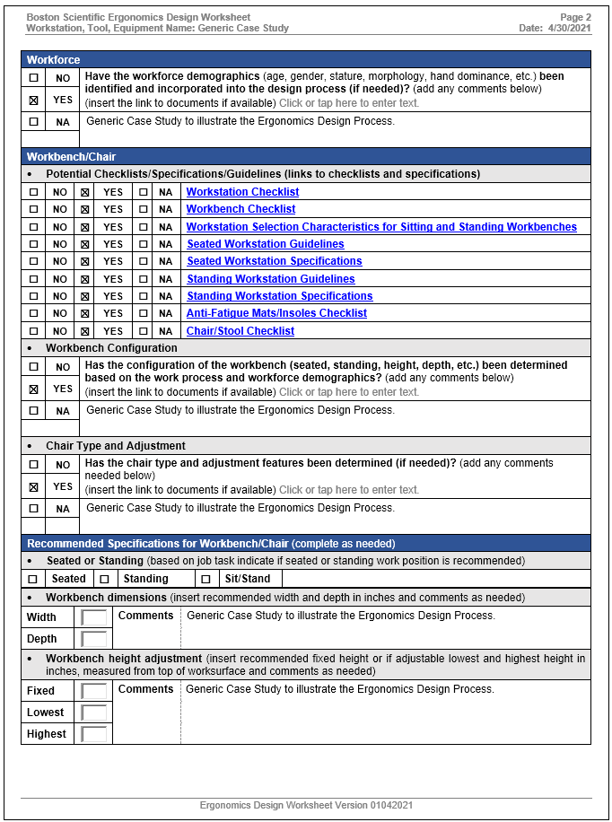

Workstation Configuration – Case Study

Casting Assembly Workstation – Before
Let’s work through a case study. At the Casting Assembly Workstation, the alignment procedure consisted of manual alignment of the parts on the casting. The workstation was at a fixed height that did not allow for any Operator adjustment to promote neutral body positions and work in the Power Zone. Other issues were that the casting parts were accessed via a fixed height container, awkward torque driver placement and a fixed height deburring station.

Casting Assembly Workstation – After
Changes were made including a height adjustable lift table for casting assembly container with a drop-down side for access and a lift table for the blade container.
The Casting Alignment Assembly Machine was completely revamped, making it an Operator controlled height adjustable workstation with anti-tie down switches and a touch screen.
The driver is now a counter-balanced torque driver with position controlled by the operator.
The deburring table is height adjustable with an overhead counterbalance for the deburring tool.
The finished product rack is on a lift table with a turntable for staging finished product on rack.
The modifications significantly enhanced health and safety factors as well as quality and productivity.

Anti-fatigue mats
What are anti-fatigue mats?
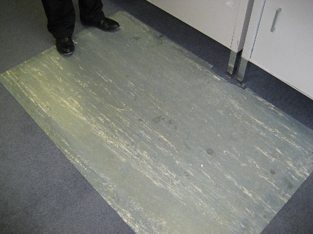
Anti-fatigue mats are compression absorbing mats placed on the floor surface designed to minimize the impact on the body of sustained standing.
What is the impact on the body of long-term standing?
Long-term standing (greater than 15 minutes of sustained standing with cumulative 2 hours or more over 8-hour period) may result in:
- Potential for increased joint wear and tear due to compression of the weight bearing joints– feet, ankles, knees, hips and spine.
- Decreased blood flow to the lower extremities, which in turn increases muscle fatigue.
- Blood/lymph fluid tendency to pool in the lower legs, potentially leading to varicose veins.
- Subjective reports of discomfort in the feet, legs, back and shoulders.
When should anti-fatigue mats be used?
Here are some general guidelines for when to use anti-fatigue mats for sustained standing and hard floor surfaces.
Sustained standing is defined as the user is confined to 1 step within the work area, for times of 15 minutes and longer and cumulative for 2 hours or more over an 8-hour period.
Hard floor surfaces include:
- Concrete floors
- Linoleum tile
- Ceramic tile
Can an anti-fatigue mat be too soft?
Standing and walking foot stability can be negatively influenced by mats that are too soft. Mats that are too soft don’t provide enough support and stability for the foot and subsequent joint stability for the ankles, knees, hips and back.
How long do anti-fatigue mats last?
How long mats last depends on usage. With heavy use, the mat may need to be replaced every 1 to 2 years. Eventually the mat will compress and lose its cushioning capability. A simple way to assess the need to replace mats is to compare the cushioning effect of the old mat to a new mat; if a significant difference is evident, it’s time to replace the mat.
Can carts be rolled on anti-fatigue mats?
Generally, carts do not roll well on anti-fatigue mats. Some mats are designed to be compatible with carts. These mats tend to be firmer and provide less cushioning benefit. Refer to mat vendors for additional information.
Anti-fatigue shoe in-soles
Anti-fatigue shoe insoles can also be part of the workstation. Criteria for insoles includes:
- Proper cushioning for the foot.
- Shoe size allows enough space for the insoles.
- Insoles are removable and replaced as they wear out.
Anti-fatigue Mats. Insoles Checklist
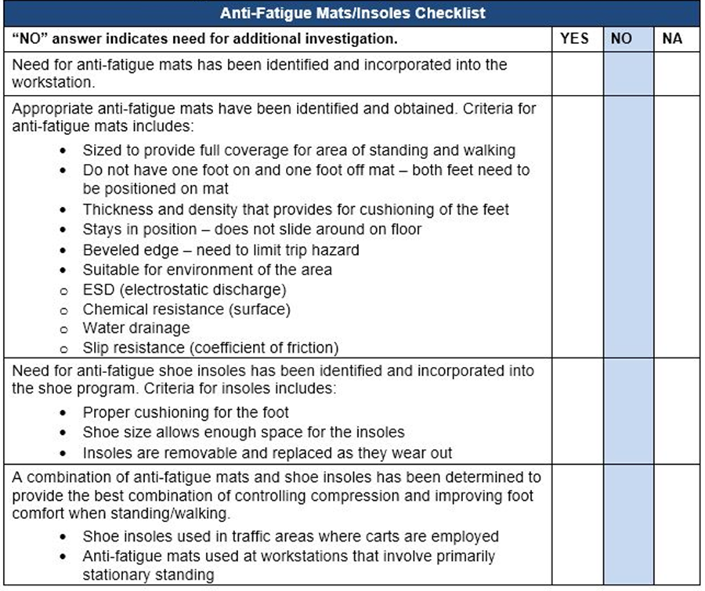

Parts/Materials/Trash

List of Parts/Materials
Has a list of all of the parts/materials required for the workstation been delineated?
More than likely as part of the Manufacturing Instructions a complete list of all the parts/materials required to assemble the product has been generated.

Storage/Staging Locations
Have storage/staging locations of parts/materials been determined?
This will ensure all needed parts/materials are in place and accessible.

Trash Receptacles
Has a location and handling of trash receptacles been determined?
Very likely trash will be generated at the workstation. Identify the type of trash and how it should be properly disposed of. Separate trash receptacles may be needed to sort trash at the workstation based on its recyclability. Determine the location of the trash receptacles to ensure adequate access to the receptacle but at the same time not limiting user access to the workbench. Determine the process of removing full receptacles to ensure they are within a reasonable weight range to be handled.
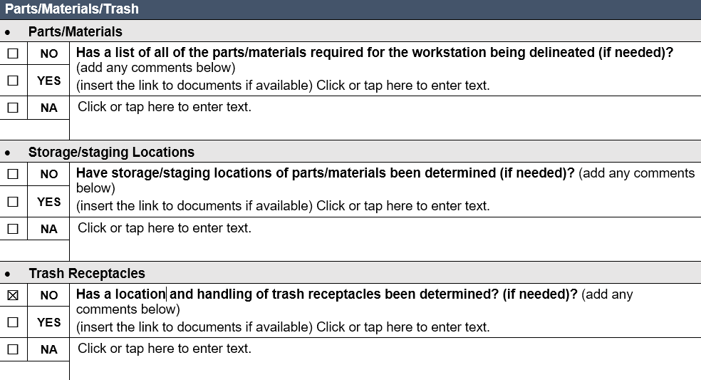

Micro-breaks
As we’ve discussed, frequent and regular body movement is a basic ergonomics principle to promote health and safety in the workplace.
You may already be familiar with the 30/30/30 Rule of Physical Movement that encourages physically active micro-breaks of about 30 seconds in length taken about every 30 minutes and do it for 30 days to make it a habit! I want to emphasize the concept because benefits include reducing tissue compression and joint stiffness and enhancing circulation.
Let’s practice what we preach by introducing a basic stretch, Large Arms Circles.
Before we try out the Large Arm Circles here are the essential guidelines for safe and effective performance.
- Absolutely have to follow any doctor's orders for restricted activities
- Perform the stretches in a technically correct manner
- Energy input is related to the benefit; be as vigorous as possible
- Start the stretch from the Neutral Position
- Joint noises, ‘snap, crackle and pop’ are normal
- Don’t hold your breath, breath in with the stretch and out with the relaxation
- Regular and consistent performance is the way to obtain the benefits
- Always control the intensity of the stretch based on your response to the stretch
Large Arm Circles
If you choose to do the Large Arm Circles, follow along with the video.

Tools
Have all the tools needed for the workstation been listed?
Providing the correct tools is a critical ergonomics principle. Safer, faster and more productive are the tangible results. The correct tools can make the difference between getting the job done or not at all. And even worse, the wrong tool can result in an injury to the user.

Brief History of Hand Tools

Stone, Wood and Bone
From an ergonomic perspective, the evolution of hand tools has been a remarkable journey, beginning with the simplest manual tools and progressing to advanced battery-powered devices. Early humans relied on rudimentary tools made from stone, wood, and bone, which were essential for basic survival tasks. These tools, while effective, required significant physical effort and often led to repetitive strain and injuries.

Bronze and Iron Ages
As human societies evolved, so did the materials and designs of hand tools. The advent of metalworking during the Bronze and Iron Ages introduced tools that were not only more durable but also more efficient. These early metal tools marked a significant improvement in productivity and reduced the physical strain on users, laying the groundwork for future ergonomics considerations in tool design.

Industrial Revolution
The Industrial Revolution was a pivotal period in the history of hand tools. This era saw the introduction of powered tools, initially driven by steam and later by electricity. These innovations drastically reduced the manual effort required, boosting productivity and allowing for more precise and complex tasks. Ergonomically, the focus began to shift towards designing tools that fit the human hand better and minimized the risk of repetitive strain injuries.

Battery-Powered Hand Tools
The late 20th century brought about another significant leap with the development of battery-powered hand tools. These cordless tools offered unprecedented mobility and convenience, further enhancing productivity and the quality of work. The ergonomic design of these tools focused on reducing weight, improving balance, and ensuring ease of use, which significantly reduced user fatigue and strain.
Despite these advancements, the increased power and capabilities of modern tools introduced new safety concerns. The risks associated with battery malfunctions, electrical hazards, and the increased force exerted by power tools necessitated the development of enhanced safety features and comprehensive training programs. Ergonomists played a crucial role in addressing these challenges, ensuring that the benefits of technological advancements did not come at the cost of worker safety.
The ergonomic design of hand tools has always aimed to optimize human performance while minimizing physical strain. This involves considering factors such as tool weight, handle shape, and the distribution of force during use. Modern ergonomic tools are designed to fit comfortably in the user's hand, reduce the need for excessive force, and minimize awkward postures, all of which contribute to reducing the risk of musculoskeletal disorders.

Integration of Smart Technology
In contemporary times, the integration of smart technology into hand tools represents the latest frontier. Tools equipped with sensors and connectivity features can monitor usage patterns, provide feedback on performance, and enhance safety through automatic shut-off mechanisms. These innovations not only improve productivity and quality but also emphasize ergonomics principles to ensure user comfort and safety.

Future of Hand Tools and Ergonomics
Looking ahead, the future of hand tools will likely see further advancements in materials and technology, pushing the boundaries of what is possible. The use of lightweight, durable materials, coupled with artificial intelligence and advanced ergonomics, will continue to enhance the functionality and safety of hand tools. Ergonomics will remain a critical consideration, ensuring that as tools become more advanced, they continue to support human health and safety.
The evolution of hand tools, from simple manual implements to sophisticated, battery-powered devices, underscores the importance of ergonomic design in enhancing productivity, quality, and safety. Each stage of this evolution reflects a continuous effort to improve the usability and effectiveness of tools while minimizing the physical toll on users.
The journey of hand tools illustrates the dynamic interplay between technological innovation and ergonomic principles. As tools continue to evolve, the focus on ergonomic design will ensure that they not only meet the demands of modern tasks but also safeguard the well-being of those who use them.

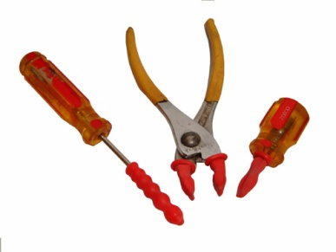
Manual to Power
As noted, the switch from manual hand tools to power tools can reduce manual force requirements. However, power tools create their own set of issues.

Torque reaction forces
Torque reaction occurs when a fastener reaches the end of its travel, transferring the torque to the tool and operator. Employ clutches and torque reaction bars to reduce torque reaction forces.
Newer tools make use of pulse rather than impact technology. These tools significantly reduce power grip force requirements.

Segmental (Hand/Arm) vibration
Segmental (hand and arm) vibration is typically found in tasks that require the use of abrasive wheels, grinders, lathes, and power hand tools. Vibration from these sources has been shown to decrease sensitivity in the hand, resulting in an unnecessary increase in local muscle contractions.

Associated with other factors
As with force, posture, repetition, and contact stress, vibration is frequently associated with other risk factors. Assess the duration of the exposure, the exposure patterns during the shift, and the force levels and postures assumed during the vibration exposure.

Questions to consider include:
- Is there tool vibration?
- Is the level of vibration high enough to have adverse effects on the worker?

Whole body vibration
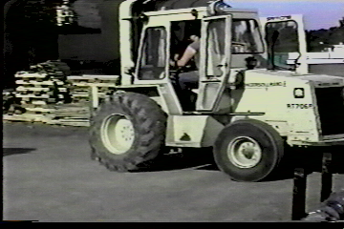
Heavy equipment and forklift drivers frequently encounter whole body vibration. This is suspected of weakening and disrupting soft tissue structures such as tendons and ligaments.
Questions to consider include:
- Is the body as a whole subjected to vibration?
- Is the level of vibration high enough to have adverse effects on worker?

Control vibration

Fastener types
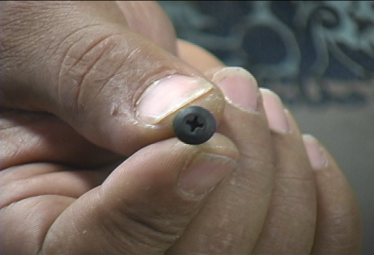
Fastener types used with various power drivers and nut runners may also play a role in vibration exposure.
Certain fasteners, because of the manner by which they engage the power tool, may drive more easily resulting in reduced exposure to vibration, sustained or high force levels, poor postures and contact stresses.
Hex head screws drive faster and with less effort than Phillips screws and Phillips screws less so than slotted screws.
In some cases, rivets, welding, or adhesives may replace the need for screw fasteners.

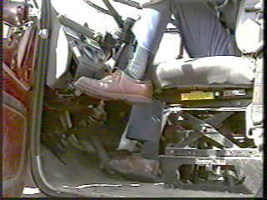
Source control
When possible, try to control vibration at the source. This is important whether the vibration is segmental or whole body in nature.
- Maintain and balance power tools on a regular basis.
- Evaluate the floor quality.
- Repair work, or even replacing vehicle seats, may be necessary to reduce exposure to whole body vibration.

Path control
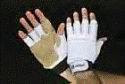
In many situations, it may not be possible to control vibrations at the source. In this situation, obstruct and dampen the path of the vibration.
Vibration attenuation covers are available that attach directly to the tools. Anti-vibration gloves with padded palms are another option. When you add these coverings, be aware the effective handle diameter increases and tool control and grip strength may be adversely affected.
Increasing the speed (RPM) at which the tool turns, frequently helps to reduce the amplitude of the vibration.

Quick-cutting abrasives in grinding and sanding
Dull bits, blades, and un-clogged abrasives significantly increase the force required to use manual or power tools and it takes longer to accomplish the task. If the bit, blade or abrasive is worn out it, it needs to be replaced with one that is effective.

Handle size
Handle size should be monitored to provide optimum power grasps. Trigger configuration should spread the required triggering force over a large area, rather than concentrated in a smaller area.

Preventive Maintenance
Preventive maintenance, based on manufacturer specifications, is critical to ensure proper operation of the tool.

Physical Demands Associated with Tool Use
Let’s examine typical physical demands associated with tool use from the ergonomics perspective.

Component Fit
A poor fit of components during an assembly process may force an assembler to "bang in" the component using the hand or other body part as a hammer. Nerve and soft tissue trauma may occur when the hands are used as hammers. Using the hands in this manner increases the likelihood of local inflammation that may cause unnecessary scarring. Eventually reduction in blood flow to the nerves and other soft tissues may occur. Coordinated effort with the vendor, in house or off site, can ensure the needed fit quality.
The type of fastener used may be an issue. Options include use of riveting, spot welding, and specialized fastening systems rather than slotted fasteners.

Tool Handle Size
Tool handle size has a major influence on controlling force levels for tool use. A power grip makes use of larger, more powerful muscles than a pinch grasp. Typically, a maximal pinch is only 20% of maximal power grasp.
Tool handle size needs to match the user’s hand size as much as possible. Grip spans of 1 ½ 2 to 2 ½ inches (3.8 to 6.3 cm) inches are ideal. Spans greater or less result in less than desirable mechanical advantage.
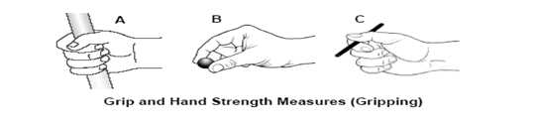
Grip and Hand Strength Criteria
The following guidelines (Grip and Hand Strength) provide criteria for various grasps and hand motions. The values assume neutral postures and easy to grip surfaces.
Note: Repetitive (REP) – 2 or more times per minute, Infrequent (INF) – less than 2 times per minute.

Grip and Hand Strength Illustrations

Criteria | Freq | Force lbs. (Max) | Description
A. Power Grip | REP | 4 | Grasp with full hand, typically with thumb overlapping the first finger. | 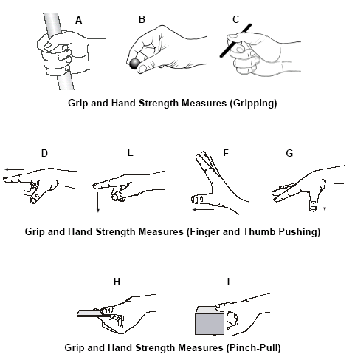
 | INF | 20
B. Pinch Grip | REP | 2 | Grasp with fingertips only, typically with fingers and thumb not touching.
 | INF | 9
C. Key Grip | REP | 2 | Grasp with thumb and side of the first finger.
 | INF | 10
D. Push forward with Index Finger | REP | 3 | Push forward with pad of index finger.
 | INF | 15
E. Push down with Index Finger | REP | 3 | Push down with pad of index finger.
 | INF | 15
F. Push Forward with Thumb | REP | 4 | Push forward with pad of thumb
 | INF | 21
G. Push Down with Thumb | REP | 2 | Push down with pad of thumb.
 | INF | 10
H. Pull with Pinch Grip 0.1” | REP | 2 | Pull toward body with pinch grip using thumb and index finger.
 | INF | 10
I. Pull with Pinch Grip 1.6” | REP | 2.5 | Pull toward body with pinch grip using thumb and index finger.

Questions:
Is a power grip used?
- For what purpose is the grip used?
- Do workers have to exert high levels of power grip force to perform tasks?
Is a pinch grip used?
- For what purpose is the grip used?
- Do workers have to exert high levels of pinch grip force to perform tasks?
- Can a change to a power grip be made?
- Can the grip be eliminated or reduced?

Coefficient of Friction
The coefficient of friction can have a major impact on controlling grip force levels. Friction between the hand and object can be increased by:
- Using rubberized coating on the object; e.g., tool handle.
- Cleaning the object of lubricants.
- Providing appropriate non-slip gloves.
- Maintaining normal skin moisture; dry skin has about 2/3s the coefficient of friction compared to moist skin.

Glove use
Determine if the glove is truly necessary. This will be a function of the reason for the glove. If the glove is used for hand protection to mitigate handling sharp or rough texture materials, the gloved hand will be able to generate larger force values than the unprotected ungloved hand.
However, if all factors are equal, generally, a gloved hand produces 25% to 30% less grip force than an ungloved hand. The hand has to overcome the resistance from the glove.
"One size fits all" policy does not work. Gloves that are too small increase the force required to overcome the resistance of the glove. Gloves that are too large hinder dexterity due to sloppiness of fit.
Tool use and postures
Moving on, let’s get into hand tool use and postures. Frequently, workers will use tools specifically designed for one purpose for some other purpose. This is often the case when using pistol grip and in-line hand tools like drivers. Consider these guidelines.
In-line grip  An in-line power tool is used when there is need for a vertical drive that occurs between the waist and elbow height | 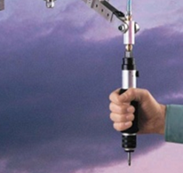 | Pistol grip  Use pistol grip tools on horizontal surfaces at waist height or for vertical surfaces between elbow and shoulder height. | 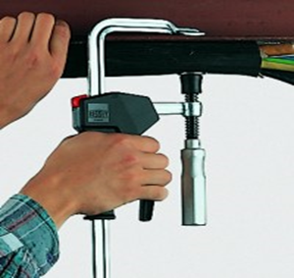
Ergonomically designed tools
In the past decade, tool manufacturers have made major strides in the design of ergonomically approved tools. Such tools include bent handle tools, reduced vibration power tools, etc. Search online for ‘ergonomics tools’ to get an idea of what is available these days. Then apply the ergonomics principles to assess if the tool truly is ‘ergonomic’ in design and use!

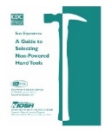
General tool guidelines
Refer to the NIOSH Guide to Selecting Non-Powered Hand Tools for additional information.
Check out the Tool Checklist.
Label Maker Case Study
Ergonomics doesn’t need to be complicated or cost a lot of money to make significant improvements. The Label Maker Case Study is a good example! Play the ‘before’ video and then go to the next slide to see what they did. Roll your curser over the video to play the video. See what the Ergonomics Team came up with. Roll your curser over the video to play the video.

Tool Checklist
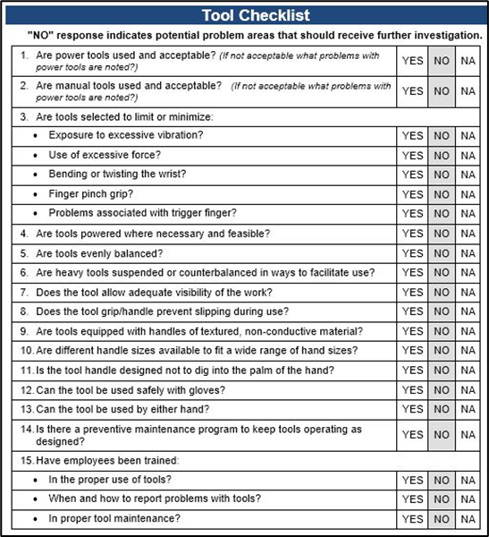

Case Study – Slag Removal
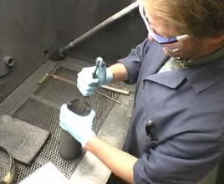
Let’s take a look at another case study.
Slag removal is a hand intensive process where carbon slag that builds up inside a canister as result of a manufacturing process needs to be removed so the canister can be put back into service.
Let’s take a look at how the process had been accomplished, brainstorm on some potential modifications and then take a look at what changes were made.

View before video
Play the ‘before video’ to observe how the task had been accomplished.

Brainstorm session
List options for ergonomics improvements.
- _____________________________________________________________________________
- _____________________________________________________________________________
- _____________________________________________________________________________
- _____________________________________________________________________________
- _____________________________________________________________________________

View after video
Play the ‘after video’ to observe how the task was modified.
What do you think? Some significant changes were made; the fixture to hold and position the canister and adding the vibrator to the file. The operator’s comments are quite revealing.
Check out the Ergonomics Risk Screen Track to learn how to perform a detailed ergonomics risk screen that scores the relative ergonomics risk level.
Complete the Worksheet.
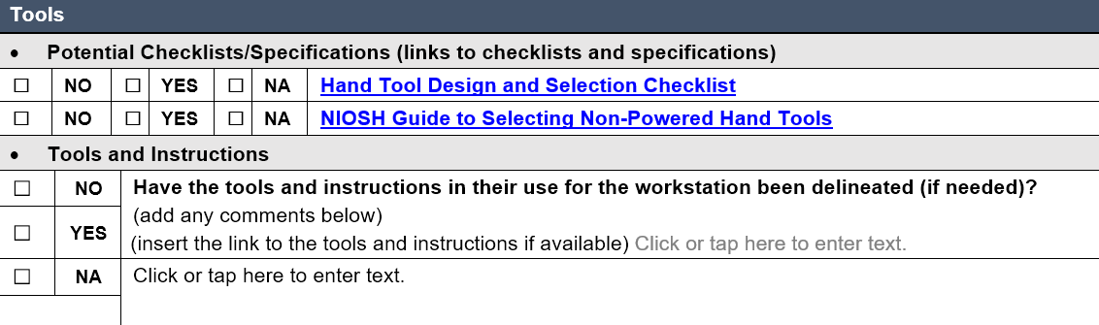

CNC Machine Deburring Table Air Hoses
Ergonomics modifications don’t have to be expensive. Older, heavier, and cumbersome air hoses were swapped out for light weight, coiled air hoses. The Operator noted a big difference because they are easier to handle and take a lot of the strain away. He said he also added the same type of hose for the compressor in his home shop.

Equipment
Has the equipment used in the workstation been listed?
Part of the workstation is the equipment used in the operation. The terms "tool" and "equipment" are often used interchangeably, but they have distinct meanings.
A tool is typically an object that is used to perform a specific task. Tools are often handheld and used manually, such as hammers, screwdrivers, or wrenches. They are designed to aid in accomplishing a specific function or task. Tools can be simple or complex but are generally considered individual items.
Equipment usually refers to a set of tools or machinery necessary for a particular purpose. It can include multiple tools, devices, or machines that work together to perform a task. Equipment is often more complex than a single tool and can include items like computers, vehicles, or industrial machinery. Equipment might require power sources like electricity or fuel.
Let’s look at several types of equipment and associated factors.

Fixtures/Jigs
A fixture is a work-holding or support device used in the manufacturing industry. What makes a fixture unique is that each one is built to fit a particular part or shape.
The main purpose of a fixture is to locate and hold a work piece during either a machining operation or some other industrial process.
A jig differs from a fixture in that it guides the tool to its correct position in addition to locating and supporting the work piece.
The primary purposes of jigs and fixtures are to:
- Reduce the cost of production
- Maintain consistent quality
- Maximize efficiency
- Enable a variety of parts to be made to correct specifications
- Reduce operator errors

Types of Fixtures

General Purpose
General purpose fixtures are usually relatively inexpensive and can be used to hold a variety and range of sizes of work pieces (examples: vices, chucks, and split collets).

Special Purpose
Special purpose fixtures are designed and built to hold a particular work piece for a specific operation on a specific machine or process.
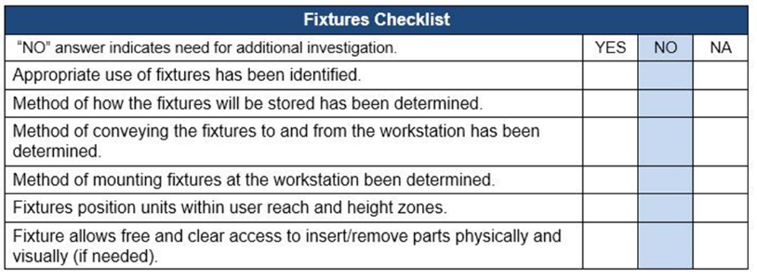

Hand and Foot Controls
Equipment needs to be controlled in terms of on and off. Hand and foot controls are used.

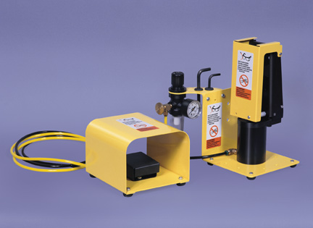
Foot pedals
Look for these factors specific to foot pedals:
- Are foot/knee control pedals used?
- Does the operator have to operate foot/knee pedals while standing?
- To operate foot pedals or knee switches, must the worker assume an unnatural or uncomfortable posture?
- Are pedals limited to two?
- Are pedals too small to allow the operator to alter the position of the foot/knee?
- Are pedals triggered at a high repetition rate?

Hand controls
Look for these factors specific to hand controls:
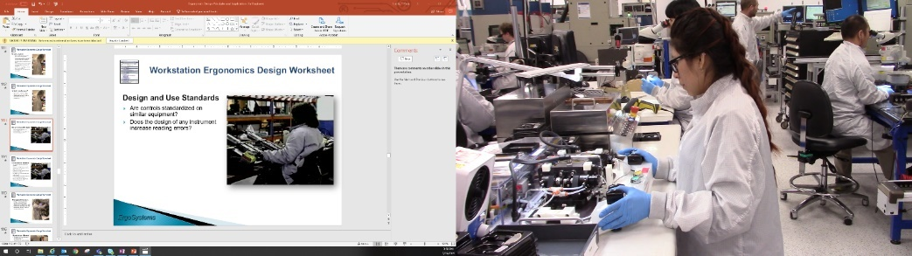
- Are hand controls used?
- Placed to allow neutral hand/arm/body position?
- Difficult (require excessive force) to operate?
- Designed (shape and configuration) that takes into account the amount and types of force required for operation?

Hand and Foot Control Checklist
Refer to the Hand and Foot Controls Checklist.
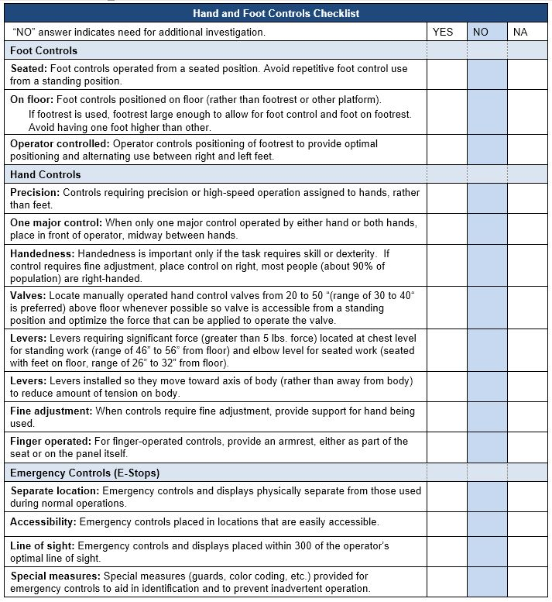

Contact Stress
Contact stress is when a part of the body or limbs is subjected to either a sharp edge or hard surface with potential for tissue compression and injury.

Contact Stress - Sharp edge
When you evaluate the type and severity of contact stress, look for any part of the body that is in contact with a sharp edge.
Examine tool handle size and shape for prominences that promote increased pressure over any point of the grasping surface of the hand. Evaluate tools regarding the amount of localized pressure tools produce in the palm of the hand. Finger contours on handles or triggering devices of tools may also produce unnecessary stress on the digits.
Examine the size and shape of any machine guards for potential contact stress. Identify and correct sharp edges or sustained pressure on the guard.

Control strategies – Round Edges
Round work surface edges that come in contact with the worker. Tool handles and trigger switches should have rounded contours.
Avoid the use of tools that require continuous or intermittent pressure on the fingers, palm, base of the wrist, forearm, and elbow. When possible, use self-opening tools such as pliers and scissors that are spring loaded. This reduces contact stresses required to open the tool. When contact stress itself cannot be avoided, the goal is to distribute the pressure over as large an area as possible by increasing the contact surface area.

Contact Stress – Sitting and Standing
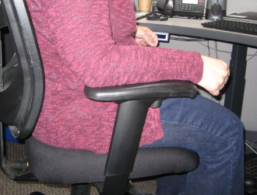
Two areas of the body that are frequently not evaluated for contact stress are the feet of people who stand all day, and the buttocks and thighs of those who sit all day.
Evaluate chairs by observing pressure at the front of the seat pan and the position of the backrest. Evaluate the potential for pressure behind the knee or at the back of the thigh caused by the edge of the seat pan.
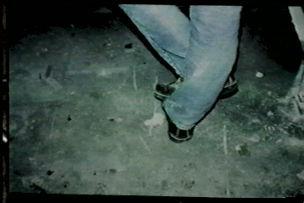
Floor surfaces can affect the comfort of workers who are required to stand for a large percentage of the day. This is a problem particularly when there is limited potential for movement.
Concrete, steel grates, uneven or vibrating floor surfaces may increase foot, leg or spinal fatigue and discomfort and can affect concentration and product quality. Check out the Contact Stress Checklist.
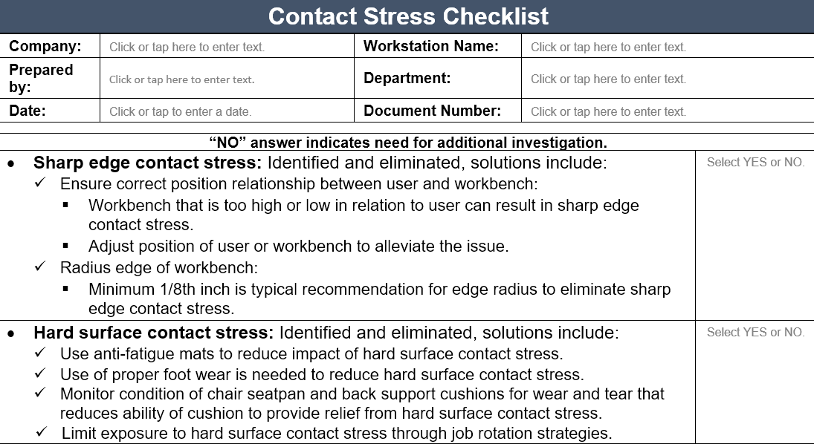

Position
The goal is to have the body in a neutral posture as much as possible. Evaluate jobs or activities that tend to force the worker out of ergonomic neutral positions and/or result in awkward or sustained positions.
Prolonged or repeated non-neutral spinal positions  Non-neutral spinal positions include bending the head, neck, and trunk forward, backward or to the side, with or without twisting. Focus on why we see the out-of-neutral spine positions. What is driving them and what can be done to mediate them. | 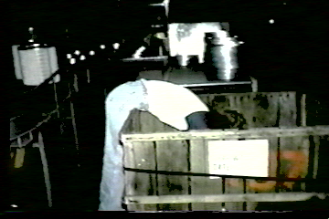
Wrist deviations greater than 15 degrees  You can demonstrate the neutral position at the wrist by making a tight fist. This results in approximately 5 degrees of extension in most people and is the position of power for the wrist. As the wrist moves away from this power position, the finger flexor tendons increase their contact against the carpal ligament or bones of the wrist. This increased contact may result in inflammation, and the pressure within the carpal tunnel may increase. | 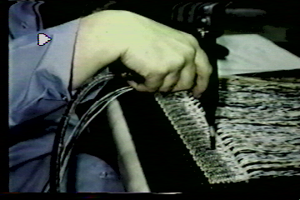
Forearm rotation  When the forearm is rotated toward the extremes of supination (palm up) and pronation (palm down), in combination with deviations of the wrist from the power position, there is a great degree of stress at the origin of the forearm muscles.  By the way, those cookies tasted quite good! | 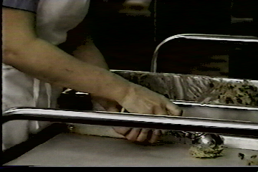
Elbows sustained above mid-chest height  Elbows positioned above mid-chest height place additional stress on the shoulder when prolonged muscle contractions are required.  In addition to inefficient use of energy, these positions also tend to cause a reduction in blood flow to the tendons in the shoulder. Called, “elbows up”, this position is a good indicator of a mismatch between worker and work height. | 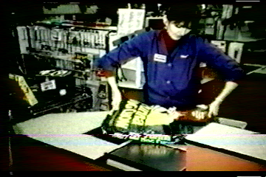
Reaching frequently behind the body or above the shoulders  Arm positions behind the body or above the shoulders tend to increase pressure within the shoulder joint while stretching many of the shoulder tendons and muscles.  Acceptable ergonomics workstation should work to eliminate reaching behind the body. | 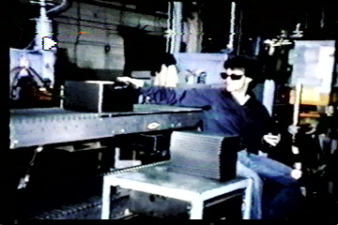

Optimizing Work Positions
Standing work position  When does it make sense to stand at a workbench?  Standing positions are more appropriate than sitting positions if:  - Frequent or relatively heavy lifting is required.  - Significant downward forces are required.  Workbenches may be modified in any number of ways. In this example, look for the 2x4 approach (wooden blocks placed under the bench legs). Of course, ensure the workbench remains stable. | 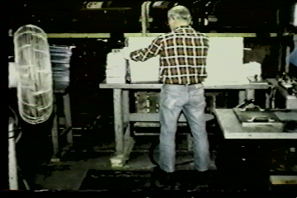
Seated work position  Use seated workstations when light assembly or precision work is performed.  The concept from a functional perspective is termed, “Proximal stability for distal precision.”  In other words, a stable core of the body supported by the seating systems provides for greater control and dexterity of the head and hands when precision assembly work is accomplished. | 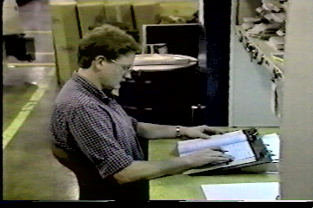
Sit/Stand work positions  In some cases, sit/stand workstations may provide a viable option. These provide for postural variability with an option to switch between seated and standing positions.  Lean platforms can be incorporated to provide for weight bearing relief of the major weight bearing joints and still allow for a standing height work position.  The worker needs to establish the correct relationship between themselves and the workbench. | 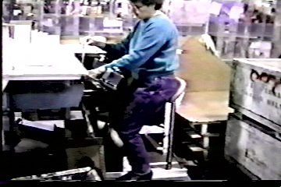
Adjustable height workstations  Adding adjustable height workstations and lift tables to a work area allows for increased postural variety for workers but also allows accommodation for variation in body stature between workers.  More workstations are making use of height adjustability between seated positions with the feet on the floor and standing positions.  Powered options (electric-hydraulic) are the way to go to make it easy to make the switch; with hand crank models, limited use has been observed. | 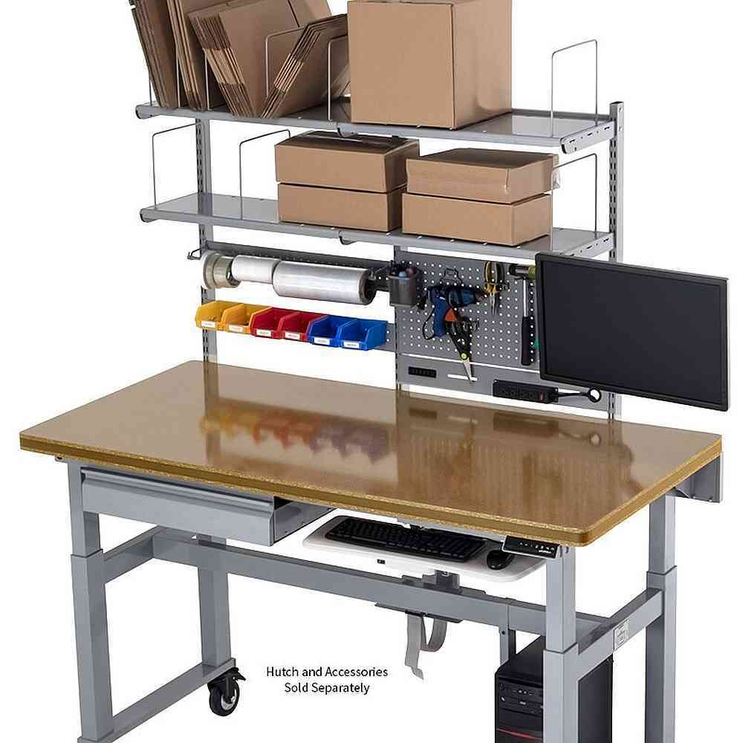
Turntables  Use turntables to bring parts closer to the worker, reducing the need for sustained or extreme forward reaching.  They work well in manufacturing workplaces to allow work within the recommended Comfort Reach Zone.  These are particularly helpful when the worker needs to access the other side of the pallet. | 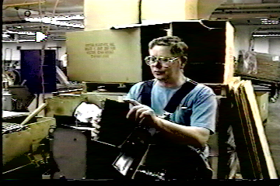
Rapid machine pacing in assembly task  Workers may work ahead on a conveyor line to create a buffer. They may work behind on a conveyor line because they cannot keep pace.  Both situations result in positions other than directly in front of the worker that are sustained and awkward postures. | 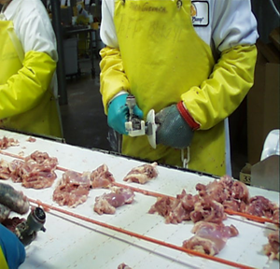
Movement  Even relatively well-designed ergonomic workstations require individuals to work in one posture.  Evaluation of the workplace should include an assessment of how often individuals have the opportunity to move out of sustained postures to perform other movements or tasks.  As human beings we have an instinctive need to physically move on a regular and consistent basis. | 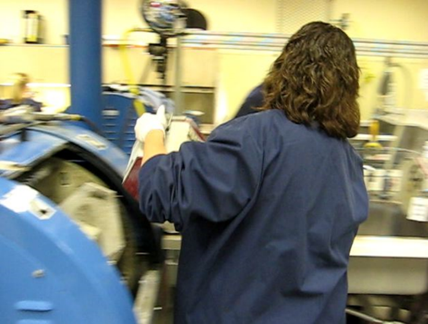

Mental Demands Associated with Equipment Use
The mental demands of work can be just as demanding and stressful as the physical demands. They require a thoughtful examination.

Is the task complex?
- Does the worker have to evaluate data before taking action?
- Must the operator sense and respond to information signals occurring simultaneously from different machines without sufficient time to do so?
- Must the operator process information at a rate which might exceed his or her capability?
- Is the job so complex it takes a long time to train workers?
- Does the task require a great deal of accuracy?
- Does this work situation require monitoring of several machines?

Is the task monotonous?
- Does the worker repeat the same task without change for the entire shift?
- Does the worker lose track of the task at hand because it’s overly monotonous?

Design and Use Standards
- Are controls standardized on similar equipment?
- Does the design of any instrument increase reading errors?

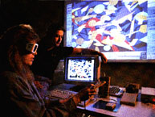
Perceptual Demands
Our ability to properly perceive our environment exerts a major influence on our interaction with it.
Issues like illumination, auditory, touch and visual acuity fall into the realm of perceptual demand.

Illumination
Evaluate the quantity and quality of light. Many of today’s office buildings have illumination levels approximately 25 to 30 per cent greater than desirable. Decreasing the amount of general overhead light and bringing in specific task lighting is effective in selected areas.
Also, consider the overall quality and level of the light in relation to the color and reflectivity of the walls, floors, and ceilings. Glare is a commonly observed problem in office environments where it’s apparent on video display terminals (VDT) screens.
Under-illumination causes forward bending of the trunk and head as individuals attempt to get closer to the material they are viewing. Task lighting can be effective to focus illumination where desired and, at the same time, control glare.

Illumination - General
- Is special lighting necessary to perform the job?
- Is the general work area including egress/ingress poorly lit?

Illumination - Task
- Is lighting inadequate for the job?
- Are controls, instruments and equipment poorly lit?
- Is the illumination not satisfactory for the task?

Illumination - Contrast
- Is contrast poor between the workspace and its surroundings?
- Is the workplace so poorly lit that there are great differences between brightness levels in panels, dials and surroundings?

Illumination - Glare
- Is glare present in the workplace?
- What is the source of the glare?
- Is glare from displays a problem?

Auditory
- Does the noise level prevent or impair verbal communication?
- Are there auditory signals?
- Are some auditory signals hard to hear in general?
- Are auditory signals difficult to distinguish from one another?

Touch
- Is there a need to tell the difference between parts by touch?
- Is it difficult to recognize controls and tools by touch and/or position?

Visual Acuity
- Does the task require fine visual judgments? (This includes the need to detect small defects, judging distances accurately, etc.)
- Are dials and instruments difficult to read quickly and accurately?
- Are controls, instruments and equipment placed where they are difficult to see? (At a bad angle, too high, too low.)
- If warning lights are present, are they located out of the center of the field of vision?
- Are dials grouped inconveniently?

Microscopes/Magnifiers
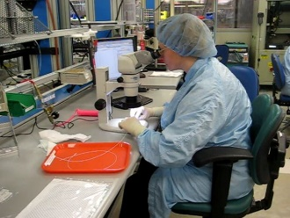
Microscopes and magnifiers are often used in manufacturing workplaces. Let’s discuss some typical factors to examine.

Multi-user
Most microscopes will be used by a variety of individuals in the workstation. As a result, it’s critically important that each user takes the time to set-up the microscope workstation for their unique needs.

Step-by-Step Set-up Protocol
Follow this step-by-step set-up protocol for microscope use.

Understand Adjustment Options
First analyze the current set-up to understand what adjustment options exist. For example, height and angle of the microscope itself, the microscope eyepiece height and angle, the stool or chair seat height, back support and armrests and/or the worksurface.

Neutral Position/Support and Reach Zone

- Position the scope for adequate room for legs to sit directly under the microscope.
- Adjust the stool or chair or worksurface to enhance neutral body position and support.
- Provide a footrest if needed to ensure adequate foot and leg support.
- Position the microscope towards the edge of the work surface to allow for neutral head and neck position.
- Position head upright and line of sight approximately 20 to 30º below straight-ahead vision.
- Adjust the height of microscope to match neutral head and neck position; the microscope maybe on a vertical support bar or an adjustable height platform.
- Adjust the eyepieces and angle of view to allow for a balanced position of the head on the shoulders.
- If they can be adjusted, use chair armrests to support forearms with elbows at sides.
- If forearms are in contact with edge of the worksurface, apply padding (foam rolls or padded edge protectors) to the edge of the work surface.
- If chair armrests interfere with arms, remove them from chairs and consider use of padded, angled microscope forearm supports to relieve fatigue and strain.

Fatigue Control
Employ fatigue control measures when at the microscope. Take micro-breaks every 20 to 30 minutes of microscope use. Stretches are beneficial to promote circulation and reduce joint stiffness.
Rotate among a variety of tasks. Mix it up throughout the day.

Microscopy - Control Eye Strain
Microscope work is obviously very visually intensive. Work to control eye strain. Make sure the scope is clean, lighting is adequate, and the microscope lamp and optical pathway are correctly aligned.
Simply looking at a distance point (more than 10 to 15 feet away) allows the eyes to relax.
Check the work environment for excessive glare and reflections from overhead lighting and adjust the internal microscope light to compensate.
Temperature, humidity, air currents, ventilation, excessive noise, and ambient lighting levels affect operator comfort and fatigue. Temperature range of 66 to 73º Fahrenheit’s suggested. Low humidity conditions lead to drying of the eyes; lubricating eye drops can be beneficial.

Microscopy – Other Tips
Tilt storage bins toward the user to reduce awkward postures while reaching for supplies. Enlarge the handle diameter of small hand tools by placing cylindrical foam around them. Make simple tool modifications if you are not able to keep wrists straight.

Video Display Microscopy
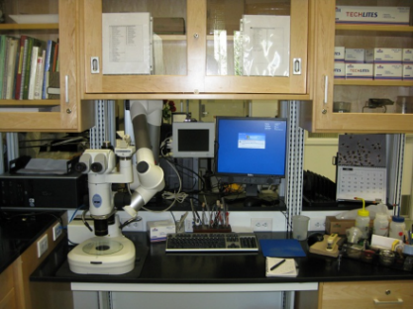
Video display microscopy is becoming more viable with technological improvements. When possible, use a video display terminal to view the sample. Place the display monitor so the top of the screen is about at eye level, viewing distance is about 24 to 28 inches (11 to 13 cm) and the display positioned directly in front of the user to look straight ahead, not turning the head to the side. Take a look at the checklist.

Microscopes/Magnifiers Checklist
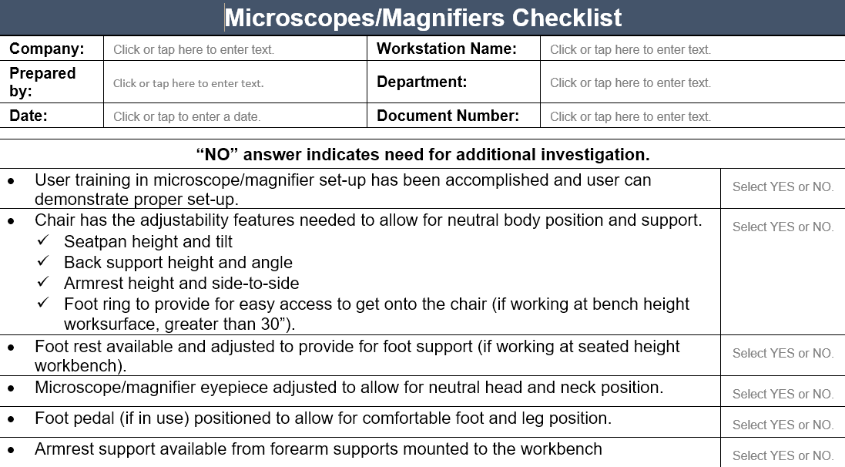

Computer (CPU, keyboard, mouse, displays)
Computer equipment is an integral part of the manufacturing process. Appropriate position of the keyboard, mouse and monitor is important. Following the ergonomics principles in terms of set-up of the computer equipment will provide a workstation that is more comfortable and productive.
Detailed computer-based ergonomics information is found in the Office Ergonomics Track. Here is a checklist.

Computer (CPU, keyboard, mouse, displays) Checklist
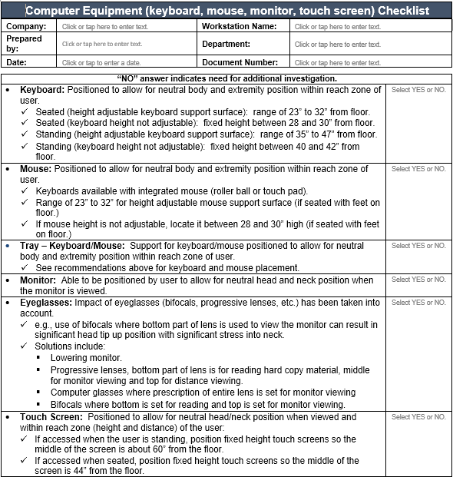

Machine Clearance and Maintenance Accessibility Guidelines

Preventive Maintenance
Preventive maintenance of tools, equipment, workstations and the facility itself have a major impact on the health, safety and productivity of the workforce.

The tale of the forklift!
Here is an “oldie but goodie!” Some years ago when conducting an ergonomics audit of a facility we identified a number of CNC machine dies stored on pallets on the floor. The dies weighed 60 to 70 lbs each and were handled manually to and from the floor level. We obviously recognized this as an issue!
As we continued the audit, we observed a number of portable lifts that could have been used to mechanically handle the dies. When we asked why they weren’t being used the response was, “Oh, they don’t work, they haven’t been maintained.” We obviously recognized this as an issue!
As the audit continued we found one working lift located in the parking lot. A basketball hoop was attached to the forklift. Now, we are not opposed to a little recreational physical activity during breaks! But it does point out the issue of how truly important preventative maintenance really is!

Regular schedule
Is there a regular maintenance schedule?

Ease of maintenance
Is the equipment designed or placed in such a way that cleaning and maintenance activities are difficult? Are containers designed for easy maintenance and repair? Does the design of the equipment allow for easy access for maintenance and repair? Are floors uneven?

Housekeeping

General
Is the workplace floor clear of clutter and obstructions, which could create the risk of slips, trips or falls? Are floors slippery?

Workstation
Does there seem to be too much clutter in the workstation? Is housekeeping at the workstation poor?

Accessibility for Maintenance
How accessible is the equipment for maintenance? Are openings large enough to permit access of both hands and offer visibility of components? Are access ports located so that operators are not exposed to hot surfaces, sharp edges, or electrical currents?
Are access ports easy to remove, with visible and accessible cover fasteners while still providing adequate machine safe-guarding? Here are some recommendations for access.
Circular Hatch, Horizontal Clearance: Min. 30" (76 cm) diameter.
Horizontal Hatch Clearance: Min. 20" (51 cm) high x 24" (61 cm) wide.

Machine Clearance and Maintenance Accessibility Checklist
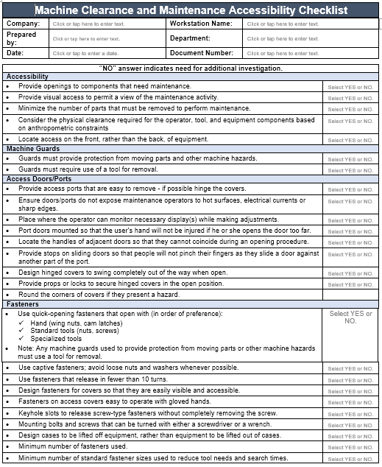

Refer to the Equipment Checklist for additional information.

Equipment Checklist
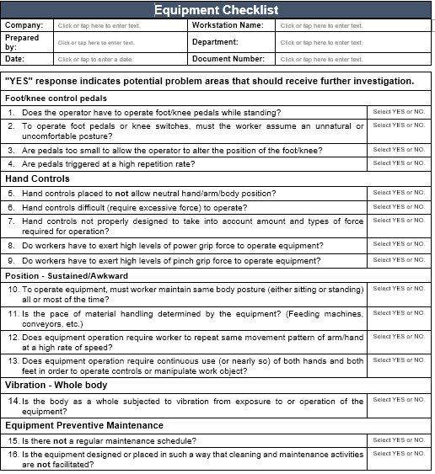

Fill out the Worksheet.
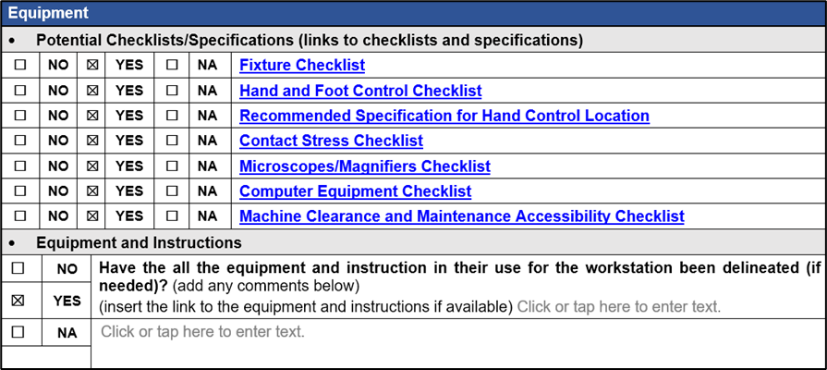

Personal Protective Equipment (PPE)
Personal protective equipment is an essential complement to an effective ergonomics process.

Mandatory
Are there conditions that require personal protective clothing or equipment? What conditions exist? What PPE is used?

Monitoring and Enforcement
How is PPE use monitored? Are PPE policies enforced?

Your own PPE!
A very important point for you is to always understand and follow the PPE requirements whenever you are onsite at a manufacturing company. Ask upfront what the PPE requirements are so you know before you get onsite. While some companies will provide you with PPE,
I encourage you to have your own PPE available. For example, the company you are consulting with has a steel-toe work shoe or boot requirement. They probably have available for visitors what are called ‘clappers’; steel toes you strap onto your existing footwear.
Immediately this sets you apart from the rest of the workforce as an outsider and can impact your credibility. Oh, by the way, the reason they are called ‘clappers’ is because they tend to make a clapping noise as you are walking. Not good!

Incremental improvement - Auto Metal Assembly Cell Insert Station
Ergonomics equipment modifications can occur incrementally as demonstrated in this example.
Years ago, the hand operated manual tool resulted in stress in the hand, wrist and elbow. As the process evolved, a battery powered driver with good improvement was added. And now with an on-going eye toward continuous improvement a counter-balanced power driver is in place.
In the Operator’s words, this made it, “150% better!”
And even one more incremental improvement. An operator-controlled height adjustable worktable was added. Now, the Operator could uniquely position the workstation to best match their stature and work process.

Ergonomics can be expensive!
Ergonomics equipment modifications can be expensive. Is it worth the investment? Let me tell you about Metal Part Straightening. Here is what the Operator said about the way it used to be done.
“The old way . . we did it all by hand. We looked down it to see if it was straight. We put it on a bench and pushed down on it manually to get it straight. Lots of pain in the shoulders and back.”
The Operator demonstrates the old manual way with about 90 pounds of downward force to straighten the blade. This method had been going on for many years. Everyone who did this task did not like it from the physical exertion perspective. The other major issue was quality. It was very important the blades were straight as part of the next assembly process. Manually straightening blades worked but not all that well.
The Automation Engineer spearheaded development and implementation of the auto straightener. The Auto Straightener takes a picture of the part and with that information flattens and straightens it mechanically. The Operator sums it up well . . .
“It’s a lot better for everything. You’re going to get parts that are good and you are going to save on your body. Now with the new way we are good to go!”
This project took several years to come to fruition and the development cost was about $250,000.00. Not cheap and not easy! But the health, safety, quality and productivity benefits derived were determined to make it well worth the investment!

Material Handling
Have the Manual Material Handling requirements been determined?

General Manual Material Handling Guidelines
Manual material handling (MMH) is significant enough of an issue that we dedicate an entire module to the ergonomics of assessing and mitigating MMH. Please refer to the Module in this Track.

Carts
Carts are commonly used to stage and transport parts, materials, tools and equipment. Refer to the Carts Checklist for specific details.

Casters
Required load capacity
- In general, each caster should have the capacity to support one-third of the total load weight; overloading, uneven floors and load distribution may place a heavier burden on one or more casters.
Mobility needs
- The larger the wheel size (and swivel radius), the greater the mobility.
- The type of bearing selected will also improve mobility and reduce rolling resistance.
Environmental conditions
- Check for dust, humidity and temperature extremes.
- Casters with sealed swivels are ideal in areas with sprays or wash-down requirements where there is lint or dust and where extreme quiet is essential.
Other application considerations
- Most casters are rated for "walking speed”.
- Higher speed applications require specialized casters to maintain load capacity and dissipate heat buildup.
Determine if caster brakes are needed
- If the cart can roll away when being loaded or stored, the caster should have brakes.
- Ensure the brakes are easy to engage and release.
Swivel or fixed position
- Determine if swivel or fixed position swivel casters are needed.
- All four casters with swivel feature will be needed for improved maneuverability in a confined area.
- Two swivel and two fixed casters will be needed for cart transport over longer distances – this allows the cart to be moved in a straight line while still allowing for maneuverability around corners. Position the swivel casters on the handle end of the cart.
- Some casters are able to be locked in a fixed position and then released to swivel.

Handles
- Cart handle placement allows for upright body position when pushing/pulling cart.
- Recommended fixed handle height is 36” to 38” – ideally needs to be suited to cart use and user population stature.
- Recommended adjustable handle height range is 36” to 46”.
- Ensure cart handle placement allows for normal stride when pushing/pulling cart (not in the way of the feet) – when possible, position the handle 6 to 8” away from the body of the cart.

Technique

Line of sight
- Ensure the cart and materials loaded will not restrict the line of sight of the user.
- If line of sight will be restricted, ensure a “spotter” is used.

One person vs. two person
- Determine if the cart can be safely handled with one person or if two are needed.
- Based on the force required to initiate and sustain cart movement,
- Force to to push/pull cart is greater than 50 lbs., cart is handled on a ramp, etc)
- Also consider if the cart should be powered.

Push vs. pull
- Typically pushing carts enables improved body mechanics compared with pulling
- Able to make use of “power position” when pushing
- Pulling technique generally places body (spine) in an out-of-neutral position
- Exceptions to the rule do exist
- May pull cart over a rough surface or threshold rather than push
- May pull pallet jack rather than push it when traveling for longer distances

Carts Checklist
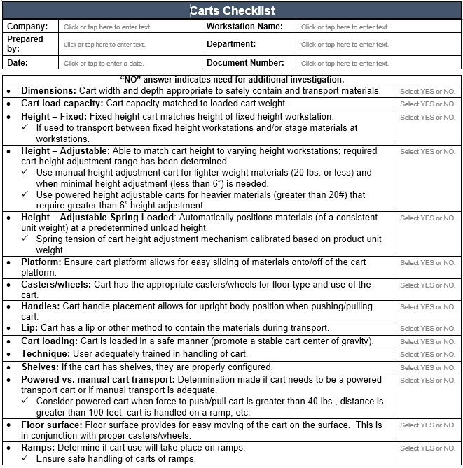

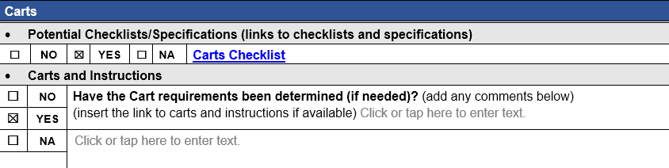

Conveyors
Often conveyors are used to transport parts and materials along an assembly line or to another location. Refer to the Conveyors Checklist for details.

Conveyors Checklist
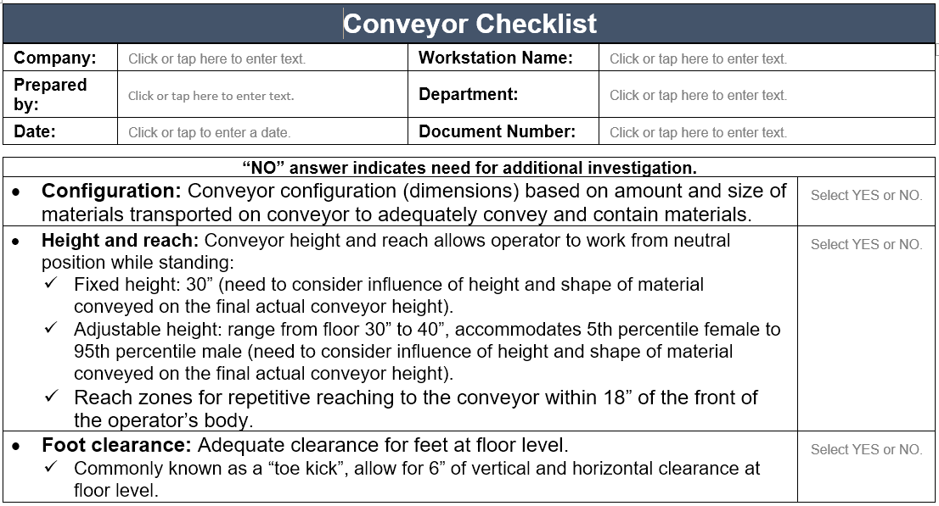

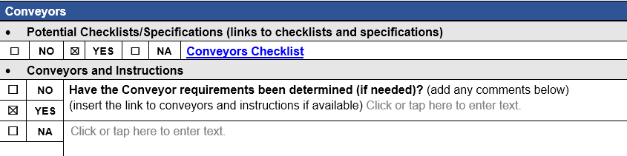

Storage/Staging
Have storage/staging locations been determined for the parts/materials?
Recalling our previous discussion regarding Reach Zones for various individuals, ensure that all parts and materials will be in appropriate locations for easy access at the workbench.
Determine how the parts/materials will be contained. They may be in bins on the workbench itself. Some parts and materials may be stored on carts or shelves and transported to the workbench as needed.

Shelves/Racks
Storage of parts, materials, and tools is part of the ergonomics design process. This could be at the workbench itself or another location. Use the Shelves/Racks Checklist for design guidelines.

Shelves/Racks Checklist
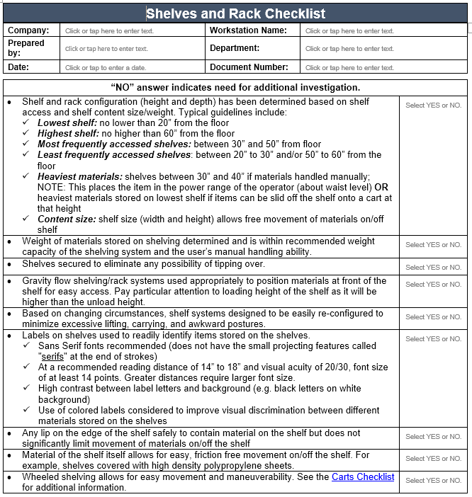
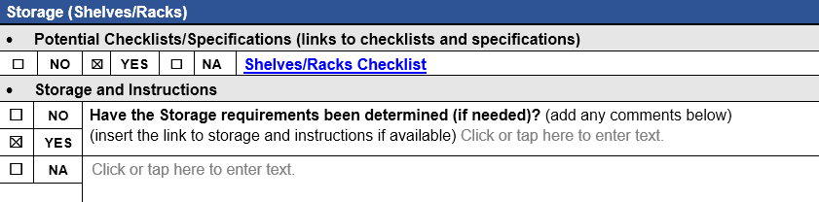

Conveyors
Often conveyors are used to transport parts and materials along an assembly line or to another location. Refer to the Conveyors Checklist for details.

Storage
Have storage/staging locations been determined for the parts/materials?
Recalling our previous discussion regarding Reach Zones for various individuals, ensure that all parts and materials will be in appropriate locations for easy access at the workbench.
Determine how the parts/materials will be contained. They may be in bins on the workbench itself. Some parts and materials may be stored on carts or shelves and transported to the workbench as needed.

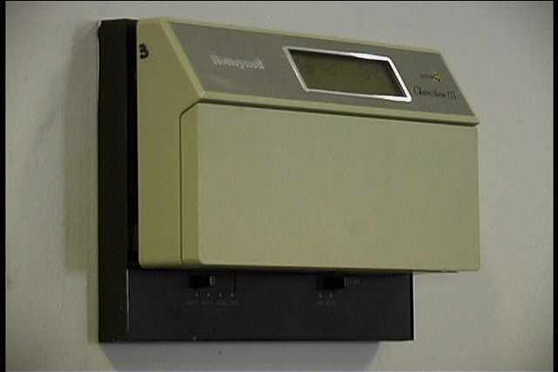
Work Environment

Control Exposure to Work Environment
Controlling exposure to the work environment including light, noise, temperature and ventilation is the next principle.
(What do you think, can we set the thermostat to a temperature that everyone will agree to? The goal is to shoot for the middle and let individuals use personal controls based on their needs.)
Use the Environment Checklist as needed for the ergonomics analysis process.

Cold
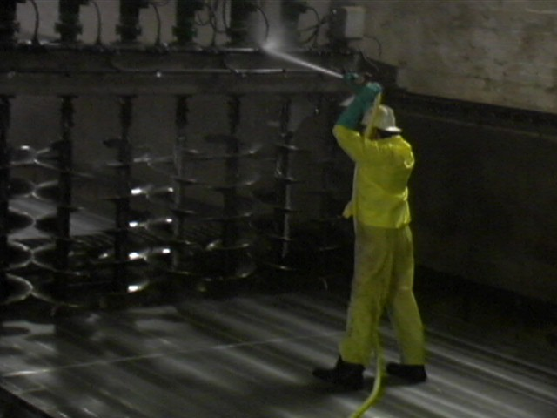
Cold environments, tools, or pneumatic tool exhaust may bring about a reduction in tissue sensitivity, manual dexterity, and grip strength.
When sensitivity decreases the amount of force exerted to perform a task increases. This requires the individual to perform more work than necessary.
Adequate personal protective equipment and appropriate worker rotation (in and out of cold environment) are also effective.
Directing tool exhaust away from the user is important for maintaining tissue sensitivity.

Heat
Hot environments result in an increase in metabolic demand. Heat may also affect an individual's ability to grasp tools and parts and to manipulate controls due to the effect of perspiration on grasp.
When perspiration increases, friction between the hand and the tool decreases. Higher force levels are again required to maintain the integrity of the grasp.
Hot and humid environments may also result in the fogging of eye protection, again complicating effective task completion.
Adequate ventilation and clothing as well as worker rotation are effective.

Air

Quality
Is there so much air contaminant in the process that it settles on displays, making them difficult to see?
Are suspended dust, mists and other particulates present in the air?

Flow
Is air circulation too low?
Is there too much air movement?
Are workers exposed to rapid environmental changes?

Humidity
Is the humidity frequently uncomfortable enough to interfere with the job?
Are there wet locations that may produce shock hazards for work with electrically powered equipment?

Noise
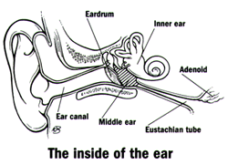
Noise is any unwanted sound. One person's music may be another person's noise. Potentially damaging noise is frequently encountered in work environments.
Noise has basic components of frequency, level, and duration. Frequency, or pitch, is measured in Hertz (Hz), or cycles per second; the higher the frequency, the higher the pitch. The range of human hearing is 20 Hz to 20 kHz. Noise is measured in decibels (dB) and is perceived as loudness.
For example:
60 dB - social conversation.
80 dB - conversing in loud noise less than one foot away.
105 dB - jet engine.
150 dB - reduced visual acuity, chest wall vibration, "gagging" sensation. Sounds may have a very short duration, such as the crack of a rifle, or a long duration, such as the engine of an industrial generator.
High noise levels can drastically impede effective communication in the workplace. Concentration is affected, negatively influencing productivity. Noise has also been blamed for excessive fatigue.

Noise Abatement
Because noise is essentially another form of vibration, intervention strategies are similar to those for the control of vibration.
Controlling noise at its source is always the best possible solution. For example, replacing noisy dot matrix printers with laser printers can be effective in office environments.
If it’s not possible to control the source of the noise, changing its path can also control it. Use acoustical sound barriers, enclosures, and sound absorbing tiles and carpet.

Noise - Questions
Is there so much process noise that hearing loss could occur?
Is there so much noise that it interferes with speech or audible signals of various kinds?
Are there noise levels that interfere with conversation or performing the job?
Is the noise level high enough to cause hearing loss?

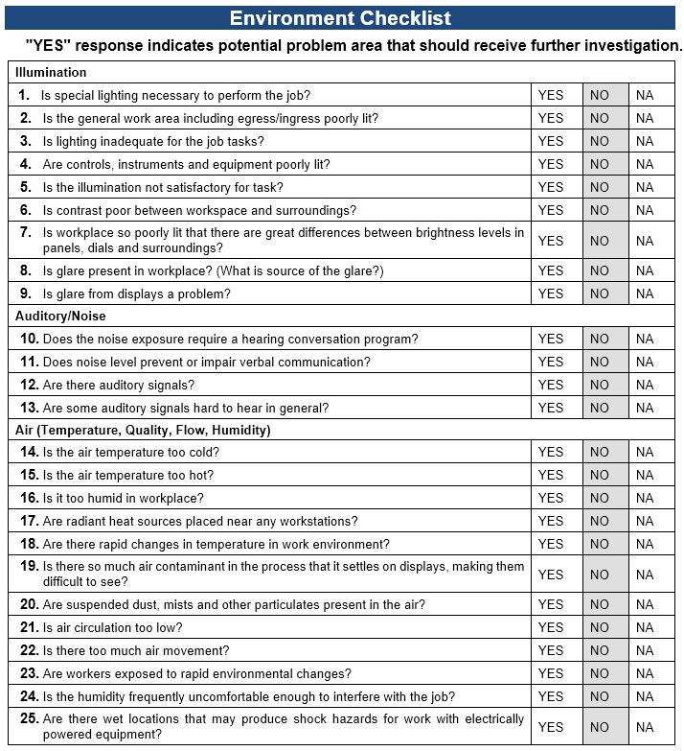
Work Environment Checklist
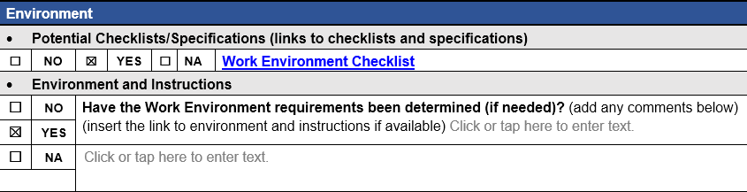

Recommended Specifications for Workstation
Now that you have determined the workstation configuration, the Worksheet has a section to document your recommendations.
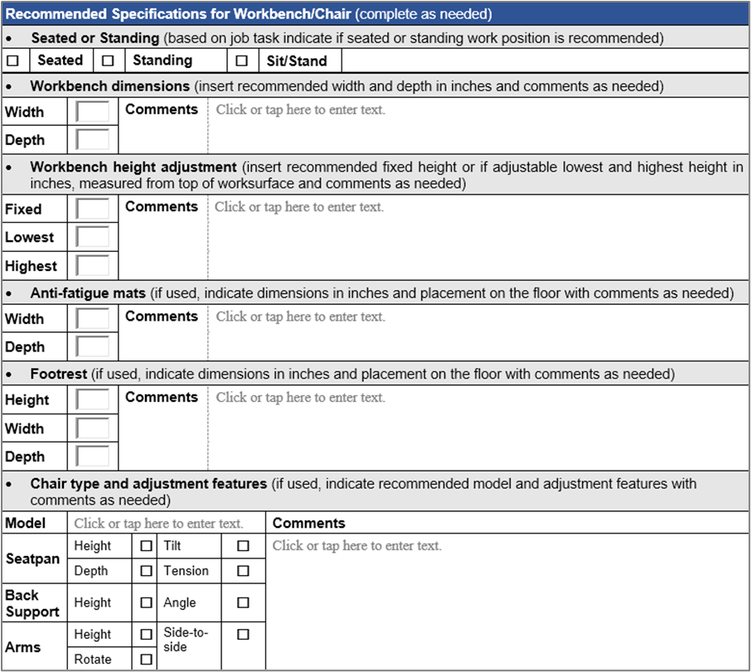

Case Study – Label Maker
Ergonomics doesn’t need to be complicated or cost a lot of money to make significant improvements. The Label Maker Case Study is a good example! Play the ‘before’ video and then go to the next slide to see what they did. Roll your curser over the video to play the video. See what the Ergonomics Team came up with. Roll your curser over the video to play the video.
Thanks for completing the Manufacturing Workstation Components Module!
While the workstations, tools and equipment that make up manufacturing workplaces have a common thread in terms of ergonomics principles, I believe you will find they each have their own unique attributes in terms of how to apply the ergonomics principles.
Next up in the Manufacturing Track is the Ergonomics Risk Screen

Module.
Thanks for your time and attention and I’ll see you soon!

Ergonomics Risk Screen


Welcome
All right, I’ll admit it, I like numbers. I like having a system that helps me understand the level of ergonomics risk of a particular task I’m assessing. As a consequence, over the years of my ergonomics practice, I’ve developed several iterations of an Ergonomics Risk Screen.
Hi everyone, welcome to the Ergonomics Risk Screen Module. I’m Mark Anderson. I’m a Certified Professional Ergonomist and Physical Therapist with more than 35 years of experience working with ergonomics.

Overview and ERS Report Formats
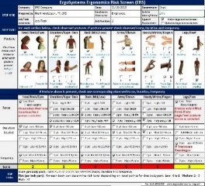
ErgoSystems Ergonomics Risk Screen (ERS) Version 11.0 is the most recent version I’ve developed. The ERS is a posture based assessment protocol intended to provide an overview assessment of the relative risk of ergonomics related factors in the physical performance of specific repetitive job tasks. The ERS makes use of an Excel spreadsheet for documentation and calculation purposes.
The ERS can quickly indicate that either the assessed job tasks are at low risk or have a potential greater relative risk. It can also point toward recommendations for additional assessment and intervention.
Three versions of the ERS are now available. One is the original comprehensive version and there are two condensed versions of the ERS available. I’ll go through the steps to use the comprehensive version in detail below.
For the condensed versions, STEP SIX (Continued ) Additional Corrective Actions If Needed has been deleted. The condensed versions have two format options:
Data First – Follows the comprehensive ERS 11.0 format where the Force, Duration, Frequency and Time Weighted Multiplier data are listed first on the form and Options and Follow-up at the end of the form. | Results First – Reorders the ERS content by placing the Options and Follow-up at the beginning of the form acting as an executive summary. Please use whatever format works best for your client.
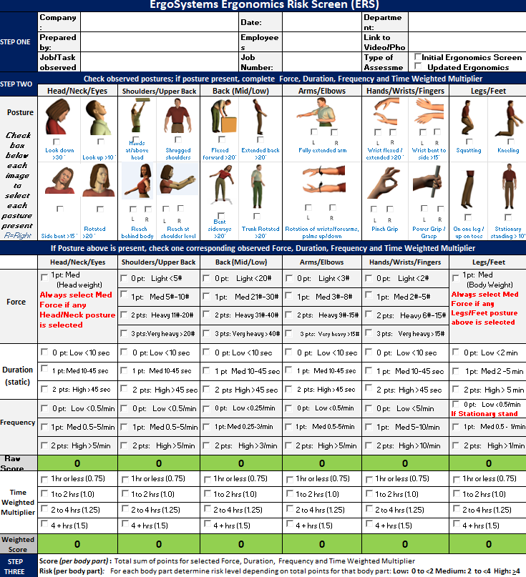 | 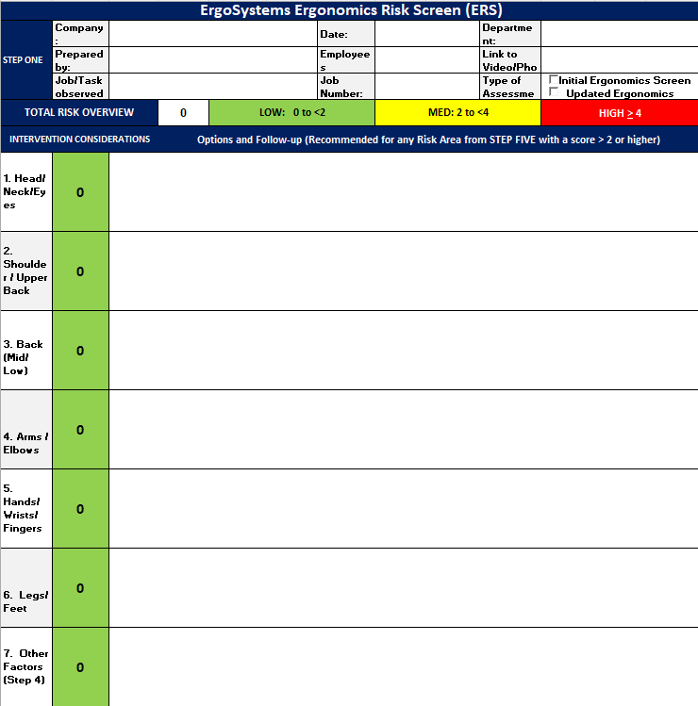

ERS Scoring Overview
You were introduced to the ERS in the earlier case studies. Now let’s get into the details of how to score it. The ERS is scored by first evaluating the position of various body parts in relation to the Neutral Position concept. Neutral Position, for the body as a whole, is with the head balanced over the shoulders, shoulders over the hips and hips over the knees and feet.
For each specific body joint, Neutral Position is defined at the mid-range of the joint’s range of motion.
From biomechanical and physiological perspectives, the Neutral Position/Mid-range of Joint Position concept is recognized as advantageous in controlling stress into the body.
As part of the analysis, if out-of-neutral postures are observed, the extent of physical exposure of each body part to the posture is documented. This includes a combination of:
- Force (typically expressed as pounds-force either imposed on the body or that the body has to generate)
- Duration (how long the out-of-neutral position is sustained)
- Frequency (how often the out-of-neutral position occurs)
For scoring the number of points increases as the intensity of the Force, Duration and Frequency increases.
Also, other factors (Training, Workstation Design, Tool and Equipment Use, Environmental Factors, etc.) are scored to help identify the root cause of the primary ergonomics risk factors.
A score of 0 to <2 is considered Low Relative Risk (indicated by GREEN), a score of >2 to <4 is considered Medium Relative Risk (indicated by YELLOW) and 4 and higher is considered High Relative Risk (indicated by RED).
The Weighted Time Multiplier is calculated based on the overall exposure. Level of Exposure is a major factor in the scoring system. As you can see if the factor you are assessing is occurring for 1 hour or less the raw score is multiplied by 0.75 thereby reducing the final score. Exposure of 1 to 2 hours does not change the raw score. With exposure of 2 to 4 hours, the multiplier is 1.25 and for 4+ hours it is 1.5. I’ll go through specific examples so you can see how this works in practice.
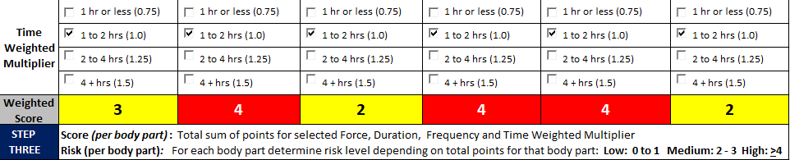
The ERS can be used as an Action Plan to document and track recommended Corrective Actions.
You can insert specific Corrective Actions, assign Responsible Persons, establish a Due Date and have Status check.
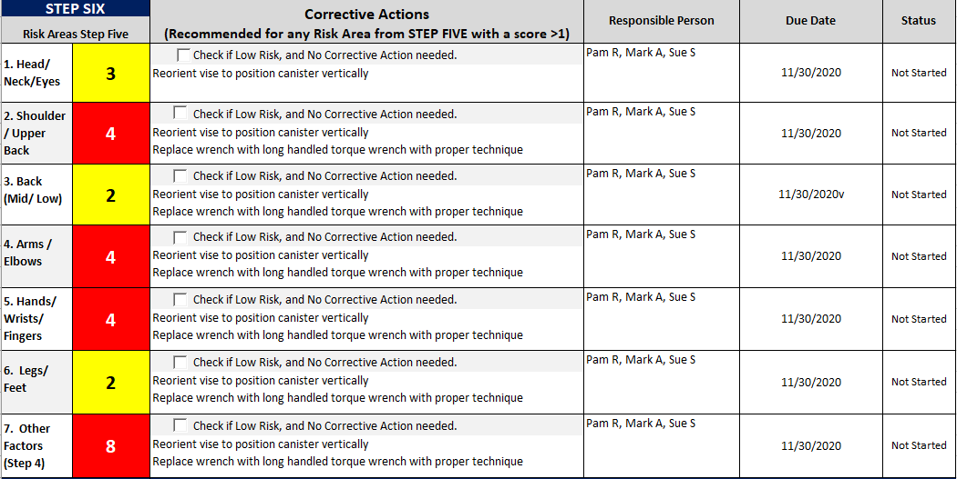

ERS Pre and Post Intervention
The ERS is often conducted pre and post ergonomics intervention to demonstrate the extent to which the intervention has been successful. Here is an example. The difference is visually apparent!
ERS Pre Intervention | ERS Post Intervention

Relative Risk Level Index – Defined and Interpretation

How Much is TOO Much?

Ergonomics analysis and subsequent recommendations revolve around answering the basic question of, “How much is too much?”
For instance:
- How awkward do the body and joint positions have to be to cause a problem? (In other words, how far out-of-neutral?)
- How much force is too much for a person to safely generate?
- How many repetitions of a task are too many?
- How far is too far for a person to functionally reach to parts and materials on a workbench.
- How to determine if the tool and equipment in use is the correct tool and equipment.
The list can go on and on! Essentially, we are talking about the factors that influence physical and mental performance.

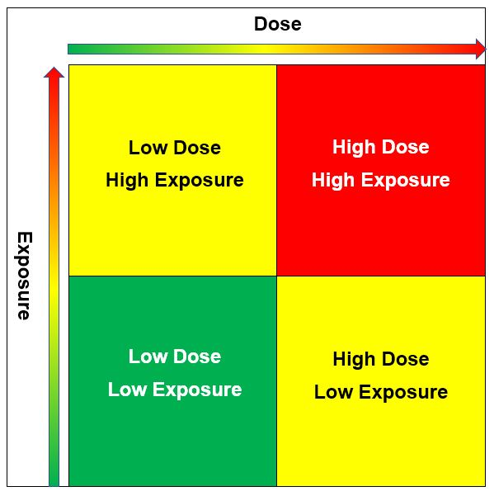
Dose/Exposure
One way to address this is the Dose/Exposure concept.
Dose – is the level of physical/mental stress of the ergonomics risk factors.
Exposure – is how long and how often the exposure to the ergonomics risk factors is occurring.
We appreciate the higher the values for Dose and Exposure, the greater the estimated relative risk.
- LOW: Considered low risk with low priority to change.
- MED: Considered medium risk, recommend modification as feasible.
- HIGH: Considered high risk, recommend concerted effort to modify.
A combination of Low Dose/Low Exposure would be considered to have a lower relative risk.
A combination of High Dose/High Exposure would be considered to have higher relative risk.
However, it’s conceivable the job task could consist of a Low Dose (minimal force levels) combined with High Exposure (high frequency). The converse is also true; High Dose (high force levels) with Low Exposure (low level frequency). This influences the score.
As we discussed, for the ERS:
- 0 to 1 is considered Low Relative Risk (indicated by GREEN)
- 2 to 3 is considered Medium Relative Risk (indicated by YELLOW)
- 4 and higher is considered High Relative Risk (indicated by RED)
For YELLOW and RED scores, additional assessment and intervention is recommended. Research has demonstrated that lowering the score through a combination of administrative, work process and engineering initiatives will generally lower the relative risk of the ergonomics factors.

Medical Analogy
What does Relative Risk mean? Consider a couple of examples.
- Two individuals can do exactly the same job. Within a short time one person experiences significant musculoskeletal issues and the other person does the job for 30 years with no problems at all.
- We generally consider cigarette smoking to be detrimental to health. Greater risk of lung cancer is well documented. However, a person can start smoking at age 10 and live to be a hundred!
This truly demonstrates the incredible variation in individual tolerance levels
In this light, how should the ERS Relative Risk Score be interpreted? Consider this medical analogy.
It’s generally understood that a combined HDL and LDL blood cholesterol level of 200 milligrams per deciliter of blood (mg/dL) and lower is advantageous. Does this mean an individual with a level of 320 will for sure die of heart disease? Or an individual with a level of 160 will never die of heart disease?
For both questions, the answer is NO. However, which score would you rather have? The obvious answer is 160. While there are other factors, the relative risk of dying from heart disease is lower with a lower level of blood cholesterol.
So specific to the ERS scoring does a score of 0 to 1 mean there is absolutely no risk of suffering a musculoskeletal disorder and does a score of 4 and higher mean absolutely for sure that a musculoskeletal disorder will occur?
The answer to both questions is NO.
So, what is the answer to the question, ‘How much is TOO much?’
Well, based on the individual variations in responses we know exist, we may well say, ‘It depends!’ And to a certain extent this is very true!
However, the Relative Risk score simply indicates that the potential for experiencing issues is greater with a higher score.
From our ergonomics perspective, through the application of ergonomics principles, our objective is to lower the Relative Risk Score and broaden the range of individuals who can safely and effectively perform the job task.

ERS Example Case Study – Oil Fill
Earlier I introduced the Oil Fill Case Study. Let’s go through how the ERS was conducted.

Background Information
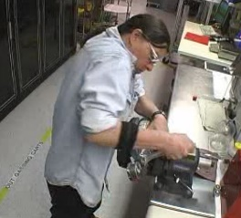
Instruments, Inc. is a company that manufactures calibration equipment. Part of the manufacturing process is to screw a gauge onto an oil fill canister. This task had been identified as a problem in terms of discomfort and even injuries reported by the workforce.
An ergonomics assessment was conducted using the ERS process and recommendations for improvement were made.
To conduct the assessment, video of the task was taken along with an interview of the worker and measurements of the workstation to document the physical demands to perform the task.

Oil Fill Video
Let’s take a look at the video. As you look at it, think about the Ergonomics Principles we outlined in the Introduction to Ergonomics Track and the information in the Manufacturing Workstation and Ergonomics Design Modules to identify potential ergonomics issues and then consider feasible and reasonable recommendations for improvement.

ERS Results

Pre-Intervention ERS
Here are the results for the Posture, Force, Duration and Time Weighted Multiplier. It’s apparent we are seeing scores in the Yellow and Red ranges with particular issues with Shoulders/Upper Back, Arms/Elbows and Hands/Wrists/Fingers. We’ll go through exactly how to score each section a little later. The Time Weighted Multiplier was scored at 1.0. The task is performed 1 to 2 hours/shift. Do the scores correlate with what you observed on the video?
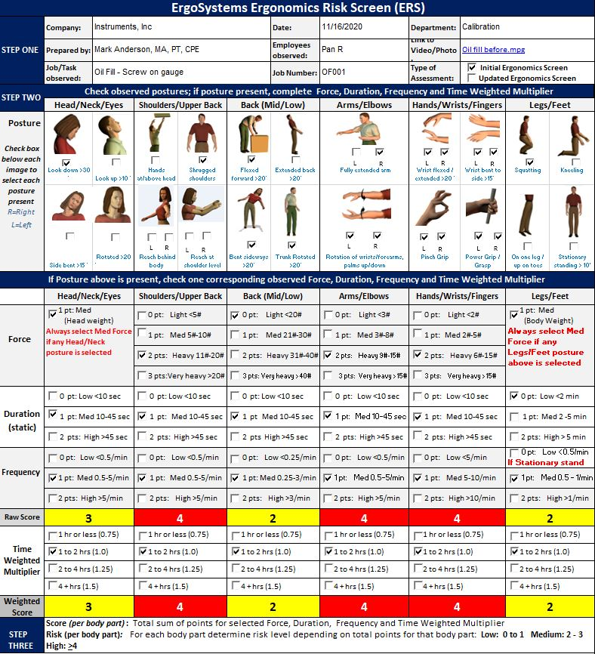

Other Factors
In the Other Factors section, we documented potential causal factors for the issues identified in the Posture, Force and Duration step. We checked eight Other Factors:
- Production/Quality – Gauge was tightened with a wrench without a definitive torque level applied
- Training – Technique observed was not effective in reducing stress
- Contact Stress – Sharp, hard edge from the wrench and gauge itself was identified
- On feet (standing or walking) > 50% of shift – Identified as an issue
- Fixture/Jig – Vise was used to stabilize the canister, ineffective use
- Tools – Fairly short wrench used to tighten the gauge
- Workstation – Questionable setup of the workstation was noted
- Worksurface height, too low – Negative influence on posture
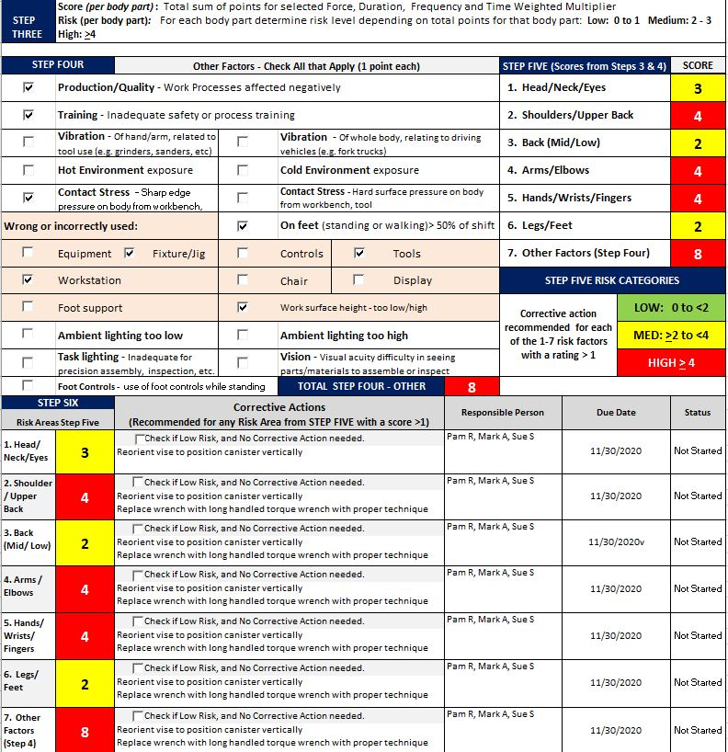

Corrective Actions
With the assessment results in hand, the next step was to generate the recommended Corrective Actions. Our goal was to recommend changes that would positively influence the factors we identified in the Posture, Force and Duration and Other Factors sections.
We collaborated with the worker, supervisor, health and safety manager and the engineer assigned to the area to come up with these straightforward recommendations:
- Reorient the vise to position the canister vertically.
- Replace the wrench with a long handled torque wrench with proper technique (this allowed documentation of the amount of torque required to effectively secure the gauge).
- Consider anti-fatigue mat or shoe in-soles due to the amount of time spent on the feet in general.
You’ll notice similar recommendations were made for each body part. This is fairly common. We need to look at the integrated whole of the risk factors and recognize that one or more changes may have an impact across the board. This was certainly the case in the Oil Fill Case Study.
Post Intervention ERS
Let’s look at the Post Intervention video clip. Once the recommendations were implemented the ERS was repeated. Take a look at the difference in the ERS scores. Visually the distinctions are dramatic.
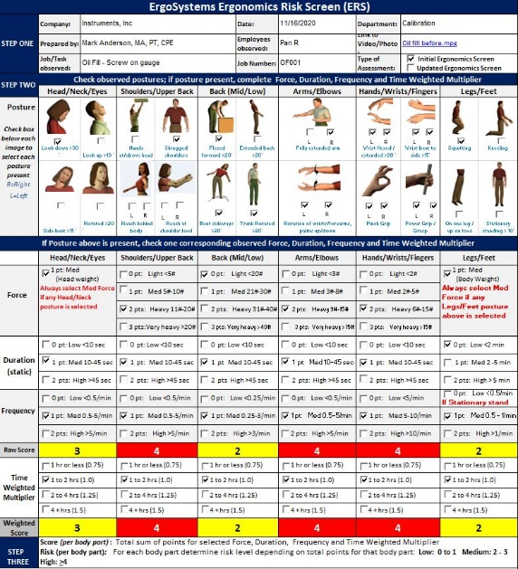 | 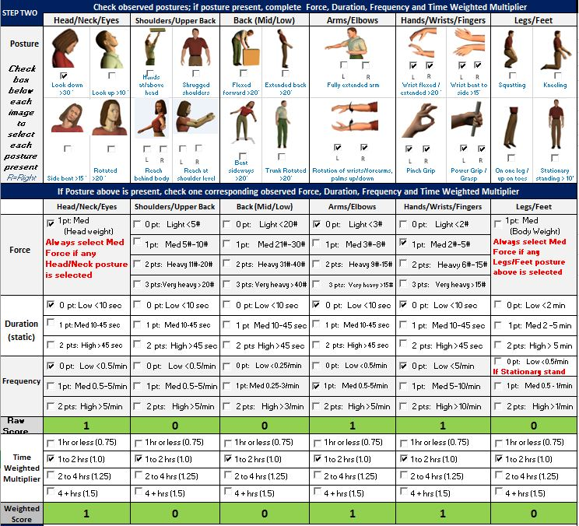
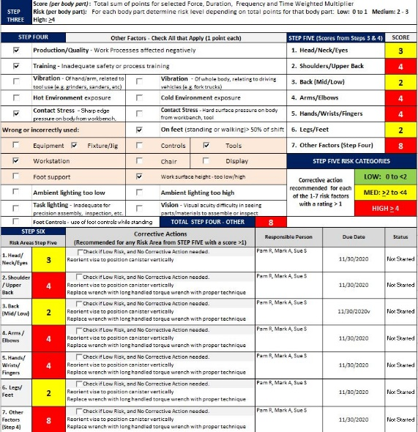 |  | 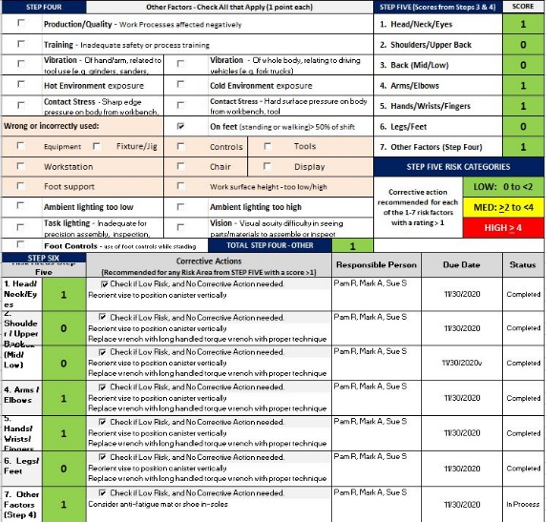

ERS – Step-by-Step
Now that we’ve had a look at the ERS process, let’s get into the nitty-gritty of how to conduct an ERS.

Step One – Identify Number of ERSs to be Conducted

ERS Breakdown Determination
A basic question is:
“For a specific job task how many different ERSs do you need to conduct to capture the needed information?”
The basic answer is:
“The job tasks assessed with the ERS need to be discrete enough to provide a focused examination of the physical demands of the job tasks.”
For example, let’s say the assembly process has five separate steps. Each step involves quite different physical demands. If you attempt to use one ERS to capture all five steps it will not have the depth of task specificity necessary to drill down to the level needed. There is simply just too much going on in a broad manner.
In this case, you’ll probably end up with five ERSs. An exception to this is if you identify some steps are essentially the same in terms of physical demand (including exposure); if so, you can group these steps together in an amalgamated ERS.

Develop Task Inventory
As you plan for the ERS process develop the Task Inventory. This is a list of the separate ERSs you’ll need to conduct. Typically, you’ll work with the company representative (Safety Manager, Supervisor, Health Professional, etc.) to put together the Inventory. This will ensure you are well organized and efficient in the data collection phase of the ERS.

Prepare ERS Worksheets
Once you have determined the extent of the Task Inventory, prepare the needed ERS worksheets. Depending on how you plan on collecting the data, you’ll either prepare printed out ERS Worksheets for each ERS and write in basic information as you collect the data OR you may bring a laptop in and fill in the Excel spreadsheet as you collect the data.
Our preference is to use the printed ERS Worksheet approach. It’s fast while on-site and also provides opportunity for written notes you can refer to as you finalize the ERS report.

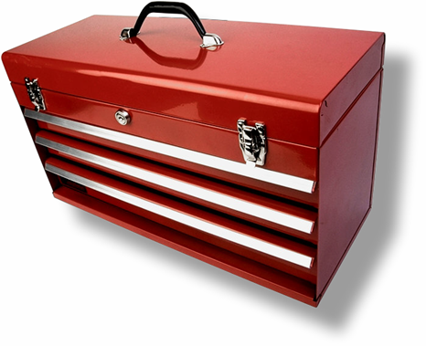
Step Two – Ergonomics Analysis Tool Box
Put together your ERS Tool Box; it will have several trays.

Personal Protective Equipment
Ensure YOU have the proper personal protective equipment and attire to conduct the analysis. At a minimum, YOU may need eye, foot, clothing, head, and hearing protection.
Don’t take it for granted; communicate with your company contact to understand what the company requirements are.
Dress at the proper level based on the worker's level of attire. For example, do not show up in a suit on an assembly production floor, just as jeans, steel toe boots and a work shirt may not be appropriate for a boardroom.

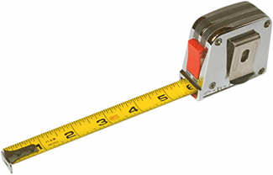
Measurement Devices
To take measurements of the workplace, you'll need:
- Stopwatch (You want to be able to time the tasks. If you use video, you won’t need a separate stop watch, as the video has time code.)
- Tape measure (I suggest you have at least a 12 foot/3 meter tape measure that is robust enough so you can extend it out a fair distance without it collapsing.)
- Force gauge and/or scale (You need to be able to measure push and pull forces and weights.)
- Photographic equipment (I strongly encourage you to use video rather than still cameras, you can always pull freeze frames off the video to insert into reports.)
A word about video and cameras in general. Typically, you must get approval for the video and/or pictures from the appropriate individuals, including the person being assessed, supervisors, managers, etc. In a few cases a written release may be needed. And in some cases, due to the proprietary nature of the workspace, video/pictures may not be allowed at all.

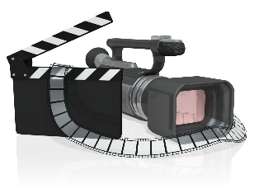
Why use Video?
If a picture is worth 1,000 words, a moving picture (video) must be worth at least 5,000 words.
Using video is one of the best ways to document an ergonomics analysis.
You can study the video over and over again at a later date.
You can show the video to other interested parties for their input.

Video “Secrets”

Don’t be accused of making home videos, follow these guidelines.
I suggest a camera with a flip-out view finder. This allows you to position the camera to get the shot and still see the view finder.
Use enough light; low light causes grainy video that is hard to analyze. If you know you’ll be in a low light area, see if you can obtain more light in the area.
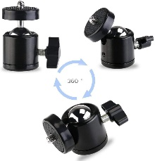
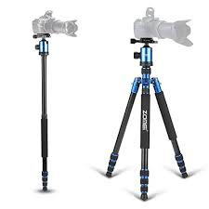
Use a tripod or monopod as much as you can. You’ll get much better quality video.
A monopod works very well to get overhead shots. A swivel ballhead mounted between the camera and the monopod works well. A wide angle lens will allow you to work in close quarters.
If you have to use a handheld technique, build a bridge with your arm against your body for stability.
Always have a backup power supply; either additional battery packs or able to run off of wall current with the AC adapter.
Plan your video sequence. Think ahead to know what shots you want.
Use the zoom sparingly. Zooming in and out in and out will drive your audience crazy.
Use manual focus (if available) to stop the auto focus from searching.
Pan (move from side to side) the camera about three times more slowly than what your eyes can track.
After videoing a few seconds, check to make sure the camcorder is working correctly. I’ve learned this the hard way!
In a loud environment, use a separate microphone to pick up interviews.
Be aware of your surroundings; don’t walk into equipment, people, etc. I always try to have someone watching “my back” to keep me out of trouble.

Videotaping Sequence
Here is the typical sequence I use to video.
Inform any people being videoed of your purposes.
Record the date and time, this will also be captured on the video by the camera.
Say the name of the job or task description on the audio portion of the video at the beginning of each task. You can also use the audio to take notes; just remember you need to view the video later to get the information.
In the viewfinder, frame an overview of the job to “set the stage.”
Capture 5 to 6 cycles of the repetitive tasks. This will allow you to time the tasks when you view the video later.
Reposition the camera to get back, side and diagonal views. If possible, get an overhead view.
Video as many different workers as you need to get an accurate portrayal of the job. You want a representative sample of the workers doing the job.
Get close up views of each of the separate job tasks and identified issues .
If needed, video the tasks immediately before and after the task being reviewed – this may also lend additional insight.
After you have videoed the job tasks, interview the worker and other company representatives to gain their input. DO NOT ask leading questions.
Be wary of sharing your opinions about the job task at this time. You don’t want to bias their comments.

Background Materials
Identify the proper background materials to have available. This includes the ERS Task Inventory, your ERS Worksheets and may also include job descriptions, sketch of the floor plan or layout, organizational chart, check lists, clipboard or notepad.

Clipboards
A word about clipboards and notepads. Some employees may associate clipboards with inspections and will have some concerns. We generally have the ERS Worksheets in a 3-ring binder. We always make sure the workers being observed are aware we are NOT inspectors; we are there to look at ergonomics factors with the intent to help improve the comfort level, health and safety of the worker and workplace.

Set of Objectives
The most important tray in your tool box is the set of objectives you bring to the job.
- What are the outcome objectives?
- Make sure you bring an "open mind.
Do not hesitate to ask questions. In fact, you’ll find most people will tell you a lot about the job and issues they may have if you simply ask them to help you understand what they do.
I often put myself in the role of “New Employee” and ask the worker to provide “Training”.
The most important thing you bring to the assessment is a new and fresh look at the situation. What has become common place to those in the workplace may be brand new to you. Take advantage of this opportunity.

Step Three – Prep for ERS Data Collection

Schedule the ERSs
Working with the appropriate company representative schedule the ERS data collection. Ensure through the company representative, the employees you are observing have been informed of the data collection process.

Estimate Time
Estimate the time needed on-site to collect the data. This is made easier with the Task Inventory because you’ll know how many ERSs you’ll be doing.

Repetitive Manufacturing Tasks
You’ll find repetitive manufacturing jobs with short duty cycles can be done quickly.
- For example, the duty cycle for the task is 30 seconds.
- Let’s say you want 2 cycles each of the side, back, front and overhead views.
- This is 8 cycles, so you are talking about 4 to 5 minutes for the overview.
- Add another 10 minutes to get the closeup shots and final interview.
- Then add another 5 to 10 minutes to get the measurements you need.
- So far, we’ve about 25 to 30 minutes total.
- Then add a 5 to 10 minute buffer to take any notes needed.
So bottom line is about 30 to 40 minutes in total. Just remember this time frame can and will vary!

Other Tasks
If the tasks for the ERS are for example in the Maintenance Department. They may be performed on an infrequent basis; weekly, monthly, or even yearly.
In this case you can either spend a year with them to collect the data OR you ask them to set up task simulations that adequately represent the physical demands of the tasks. This simulation strategy works well with a little preparation upfront.

Step Four – Obtain Data (Video, Interviews, Measurements)
Using the strategies discussed above to obtain the onsite video, interviews, measurements, fill out ERS worksheets, etc. Compare experienced faster and injury-free workers with those who are inexperienced, fatigued, uncomfortable or reporting pain or injury.
Determine if there are differences in work technique among these groups.

Step Five – Complete ERS Worksheet and Report
Let’s go step-by-step through completing the ERS Worksheet. Look for tips about how to efficiently interpret the data. The ERS Worksheet is in the Excel spreadsheet format.
Open the ERS Worksheet Template and save the file with an appropriate name.

ERS Step One – Background Information
Company: | Enter the Company name and contact information.
Prepared by: | Enter the name and contact information of person conducting the ERS.
Job/Task observed: | Enter the name of the job/task being observed; try to use the existing name if available. Sometimes you may need to make up a descriptive name.
Date: | Enter the date the ERS data collection took place.
Employees observed: | Enter the names of Employees observed if available.
Job Number: | If the company has a specific job/task number in their system enter it to keep track of the ERS. Otherwise enter an ERS Job Number of your nomenclature. (e.g., #001)
Department: | Enter the Department name where the ERS was conducted.
Link to Video/Photo: | Enter the Link to the folder that contains the video/photo files. The complete ERS report will include the ERS Worksheet and any associated files.
Type of Assessment | Check the appropriate box indicating if this ERS is the Initial ERS or an Updated ERS/

ERS Step Two – Posture, Force, Duration, Frequency and Time Weighted Multiplier

Posture
Based on your observations check the appropriate boxes for each of the posture sections. Essentially you are looking for out-of-neutral postures more than a defined amount.
Is it possible to use a goniometer to obtain the measures (either by direct measurement or by way of video), but honestly the best strategy is to estimate them by eye. Don’t agonize over 19 or 21 degrees when the guideline indicates 20 degrees. If it’s about 20 degrees or more, that is accurate enough.
With a little practice you can get quite good at estimating angles.
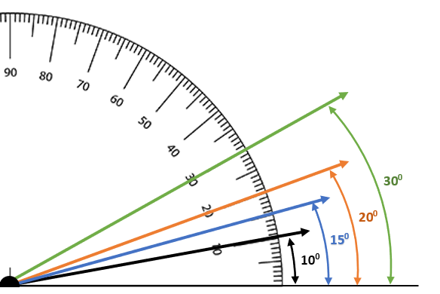

Head/Neck/Eyes
Identify head and neck positions that are out-of-neutral as indicated.

Shoulders/Upper Back
Identify out-of-neutral positions that have impact on the shoulders and upper back. Think of this as impacting the shoulder girdle influenced by upper extremity position to accomplish the task at hand.

Back (Mid/Low)
Identify out-of-neutral mid and low back positions that impact the core of the body.

Arms/Elbows
Fully extended arms involve reaching out from the trunk with the elbows extended to reach to and/or handle materials. Rotation of the wrists/forearms, palms up/down involves tasks that require alternating between palms up and down position (pronation and supination). Examples include wringing water out of towel or turning a screwdriver.

Hands/Wrists/Fingers
Identify out-of-neutral wrist positions to accomplish the task at hand. Identify pinch and power grip hand activities.
Pinch Grip – The fingers are on one side of an object, and the thumb is on the other. Typically, an object lifted in a pinch grip does not touch the palm.
Power Grip – Formed with the fingers and the palm of the hand to move or manipulate objects.

Legs/Feet
Squatting – Defined as bending the hips and knees.
Kneeling – Defined as bearing body weight through one knee or both; either stationary or ‘walking on the knees’.
On one leg/up on toes – Defined as standing on one leg only or up on the toes, for example to reach to a higher level.
Stationary Standing – Defined as standing in one position within a confined space for more than 10 minutes. A person can shift body weight from one leg to the other but is not able to take steps away from the position.

Force

Material Handling
For each of the posture categories check the appropriate box based on the measured and/or estimated force levels. Force can be generated in a variety of ways:
Body and extremity weight only – muscular force required to move and position body/extremities.
Material handling (lifting) – objects are lifted/lowered manually.
Material handling (push/pull) – objects are moved via push and/or pull forces (e.g., moving a cart and pushing on wrench handle).
Lifting force requirements can be determined through use of a force gauge or scale to determine the weight of the object.
Push/Pull force requirements can be measured with a force gauge. Typically, you’ll want to do three trials to get a consistent outcome and take the average of the three.

Hand Grasp (pinch and power)
Hand grasp force requirements involving pinch and power grips are more challenging to obtain. Here are a few strategies:
Tool specifications – some hand tools may have published force requirements to activate. For example, a hand stapler manufacturer may list them in the tool specs.
Indirect measurements – using grip and pinch dynamometers you can obtain a reasonable indirect measurement by first performing the grip or pinch task as typically performed and then simulating the task using the grip or pinch dynamometer. Essentially, you are using the body’s neuromuscular sensory system as a measurement device. Typically, you’ll want to do three trials to get a consistent outcome and take the average of the three.
We’ll go through each category to provide specific details.

Head/Neck/Eyes
Always select 1 pt: Med if any Head/Neck posture is checked in the Posture section. This takes into account the weight of the head (about 6 to 7% of body, in the typical range of 8 to 14#) and the impact on the body to support the head in the out-of-neutral position.

Shoulders/Upper Back
If any of the postures are checked, estimate the load either imposed on the shoulders and upper back or required to be generated by the muscle groups of the shoulders/upper back.

Hands at/above head:
- If only reaching overhead with both arms without any object involved, check 2 pts: Heavy 11# to 20# (5 to 9 kg) to account for the weight of both arms being held overhead. An upper extremity weighs about 5 to 6% of body weight.
- If only reaching overhead with only one arm without any object involved, check 1 pt: Med 5# to 10# (2.3 to 4.6 kg) to account for the weight of one arm being held overhead. An upper extremity weighs about 5 to 6% of body weight.
- If an object is being handled, weigh the object and score appropriately based on the weight of the object.

Shrugged shoulders
- Determine the weight of the object being lifted or held in position that results in the shrugged shoulder position.

Reach behind body
- If only reaching behind the body with one arm without any object involved, check 1 pt: Med 5# to 10# (2.3 to 4.6 kg) to account for the weight of the arm. An upper extremity weighs about 5 to 6% of body weight.
- If an object is being handled, weigh the object and score appropriately based on the weight of the object.

Reach at shoulder level
- If only reaching at shoulder level with one arm without any object involved, check 1 pt: Med 5# to 10# (2.3 to 4.6 kg) to account for the weight of the arm. An upper extremity weighs about 5 to 6% of body weight.
- If reaching at shoulder level with both arms without any object involved, check 2 pt: Med 11# to 20# (5 to 9 kg) to account for the weight of the arm. An upper extremity weighs about 5 to 6% of body weight.
- If an object is being handled, weigh the object and score appropriately based on the weight of the object.

Back (Mid/Low)
- If any of the postures are checked, estimate the load either imposed on the back (low/mid) or required to be generated by the muscle groups of the back (low/mid).
- If no object is being handled check 0 pt: Light <20# (9 kg). The Duration and Frequency scoring will pick up the extent of the stress from the postures.
- If an object is being handled, weigh the object and score appropriately based on the weight of the object.
- If an object is being pushed or pulled, determine the force requirements and score appropriately.

Arms/Elbows
Estimate the force required to perform the tasks involving the arms reaching out from the trunk with the elbows extended to reach to and/or handle materials. Consider the weight of objects being handling and/or manipulated.
Estimate the force required to rotate the wrists/forearms, palms up/down to accomplish the tasks. Consider the weight of objects being handling and/or manipulated.

Hands/Wrists/Fingers
For the out-of-neutral wrist positions estimate the force involved. Refer to the Hand Grasp (Pinch and Power) section above for additional information.

Legs/Feet
Always select 1 pt: Med if any Legs/Feet position is checked in the Posture section. This takes into account the weight of the body on the weight bearing joints (spine, hips, knees, ankles and feet.

Duration (static)
For each of the Posture categories score the Duration based on the indicated point system.
The scoring is same for all the categories except for Legs/Feet. Recall the Stationary Standing box was checked if greater than 10 minutes was identified. If so, for Duration check 2 pts: High > 5 min.

Frequency
Frequency is determined by how often the identified positions occurs. Reviewing the video is the best way to determine frequency; you can time the task based on the time code on the video.
The scoring system varies a bit across the postures. This is a reflection of the different impact frequency has on different body parts.
For example, a Flexed Forward Back (Mid/Low) posture frequency of 5/minute would involve significantly more physiological effort than 5/minute for the Hands/Wrists/Fingers.
Take a moment to look at the nomenclature used.
- 0.5/min equates to once every 2 minutes
- 0.25/min equates to once every 4 minutes
For Legs/Feet, if Stationary Standing > 10 min is checked in the Posture section, the Frequency is checked as 0 Pt Low < 2 min because we’ve already accounted for it in the Duration category.

Time Weighted Multiplier
Recalling that Exposure is an important factor in assessing overall relative risk, the next step is to apply the Time Weighted Multiplier (TWM). The TWM reflects the amount of exposure of each category in terms of hours/day. The breakdown is:
- 1 hr or less (0.75)
- 1 to 2 hrs (1.0)
- 2 to 4 hrs (1.25)
- 4 + hrs (1.5)
When you perform the data collection obtain the needed information to be able to fill in the TWM.

ERS Step Three – Raw and Weighted Score
The Raw and Weighted Scores have now been calculated per body part.

ERS Step Four – Other Factors
In Step Four – Other Factors we examine other factors that influence the performance of the task. Each Other Factor we identify as an issue receives one point in the Other Factors score.
One way to think about Step Four is it helps us get to the underlying reasons why we saw the scores we saw in Step Two. For example, we may have identified a RED score in the Back (Low/Mid) section due Flexed Forward > 20 degrees. In Step Four we identify the Worksurface Height is too low. This information also leads in directions of potential intervention recommendations.
Let’s review the Other Factors and offer some tips to complete Step Four.

General Factors

Production/Quality
Production/Quality may be negatively impacted by poor ergonomics design. In discussion with company representatives try to determine through production and quality metrics if this is the case, if so, check the box.

Training
Competency-based training is one of the ten major ergonomics principles. Inadequate safety and/or process training may be evident. For example, if you observe three employees doing the same task and see three different ways of doing it, determine if training (or lack of) is at the base of the issue.

Vibration (Hand/Arm and Whole Body)
Once you identify vibration (hand/arm and whole body) is occurring, determine if it’s significant enough to cause medical related issues based on injury/illness records or by subjective employee reports.

Environment (Hot/Cold)
Check out the Environment Checklist for additional information.

Contact Stress (Sharp Edge and Hard Surface)
Identify any contact stress (Sharp Edge and Hard Surface) issues and check the box if needed.

On Feet (standing or walking > 50% of shift)
Check if standing and/or walking is occurring more than 50% of the shift. This may include other tasks that are not part of the ERS. You’ll need to determine this by asking about the among of time spent standing or walking.

Lighting –Ambient
Investigate if ambient lighting levels are inadequate for safe area ingress/egress. You yourself may have issues with the lighting in conjunction with worker reports. Consult with the appropriate company representatives as needed.

Lighting – Task
Investigate if task lighting levels are inadequate for precision assembly and quality inspections. You yourself may have issues with the lighting in conjunction with worker reports. Consult with the appropriate company representatives as needed.

Vision
Based on observation and worker interviews determine if visual acuity in seeing parts/materials to assemble or inspect is an issue.

Foot Controls
Identify if foot controls are used while standing.

Wrong or Incorrectly Used:
Investigate the workstation and associated accessories to determine if they are the correct items and used correctly.
Apply the ergonomics principles and access the checklists for additional information.
This includes:
Equipment  Fixtures/Jigs  Controls  Tools | Workstation  Chair  Display | Foot Support  Worksurface height (too low/high)

ERS Step Five – Scores from Steps 3 and 4
In Step Five, the scores from Steps 3 and 4 are tabulated.

ERS Step Six – Corrective Actions
Step Six provides an opportunity to recommend Corrective Actions specific to each of the Risk Areas. It can be used as an Action Plan with assignments of the Responsible Person, Due Date and Status update (pull down menu for No Corrective Action Needed, Not Started, In Process, Completed)
Step Six also has space to enter Other Issues and Additional Corrective Actions if Needed.

Step Six – Implement Solutions
The goal is to accomplish controlled measurable change. If you change too many variables all at once you run the risk of not being able to recognize what did and did not work. Apply the principles but be careful of generalizations. In all likelihood, the "normal" person does not exist.
The modification itself is not the issue; the acceptance and integration of the modification is the issue. Introducing the job modification into the workplace only begins the process. Check out the Ergonomics Implementation Track for more information.

Cost Analysis
We recognize that many jobs and tasks performed may not be designed safely or efficiently and must be improved. We must be able to justify our requests for ergonomic improvements in terms that management can understand. That’s right - dollars and cents.
Here is a simple formula that can be used to decide how to intervene. It’s useful to justify the ergonomics intervention either when significant resources are involved or when little or no resources are required. This formula will help prioritize the ergonomics project list.
ROI = Total Estimated Benefits/Total Cost of Intervention
Return of investment (ROI) is the primary calculation in this formula. It requires the following information.

Estimated Benefits of Intervention:

Direct Benefits:
- Reduced labor costs
- Productivity gains
- Lower injury/illness costs

Indirect Benefits:
- Quality improvements
- Reduced scrap/rework
- Improved morale
- Improved idea sharing and problem solving
- Improved teamwork/ownership
- Reduced absenteeism

Costs of Intervention:
- Material/Hardware Costs
- Labor cost for installation
- Training costs
- Any other costs related to the intervention
For the inexpensive fixes you don’t need to spend a great deal of time gathering data and calculating your ROI. For more expensive and important projects this time will be well worth it.

ROI Worksheets
Cornell University Ergonomics (http://ergo.human.cornell.edu/CUROIEstimator.htm) has produced worksheets to assist in calculating ROI:
1.) If actual cost data is available.
2.) If estimated cost data is used.
3.) If no cost data is used.
Please refer to the worksheets for additional details. ROI information can assist in making the right decision when the ROI is high, and the payback period is relatively short.

Step Seven – Follow-up
Proper outcomes evaluation continues the process. On-going measures are compared to the initial performance measures.
- Compare at set intervals (1, 3, 9, and 12-month intervals).
- Determine changes in performance measures.
- Detail lessons learned to modify the interventions.
- Reevaluate and repeat the analysis steps.

ERS Practice

CNC Reservoir Case Study
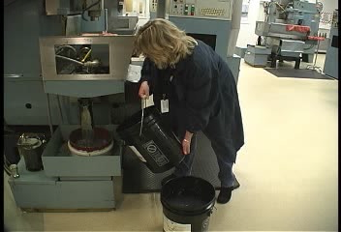
Like any other skill you are working to develop, the way to improve skill levels is to practice. We’ve included the CNC Reservoir Case Study for additional practice.
Please access the Case Study that includes the pre and post intervention videos and the ERS worksheets along with all the details you need.

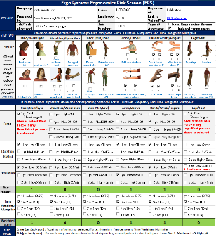
Next Steps
The Ergonomics Risk Screen is an important tool to objectively analyze the ergonomics factors of job tasks and determine the relative risk of the factors.
The ERS process helps you and your clients come up with reasonable and feasible ergonomics recommendations to enhance health, safety and productivity!
Thanks for your time and attention!

Manual Material Handling

Welcome

A basic question I get on a regular basis is, “How much weight can a person lift?
It’s a very valid question.
According to the Bureau of Labor Statistics (BLS), back injuries account for one of every five injuries and illnesses in the workplace. Eighty percent of these injuries occur to the lower back and are associated with manual material handling tasks.
Hi everyone. Welcome to the Ergonomics Manual Material Handling Module.
I’m Mark Anderson. I’m a Certified Professional Ergonomist and Physical Therapist with more than 35 years of experience working in ergonomics.

How Much Weight Can a Person Lift?
Most clients I work with have a policy that delineates a certain number of pounds considered acceptable for a one-person manual lift. About 40 pounds is what I typically see. Here is the rub, I can show you a lifting task where the object weighs 10 pounds, and it can’t be done safely. I can show you another task where the object weighs 60 pounds, and it probably can be done safely by a majority of workers.
So, to answer this question, ‘How much weight can a person lift?’, I think we need to ask another question, “What are the factors that influence how much weight a person can safely lift?”
And a third question, “Based on these factors, can a mathematical formula be developed to predict how much weight a person can safely and effectively lift?”
Not surprisingly, these questions have been studied extensively over the past 50 years.
And then we should ask one more question, “How can we apply this information to identify the level of risk of manual material handling and then offer reasonable interventions?”
These are the topics we’ll explore in the Manual Material Handling Module.

Physical Demands
Manual Material Handling is by definition physical in nature. Manual material handling (MMH) is commonly seen in many diverse settings, not just in warehouses. OSHA has identified the stresses associated with manual material handling as one of the major work-related factors to examine and alleviate to improve health and safety in the workplace.
MMH levels are a function of the weight of the tools, containers, boxes, parts, carts, etc. Whether lifted, carried, pushed, or pulled, the force required to move or manipulate the object directly creates stress on the body.
Our goal is to understand the level of physical exertion that is related to manual material handling. For example:
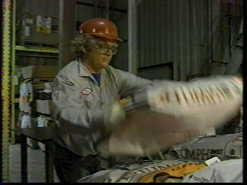
- Does the job involve peak loads of muscular effort?
- Do workers have to lift objects, boxes, parts, materials?
- Does the task require:
    - Strenuous one-hand lifting?
    - Strenuous two-hand lifting?
    - Lifting over too great a vertical distance (near floor or above shoulders)?
    - Lifting at too great a horizontal distance?
    - Difficult-to-grasp items?
    - Pushing or pulling hand trucks or carts up or down inclines or ramps?
- Does the job require handling of oversized objects?
- Does the job require two-person lifting?
- Is help for heavy lifting or exerting force unavailable?
- Do workers have to push or pull objects?
- Large breakaway forces to get the object started?
- Does the job lack material handling aids such as air hoists or scissors tables?

Occupational Biomechanics
You might recall in the Introduction to Ergonomics Track one of the ergonomics principles we introduced was Control Manual Material Handling. We looked at Occupational Biomechanics information specific to intra-discal pressures generated with manual handling.
In the 1970’s, what have become classic research studies in the investigation of postural influences on in-vivo lumbar intervertebral disc pressures were conducted by Alf Nachemson, MD, PhD and colleagues. Results revealed increased discal pressures based on lever arm lengths in the spinal column.

Lifting Calculators
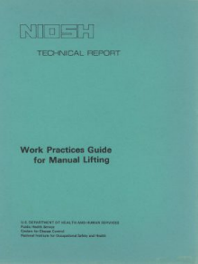
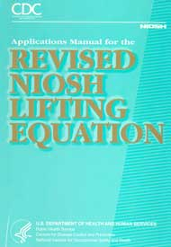
We noted that a number of Lifting Calculators and Guidelines have been developed to analyze lifting tasks. One of the first guidelines was the NIOSH (National Institute for Occupational Safety and Health) Work Practices Guide for Manual Lifting published in 1981 with a Revised Guide published in 1994.
A mathematical formula to predict how much a person can safely lift was introduced in the Guide.

Lifting Guide Criteria
Four criteria were studied to develop the original Guide:
- Epidemiology – Identification of incidence, distribution and potential controls for illness and injury in a population.
- Biomechanical – Study of the impact on the musculoskeletal structure, (particularly the low back) from lifting.
- Physiological – Study of the body’s metabolic and circulatory responses to lifting.
- Psychophysical – Studies performed to quantify the subjective tolerance of people to the stresses of manual material handling.
I would encourage you to read the Guides if you are interested in an in-depth look at the factors. They are readily available on-line.
1991 Version
https://www.cdc.gov/niosh/docs/81-122/pdf/81-122.pdf?id=10.26616/NIOSHPUB81122
1994 Version
https://www.cdc.gov/niosh/docs/94-110/pdfs/94-110.pdf?id=10.26616/NIOSHPUB94110

Lifting Scenario
To gain an appreciation of the nuts and bolts of assessing manual material handling operations, let’s work on developing a list of parameters that influence how much a person can lift based on our experiences of lifting.
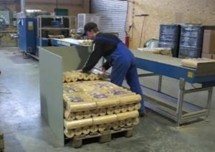
For our lifting scenario, imagine we are assessing a warehouse worker palletizing boxes coming off of a conveyor line by loading them onto a pallet.
The manual handling tasks are repetitive (handling one box every minute) and the worker starts with a row of boxes on the pallet and then builds up box levels to about a five-foot height (shoulder level).

Potential Lifting Factors
What are the factors that influence the worker’s performance? Make it personal by imagining you are doing the material handling or even better yet, imagine your mother is palletizing the boxes!
I’ll kick off a brainstorming session by thinking about the last time I was lifting some bags of sand into the bed of my truck at the big box store. When I reached out to pick up a bag, the farther away I reached, the heavier the bag seemed to get! This is a phenomenon we’ve all experienced.
Let’s name this factor Horizontal Distance and define it as, “How far away from our body is the item or box when we lift it; the farther away the greater the stress into the body.”

Brainstorm – Potential Lifting Factors
Brainstorm – list as many factors as you can think of that will influence the palletizing operation.
Horizontal Distance – how far away from our body is the box when we lift it; the farther away the greater the stress into the body

Potential Lifting Factors
How did you do? Check out this list.
- Horizontal Distance – how far away from our body is the box when we lift it; the farther away the greater the stress into the body
- Frequency – how often do we have to lift the box; how many times per minute
- Duration – over how long a period of time during the shift does the lifting occur; less than an hour, one to two hours, two to four hours, more than four hours
- Spine Twisting – does twisting or rotating of the spine (of the lower back particularly) occur to perform the lift
- Vertical Distance Origin – how high the box is from the floor at the start of the lift; at higher than mid-chest level the greater the stress on the body to handle the load
- Vertical Distance Destination – how high the box is from the floor at the end of the lift; at lower than waist to mid-chest level the greater the stress on the body to handle the load
- Item/Box Size – is the item or box large and unwieldy, out of balance, difficult or even impossible to hold close the body thereby increasing the horizontal distance
- Grip on the Box – is the box easy to grip with handholds/handles or hard to grip with no handholds and maybe even slippery
- Actual Object Weight – how much does the box weigh or what is the range of weights if the boxes vary in weight.
You probably came up with many if not all of the factors and when you reflect on the Ergonomics Principles found in the Introduction to Ergonomics Track you can see how these factors influence lifting performance.

Simplified Lifting Calculator
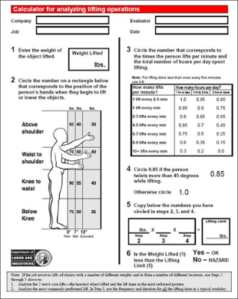
If we compare what we came up with in our brainstorming session to the NIOSH Work Practices Guide for Manual Lifting (Revised) we would see these are the primary parameters in the Guides.
Refer to the Guides if you would like more details. For our purposes, we’ll introduce a simplified version of the lifting calculator.
The States of Washington and Oregon Departments of Labor and Industries developed a version of the NIOSH Work Practices Guide for Manual Lifting. It’s called the LNI Lifting Calculator.
A few issues to be aware of when you use the LNI lifting calculator include:
- The estimated Lifting Limit’s based on the predicted capability of healthy adults to handle the weight; this includes about 95% of healthy males and about 75% of healthy females. There certainly are some individuals who can safely handle more than the predicted Lifting Limit.
- Stature of the individual is not considered in the calculation.
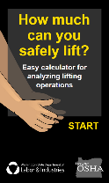
- Gender of the individual is not considered in the calculation.

LNI Lifting Calculator Online App
The LNI Lifting Calculator is available as an online app and I encourage you to check it out at https://osha.oregon.gov/OSHAPubs/apps/liftcalc/lift-calculator.html.

Manual Material Handling Basic Criteria
So, in overview, the LNI Lifting Calculator considers basic criteria of the manual material handling event:

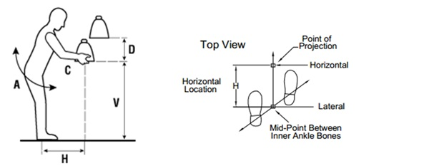
Actual Object Weight
Know the actual weight of the object. If a range of weights is noted; for example, 30 to 40# (13.5 to 18.1 kg), use the higher value in your calculations because it would be the “worst case”.

Horizontal Distance (H)
How far from the body is the object being handled?
The farther away, the longer the lever arm and the more stress into the body.
Estimating Horizontal Distance (H) can be a little tricky. The horizontal location is determined by measuring the distance between the point projected on the floor directly below the mid-point of the hands grasping the object (center of mass), and the mid-point of a line between the inside ankle bones as pictured.
The LNI Lifting Calculator uses predetermined Horizontal Distance values of: 0”, 7” or 12” (0 cm, 18 cm or 30 cm).

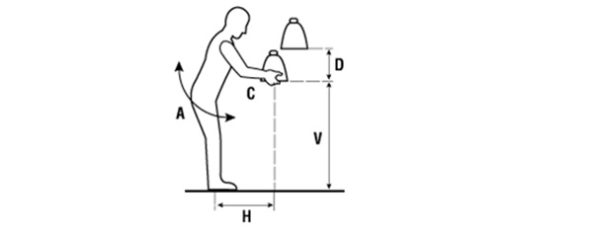
Vertical Position
At what level from the floor is the object being handled?
The farther away from the Optimal Lifting Zone (about waist level) the more stress into the body.
The vertical location is measured from the floor (or standing surface) to the vertical mid-point between the hand grasps as defined by large middle knuckle of the hand.
You may need to determine two Vertical Position measurements (V is the origin position and V + D is the destination position) and perform two calculations.

Frequency and Duration
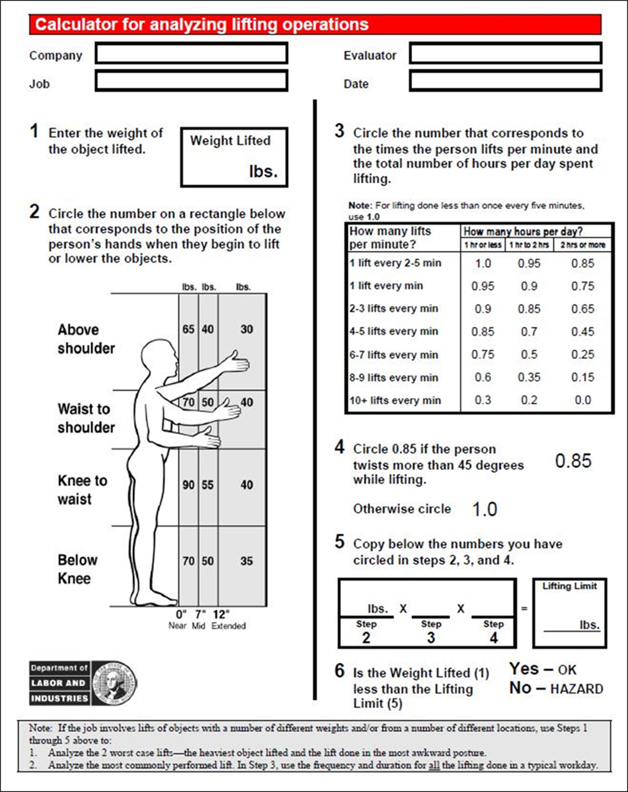
How often and for how long is the object being handled?
From the physiological fatigue standpoint, once every five minutes is dramatically different than 10 times per minute. Frequency has a huge impact. Frequency is categorized as lifts per minute. Look at the LNI Lifting Calculator Worksheet to see the categories of ‘How many lifts per minute’.
Duration is how long throughout the shift the handling is occurring? Over the course of the shift is the manual handling occurring for an hour total or two or the entire shift?
Longer duration is related to increased exposure to stress and results in lower weight limits.

Relationship between hours/day and multiplier.
Look at the LNI Lifting Calculator Worksheet to see the relationship between the hours/day and the multiplier. For example, for one lift occurring every 2-5 minutes at a cumulative duration of one hour or less in the shift, the multiplier is 1.0 and has no impact on the calculation.
On the other end of the spectrum for 10+ lifts occurring every minute at a cumulative duration of two hours or more in the shift, the multiplier is 0.0 and essentially indicates this lift should not be performed.
Then you’ll see the multiplier is on a sliding scale between these two points.

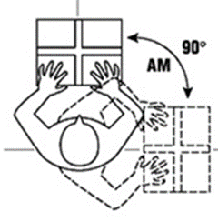
Spine Rotation
Is spinal rotation occurring during the lift?
Rotation of the spine, particularly with forward bending when lifting has been determined to result in significant shear and compression force into the spine.
Estimate spine rotation as the angle between the shoulders and hips from origin to destination of the lift. For spine rotation more than 45 degrees, the multiplier is 0.85.

Object size and grip
What shape and size is the object and how well can it be gripped? Smaller, well-balanced objects with handholds are easier to handle. The 1994 revised NIOSH Work Practices Guide for Manual Lifting added a hand-to-container coupling factor.
The LNI Lifting Calculator does not include a hand-to-container factor; if you identify this as an issue you’ll want to make note of this and perhaps decrease the recommended weight or recommend a change in object size or grasping.

LNI Lifting Calculator Worksheet
We’ll go through the LNI Lifting Calculator Worksheet so you can see the underlying strategy it makes use of. Take an overview look at the form.
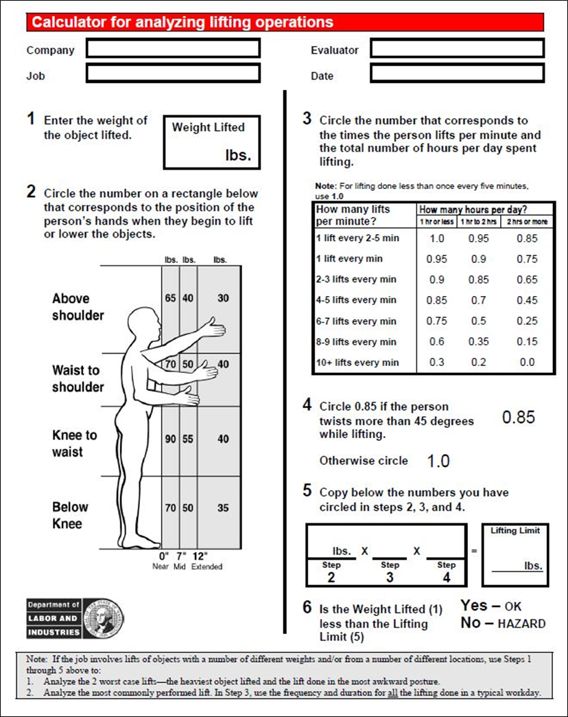

Manual Material Handling Case Study – Handle Speaker

Handle Speaker Background
Let’s work on a material handling case study to get a feel of how to use the LNI Lifting Calculator. Sound technicians at a company are responsible for setting up speaker systems on-site at various venues. Here are the specifics:
- Speaker weight is 45# (20.5 kg)
- Speaker is lifted from the floor and placed on the top of a stand (about 60”/152 cm) off the ground)
- Duration is for one hour or less/day
- Frequency is 1 lift/min
We need to perform the calculation twice; first for the lift from the floor and second for the speaker lift and placement on the stand. Let’s check out the video.
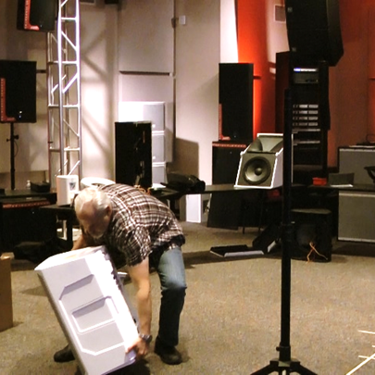 | 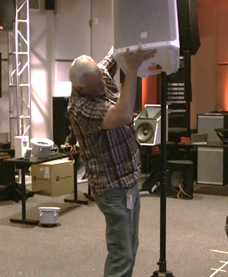

Lift from Floor
Let’s do the Lift from Floor calculation first.  - The Weight Lifted is 45# (20.5 kg).  - Hand Position is Below Knee at 7” (18 cm); you’ll see the 50# (22.7 kg) box is checked.  - Lifts/min is 1 lift per minute.  - Hours/day is 1 hr or less per day. So, the appropriate box is checked; the multiplier is 0.95.  - Twists more than 45 degrees: the answer is no. So, the 1.0 multiplier box is checked.  Next, we do the math:  50# (22.7 kg) x 0.95 x 1.0 = 47.5# (21.5 kg).  Is the Weight Lifted (45#/20.5 kg) less than the Lifting Limit (47.5#/21.5 kg).  It’s, so we answer YES – OK. | 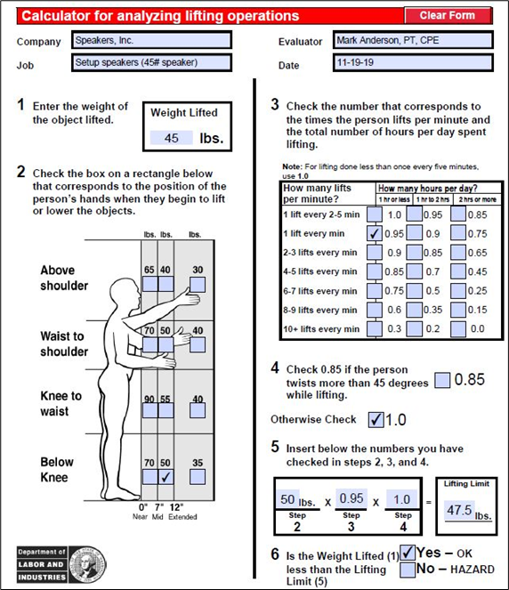

Lift to Stand
Now, let’s do the Lift to Stand calculation.  - The Weight Lifted is still 45# (20.5 kg).  - To place the speaker on the stand the Hand Position is Above Shoulder at 7” (18 cm) and you’ll see the 40# (18.1 kg) box is checked.  - The Lifts/min is still 1 per minute.  - The Hours/day is still 1 hr or less per day.  - Now we do see twisting more than 45 degrees and the 0.85 multiplier box is checked.  Doing the math we get:  40# (18.1 kg) x 0.95 x 0.85 = 32.3# (14.7 kg).  Is the Weight Lifted (45#/20.5 kg) less than Lifting Limit (32.3#/14.7 kg)?  The answer is NO – Hazard. | 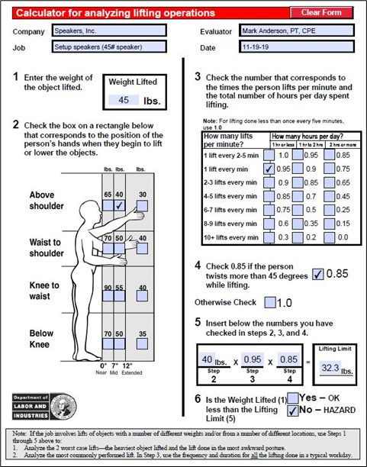

Manual Material Handling Controls
Some type of manual material handling control is recommended. Take a moment and list some options.
What did you come up with? Options could include:
- Two-person lift policy
- Mechanical lifting device
- Worker body mechanics and technique training
- Functional capacity testing to identify if a particular individual has the functional capacity to safely handle the lift or perhaps some other options.

Manual Material Handling Assessment Practice
To gain additional practice in using the LNI Lifting Calculator, download the Manual Material Handling Case Study.
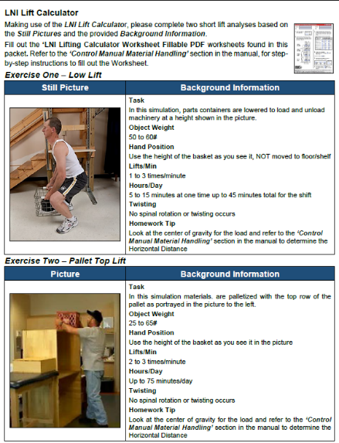
Here are some tips:
- Use the LNI Lifting Calculator Worksheet Fillable PDF (from your training materials) for the assignment. You can certainly check out the on-line version we discussed; however, we would encourage you to use the Worksheet to better understand how the calculator works.
- Review the basic criteria of the manual material handling event.
- Carefully read the instructions to get all the details you need to complete the exercise.
- If a range of weights is noted; for example, 30 to 40#/13.6 to 18.1 kg, use the higher value in your calculations because it would be the “worst case”.
Please complete the Manual Material Handling Case Study.

Manual Material Handling Guidelines
Now that you have an understanding of available assessment tools, let’s detail specific issues to identify and provide guidelines for mitigation efforts.
Take a look at the Manual Material Handling Checklist. A summary of the Guidelines includes:
- Eliminate (as feasible) manual handling by using mechanical handling equipment (forklifts, powered lifts, etc.).
- Reduce the physical stress of manual handling by using manual handing equipment (carts, two-wheelers, etc.).
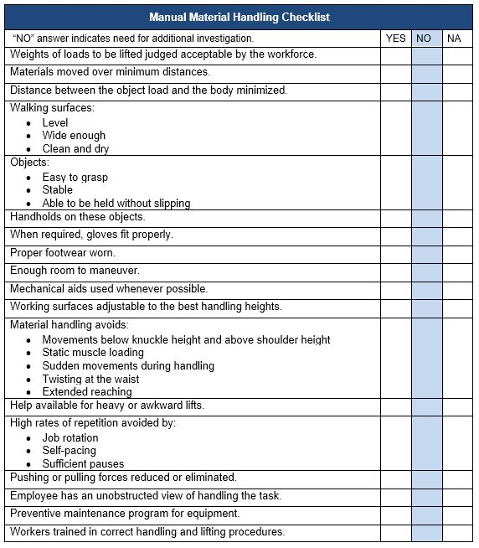

MMH Intervention strategies
MMH intervention strategies to control force levels related to the weight of the load include:
  - Design job to reduce static muscle loading. (Provide jigs, fixtures, clamps, spot welds, etc. to hold work object.)
  - Workers learn how to better control static muscle loading. (Body mechanics, stretching, etc.)
  - Make use of mechanical devices, hoists, lifts, etc. to eliminate manual lifting.
  - Slide rather than lifting the weight.
  - Eliminate the effect of gravity by counterbalancing the weight, a method commonly used with tools.
  - Remove physical barriers, thereby reducing the horizontal distance (long lever arm).
  - Relocate storage heights with heavier objects stored between mid- thigh and waist height.
  - Work with vendors to provide material either in smaller unit weights (e.g., 50 pounds, rather than 100 pounds) or in bulk that requires handling with mechanical means.
  - Provide adjustable height surfaces (e.g., scissors tables) to maintain desired height of material.
  - Reposition the worker to provide greater mechanical advantage, e.g., use body weight rather than musculoskeletal strength.
  - Reposition the work material, e.g., bring parts and tools within reach envelope; place bin on a bin tipper or provide side drop-down bins
  - The safest lift of all is the one that does not occur. Whenever possible slide objects rather than lift them. Friction between the surface and object may be a problem. Friction can by decreased by:
    - Line storage shelves with decreased friction liners (e.g., Teflon sheets).
    - Spray-on products will reduce friction (may cause a toxic substance problem.)
  - Use roller conveyor systems to transport materials.
  - Maintain the quality of floor conditions to eliminate cracks and general deterioration.
  - Use appropriate type and size of casters or wheels as original equipment or retrofit, depending on floor type.

Recommended Dimensions for Lifting Comfort Zone
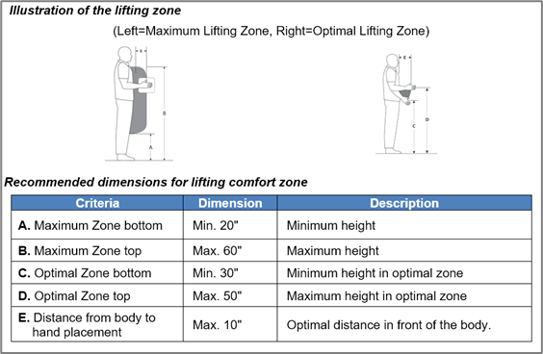

Manual Material Handling Checklist
Take a look at the Manual Material Handling Checklist as needed for the general ergonomics analysis process.

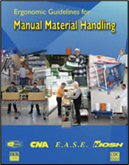
NIOSH Ergonomics Guidelines for Manual Material Handling
Check out the NIOSH Ergonomics Guidelines for Manual Material Handling.
https://www.cdc.gov/niosh/docs/2007-131/default.html
Another good resource is the Canadian Centre for Occupational Health and Safety.
https://www.ccohs.ca/oshanswers/ergonomics/mmh/
The OSH Answers Fact Sheets on Manual Material Handling are informative.

Mechanical Handling Equipment (MHE)
What is the safest lift that can be accomplished? It’s the one not accomplished!
While this may be a bit of a trick question, the answer makes good sense. In other words, the use of mechanical handling equipment whenever feasible, rather than manual handling is good ergonomics. A wide variety of MHE types, configuration and capabilities exist:
- Pallet jacks
- Overhead cranes
- Forklifts
- Vacuum/suction lifts
- Other

Material Handling Case Study
Let’s go through one last MMH Case Study. Take a look at the video. What do you think? Is this a safe and productive way to do this job?
The worker is bending over to reach into the container. This could result in an injury as well as negatively impact quality and productivity.
Brainstorm on Potential improvements. Do any improvements come to mind to accomplish this change?
Spend a moment and list your ideas:
1. __________________________________
2. __________________________________
3. __________________________________
What did you come up with?
Take a look at this video clip. A powered, employee-controlled, height-adjustable container lift was installed. This was probably one of your ideas! Now the worker can control the height of the container so he can work in a much improved position. You just used ergonomics to improve both the safety and productivity of the employee.

Ergonomics and Manual Material Handling
Manufacturing, office, warehouse, health care; no matter what work environment in which you apply ergonomics principles, controlling manual material handling is an integral part of a safe and productive workplace.
I hope our discussion on Manual Material Handling assessment and control methods has been informative for you.

Summary and Thanks!
Thanks for completing the Ergonomics Manufacturing Track!
While the workstations, tools and equipment that make up manufacturing workplaces have a common thread in terms of ergonomics principles, you’ll find they each have their own unique attributes in terms of how to apply the ergonomics principles.
For me, working in the manufacturing ergonomics realm has been very rewarding; I particularly have enjoyed the collaboration among all of those involved. You’ll make a significant positive difference in the health, safety and productivity of those working in manufacturing.
Please check out the other ERGONOMICS ON-DEMAND Tracks that can add value to your practice!
Thanks for your time and attention!

