Grip and Hand Strength Checklist
Company: | Click or tap here to enter text. | Workstation Name: | Click or tap here to enter text.
Prepared by: | Click or tap here to enter text. | Department: | Click or tap here to enter text.
Date: | Click or tap to enter a date. | Document Number: | Click or tap here to enter text.

“NO” answer indicates need for additional investigation.
- Level of grip and hand strength required to perform the tasks has been identified and is within acceptable limits. | Select YES or NO.

Grip and Hand Strength Illustrations
The following guidelines provide criteria for various grasps and hand motions. The values assume neutral postures and easy to grip surfaces. Note: Repetitive (Rep) is 2 or more times per minute, Infrequent (Inf) is less than 2 times per minute.
Criteria | Freq | Force (Max) | Description
A. Power Grip | Rep | 4 lbs. | Grasp with full hand, typically with thumb overlapping the first finger. | 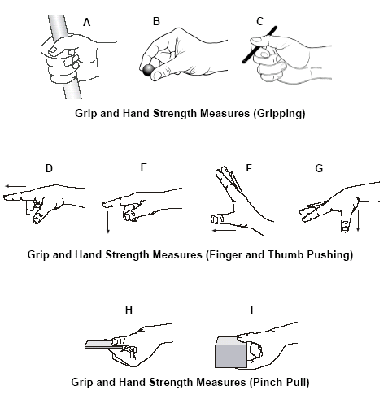
 | Inf | 20 lbs.
B. Pinch Grip | Rep | 2 lbs. | Grasp with finger tips only, typically with fingers and thumb not touching.
 | Inf | 9 lbs.
C. Key Grip | Rep | 2 lbs. | Grasp with thumb and side of the first finger.
 | Inf | 10 lbs.
D. Push forward with Index Finger | Rep | 3 lbs. | Push forward with pad of index finger.
 | Inf | 15 lbs.
E. Push down with Index Finger | Rep | 3 lbs. | Push down with pad of index finger.
 | Inf | 15 lbs.
F. Push Forward with Thumb | Rep | 4 lbs. | Push forward with pad of thumb
 | Inf | 21 lbs.
G. Push Down with Thumb | Rep | 2 lbs. | Push down with pad of thumb.
 | Inf | 10 lbs.
H. Pull with Pinch Grip 0.1” | Rep | 2 lbs. | Pull toward body with pinch grip using thumb and index finger.
 | Inf | 10 lbs.
I. Pull with Pinch Grip 1.6” | Rep | 2.5 lbs. | Pull toward body with pinch grip using thumb and index finger.
 | Inf | 13 lbs.

