Seated Workstation Guidelines
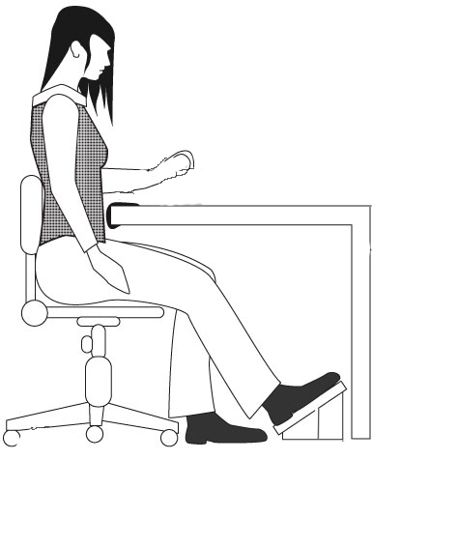 | - All items required for the work should be located within the reach zones (not on the floor).  - Handling of items should be limited to no more than 6 inches above the work surface.  - Large forces (> 10#) should not be required.  - A good chair with a high degree of adjustability should be provided.  - Proper clearance beneath the work surface for legs and toes is necessary.  - Sufficient thigh clearance between the seat pan and the underside of the work surface is required.  - Reaches above shoulder level should be kept to a minimum.  - Padded forearm rests should be provided along the edge of the table.  - Foot rests, preferably adjustable, should be provided.  - Workplace layout should minimize twisting at the waist.  - Seated work height should be based on resting elbow height with relation to the work surface.

Illustration of seated work surface heights
(Left to right: precision work, light assembly, manual work)
