Workstation Selection Characteristics for Sitting and Standing Workbenches
Should the workbench be used seated, standing or allow for a sit/stand configuration?
In terms of worker position, the type of work performed generally determines workstation design: seated or standing. Apply the specific workstation characteristics noted in the table to help select the appropriate working posture for various tasks. When both seated and standing conditions apply, design according to the standing workstation criteria.
Workstation Characteristic | Configuration
 | Sitting |  | Standing
 | 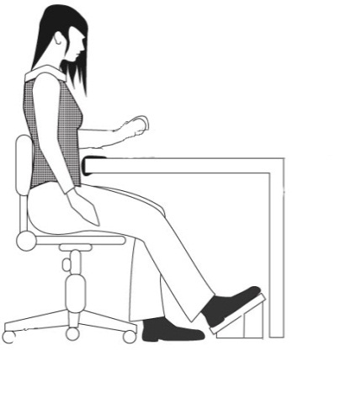 |  | 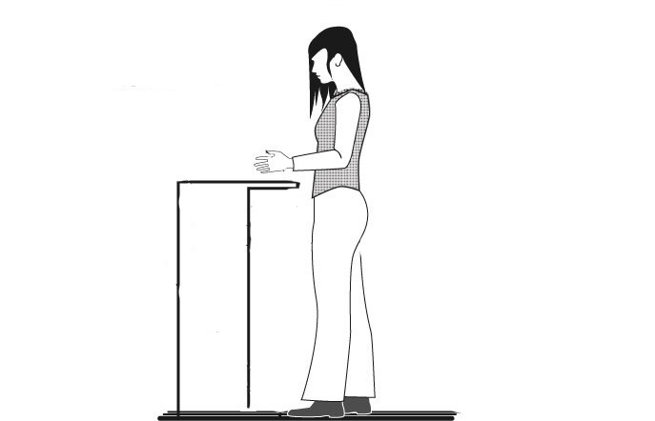
Side-to-Side Movement | Within seated workspace |  | Frequent movement outside of comfort zone
Task Duration | Sustained, > 5 minutes at one time |  | Intermittent, < than 5 minutes at one time
Hand Heights | < 6” above surface |  | > 6” above surface
Weight Handled | < 5 lbs. |  | > 5 lbs.
Reaches | Within Comfort Zone (within 12”) |  | Forward reaches of > 12”
Forces Exerted | < 5 lbs. |  | Downward forces of > 5 lbs.
Clearance | Seated clearances for legs and feet are met |  | Knee clearance < 18” or  foot clearance < 22”
Manipulation | Fine manipulation |  | Fine manipulation not required
Use of Feet | Foot pedals are used |  | No foot pedals are used
Seated workstations |  | Standing workstations
A high degree of precision is required (fine manipulation and visual attention).  Feet are used for control operations.  All tools and materials can be easily supplied and handled within the reach envelope.  The job consists of long work periods (over 5 minutes).  Hands are not required to work more than 6 inches above the work surface.  Low forces are exerted (weights are less than 10 lbs.). |  | The work requires frequent high, low, or extended reaches outside of the comfortable arm reach envelope (more than 12 inches).  Frequent walking is required.  Large forces are exerted or heavy weights are handled (objects weighing >10 lbs.).  It is impossible to provide leg room for a seated operator (less than 18 inches of knee clearance and less than 19-24 inches of foot clearance).  Frequent movement between various workstations (every 5 minutes or less).  Intermittent task duration.  Items are handled more than 6 inches above the work surface.  Downward forces of more than 10 lbs are required.

