Standing Workstation Specifications
Illustration of Standing Workstation Dimensions
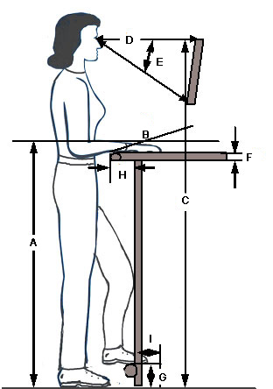

 | Criteria | Dimension |  | Description
 | A. Height | Adjustable Height Workbench | Fixed Height Workbench | Distance from floor to height on the workbench at which the hands will accomplish the task.  NOTE: This may NOT be the actual height of the worksurface. Dependent on size and placement of the object, etc. on the worksurface. Defined as the ‘hand work height”
 | - Precision | 38” to 48” | 44”
 | - Light assembly | 36” to 46” | 40”
 | - Heavy assembly | 26” to 40” | 36”
 | B. Inclination | Adjustable from -5° to 35°  ( -) = away from operator  (+) = towards operator |  | Inclination of work surface.  Inclined work surface will present the materials closer in the user's reach zone.
 | C. Screen height | Adjustable screen: 56”-72"  Fixed: 54” |  | Floor to top of the screen.
 | D. Viewing Distance | 18-30" |  | Distance from eyes to screen.
 | E. Viewing Angle | 0° - 35° |  | Adjusted by user as indicated
 | F. Worksurface edges | At least 1/8" radius on the worksurface edge |  | Eliminate any issue of contact stress.
 | G. Foot rest height | Min 4"” off the floor |  | Floor to foot position.
 | H. Knee clearance | Minimum of 5” |  | Allows for knee clearance.
 | I. Foot clearance | Minimum of 4" |  | Allows for foot clearance.

