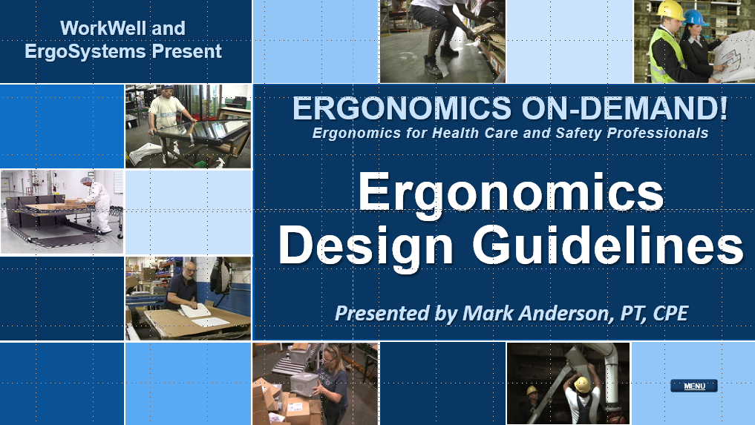

Developed by:
Mark A. Anderson, MA, PT, CPE
Certified Professional Ergonomist
Physical Therapist
ErgoSystems Consulting, LLC.
7421 West Shoreline Drive
Waconia, MN 55387
Voice: 952-401-9296
Mark.Anderson@ergosystemsconsulting.com
www.ergosystemsconsulting.com

The information contained in this training workbook has been developed in good faith and is believed to present good ergonomics principles and practices. ErgoSystems Consulting, LLC and all other participating organizations make no representations or warranties as to the completeness or accuracy of the materials thereof. Persons using this information must make their own determination as to its suitability for their purposes. ErgoSystems Consulting, LLC and all other participating organizations are in no way responsible for damages of any nature resulting from the use of this information.

Copyright 1997 to 2021 ErgoSystems Consulting, LLC., All Rights Reserved Version 2_04222021

Table of Contents
Ergonomics Design Guidelines Track 3
Welcome! 3
Questions, Questions, Questions! 3
Ergonomics Defined 3
Ergonomics Design Guidelines 3
Table of Contents 3
Accessing the Ergonomics Design Guidelines 5

Ergonomics Design Guidelines Track

Welcome!
Welcome to the Ergonomics Design Guidelines Track!
Hello everyone, I’m Mark Anderson. I am a Certified Professional Ergonomist and Physical Therapist with more than 30 years of experience working with ergonomics in a wide variety of settings.

Questions, Questions, Questions!
One of the things I have discovered in working in ergonomics on an on-going, day-in, day-out basis is you need to be able to answer questions like:
- How high should that workbench be?
- We need a transport cart, what specifications does it need to meet?
- Where should we position the foot and hand controls for that machine?
- How should we position the touch screen monitors on the production line?
- How high should the conveyor belt be?
- How much force is needed to grip a tool and what is acceptable?
- How much weight can a worker reasonably lift?
- What clearance do we need for the operator’s feet and legs at the workbench?
- We are setting up a storage racking system, how should we adjust the shelf heights?
- Honestly, the list of questions goes on and on!
I suspect you are getting the point I am making. You become the go-to resource in ergonomics workstation, tool and equipment design.

Ergonomics Defined
In the Introduction to Ergonomics Track we defined ergonomics in the systems design context as:
Optimizing all aspects of job performance - safety, quality and productivity - accomplished through the appropriate DESIGN AND USE of work processes, workstations, tools and equipment and the overall organization of work.
Design is a critical word in the definition. Over the past 30 years I have been compiling answers to at least some of the questions. Believe me I am still learning everyday as something new pops up!
Honestly, that is what keeps it interesting to me. Like you, I enjoy solving problems and seeing the positive results.

Ergonomics Design Guidelines
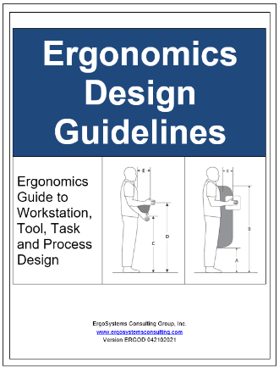
At any rate, I have put together a series of Checklists, Guidelines and Specifications for workstations, tools and equipment in terms of ergonomics.
The Guidelines are available to you as a separate document you can print out and/or access as you need.

Table of Contents
Looking at the Table of Contents for the Guidelines you will see a wide range of topics ranging from Carts to Chairs/Stools to Controls to Conveyors to Fixtures to Grip and Hand Strength to Microscopes to Manual Material Handling to a whole host of Seated and Standing Workstation Guidelines and Specifications.
Table of Contents

Welcome to Ergonomics Design Guidelines  Primary Ergonomics Risk Factors  Primary Ergonomics Principles  Carts  - Cart Checklist  - Casters – Additional Information  - Handles – Additional Information  - Technique – Additional Information  - Shelves – Additional Information  Chairs/Stools  - Chair/Stool Checklist  Computer Workstation Guidelines  - Computer Equipment (keyboard, mouse, monitor, touch screen) Checklist  Contact Stress:  - Contact Stress Checklist  - Contact stress – sharp edge  - Contact stress – hard surface  Controls – Hand and Foot  - Hand and Foot Controls Checklist  - Recommended Specifications for Control Location  Conveyors  - Conveyor Checklist  Displays/Monitors  - Displays/Monitors Checklist  - Recommendations for Display Location – Seated and Standing  Environment  - Auditory, Temperature and Visual Checklist  - Auditory  - Temperature  Fixtures  - Fixtures Checklist  Floor: Anti-Fatigue Mats/Shoe Insoles  - Anti-Fatigue Mats/Insoles Checklist | Grip and Hand Strength  - Grip and Hand Strength Checklist  Hand Tool Design and Selection  - Tools: Checklist  - General tool guidelines  Machine Clearance and Maintenance Accessibility Guidelines  - Machine Clearance and Maintenance Accessibility Checklist  - Accessibility  - Access Doors/Ports  - Fasteners  - Accessibility for Maintenance  Manual Material Handling Guidelines  - Manual Material Handling Checklist  Microscopes/Magnifiers  - Microscopes/Magnifiers Checklist  Neutral Posture  Reach Zones (Comfort and Functional)  - Comfort Reach Zone  - Functional Reach Zone  Shelves and Racks  - Shelves Checklist  Workstation Types and Characteristics  - Workstation Checklist  - Workstation Selection Characteristics for Sitting and Standing Workstations  - Seated Workstation Guidelines  - Seated Workstation Specifications  - Standing Workstation Guidelines  - Standing Workstation Specifications  - Sit/Stand Workstation Guidelines  Glossary

Accessing the Ergonomics Design Guidelines
When thinking how best to introduce the Ergonomics Design Guidelines to you, I knew for sure I did NOT want to go through each and every Checklist and Specification with you!
I don’t think I would be awake at the end and I’m sure you would not be.
Instead, I would encourage you to browse the Ergonomics Design Guidelines to get a sense of what is included. You may have noticed in the other Tracks, I reference the Guidelines as appropriate. As you continue to work in ergonomics, please access the Guidelines as you run across questions that you need to answer.
I can’t guarantee every question is answered, but I hope it provide some answers. Remember to always use your professional judgement when making use of the information.
Thanks for your time and attention!

