Ergonomics Design Guidelines
Ergonomics Guide to Workstation, Tool, Task and Process Design | 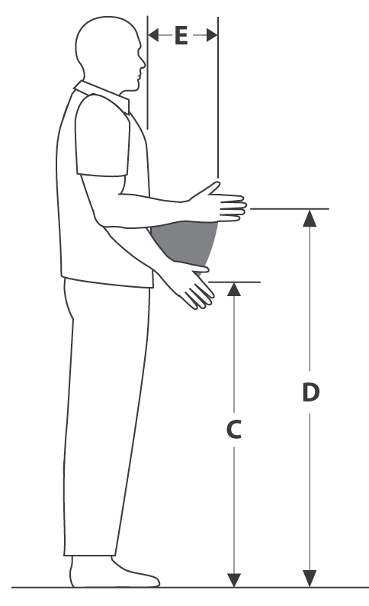 | 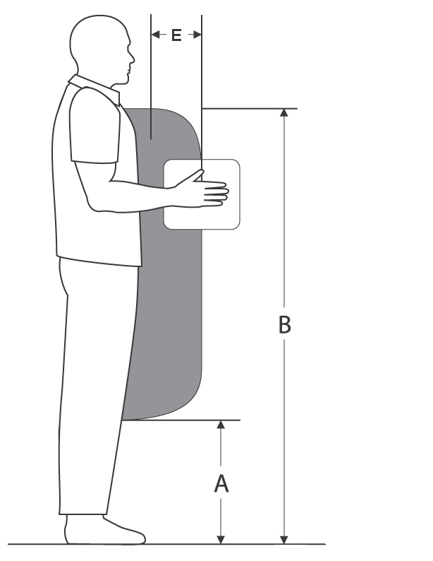

ErgoSystems Consulting, LLC.
www.ergosystemsconsulting.com
Version ERGOD 042202021

Developed by:
Mark A. Anderson, MA, PT, CPE
Certified Professional Ergonomist
Physical Therapist
ErgoSystems Consulting, LLC.
7421 West Shoreline Drive
Waconia, MN 55387
Voice: 952-401-9296
Mark.Anderson@ergosystemsconsulting.com
www.ergosystemsconsulting.com

The information contained in this training workbook has been developed in good faith and is believed to present good ergonomics principles and practices. ErgoSystems Consulting, LLC and all other participating organizations make no representations or warranties as to the completeness or accuracy of the materials thereof. Persons using this information must make their own determination as to its suitability for their purposes. ErgoSystems Consulting, LLC and all other participating organizations are in no way responsible for damages of any nature resulting from the use of this information.

Copyright 1997 to 2021 ErgoSystems Consulting, LLC
All Rights Reserved

Table of Contents
Welcome to Ergonomics Design Guidelines 5
Checklists and Specifications 5
Ergonomics Risk Factors 5
Ergonomics Scientific Foundations 5
Ergonomics Principles 5
Bottom line 5
Carts and Casters 6
Carts Checklist 6
Casters – Additional Information 7
Handles – Additional Information 7
Technique – Additional Information 7
Shelves – Additional Information 8
Chairs/Stools 9
Chair/Stool Checklist 9
Computer Workstation Guidelines 10
Computer Equipment (keyboard, mouse, monitor, touch screen) Checklist 10
Contact Stress 11
Contact Stress Checklist 11
Contact stress – sharp edge 11
Contact stress – hard surface 11
Controls – Hand and Foot 12
Hand and Foot Controls Checklist 12
Recommended Specifications for Control Location 14
Conveyors 15
Conveyor Checklist 15
Displays/Monitors 16
Displays/Monitors Checklist 16
Recommendations for Display Location – Seated and Standing 16
Environment 17
Auditory, Temperature and Visual Checklist 17
Auditory 17
Fixtures 18
Fixtures Checklist 18
Fixture 18
Jigs 18
Primary purpose 18
Types of Fixtures 18
Floor: Anti-Fatigue Mats/Shoe Insoles 19
Anti-Fatigue Mats/Insoles Checklist 19
What are anti-fatigue mats? 19
What is the impact on the body of long-term standing? 19
When should anti-fatigue mats be used? 19
Can an anti-fatigue mat be too soft? 20
How long do anti-fatigue mats last? 20
Can carts be rolled on anti-fatigue mats? 20
Grip and Hand Strength 21
Grip and Hand Strength Checklist 21
Grip and hand strength criteria 21
Hand Tool Design and Selection 22
Tools: Checklist 22
General tool guidelines 22
Machine Clearance and Maintenance Accessibility Guidelines 23
Machine Clearance and Maintenance Accessibility Checklist 23
Accessibility 23
Access Doors/Ports 23
Fasteners 23
Accessibility for Maintenance 24
Manual Material Handling Guidelines 25
Manual Material Handling Checklist 25
Microscopes/Magnifiers 27
Microscopes/Magnifiers Checklist 27
Neutral Posture 28
Reach Zones (Comfort and Functional) 30
Comfort Reach Zone 30
Functional Reach Zone 30
Shelves and Racks 31
Shelves and Racks Checklist 31
Workstation Types and Characteristics 32
Workstation Checklist 32
Workstation Selection Characteristics for Sitting and Standing Workstations 32
Seated Workstation Guidelines 35
Seated Workstation Specifications 36
Standing Workstation Guidelines 37
Standing Workstation Specifications 38
Sit/Stand Workstation Guidelines 39
Glossary 40

Welcome to Ergonomics Design Guidelines
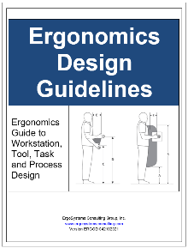
Ergonomics Reference Guide provides ergonomics checklists, specifications and supporting information to assist in designing tasks, tools, equipment and workstations to enhance productivity and quality of the work product and reduce the risk of injury in the workplace. This information is provided within the context of professional judgment rendered on the part of user.
Applying ergonomics principles will help ensure jobs are performed by workers in a safe, efficient and pain-free manner by:
- “Working smarter not harder.”
- “Fitting the task (i.e., tools, equipment, facilities, etc.) to the worker rather than forcing the worker to fit the task.”

Checklists and Specifications
All the Checklists and Specifications in the Ergonomics Design Guidelines are available as separate fillable documents in the Resources Section.

Ergonomics Risk Factors
Primary ergonomics risk factors in the workplace that contribute to decreased productivity and quality and increased work-related musculoskeletal disorders (WMSDs) include:
- Awkward and sustained postures
- Excessive forces imposed on the body or generated by the body
- Excessive frequency and duration of tasks
- Uncontrolled environmental factors (illumination, noise, thermal, ventilation, vibration)
- Uncontrolled perceptual demand factors (auditory, touch, visual)

Ergonomics Scientific Foundations
- Occupational Biomechanics
- Work Physiology
- Engineering Psychology
- Epidemiology
- Anthropometry

Ergonomics Principles

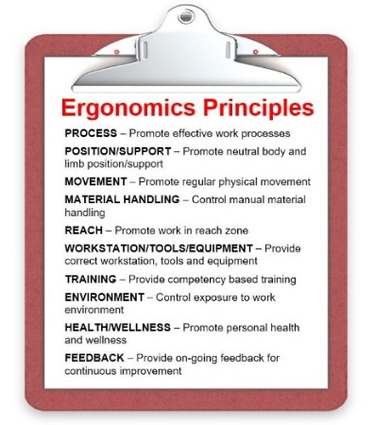
- Promote effective work processes
- Promote neutral body and limb position and support for body/limbs
- Promote physical movement
- Promote effect effective material handling
- Promote work in the user’s reach zone
- Provide correct tools, equipment and facilities
- Provide competency based training
- Control exposure to work environment
- Promote health and wellness
- Provide on-going feedback and follow-up

Bottom line
Bottom line . . . incorporating ergonomics principles into the design and use of tasks, tools, equipment and workstations will improve productivity and quality and reduce or eliminate work related injuries.
A more comfortable, safe and productive working environment is the end result!

Carts and Casters

Carts Checklist
“NO” answer indicates need for additional investigation. | YES | NO | NA
Dimensions: Cart width and depth appropriate to safely contain and transport materials.
Cart load capacity: Cart capacity matched to loaded cart weight.
Height – Fixed: Fixed height cart matches height of fixed height workstation.
- If used to transport between fixed height workstations and/or stage materials at workstations.
Height – Adjustable: Able to match cart height to varying height workstations; required cart height adjustment range has been determined.
- Use manual height adjustment cart for lighter weight materials (20 lbs. or less) and when minimal height adjustment (less than 6”) is needed.
- Use powered height adjustable carts for heavier materials (greater than 20#) that require greater than 6” height adjustment.
Height – Adjustable Spring Loaded: Automatically positions materials (of a consistent unit weight) at a predetermined unload height.
- Spring tension of cart height adjustment mechanism calibrated based on product unit weight.
Platform: Ensure cart platform allows for easy sliding of materials onto/off of the cart platform.
Casters/wheels: Cart has the appropriate casters/wheels for floor type and use of the cart.
Handles: Cart handle placement allows for upright body position when pushing/pulling cart.
Lip: Cart has a lip or other method to contain the materials during transport.
Cart loading: Cart is loaded in a safe manner (promote a stable cart center of gravity).
Technique: User adequately trained in handling of cart.
Shelves: If the cart has shelves, they are properly configured.
Powered vs. manual cart transport: Determination made if cart needs to be a powered transport cart or if manual transport is adequate.
- Consider powered cart when force to push/pull cart is greater than 40 lbs., distance is greater than 100 feet, cart is handled on a ramp, etc.
Floor surface: Floor surface provides for easy moving of the cart on the surface. This is in conjunction with proper casters/wheels.
Ramps: Determine if cart use will take place on ramps.
- Ensure safe handling of carts of ramps.

Casters – Additional Information

Required load capacity
- In general, each caster should have the capacity to support one-third of the total load weight; overloading, uneven floors and load distribution may place a heavier burden on one or more casters.

Mobility needs
- The larger the wheel size (and swivel radius), the greater the mobility.
- The type of bearing selected will also improve mobility and reduce rolling resistance.

Environmental conditions
- Check for dust, humidity and temperature extremes.
- Casters with sealed swivels are ideal in areas with sprays or wash-down requirements where there is lint or dust and where extreme quiet is essential.

Other application considerations
- Most casters are rated for "walking speed”.
- Higher speed applications require specialized casters to maintain load capacity and dissipate heat buildup.

Determine if caster brakes are needed
- If the cart can roll away when being loaded or stored the caster should have brakes.
- Ensure the brakes are easy to engage and release.

Swivel or fixed position
- Determine if swivel or fixed position swivel casters are needed.
- All four casters with swivel feature will be needed for improved maneuverability in a confined area.
- Two swivel and two fixed casters will be needed for cart transport over longer distances – this allows the cart to be moved in a straight line while still allowing for maneuverability around corners. Position the swivel casters on the handle end of the cart.
- Some casters are able to be locked in a fixed position and then released to swivel.

Handles – Additional Information
Cart handle placement allows for upright body position when pushing/pulling cart.
- Recommended fixed handle height is 36” to 38” – ideally needs to be suited to cart use and user population stature.
- Recommended adjustable handle height range is 36 to 46”.
- Ensure cart handle placement allows for normal stride when pushing/pulling cart (not in the way of the feet) – as possible, position the handle 6 to 8” away from the body of the cart.

Technique – Additional Information

Line of sight
- Ensure the cart and materials loaded will not restrict the line of sight of the user.
- If line of sight will be restricted, ensure a “spotter” is used.

One-person vs. two-person
Determine if the cart can be safely handled with one person or if two are needed.
- Based on force required to initiate and sustain cart movement.

e.g., force to push/pull cart is greater than 50 lbs., cart is handled on a ramp, etc.
- Also consider if the cart should be powered.

Push vs. pull
Typically pushing carts enables improved body mechanics technique than pulling
- Able to make use of “power position” when pushing
- Pulling technique generally places body (spine) in an out-of-neutral position

Exceptions to the rule do exist
- May pull cart over a rough surface or threshold rather than push
- May pull pallet jack rather than push it when traveling for longer distances

Shelves – Additional Information
If the cart has shelves, they are properly configured.
- For typical three shelf level cart: (assuming shelf levels at approximately 6”, 30” and 54” from the floor):

Place the heaviest items on middle shelf

Place lighter items on bottom and top shelves

As possible refrain from using bottom shelf on a regular basis – difficult to manually handle materials at this low level
- Ensure carts are appropriately rated for expected load.
- Loading of shelves must not make carts/shelves unstable.

Chairs/Stools

Chair/Stool Checklist
“NO” answer indicates need for additional investigation. | YES | NO | NA
Required: Determination made if a chair/stool is needed at the workstation. Refer to Workstation Types and Characteristics for guidelines.
Height adjustment range: Seatpan height adjustment range matches the worksurface height.
Worksurface height | Seat pan height (approximate adjustment range from floor to top surface of seat pan)
28” to 30” | 16” to 22”
31” to 33” | 19” to 25”
34” to 36” | 22” to 28”
37” to 42” | 25” to 35”

Adjustment features: Needed adjustment features have been determined. Features typically include:
- Seatpan height, tilt (including rocking tension) and depth.
- Back support height and angle.
- Armrest height, side-to-side and rotation (if armrests are included).
- Foot ring height adjustment for stools.
Casters: Appropriate casters for floor surface and use.
- Hard shell casters for carpeted floors.
- Softer, rubberized castes for hard surface floors (concrete, tile, etc.)
- Braking casters – if needed to limit chair from “scooting” away from user as they sit down. (Note: casters engage when the chair is NOT in use; in other words when the user is in the chair it WILL roll.
Base: Five leg base to minimize possibility of chair tipping.
Foot rest: Foot rest (separate from foot ring on the chair) available for foot support if feet are not on the floor once the seat pan height has been adjusted based on worksurface height.
- Typically, the Lyon Industrial Foot Rest is used (source: Staples).
Chair size: Overall chair size suitable for user body stature and size.
- May require petite or large/tall chairs for some users.
ESD and/or Clean room: Determination made if chair/stools needs to be ESD and/or clean room certified.
Training: User has been adequately trained in adjustment and use.
- Critical point – the best chair in the world has limited value with inadequate training.

Computer Workstation Guidelines

Computer Equipment (keyboard, mouse, monitor, touch screen) Checklist
“NO” answer indicates need for additional investigation. | YES | NO | NA
Keyboard: Positioned to allow for neutral body and extremity position within reach zone of user.
- Seated (height adjustable keyboard support surface): range of 23” to 32” from floor.
- Seated (keyboard height not adjustable): fixed height between 28 and 30” from floor.
- Standing (height adjustable keyboard support surface): range of 35” to 47” from floor.
- Standing (keyboard height not adjustable): fixed height between 40 and 42” from floor.
Mouse: Positioned to allow for neutral body and extremity position within reach zone of user.
- Keyboards available with integrated mouse (roller ball or touch pad).
- Range of 23” to 32” for height adjustable mouse support surface (if seated with feet on floor.)
- If mouse height is not adjustable, locate it between 28 and 30” high (if seated with feet on floor.)
Tray – Keyboard/Mouse: Support for keyboard/mouse positioned to allow for neutral body and extremity position within reach zone of user.
- See recommendations above for keyboard and mouse placement.
Monitor: Able to be positioned by user to allow for neutral head and neck position when the monitor is viewed. Refer to Displays for details.
Eyeglasses: Impact of eyeglasses (bifocals, progressive lenses, etc.) has been taken into account.
- e.g., use of bifocals where bottom part of lens is used to view the monitor can result in significant head tip up position with significant stress into neck.
- Solutions include:

Lowering monitor.

Progressive lenses, bottom part of lens is for reading hard copy material, middle for monitor viewing and top for distance viewing.

Computer glasses where prescription of entire lens is set for monitor viewing

Bifocals where bottom is set for reading and top is set for monitor viewing.
Touch Screen: Positioned to allow for neutral head/neck position when viewed and within reach zone (height and distance) of the user:
- If accessed when the user is standing, position fixed height touch screens so the middle of the screen is about 60” from the floor.
- If accessed when seated, position fixed height touch screens so the middle of the screen is 44” from the floor.

Contact Stress

Contact Stress Checklist
“NO” answer indicates need for additional investigation. | YES | NO | NA
Sharp edge contact stress: Identified and eliminated, solutions include:
- Ensure correct position relationship between user and workbench:

Workbench that is too high or low in relation to user can result in sharp edge contact stress.

Adjust position of user or workbench to alleviate the issue.
- Radius edge of workbench:

Minimum 1/8th inch is typical recommendation for edge radius to eliminate sharp edge contact stress.
Hard surface contact stress: Identified and eliminated, solutions include:
- Use anti-fatigue mats to reduce impact of hard surface contact stress.
- Use of proper foot wear is needed to reduce hard surface contact stress.
- Monitor condition of chair seatpan and back support cushions for wear and tear that reduces ability of cushion to provide relief from hard surface contact stress.
- Limit exposure to hard surface contact stress through job rotation strategies.

Contact stress – sharp edge
When the edge of a workstation, tool guard, etc. is in contact with the body in a concentrated manner contact stress – sharp edge is evident. Result can be damage to soft tissue at the area of contact stress due to decrease in blood flow to the area and to increase in mechanical pressure on soft tissue – muscle, tendon, nerve, blood vessel, etc.

Contact stress – hard surface
Sustained contact of a body part with a hard surface such as sustained standing sitting on a hard surface is defined as contact stress – hard surface. Result can be damage to the compressed tissue due to decreased blood flow to the area.

Controls – Hand and Foot
Refer to Checklist below and Recommended Specifications for Controls for additional details.

Hand and Foot Controls Checklist
“NO” answer indicates need for additional investigation. | YES |  | NO |  | NA
Foot Controls
Seated: Foot controls operated from a seated position. Avoid repetitive foot control use from a standing position.
On floor: Foot controls positioned on floor (rather than foot rest or other platform).
- If footrest is used, footrest large enough to allow for foot control and foot on footrest.
- Avoid having one foot higher than other.
Operator controlled: Operator controls positioning of footrest to provide optimal positioning and alternating use between right and left feet.
Hand Controls
Precision: Controls requiring precision or high-speed operation assigned to hands, rather than feet.
One major control: When only one major control operated by either hand or both hands, place in front of operator, midway between hands.
Handedness: Handedness is important only if the task requires skill or dexterity. If control requires fine adjustment, place control on right, most people (about 90% of population) are right-handed.
Valves: Locate manually operated hand control valves from 20 to 50 “(range of 30 to 40“ is preferred) above floor whenever possible so valve is accessible from a standing position and optimize the force that can be applied to operate the valve.
Levers: Levers requiring significant force (greater than 5 lbs. force) located at chest level for standing work (range of 46” to 56” from floor) and elbow level for seated work (seated with feet on floor, range of 26” to 32” from floor).
Levers: Levers installed so they move toward axis of body (rather than away from body) to reduce amount of tension on body.
Fine adjustment: When controls require fine adjustment, provide support for hand being used.
Finger operated: For finger-operated controls, provide an armrest, either as part of the seat or on the panel itself.
Emergency Controls (E-Stops)
Separate location: Emergency controls and displays physically separate from those used during normal operations.
Accessibility: Emergency controls placed in locations that are easily accessible.
Line of sight: Emergency controls and displays placed within 30⁰ of the operator’s optimal line of sight.
Special measures: Special measures (guards, color coding, etc.) provided for emergency controls to aid in identification and to prevent inadvertent operation.

Recommended Specifications for Control Location

Hand Control Location  (seated workstation) | Specification |  | Description
 | Max | Min
Vertical location of infrequently used controls. | 55” | 21” | Measurement is from floor to centerline of control.
Vertical location of infrequently used but critical controls (e.g. emergency stop). | 39” | 21” | Measurement is from floor to centerline of control.
Vertical location of frequently used controls. | 42” | 30” | Measurement is from floor to centerline of control.
Horizontal reach to infrequently used controls. | 22” | 9” | Horizontal reaches measured from shoulder joint to center of the hand.
Horizontal reach to frequently used controls. | 14” | 9” | Horizontal reaches measured from shoulder joint to the center of the hand.
Hand Control Location  (standing workstation) | Specification |  | Description
 | Max | Min
Vertical location of infrequently used and/or critical controls (e.g. emergency stop). | 65” | 33” | Measurement is from standing surface to centerline of control.
Vertical location of frequently used controls. | 50” | 37” | Measurement is from standing surface to centerline of control.
Horizontal reach to infrequently used controls. | 22” | 9” | Horizontal reach measured from shoulder joint.
Horizontal reach to frequently used controls. | 14” | 9” | Horizontal reach measured from shoulder joint.

Conveyors

Conveyor Checklist
“NO” answer indicates need for additional investigation. | YES | NO | NA
Configuration: Conveyor configuration (dimensions) based on amount and size of materials transported on conveyor to adequately convey and contain materials.
Height and reach: Conveyor height and reach allows operator to work from neutral position while standing:
- Fixed height: 30” (need to consider influence of height and shape of material conveyed on the final actual conveyor height).
- Adjustable height: range from floor 30” to 40”, accommodates 5th percentile female to 95th percentile male (need to consider influence of height and shape of material conveyed on the final actual conveyor height).
- Reach zones for repetitive reaching to the conveyor within 18” of the front of the operator’s body.
Foot clearance: Adequate clearance for feet at floor level.
- Commonly known as a “toe kick”, allow for 6” of vertical and horizontal clearance at floor level.

Displays/Monitors

Displays/Monitors Checklist
“NO” answer indicates need for additional investigation. | YES | NO | NA
Displays (montiors, touch screens, etc.) positioned to allow for neutral head, neck and arm position.

Recommendations for Display Location – Seated and Standing
Display Location  (seated station) | Specification | Description
Height of monitors (single monitor) | Maximum: 50”  Minimum: 37” | Measured made from floor to top of screen.
Height of video display terminal (stacked monitors) | Maximum: 55”  If 55”, tilt downward 15°  Minimum: 37”  Primary monitor in vertically stacked configuration is bottom monitor | Measured from floor to top of screen.
Height of touch screen monitor | Maximum: 44”  If < 40”, tilt upward 30⁰ | Measured from floor to middle of screen.

Display Location  (standing station) | Specification | Description
Height of video display terminal (single monitor) | Maximum: 66”  Minimum: 52” | Measured from floor to top of screen.
Height of video display terminal (stacked monitors) | Maximum: 72”  The primary monitor in a vertically stacked configuration is the bottom monitor. | Measured from floor to top line of screen
Height of touch screen monitor | Maximum: 60”  If > 55” allow for 20⁰ of downward tilt  If < 52” allow for upward tilt of 30°  If < 45” allow for upward tilt of 45° | Measured from floor to middle of the screen.

Environment

Auditory, Temperature and Visual Checklist
“NO” answer indicates need for additional investigation. | YES | NO | NA
Hearing protection: Need for hearing protection has been determined.
Noise level: Noise level has been measured and is in the recommended range for a productive work environment (54-59 dBA).
Temperature: Ambient temperature is acceptable for work being performed. Refer to Type of Work table below.
Illuminance: Illuminance level is suitable for type of work performed.
Glare: Glare has been identified and controlled.

Auditory
Noise levels above 70 dB make verbal communication difficult. Noise levels between 54-59 dBA is the recommended range for a productive work environment. This range will, to some extent mask conversations of others, while speech communication between two employees remains undisturbed.

Fixtures

Fixtures Checklist
“NO” answer indicates need for additional investigation. | YES | NO | NA
Appropriate use of fixtures has been identified.
Method of how the fixtures will be stored has been determined.
Method of conveying the fixtures to and from the workstation has been determined.
Method of mounting fixtures at the workstation been determined.
Fixtures position units with user reach and height zones.
Fixture allows free and clear access to insert/remove parts physically and visually (if needed).

Fixture
A fixture is a work-holding or support device used in the manufacturing industry. What makes a fixture unique is that each one is built to fit a particular part or shape. The main purpose of a fixture is to locate and, in some cases, hold a work piece during either a machining operation or some other industrial process.

Jigs
A jig differs from a fixture in that it guides the tool to its correct position in addition to locating and supporting the work piece.

Primary purpose
The primary purposes of jigs and fixtures are to:
- Reduce the cost of production
- Maintain consistent quality
- Maximize efficiency
- Enable a variety of parts to be made to correct specifications
- Reduce operator errors

Types of Fixtures
General Purpose - They are usually relatively inexpensive and can be used to hold a variety and range of sizes of work pieces (examples: vices, chucks, split collets).
Special Purpose - They are designed and built to hold a particular work piece for a specific operation on a specific machine or process.

Floor: Anti-Fatigue Mats/Shoe Insoles

Anti-Fatigue Mats/Insoles Checklist
“NO” answer indicates need for additional investigation. | YES | NO | NA
Need for anti-fatigue mats has been identified and incorporated into the workstation.
Appropriate anti-fatigue mats have been identified and obtained. Criteria for anti-fatigue mats includes:
- Sized to provide full coverage for area of standing and walking
- Do not have one foot on and one foot off mat – both feet need to be positioned on mat
- Thickness and density that provides for cushioning of the feet
- Stays in position – does not slide around on floor
- Beveled edge – need to limit trip hazard
- Suitable for environment of the area

ESD (electro static discharge)

Chemical resistance (surface)

Water drainage

Slip resistance (coefficient of friction)
Need for anti-fatigue shoe insoles has been identified and incorporated into the shoe program. Criteria for insoles includes:
- Proper cushioning for the foot
- Shoe size allows enough space for the insoles
- Insoles are removable and replaced as they wear out
A combination of anti-fatigue mats and shoe insoles has been determined to provide the best combination of controlling compression and improving foot comfort when standing/walking.
- Shoe insoles used in traffic areas where carts are employed
- Anti-fatigue mats used at workstations that involve primarily stationary standing

What are anti-fatigue mats?
- Anti-fatigue mats are compression absorbing mats placed on the floor surface designed to minimize the impact on the body of sustained standing.

What is the impact on the body of long-term standing?
- Long term standing (greater than 15 minutes of sustained standing with cumulative 2 hours or more over 8 hour period) may result in:
- Potential for increased joint wear and tear due to compression of the weight bearing joints– feet, ankles, knees, hips and spine
- Decreased blood flow to the lower extremities, which in turn increases muscle fatigue
- Blood/lymph fluid tendency to pool in the lower legs, potentially leading to varicose veins
- Subjective reports of discomfort in the feet, legs, back and shoulders

When should anti-fatigue mats be used?

Sustained standing:
- Area: sustained standing confined to 2 to 3 steps within the area
- Time: 15 minutes and longer
- Cumulative: 2 hours or more over an 8 hour period

Hard floor surface:
- Concrete
- Linoleum tile
- Ceramic tile
- Etc.

Can an anti-fatigue mat be too soft?
- Standing and walking foot stability can be negatively influenced by mats that are too soft.
- Mats that are too soft don’t provide enough support and stability for the foot and subsequent joint stability for the ankles, knees, hips and back.

How long do anti-fatigue mats last?
- Depends on usage
- With heavy use may need to be replaced every 1 to 2 years
- Eventually the mat will compress and lose its cushioning capability
- A simple way to assess the need to replace mats is to compare the cushioning effect of the old mat to a new mat; If a significant difference is evident, it is time to replace the mat

Can carts be rolled on anti-fatigue mats?
- Generally, carts do not roll well on anti-fatigue mats
- Some mats are designed to be compatible with carts
- These mats tend to be more firm and provide less cushioning benefit
- Refer to mat vendors for additional information

Grip and Hand Strength

Grip and Hand Strength Checklist
“NO” answer indicates need for additional investigation. | YES | NO | NA
Level of grip and hand strength required to perform the tasks has been identified and is within acceptable limits.

Grip and hand strength criteria
The following guidelines provide criteria for various grasps and hand motions. The values assume neutral postures and easy to grip surfaces.
Note: Repetitive – 2 or more times per minute, Infrequent – less than 2 times per minute.

Grip and Hand Strength Illustrations
Criteria | Freq | Force (Max) | Description
A. Power Grip | Rep | 4 lbs. | Grasp with full hand, typically with thumb overlapping the first finger.
 | Inf | 20 lbs.
B. Pinch Grip | Rep | 2 lbs. | Grasp with finger tips only, typically with fingers and thumb not touching.
 | Inf | 9 lbs.
C. Key Grip | Rep | 2 lbs. | Grasp with thumb and side of the first finger.
 | Inf | 10 lbs.
D. Push forward with Index Finger | Rep | 3 lbs. | Push forward with pad of index finger.
 | Inf | 15 lbs.
E. Push down with Index Finger | Rep | 3 lbs. | Push down with pad of index finger.
 | Inf | 15 lbs.
F. Push Forward with Thumb | Rep | 4 lbs. | Push forward with pad of thumb
 | Inf | 21 lbs.
G. Push Down with Thumb | Rep | 2 lbs. | Push down with pad of thumb.
 | Inf | 10 lbs.
H. Pull with Pinch Grip 0.1” | Rep | 2 lbs. | Pull toward body with pinch grip using thumb and index finger.
 | Inf | 10 lbs.
I. Pull with Pinch Grip 1.6” | Rep | 2.5 lbs. | Pull toward body with pinch grip using thumb and index finger.
 | Inf | 13 lbs.

Hand Tool Design and Selection

Tools: Checklist
“NO” answer indicates need for additional investigation. | YES | NO | NA
Tools selected to limit or minimize:
- Exposure to excessive vibration.
- Use of excessive force.
- Bending or twisting wrist.
- Finger pinch grip.
- Problems associated with trigger finger (prolonged flexion with forceful exertion).
Tools powered where necessary and feasible.
Tools evenly balanced in the hand during use.
Heavy tools suspended or counterbalanced to facilitate use.
Tool allows adequate visibility of work.
Tool handle
Tool grip/handle prevents slipping during use.
Equipped with handles of textured, non-conductive material.
Different handle sizes available to fit a wide range of hand sizes.
Handle designed to NOT dig into palm of hand.
Tool used safely with gloves.
Tool used by either hand.
Preventive maintenance program to keep tools operating as designed.
Employees trained:
Proper use of tools.
When and how to report problems with tools.
Proper tool maintenance.

General tool guidelines
Refer to NIOSH Guide to Selecting Non-Powered Hand Tools

Machine Clearance and Maintenance Accessibility Guidelines

Machine Clearance and Maintenance Accessibility Checklist
“NO” answer indicates need for additional investigation. | YES | NO | NA

Accessibility
- Provide openings to components that need maintenance.
- Provide visual access to permit a view of the maintenance activity.
- Minimize the number of parts that must be removed to perform maintenance.
- Consider the physical clearance required for the operator, tool, and equipment components based on anthropometric constraints
- Locate access on the front, rather than the back, of equipment.
Machine Guards
- Guards must provide protection from moving parts and other machine hazards.
- Guards must require use of a tool for removal.

Access Doors/Ports
- Provide access ports that are easy to remove - if possible hinge the covers.
- Ensure doors/ports do not expose maintenance operators to hot surfaces, electrical currents or sharp edges.
- Place where the operator can monitor necessary display(s) while making adjustments.
- Port doors mounted so that the user’s hand will not be injured if he or she opens the door too far.
- Locate the handles of adjacent doors so that they cannot coincide during an opening procedure.
- Provide stops on sliding doors so that people will not pinch their fingers as they slide a door against another part of the port.
- Design hinged covers to swing completely out of the way when open.
- Provide props or locks to secure hinged covers in the open position.
- Round the corners of covers if they present a hazard.

Fasteners
- Use quick-opening fasteners that open with (in order of preference):
- Hand (wing nuts, cam latches)
- Standard tools (nuts, screws)
- Specialized tools
- Note: Any machine guards used to provide protection from moving parts or other machine hazards must use a tool for removal.
- Use captive fasteners; avoid loose nuts and washers whenever possible.
- Use fasteners that release in fewer than 10 turns.
- Design fasteners for covers so that they are easily visible and accessible.
- Fasteners on access covers easy to operate with gloved hands.
- Keyhole slots to release screw-type fasteners without completely removing the screw.
- Mounting bolts and screws that can be turned with either a screwdriver or a wrench.
- Design cases to be lifted off equipment, rather than equipment to be lifted out of cases.
- Minimum number of fasteners used.
- Minimum number of standard fastener sizes used to reduce tool needs and search times.

Accessibility for Maintenance
- Openings are large enough to permit access of both hands and offer visibility of components.
- Access ports are located so that operators are not exposed to hot surfaces, sharp edges, or electrical currents.
- Access ports are easy to remove, with visible and accessible cover fasteners while still providing adequate machine safe-guarding.
- Circular Hatch, Horizontal Clearance: Min. 30" diameter.
- Horizontal Hatch Clearance: Min. 20" high x 24" wide.

Manual Material Handling Guidelines

Manual Material Handling Checklist
“NO” answer indicates need for additional investigation. | YES | NO | NA
Weights of loads to be lifted judged acceptable by the workforce.
Materials moved over minimum distances.
Distance between the object load and the body minimized.
Walking surfaces:
- Level
- Wide enough
- Clean and dry
Objects:
- Easy to grasp
- Stable
- Able to be held without slipping
Handholds on these objects.
When required, gloves fit properly.
Proper footwear worn.
Enough room to maneuver.
Mechanical aids used whenever possible.
Working surfaces adjustable to the best handling heights.
Material handling avoids:
- Movements below knuckle height and above shoulder height
- Static muscle loading
- Sudden movements during handling
- Twisting at the waist
- Extended reaching
Help available for heavy or awkward lifts.
High rates of repetition avoided by:
- Job rotation
- Self-pacing
- Sufficient pauses
Pushing or pulling forces reduced or eliminated.
Employee has an unobstructed view of handling the task.
Preventive maintenance program for equipment.
Workers trained in correct handling and lifting procedures.

Oregon OSHA Interactive Lifting Calculator
Link to Washington State Labor and Industries and Oregon OSHA lifting calculator.
http://www.orosha.org/interactive/lifting/lift_safety.html

General Manual Material Handling Guidelines
- Load weight should be less than 51 pounds for a single person lift.
- Handle load within the maximum comfort zone.
- Handle load at a horizontal distance less than 12 inches from the body.
- Ideally, the frequency of lifting is once every five minutes or less, and a maximum frequency of 15 lifts per minute.
- Perform lifts without twisting.
- Provide a stable load to reduce balance shifting while lifting or carrying.
- Standing surfaces should be stable and high-friction.
- The load dimensions should allow a comfortable grasp, adequate handles are preferred.
- An optimal handle design has a 0.75 inch diameter, 4.5 inches or more in length, a 2 inch clearance, and has a cylindrical shape with a smooth, non-slip surface.
- An optimal handhold cutout should have a height of 3 inches or more, 4.5 inches in length, and have a semi-oval shape.
- Containers should be 16 inches or less in width and less than 12 inches in height for manual material handling purposes.

Illustration of the lifting zone
(Left=Maximum Lifting Zone, Right=Optimal Lifting Zone)

Recommended dimensions for lifting comfort zone
Criteria | Dimension | Description
A. Maximum Zone bottom | Min. 20" | Minimum height
B. Maximum Zone top | Max. 60" | Maximum height
C. Optimal Zone bottom | Min. 30" | Minimum height in optimal zone
D. Optimal Zone top | Max. 50" | Maximum height in optimal zone
E. Distance from body to hand placement | Max. 10" | Optimal distance in front of the body.

Microscopes/Magnifiers

Microscopes/Magnifiers Checklist
“NO” answer indicates need for additional investigation. | YES | NO | NA
User training in microscope/magnifier set-up has been accomplished and user can demonstrate proper set-up.
Chair has the features needed to allow for neutral body position and support.
- Seatpan height and tilt
- Back support height and angle
- Armrest height and side-to-side
- Foot ring to provide for easy access to get onto the chair (if working at bench height worksurface, greater than 30”).
Foot rest available and adjusted to provide for foot support (if working at bench height worksurface, greater than 30”)
Microscope/magnifier eyepiece adjusted to allow for neutral head and neck position.
Foot pedal (if in use) positioned to allow for comfortable foot and leg position.

Neutral Posture
Question:
What is the foundation of the body?
Answer:
Is it your feet? If you sprain an ankle can you still get around? Pair of crutches and away you go!
How about if you "sprain" your back? Now it's a whole different story - a back problem really limits your function.
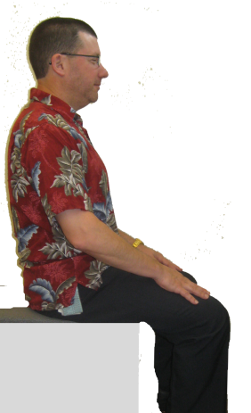
The foundation or core of the body is the pelvis and spine. How we position ourselves - in other words, our posture - is critically important.
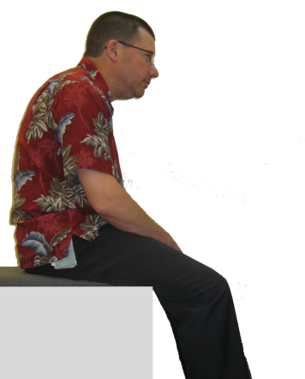
Slouched vs. neutral posture
Consider a person who stands or sits in a slouched posture - putting undue stress and strain into the ligaments, joints, nerves, muscles and tendons. The body is out alignment.
On the other hand, neutral posture provides position and support for the body and limbs in a well-balanced, well aligned position.
True, you can't spend all of your time in neutral but the goal is to spend as much time as you can in this beneficial position.
In fact if you can spend 15% more time in an improved neutral posture for many individuals this can make all the difference in the world!
Spine neutral position  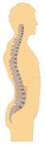  A neutral spine is in an S-shape: inward curves in the low back and neck; outward curve in the mid-back.  The advantage is that this spring like shape is able to better deal with compression and shear stresses in the spine. | Arm/hand neutral position  Neutral is the midrange of joint position. What is neutral for the arms and hands?  For the arms/hands this is with the shoulders relaxed, elbows at the sides flexed to about 90 degrees and the hands positioned with the thumbs pointing up.  Again, it isn't possible to spend all your time in this arm/hand neutral position; but 15% more can help.
Maintaining and supporting reasonable neutral posture for your arms, legs and spine is one of the most important goals of ergonomics!
Neutral posture is when the body is in a balanced position or posture with the least amount of effort to function. Each body part has an ideal neutral position:
- Head balanced over shoulders in line with the shoulders and hips.
- Back straight (supported when sitting) with normal curves maintained. When viewed from the side inward curves in the low back and neck and an outward curve in the mid-back where the ribs attach to the spine.
- Hips and knees at a 95⁰ to 105⁰ angle when seated.
- Hips and knees straight when standing.
- Arms at sides, elbows close to the sides and bent at a 95⁰ to 105⁰ angle.
- Hands, wrists, and forearms in a straight line; bent no more than 10⁰ up or down.
- Feet on floor or supported by a foot rest.

Illustration of Neutral Position at Sitting and Standing Workstations
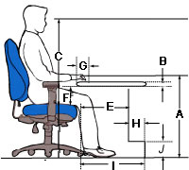 | 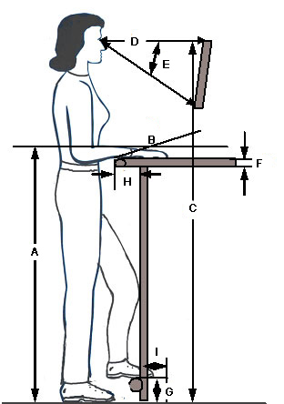

Reach Zones (Comfort and Functional)
We define two Reach Zones: Comfort and Functional.

Comfort Reach Zone
The Comfort Reach Zone is the area that can be easily be reached within the length of the forearm, with the elbow at the side.
The vertical aspect of the Comfort Reach Zone is from waist to mid-chest height with elbows at the sides within reach of the forearms.
Hand activities like keyboard use, assembly and forceful exertions are accomplished in the Comfort Reach Zone.
- Keyboard/hand writing, etc.: at elbow height.
- Precise assembly requiring good visual access: 4 to 6” above elbow height.
- Forceful downward exertion: 4 to 6” below elbow height.

Functional Reach Zone
The Functional Reach Zone is the area that can be reached by extending the arm from the shoulder to the center of the hand allowing for functional grasp.
- Reach arms forward, from middle of hands to chest is forward functional reach.
- Hold arms out in front about shoulder level; this is the upper limit
- Hands at sides are the bottom limit of reach zone.
- Hold arms out to sides to form about a 90 degree angle from the mid line; this is the side-to-side reach zone.
All materials, tools, controls, and containers, should be arranged within the Functional Reach Zone whenever possible:
- Place frequently used items near the place of use.
- Store infrequently used items away from the place of use.
- Store items together if they are used together and store them in the sequence in which they are used.

Shelves and Racks

Shelves and Racks Checklist
“NO” answer indicates need for additional investigation. | YES | NO | NA
Shelf and rack configuration (height and depth) has been determined based on shelf access and shelf content size/weight. Typical guidelines include:
- Lowest shelf: no lower than 20” from the floor
- Highest shelf: no higher than 60” from the floor
- Most frequently accessed shelves: between 30” and 50” from floor
- Least frequently accessed shelves: between 20” to 30” and/or 50” to 60” from the floor
- Heaviest materials: shelves between 30” and 40” if materials handled manually; NOTE: This places the item in the power range of the operator (about waist level) OR heaviest materials stored on lowest shelf if items can be slid off the shelf onto a cart at that height
- Content size: shelf size (width and height) allows free movement of materials on/off shelf
Weight of materials stored on shelving determined and is within recommended weight capacity of the shelving system.
Shelves secured to eliminate any possibility of tipping over.
Gravity flow shelving/rack systems used appropriately to position materials at front of the shelf for easy access. Pay particular attention to loading height of the shelf as it will be higher than the unload height.
Based on changing circumstances, shelf systems designed to be easily re-configured to minimize excessive lifting, carrying, and awkward postures.
Labels on shelves used to readily identify items stored on the shelves.
- Sans Serif fonts recommended (does not have the small projecting features called "serifs" at the end of strokes)
- At a recommended reading distance of 14” to 18” and visual acuity of 20/30, font size of at least 14 points.
- High contrast between label letters and background (e.g. black letters on white background)
- Use of colored labels considered to improve visual discrimination between different materials stored on the shelves
Any lip on the edge of the shelf safely contains material on the shelf but does not significantly limit movement of materials on/off the shelf
The material of the shelf itself allows for easy, friction free movement on/off the shelf. For example, shelves covered with high density polypropylene sheets.
Wheeled shelving allows for easy movement and maneuverability. See Carts for additional information.

Workstation Types and Characteristics

Workstation Checklist
“NO” answer indicates need for additional investigation. | YES | NO |  |  | NA
Configuration
Workstation configuration has been determined (sit, stand or sit/stand). Workstation Selection Characteristics
Seated workstation guidelines have been identified and incorporated into workstation design. Includes seated worksurface heights and seated workstation dimensions.
Standing workstation guidelines have been identified and incorporated into workstation design. Includes standing worksurface heights and standing workstation dimensions.
The work space allows for full range of movement.
Mechanical aids and equipment are available.
Height of the work surface adjustable.
Work surface can be tilted or angled to provide improved access.
Is the workstation designed to reduce or eliminate:
- Bending or twisting at the wrist?
- Reaching above the shoulder?
- Static muscle loading?
- Full extension of the arms?
- Raised elbows?
Workers able to vary posture.
Hands and arms free from sharp edges on work surfaces.
Armrest provided where needed.
Footrest provided where needed.
Floor surface free of obstacles and flat.
Cushioned floor mats provided for employees required to stand for long periods.
Chairs or stools easily adjustable and suited to the task.
Task elements visible from comfortable positions.
Preventive maintenance program for mechanical aids, tools, and other equipment.
Workstation Selection Characteristics for Sitting and Standing Workstations
In terms of worker position, the type of work performed generally determines workstation design: seated or standing.
Apply the specific workstation characteristics noted in the table to help select the appropriate working posture for various tasks. When both seated and standing conditions apply, design according to the standing workstation criteria.

Workstation Characteristic | Configuration
 | Sitting | Standing
 | 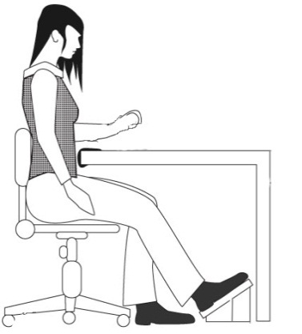 | 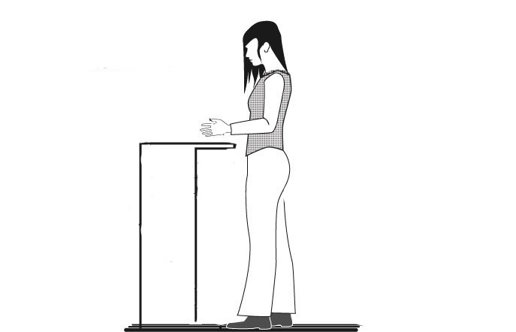
Side-to-Side Movement | Within seated workspace | Frequent movement outside of comfort zone
Task Duration | Sustained, > 5 minutes at one time | Intermittent, < than 5 minutes at one time
Hand Heights | < 6” above surface | > 6” above surface
Weight Handled | < 5 lbs | > 5 lbs
Reaches | Within Comfort Zone (within 12”) | Forward reaches of > 12”
Forces Exerted | < 5 lbs | Downward forces of > 5 lbs
Clearance | Seated clearances for legs and feet are met | Knee clearance < 18” or  foot clearance < 22”
Manipulation | Fine manipulation | Fine manipulation not required
Use of Feet | Foot pedals are used | No foot pedals are used

Seated workstations | Standing workstations
A high degree of precision is required (fine manipulation and visual attention).  Feet are used for control operations.  All tools and materials can be easily supplied and handled within the reach envelope.  The job consists of long work periods (over 5 minutes).  Hands are not required to work more than 6 inches above the work surface.  Low forces are exerted (weights are less than 10 lbs.). | The work requires frequent high, low, or extended reaches outside of the comfortable arm reach envelope (more than 12 inches).  Frequent walking is required.  Large forces are exerted or heavy weights are handled (objects weighing >10 lbs).  It is impossible to provide leg room for a seated operator (less than 18 inches of knee clearance and less than 19-24 inches of foot clearance).  Frequent movement between various workstations (every 5 minutes or less).  Intermittent task duration.  Items are handled more than 6 inches above the work surface.  Downward forces of more than 10 lbs are required.

Seated Workstation Guidelines
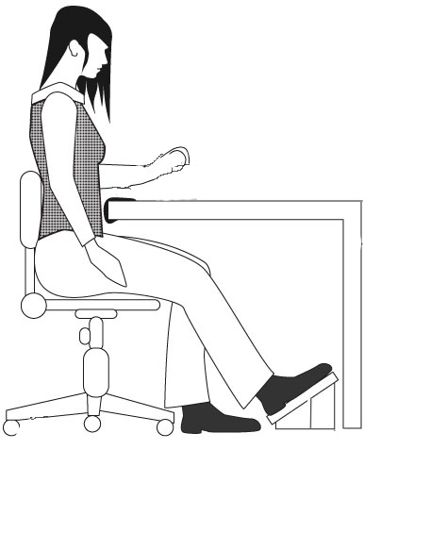
- All items required for the work should be located within the reach zones (not on the floor).
- Handling of items should be limited to no more than 6 inches above the work surface.
- Large forces (> 10#) should not be required.
- A good chair with a high degree of adjustability should be provided.
- Proper clearance beneath the work surface for legs and toes is necessary.
- Sufficient thigh clearance between the seat pan and the underside of the work surface is required.
- Reaches above shoulder level should be kept to a minimum.
- Padded forearm rests should be provided along the edge of the table.
- Foot rests, preferably adjustable, should be provided.
- Workplace layout should minimize twisting at the waist.
- Seated work height should be based on resting elbow height with relation to the work surface.

Illustration of seated work surface heights
(Left to right: precision work, light assembly, manual work)
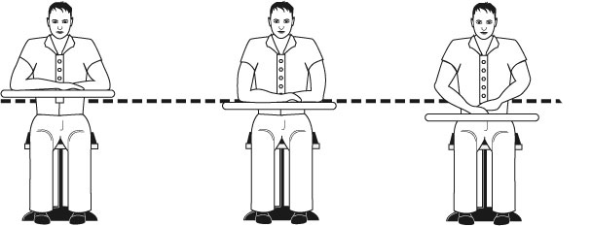

Seated Workstation Specifications

Illustration of seated workstation dimensions

Seated workstation dimensions
Criteria | Dimension |  | Description
A. Worksurface height | Adjustable Worksurface | Fixed Height Worksurface (with chair/ footrest) | Distance from the floor to placement of hands on the work surface.  NOTE: This may not be the actual worksurface height - it reflects the hand work height based on size of the object.
- Precision work | 26” to 36” | 34”
- Light assembly | 22” to 32” | 29”
- Manual work | 20” to 28” | 26”
B. Work surface thickness | Fixed: 46” |  | Allows for thigh clearance.
C. Screen height | Maximum of 2” Adjustable: 44” to 50” |  | Distance from floor to top of screen.
D. Knee space - width | Minimum of 20” |  | Side-to-side clearance for legs.
E. Knee space - front to back | Minimum of 16" |  | Allows for knee clearance.  .
F. Thigh clearance | Minimum of 8” |  | Seatpan top to undersurface of the worksurface.
G. Distance to work | up to 4” |  | Front of worksurface to hand work position.
H. Foot space depth | Minimum of 4” |  | Allows for foot clearance.
I. Distance for toe clearance | Minimum of 20" |  | Allows for foot clearance with legs extended.
J. Foot space | Minimum of 4” |  | Allows for foot clearance.

Standing Workstation Guidelines

Illustration of standing workstation features
If the same workbench will be used by a variety of workers, then apply one of these approaches:
Provide a height adjustable workbench.
Design the height of the work surface to accommodate the taller worker and provide platforms for the others to stand on.
Adjust the height of the work on the workbench with a lift or platform.
Work height should be based on resting elbow height and the type of work being performed.
Provide footrests, preferably adjustable, to reduce low back fatigue.
Locate the foot rail 6 inches off the floor.
Minimum foot rail length of 24 inches.
Provide anti-fatigue mats if standing on hard surfaces for long periods of time is required.
- At least ½ inch thick.
- Interlocking edges for securely joining adjacent edges.
- Beveled edges to eliminate trip hazards, prevent curling, and easy cart access.
- Cleanable.
Avoid the use of foot pedals. If necessary, then provide a support stool to avoid over use of one leg for support.
If large forces must be exerted, then design to allow pushing rather than pulling. The standing worker’s arms have more power when pushing.
Even though the standing operator is free to move about, design the workplace to eliminate:
- Strained head positions because of visual requirements.
- Stooping and bending.
- Twisting of the body.
- Excessive reaches.
Provide at least 5 inches for knee clearance, with an additional 6 inches for toe clearance.

Standing Workstation Specifications
Illustration of standing workstation dimensions
 | Criteria | Dimension |  | Description
 | A. Height | Adjustable Height Workbench | Fixed Height Workbench | Distance from floor to height on the workbench at which the hands will accomplish the task.  NOTE: This may NOT be the actual height of the worksurface. Dependent on size and placement of the object, etc. on the worksurface. Defined as the ‘hand work height”
 | - Precision | 38” to 48” | 44”
 | - Light assembly | 36” to 46” | 40”
 | - Heavy assembly | 26” to 40” | 36”
 | B. Inclination | Adjustable from -5° to 35°  ( -) = away from operator  (+) = towards operator |  | Inclination of work surface.  Inclined work surface will present the materials closer in the user's reach zone.
 | C. Screen height | Adjustable screen: 56”-72"  Fixed: 54” |  | Floor to top of the screen.
 | D. Viewing Distance | 18-30" |  | Distance from eyes to screen.
 | E. Viewing Angle | 0° - 35° |  | Adjusted by user as indicated
 | F. Worksurface edges | At least 1/8" radius on the worksurface edge |  | Eliminate any issue of contact stress.
 | G. Foot rest height | Min 4"” off the floor |  | Floor to foot position.
 | H. Knee clearance | Minimum of 5” |  | Allows for knee clearance.
 | I. Foot clearance | Minimum of 4" |  | Allows for foot clearance.

Sit/Stand Workstation Guidelines
Guidelines for sit/stand workstations are similar to those for standing workstations with a few modifications listed below.

Sit/Stand Workstation Adjustability:
- Minimum height range from floor to top of work surface or keyboard is 36 to 48 inches.
- The recommended height for tasks involving large-size products or drawings is 44 inches above the floor.
- For tasks that can be done while sitting or standing, the recommended work surface height is 42 inches above the floor.
- Work surface should be height adjustable in 1 inch increments or less.
- Height should be easily adjusted by multiple users (crank, pneumatic, etc.).
- Adjacent work surfaces should have the same range of height adjustability.
- Furniture legs, supports, or posts should not impair movement between these surfaces.
- Computer and work surfaces should be free standing and easily height adjustable by each user.
- Enough clearance should be allowed between adjoining surfaces to avoid pinching fingers during adjustment.
- If computer work surface is not easily height adjustable:
- Computer monitors should be on articulated monitor arms for easy adjustability.
- Keyboards should be on adjustable keyboard trays or articulating arms.
- Use a height adjustable chair at high workstations when adequate leg room is provided and when the task can be performed while either sitting or standing.
- The support stool is designed for use at high workstations with inadequate leg room to support standing or where regular changes in work position are required.

Glossary
Anthropometry: The measurement of the dimensions, and certain other physical characteristics such as weight and centers of gravity, of the human body as a whole or of its segments.
Clearance dimensions: The dimensions of a workspace required to provide appropriate space for body members to maneuver without interference from surrounding structures or equipment.
Contact point or Pressure point: A body site at which an item of workplace equipment or a tool exerts pressure on the tissues. Soft tissue sites are of most concern to ergonomics since the compression of the tissue can occlude blood vessels, irritate nerves and tendons, or damage the muscle tissue itself.
Dynamic work: Work activities involving movement and thus requiring the muscles to both contract and relax during the activity.
Elbow height: The anthropometric dimension referring to the height of the elbow above the floor when the arm is hanging relaxed at the side of the standing individual.
Elbow rest height: The anthropometric dimension referring to the elbow above the seat surface when the upper arm is hanging relaxed and the elbow is bent so that the forearm is parallel with the floor.
Ergonomics: The scientific study of the relationship between humans and their working environment.
Extended reach radius: The area that can be reached by extending the arm from the shoulder.
Fixed work posture: A work posture that does not permit the operator to freely change position so as to relieve postural stress. Fixed postures tend to statically load muscle groups since movement of the body segments and/or trunk is inhibited.
Foot-candle: A unit measure of illumination striking a surface. On foot-candle is equivalent to one lumen per square foot.
Functional reach or “dynamic” reach: An anthropometric dimension representing the arm reach capability when the body is allowed to bend and/or rotate at the shoulder and hips so as to extend the reach beyond that obtainable when the body is in a static or fixed posture.
Normal reach radius: The area that can be conveniently reached with a sweep of the forearm, with the upper arm hanging in a natural position vertically at the side. All materials, tools, controls, and containers should be arranged within the normal reach radius whenever possible.
Normal work area: The area in front of the worker which can be used for work with a normal expenditure of effort.
Power grasp/grip: A grasp in which the hand wraps around the handle being grasped. In the power grasp the thumb aligns the hand with the long axis of the forearm and the wrist assumes a slight ulnar deviation. The power grip provides more than five times the gripping strength of a precision grip.
Precision grasp/grip: A grasp in which the object is held by the force of the thumb vs. the first (or first and second) finger(s). It provides precise aim but has limited strength.
Reach envelope: The surface in space centered on the left/right midline plane of the body representing the reach capability of the population percentile of interest. The envelope may be described as a functional reach envelope.
Viewing angle: The angle, either vertical or horizontal, at which the worker views the task measured from the center line of the horizontal line of sight when the operator is looking straight ahead.

