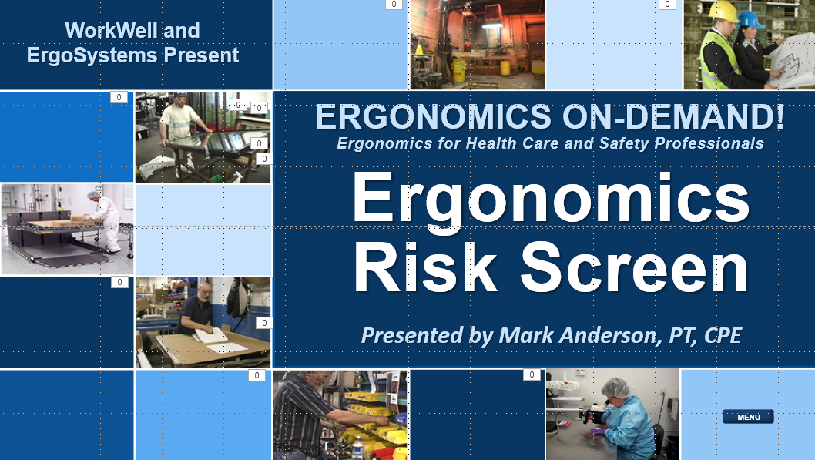

Developed by:
Mark A. Anderson, MA, PT, CPE
Certified Professional Ergonomist
Physical Therapist
ErgoSystems Consulting, LLC.
7421 West Shoreline Drive
Waconia, MN 55387
Voice: 952-401-9296
Mark.Anderson@ergosystemsconsulting.com
www.ergosystemsconsulting.com

The information contained in this training workbook has been developed in good faith and is believed to present good ergonomics principles and practices. ErgoSystems Consulting, LLC and all other participating organizations make no representations or warranties as to the completeness or accuracy of the materials thereof. Persons using this information must make their own determination as to its suitability for their purposes. ErgoSystems Consulting, LLC and all other participating organizations are in no way responsible for damages of any nature resulting from the use of this information.

Copyright 1997 to 2021 ErgoSystems Consulting, LLC., All Rights Reserved Version 2_04222021

Table of Contents
Table of Contents 2
Ergonomics Risk Screen Track 4
Welcome 4
Overview 4
ERS Scoring 4
ERS Pre and Post Intervention 4
Relative Risk Level Index – Defined and Interpretation 6
How Much is TOO Much? 6
Dose/Exposure 6
Medical Analogy 7
ERS Example Case Study – Oil Fill 7
Background Information 7
Oil Fill Video 8
ERS Results 8
Pre-Intervention ERS 8
Other Factors 9
Corrective Actions 9
ERS – Step-by-Step 11
Step One – Identify Number of ERSs to be Conducted 11
ERS Breakdown Determination 11
Develop Task Inventory 11
Prepare ERS Worksheets 11
Step Two – Ergonomics Analysis Tool Box 11
Personal Protective Equipment 11
Measurement Devices 12
Why use Video? 12
Background Materials 13
Clipboards 13
Set of Objectives 13
Step Three – Prep for ERS Data Collection 14
Schedule the ERSs 14
Estimate Time 14
Step Four – Obtain Data (Video, Interviews, Measurements) 14
Step Five – Complete ERS Worksheet and Report 14
ERS Step One – Background Information 14
ERS Step Two – Posture, Force, Duration, Frequency and Time Weighted Multiplier 15
ERS Step Three – Raw and Weighted Score 19
ERS Step Four – Other Factors 19
ERS Step Five – Scores from Steps 3 and 4 20
ERS Step Six – Corrective Actions 20
Step Six – Implement Solutions 20
Cost Analysis 20
Step Seven – Follow-up 21
ERS Practice 21
CNC Reservoir Case Study 21
Next Steps 22

Ergonomics Risk Screen Track

Welcome
Welcome to the Ergonomics Risk Screen Track.
Hi everyone, I’m Mark Anderson. I am a Certified Professional Ergonomist and Physical Therapist with more than 30 years of experience working with ergonomics.
Thanks for your interest in Ergonomics and the Ergonomics Risk Screen assessment tool!

Overview
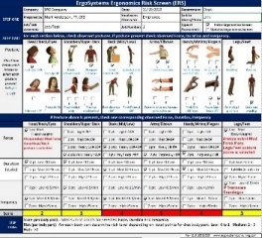
ErgoSystems Ergonomics Risk Screen (ERS) Version 11.0 is an ergonomics risk factor screening tool developed by Mark Anderson, MA, PT, CPE.
The ERS is a posture based assessment protocol intended to provide an overview assessment of the relative risk of ergonomics related factors in the physical performance of specific repetitive job tasks. The ERS makes use of an Excel spreadsheet for documentation and calculation purposes.
The ERS can quickly indicate that either the assessed job tasks are at low risk or have a potential greater relative risk. It can also point toward recommendations for additional assessment and intervention.

ERS Scoring
The ERS is scored by first evaluating the position of various body parts in relation to the Neutral Position concept. Neutral Position, for the body as a whole, is with the head balanced over the shoulders, shoulders over the hips and hips over the knees and feet.
For each specific body joint, Neutral Position is defined at the mid-range of the joint’s range of motion.
From biomechanical and physiological perspectives, the Neutral Position/Mid-range of Joint Position concept is recognized as advantageous in controlling stress into the body.
As part of the analysis, if out-of-neutral postures are observed, the extent of physical exposure of each body part to the posture is documented. This includes a combination of:
- Force (typically expressed as pounds-force either imposed on the body or that the body has to generate)
- Duration (how long the out-of-neutral position is sustained)
- Frequency (how often the out-of-neutral position occurs)
For scoring the number of points increases as the intensity of the Force, Duration and Frequency increases.
Also, other factors (Training, Workstation Design, Tool and Equipment Use, Environmental Factors, etc.) are scored to help identify the root cause of the primary ergonomics risk factors.
A score of 0 to <2 is considered Low Relative Risk (indicated by GREEN), a score of >2 to <4 is considered Medium Relative Risk (indicated by YELLOW) and 4 and higher is considered High Relative Risk (indicated by RED).
A Weighted Time on Task modifier is also calculated based on overall exposure.
The ERS can be used as an Action Plan to document and track recommended Corrective Actions.

ERS Pre and Post Intervention
The ERS is often conducted pre and post ergonomics intervention to demonstrate the extent to which the intervention has been successful. What difference do you see?
ERS Pre Intervention | ERS Post Intervention
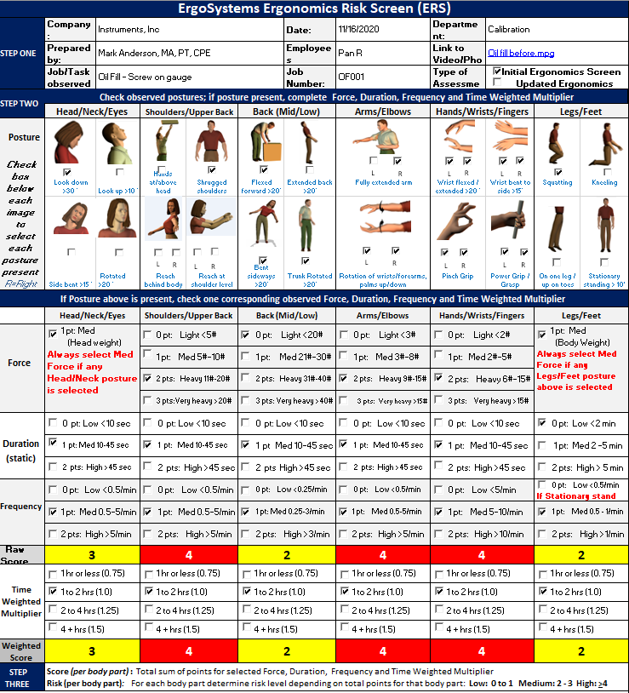 | 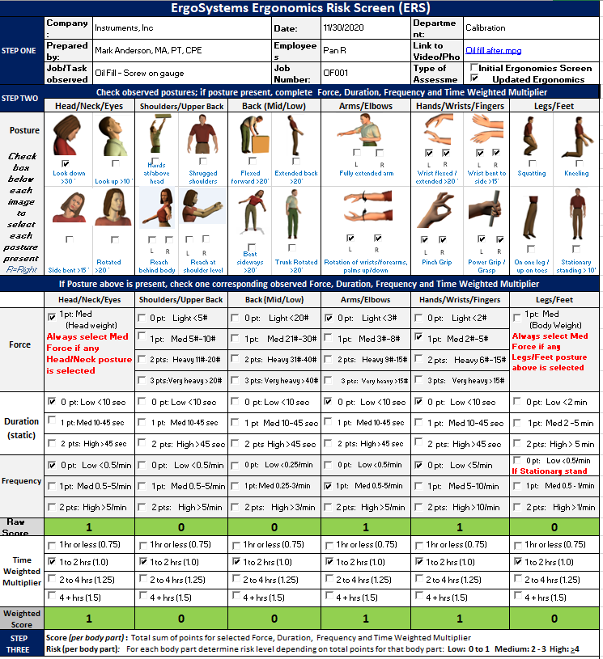
The Weighted Time Multiplier is calculated based on the overall exposure.
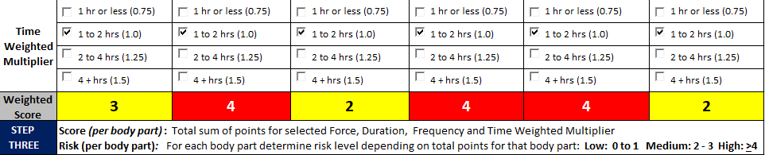
The ERS can be used as an Action Plan to document and track recommended Corrective Actions.
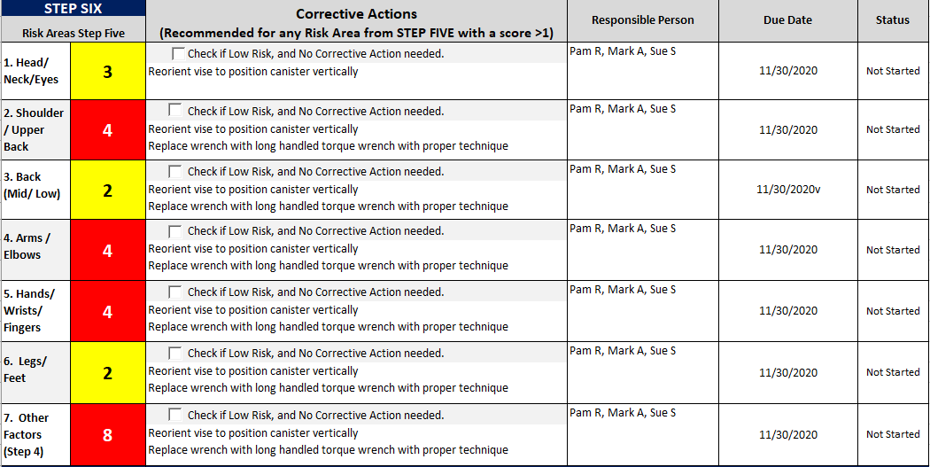

Relative Risk Level Index – Defined and Interpretation

How Much is TOO Much?
Ergonomics analysis and subsequent recommendations revolve around answering the basic question of, “How much is too much?”
For instance:
- How awkward do the body and joint positions have to be to cause a problem? (In other words, how far out-of-neutral?)
- How much weight is too much for a person to safely lift?
- How much force is too much for a person to safely generate?
- How many repetitions of a task are too many?
- How far is too far for a person to functionally reach to parts and materials on a workbench.
- How to determine if the tool and equipment in use is the correct tool and equipment.
- The list can go on and on!
Essentially, we are talking about the factors that influence physical and mental performance.

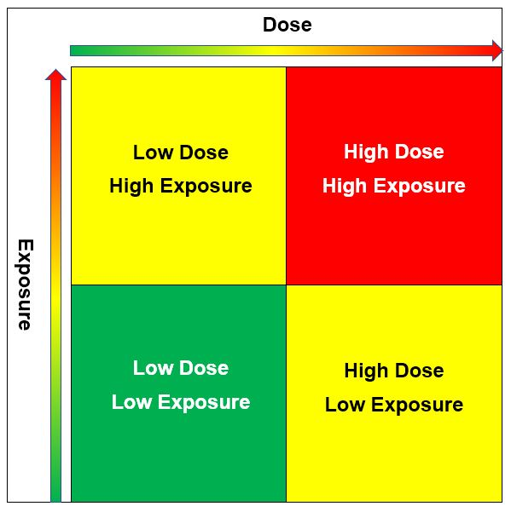
Dose/Exposure
One way to address this is the Dose/Exposure concept.
Dose – is defined as the level of physical/mental stress of the ergonomics risk factors.
Exposure – is defined as how long and how often the exposure to the ergonomics risk factors is occurring.
We appreciate the higher the values for Dose and Exposure, the greater the estimated relative risk.
- LOW considered low risk with low priority to change.
- MED considered medium risk, recommend modification as feasible.
- HIGH considered high risk, recommend concerted effort to modify.
A combination of Low Dose/Low Exposure would be considered to have a lower relative risk.
A combination of High Dose/High Exposure would be considered to have higher relative risk.
However, it is conceivable the job task could consist of a Low Dose (minimal force levels) combined with High Exposure (high frequency). The converse is also true; High Dose (high force levels) with Low Exposure (low level frequency). This influences the score.
As we discussed, for the ERS:
- 0 to 1 is considered Low Relative Risk (indicated by GREEN)
- 2 to 3 is considered Medium Relative Risk (indicated by YELLOW)
- 4 and higher is considered High Relative Risk (indicated by RED)

For YELLOW and RED scores, additional assessment and intervention is recommended. Research has demonstrated that lowering the score through a combination of administrative, work process and engineering initiatives will generally lower the relative risk of the ergonomics factors.

Medical Analogy
What does Relative Risk mean? Consider a couple of examples.
- Two individuals can do exactly the same job. Within a short time one person experiences significant musculoskeletal issues and the other person does the job for 30 years with no problems at all.
- We generally consider cigarette smoking to be detrimental to health. Greater risk of lung cancer is well documented. However, a person can start smoking at age 10 and live to be a hundred!
This truly demonstrates the incredible variation in individual tolerance levels
In this light, how should the ERS Relative Risk Score be interpreted? Consider this medical analogy.
It is generally understood that a combined HDL and LDL blood cholesterol level of 200 milligrams per deciliter of blood (mg/dL) and lower is advantageous. Does this mean an individual with a level of 320 will for sure die of heart disease? Or an individual with a level of 160 will never die of heart disease?
For both questions the answer is NO. However, which score would you rather have. The obvious answer is 160. While there are other factors, the relative risk of dying from heart disease is lower with a lower level of blood cholesterol.
So specific to the ERS scoring does a score of 0 to 1 mean there is absolutely no risk of suffering a musculoskeletal disorder and does a score of 4 and higher mean absolutely for sure that a musculoskeletal disorder will occur?
The answer to both questions is NO.
So, what is the answer to the question, ‘How much is TOO much?’
Well based on the individual variations in responses we know exist, we may well say, ‘It depends!’ And to a certain extent this is very true!
However, the Relative Risk score simply indicates that the potential for experiencing issues is greater with a higher score.
From our ergonomics perspective, through the application of ergonomics principles, our objective is to lower the Relative Risk Score and broaden the range of individuals who can safely and effectively perform the job task.

ERS Example Case Study – Oil Fill
In the Manufacturing Ergonomics Track we introduced the Oil Fill Case Study. Let’s go through how the ERS was conducted.

Background Information
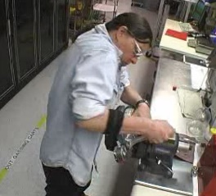
Instruments, Inc. is a company that manufactures calibration equipment. Part of the manufacturing process is to screw a gauge onto an oil fill canister.
This task had been identified as a problem in terms of discomfort and even injuries reported by the workforce.
An ergonomics assessment was conducted using the ERS process and recommendations for improvement were made.
To conduct the assessment video of the task was taken along with interview of the worker and measurements of the workstation and physical demands to perform the task.

Oil Fill Video
Let’s take a look at the video. As you look at it, think about the Ergonomics Principles we outlined in the Introduction to Ergonomics Track and the information in the Manufacturing Ergonomics Track to identify potential ergonomics issues and consider feasible and reasonable recommendations for improvement.

ERS Results

Pre-Intervention ERS
Here are the results for the Posture, Force, Duration and Time Weighted Multiplier. It is apparent we are seeing scores in the Yellow and Red ranges with particular issue with Shoulders/Upper Back, Arms/Elbows and Hands/Wrists/Fingers. We will go through exactly how to score each section a little later. The Time Weighted Multiplier was scored at 1.0. The task is performed 1 to 2 hours/shift. Do the scores correlate with what you observed on the video?
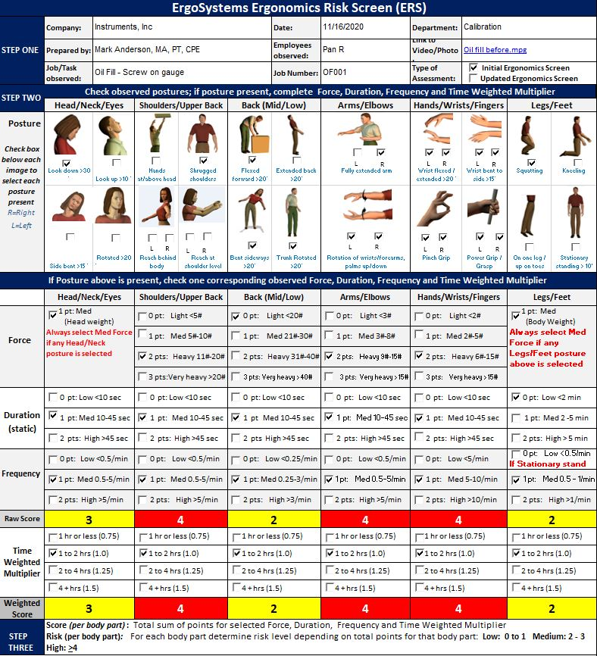

Other Factors
In the Other Factors section, we documented potential causal factors for the issues identified in the Posture, Force and Duration step. We checked eight Other Factors:
- Production/Quality – Gauge was tightened with a wrench without a definitive torque level applied
- Training – Technique observed was not effective in reducing stress
- Contact Stress – Sharp, hard edge from the wrench and gauge itself was identified
- On feet (standing or walking) > 50% of shift – Identified as an issue
- Fixture/Jig – Vise was used to stabilize the canister, ineffective use
- Tools – Fairly short wrench used to tighten the gauge
- Workstation – Questionable setup of the workstation was noted
- Worksurface height, too low – Negative influence on posture

Corrective Actions
With the assessment results in hand, the next step was to generate the recommended Corrective Actions. Our goal was to recommend changes that would positively influence the factors we identified in the Posture, Force and Duration and Other Factors sections.
We collaborated with the worker, supervisor, health and safety manager and the engineer assigned to the area to come up with these straightforward recommendations:
- Reorient the vise to position the canister vertically.
- Replace the wrench with a long handled torque wrench with proper technique (this allowed documentation of the amount of torque required to effectively secure the gauge).
- Consider anti-fatigue mat or shoe in-soles due to the amount of time spent on the feet in general.
You will notice about the same recommendations were made for each body part. This is fairly common. We need to look at the integrated whole of the risk factors and recognize that one or more changes may have an impact across the board. This was certainly the case in the Oil Fill Case Study.
Post Intervention ERS
Let’s look at the Post Intervention video clip. Once the recommendations were implemented the ERS was repeated. Take at a look at the difference in the ERS scores. Visually the distinctions are dramatic.
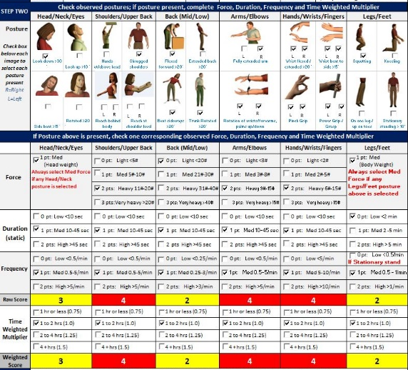 | 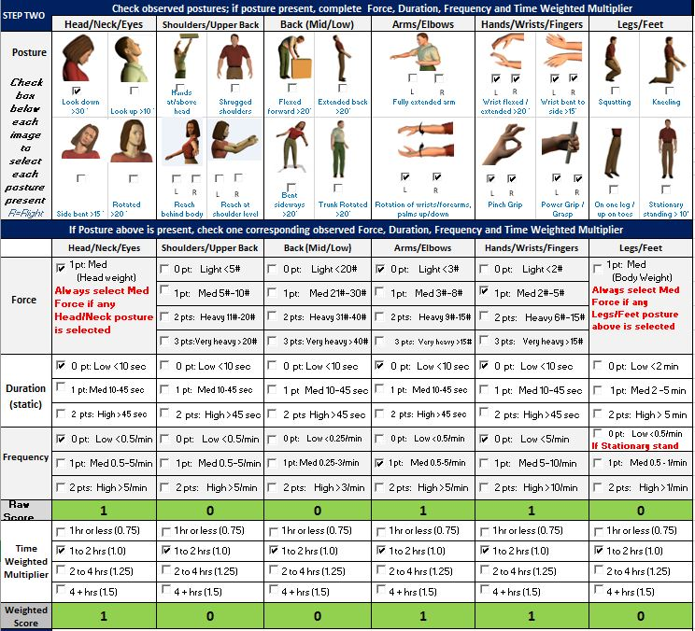
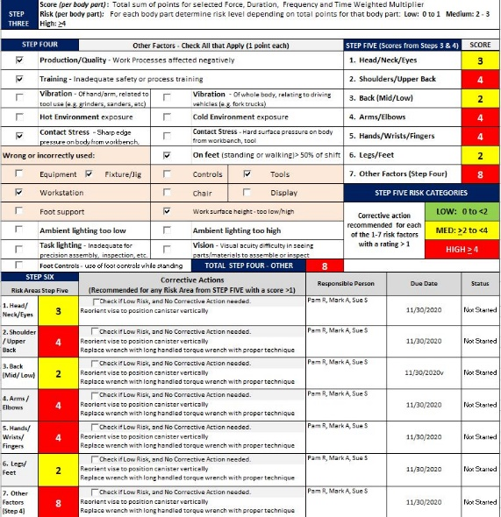 | 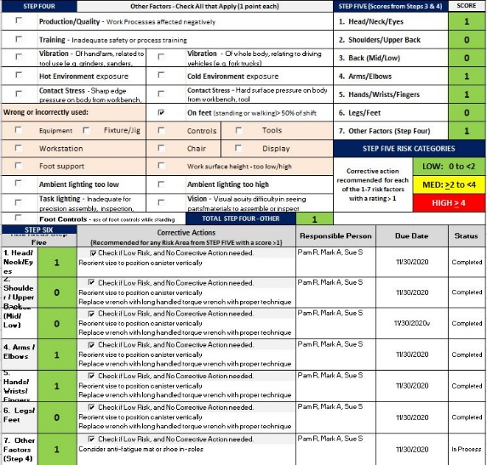

ERS – Step-by-Step
Now that we have had a look at the ERS process, let’s get into the nitty-gritty of how to conduct an ERS.

Step One – Identify Number of ERSs to be Conducted

ERS Breakdown Determination
A basic question is:
“For a specific job task how many different ERSs do you need to conduct to capture the needed information?”
The basic answer is:
“The job tasks assessed with the ERS need to be discrete enough to provide a focused examination of the physical demands of the job tasks.”
For example, let’s say the assembly process has five separate steps. Each step involves quite different physical demands. If you attempt to use one ERS to capture all five steps it will not have the depth of task specificity necessary to drill down to the level needed. There is simply just too much going on in a broad manner.
In this case, you will probably end up with five ERSs. An exception to this is if you identify some steps are essentially the same in terms of physical demand (including exposure); if so, you can group these steps together in an amalgamated ERS.

Develop Task Inventory
As you plan for the ERS process develop the Task Inventory. This is a list of the separate ERSs you will need to conduct. Typically, you will work with the company representative (Safety Manager, Supervisor, Health Professional, etc.) to put together the Inventory. This will ensure you are well organized and efficient in the data collection phase of the ERS.

Prepare ERS Worksheets
Once you have determined the extent of the Task Inventory, prepare the needed ERS worksheets. Depending on how you plan on collecting the data, you will either prepare printed out ERS Worksheets for each ERS and write in basic information as you collect the data OR you may bring a laptop in and fill in the Excel spreadsheet as you collect the data.
Our preference is to use the printed ERS Worksheet approach. It is fast while on-site and also provides opportunity for written notes you can refer to as you finalize the ERS report.

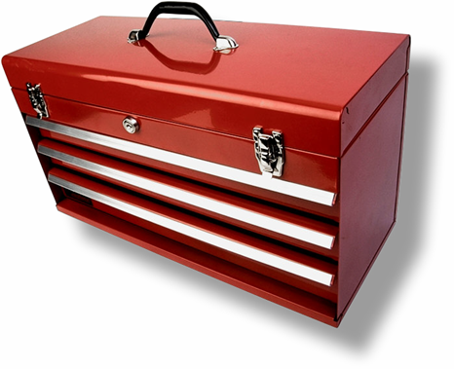
Step Two – Ergonomics Analysis Tool Box
Put together your ERS Tool Box; it will have several trays.

Personal Protective Equipment
Ensure that YOU have the proper personal protective equipment and attire to conduct the analysis. At a minimum, YOU may need eye, foot, clothing, head, and hearing protection.
Don’t take it for granted; communicate with your company contact to understand what the company requirements are.
Dress at the proper level based on the worker's level of attire. For example, do not show up in a suit on an assembly production floor, just as jeans, steel toe boots and a work shirt may not be appropriate for a boardroom.

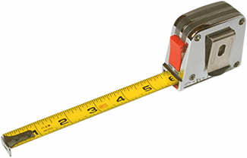
Measurement Devices
To take measurements of the workplace, you'll need:
- Stopwatch (You want to be able to time the tasks. If you use video, you won’t need a separate stop watch, the video has time code.)
- Tape measure (I suggest you have at least a 12 foot/3 meter tape measure that is robust enough so you can extend it out a fair distance without it collapsing.)
- Force gauge and/or scale (You need to be able to measure push and pull forces and weights.)
- Photographic equipment (I strongly encourage you to use video rather than still cameras, you can always pull freeze frames off the video to insert into reports.)
A word about video and cameras in general. Typically, you must get approval for the video and/or pictures from the appropriate individuals, including the person being assessed, supervisors, managers, etc. In a few cases a written release may be needed. And in some cases, due to the proprietary nature of the workspace, video/pictures may not be allowed at all.

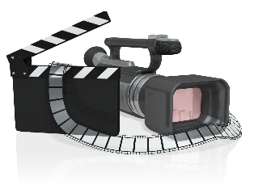
Why use Video?
If a picture is worth 1,000 words, a moving picture (video) must be worth at least 5,000 words.
- Using video is one of the best ways to document an ergonomics analysis.
- You can study the video over and over again at a later date.
- You can show the video to other interested parties for their input.

Video “Secrets”
Don’t be accused of making home videos, follow these guidelines.
- I suggest a camera with a flip-out view finder. This allows you to position the camera to get the shot and still see the view finder.
- Use enough light; low light causes grainy video that is hard to analyze. If you know you will be in a low light area, see if you can obtain more light in the area.
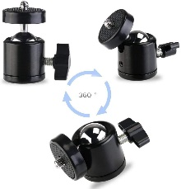
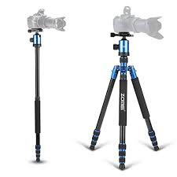
- Use a tripod or monopod as much as you can. You will get much better quality video.
- A monopod works very well to get overhead shots. A swivel ballhead mounted between the camera and the monopod works well. A wide angle lens will allow you to work in close quarters.
- If you have to use a handheld technique, build a bridge with your arm against your body for stability.
- Always have a backup power supply; either additional battery packs or able to run off of wall current with the AC adapter.
- Plan your video sequence. Think ahead to know what shots you want.
- Use the zoom sparingly. Zooming in and out in and out will drive your audience crazy.
- Use manual focus (if available) to stop the auto focus from searching.
- Pan (move from side to side) the camera about three times more slowly than what your eyes can track.
- After videoing a few seconds, check to make sure the camcorder is working correctly. I have learned this the hard way!
- In a loud environment, use a separate microphone to pick up interviews.
- Be aware of your surroundings; don’t walk into equipment, people, etc. I always try to have someone watching “my back” to keep me out of trouble.

Videotaping Sequence
Here is the typical sequence I use to video.
- Inform any people being videoed of your purposes.
- Record the date and time, this will also be captured on the video by the camera.
- Say the name of the job or task description on the audio portion of the video at the beginning of each task. You can also use the audio to take notes; just remember you need to view the video later to get the information.
- In the viewfinder, frame an overview of the job to “set the stage.”
- Capture 5 to 6 cycles of the repetitive tasks. This will allow you to time the tasks when you view the video later.
- Reposition the camera to get back, side and diagonal views. If possible, get an overhead view.
- Video as many different workers as you need to get an accurate portrayal of the job. You want a representative sample of the workers doing the job.
- Get close up views of each of the separate job tasks and identified issues .
- If needed, video the tasks immediately before and after the task being reviewed – this may also lend additional insight.
- After you have videoed the job tasks, interview the worker and other company representatives to gain their input. DO NOT ask leading questions.
- Be wary of sharing your opinions about the job task at this time. You don’t want to bias their comments.

Background Materials
Identify the proper background materials to have available. This includes the ERS Task Inventory, your ERS Worksheets and may also include job descriptions, sketch of the floor plan or layout, organizational chart, check lists, clipboard or notepad.

Clipboards
A word about clipboards and notepads. Some employees may associate clipboards with inspections and will have some concerns. We generally have the ERS Worksheets in a 3-ring binder. We always make sure the workers being observed are aware we are NOT inspectors; we are there to look at ergonomics factors with the intent to help improve the comfort level, health and safety of the worker and workplace.

Set of Objectives
The most important tray in your toolbox is the set of objectives you bring to the job.
- What are the outcome objectives?
- Make sure you bring an "open mind.
Do not hesitate to ask questions. In fact, you will find most people will tell you a lot about the job and issues they may have if you simply ask them to help you understand what they do.
I often put myself in the role of “New Employee” and ask the worker to provide “Training”.
The most important thing you bring to the assessment is a new and fresh look at the situation. What has become common place to those in the workplace may be brand new to you. Take advantage of this opportunity.

Step Three – Prep for ERS Data Collection

Schedule the ERSs
Working with the appropriate company representative schedule the ERS data collection. Ensure through the company representative, the employees you are observing have been informed of the data collection process.

Estimate Time
Estimate the time needed on-site to collect the data. This is made easier with the Task Inventory because you will know how many ERSs you will be doing.

Repetitive Manufacturing Tasks
You will find repetitive manufacturing jobs with short duty cycles can be done quickly.
- For example, the duty cycle for the task is 30 seconds.
- Let’s say you want 2 cycles each of the side, back, front and overhead views.
- This is 8 cycles, so you are talking about 4 to 5 minutes for the overview.
- Add another 10 minutes get the closeup shots and final interview.
- Then add another 5 to 10 minutes to get the measurements you need.
- So far, we have about 25 to 30 minutes total.
- Then add a 5 to 10 minute buffer to take any notes needed.
So bottom line is about 30 to 40 minutes in total. Just remember this time frame can and will vary!

Other Tasks
If the tasks for the ERS are for example in the Maintenance Department. They may be performed on an infrequent basis; weekly or monthly or even yearly.
In this case you can either spend a year with them to collect the data OR you ask them to set up task simulations that adequately represent the physical demands of the tasks. This simulation strategy works pretty well with a little preparation upfront.

Step Four – Obtain Data (Video, Interviews, Measurements)
Using the strategies discussed above to obtain the onsite video, interviews, measurements, fill out ERS worksheets, etc. Compare experienced faster and injury-free workers with those who are inexperienced, fatigued, uncomfortable or reporting pain or injury.
Determine if there are differences in work technique among these groups.

Step Five – Complete ERS Worksheet and Report
Let’s go step-by-step through completing the ERS Worksheet. Look for tips about how to efficiently interpret the data. The ERS Worksheet is in the Excel spreadsheet format.
Open the ERS Worksheet Template and save the file with an appropriate name.

ERS Step One – Background Information
Company: | Enter the Company name and contact information.
Prepared by: | Enter the name and contact information of person conducting the ERS.
Job/Task observed: | Enter the name of the job/task being observed; try to use the existing name if available. Sometimes you may need to make up a descriptive name.
Date: | Enter the date the ERS data collection took place.
Employees observed: | Enter the names of Employees observed if available.
Job Number: | If the company has a specific job/task number in their system enter it to keep track of the ERS. Otherwise enter an ERS Job Number of your nomenclature. (e.g., #001)
Department: | Enter the Department name where the ERS was conducted.
Link to Video/Photo: | Enter the Link to the folder that contains the video/photo files. The complete ERS report will include the ERS Worksheet and any associated files.
Type of Assessment | Check the appropriate box indicating if this ERS is the Initial ERS or an Updated ERS/

ERS Step Two – Posture, Force, Duration, Frequency and Time Weighted Multiplier

Posture
Based on your observations check the appropriate boxes that for each of the posture sections. Essentially you are looking for out-of-neutral postures more than a defined amount.
Is it possible to use a goniometer to obtain the measures (either by direct measurement or by way of video), but honestly the best strategy is to estimate them by eye. Don’t agonize over 19 or 21 degrees when the guideline indicates 20 degrees. If it is about 20 degrees or more, that is accurate enough.
With a little practice you can get quite good at estimating angles.
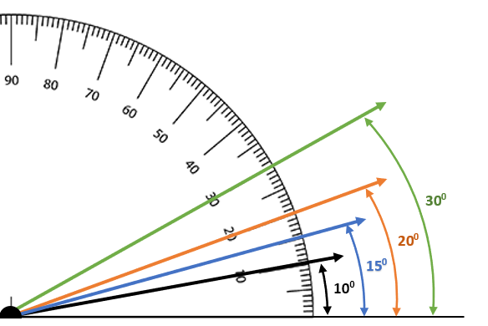

Head/Neck/Eyes
Identify head and neck positions that are out-of-neutral as indicated.

Shoulders/Upper Back
Identify out-of-neutral positions that have impact on the shoulders and upper back. Think of this as impacting the shoulder girdle influenced by upper extremity position to accomplish the task at hand.

Back (Mid/Low)
Identify out-of-neutral mid and low back positions that impact the core of the body.

Arms/Elbows
Fully extended arms involve reaching out from the trunk with the elbows extended to reach to and/or handle materials. Rotation of the wrists/forearms, palms up/down involves tasks that require alternating between palms up and down position (pronation and supination). Examples include wringing water out of towel or turning a screwdriver.

Hands/Wrists/Fingers
Identify out-of-neutral wrist positions to accomplish the task at hand. Identify pinch and power grip hand activities.
Pinch Grip – The fingers are on one side of an object, and the thumb is on the other. Typically, an object lifted in a pinch grip does not touch the palm.
Power Grip – Formed with the fingers and the palm of the hand in order to move or manipulate objects.

Legs/Feet
Squatting – Defined as bending the hips and knees.
Kneeling – Defined as bearing body weight through one knee or both; either stationary or ‘walking on the knees’.
On one leg/up on toes – Defined as standing on one leg only or up on the toes, for example to reach to a higher level.
Stationary Standing – Defined as standing in one position within a confined space for more than 10 minutes. Person can shift body weight from one leg to the other but not able to take steps away from the position.

Force

Material Handling
For each of the posture categories check the appropriate box based on the measured and/or estimated force levels. Force can be generated in a variety of ways:
- Body and extremity weight only – muscular force required to move and position body/extremities.
- Material handling (lifting) – objects are lifted/lowered manually.
- Material handling (push/pull) – objects are moved via push and/or pull forces (e.g., moving a cart and pushing on wrench handle).
Lifting force requirements can be determined through use of a force gauge or scale to determine the weight of the object.
Push/Pull force requirements can be measured with a force gauge. Typically, you will want to do three trials to get a consistent outcome and take the average of the three.

Hand Grasp (pinch and power)
Hand grasp force requirements involving pinch and power grips are more challenging to obtain. Here are some strategies:
- Tool specifications – some hand tools may have published force requirements to activate. For example, a hand stapler manufacturer may list them in the tool specs.
- Indirect measurements – using grip and pinch dynamometers you can obtain a reasonable indirect measurement by first performing the grip or pinch task as typically performed and then simulate the task using the grip or pinch dynamometer. Essentially you are using the body’s neuromuscular sensory system as a measurement device. Typically, you will want to do three trials to get a consistent outcome and take the average of the three.
We’ll go through each category to provide specific details.

Head/Neck/Eyes
Always select 1 pt: Med if any Head/Neck posture is checked in the Posture section. This takes into account the weight of the head (about 6 to 7% of body, in the typical range of 8 to 14#) and the impact on the body to support the head in the out-of-neutral position.

Shoulders/Upper Back
If any of the postures are checked, estimate the load either imposed on the shoulders and upper back or required to be generated by the muscle groups of the shoulders/upper back.

Hands at/above head:
- If only reaching overhead with both arms without any object involved, check 2 pts: Heavy 11# to 20# (5 to 9 kg) to account for the weight of both arms being held overhead. An upper extremity weighs about 5 to 6% of body weight.
- If only reaching overhead with only one arm without any object involved, check 1 pt: Med 5# to 10# (2.3 to 4.6 kg) to account for the weight of one arm being held overhead. An upper extremity weighs about 5 to 6% of body weight.
- If an object
- t is being handled, weigh the object and score appropriately based on the weight of the object.

Shrugged shoulders
- Determine the weight of the object being lifted or held in position that results in the shrugged shoulder position

Reach behind body
- If only reaching behind the body with one arm without any object involved, check 1 pt: Med 5# to 10# (2.3 to 4.6 kg) to account for the weight of the arm. An upper extremity weighs about 5 to 6% of body weight.
- If an object is being handled, weigh the object and score appropriately based on the weight of the object.

Reach at shoulder level
- If only reaching at shoulder level with one arm without any object involved, check 1 pt: Med 5# to 10# (2.3 to 4.6 kg) to account for the weight of the arm. An upper extremity weighs about 5 to 6% of body weight.
- If reaching at shoulder level with both arms without any object involved, check 1 pt: Med 11# to 20# (5 to 9 kg) to account for the weight of the arm. An upper extremity weighs about 5 to 6% of body weight.
- If an object is being handled, weigh the object and score appropriately based on the weight of the object.

Back (Mid/Low)
- If any of the postures are checked, estimate the load either imposed on the back (low/mid) or required to be generated by the muscle groups of the back (low/mid).
- If no object is being handled check 0 pt: Light <20# (9 kg). The Duration and Frequency scoring will pick up the extent of the stress from the postures.
- If an object is being handled, weigh the object and score appropriately based on the weight of the object.
- If an object is being pushed or pulled, determine the force requirements and score appropriately.

Arms/Elbows
Estimate the force required to perform the tasks involving the arms reaching out from the trunk with the elbows extended to reach to and/or handle materials. Consider the weight of objects being handling and/or manipulated.
Estimate the force required to rotate the wrists/forearms, palms up/down to accomplish the tasks. Consider the weight of objects being handling and/or manipulated.

Hands/Wrists/Fingers
For the out-of-neutral wrist positions estimate the force involved. Refer to the Hand Grasp (Pinch and Power) section above for additional information.

Legs/Feet
Always select 1 pt: Med if any Legs/Feet position is checked in the Posture section. This takes into account the weight of the body on the weight bearing joints (spine, hips, knees, ankles and feet.

Duration (static)
For each of the Posture categories score the Duration based on the indicated point system.
The scoring is same for all the categories except for Legs/Feet. Recall the Stationary Standing box was checked if greater than 10 minutes was identified. If so, for Duration check 2 pts: High > 5 min.

Frequency
Frequency is determined by how often the identified positions occurs. Reviewing the video is the best way to determine frequency; you can time the task based on the time code on the video.
The scoring system varies a bit across the postures. This is a reflection of the different impact frequency has on different body parts.
For example, a Flexed Forward Back (Mid/Low) posture frequency of 5/minute would involve significantly more physiological effort than 5/minute for the Hands/Wrists/Fingers.
Take a moment to look at the nomenclature used.
- 0.5/min equates to once every 2 minutes
- 0.25/min equates to once every 4 minutes
For Legs/Feet, if Stationary Standing > 10 min is checked in the Posture section, the Frequency is checked as 0 Pt Low < 2 min because we have already accounted for it in the Duration category.

Time Weighted Multiplier
Recalling that Exposure is an important factor in assessing overall relative risk the next step is to apply the Time Weighted Multiplier (TWM). The TWM reflects the amount of exposure of each category in terms of hours/day. The breakdown is:
- 1 hr or less (0.75)
- 1 to 2 hrs (1.0)
- 2 to 4 hrs (1.25)
- 4 + hrs (1.5)
When you perform the data collection obtain the needed information to be able to fill in the TWM.

ERS Step Three – Raw and Weighted Score
The Raw and Weighted Scores have now been calculated per body part.

ERS Step Four – Other Factors
In Step Four – Other Factors we examine a number of other factors that influence the performance of the task. Each Other Factor we identify as an issue receives one point in the Other Factors score.
One way to think about Step Four is it helps us get to the underlying reasons why we saw the scores we saw in Step Two. For example, we may have identified a RED score in the Back (Low/Mid) section due Flexed Forward > 20 degrees. In Step Four we identify the Worksurface Height is too low. This information also leads in directions of potential intervention recommendations.
Let’s review the Other Factors and offer some tips to complete Step Four.

General Factors

Production/Quality
Production/Quality may be negatively impacted by poor ergonomics design. In discussion with company representative try to determine through production and quality metrics if this is the case, if so, check the box.

Training
Competency-based training is one of the ten major ergonomics principles. Inadequate safety and/or process training may be evident. For example, if you observe three employees doing the same task and see three different ways of doing it, determine if training (or lack of) is at the base of the issue.

Vibration (Hand/Arm and Whole Body)
Once you identify vibration (hand/arm and whole body) is occurring, determine if it is significant enough to cause medical related issues based on injury/illness records or by subjective employee reports.

Environment (Hot/Cold)
Check out the Environment Checklist for additional information.

Contact Stress (Sharp Edge and Hard Surface)
Identify any contact stress (Sharp Edge and Hard Surface) issues and check the box if needed.

On Feet (standing or walking > 50% of shift)
Check if standing and/or walking is occurring more than 50% of the shift. This may include other tasks that are not part of the ERS. You will need to determine this by asking about the among of time spent standing or walking.

Lighting –Ambient
Investigate if ambient lighting levels are inadequate for safe area ingress/egress. You yourself may have issues with the lighting in conjunction with worker reports. Consult with the appropriate company representatives as needed.

Lighting – Task
Investigate if task lighting levels are inadequate for precision assembly and quality inspections. You yourself may have issues with the lighting in conjunction with worker reports. Consult with the appropriate company representatives as needed.

Vision
Based on observation and worker interviews determine if visual acuity in seeing parts/materials to assemble or inspect is an issue.

Foot Controls
Identify if foot controls are used while standing.

Wrong or Incorrectly Used:
Investigate the workstation and associated accessories to determine if they are the correct items and used correctly.
Apply the ergonomics principles and access the checklists for additional information.
This includes:
- Equipment  - Fixtures/Jigs  - Controls  - Tools | - Workstation  - Chair  - Display | - Foot Support  - Worksurface height (too low/high)

ERS Step Five – Scores from Steps 3 and 4
In Step Five the scores from Steps 3 and 4 are tabulated.

ERS Step Six – Corrective Actions
Step Six provides an opportunity to recommend Corrective Actions specific to each of the Risk Areas. It can be used as an Action Plan with assignments of the Responsible Person, Due Date and Status update (pull down menu for No Corrective Action Needed, Not Started, In Process, Completed)
Step Six also has space to enter Other Issues and Additional Corrective Actions if Needed.

Step Six – Implement Solutions
The goal is to accomplish controlled measurable change. If you change too many variables all at once you run the risk of not being able to recognize what did and did not work. Apply the principles but be careful of generalizations. In all likelihood, the "normal" person does not exist.
The modification itself is not the issue; the acceptance and integration of the modification is the issue. Introducing the job modification into the work place only begins the process. Check out the Ergonomics Problem Solving and Ergonomics Teams and Programs Tracks for more information.

Cost Analysis
We recognize that many jobs and tasks performed may not be designed safely or efficiently and must be improved. We must be able to justify our requests for ergonomic improvements in terms that management can understand. That’s right - dollars and cents.
Here is a simple formula that can be used to decide how to intervene. It is useful to justify the ergonomics intervention either when significant resources are involved or when little or no resources are required. This formula will help prioritize the ergonomics project list.
ROI = Total Estimated Benefits/Total Cost of Intervention
Return of investment (ROI) is the primary calculation in this formula. It requires the following information.

Estimated Benefits of Intervention:

Direct Benefits:
- Reduced labor costs
- Productivity gains
- Lower injury/illness costs

Indirect Benefits:
- Quality improvements
- Reduced scrap/rework
- Improved morale
- Improved idea sharing and problem solving
- Improved team work/owner-ship
- Reduced absenteeism

Costs of Intervention:
- Material/Hardware Costs
- Labor cost for installation
- Training costs
- Any other costs related to the intervention
For the inexpensive fixes you don’t need to spend a great deal of time gathering data and calculating your ROI. For more expensive and important projects this time will be well worth it.

ROI Worksheets
Cornell University Ergonomics (http://ergo.human.cornell.edu/CUROIEstimator.htm) has produced worksheets to assist in calculating ROI:
1.) If actual cost data is available.
2.) If estimated cost data is used.
3.) If no cost data is used.
Please refer to the worksheets for additional details. ROI information can assist in making the right decision when the ROI is high and the payback period is relatively short.

Step Seven – Follow-up
Proper outcomes evaluation continues the process. On-going measures are compared to the initial performance measures.
- Compare at set intervals (1, 3, 9, and 12-month intervals).
- Determine changes in performance measures.
- Detail lessons learned to modify the interventions.
- Reevaluate and repeat the analysis steps.

ERS Practice

CNC Reservoir Case Study
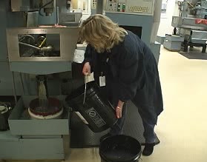
Like any other skill you are working to develop, the way to improve skill levels is to practice. We have included the CNC Reservoir Case Study for additional practice.
Please access the Case Study that includes the pre and post intervention videos and ERS worksheets along with all the details you need.

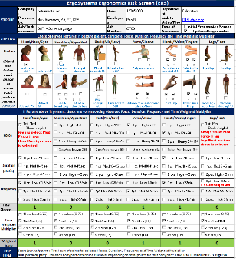
Next Steps
The Ergonomics Risk Screen is an important tool to objectively analyze the ergonomics factors of job tasks and determine the relative risk of the factors.
The ERS process helps you and your clients come up with reasonable and feasible ergonomics recommendations to enhance health, safety and productivity!
Thanks for your time and attention!

