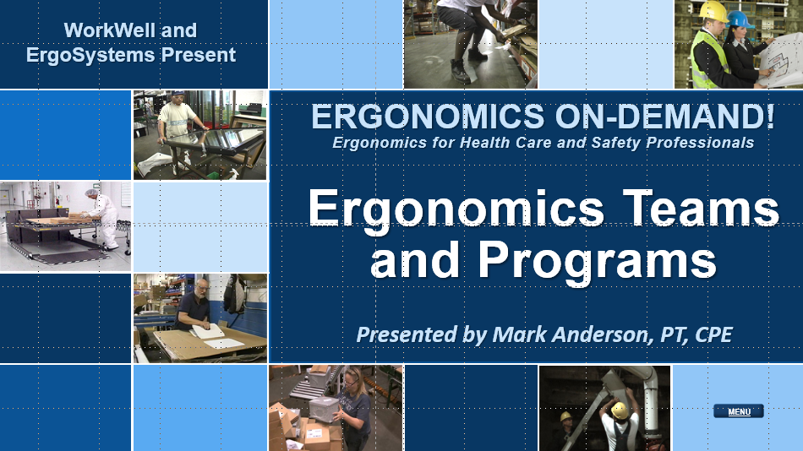

Developed by:
Mark A. Anderson, MA, PT, CPE
Certified Professional Ergonomist
Physical Therapist
ErgoSystems Consulting, LLC.
7421 West Shoreline Drive
Waconia, MN 55387
Voice: 952-401-9296
Mark.Anderson@ergosystemsconsulting.com
www.ergosystemsconsulting.com

The information contained in this training workbook has been developed in good faith and is believed to present good ergonomics principles and practices. ErgoSystems Consulting, LLC and all other participating organizations make no representations or warranties as to the completeness or accuracy of the materials thereof. Persons using this information must make their own determination as to its suitability for their purposes. ErgoSystems Consulting, LLC and all other participating organizations are in no way responsible for damages of any nature resulting from the use of this information.

Copyright 1997 to 2021 ErgoSystems Consulting, LLC., All Rights Reserved Version 2_04222021

Table of Contents
Ergonomics Teams and Programs Track 3
Welcome 3
Introduction to Ergonomics 3
Evolution of Ergonomics Consultation 3
Collaborative Ergonomics 3
Your Journey? 4

Ergonomics Teams and Programs Track

Welcome
Hello everyone. Welcome to the Ergonomics Teams and Programs Track!
I’m Mark Anderson. I am a Certified Professional Ergonomist and Physical Therapist. I have been fortunate to work in ergonomics over the past 30 plus years.

Introduction to Ergonomics
I was first introduced to ergonomics in 1985. I was completing Physical Therapy graduate school and working in an Industrial Rehabilitation program primarily with Worker’s Comp patients. I was trained in performing Functional Capacity Evaluations and the Work Hardening process as it was called back in the day.
One day, it occurred to me I needed to have a better idea of the job demands my patients were returning to as they completed the rehab process. I was able to arrange a tour of the workplace of one of my patients. This really was the first step in my ergonomics career.
Shortly after that I attended my first ergonomics course at the Center for Ergonomics at the University of Michigan in Ann Arbor. I found I was able to add the components of ergonomics workstation and tool design and analysis to my clinical practice and recognized this had value.

Evolution of Ergonomics Consultation
I continued my education and experience in ergonomics and in the early 1990’s, I made a decision to move into a full time ergonomics consulting practice. In 1993, I went through the certification process of the Board of Certification in Professional Ergonomics (www.bcpe.org) to gain certification as a professional ergonomist.
My ergonomics consulting process continued to evolve; where initially I was performing ergonomics analysis and consultation for specific patients and clients, I was now working with companies more at a macro level.
I was providing ergonomics training to company representatives including health and safety, engineering, management and workers. I was asked to facilitate the development and implementation of Ergonomics Teams and Ergonomics Programs.

Collaborative Ergonomics
I was developing my philosophy of what I call ‘collaborative ergonomics’. You might recall I mentioned this in the Ergonomics Manufacturing Track.
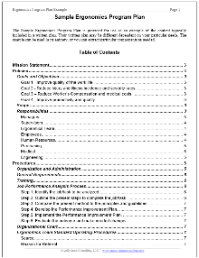
My experience taught me ergonomics is most successful when all the stakeholders – workers, management, supervision, health and safety, engineers, technicians, medical, facilities – come together in collaboration to identify the ergonomics issues, make appropriate recommendations and then work together to implement and follow-up on the recommendations.
What this has essentially taught me, in my experience anyway, is the value of Ergonomics Teams and Programs. To that end I have provided an Ergonomics Program Plan example to give you a framework of an ergonomics program.
Please feel free to review it and use it as it benefits you.

Your Journey?
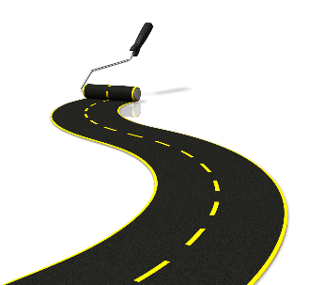
So, this has been my ergonomics journey so far; I have found it be productive and rewarding! Now where will your journey take you?
I know of many health care professionals who have continued to work clinically and have incorporated ergonomics into their practices.
I know of some who have gone the more corporate route working with companies at the macro level.
Bottom line – many opportunities in many different formats are available for health care and safety professionals. I wish you the best in whatever direction your unique journey takes you!
Thanks for your time and attention!

