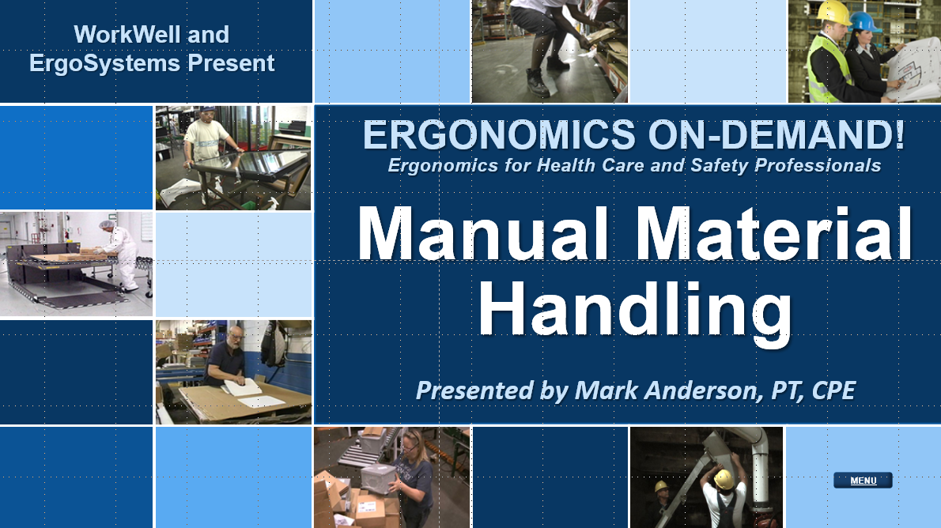

Developed by:
Mark A. Anderson, MA, PT, CPE
Certified Professional Ergonomist
Physical Therapist
ErgoSystems Consulting, LLC.
7421 West Shoreline Drive
Waconia, MN 55387
Voice: 952-401-9296
Mark.Anderson@ergosystemsconsulting.com
www.ergosystemsconsulting.com

The information contained in this training workbook has been developed in good faith and is believed to present good ergonomics principles and practices. ErgoSystems Consulting, LLC and all other participating organizations make no representations or warranties as to the completeness or accuracy of the materials thereof. Persons using this information must make their own determination as to its suitability for their purposes. ErgoSystems Consulting, LLC and all other participating organizations are in no way responsible for damages of any nature resulting from the use of this information.

Copyright 1997 to 2021 ErgoSystems Consulting, LLC., All Rights Reserved Version 2_04222021
Table of Contents
Manual Material Handling Track 3
Welcome 3
How Much Weight Can a Person Lift? 3
Occupational Biomechanics 3
Lifting Calculators 4
Lifting Guide Criteria 4
Lifting Scenario 4
Potential Lifting Factors 4
Brainstorm – Potential Lifting Factors 5
Potential Lifting Factors 5
Simplified Lifting Calculator 6
Manual Material Handling Basic Criteria 6
Actual Object Weight 6
Horizontal Distance (H) 6
Vertical Position 6
Frequency and Duration 7
Spine Rotation 7
Object size and grip 7
LNI Lifting Calculator Online App 6
LNI Lifting Calculator Worksheet 7
Manual Material Handling Case Study – Handle Speaker 9
Handle Speaker Background 9
Lift from Floor 9
Lift to Stand 10
Manual Material Handling Controls 10
Manual Material Handling Guidelines 10
NIOSH Ergonomics Guidelines for Manual Material Handling 11
Manual Material Handling Assessment Practice 11
Ergonomics and Manual Material Handling 11

Manual Material Handling Track

Welcome
Welcome to the Ergonomics Manual Material Handling Track.
Hi everyone, I’m Mark Anderson. I am a Certified Professional Ergonomist and Physical Therapist with more than 30 years of experience working with ergonomics. Thanks for your interest in Ergonomics and Manual Material Handling.

How Much Weight Can a Person Lift?
A basic question I get on a regular basis is, “How much weight can a person lift in a safe and effective way?
To answer this question, I think we need to ask another question, “What are the factors that influence how much weight a person can safely lift?”
And a third question, “Based on these factors, can a mathematical formula be developed to predict how much a person can safely and effectively lift?”
Not surprisingly, these questions have been studied extensively over the past 50 years.
And then we should ask one more question, “How can we apply this information to identify the level of risk of manual material handling and then offer reasonable interventions?”
These are the topics we will explore in the Ergonomics Manual Material Handling Track.

Occupational Biomechanics
You might recall in the Introduction to Ergonomics Track one of the ergonomics principles we introduced was to Control Manual Material Handling. We looked at Occupational Biomechanics information specific to intra-discal pressures generated with manual handling. In the 1970’s, what have become classic research studies in the investigation of postural influences on in-vivo lumbar intervertebral disc pressures were conducted by Alf Nachemson, MD, PhD and colleagues. Results revealed increased discal pressures based on lever arm lengths in the spinal column.
With in-vivo lumbar intervertebral disc pressures normalized to 100% when in a neutral upright standing position, discal pressures with lifting about a 30 lb. box from a 30⁰ flexed forward posture of the low back position were almost 500%! Holding the same box in an upright posture as close to the body as possible resulted in about half that of about 225%. Decreasing the lever arm distance makes a huge difference.
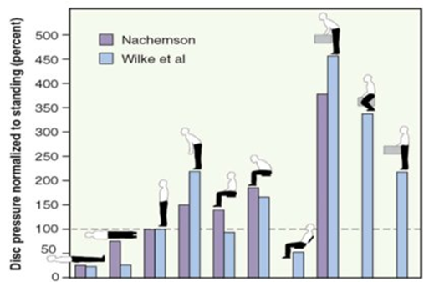 | Disc Pressure Measurements  Nachemson, AL  Spine, 31 Dec 1980, 6(1):93-97  New In Vivo Measurements of Pressures in the Intervertebral Disc in Daily Life  Hans–Joachim Wilke, PhD,* Peter Neef, MD,† Marco Caimi, MD,‡ Thomas Hoogland, MD,§ and Lutz E. Claes, PhD*  Spine, Volume 24, Number 8, pp 755–762  ©1999, Lippincott Williams & Wilkins, Inc.

Lifting Calculators
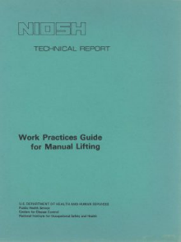
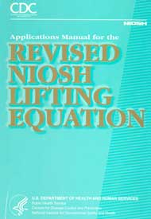
We noted that a number of Lifting Calculators and Guidelines have been developed to analyze lifting tasks. One of the first guidelines was the NIOSH (National Institute for Occupational Safety and Health) Work Practices Guide for Manual Lifting published in 1981 with a Revised Guide published in 1994.
A mathematical formula to predict how much a person can safely lift was introduced in the Guide.

Lifting Guide Criteria
Four criteria were studied to develop the original Guide:
- Epidemiology – Identification of incidence, distribution and potential controls for illness and injury in a population.
- Biomechanical – Study of the impact on the musculoskeletal structure, (particularly the low back) from lifting.
- Physiological – Study of the body’s metabolic and circulatory responses to lifting.
- Psychophysical – Studies performed to quantify the subjective tolerance of people to the stresses of manual material handling.
I would encourage you to read the Guides if you are interested in an in-depth look at the factors. They are readily available on-line.
1991 Version
https://www.cdc.gov/niosh/docs/81-122/pdf/81-122.pdf?id=10.26616/NIOSHPUB81122
1994 Version
https://www.cdc.gov/niosh/docs/94-110/pdfs/94-110.pdf?id=10.26616/NIOSHPUB94110

Lifting Scenario
To gain an appreciation of the nuts and bolts of assessing manual material handling operations, let’s work on developing a list of parameters that influence how much a person can lift based on our experiences of lifting.
For our lifting scenario, imagine we are assessing a warehouse worker palletizing boxes coming off of a conveyor line by loading them onto a pallet.
The manual handling tasks are repetitive (handling one box every minute) and the worker starts with a row of boxes on the pallet and then builds up box levels to about a five foot height (shoulder level).

Potential Lifting Factors
What are the factors that influence the worker’s performance? Make it personal by imagining you are doing the material handling or even better yet, imagine your mother is palletizing the boxes!
I’ll kick off a brainstorming session by thinking about the last time I was lifting some bags of sand into the bed of my truck at the big box store. When I reached out to pick up a bag, the farther away I reached to the bag. the heavier the bag seemed to get! This a phenomenon we have all experienced.
Let’s name this factor Horizontal Distance and define it as, “how far away from our body is the item or box when we lift it; the farther away the greater the stress into the body.”

Brainstorm – Potential Lifting Factors
Brainstorm – list as many factors as you can think of that will influence the palletizing operation.
Horizontal Distance – how far away from our body is the box when we lift it; the farther away the greater the stress into the body

Potential Lifting Factors
How did you do? Check out this list.
- Horizontal Distance – how far away from our body is the box when we lift it; the farther away the greater the stress into the body
- Frequency – how often do we have to lift the box; how many times per minute
- Duration – over how long a period of time during the shift does the lifting occur; less than an hour, one to two hours, two to four hours, more than four hours
- Spine Twisting – does twisting or rotating of the spine (of the lower back particularly) occur to perform the lift
- Vertical Distance Origin – how high the box is from the floor at the start of the lift; at higher than mid-chest level the greater the stress on the body to handle the load
- Vertical Distance Destination – how high the box is from the floor at the end of the lift; at lower than waist to mid-chest level the greater the stress on the body to handle the load
- Item/Box size – is the item or box large and unwieldy, out of balance, difficult or even impossible to hold close the body thereby increasing the horizontal distance
- Grip on the box – is the box easy to grip with handholds/handles or hard to grip with no handholds and maybe even slippery
- Actual object weight – how much does the box weigh or what is the range of weights if the boxes vary in weight.
You probably came up with many if not all of the factors and when you reflect on the Ergonomics Principles found in the Introduction to Ergonomics Track you can see how these factors influence lifting performance.

Simplified Lifting Calculator
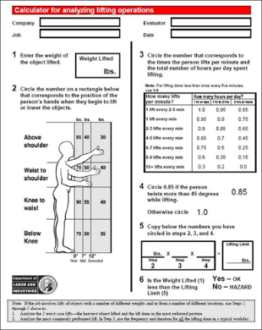
If we compare what we came up with in our brainstorming session to the NIOSH Work Practices Guide for Manual Lifting (Revised) we would see these are the primary parameters in the Guides.
Refer to the Guides if you would like more details. For our purposes we will introduce a simplified version of the lifting calculator.
The States of Washington and Oregon Departments of Labor and Industries developed a version of the NIOSH Work Practices Guide for Manual Lifting. It is called the LNI Lifting Calculator.
A few issues to be aware of when you use the LNI lifting calculator include:
- The estimated Lifting Limit is based on the predicted capability of health adults to handle the weight; this includes about 95% of healthy males and about 75% of healthy females. There certainly are some individuals who can safely handle more than the predicted Lifting Limit.
- Stature of the individual is not considered in the calculation.
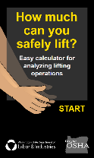
- Gender of the individual is not considered in the calculation.

LNI Lifting Calculator Online App
The LNI Lifting Calculator is available as an online app and I encourage you to check it out at https://osha.oregon.gov/OSHAPubs/apps/liftcalc/lift-calculator.html

Manual Material Handling Basic Criteria
So, in overview, the LNI Lifting Calculator considers basic criteria of the manual material handling event:

Actual Object Weight
Determine the actual weight of the object. If a range of weights is noted; for example, 30 to 40# (13.5 to 18.1 kg), use the higher value in your calculations because it would be the “worst case”.

Horizontal Distance (H)
How far from the body is the object being handled?
The farther away, the longer the lever arm and the more stress into the body.
Estimating Horizontal Distance (H) can be a little tricky. The horizontal location is determined by measuring the distance between the point projected on the floor directly below the mid-point of the hands grasping the object (center of mass), and the mid-point of a line between the inside ankle bones as pictured.
The LNI Lifting Calculator uses predetermined Horizontal Distance values of: 0”, 7” or 12” (0 cm, 18 cm or 30 cm).

Vertical Position
At what level from the floor is the object being handled?
The farther away from the Optimal Lifting Zone (about waist level) the more stress into the body.
The vertical location is measured from the floor (or standing surface) to the vertical mid-point between the hand grasps as defined by large middle knuckle of the hand.
You may need to determine two Vertical Position measurements (V is the origin position and V + D is the destination position) and perform two calculations.

Frequency and Duration
How often and for how long is the object being handled?
From the physiological fatigue standpoint, once every five minutes is dramatically different than 10 times per minute. Frequency has a huge impact. Frequency is categorized as lifts per minute. Look at the LNI Lifting Calculator Worksheet to see the categories of ‘How many lifts per minute’.
Duration is how long throughout the shift the handling is occurring? Over the course of the shift is the manual handling occurring for an hour total or two or the entire shift?
Longer duration is related to increased exposure to stress and results in lower weight limits.

Relationship between hours/day and multiplier.
Look at the LNI Lifting Calculator Worksheet to see the relationship between the hours/day and the multiplier. For example, for one lift occurring every 2-5 minutes at a cumulative duration of one hour or less in the shift, the multiplier is 1.0 and has no impact on the calculation.
On the other end of the spectrum for 10+ lifts occurring every minute at a cumulative duration of two hours or more in the shift, the multiplier is 0.0 and essentially indicates this lift should not be performed.
Then you will see the multiplier is on a sliding scale between these two points.

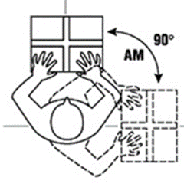
Spine Rotation
Is spinal rotation occurring during the lift?
Rotation of the spine, particularly with forward bending when lifting has been determined to result in significant shear and compression force into the spine.
Estimate spine rotation as the angle between the shoulders and hips from origin to destination of the lift. For spine rotation more than 45 degrees, the multiplier is 0.85.

Object size and grip
What shape and size is the object and how well can it be gripped? Smaller, well-balanced objects with handholds are easier to handle. The 1994 revised NIOSH Work Practices Guide for Manual Lifting added a hand-to-container coupling factor.
The LNI Lifting Calculator does not include a hand-to-container factor; if you identify this as an issue you will want to make note of this and perhaps decrease the recommended weight or recommend a change in object size or grasping.

LNI Lifting Calculator Worksheet
We will go through the LNI Lifting Calculator Worksheet so you can see the underlying strategy to use it.
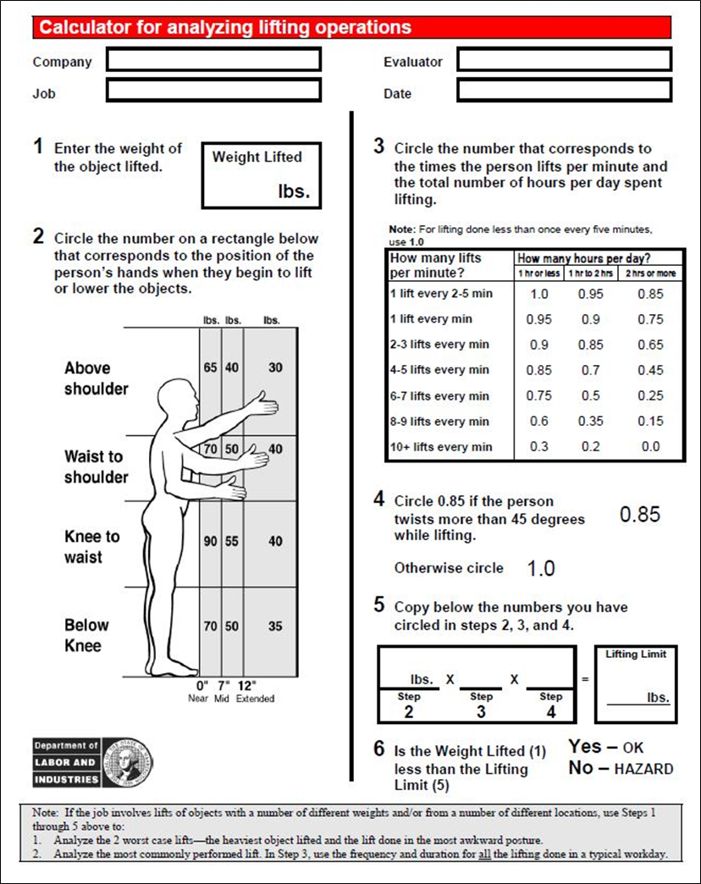

Manual Material Handling Case Study – Handle Speaker

Handle Speaker Background
Let’ s work on a material handling case study to get a feel of how to use the LNI Lifting Calculator. Sound technicians at a company are responsible for setting up speaker systems on-site at various venues. Here are the specifics:
- Speaker weight is 45# (20.5 kg)
- Speaker is lifted from the floor and placed on the top of a stand (about 60”/152 cm) off the ground)
- Duration is for one hour or less/day
- Frequency is 1 lift/min
We need to perform the calculation twice; first for the lift from the floor and second for the speaker lift and placement on the stand. Let’s check out the video.
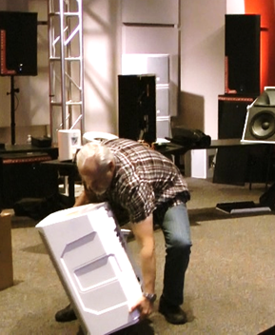 | 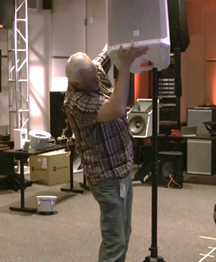

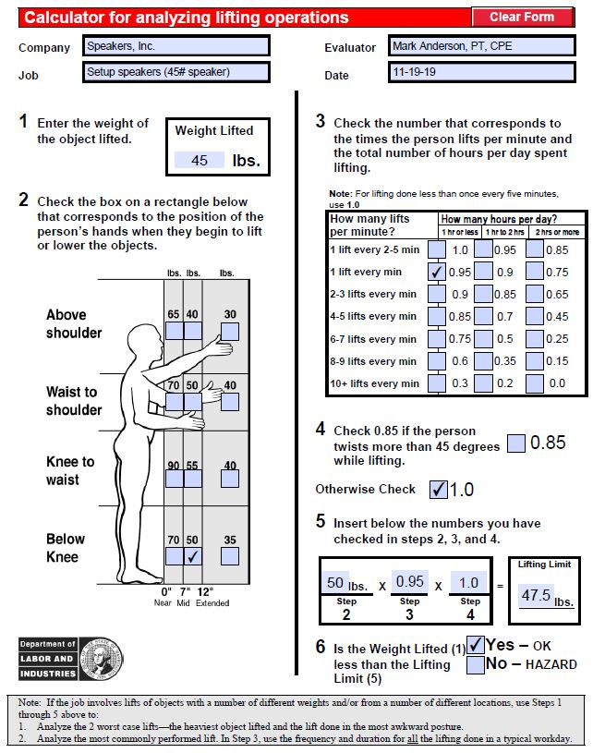
Lift from Floor
Let’s do the Lift from Floor calculation first.
The Weight Lifted is 45# (20.5 kg)
Hand Position is Below Knee at 7” (18 cm); you will see the 50# (22.7 kg) box is checked
Lifts/min is 1
Hours/day is 1 hr or less
So, the appropriate box is checked; the multiplier is 0.95
Twists more than 45 degrees: the answer is no. So the 1.0 multiplier box is checked.
Next, we do the math:
50# (22.7 kg) x 0.95 x 1.0 = 47.5# (21.5 kg).
Is the Weight Lifted (45#/20.5 kg) less than the Lifting Limit (47.5#/21.5 kg).
It is, so we answer YES – OK.

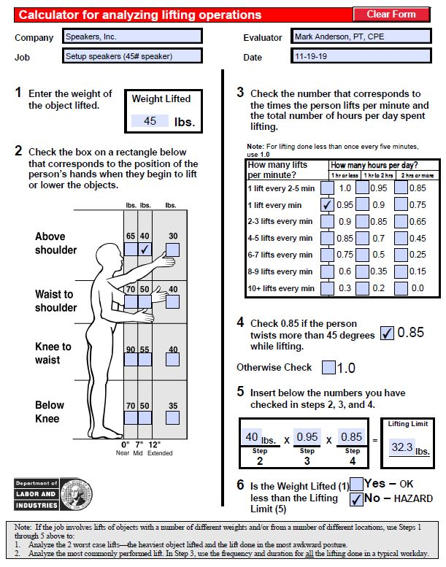
Lift to Stand
Now, let’s do the Lift to Stand calculation. The Weight Lifted is still 45# (20.5 kg).
To place the speaker on the stand the Hand Position is Above Shoulder at 7” (18 cm) and you will see the 40# (18.1 kg) box is checked.
The Lifts/min is still 1.
The Hours/day is still 1 hr or less.
Now we do see twisting more than 45 degrees and the 0.85 multiplier box is checked.
Doing the math we get:
40# (18.1 kg) x 0.95 x 0.85 = 32.3# (14.7 kg).
Is the Weight Lifted (45#/20.5 kg) less than Lifting Limit (32.3#/14.7 kg)?
The answer is NO – Hazard.

Manual Material Handling Controls
Some type of manual material handling control is recommended to be considered.
Take a moment and list some options:
What did you come up with? This might include a two-person lift policy, a mechanical lifting device, worker body mechanics and technique training, functional capacity testing to identify if a particular individual has the functional capacity to safely handle the lift or perhaps some other options.

Manual Material Handling Guidelines
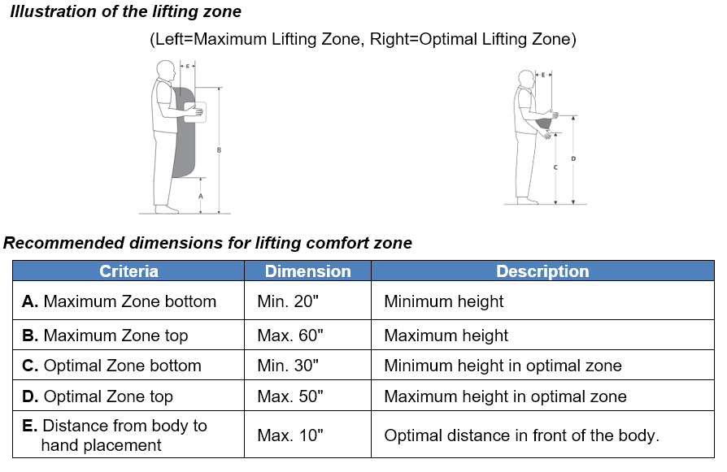
Take a look at the Manual Material Handling Checklist as needed for the general ergonomics analysis process in the Ergonomics Design Guidelines Track.
A summary of the Guidelines includes:
- Eliminate (as feasible) manual handling by using mechanical handling equipment (forklifts, powered lifts, etc.).
- Reduce the physical stress of manual handling by using manual handing equipment (carts, two-wheelers, etc.).

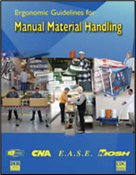
NIOSH Ergonomics Guidelines for Manual Material Handling
Check out the NIOSH Ergonomics Guidelines for Manual Material Handling at:
https://www.cdc.gov/niosh/docs/2007-131/default.html
Another good resource is the Canadian Centre for Occupational Health and Safety.
https://www.ccohs.ca/oshanswers/ergonomics/mmh/
The OSH Answers Fact Sheets on Manual Material Handling are informative.

Manual Material Handling Assessment Practice
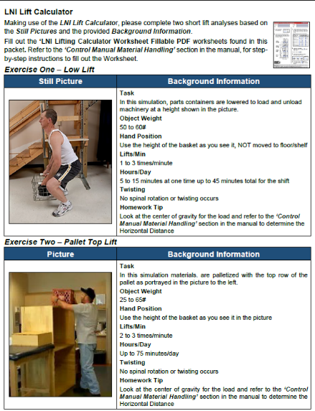
To gain additional practice in using the LNI Lifting Calculator, download the Manual Material Handling Case Study.
Here are some tips:
- Use the LNI Lifting Calculator Worksheet Fillable PDF (from your training materials) for the assignment. You can certainly check out the on-line version we discussed; however, we would encourage you to use the Worksheet to better understand how the calculator works.
- Review the basic criteria of the manual material handling event.
- Carefully read the instructions to get all the details you need to complete the exercise.
- If a range of weights is noted; for example, 30 to 40#/13.6 to 18.1 kg, use the higher value in your calculations because it would be the “worst case”.

Ergonomics and Manual Material Handling
Manufacturing, office, warehouse, health care; no matter what work environment in which you apply ergonomics principles, controlling manual material handling is an integral part of a safe and productive workplace.
I hope our discussion on Manual Material Handling assessment and control methods has been informative for you. The Manufacturing Ergonomics Track includes very specific examples of applying control measures; check it out for additional ideas.
As always, thanks for your time and attention!

