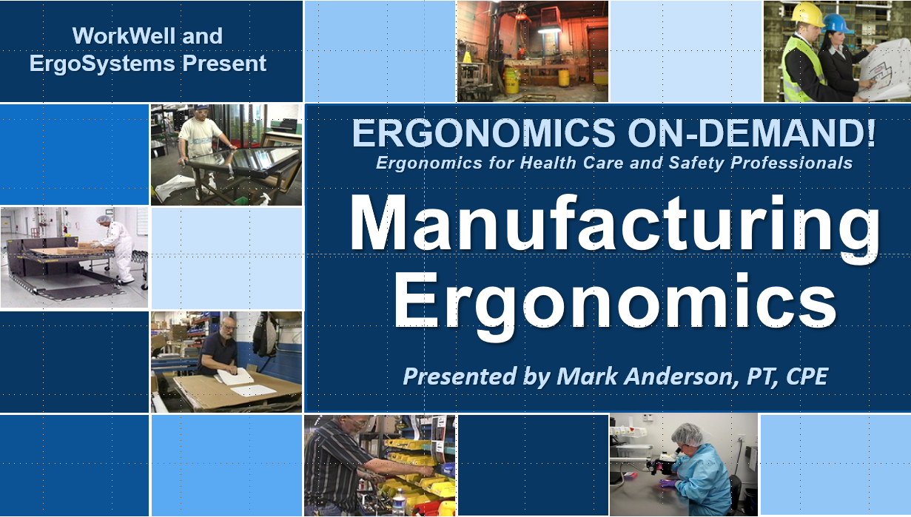
Developed by:
Mark A. Anderson, MA, PT, CPE
Certified Professional Ergonomist
Physical Therapist
ErgoSystems Consulting, LLC.
7421 West Shoreline Drive
Waconia, MN 55387
Voice: 952-401-9296
Mark.Anderson@ergosystemsconsulting.com
www.ergosystemsconsulting.com

The information contained in this training workbook has been developed in good faith and is believed to present good ergonomics principles and practices. ErgoSystems Consulting, LLC and all other participating organizations make no representations or warranties as to the completeness or accuracy of the materials thereof. Persons using this information must make their own determination as to its suitability for their purposes. ErgoSystems Consulting, LLC and all other participating organizations are in no way responsible for damages of any nature resulting from the use of this information.

Copyright 1997 to 2021 ErgoSystems Consulting, LLC., All Rights Reserved Version 2_07142021

Table of Contents
Ergonomics Manufacturing Track 6
Welcome 6
Collaborative Ergonomics 6
Ergonomics Manufacturing Track 6
Manufacturing Ergonomics – Components 6
Ergonomics and Systems Design 6
Case Study – Oil Fill 7
View before video 7
Brainstorming session 7
View after video 7
Workstation Purpose 8
Manufacturing Work Process 8
Manufacturing Instructions 8
Cycle Time/Takt Time/Line Balancing 9
Job/Task Rotation 9
Work Process: Design Conventions and Human Behavior Checklist 9
Workforce 9
Work Force Demographics 9
Age 9
Gender 10
Stature and Morphology 10
Hand Dominance 10
Workbench and Chair 10
Stationary/Mobile 10
Adjustability features 10
Work height 10
Work reach envelope 11
Chair/stool 11
Equipment controls 11
Worker movement 11
Space and clearance 11
Workbench Configuration 11
Workstation Selection Characteristics for Sitting and Standing Workbenches 11
Workbench Height 12
Chair/Stool Configuration 13
Objectives of chair/stool 13
Types of seating systems 13
Chair/Stool criteria 14
Chair/Stool solutions 16
Anti-fatigue mats 16
Parts/Materials/Trash 17
List of Parts/Materials 17
Storage/Staging Locations 17
Trash Receptacles 17
Micro-breaks 17
Tools 18
Manual to Power 18
Torque reaction forces 18
Segmental (Hand/Arm) vibration 18
Questions to consider include: 18
Whole body vibration 19
Control vibration 19
Case Study – Slag Removal 20
View before video 20
Brain storm session 20
View after video 20
Equipment 20
Fixtures/Jigs 20
Types of Fixtures 21
Hand and Foot Controls 21
Foot pedals 21
Hand controls 21
Hand and Foot Control Checklist 21
Contact Stress 21
Contact Stress - Sharp edge 21
Contact Stress – Sitting and Standing 22
Microscopes/Magnifiers 22
Multi-user 22
Step-by-Step Set-up Protocol 22
Computer (CPU, keyboard, mouse, displays) 24
Machine Clearance and Maintenance Accessibility Guidelines 24
Preventive Maintenance 24
The tale of the forklift! 24
Housekeeping 24
Accessibility for Maintenance 24
Physical Demands Associated with Tool and Equipment Use 25
Component Fit 25
Force – Grip 25
Coefficient of Friction 25
Glove use 25
Tool use and postures 26
In-line grip 26
Pistol grip 26
Ergonomically designed tools 26
General tool guidelines 26
Label Maker Case Study 26
Position 26
Prolonged or repeated non-neutral spinal positions 26
Wrist deviations greater than 15 degrees 26
Forearm rotation 27
Elbows sustained above mid-chest height 27
Reaching frequently behind the body or above the shoulders 27
Optimizing Work Positions 27
Standing work position 27
Seated work position 28
Sit/Stand work positions 28
Adjustable height work stations 28
Turntables 28
Rapid machine pacing in assembly task 29
Movement 29
Mental Demands Associated with Tool and Equipment Use 29
Is the task complex? 29
Is the task monotonous? 29
Design and Use Standards 29
Perceptual Demands 29
Illumination 30
Illumination - General 30
Illumination - Task 30
Illumination - Contrast 30
Illumination - Glare 30
Auditory 30
Touch 30
Visual Acuity 30
Personal Protective Equipment (PPE) 30
Mandatory 31
Monitoring and Enforcement 31
Your own PPE! 31
Material Handling 31
Physical Demands 31
Metabolic Load 31
Force - Lift/Push/Pull 31
Force – Lift/Push/Pull Intervention strategies 32
Force - Workflow and Rate 33
Carts 33
Casters 33
Handles 33
One person vs. two person 34
Push vs. pull 34
Conveyors 34
Storage 34
Shelves/Racks 34
Work Environment 35
Control Exposure to Work Environment 35
Summary and Thanks! 35

Ergonomics Manufacturing Track

Welcome
Welcome to the Ergonomics Manufacturing Track!
Hello everyone, I’m Mark Anderson. I am a Certified Professional Ergonomist and Physical Therapist with more than 30 years of experience working with ergonomics in manufacturing.

Collaborative Ergonomics
I am a strong proponent of what I call ‘collaborative ergonomics’. What do I mean? My experience has taught me manufacturing ergonomics is most successful when all the stakeholders – workers, management, supervision, health and safety, engineers, technicians, medical, facilities – come together in collaboration to identify the ergonomics issues, make appropriate recommendations and then work together to implement and follow-up on the recommendations.

Ergonomics Manufacturing Track
In the Ergonomics Manufacturing Track, we apply the ergonomics foundations and principles we covered in the Introduction to Ergonomics Track to workstations, tools and equipment found in the manufacturing workplace.

Manufacturing Ergonomics – Components
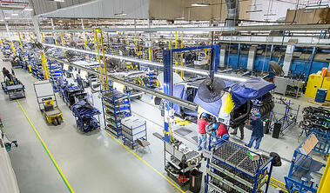
I have had the opportunity to apply ergonomics principles to many different manufacturing workstations over the years. Take a look at a typical manufacturing workstation. What will you see?
Well, generally you will see some sort of workbench with a chair or stool. Of course, you will see the worker or workers doing the work.
You will see a variety of parts and materials along with the tools and equipment needed to assembly the widget or whatever is being accomplished at the workstation.
You will see manufacturing instructions, either computer based or hard copy, the worker uses to guide the manufacturing process.
There will be storage systems (bins, shelves and so on) to store and stage the parts, materials, tools and equipment and a trash receptacle to handle the trash produced.
You may see manual or powered systems to convey materials to and from the workstation; this could include pallet jacks, carts, conveyors and so on.
Of course, we also have to recognize the environment of the workstation; light, noise, temperature and ventilation.
All of these components need to work together to create a workstation that is safe and productive.

Ergonomics and Systems Design
In the Introduction to Ergonomics Track we defined ergonomics:
Optimizing all aspects of job performance - safety, quality and productivity - accomplished through the appropriate DESIGN AND USE of work processes, workstations, tools and equipment and the overall organization of work.
We recognize that the systems design approach is crucial to successful ergonomics. To achieve our objective of a safe and effective workplace we needed to understand the set of circumstances that result in a certain outcome.
If the current set of circumstances do not provide the desired outcome, we need to figure out how to change them in reasonable and feasible ways. We need to change the circumstances to change the response!
We will take a closer look at each of the components in the manufacturing workplace and how they are inter-related from the ergonomics perspective but first let’s go through a case study to give you a sense of ergonomics in the manufacturing workplace.

Case Study – Oil Fill
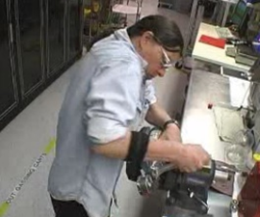
Instruments, Inc. manufactures calibration equipment. Part of the manufacturing process is to screw a gauge onto an oil fill canister. This task had been identified as a problem in terms of discomfort and even injuries reported by the workforce.
An ergonomics assessment was conducted using the Ergonomics Risk Screen process and recommendations for improvement were made. For details about how to conduct the Ergonomics Risk Screen please refer to the Ergonomics Risk Screen Track.
For now, let’s take a look at how the process had been accomplished, brain storm on some potential modifications and then take a look what changes were made.

View before video
Play the ‘before video’ to observe how the task had been accomplished.

Brainstorming session
List options for ergonomics improvements.

View after video
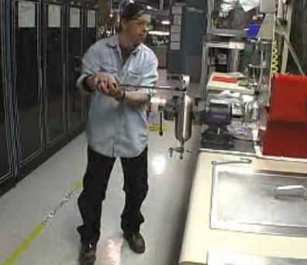
Play the after video to observe how the task was modified. What do you think?
I collaborated with the worker, supervisor, health and safety manager and the engineer assigned to the area to come up with these straightforward recommendations:
- Reorient the vise to position the canister vertically
- Replace the wrench with long handled torque wrench with proper technique (also now able to document the amount of torque required to effectively secure the gauge)
A significant improvement was noted.
To give you a sense of the before and after difference in the ERS results, take a look at the forms. Green indicates low or no risk. Yellow and red indicate higher levels of relative risk.
Visually the distinctions are quite dramatic!
Before Ergonomics Inteventions | After Ergonomics Interventions
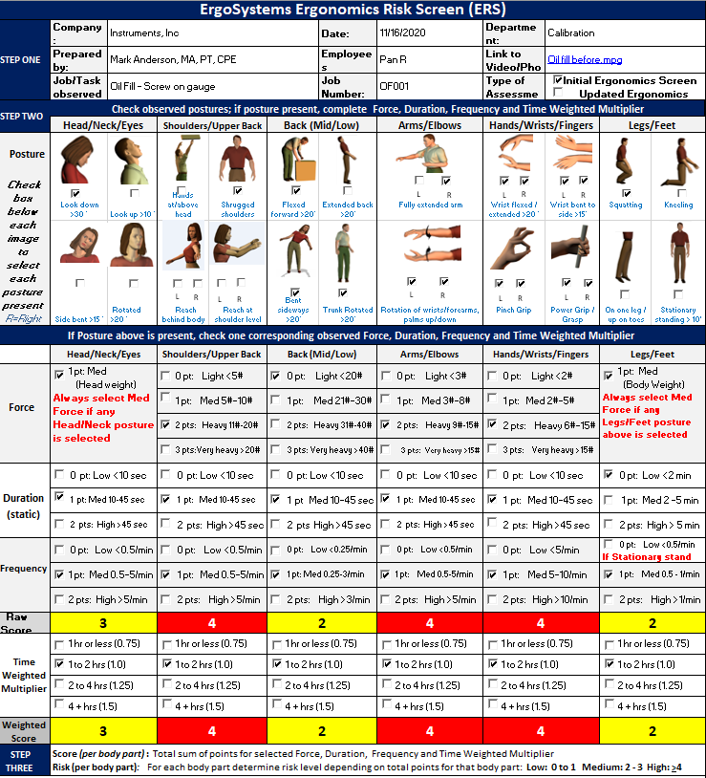 |  | 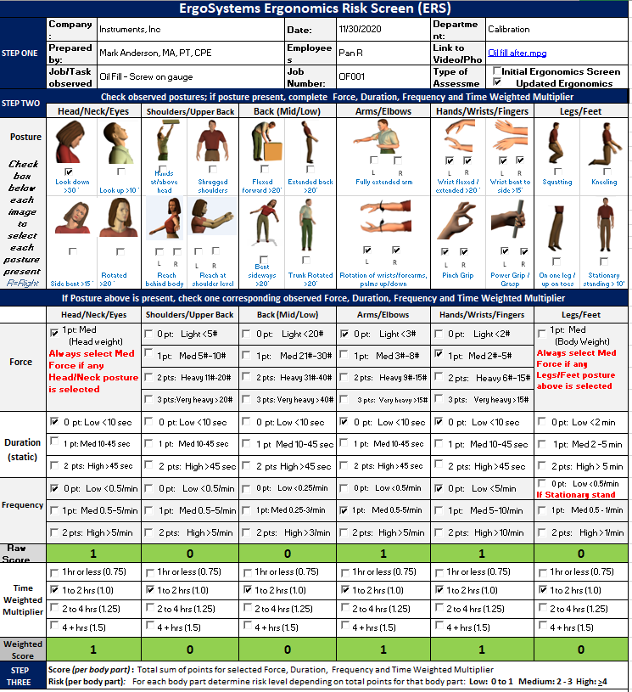

Check out the Ergonomics Risk Screen Track to learn how to perform the detailed Ergonomics Risk Screen that scores the relative ergonomics risk level.

Workstation Purpose
An obvious but critical first step is to identify the purpose of the workstation.
As much as possible, understand what will be manufactured in the workstation in terms of item size and weight, manufacturing methods, production quantities and so on.

Manufacturing Work Process
You might recall the first ergonomics principle we introduced in the Introduction to Ergonomics Track was to Promote Effective Work Processes. We want to apply these concepts to the manufacturing workplace.

Manufacturing Instructions
A very good place to start is the manufacturing instructions. More than likely detailed manufacturing instructions have been written for the manufacturing process. Or . . . perhaps not, if this is a brand-new work process. At any rate, review the current or proposed manufacturing instructions if available to determine if they include specific reference to ergonomics related procedures.
For example, are there specific instructions in the setup and use of the workbench? Many workbenches are user-controlled height adjustable. Is instruction provided to the user about how to adjust the height of the workbench to meet his or her specific stature based on the job task that is being performed?

Cycle Time/Takt Time/Line Balancing
Have cycle times, takt times and line balancing been determined?
Cycle time is determined by the time it actually takes to complete a specific task as part of the assembly process, with overall cycle time defined as the time it takes to complete the entire assembly.
Takt time is dependent on the customer demand (takt time = available time/total demand).
Are the cycle and takt times in unison? When a line is balanced in terms of cycle and takt times, job performance is optimized. If the actual cycle time is less than the determined takt time, we may need to look for ways to reduce the cycle time, e.g., optimize processes, employ more resources, etc.

Job/Task Rotation
Has job or task rotation been factored into the work process?
Machines typically are designed to perform the exact same task in a highly repetitive manner maintaining a high level of consistent performance. As manufacturing automation becomes more and more sophisticated, we are seeing more machines in the workplace.
On the other hand, human beings depend on variety of activity, both physically and mentally to optimize performance. We are extremely good at making the minute adjustments needed to successfully accomplish an intricate assembly process.
We recognize human beings are not machines. Job or task rotation can be an effective means to optimize human performance by providing for a variety of different physical demands.

Work Process: Design Conventions and Human Behavior Checklist
The Ergonomics Design Guidelines Track includes a checklist (Work Process: Design Conventions and Human Behavior Checklist) to help you evaluate the overall work process.

Workforce
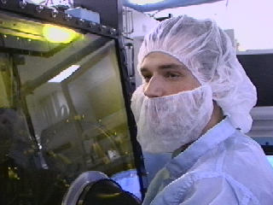
The Workforce is the critical component in the success of the workplace.
The essence of ergonomics focuses on enhancing the health, safety and productivity of the people doing the job!

Work Force Demographics
Have the workforce demographics been identified and incorporated as needed into the workstation design?
When ergonomics is used at the organizational level, it is used to develop a description of the individual worker and/or workforce: age, fitness level, training and experience levels, gender breakdown, body stature, hand dominance and so on. Consideration of the workforce demographics enhances the design process.

Age
Physiological changes occur as a matter of aging:
- Strength and flexibility may significantly decrease.
- Aerobic capacity and endurance decrease.
- Visual acuity may deteriorate.
- Reflexes and hand-eye coordination may deteriorate.
Changes also take place in psychosocial aspects. With age, work experience associated with work expertise is enhanced. Experienced workers bring a valuable factor to the workplace.

Gender
Knowledge of the gender breakdown is often required to implement successful ergonomics interventions. This is important to know in terms of proper:
- Fit and use of workstations, tools, equipment and clothing. For example, small hand size vs. large hand size in relation to tool handle size.
- Match between physical demands of the job and functional capacity levels of the worker.

Stature and Morphology
Anthropometry - the study of the size and shape of the body plays an important role. Assessing the stature and morphology numerical ranges of the workforce is necessary to provide for adequate design and use of the workplace.
In other words . . . How tall? How short? How big? How small? This is the science of Anthropometry – a topic we will go into in more depth in the Ergonomics Anthropometry Track.

Hand Dominance
Approximately 90% of the general population is right-hand dominant.
As a result, most workstations, tools and equipment are designed and set up to accommodate right hand dominance use. This often presents complications for the remaining 10% of the workforce. Of course, there are those lucky few who are ambidextrous! Look for opportunities to minimize the impact on left-hand dominant workers so the task can be performed well either right or left handed or can be easily switched from right to left hand use.

Workbench and Chair
In the manufacturing assembly workplace, the workbench and chair are at the center of the workstation. Providing an appropriate workbench and seating system that promotes appropriate application of the ergonomics principles is essential.

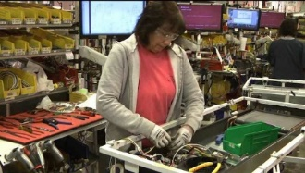
Stationary/Mobile
A good first question to address is the workstation stationary or mobile? A stationary work station is used primarily in one position.
We’ll discuss recommended adjustability workstation features a little later.
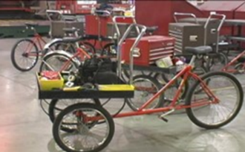
Or is the work station mobile – taken from job site to job site? If so, how is it transported? This could be a rolling cart. Check out the information on selection and use of carts in the Ergonomics Design Guidelines Track.
I have seen mobile workstations on tricycles with storage bins; they work well in large manufacturing facilities to quickly and efficiently get around.

Adjustability features
Can the work station be adjusted to accommodate the needs of different workers and work processes?

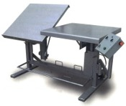
Work height
- Does the height of the work surface permit a comfortable view of the job being done?
- Is the height of the work surface adjustable?
- Does the height of the work surface permit satisfactory arm posture? (Correct hand height depends on type of work performed and object worked on.)

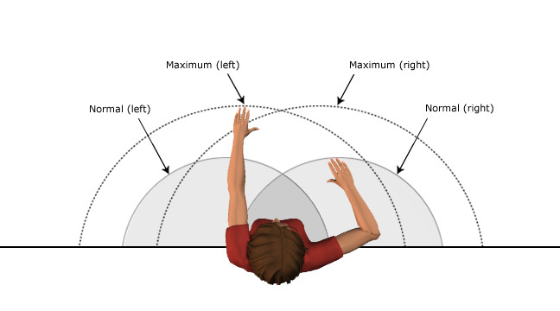
Work reach envelope
- Can the worker keep horizontal stretches within the range of normal arm reach?
- Refer to the anthropometric data tables for additional details.

Chair/stool
- If a chair/stool is provided, is its design satisfactory? (Adequate back support, vertical adjustability, etc.)

Equipment controls
- Can equipment controls and machinery be adjusted to accommodate the needs of different operators?

Worker movement
- Is it possible for the worker to alternate sitting and standing when performing the task?

Space and clearance
- If containers are used, are they placed conveniently?
- Is there adequate space at the work station to perform the work comfortably?
- Does the positioning of equipment controls and work surface make it possible to maintain a comfortable posture?
- Is the workplace accessible to material handling equipment?
- Is clearance space in the workplace adequate for maintenance tasks?

Workbench Configuration
The Ergonomics Design Guidelines Track is the go-to guide for workstation, workbench, seated and standing configurations and much more detail; I encourage you to review it so you will be familiar with its contents and can refer to it as you need to. For example, let’s take a look at how to determine if a seated or standing work position is most beneficial.

Workstation Selection Characteristics for Sitting and Standing Workbenches
In terms of worker position, the type of work performed generally determines workstation configuration: seated or standing. Check out the table.
Workstation Characteristic | Configuration
 | Sitting | Standing
 | 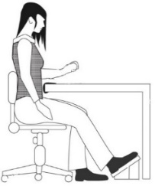 | 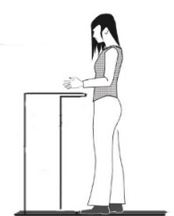
Side-to-Side Movement | Within seated workspace | Frequent movement outside of comfort zone
Task Duration | Sustained, > 5 minutes at one time | Intermittent, < than 5 minutes at one time
Hand Heights | < 6” (15 cm) above surface | > 6” (15 cm) above surface
Weight Handled | < 5 lbs (2.2 kg) | > 5 lbs (2.2 kg)
Reaches | Within Comfort Zone (within 12”, 30 cm) | Forward reaches of > 12”, 30 cm
Forces Exerted | < 5 lbs (2.2 kg) | Downward forces of > 5 lbs (2.2 kg)
Clearance | Seated clearances for legs and feet are met | Knee clearance < 18” (46 cm) or  foot clearance < 22” (56 cm)
Manipulation | Fine manipulation | Fine manipulation not required
Use of Feet | Foot pedals are used | No foot pedals are used
Here are some general guidelines for seated vs standing work positions.

Seated workstations
- A high degree of precision is required (fine manipulation and visual attention).
- Feet are used for control operations.
- All tools and materials can be easily supplied and handled within the reach envelope.
- The job consists of long work periods (over 5 minutes).
- Hands are not required to work more than 6 inches (15 cm) above the work surface.
- Low forces are exerted (weights are less than 5 lbs. (2.2 kg))

Standing workstations
- The work requires frequent high, low, or extended reaches outside of the comfortable arm reach envelope (more than 12 inches, 30 cm).
- Frequent walking is required.
- Large forces are exerted, or heavy weights are handled (objects weighing > 5 lbs., 2.2 kg).
- It is impossible to provide leg room for a seated operator (less than 18”, 46 cm of knee clearance and less than 22”, 56 cm of foot clearance).
- Frequent movement between various workstations (every 5 minutes or less).
- Intermittent task duration.
- Items are handled more than 6” (15 cm) above the work surface.
- Downward forces of more than 5 lbs. (2.2 kg) are required.

Workbench Height
Workbench height, whether seated or standing, is determined by three factors: the anthropometry of the worker and the position of the hands and head to see and manipulate the object and the physical demands required to accomplish the task.
Three types of work are typically recognized: precision work, light assembly and manual work.

Workbench standing height table
Here is a table that outlines general workbench height recommendations for a standing height workbench.
Please note these recommendations are for a general population and individual variation can occur within a particular worker.

Task | Adjustable Height Workbench | Fixed Height Workbench
Precision | 40” to 52” (102 to 132 cm | 45” (114 cm)
Light assembly | 36” to 48” (91 to 122 cm) | 42” (107 cm)
Heavy assembly | 32” to 44” (81 to 112 cm) | 37” (94 cm)

Seated workbench heights
Here is an illustration of the three worksurface heights at a seated workbench
Precision Work Light Assembly Manual Work
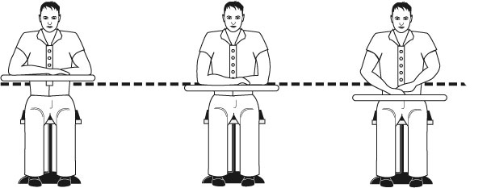
Check out the Workstation, Workbench and Chair/Stool Checklists as needed in the Ergonomics Design Guidelines Track.

Chair/Stool Configuration
Depending on the type of work being accomplished, the use of a chair or stool can be a vital component in the manufacturing workplace. We will cover the basics of chairs and stools here; please refer to the Office Ergonomics Track for additional details.
We define a chair as a seating system where the seatpan can be adjusted so the user’s feet are supported on the floor. A stool on the other hand, typically has a higher seatpan and the user’s feet will not be able to be placed on the floor – a footrest will be required for foot support.

Objectives of chair/stool
What does the chair or stool accomplish for the user?
- Support body and limbs to provide relief from weight bearing.
- Provide a stable base or platform for the body and limbs.
- Position the user at the correct height and reach relationship to the worksurface and tasks at hand.
- Allow for easy change in position/movement of the user.

Types of seating systems
A number of seating systems are available and include task chairs, stools, lean platforms and other miscellaneous seating.
Lean platforms allow for the user to remain in a standing position while obtaining relief for the weight bearing joints (back, hips, knee and ankles).
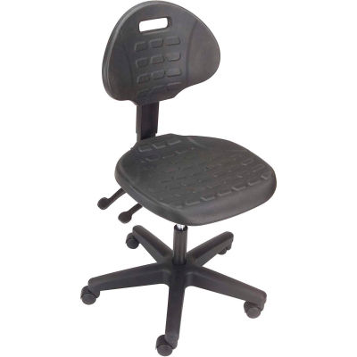 | 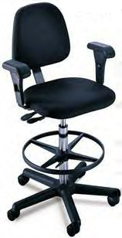 | 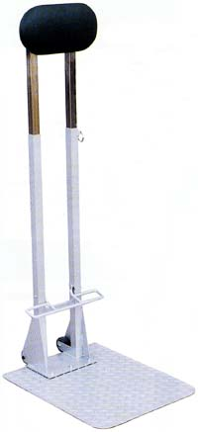

Chair/Stool criteria
Let’s take a look at basic chair and stool criteria.

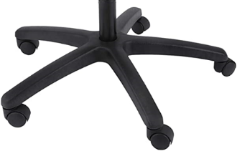
Legs
A 5-point support system for the legs is the industry standard.
This is specifically intended to reduce the likelihood of inadvertently tipping over the chair. The older style 4-point leg systems hopefully are a thing of the past.

Casters
Different types of chair casters are necessary based on the floor surface.
Most office workstations will have a carpeted floor and should have ‘carpet caster’ to match. This will typically be a fairly wide, hard plastic shell caster that rolls smoothly on the softer floor surface.
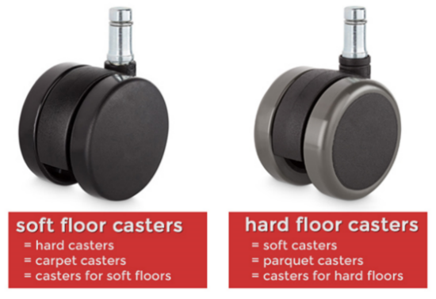
On the other hand, most manufacturing floors will be a hard surface such as tile or concrete and the caster type should be a softer, often rubberized material that allows for increased friction between the caster and floor.
Imagine a ‘carpet caster’, hard plastic shell on a hard surface floor. What do you get? The user goes for a ride!
Reports have noted users have fallen out of their chairs because the chair slipped away from them when they tried to sit down.
The only exception noted may be in a control room where the user wants to quickly “scoot” along the control room workstation for side-to-side access.
Remember the ‘rule of opposites’. Hard caster on a soft floor and soft caster on a hard floor.

Floor surface
The floor surface of the workstation is important to consider in terms of providing ease of rolling the chair on the floor surface, a nonskid surface to prevent slips and falls and a non-glare surface to reduce overall glare in the workstation.

Seatpan
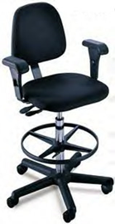
Seatpan height, tilt, tension and depth adjustability need to be suited for the individual user's body segment length and size.
If the height of the seatpan is not fixed, the type of mechanism to raise or lower the seatpan could be spin up/spin down but in a modern chair will be a gas pneumatic cylinder.
For the chair to go up, typically you will pull up on the control lever while somewhat standing out of the chair and then release the lever when at the desired height.
To lower the chair, pull up on the lever and carefully sit to put some body weight into chair. Release the lever when the chair is at the desired height.
Typically, the seatpan has a tilt or angle adjustment. Look for a lever or control that locks and unlocks the tilt mechanism.
If the seatpan has a tilt adjustment feature, look for a seat pan tension adjustment (typically on the undersurface of the seatpan). If the tension is too loose, the seatpan tilt is not controlled and the person may tip backward and not be happy! The appropriate seatpan tension provides a balance between adequate support and movement in the chair.
The seat pan height and angle will establish the relationship between the user, work surface and the floor
A seatpan slide is also a recommended feature. This allows for the apparent depth of the seatpan to be changed to fit the user. Look for a lever that allows the seatpan to move forward and backward in relation to the back support. A gap about 2 to 3 inches between the front edge of the chair and the back the knee is desired.

Back support
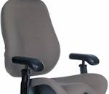
Back support height and angle needs to be suited for the individual user's body segment length and size.
The back support angle and height influence the angle between the upper and lower body as well as the relationship to the worksurface. The back support height allows the user to adjust the lumbar support built into the back support so that it can comfortably support the lower back.

Cushion
A suitable cushion - in terms of foam density, wearability and breathability, type of material (fabric or rubberized) - for the seatpan and back support should be in the chair. A number of chairs have introduced web or mesh fabrics in place of the traditional cushion.

Armrests
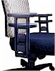
Armrests may be used to support the weight of the arms and upper body. If used, the armrests need to be adjustable in height, lateral position and perhaps axial rotation. Non-adjustable armrests on office task chairs are essentially non-functional.
The armrest adjustments allow positioning the armrests where they will provide adequate support for the arms and shoulders in neutral postures.
Appropriate upper extremity support through the forearms supported on the armrests will “unload” the neck, shoulders and back to reduce axial weight bearing.

Adjustment levers/knobs/controls
Adjustment levers/knobs/controls for the chair/stool should generally be within easy reach of the user when seated in the chair. The levers should be easy to manipulate and not be so complicated that they discourage use.

Chair/Stool solutions

Manual
Look for the chair/stool manual for specific information or to talk to someone who handles chairs/stools in the work area. Most chair manufacturers have how-to-adjust videos on their websites.

Hands-on approach
Better yet just start playing with the adjustments. Most people learn best by the “hands-on” approach. Practice relates to increased comfort level and efficiency of adjustment. Have the person practice going between the recommended seated postures. Promote their commitment for the next two to four weeks to make the change a habit so they will integrate this behavior into their day-to-day routines.

Chair/Stool adjustment tips and techniques
Here is a series of chair/stool adjustment steps along with tips and techniques:
Adjust the seat pan height to get feet on the floor with even pressure on hips and thighs.
If the feet do not touch the floor adjust the seat pan height to get the feet on the floor with even pressure on hips and thighs – if still not possible to get the seatpan low enough, a footrest will be needed. Another option is to replace the chair with one that will go low enough. With a stool in place a footrest will need to be used for adequate foot support.
Adjust the seat pan/back support tension to hold body in a solid upright neutral position.
Adjust the height and angle of the back support to fill in the low back curve.
Adjust the armrests if they are adjustable, see if they can be adjusted to provide neutral support for the arms based on particular job tasks.

Anti-fatigue mats
What are anti-fatigue mats?
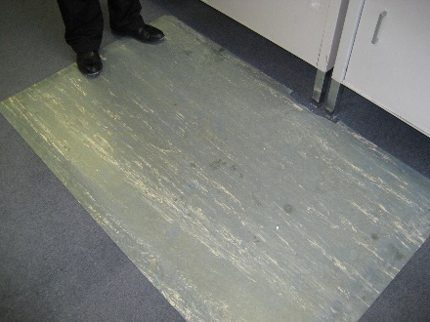
Anti-fatigue mats are compression absorbing mats placed on the floor surface designed to minimize the impact on the body of sustained standing.
What is the impact on the body of long-term standing?
Long term standing (greater than 15 minutes of sustained standing with cumulative 2 hours or more over 8-hour period) may result in:
- Potential for increased joint wear and tear due to compression of the weight bearing joints– feet, ankles, knees, hips and spine
- Decreased blood flow to the lower extremities, which in turn increases muscle fatigue
- Blood/lymph fluid tendency to pool in the lower legs, potentially leading to varicose veins
- Subjective reports of discomfort in the feet, legs, back and shoulders
When should anti-fatigue mats be used?
Here are some general guidelines when to use anti-fatigue mats for sustained standing and hard floor surfaces.
Sustained standing definition is when the user is confined to 1 step within the work area; for times of 15 minutes and longer and cumulative for 2 hours or more over an 8-hour period.
Hard floor surfaces include:
- Concrete floors
- Linoleum tile
- Ceramic tile
Can an anti-fatigue mat be too soft?
Standing and walking foot stability can be negatively influenced by mats that are too soft. Mats that are too soft don’t provide enough support and stability for the foot and subsequent joint stability for the ankles, knees, hips and back.
How long do anti-fatigue mats last?
Depends on usage. With heavy use may need to be replaced every 1 to 2 years. Eventually the mat will compress and lose its cushioning capability. A simple way to assess the need to replace mats is to compare the cushioning effect of the old mat to a new mat; If a significant difference is evident, it is time to replace the mat
Can carts be rolled on anti-fatigue mats?
Generally, carts do not roll well on anti-fatigue mats. Some mats are designed to be compatible with carts. These mats tend to be firmer and provide less cushioning benefit. Refer to mat vendors for additional information
Anti-fatigue shoe in-soles
Anti-fatigue shoe insoles can also be part of the workstation. Criteria for insoles includes:
- Proper cushioning for the foot
- Shoe size allows enough space for the insoles
- Insoles are removable and replaced as they wear out

Parts/Materials/Trash

List of Parts/Materials
More than likely as part of the Manufacturing Instructions a complete list of all the parts/materials required to assemble the product has been generated.

Storage/Staging Locations
Have storage/staging locations of parts/materials been determined? This will ensure all needed parts/materials are in place and accessible.

Trash Receptacles
More than likely trash will be generated at the workstation. Identify the type of trash and how it should be properly disposed of. Separate trash receptacles may be needed to sort trash at the workstation based on its recyclability. Determine the location of the trash receptacles to ensure adequate access to the receptacle but at the same time not limiting user access to the workbench. Determine the process of removing full receptacles to ensure they are within a reasonable weight range to be handled.

Micro-breaks
As we have discussed, frequent and regular body movement is a basic ergonomics principle to promote health and safety in the workplace.
You may already be familiar with the 30/30/30 Rule of Physical Movement that encourages physically active micro-breaks of about 30 seconds in length taken about every 30 minutes and do it for 30 days to make it a habit! I want to emphasize the concept because benefits include reducing tissue compression and joint stiffness and enhancing circulation.
Let’s practice what we preach by introducing a basic stretch, Large Arms Circles.
Before we try out the Large Arm Circles here are the essential guidelines for safe and effective performance.
- Absolutely have to follow any doctor's orders for restricted activities
- Perform the stretches in a technically correct manner
- Energy input is related to the benefit; be as vigorous as possible
- Start the stretch from the Neutral Position
- Joint noises, ‘snap, crackle and pop’ are normal
- Don’t hold your breath, breath in with the stretch and out with the relaxation
- Regular and consistent performance is the way to obtain the benefits
- Always control the intensity of the stretch based on your response to the stretch
Large Arm Circles
If you choose to do the Large Arm Circles, follow along with the video.

Tools
Providing the correct tools is a critical ergonomics principle. Safer, faster and more productive are the tangible results. The correct tools can make the difference between getting the job done or not at all. And even worse, the wrong tool can result in an injury to the user.

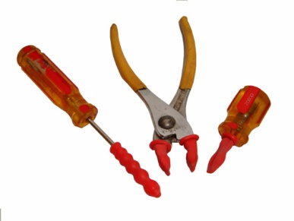
Manual to Power
A switch from manual hand tools to power tools can reduce force levels. Power tools create their own set of issues.

Torque reaction forces
Torque reaction occurs when a fastener reaches the end of its travel, transferring the torque to the tool and operator. Employ clutches and torque reaction bars to reduce torque reaction forces.
Newer tools make use of pulse rather than impact technology. These tools significantly reduce power grip force requirements.

Segmental (Hand/Arm) vibration
Segmental vibration is typically found in tasks that require the use of abrasive wheels, grinders, lathes, and power hand tools. Vibration from these sources has been shown to decrease sensitivity in the hand, resulting in an unnecessary increase in local muscle contractions.

Associated with other factors
As with force, posture, repetition, and contact stress, vibration is frequently associated with other risk factors. Assess the duration of the exposure, the exposure patterns during the shift, and the force levels and postures assumed during the vibration exposure.

Questions to consider include:
- Is there tool vibration?
- Is the level of vibration high enough to have adverse effects on the worker?

Whole body vibration
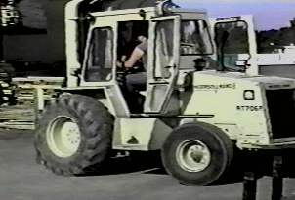
Heavy equipment and forklift drivers frequently encounter whole body vibration. This is suspected of weakening and disrupting soft tissue structures such as tendons and ligaments.
Questions to consider include:
- Is body as a whole subjected to vibration?
- Is level of vibration high enough to have adverse effects on worker?

Control vibration

Fastener types
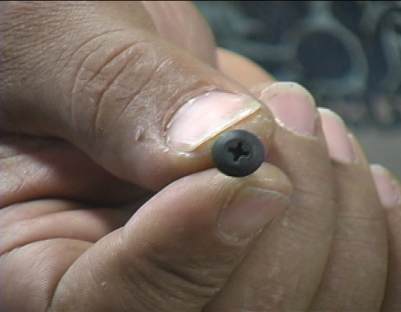
Fastener types used with various power drivers and nut runners may also play a role in vibration exposure.
Certain fasteners, because of the manner by which they engage the power tool, may drive more easily resulting in reduced exposure to vibration, sustained or high force levels, poor postures and contact stresses.
Hex head screws drive faster and with less effort than Phillips screws and Phillips screws less so than slotted screws.
In some cases, rivets, welding, or adhesives may replace the need for screw fasteners.

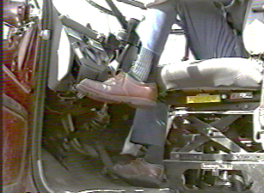
Source control
When possible, try to control vibration at the source. This is important whether the vibration is segmental or whole body in nature.
- Maintain and balance power tools on a regular basis.
- Evaluate the floor quality.
- Repair work, or even replacing vehicle seats, may be necessary to reduce exposure to whole body vibration.

Path control
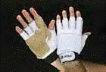
In many situations, it may not be possible to control vibrations at the source. In this situation, obstruct and dampen the path of the vibration.
Vibration attenuation covers that attach directly to the tools.
Wear gloves with padded palms.
When you add these coverings, be aware the effective handle diameter increases and tool control and grip strength may be adversely affected.
Increasing the speed (RPM) at which the tool turns, frequently helps to reduce the amplitude of the vibration.

Quick-cutting abrasives in grinding and sanding
Sharp bits, blades, and un-clogged abrasives significantly reduce the force required to use manual or power tools.

Handle size
Handle size should be monitored to provide optimum power grasps. Trigger configuration should spread the required triggering force over a large area, rather than concentrated in a smaller area.

Preventive Maintenance
Preventive maintenance, based on manufacturer specifications, is critical to ensure proper operation of the tool. Sharp bits, blades and un-clogged abrasives significantly reduce the force required to use manual or power tools.

Case Study – Slag Removal
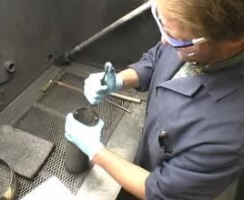
Let’s take a look at another case study.
Slag removal is a hand intensive process where carbon slag that builds up inside a canister as result of a manufacturing process needs to be removed so the canister can be put back into service.
Let’s take a look at how the process had been accomplished, brain storm on some potential modifications and then take a look what changes were made.

View before video
Play the ‘before video’ to observe how the task had been accomplished.

Brain storm session
List options for ergonomics improvements.
- _____________________________________________________________________________
- _____________________________________________________________________________
- _____________________________________________________________________________
- _____________________________________________________________________________
- _____________________________________________________________________________

View after video
Play the ‘after video’ to observe how the task was modified.
What do you think? Some significant changes were made; the fixture to hold and position the canister and adding the vibrator to the file. The operator’s comments are quite revealing.
Check out the Ergonomics Risk Screen Track to learn how to perform a detailed ergonomics risk screen that scores the relative ergonomics risk level.

Equipment
Part of the workstation is the equipment used in the operation. Let’s look at a number of factors.

Fixtures/Jigs
A fixture is a work-holding or support device used in the manufacturing industry. What makes a fixture unique is that each one is built to fit a particular part or shape.
The main purpose of a fixture is to locate and, in some cases, hold a work piece during either a machining operation or some other industrial process.
A jig differs from a fixture in that it guides the tool to its correct position in addition to locating and supporting the work piece.
The primary purposes of jigs and fixtures are to:
- Reduce the cost of production
- Maintain consistent quality
- Maximize efficiency
- Enable a variety of parts to be made to correct specifications
- Reduce operator errors

Types of Fixtures

General Purpose
General purpose fixtures are usually relatively inexpensive and can be used to hold a variety and range of sizes of work pieces (examples: vices, chucks, split collets).

Special Purpose
Special purpose fixtures are designed and built to hold a particular work piece for a specific operation on a specific machine or process.

Hand and Foot Controls

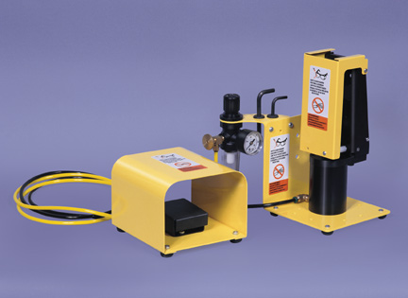
Foot pedals
- Are foot/knee control pedals used?
- Does the operator have to operate foot/knee pedals while standing?
- To operate foot pedals or knee switches, must the worker assume an unnatural or uncomfortable posture?
- Are pedals limited to two?
- Are pedals too small to allow the operator to alter the position of the foot/knee?
- Are pedals triggered at a high repetition rate?

Hand controls
- Are hand controls used?
- Placed to allow neutral hand/arm/body position?
- Difficult (require excessive force) to operate?
- Designed (shape and configuration) to take into account the amount and types of force required for operation?

Hand and Foot Control Checklist
Refer to the Hand and Foot Control Checklist and Recommended Specifications for Controls in the Ergonomics Design Guidelines Track for additional details.

Contact Stress
Contact stress is when a part of the body or limbs is subjected to either a sharp edge or hard surface with potential for tissue compression and injury.

Contact Stress - Sharp edge
When you evaluate the type and severity of contact stress, look for any part of the body that is in contact with a sharp edge.
Examine tool handle size and shape for prominences that promote increased pressure over any point of the grasping surface of the hand. Evaluate tools regarding the amount of localized pressure tools produce in the palm of the hand. Finger contours on handles or triggering devices of tools may also produce unnecessary stress on the digits.
Examine the size and shape of any machine guards for potential contact stress. Identify and correct sharp edges or sustained pressure on the guard.

Control strategies – Round Edges
Round work surface edges that come in contact with the worker. Tool handles and trigger switches should have rounded contours.
Avoid the use of tools that require continuous or intermittent pressure on the fingers, palm, base of the wrist, forearm, and elbow. When possible, use self-opening tools such as pliers and scissors that are spring loaded. This reduces contact stresses required to open the tool.
When contact stress itself cannot be avoided, the goal is to distribute the pressure over as large an area as possible by increasing the contact surface area.

Hands are NOT HAMMERS!
When the hand is used as a hammer nerve and soft tissue trauma may occur to the hand. Inappropriate techniques and work processes are frequently the culprit. Encourage workers to be aware of potential problem areas, for example pressure over vulnerable areas of body where nerves and blood vessels are close to surface. Use appropriate tools for the job!

Contact Stress – Sitting and Standing
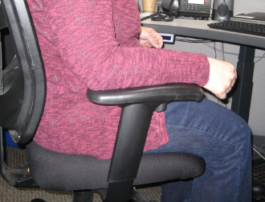
Two areas of the body that are frequently not evaluated for contact stress are the feet of people who stand all day, and the buttocks and thighs of those who sit all day.
Evaluate chairs by observing pressure at the front of the seat pan and the position of the backrest. Evaluate the potential for pressure behind the knee or at the back of the thigh caused by the edge of the seat pan.
Floor surfaces can affect the comfort of workers who are required to stand for a large percentage of the day. This is a problem particularly when there is limited potential for movement.
Concrete, steel grates, uneven or vibrating floor surfaces may increase foot, leg or spinal fatigue and discomfort and can affect concentration and product quality.

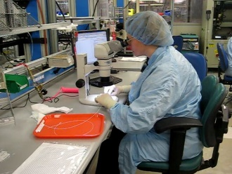
Microscopes/Magnifiers
Microscopes and magnifiers are often used in manufacturing workplaces. Let’s discuss some typical factors to examine.

Multi-user
Most microscopes will be used by a variety of individuals in the workstation. As a result, it is critically important that each user take the time to set-up the microscopy workstation for their unique needs.

Step-by-Step Set-up Protocol
Follow this step-by-step set-up protocol for microscope use.

Understand Adjustment Options
First analyze the current set-up to understand what adjustment options exist. For example, height and angle of the microscope itself, the microscope eyepiece height and angle, the stool or chair seat height, back support and armrests and/or the worksurface.

Neutral Position/Support, Reach Zone
- Position the scope for adequate room for legs to sit directly under the microscope
- Adjust the stool or chair or worksurface to enhance neutral body position and support
- Provide a footrest if needed to ensure adequate foot and leg support
- Position the microscope towards the edge of the work surface to allow for neutral head and neck position
- Position head upright and line of sight approximately 20 to 30º below straight-ahead vision
- Adjust the height of microscope to match neutral head and neck position; the microscope maybe on a vertical support bar or an adjustable height platform
- Adjust the eyepieces and angle of view to allow for a balanced position of the head on the shoulders
- If they can be adjusted, use chair armrests to support forearms with elbows at sides.
- If forearms are in contact with edge of the worksurface, apply padding (foam rolls or padded edge protectors) to the edge of the work surface
- If chair armrests interfere with arms, remove them from chairs and consider use of padded, angled microscope forearm supports to relieve fatigue and strain

Fatigue Control
Employ fatigue control measures. Take micro-breaks every 20 to 30 minutes of microscope use. Stretches are beneficial to promote circulation and reduce joint stiffness.
Rotate between a variety of tasks. Mix it up throughout the day.

Microscopy – Other Tips
Tilt storage bins toward user to reduce awkward postures while reaching for supplies. Enlarge the handle diameter of small hand tools by placing cylindrical foam around them. Make simple tool modifications if you are not able to keep your wrists straight.

Microscopy - Control Eye Strain
Microscope work is obviously very visually intensive. Work to control eye strain. Make sure the scope is clean, lighting is adequate, and the microscope lamp and optical pathway are correctly aligned.
Simply looking at a distance point (more than 10 to 15 feet away) allows the eyes to relax.
Check the work environment for excessive glare and reflections from overhead lighting and adjust the internal microscope light to compensate.
Temperature, humidity, air currents, ventilation, excessive noise, and ambient lighting levels affect operator comfort and fatigue. Temperature range of 66 to 73º Fahrenheit is suggested. Low humidity conditions lead to drying of the eyes; eye drops can be beneficial for some.

Video Display Microscopy
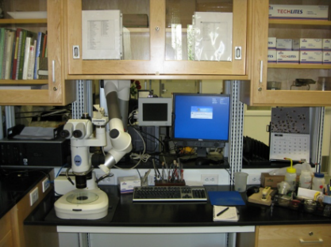
Video display microscopy is becoming more viable with technological improvements. When possible, use a video display terminal to view the sample. Place the display monitor so the top of the screen is about at eye level, viewing distance is about 24 to 28 inches (11 to 13 cm) and the display positioned directly in front of the user to look straight ahead, not turning the head to the side.

Computer (CPU, keyboard, mouse, displays)
Computer equipment is an integral part of the manufacturing process. Appropriate position of the keyboard, mouse and monitor is important. Following the ergonomics principles in terms of set-up of the computer equipment will provide a workstation that is more comfortable and productive.
Detailed computer based ergonomics information is found in the Office Ergonomics Track.

Machine Clearance and Maintenance Accessibility Guidelines

Preventive Maintenance
Preventive maintenance of tools, equipment, workstations and the facility itself have a major impact on the health, safety and productivity of the workforce.

The tale of the forklift!
Here is an “oldie but goodie!”
Some years when conducting an ergonomics audit of a facility we identified a number of CNC machine dies stored on pallets on the floor. The dies weighed 60 to 70 lbs each and were handled manually to and from the floor level. We obviously recognized this as an issue!
As we continued the audit, we observed a number of portable lifts that could have been used to mechanically handle the dies. When we asked why they weren’t being used the response was, “Oh, they don’t work, they haven’t been maintained.” We obviously recognized this as an issue!
Well as the audit continued, in the parking lot we found one lift that was working; a basketball hoop was attached to the forklift. Now we are not opposed to a little recreational physical activity during breaks!
But it does point up the issue how truly important preventative maintenance really is!

Regular schedule
Is there a regular maintenance schedule?

Ease of maintenance
Is the equipment designed or placed in such a way that cleaning and maintenance activities are difficult? Are containers designed for easy maintenance and repair? Does the design of the equipment allow for easy access for maintenance and repair? Are floors uneven?

Housekeeping

General
Is the workplace floor clear of clutter and obstructions, which could create the risk of slips, trips or falls? Are floors slippery?

Workstation
Does there seem to be too much clutter in the workstation? Is housekeeping at the workstation poor?

Accessibility for Maintenance
Openings large enough to permit access of both hands and offer visibility of components. Access ports are located so that operators are not exposed to hot surfaces, sharp edges, or electrical currents.
Access ports are easy to remove, with visible and accessible cover fasteners while still providing adequate machine safe-guarding.
Circular Hatch, Horizontal Clearance: Min. 30" (76 cm) diameter.
Horizontal Hatch Clearance: Min. 20" (51 cm) high x 24" (61 cm) wide.

Physical Demands Associated with Tool and Equipment Use
Let’s examine typical physical demands associated with tool and equipment use from the ergonomics perspective.

Component Fit
A poor fit of components during an assembly process may force an assembler to "bang in" the component using the hand or other body part as a hammer. Nerve and soft tissue trauma may occur when the hands are used as hammers. Using the hands in this manner increases the likelihood of local inflammation that may cause unnecessary scarring. Eventually reduction in blood flow to the nerves and other soft tissues may occur.
Coordinated effort with the vendor, in house or off site, can ensure the needed fit quality.
The type of fastener used may be at issue. Options include use of riveting, spot welding, and use of specialized fastening systems rather than slotted fasteners.

Force – Grip
Whether using tools or handling boxes, grip has a major influence on controlling force levels. A power grip makes use of larger, more powerful muscles than does a pinch grasp.
Typically, a maximal pinch is only 20% of maximal power grasp.
Adjusting coupling can facilitate the use of power grips. Grip spans of 1 1/2 to 2 inches (4 to 5 cm) are ideal. Spans greater or less result in less than desirable mechanical advantage.
Questions:
- Is a power grip used?
- For what purpose is the grip used?
- Do workers have to exert high levels of power grip force to perform tasks?
- Is a pinch grip used?
- For what purpose is the grip used?
- Do workers have to exert high levels of pinch grip force to perform tasks?
- Can a change to a power grip be made?
- Can the grip be eliminated or reduced?

Coefficient of Friction
The coefficient of friction can have a major impact on controlling grip force levels. Friction between the hand and object can be increased by:
- Use rubberized coating on the object; e.g., tool handle.
- Clean the object of lubricants.
- Provide appropriate non-slip gloves.
- Maintain normal skin moisture; dry skin has about 2/3s the coefficient of friction compared to moist skin.

Glove use
Gloves are commonly seen in work environments. The type and fit of the glove should reflect the purpose of the glove. Determine if the glove is truly necessary. Generally, a gloved hand is able to produce a maximum of 25% to 30% less force than an ungloved hand.
A "one size fits all" policy does not work. Gloves that are too small increase the force required to overcome the resistance of the glove. Gloves that are too large hinder dexterity due to sloppiness of fit.

Tool use and postures
Moving on, let’s get into hand tool use and postures. Frequently workers will use tools specifically designed for one purpose but will use it some other purpose. This is often the case when using pistol grip and in-line hand tools like drivers. Consider these guidelines.
In-line grip  An in-line power tool is used when there is need for a vertical drive that occurs between the waist and elbow height | 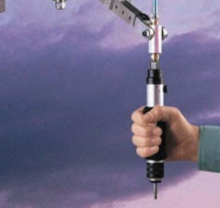 | Pistol grip  Use pistol grip tools on horizontal surfaces at waist height or for vertical surfaces between elbow and shoulder height. | 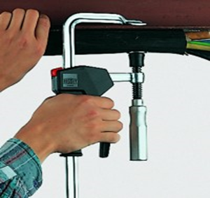

Ergonomically designed tools
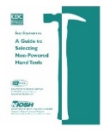
In the past decade, tool manufacturers have made major strides in the design of ergonomically approved tools. Such tools include bent handle tools, reduced vibration power tools, etc. Search on ‘ergonomics tools’ to get an idea of what is available these days. Then apply the ergonomics principles to assess if the tool truly is ‘ergonomic’ in design and use!

General tool guidelines
Refer to the NIOSH Guide to Selecting Non-Powered Hand Tools for additional information.

Label Maker Case Study
Ergonomics doesn’t need to be complicated or cost a lot of money to make significant improvement. The Label Maker Case Study is a good example! Play the ‘before’ video and then go to the next slide to see what they did. Roll your curser over the video to play the video. See what the Ergonomics Team came up with. Roll your curser over the video to play the video.

Position
The goal is to have the body in a neutral posture as much as possible. Evaluate jobs or activities that tend to force the worker out of ergonomic neutral positions and/or result in awkward or sustained positions.
Prolonged or repeated non-neutral spinal positions  Non-neutral spinal positions include bending the head, neck, and trunk forward, backward or to the side, with or without twisting. Focus on why we see the out-of-neutral spine positions. What is driving them and what can be done to mediate them. | 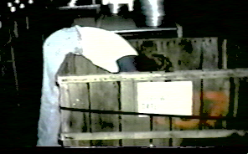
Wrist deviations greater than 15 degrees  You can demonstrate the neutral position at the wrist by making a tight fist. This results in approximately 5 degrees of extension in most people and is the position of power for the wrist. As the wrist moves away from this power position, the finger flexor tendons increase their contact against the carpal ligament or bones of the wrist. This increased contact may result in inflammation, and the pressure within the carpal tunnel may increase. | 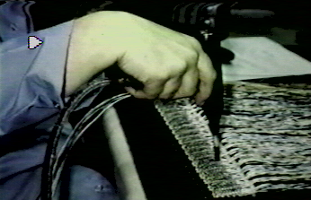
Forearm rotation  When the forearm is rotated toward the extremes of supination (palm up) and pronation (palm down), in combination with deviations of the wrist from the power position, there is a great degree of stress at the origin of the forearm muscles.  By the ways, those cookies tasted quite good! | 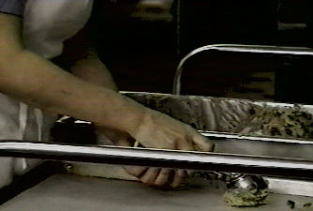
Elbows sustained above mid-chest height  Elbows positioned above mid-chest height place additional stress on the shoulder when prolonged muscle contractions are required.  In addition to inefficient use of energy, these positions also tend to cause a reduction in blood flow to the tendons in the shoulder. Called, “elbows up”, this position is a good indicator of a mismatch between worker and work height. | 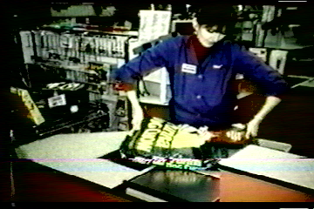
Reaching frequently behind the body or above the shoulders  Arm positions behind the body or above the shoulders tend to increase pressure within the shoulder joint while stretching many of the shoulder tendons and muscles.  Acceptable ergonomics workstation should work to eliminate reaching behind the body. | 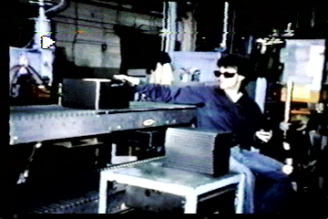

Optimizing Work Positions
Standing work position  When does it make sense to stand at a workbench?  Standing positions are more appropriate than sitting positions if:  Frequent or relatively heavy lifting is required.  Significant downward forces are required.  Workbenches may be modified in any number of ways. In this example look for the 2x4 approach (wooden blocks placed under the bench legs). Of course, ensure the workbench remains stable. | 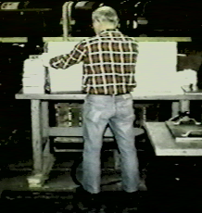
Seated work position  Use seated work stations when light assembly or precision work is performed.  The concept from a functional perspective is termed, “Proximal stability for distal precision.”  In other words, a stable core of the body supported by the seating systems provides for greater control and dexterity of the head and hands when precision assembly work is accomplished. | 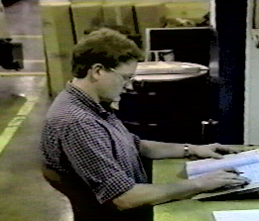
Sit/Stand work positions  In some cases, sit/stand work stations may provide a viable option. These provide for postural variability with an option to switch between seated and standing positions.  Lean platforms can be incorporated to provide for weight bearing relief of the major weight bearing joints and still allow for a standing height work position.  The worker needs to establish the correct relationship between themselves and the workbench. | 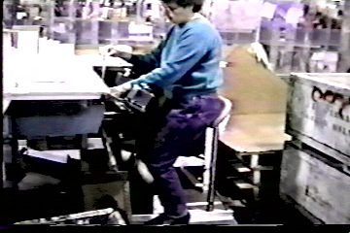
Adjustable height work stations  Adding adjustable height work stations and lift tables to a work area allows for increased postural variety for workers but also allows accommodation for variation in body stature between workers.  More and more workstations are making use of height adjustability between seated positions with the feet on the floor and standing.  Powered options (electric-hydraulic) are the way to go to make it easy to make the switch; with hand crank models limited use has been observed. | 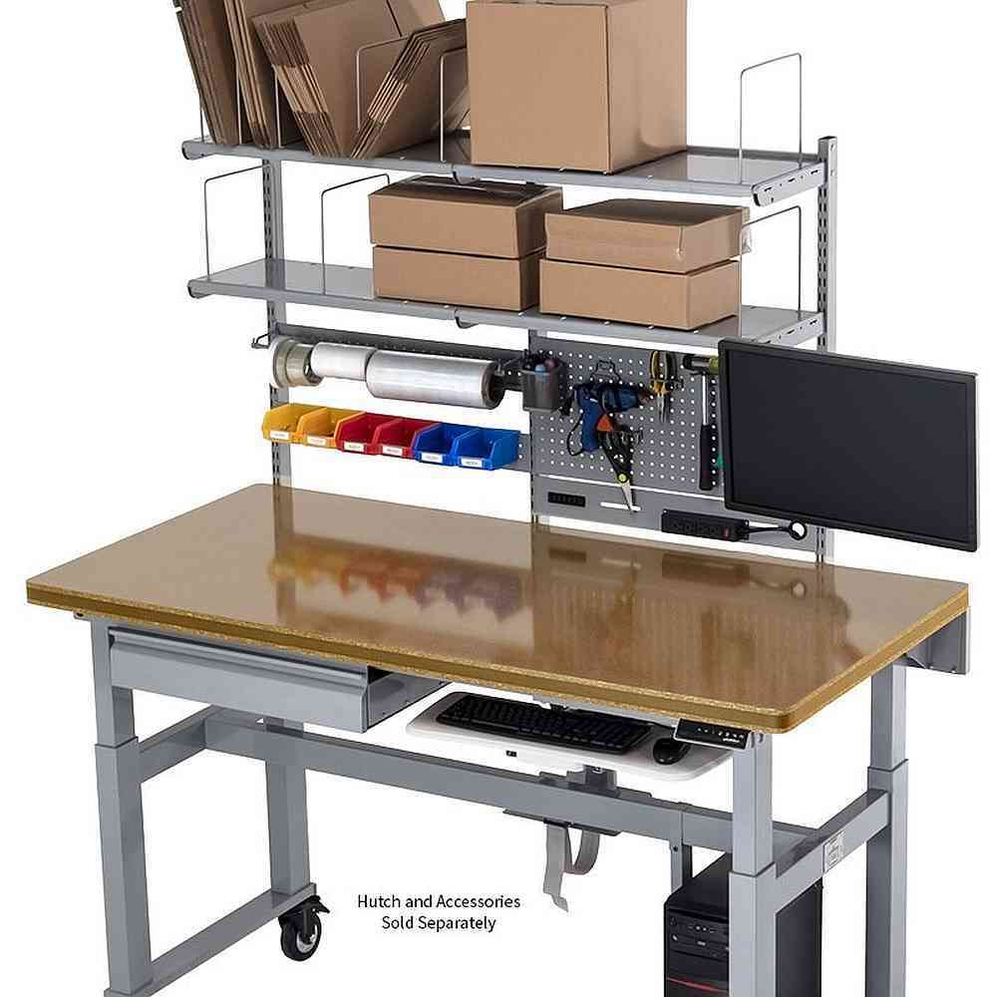
Turntables  Use turntables to bring parts closer to the worker, reducing the need for sustained or extreme forward reaching.  They work well in manufacturing workplaces to allow work within the recommended Comfort Reach Zone.  These are particularly helpful when the worker needs to access the other side of the pallet. | 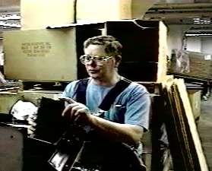
Rapid machine pacing in assembly task  Workers may work ahead on a conveyor line to create a buffer. They may work behind on a conveyor line because they cannot keep pace  Both situations result in positions other than directly in front of the worker that are sustained and awkward postures. | 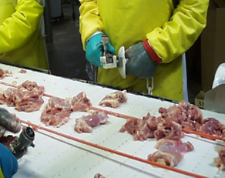
Movement  Even relatively well-designed ergonomic work stations require individuals to work in one posture.  Evaluation of the work place should include an assessment of how often individuals have the opportunity to move out of sustained postures to perform other movements or tasks.  As human beings we have an instinctive need to physically move on a regular and consistent basis. | 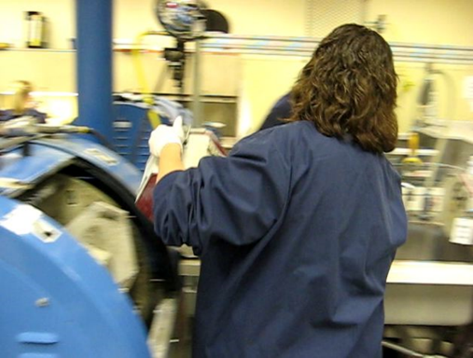

Mental Demands Associated with Tool and Equipment Use
The mental demands of work can be just as demanding and stressful as the physical demands. They require a thoughtful examination.

Is the task complex?
- Does the worker have to evaluate data before taking action?
- Must the operator sense and respond to information signals occurring simultaneously from different machines without sufficient time to do so?
- Must the operator process information at a rate, which might exceed his or her capability?
- Is the job so complex it takes a long time to train workers?
- Does the task require a great deal of accuracy?
- Does this work situation require monitoring several machines?

Is the task monotonous?
- Does the worker repeat the same task without change for the entire shift?
- Does the worker lose track of the task at hand because it is overly monotonous?

Design and Use Standards
- Are controls standardized on similar equipment?
- Does the design of any instrument increase reading errors?

Perceptual Demands
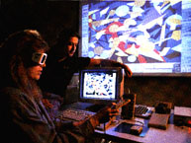
Our ability to properly perceive our environment exerts a major influence on our interaction with it. Issues like illumination, auditory, touch and visual acuity fall into the realm of perceptual demand.

Illumination
Evaluate the quantity and quality of light. Also, consider the overall quality and level of the light in relation to the color and reflectivity of the walls, floors, and ceilings. Glare is a commonly observed problem in work environments where it is apparent on computer screens.
Under-illumination facilitates forward bending of the trunk and head as individuals attempt to get closer to the material they are viewing. Task lighting can be effective to focus illumination where desired and at the same time control glare.

Illumination - General
- Is special lighting necessary to perform the job?
- Is the general work area including egress/ingress poorly lit?

Illumination - Task
- Is lighting inadequate for the job?
- Are controls, instruments and equipment poorly lit?
- Is the illumination not satisfactory for the task?

Illumination - Contrast
- Is contrast poor between the workspace and its surroundings?
- Is the workplace so poorly lit that there are great differences between brightness levels in panels, dials and surroundings?

Illumination - Glare
- Is glare present in the workplace?
- What is the source of the glare?
- Is glare from displays a problem?

Auditory
- Does the noise level prevent or impair verbal communication?
- Are there auditory signals?
- Are some auditory signals hard to hear in general?
- Are auditory signals difficult to distinguish from one another?

Touch
- Is there a need to tell the difference between parts by touch?
- Is it difficult to recognize controls and tools by touch and/or position?

Visual Acuity
Does the task require fine visual judgments? (This includes the need to detect small defects, judging distances accurately, etc.) Are dials and instruments difficult to read quickly and accurately?
Are controls, instruments and equipment placed where they are difficult to see? (At a bad angle, too high, too low.) If warning lights are present, are they located out of the center of the field of vision? Are dials grouped inconveniently?

Personal Protective Equipment (PPE)
Personal protective equipment is an essential complement to an effective ergonomics process.

Mandatory
Are there conditions that require personal protective clothing or equipment? What conditions exist? What PPE is used?

Monitoring and Enforcement
How is PPE use monitored? Are PPE policies enforced?

Your own PPE!
A very important point is for you to always understand and follow the PPE requirements whenever you are onsite at a manufacturing company. Ask upfront what the PPE requirements are so you know before you get onsite. While some companies will provide you with PPE,
I encourage you to have your own PPE available. For example, the company you are consulting with has a steel-toe work shoe or boot requirement. They probably have available for visitors what are called ‘clappers’; steel toes you strap onto your existing footwear.
Immediately this sets you apart from the rest of the workforce as an outsider and can impact your credibility.
Oh, by the way, the reason they are called ‘clappers’ is because they tend to make a clapping noise as you are walking. Not good!

Material Handling
Have the Manual Material Handling requirements been determined? Please refer to the Manual Materials Handling and Ergonomics Design Guidelines Tracks for details about controlling material handling.

Physical Demands

Metabolic Load
- Does the job involve peak loads of muscular effort?
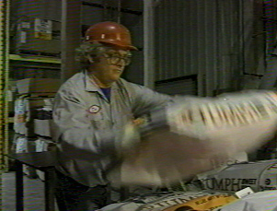
- How often do peak loads occur and how long do they last?
- Are there signs of unacceptable fatigue on the worker's part? (i.e. profuse sweating, red flushed face, heavy and labored breathing, poor coordination, etc.)
- Is there frequent daily stair or ladder climbing?
- Is recovery time figured into the work process?

Force - Lift/Push/Pull
Manual material handling is commonly seen in many diverse settings, not just in warehouses. OSHA has identified the stresses associated with manual material handling as one of the major factors to examine and alleviate.
Force levels are a function of the weight of the tools, containers, boxes, parts, carts, etc. Whether lifted, carried, pushed, or pulled, the force required to move or manipulate the object directly creates stress on the body.

Questions
- Do workers have to lift objects, boxes, parts, materials?
- Does the task require:
    - Strenuous one-hand lifting?
    - Strenuous two-hand lifting?
    - Lifting over too great a vertical distance (near floor or above shoulders)?
    - Lifting at too great a horizontal distance?
    - Difficult-to-grasp items?
    - Pushing or pulling hand trucks or carts up or down inclines or ramps?
- Does the job require handling of oversized objects?
- Does the job require two-person lifting?
- Is help for heavy lifting or exerting force unavailable?
- Do workers have to push or pull objects?
- Large breakaway forces to get the object started?
- Does the job lack material handling aids such as air hoists or scissors tables?

Force – Lift/Push/Pull Intervention strategies
Intervention strategies to control force levels related to the weight of the load include:
  - Design job to reduce static muscle loading. (Provide jigs, fixtures, clamps, spot welds, etc. to hold work object.)
  - Workers learn how to better control static muscle loading. (Body mechanics, stretching, etc.)
  - Make use of mechanical devices, hoists, lifts, etc. to eliminate manual lifting.
  - Slide rather than lifting the weight.
  - Eliminate the effect of gravity by counterbalancing the weight, a method commonly used with tools.
  - Remove physical barriers, thereby reducing the horizontal distance (long lever arm).
  - Relocate storage heights with heavier objects stored between mid- thigh and waist height.
  - Work with vendors to provide material either in smaller unit weights (e.g., 50 pounds, rather than 100 pounds) or in bulk that requires handling with mechanical means.
  - Provide adjustable height surfaces (e.g., scissors tables) to maintain desired height of material.
  - Reposition the worker to provide greater mechanical advantage; e.g., use body weight rather than musculoskeletal strength.
  - Reposition the work material; e.g., bring parts and tools within reach envelope; place bin on a bin tipper or provide side drop-down bins
  - The safest lift of all is the one that does not occur. Whenever possible slide objects rather than lift them. Friction between the surface and object may be a problem. Friction can by decreased by:
  - Line storage shelves with decreased friction liners (e.g., Teflon sheets).
  - Spray-on products will reduce friction (may cause a toxic substance problem.)
  - Use roller conveyor systems to transport materials.
  - Maintain the quality of floor conditions to eliminate cracks and general deterioration.
  - Use appropriate type and size of casters or wheels as original equipment or retrofit, depending on floor type.

Force - Workflow and Rate
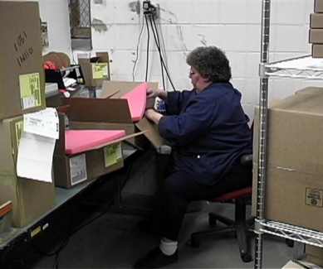
The factors of workflow and rate contribute to the effect of force on the musculoskeletal system. The duty cycle of the job demand determines the force dose-exposure.
Reducing either the dose (level of force) or the exposure (duration of the force) is desirable. Reduce exposure through administrative controls including job rotation and job enlargement.

Carts
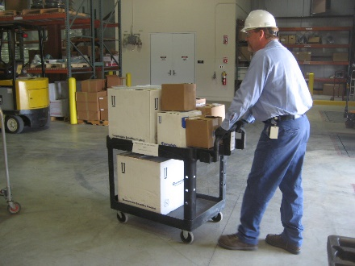
Carts are commonly used to stage and transport parts, materials, tools and equipment. Refer to the Carts Checklist in the Ergonomics Design Guidelines Track for specific details.

Casters
Casters will be found on any number of carts, rolling shelves, lifts and so on.

Capacity and size
In general, each caster should have the capacity to support one-third of the total load weight; overloading, uneven floors and load distribution may place a heavier burden on one or more casters.
The larger the caster size (and swivel radius), the greater the mobility. The type of bearing selected will also improve mobility and reduce rolling resistance.

Exposure
Check for dust, humidity and temperature extremes that the caster will have to be able to endure.
Casters with sealed swivels are ideal in areas with sprays or wash-down requirements where there is lint or dust and where extreme quiet is essential.
Most casters are rated for "walking speed”. Higher speed applications require specialized casters to maintain load capacity and dissipate heat buildup.

Brakes and Swivel
If the cart can roll away when being loaded or stored the caster should have brakes. Ensure the brakes are easy to engage and release.
Determine if swivel or fixed position swivel casters are needed. All four casters with swivel feature will be needed for improved maneuverability in a confined area. Two swivel and two fixed casters will be needed for cart transport over longer distances – this allows the cart to be moved in a straight line while still allowing for maneuverability around corners. Position the swivel casters on the handle end of the cart. Some casters are able to be locked in a fixed position and then released to swivel.

Handles
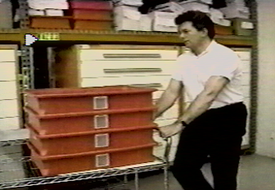
Cart handle placement allows for upright body position when pushing/pulling cart. Recommended fixed handle height is 36” to 38” (91 to 96 cm)– ideally needs to be suited to cart use and user population stature. Recommended adjustable handle height range is 36 to 46” (91 to 117 cm).
Ensure cart handle placement allows for normal stride when pushing/pulling cart (not in the way of the feet) – as possible, position the handle 6 to 8” (15 to 20 cm) away from the body of the cart.
Ensure the cart and materials loaded will not restrict the line of sight of the user. If line of sight will be restricted, ensure a “spotter” is used.

One person vs. two person
Determine if the cart can be safely handled with one person or if two are needed. This can be based on the force required to initiate and sustain cart movement. e.g. force to push/pull cart is greater than 50 lbs. (23 kg), cart is handled on a ramp, etc. a two person approach is recommended.
Also consider if the cart should be powered.

Push vs. pull
Typically pushing carts enables improved body mechanics technique than pulling. The person is able to make use of “power position” when pushing. Pulling technique generally places the body (spine) in an out-of-neutral position.
Exceptions to the rule do exist; for example, pulling cart over a rough surface or threshold rather than pushing it. Or may pull a pallet jack rather than push it when traveling for longer distances.

Conveyors
Often conveyors are used to transport parts and materials along an assembly line or to some other location. Refer to the Conveyors Checklist for details.

Storage
Have storage/staging locations been determined for the parts/materials?
Recalling our previous discussion regarding Reach Zones for various individuals, ensure that all parts and materials will be in appropriate locations for easy access at the workbench.
Determine how the parts//materials will be contained. They may be in bins on the workbench itself. Some parts and materials maybe stored on carts or shelves and transported to the workbench as needed.

Shelves/Racks
Storage of parts, materials, tools, etc. is part of the ergonomics design process. This could be at the workbench itself or some other location.
Use the Shelves/Racks Checklist for design guidelines. Here is an example of what is in the checklist.
Shelves/Racks Checklist
“NO” answer indicates need for additional investigation. | YES | NO | NA
Shelf and rack configuration (height and depth) has been determined based on shelf access and shelf content size/weight. Typical guidelines include:
- Lowest shelf: no lower than 20” from the floor
- Highest shelf: no higher than 60” from the floor
- Most frequently accessed shelves: between 30” and 50” from floor
- Least frequently accessed shelves: between 20” to 30” and/or 50” to 60” from the floor
- Heaviest materials: shelves between 30” and 40” if materials handled manually; NOTE: This places the item in the power range of the operator (about waist level) OR heaviest materials stored on lowest shelf if items can be slid off the shelf onto a cart at that height
- Content size: shelf size (width and height) allows free movement of materials on/off shelf

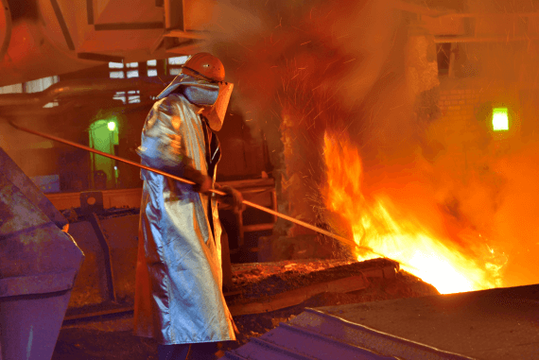
Work Environment

Control Exposure to Work Environment
Controlling exposure to the work environment including light, noise, temperature and ventilation is one of the basic ergonomics principles.
Use the Environment Checklist as needed for the ergonomics analysis process.

Summary and Thanks!
Thanks for completing the Ergonomics Manufacturing Track!
While the workstations, tools and equipment that make up manufacturing workplaces have a common thread in terms of ergonomics principles, I believe you will find they each have their own unique attributes in terms of how to apply the ergonomics principles.
For me, working in the manufacturing ergonomics realm has been very rewarding; I particularly have enjoyed the collaboration among all of those involved.
You will make a significant positive difference in the health, safety and productivity of those working in manufacturing.
Please check out the other ERGONOMICS ON-DEMAND Tracks that make sense for you!
Thanks for your time and attention!

