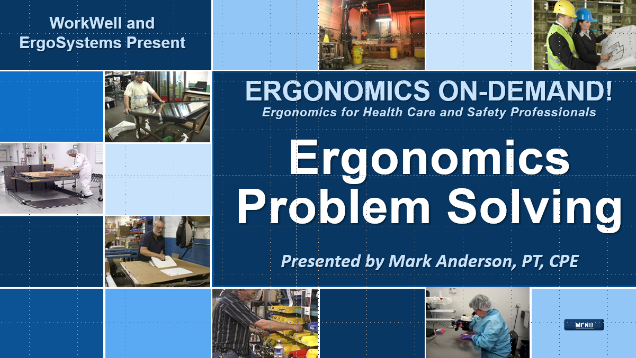

Developed by:
Mark A. Anderson, MA, PT, CPE
Certified Professional Ergonomist
Physical Therapist
ErgoSystems Consulting, LLC.
7421 West Shoreline Drive
Waconia, MN 55387
Voice: 952-401-9296
Mark.Anderson@ergosystemsconsulting.com
www.ergosystemsconsulting.com

The information contained in this training workbook has been developed in good faith and is believed to present good ergonomics principles and practices. ErgoSystems Consulting, LLC and all other participating organizations make no representations or warranties as to the completeness or accuracy of the materials thereof. Persons using this information must make their own determination as to its suitability for their purposes. ErgoSystems Consulting, LLC and all other participating organizations are in no way responsible for damages of any nature resulting from the use of this information.

Copyright 1997 to 2021 ErgoSystems Consulting, LLC., All Rights Reserved Version 2_04222021

Table of Contents
Table of Contents 2
Ergonomics Problem Solving Track 3
Welcome 3
Are you a “Problem Solver”? 3
Thinking out of the box! 3
Ergonomics Problem Solving Caveats 3
Design Dictates Performance 3
Understand and Make Productive Use of Human Behavior 4
Do not fix without adequate analysis! 5
Look up and down stream! 5
Don’t generalize from a sample of one! 5
Scope of Influence 6
Creating Positive Change 6
Problem Solver 8

Ergonomics Problem Solving Track

Welcome
Welcome to the Ergonomics Problem Solving Track.
Hi everyone, I’m Mark Anderson. I am a Certified Professional Ergonomist and Physical Therapist. I have been fortunate to work in ergonomics over the past 30 years.

Are you a “Problem Solver”?
Let me ask you a question, “Are you a problem solver?”
I am willing to bet you are. I think you gain satisfaction from analyzing a situation and coming up with ways to make it better. There is no doubt, that identifying and solving problems is at the core of the ergonomics process.

Thinking out of the box!
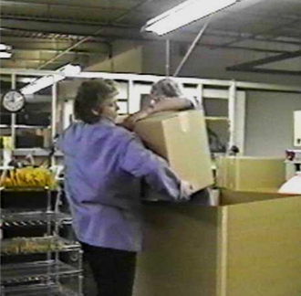
Let me tell you about two workers who were responsible for overpacking. Overpacking is where smaller boxes are put into a larger overpack box for shipping and also the small boxes need to be removed from the overpack. To remove the small boxes, they would reach to the top layer of boxes by reaching over the side of the overpack. By the time they got to the bottom layer of the small boxes, they were having a very difficult time reaching way to the bottom to lift out the boxes.
They thought about it and came up with a solution. They discovered using a step stool, one of them could actually get into the overpack box and working together it was much easier for them to get the small boxes out!
You probably have heard about, ‘thinking out of the box’ when problem solving. Well, these two literally got into the box to solve their problem!
As it turned out, the long term solution was to go to an overhead mounted suction lifting device to place and remove the smaller boxes.

Ergonomics Problem Solving Caveats
Over the years of working in ergonomics, I have been part of collaborating with many individuals and organizations as part of the ergonomics problem solving process. I have seen the process work very well and honestly sometimes when it has not worked all that well.
I would like to share with you what I have learned over the years. In my mind, here are important caveats to improve the success of problem solving.

Design Dictates Performance
In the ERGONOMICS ON-DEMAND! Tracks we have placed ergonomics squarely in the realm of Systems Design.
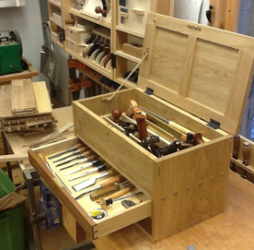
For example, putting a toolbox on the floor promotes poor technique to remove the tools; this technique is ineffective and increases physical stress into the worker’s body. We recognize it does not work to tell the worker to be “really, really careful when they bend over at the waist” to reach to the toolbox.
We defined ergonomics as, ‘Changing the circumstances to change the response!’ The successful response in this case involves repositioning the toolbox to waist height on a platform to promote the desired technique.
When we apply the Ten Principles of Ergonomics, we introduced in the Introduction to Ergonomics Track as part of the Systems Design approach to workstations, tools, equipment and work processes, we can apply these concepts in any workplace for any ergonomics problems.
Design dictates performance. Good design of the workstation, tools and equipment leads to effective and safe work processes. Poor design leads to the opposite. Our goal is to use ergonomics to improve the design of workstations, tools, equipment and work processes overall.

Understand and Make Productive Use of Human Behavior
I think we are by human nature, ‘people watchers’. The next time you are sitting at a shopping mall or bus terminal waiting for your partner or the bus to come, I would be willing to bet you are watching all the people coming and going. You are wondering where they are going and what they are doing. We are fascinated by our fellow human beings!
Human behavior is a most fascinating field of study. However, it also can be quite frustrating. What do I mean? There are reasons why we do what we do; sometimes we just cannot initially figure out what they are! We need to dig a little deeper.

Container
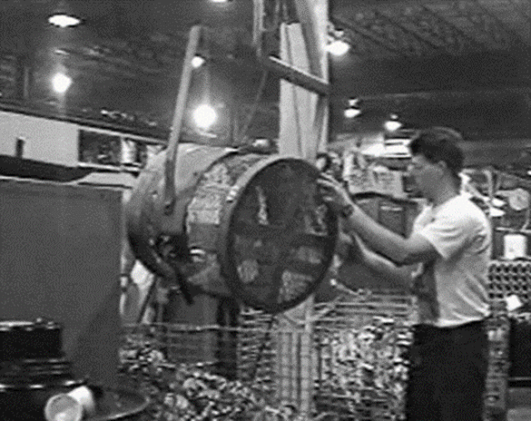
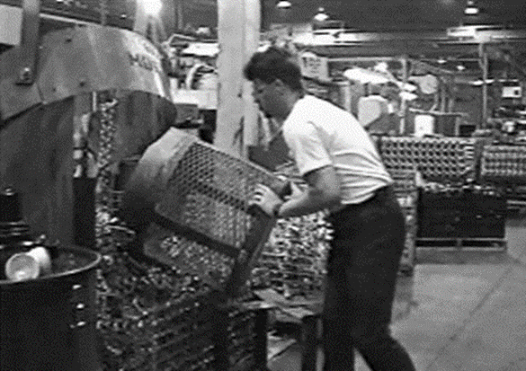
I’ll give you an example. I was working with a company that manufactured oil filters. Part of the fabrication process involved dumping a container of parts that were coming off of a conveyor. The container was on a cart, that once full, was rolled over to and dumped into a larger palletainer. The technique used was to manually tip the container. It was physically demanding.
Further investigation revealed this had previously been identified as a problem and an overhead manual chain hoist had been installed to alleviate the manual handling aspect of the task. What do you think? How many people used the chain hoist?
The answer was zero! Nobody used it. Everyone knew it was there and they knew how to use it, but nobody used it.
Why not? What do you think? List some reasons why you think it wasn’t used.
They knew it was there, they knew how to use it, management encouraged them to use it but did not mandate its use. What was the reason they did not use it?
Well, I timed how long it took to dump it by hand and it took literally a few seconds; very quick.
I then timed how long it took to use the chain hoist, quite a few steps were involved to secure the container to the strap system of the hoist, lift it up by pulling the chain, tip it into the palletainer, lower it back down, release the straps and complete the process. How long do you think it took? More than a minute. Let’s see a few seconds compared to a few minutes. Seconds compared to minutes. They chose seconds over minutes. Most people would!
So, now we understood the ‘why’ behind the behavior. Use of the chain hoist could have been mandated by management and this would have alleviated the physically demanding aspect. However, looking at this from the ergonomics design perspective, a much better solution was to re-layout the production line to eliminate the need to transport the container to the palletainer.

Human Behavior and Design Convention
From the ergonomics perspective we have discussed how important it is to understand and make productive use of human behavior. We discussed that you cannot depend solely on a person’s common sense to make good ergonomics decisions. As it turns out, we know in our study of population stereotypes that different people sometimes see and experience things differently.
But we also know that there is a set of Human Behavior and Design Conventions we can use to increase the level of consistent performance. If we offer a solution that is contrary to the nature of human behavior, the solution will not be effective. Our goal is to understand and make effective use of human behavior as much as possible.

Do not fix without adequate analysis!
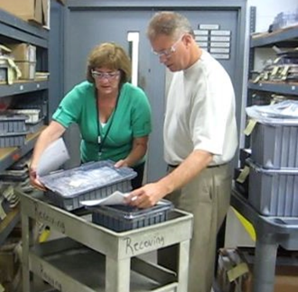
So, we are problem solvers and that is a good thing. However, many novice analysts (and sometimes some experienced ones) cause themselves and others trouble because they try to "fix stuff" without fully knowing why or what or when or who. We want to jump to the answer right away.
Sometimes just slowing down a little bit and ensuring an adequate analysis has been completed before offering recommendations in the long run will save time and make the whole analysis process better!
Do not fix ‘stuff’ without adequate analysis.

Look up and down stream!
Sometimes when we look at a job task, all we see is what is in front of us. We seem to have blinders on. Blinders can work well for horses to help calm them but not so well in ergonomics.
It is imperative that we look both ‘up and down stream’ to see the context of a single work station or job demand within the overall production scheme. A change made at one stage of the process can have a detrimental impact at a stage later one.

Don’t generalize from a sample of one!
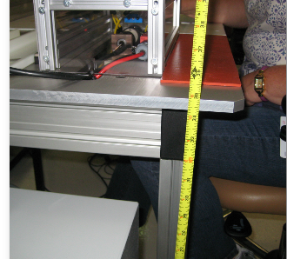
One time working with an engineer on a project designing a new workbench, we needed to write the specifications for the workbench dimensions. We needed to determine the workbench height. A suggestion was made to go out to the existing workbench with a tape measure in hand, stand at the workbench in the work position and measure from the hand height to the floor. This dimension would then give us the workbench height.
What do you think? Is this s viable method? Well, it could be if only the person who took the measurement would ever be the person using the workbench. This was going to be a multi-user workbench and for most everyone else this strategy would be an issue.
A common error is to make the assumption that just because it makes sense or works for a particular individual it will also work for the entire population. We don’t want to generalize from a sample of one; particularity if we are the sample of one!
Recognize the diversity that exists in the user population and design to take this into account.

Scope of Influence
Ergonomics interventions, like everything else have limits on what is possible to accomplish. The limits are typically resource related – money, time, knowledge and so on. As much as you can identify these limits. You need to have a sense of what is possible. I call this knowing the ‘scope of influence’ of the situation.
If we offer a solution that is beyond the scope of influence of the individual, the department, or the organization, the solution will not work. We need to offer solutions that are reasonable and feasible.
Now, this doesn’t mean not to think ‘big’ sometimes in terms of long term change. But offer a range of solutions. Short term solutions that can be implemented quickly. Mid-range solutions more in the weeks to months range that may require additional resources and the long term solutions in the months and even longer term. Understand the ‘scope of influence’.

Creating Positive Change
True or false statement, “In most cases most people like change, they embrace change!”
Now, it is true that every once in a while, you may find someone who truly does like change and maybe that person is you. However, we know that most people have a very hard time with change.
The expression, “We are creatures of habit.’ is quite apt.
Recall what we want to accomplish with ergonomics. We want to ‘CHANGE the circumstances to CHANGE the response!’ In fact, in my experience in many cases, identifying the ergonomics issues is fairly straight-forward. The really interesting part is to try to get people to accept the recommended changes.
‘CHANGE the circumstances to CHANGE the response!
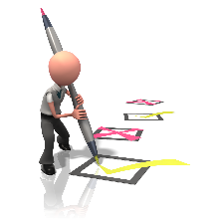
When we introduce change, we have to do it in a very careful way, otherwise the solutions will not work. How can we facilitate change? Creating positive change is truly the core of any successful ergonomics process.
Work through this exercise. Pull from your own experiences with change. Consider why people resist change and what can be done to facilitate change.

Why do people resist change?
Why do people resist change? | How to facilitate change!

Resist Change | Facilitate Positive Change
Fear of change! | Knowledge to overcome fear
Habit! | Practice correct habit
Do not recognize need for change! | Education on how to recognize need for change
Do not know how to accomplish change! | Education, training and practice to accomplish change
Was not their idea! | Emphasize inclusion not exclusion
The change is forced on them! | Obtain group input with their involvement to promote “ownership”
No one else is changing! | Emphasize peer group involvement

Facilitate Positive Change
What did you come up with? Here are some thoughts about why people resist change and some potential ways to facilitate change.

Fear of change!
Change is a great unknown. Instinctively we have a fear of the unknown and generally for good reason. Have you ever been home alone on a dark night and all of sudden you hear a noise in the garage? What was that? A bugler?
Something had changed and we were fearful of it. This is an instinctual protective response. What do we do next? Well, that depends. We might call 911 or we might go investigate. If we do go investigate and find out, ‘Oh, it was the cat that knocked over the broom’. With this new knowledge we have alleviated our fear. In the workplace how can help alleviate the fear of change? My experience has been that providing knowledge associated with competency-based training is a potent mediating factor.

Habit!
Without the habits we have developed over the years we wouldn’t do very well. Many habits are very beneficial, they allow us to function ‘on cruise control’ so to speak. We also know that some habits are not so good for us. As humans we can get very accustomed to whatever we do on a regular basis. We literally have constructed neuro-circuitry to that end. And this is true even if the habits we have become accustomed to are not so good for us.
For example, at work we may have an ingrained habit to use a certain tool in a certain way to perform a task in a certain way. Perhaps a new tool is the ergonomics recommendation. We are really used to the old tool and have a hard time giving it up.
Is it possible to as the saying goes to ‘Teach a dog a new trick?’ Well, as it turns out it is! With the correct practice over time, we can actually establish new circuitry. That is why one of the ten ergonomics principles is to provide competency-based training.

Do not recognize need for change!
One of the first steps to making a successful change is to recognize the need for the change. If we don’t appreciate the need for change, why in the world would we change! Here again is where knowledge associated with training is a potent factor in facilitating the change.
Our goal is to help facilitate recognition for the need for the change.

Do not know how to accomplish change!
It may be the need to change is appreciated but the actual ‘how to accomplish the change’ is in question. Once again education, training and then appropriate practice over time will make the difference.

Was not their idea!
Have you ever heard this one, “It is not my idea and I don’t want to change!”
This is sort of human nature coming to the forefront. In my experience, ‘People support what they help to create.’
We mentioned in the Introduction to Ergonomics Track that the best people to practice ergonomics are the workers themselves. I have had some of the most success with ergonomics when the workers are an integral part of performing the ergonomics analysis and in implementing the recommendations. We want to emphasize inclusion not practice exclusion.

Change is forced on them!
As humans we do not like it when we are forced to do something even if it may be for our good. This, of course, is where the expression, “Cut off your nose to spite your face!” comes from.
This may be a reflection of the organization’s culture where the workforce has little input on how the work is accomplished. This can be a tough nut to crack. I have found that the best approach is to look for relatively small changes that can be accomplished in the organization and build on them. “Success breeds success!”
I will be honest and say I once terminated my consulting work with an organization because of the organization’s culture. I found out it was not compatible with my approach to accomplish the objectives. Once again, we want to emphasize inclusion and not practice exclusion.

No one else is changing!
Peer pressure is an amazing thing. We are influenced by what others around us are doing. For most of us, standing alone is a tough thing to do. We can use the positive impact of peer pressure by putting in place strategies that involve the group as whole.

Problem Solver
Ergonomics is all about problem solving. Some of the greatest personal and professional satisfaction in my work as an ergonomist has come from collaborative problem solving.
As you continue to use ergonomics principles and applications in your practice, I hope this is true for you as well!
Thanks for your time and attention!

