ErgoSystems ErgoRED Quick Screen
The ErgoRED Quick Screen allows you to quickly evaluate a task to determine if pertinent ergonomics risk factors are evident. It is NOT intended to be a detailed ergonomics analysis – use it as a quick screen. If significant factors are identified use the Ergonomics Risk Factor Analysis Worksheet.

Company: |  | Date: |  | Department/  Work Unit:
Prepared by: |  | Time: |  | Safety FYIs/ Injury History:
Job/Task Observed: |  | # People Affected: |  | Employees Observed:

Reported Issues |  | YES | NO
Indicate if any ergonomics issues for the job/task have been reported. If checked “YES”, additional evaluation is warranted. You can use the Ergonomics Risk Factor Analysis Worksheet for the more detailed ergonomics analysis. | Safety FYI
 | Incident Report
 | Supervisor/Employee

Posture, Force, Duration and Frequency by Body Part
Use the ergonomics principle of Neutral Posture to identify by Body Part if out-of-neutral postures exist; and if so, indicate if level of Force to accomplish the task is Light, Mod, Heavy, or Very Heavy. Next determine if the task requires Low, Mod or High Duration (defined as static/sustained effort) and Low, Mod or High Frequency (defined as repetitions/minute) to accomplish the task.
A rating of “Heavy”, “Very Heavy”, “Mod” or “High” indicates the need for use of the Ergonomics Risk Factor Analysis Worksheet for more detailed ergonomics analysis and intervention.

Body Part | Posture |  |  |  |  |  |  | Force | Duration (static) | Frequency
Neck | Look down > 30º  Look up > 10⁰  Side bent > 15⁰  Rotated > 20º | 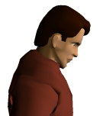 | 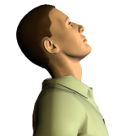 |  | 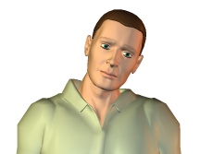 |  | 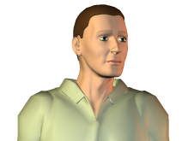 | Light: < 5#  Mod: 5# to 10#  Heavy: 10# to 20#  Very Heavy: > 20# | Low: < 10 sec  Mod: 10 to 45 sec  High: > 45 sec | Low: < 0.5/min  Mod: 0.5 to 5/min  High: > 5/min
Shoulders | Hands at shoulder/above  Shrugged shoulders  Reach behind body | 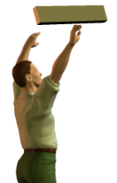 |  | 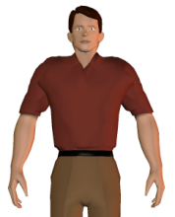 |  | 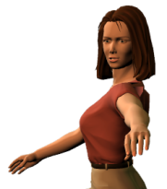 |  | Light: < 5#  Mod: 5# to 10#  Heavy: 10 # to 15#  Very Heavy: >15# | Low: < 10 sec  Mod: 10 to 45 sec  High: > 45 sec | Low: < 0.5/min  Mod: 0.5 to 5/min  High: > 5/min
Back | Flexed forward >20º  Extended backward > 20⁰  Bent sideways > 20⁰  Rotated >20º | 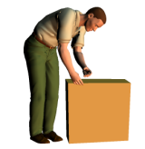 | 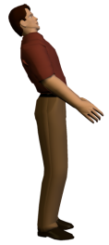 |  | 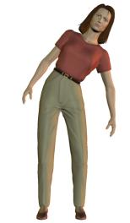 |  | 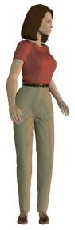 | Light: < 10#  Mod: 10# to 20#  Heavy: 20# to 40#  Very Heavy: >40# | Low: < 10 sec  Mod: 10 to 45 sec  High: > 45 sec | Low: < 0.25/min  Mod: 0.25 to 3/min  High: > 3/min
Elbows | Fully extended arm  Rotation of wrists/forearms, palms up/down | 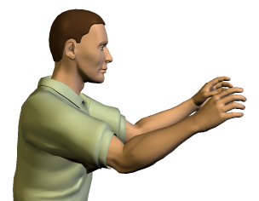 |  |  | 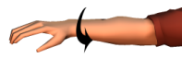 |  |  | Light: < 3#  Mod: 3# to 8#  Heavy: 8# to 15#  Very Heavy: >15# | Low: < 10 sec  Mod: 10 to 45 sec  High: > 45 sec | Low: < 0.5/min  Mod: 0.5 to 5/min  High: > 5/min
 |  |  |  |  | 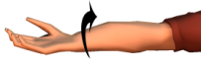
Hands, Wrists, Fingers | Wrist flexed/ extended > 20º  Wrist deviated to side > 15º  Pinch grip  Power grip | 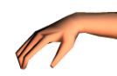 | 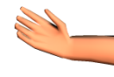 |  | 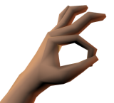 |  | 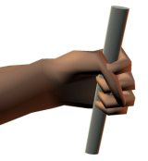 | Light: < 2#  Mod: 2# to 5#  Heavy: 5# to 10#  Very Heavy: >10# | Low: < 10 sec  Mod: 10 to 45 sec  High: > 45 sec | Low: < 1/min  Mod: 1 to 5/min  High: > 5/min
 |  | 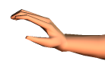 | 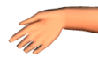
Legs | Squatting  Kneeling  On one leg/up on toes | 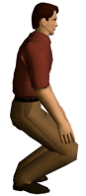 |  | 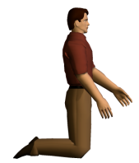 |  | 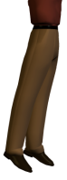 |  | Light: < 20#  Mod: 20# to 40#  Heavy: 40# to 60#  Very Heavy: >60# | Low: < 10 sec  Mod: 10 to 45 sec  High: > 45 sec | Low: < 0.5/min  Mod: 0.5 to 3/min  High: > 3/min

Other Factors | YES | NO |  | Other Factors | YES | NO
Production/Quality – affected negatively |  |  |  | Contact Stress – hard surface pressure on body from sitting or standing
Training – inadequate safety or process training |  |  |  | Contact Stress – sharp edge pressure on body from workbench or tool, etc.
Vibration – tool use (grinders, sanders, etc.) |  |  |  | Tools – incorrect tool or used incorrectly
Vibration – driving vehicles (fork trucks, etc.) |  |  |  | Task lighting – inadequate task light for inspection
Temperature/Cold – exposure to cold environments |  |  |  | Ambient lighting – too low or high level of ambient lighting
Temperature/Hot – exposure to hot environments |  |  |  | Vision – difficulty in seeing parts/materials

