ErgoSystems Ergonomics Risk Factor Analysis

STEP ONE | Company: |  | Date: |  | Department/  Work Unit:
 | Prepared by: |  | Time: |  | Safety FYIs/ Injury History:
 | Job/Task Observed: |  | # People Affected: |  | Employees Observed:

STEP TWO | Head/Neck/Eyes |  |  | Shoulders/Upper Back |  |  | Back (Mid/Low) |  |  | Arms/Elbows |  | Hands/Wrists/Fingers |  |  | Legs/Feet
Posture | 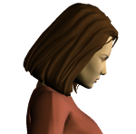 |  | 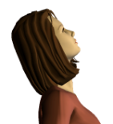 | 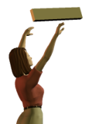 |  | 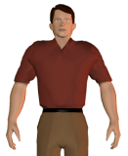 | 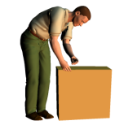 |  | 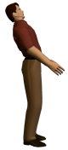 | 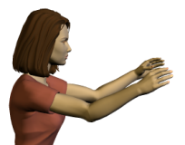 |  | 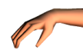 |  | 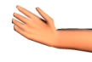 | 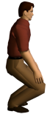 |  | 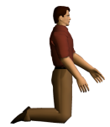
 |  |  |  |  |  |  |  |  |  |  |  | 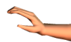 |  | 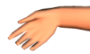
 | 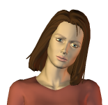 |  | 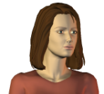 | 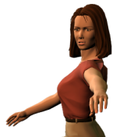 |  |  | 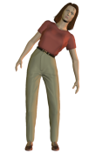 |  | 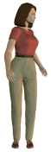 | 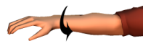  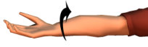 |  | 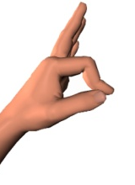 |  | 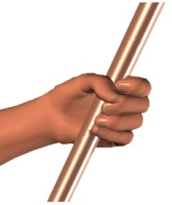 | 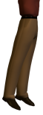
 | Look down > 30⁰  Look up > 10⁰  Side bent > 15⁰  Rotated > 20⁰ |  |  | Hands at/above shoulders/head  Shrugged shoulders  Reach behind body |  |  | Flexed forward >20⁰  Extended back > 20⁰  Bent sideways > 20⁰  Rotated >20⁰ |  |  | Fully extended arm  Rotation of wrists/forearms, palms up/down |  | Wrist flex/extend > 20º  Wrist bent to side > 15º  Pinch grip  Power grip |  |  | Squatting  Kneeling  On one leg/up on toes
Force | 0 | Light: < 5# |  | 0 | Light: < 5# |  | 0 | Light: < 10# |  | 0 | Light: < 3# | 0 | Light: < 2# |  | 0 | Light: < 20#
 | 1 | Mod: 5# to 10# |  | 1 | Mod: 5# to 10# |  | 1 | Mod: 10# to 20# |  | 1 | Mod: 3# to 8# | 1 | Mod: 2# to 5# |  | 1 | Mod: 20# to 40#
 | 2 | Heavy: 10# to 20# |  | 2 | Heavy: 10 # to 20# |  | 2 | Heavy: 20# to 40# |  | 2 | Heavy: 8# to 15# | 2 | Heavy: 5# to 10# |  | 2 | Heavy: 40# to 60#
 | 3 | Very Heavy: > 20# |  | 3 | Very Heavy: >20# |  | 3 | Very Heavy: >40# |  | 3 | Very Heavy: >15# | 3 | Very Heavy: >10# |  | 3 | Very Heavy: >60#
Duration (static) | 0 | Low: < 10 sec |  | 0 | Low: < 10 sec |  | 0 | Low: < 10 sec |  | 0 | Low: < 10 sec | 0 | Low: < 10 sec |  | 0 | Low: < 10 sec
 | 1 | Mod: 10 to 45 sec |  | 1 | Mod: 10 to 45 sec |  | 1 | Mod: 10 to 45 sec |  | 1 | Mod: 10 to 45 sec | 1 | Mod: 10 to 45 sec |  | 1 | Mod: 10 to 45 sec
 | 2 | High: > 45 sec |  | 2 | High: > 45 sec |  | 2 | High: > 45 sec |  | 2 | High: > 45 sec | 2 | High: > 45 sec |  | 2 | High: > 45 sec
Frequency | 0 | Low: < 0.5/min |  | 0 | Low: < 0.5/min |  | 0 | Low: < 0.25/min |  | 0 | Low: < 0.5/min | 0 | Low: < 1/min |  | 0 | Low: < 0.5/min
 | 1 | Mod: 0.5 to 5/min |  | 1 | Mod: 0.5 to 5/min |  | 1 | Mod: 0.25 to 3/min |  | 1 | Mod: 0.5 to 5/min | 1 | Mod: 1 to 5/min |  | 1 | Mod: 0.5 to 3/min
 | 2 | High: > 5/min |  | 2 | High: > 5/min |  | 2 | High: > 3/min |  | 2 | High: > 5/min | 2 | High: > 5/min |  | 2 | High: > 3/min

STEP THREE | Score (per body part): total number of checked boxes for Posture plus sum of numbers circled for Force, Duration and Frequency  Risk (per body part) : for each body part determine risk level depending on the total points for that body part: Low: 0 to 1, Mod: 2 to 3, High > 4
Score  www.ergosystemsconsulting.com 952-401-9296 |  | LL LM LHL |  | LL LM LHL |  | LL LM LHL |  | LL LM LHL |  | LL LM LHL |  | L L LM LHL

STEP FOUR | Other Factors | YES | NO |  | STEP FIVE | Discomfort Survey/Employee Input
Production/Quality – Work processes affected negatively |  |  |  |  | Complete survey based on average workday.  Indicate left and right side using Key below: |  | Employee Comments:
Training – Inadequate safety or process training |  |  |  |  | 0= NONE/MINIMAL: Some discomfort, able to reasonable cope while performing general tasks
Vibration – Of hand/arm, related to tool use (grinders, sanders, etc.) |  |  |  |  | 1=MODERATE: Moderate discomfort, some difficulty in performing general activities.
Vibration – Of whole body, related to driving vehicles (fork trucks, etc.) |  |  |  |  | 2=SEVERE: Significant difficulty in performing general activities.
Temperature/Hot – Exposure to hot environments |  |  |  |  | 3=MAX: Maximum discomfort (unable to function, admitted to the hospital.)
Temperature/Cold – Exposure to cold environments |  |  |  |  | Body Part Left Right  - Head/Neck/ Eyes  - Shoulders/ Upper Back  - Back (Mid/Low)  - Arms/Elbows  - Hands/Wrists/ Fingers  - Legs/Feet  Left ( ) + Right ( ) = ( ) |  | 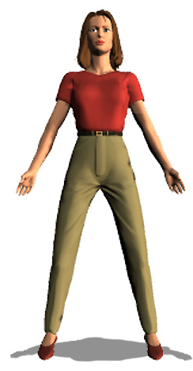 | 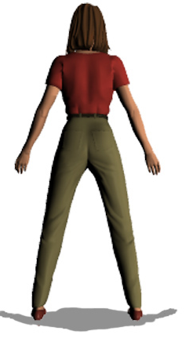
Contact Stress –Hard surface pressure on body from sitting or standing
Contact Stress – Sharp edge pressure on body from workbench, tool, etc.
Tools – Incorrect tool or tool used incorrectly
Task lighting – Inadequate task light for inspection
Ambient lighting – Too low or too high level of ambient lighting
Vision – Difficulty in seeing parts/materials to assemble or inspect

STEP SIX | Total Score |  |  | STEP SEVEN | Action Plan
Head/Neck/Eyes |  |  |  | Corrective Action Responsible Person(s) Due Date Status  Not Started  In Process  Completed  Not Started  In Process  Completed  Not Started  In Process  Completed
Shoulders/Upper Back
Back (Mid/Low)
Arms/Elbows
Hands/Wrists/Fingers
Legs/Feet
Other Factors
Discomfort Survey
TOTAL SCORE
SCORING KEY: LOW: 0 to15 MOD: 16 to 30 HIGH: > 30

CURRENT MAJOR STEPS | ERGONOMICS ISSUES | POTENTIAL SOLUTIONS
MISC NOTES

FOLLOW-UP
www.ergosystemsconsulting.com 952-401-9296

