ErgoSystems Ergonomics Risk Factor Analysis (Post-Intervention)

STEP ONE | Company: | ABC Company, Inc. | Date: | 8/28/2011 | Department/  Work Unit: | Machine Center
 | Prepared by: | Mark Johnson | Time: | 10:00 AM | Safety FYIs/ Injury History: | 3 FYIs, 0 incidents
 | Job/Task Observed: | Fill CNC Reservoirs, 5 gal buckets, 75 to 100 feet, fill each of 7 CNC 1 to 3/week | # People Affected: | 3 | Employees Observed: | Amy Sedon

STEP TWO | Head/Neck/Eyes |  |  | Shoulders/Upper Back |  |  | Back (Mid/Low) |  |  | Arms/Elbows |  | Hands/Wrists/Fingers |  |  | Legs/Feet
Posture |  |  |  | 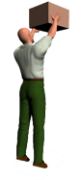 |  | 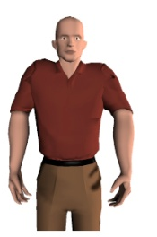 | 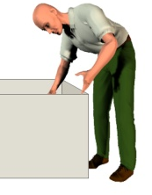 |  | 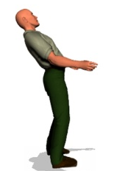 |  |  | 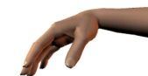 |  | 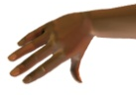 | 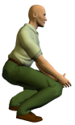 |  | 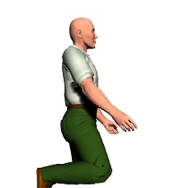
 |  |  |  |  |  |  |  |  |  |  |  | 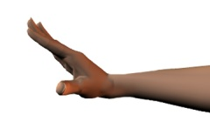 |  | 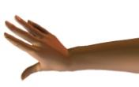
 |  |  |  |  |  | 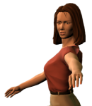 | 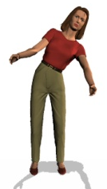 |  | 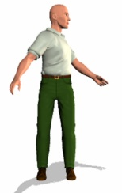 | 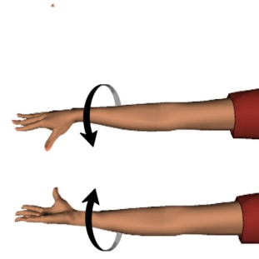 |  | 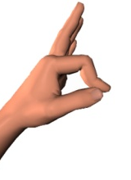 |  | 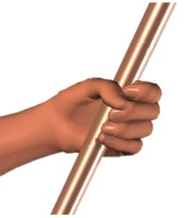 | 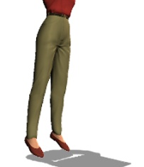 |  | 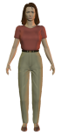
 | Look down > 30⁰  Look up > 10⁰  Side bent > 15⁰  Rotated > 20⁰ |  |  | Reach above shoulder ht  Shrugged shoulders  Reach to side of body  Reach behind body |  |  | Flexed forward >20⁰  Extended back > 20⁰  Bent sideways > 20⁰  Rotated >20⁰ |  |  | Fully extended arm  Rotation of wrists/ forearms, palms up/down |  | Wrist flex/extend > 20º  Wrist bent to side > 15º  Pinch grip  Power grip |  |  | Squatting  Kneeling  On one leg/up on toes  Sustained standing
Force | 0 | Light: Neutral head |  | 0 | Light: < 5# |  | 0 | Light: Neutral back pos |  | 0 | Light: < 3# | 0 | Light: < 2# |  | 0 | NA
 | 1 | Mod: Head wt (HW) only |  | 1 | Mod: 5# to 10# |  | 1 | Mod: Body + up to 20# |  | 1 | Mod: 3# to 8# | 1 | Mod: 2# to 5# |  | 1 | Mod: Body wt (BW) only
 | 2 | Heavy: HW + up to 20# |  | 2 | Heavy: 10 # to 20# |  | 2 | Heavy: Body + 20# to 40# |  | 2 | Heavy: 8# to 15# | 2 | Heavy: 5# to 10# |  | 2 | Heavy: BW + up to 40#
 | 3 | Very Heavy: > HW + 20# |  | 3 | Very Heavy: >20# |  | 3 | Very Hvy: > Body+ > 40# |  | 3 | Very Heavy: >15# | 3 | Very Heavy: >10# |  | 3 | Very Heavy: BW + > 60#
Duration (static) | 0 | Low: < 10 sec |  | 0 | Low: < 10 sec |  | 0 | Low: < 10 sec |  | 0 | Low: < 10 sec | 0 | Low: < 10 sec |  | 0 | Low: < 10 sec
 | 1 | Mod: 10 to 45 sec |  | 1 | Mod: 10 to 45 sec |  | 1 | Mod: 10 to 45 sec |  | 1 | Mod: 10 to 45 sec | 1 | Mod: 10 to 45 sec |  | 1 | Mod: 10 sec to 30 min
 | 2 | High: > 45 sec |  | 2 | High: > 45 sec |  | 2 | High: > 45 sec |  | 2 | High: > 45 sec | 2 | High: > 45 sec |  | 2 | High: > 30 min
Frequency | 0 | Low: < 0.5/min |  | 0 | Low: < 0.5/min |  | 0 | Low: < 0.25/min |  | 0 | Low: < 0.5/min | 0 | Low: < 1/min |  | 0 | Low: < 0.5/min
 | 1 | Mod: 0.5 to 5/min |  | 1 | Mod: 0.5 to 5/min |  | 1 | Mod: 0.25 to 3/min |  | 1 | Mod: 0.5 to 5/min | 1 | Mod: 1 to 5/min |  | 1 | Mod: 0.5 to 3/min
 | 2 | High: > 5/min |  | 2 | High: > 5/min |  | 2 | High: > 3/min |  | 2 | High: > 5/min | 2 | High: > 5/min |  | 2 | High: > 3/min

STEP THREE | Score (per body part): total number of checked boxes for Posture plus sum of numbers circled for Force, Duration and Frequency  Risk (per body part) : for each body part circle the risk level depending on the total points for that body part: Low: 0 to 1, Mod: 2 to 3, High > 4
Score | 2 LL LM LHL | 0 LL LM LHL | 0 LL LM LHL | 0 LL LM LHL | 3 LL LM LHL | 0 LL LM LHL
Form V2_041413 www.ergosystemsconsulting.com 952-401-9296

STEP FOUR | Other Factors | YES | NO |  | STEP FIVE | Discomfort Survey/Employee Input Summary
Production/Quality – Work processes affected negatively |  |  |  |  | Complete survey based on average workday.  Indicate left and right side using Key below: |  | Employee Comments:  - Reported significant decrease in discomfort in back, hands, arms and shoulders when using cart to transport buckets between fill station and reservoir at the CNC machines.  - No longer have to bend down when using hose to fill the buckets.  - Have to tip bucket and dump into reservoir.  NOTE: Scores are average of 3 individuals completing the Discomfort Survey
Training – Inadequate safety or process training |  |  |  |  | 0 = NONE/MINIMAL: Some discomfort, able to reasonable cope while performing general tasks
Vibration – Of hand/arm, related to tool use (grinders, sanders, etc.) |  |  |  |  | 1 = MODERATE: Moderate discomfort, some difficulty in performing general activities.
Vibration – Of whole body, related to driving vehicles (fork trucks, etc.) |  |  |  |  | 2 = SEVERE: Significant difficulty in performing general activities.
Temperature/Hot – Exposure to hot environments |  |  |  |  | 3 = MAX: Maximum discomfort (unable to function, admitted to the hospital.)
Temperature/Cold – Exposure to cold environments |  |  |  |  | Body Part Left Right  - Head/Neck/ Eyes 0 0  - Shoulders/ Upper Back 0 0  - Back (Mid/Low) 1 1  - Arms/Elbows 0 0  - Hands/Wrists/ Fingers 0 1  - Legs/Feet 0 0  Left (1) + Right (2) = (3) |  | 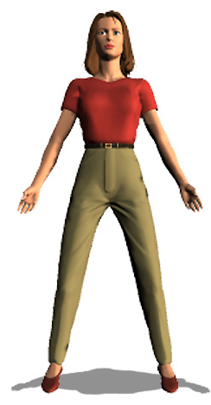 | 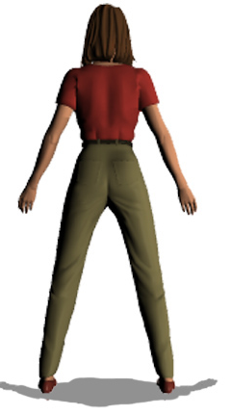
Contact Stress –Hard surface pressure on body from sitting or standing
Contact Stress – Sharp edge pressure on body from workbench, tool, etc.
Tools – Incorrect tool or tool used incorrectly
Task lighting – Inadequate task light for inspection
Ambient lighting – Too low or too high level of ambient lighting
Vision – Difficulty in seeing parts/materials to assemble or inspect

STEP SIX | Total Score |  |  | STEP SEVEN | Action Plan
Head/Neck/Eyes |  | 2 |  | Corrective Action Responsible Person(s) Due Date Status  Obtain cart to position and transport buckets from fill station to CNCs. Cart needs to be able to position bucket at knee level and easy to maneuver. Mark Johnson 8/28/2011 Not Started In Process Completed  Not Started  In Process  Completed  Not Started  In Process  Completed
Shoulders/Upper Back |  | 0
Back (Mid/Low) |  | 0
Arms/Elbows |  | 0
Hands/Wrists/Fingers |  | 3
Legs/Feet |  | 0
Other Factors |  | 1
Discomfort Survey |  | 3
TOTAL SCORE  SCORING KEY: LOW: 0 to15 MOD: 16 to 30 HIGH: > 30 |  | 9

