ErgoSystems Office Ergonomics Assessment
Last name: |  | Stature: | ft in | Work hours:
First name: |  | Shoe heel ht: | in | Comments:
Date: | Click here to enter a date. | Handedness:
 |  | Vision:
Company: |  | Job tasks:
Location: |  | Job demands:
 |  | User:
 |  | Other station:
Assessment performed by Mark Anderson, MA, PT, CPE, ErgoSystems Consulting Group, Inc. 7421 West Shoreline Dr., Waconia, MN 55387, Voice: 952-401-9296
Email: mark.anderson@ergosystemsconsulting.com.
The purpose of the assessment is to focus on ergonomics issues of the workstation, work practices, and work process to provide a set of workstation set-up specifications and to offer reasonable suggestions to help improve comfort, safety, and productivity in the workplace.
The 30/30 rule was encouraged - this promotes physical movement up and out of chair for at least 30 seconds at least every 30 minutes.

Chair |  | Comment | Recommendation
Type |  |  | Instructed in upright “keyboard position” and semi-reclined “conversation position”. Recommended to alternate between these two seated postures based on job tasks throughout day.
Legs
Casters
Seat
Back
Arms
Foot support/Clearance |  | Comment | Recommendation
Feet
Footrest
Worksurface |  | Comment | Recommendation
Config
Type
Keyboard Tray |  | Comment | Recommendation
Used
Adjust
Keyboard |  | Comment | Recommendation
Type
Location
Mouse |  | Comment | Recommendation
Type
Location
CPU |  | Comment | Recommendation
Type
Location
Monitor |  | Comment | Recommendation
Type
Number
Telephone |  | Comment | Recommendation
Type
Location
Document holder |  | Comment | Recommendation
Type
Location
Storage |  | Comment | Recommendation
Desktop
File
Lighting |  | Comment | Recommendation
Ambient
Task

Recommended Specifications (inches)
Specification | Sit | Stand |  | Description | Key
Seatpan height: |  |  |  | Seatpan height: distance from floor to seatpan (at side of seatpan) with user in chair. | 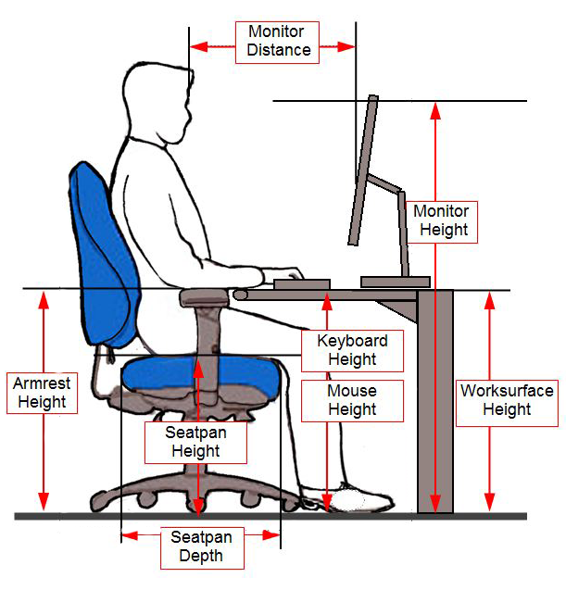
Seatpan depth: |  |  |  | Seatpan depth: distance from back support to front of seatpan and allows for 1.5 to 2” of space between back of knee and front of seatpan.
Seatpan width: |  |  |  | Seatpan width: distance side-to-side of seatpan; allows for 1.5 to 2” between thigh and edge of seatpan.
Armrest height: |  |  |  | Armrest height: distance from top of armrest to floor.
Armrest width |  |  |  | Armrest width: distance between armrests measured from outside edge of each armrest.
Writing / reading desk: |  |  |  | Worksurface height: (writing/reading desk) is distance from floor to top surface of worksurface.
Keyboard / mouse height: |  |  |  | Keyboard/mouse height: distance from floor to top surface of platform that keyboard/mouse rest on.
Monitor height: |  |  |  | Monitor height: height from floor to top of monitor screen (not top of monitor bezel).
Monitor distance: |  |  |  | Monitor distance: from eye position (bridge of nose between eyes) to screen.

Common Keyboard Shortcuts
[CTRL] – A | Select “all” on a page | [CTRL] – S | Saves current file | [ALT] – F4 | Close current program
[CTRL] – B | Apply “bold” to selection | [CTRL] – U | Apply “underlining” to selection | [ALT] – Tab | Toggles user through all open programs
[CTRL] – C | Copy the selection | [CTRL] – V | Paste contents of clipboard | [Home] | Move to beginning of current line
[CTRL] – F | Find particular text on a page | [CTRL] – W | Same as File > Close | [End] | Move to end of current line
[CTRL] – I | Apply “italics” to selection | [CTRL] – X | Cut the selection | [CTRL] – Home | Return to “Home” position (upper left) of window
[CTRL] – O | Same as File > Open | [CTRL] – Y | Redo last action | [CTRL] – End | Move to “End” position (lower right) of window
[CTRL] – P | Print | [CTRL] – Z | Undo last action | [Tab] | Tab forward through fields
[CTRL] – R | Refresh current page |  |  | [SHIFT] – Tab | Move backward when tabbing through fields

