Discomfort Survey
Based on your average workday, please complete the Discomfort Survey. Fill in all of the boxes below. Please respond honestly and thoughtfully. Your responses are anonymous. THANK YOU! | Survey:
 | Date: | / / | Handedness: | R or L
 | Line:
 | Operation:
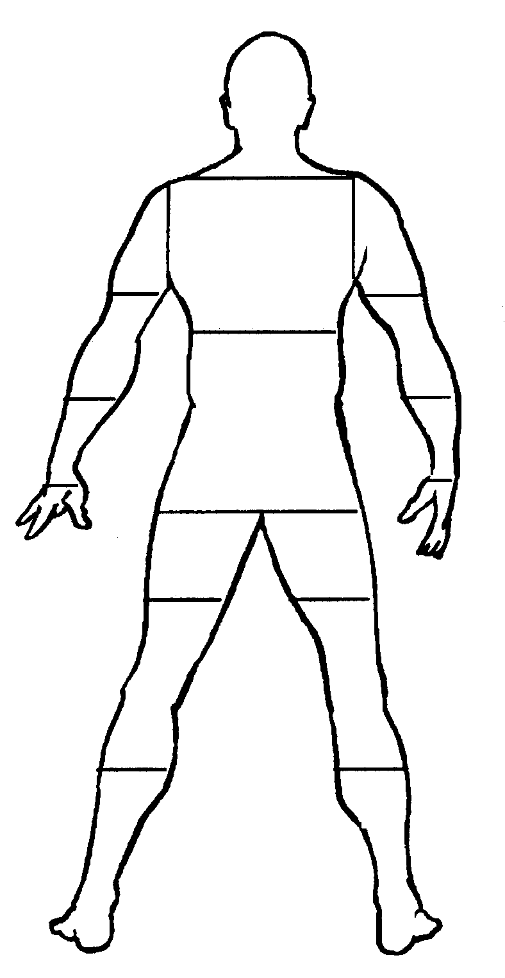
- Describe symptoms (if any) by writing the letters (N, T, A, B) on the body diagram on the area of the body involved. (SEE KEY BELOW FOR DEFINTIONS)
A
B
C
D
E
H
J
I
F
G
Left Side
Right Side
N=Numbness T=Tingling A=Aching B=Burning
- Rate discomfort for each region (A-J) by writing the number (0 to 10) in the box.
0=NONE: No discomfort at all.
5=MODERATE: Moderate discomfort, some difficulty in performing general activities.
10=MAX: Maximum discomfort (unable to function, admitted to the hospital.)

 | BODY PART | NONE |  | MAX
A | Head/Neck/Eyes | 0…. |  | . . . 10
B | Upper/Mid Back | 0…. |  | . . . 10
C | Low Back/Pelvis | 0…. |  | . . . 10
D | Shoulder/Upper Arm | 0…. |  | . . . 10
E | Elbow/Mid Arm | 0…. |  | . . . 10
F | Forearm/Wrist | 0…. |  | . . . 10
G | Hand | 0…. |  | . . . 10
H | Upper Leg/Hip | 0…. |  | . . . 10
I | Mid Leg/Knee | 0…. |  | . . . 10
J | Lower Leg/Foot | 0…. |  | . . . 10
- Please respond to questions below:
 |  | MIN |  | MAX
How hard is your work (physical/mental demands? |  | 0…. |  | . . . 10
How much energy do you have left after work? |  | 0…. |  | . . . 10
Rate the level of your job satisfaction. |  | 0…. |  | . . . 10
OVER FOR ADDITIONAL COMMENTS
Please list ways to make your work more comfortable, safe and productive.
1.

2.

3.

4.

5.

